

Ricardo Ruiz Maldonado

Escuela superior de cómputo | Instituto politécnico Nacional

Practice 4

PWM with dip switch

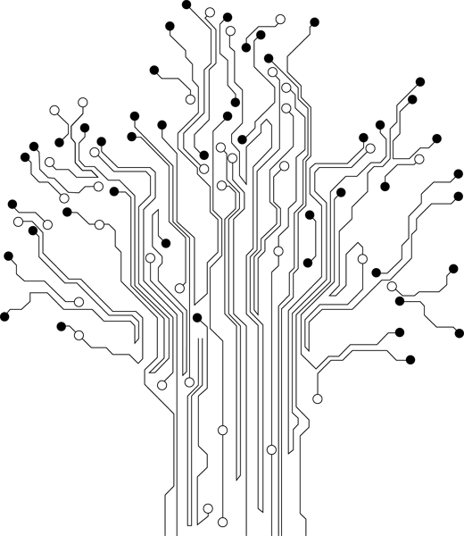

**Profesor:** Paz Rodríguez Héctor Manuel

**Grupo:** 3CV3

Marco Teórico

# PWM

Pulse Width Modulation (PWM) is one method of reducing the perceived luminance in displays, which it achieves by cycling the backlight on and off very rapidly. This generally means that at 100% brightness a constant voltage is applied to the backlight and it is continuously lit. As you lower the brightness control the perceived luminance for the user reduces due to a number of possible controlling factors:

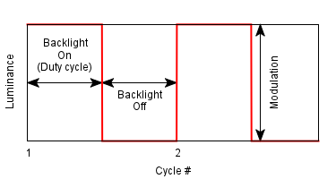

Pulse width modulation (PWM) is a technique of controlling the amount of power delivered to an electronic load using an on-off digital signal. The fraction of the period for which the signal is on is known as the duty cycle. The average DC value of the signal can be varied by varying the duty cycle. The duty cycle can be anywhere between 0 (signal is always off) to 1 (signal is constantly on). Suppose, if the signal has +5 V while it is on and 0 V during off condition, then by changing the duty cycle of the signal, any voltage between 0-5 V can be simulated. This method is commonly used for controlling speeds of DC motors and brightness of lamps.

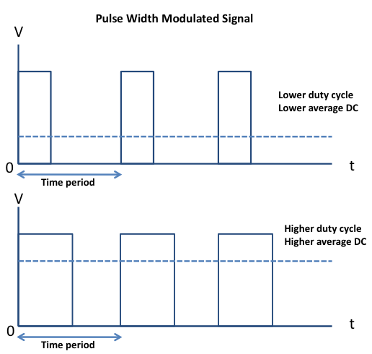

PWM (Pulse Width Modulation) is the term used to describe using a digital signal to generate an analogue output signal. This is usually used to control the average power to a load in a motor speed control circuit.

# Material

* Pazuino
* Led externo a la tarjeta
* Dip switch incluido en la Pazuino

# Desarrollo y Funcionamiento

Para el desarrollo de esta práctica se hizo uso del Puerto B del microcontrolador y del registro R16. El registro R16 se usa para poner los pines del puerto B como salida, a su vez que recibe el valor que se lee del puerto A, en esta practica se tiene un loop que esta leyendo constantemente.

# Código

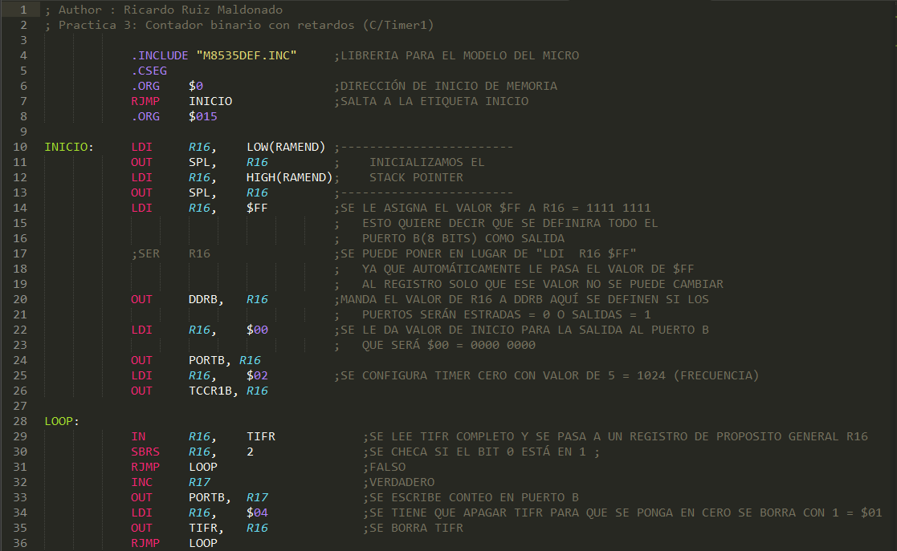

# Conclusiones

Hasta el momento todas las señales que se habían usado eran de salida, esta práctica fue especial por que abrió un nuevo mundo al poder recibir señales haciendo posible que nuevas aplicaciones se pudieran realizar