

Ricardo Ruiz Maldonado

Escuela superior de cómputo | Instituto politécnico Nacional

Practice 0.1

Semaphore

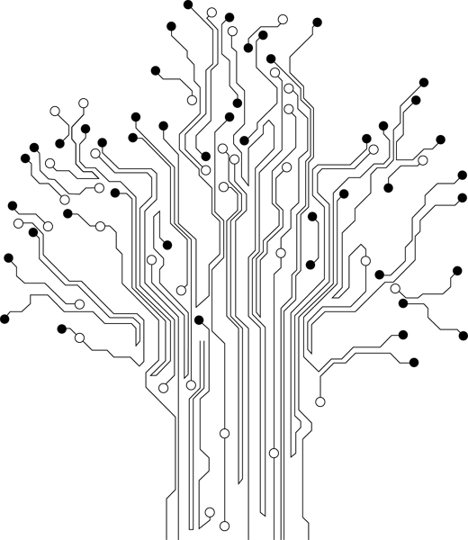

**Profesor:** Paz Rodríguez Héctor Manuel

**Grupo:** 3CV3

Theoretical Reference

# Introduction

***Register:***

A register or a memory cell is an electronic circuit which can memorize the state of one byte. Besides 8 bits available to the user, each register has also a number of addressing bits. It is important to remember that:

All registers of ROM as well as those of RAM referred to as general-purpose registers are mutually equal and nameless. During programming, each of them can be assigned a name, which makes the whole operation much easier.

***Timers / Counters:***

Most programs use these miniature electronic "stopwatches" in their operation. These are commonly 8- or 16-bit SFRs the contents of which is automatically incremented by each coming pulse. Once the register is completely loaded, an interrupt is generated

If these registers use an internal quartz oscillator as a clock source, then it is possible to measure the time between two events (if the register value is T1 at the moment measurement has started, and T2 at the moment it has finished, then the elapsed time is equal to the result of subtraction T2-T1 ). If the registers use pulses coming from external source, then such a timer is turned into a counter.

This is only a simple explanation of the operation itself. It’s somehow more complicated in practice.

# Material

* Pazuino

# Development and implementation

Para el desarrollo de esta práctica se hizo uso del Puerto B del microcontrolador y de los registros R16, R20, R21 y R22. El registro R16 se usa para poner los pines del puerto B como salida, en esta práctica se generaron 3 subrutinas para enciclar el recorrido de 0 a 255 de tres registros ocupando asi 1, 2 y 3 segundos del procesador y asi poder prender los leds para simular un semáforo.

# Code

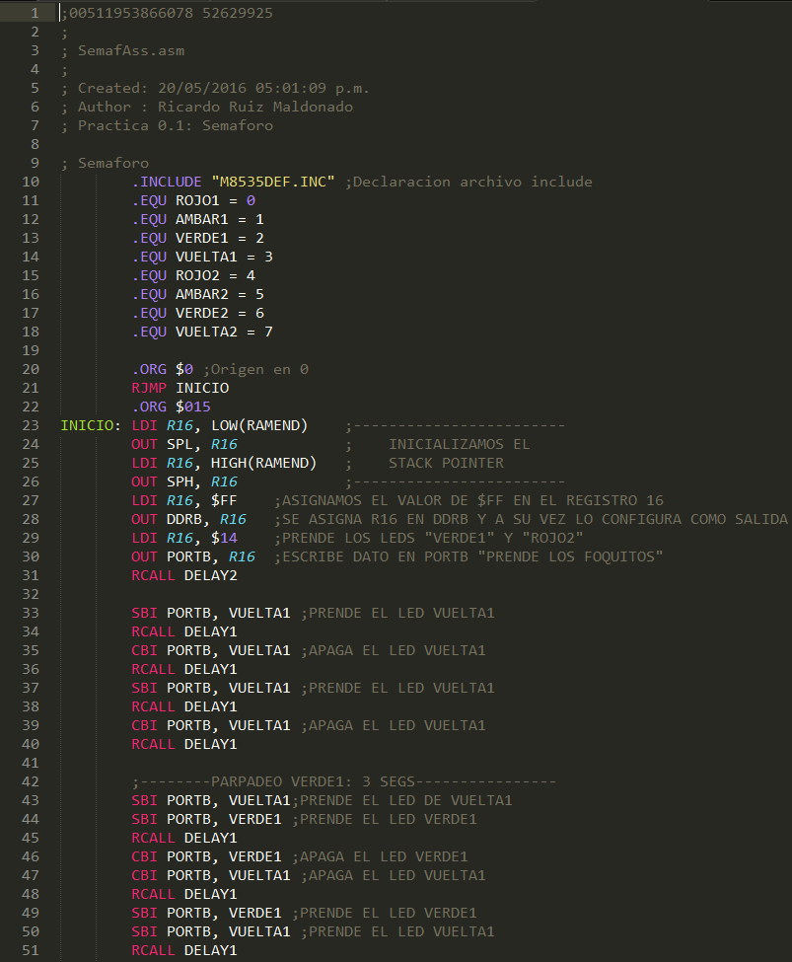

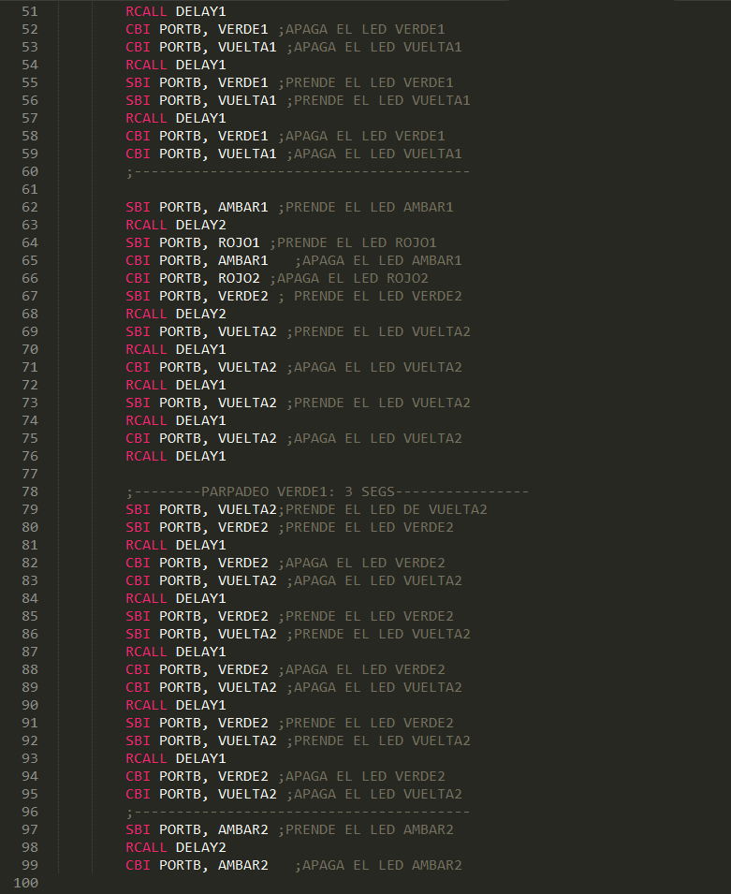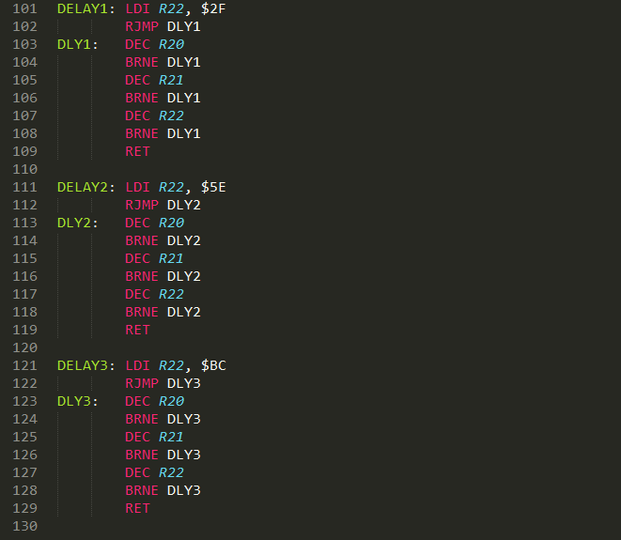

# Conclusiones

La forma de pensar necesaria para programar en ensamblador es un poco diferente a la normalmente utilizada, si bien no estoy acostumbrado creo que esto me ayuda abrir mi mente a nuevas ideas