

Ricardo Ruiz Maldonado

Escuela superior de cómputo | Instituto politécnico Nacional

Practice 2

Reading and writing ports

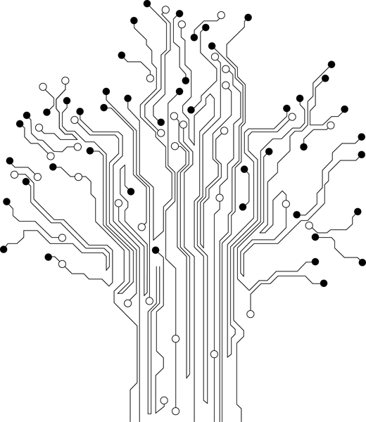

**Profesor:** Paz Rodríguez Héctor Manuel

**Grupo:** 3CV3

Theoretical Reference

# Puertos del atmega8535

***Harvard architecture:***

In Harvard architecture, the data bus and address bus are separate. Thus a greater flow of data is possible through the central processing unit, and of course, a greater speed of work. Separating a programme from data memory makes it further possible for instructions not to have to be 8-bit words. For example the Microchip PIC16F84 microcontroller uses 14 bits for instructions which allows for all instructions to be one word instructions. It is also typical for Harvard architecture to have fewer instructions than Von-Neumann's, and to have instructions usually executed in one cycle. Microcontrollers with Harvard architecture are also called Reduced Instruction Set Computer (RISC) microcontrollers. Microprocessors with Von-Neumann's architecture are called Complex Instruction Set Computers (CISC).

***Input / output ports (I/O Ports):***

In order to make the microcontroller useful, it is necessary to connect it to peripheral devices. Each microcontroller has one or more registers (called a port) connected to the microcontroller pins.

# Material

* Pazuino
* Leds
* Minidip

# Desarrollo y Funcionamiento

The purpose of this program is to light several LEDs on PORTB by configuring the output port B and typing a value in the B port and finally a data read from port A.

# Code

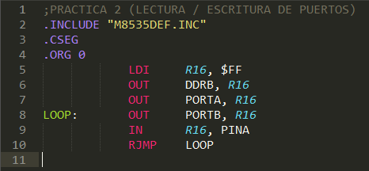

# Conclusiones

Hasta el momento todas las señales que se habían usado eran de salida, esta práctica fue especial por que abrió un nuevo mundo al poder recibir señales haciendo posible que nuevas aplicaciones se pudieran realizar