

Ricardo Ruiz Maldonado

Escuela superior de cómputo | Instituto politécnico Nacional

Practice 0

Counter without delay

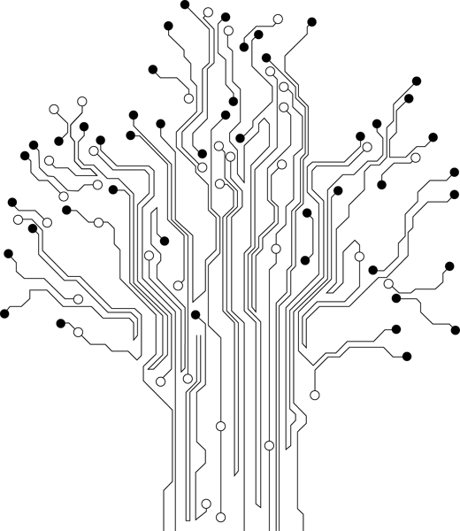

**Profesor:** Paz Rodríguez Héctor Manuel

**Grupo:** 3CV3

Theoretical Reference

# Atmega8535 / Pazuino

It is a small computer on a single integrated circuit containing a processor core, memory, and programmable input/output peripherals. Program memory in the form of NOR flash or OTP ROM is also often included on chip, as well as a typically small amount of RAM. Microcontrollers are designed for embedded applications, in contrast to the microprocessors used in personal computers or other general purpose applications.

Microcontrollers are used in automatically controlled products and devices, such as automobile engine control systems, implantable medical devices, remote controls, office machines, appliances, power tools, toys and other embedded systems. By reducing the size and cost compared to a design that uses a separate microprocessor, memory, and input/output devices, microcontrollers make it economical to digitally control even more devices and processes. Mixed signal microcontrollers are common, integrating analog components needed to control non-digital electronic systems.

## I/O diagram

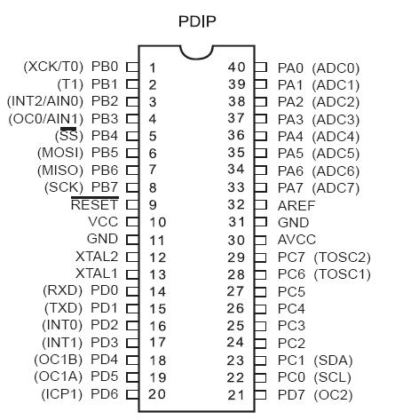

## Architecture

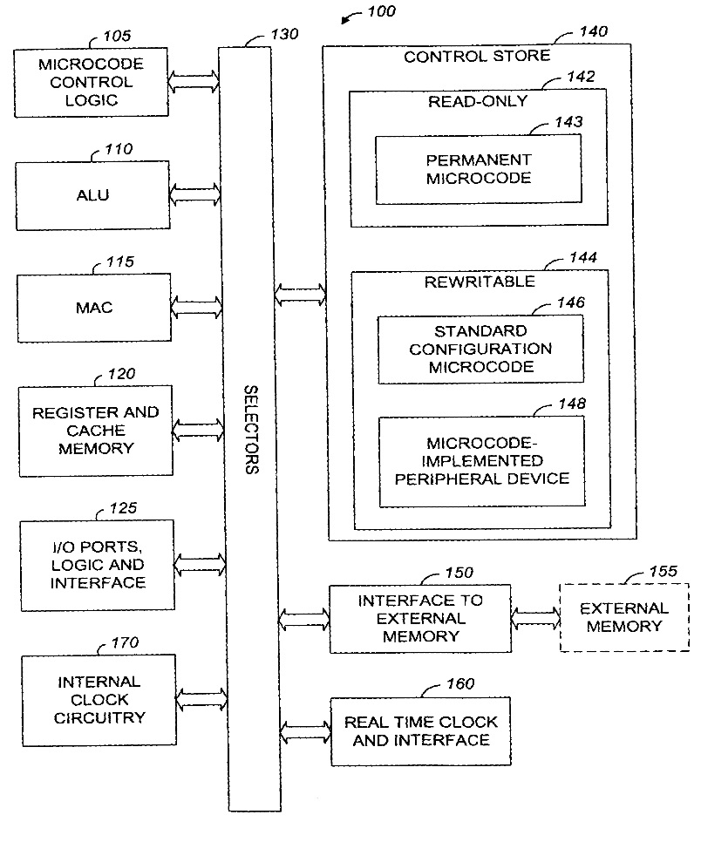

# Resources

* Pazuino

# Development and implementation

The sole purpose of this program is to light several LEDs on PORTB (**Without a delay**).

As soon as the microcontroller is turned on, all the LEDs emit light for an instant of time.

The delay function is to provide a time delay in this practice the delay time will not exist, so apparently the LEDs remain active all the time.

# Code

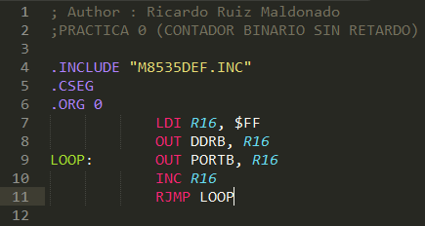

# Conclusiones

Esta práctica fue muy útil para empezar a familiarizarme con el IDE AVR studio y con el lenguaje de programación ensamblador, para mí fue toda una aventura empezar a familiarizarme con el funcionamiento de los registros y de las instrucciones necesarias para ejecutar el programa.