|  |  |
| --- | --- |
| **rpg thrift store: user manual** | **This user manual teaches you how to use the RPG Thrift Store web store.** |

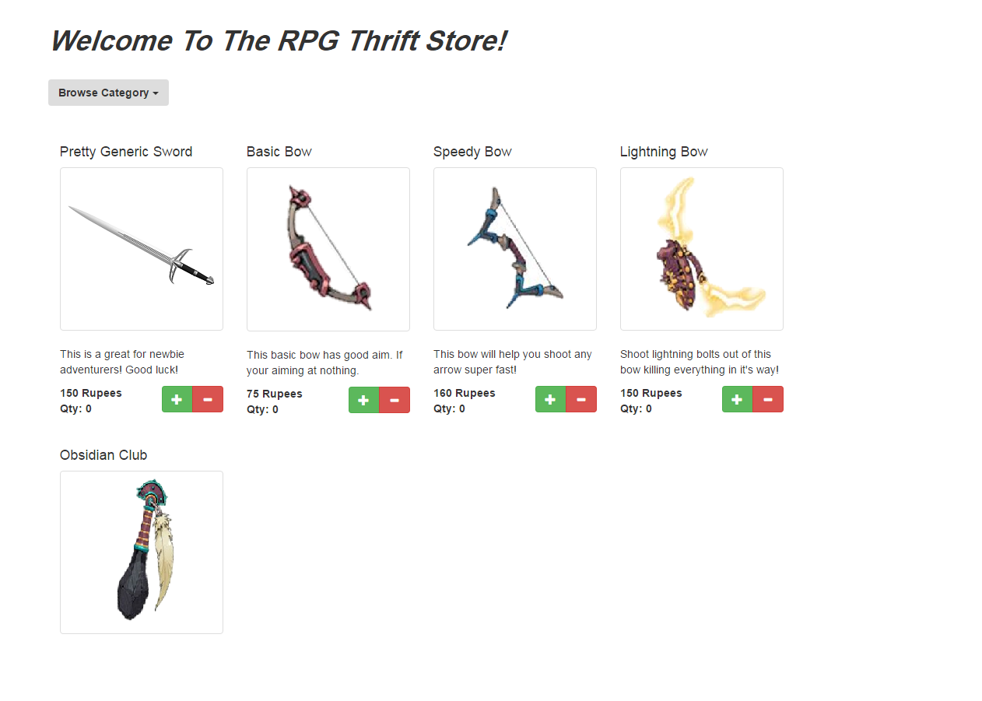

Good day to you fellow traveler, since this may be your first time here I thought I’d help you a bit.

First, we sell a lot of things at RPG Thrift Shop. To find out what you click on Browse Category to my left and you’ll get this drop-down menu. From there you can select from a simple list for what you need from weapons to books.

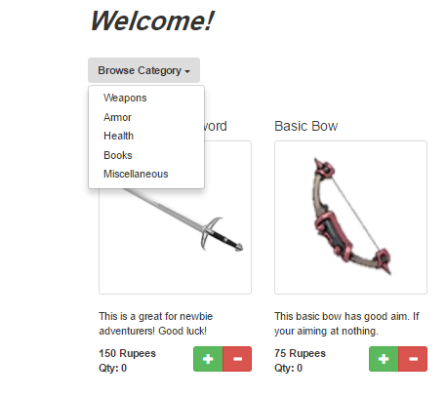



Now, let’s say you need some health based items. What you want to do is click on Health under the categories.

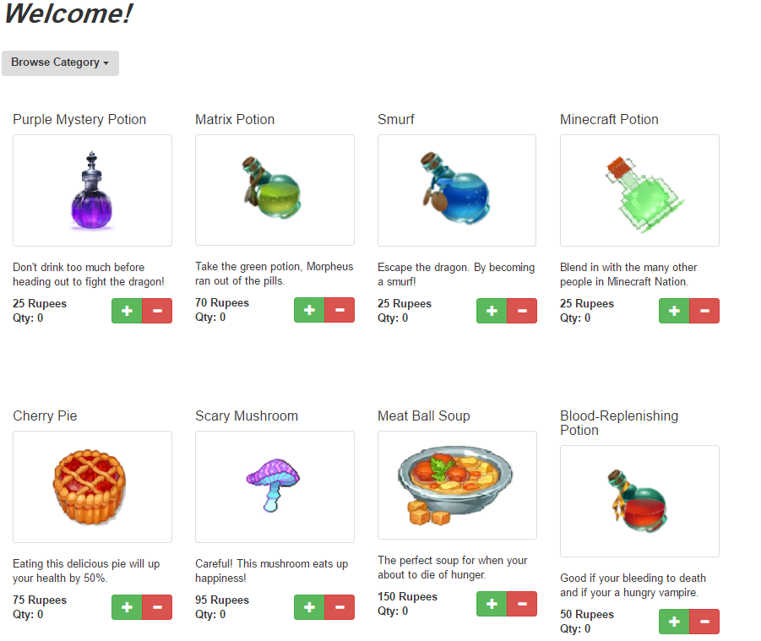

Now, on this page say you want 10 matrix potions. What you want to do is click this plus sign right here 10 times.

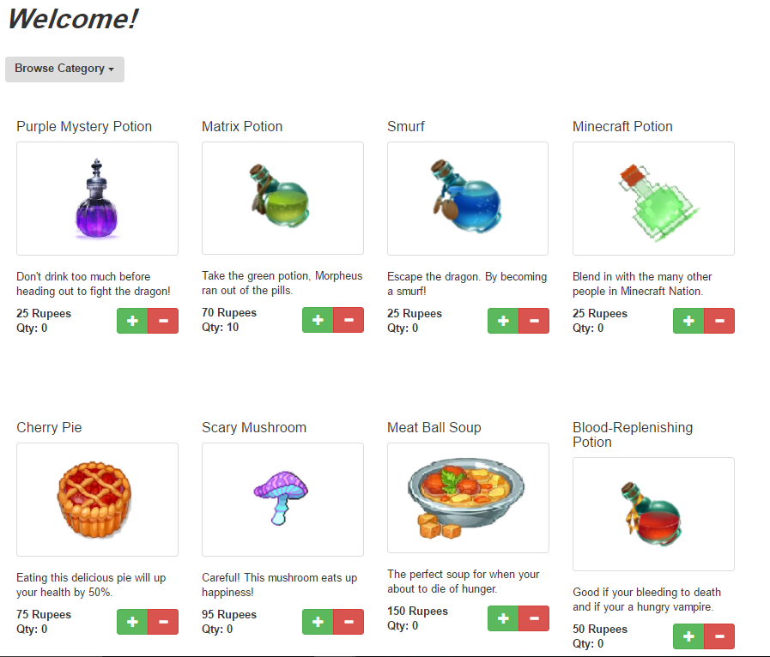

Like magic you have 10 matrix potions. But wait one of your travelers has mysteriously died thus you need one less what do you do??? Simply hit the minus button right here to take away what you don’t need…

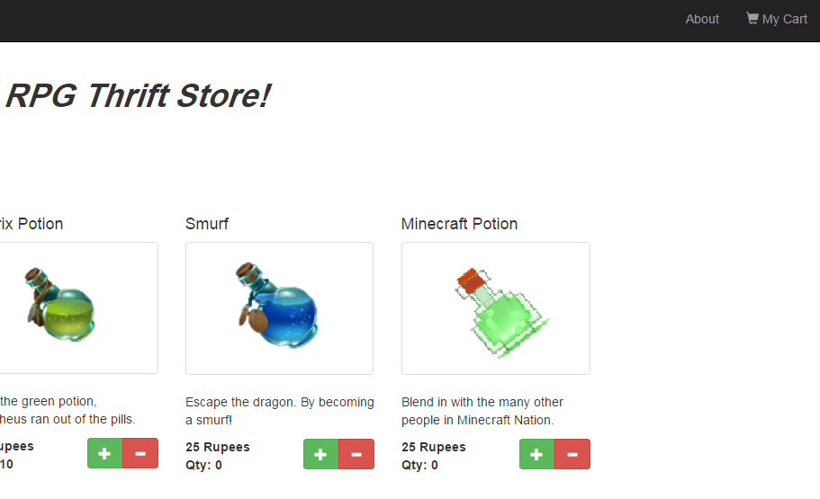

Now, let’s say you’re done shopping because who needs armor and weapons…HAHA you are a man of men and can fisticuffs your enemies to death. To check out just click the My Cart in the upper right corner.

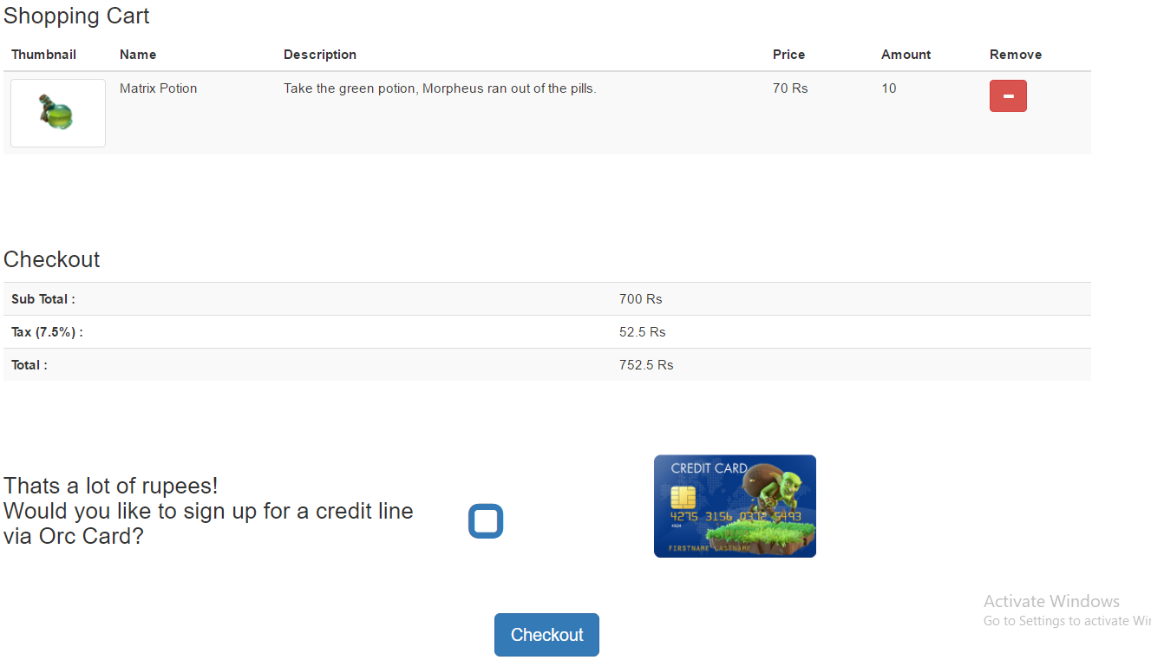

Now this is your shopping cart, if for whatever reason another one of your travelers dies you can remove more potions with the minus button. But if you don’t need to you can click the checkout button at the bottom.

Now if you can’t tell, you’re spending a lot of money here. Since you don’t have a spell for infinite money you can always sign up for our credit card by checking that little blue box

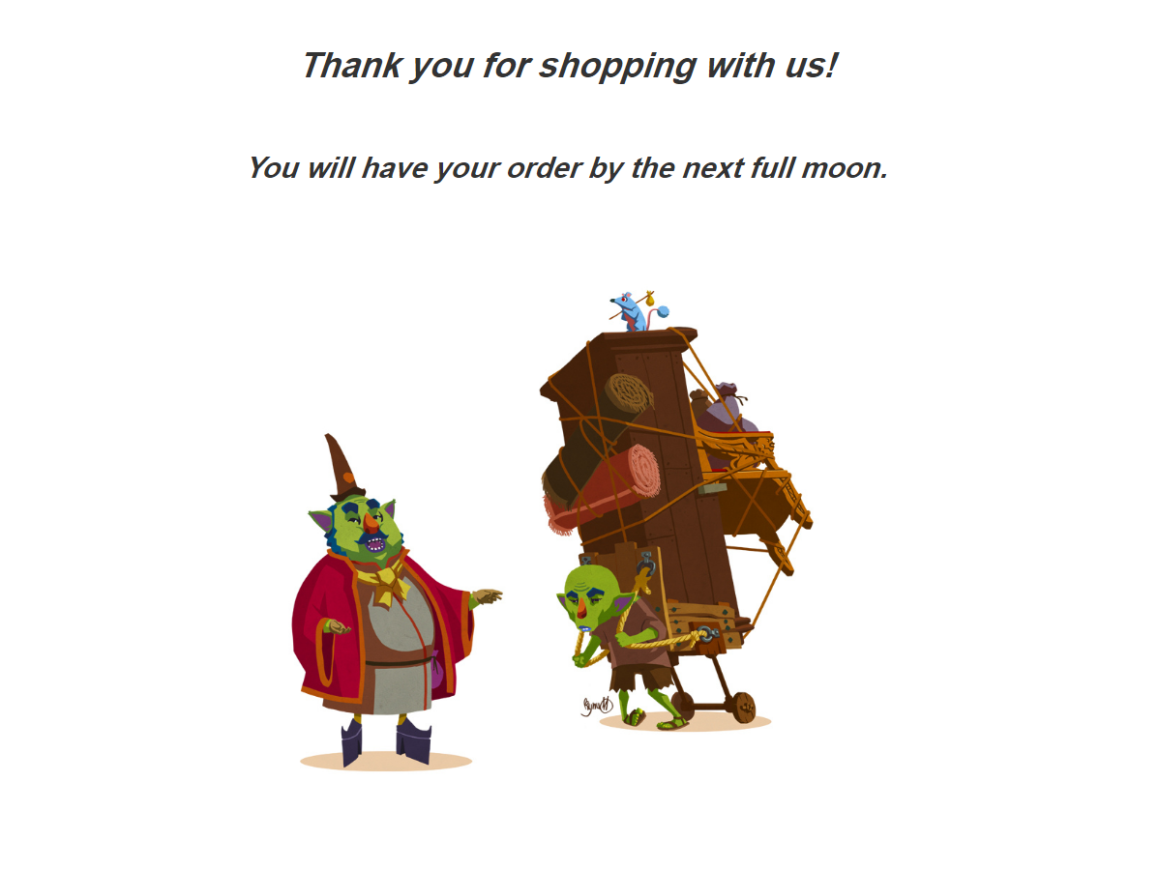

After you hit the check-out button your items will be on their way. Hopefully in that time no one else dies ;). Hopefully this guide has helped you with the navigation of the RPG Thrift Shops supported by your local dead bodies. Have a nice day :D…