RUNNING THE TOOL AND INTERPRETING RESULTS

Once all of the parameters have been defined for 1 or more scenarios, click on the ‘Run Optimization’ button at the top of the grey sidebar. Please be patient as results will take 1 – 3 minutes to produce. In most browsers, a status bar will appear at the top of the page to give you an idea of progress. A text box will also appear at the top right of the page saying “Calculation in Process”, which will then change to “Post Processing”, and will then disappear when the optimization is complete.

NOTE: NPLCC tool users are not limited by computational capacity on their own computer in running optimizations because calculations are done on an external, virtual server hosted at the University of British Columbia by Prof. Peter Arcese, FRBC Chair in Applied Conservation Biology (Arcese lab). Scenario results are populated in the ‘Results + Download’ and the ‘Result Map’ tabs.

Detailed explanations of how to download, view, and interpret results are provided below.

SUMMARY TABLES

After the optimization has run, you will find a summary table of the optimal solution(s) in the ‘Results + Download’ tab. The Result Summary Table will display the optimal solution for each scenario by row. Th (if you only ran one scenario, there will only be one row in the table). NOTE: you will have to scroll right to see the entire table. You can also download the Result Summary Table as a .csv file by clicking the ‘Results download’ button. Explanations for all the Result Summary Table column headers are provided in Table 3. 16.

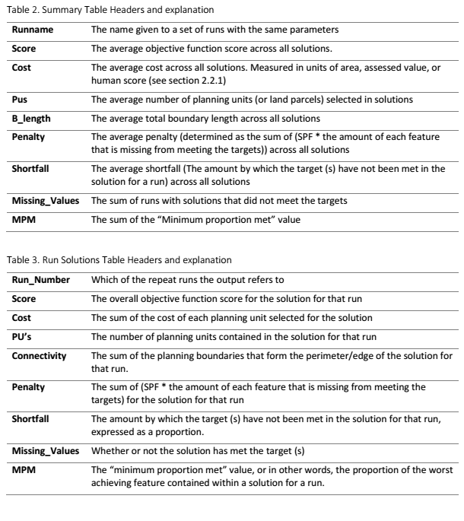

**VIEWING RESULTS in ESRI ArcMap**

You can view a map of each optimal solution in 2 ways: Option 1: Click on the ‘Result Map’ tab after your optimization has finished running. Here you will see a standard basemap of the Georgia Basin region overlain by your solution(s). You can change the basemap shown by selecting StreetMap, Aerial, or Terrain on the legend provided. The legend associated with your solution(s) is called ‘selected’, where selected planning units are displayed in blue (1), and unselected units in red (0). If you ran more than one scenario, each named scenario will populate in the legend box so you can select/deselect each one for comparison. Figure 6: Example result map as viewed from the NPLCC tool interface after running two land prioritization scenarios (depicted on legend as “chl66” and “cha66”). Selected planning units coloured in blue, unselected units in red. Option 2: Click on the “Download output raster” button in the “Results + Download” tab. This will initiate the download of a zip file containing the result in .tiff raster format. Unzip the folder onto your local harddrive. If you have ArcGIS, open ArcMap and use the Catalog sidebar to drag the .tiff file from its location on the harddrive into the viewing pane. The raster should display properly when viewed in a blank map template. However, you may need to use the Project Raster tool if you are using other layers with a different coordinate system and projection (the tool uses NAD 1927 UTM Zone 10N). It may also be necessary to change the Symbology to correctly display selected planning units. To do this, right click on the raster in the Layers sidebar and go to Properties◊ Symbology. The default display setting is ‘stretched’, but we recommend changing this to ‘classified’ using the selection pane on the left side of the Properties dialog box.

Ensure that one class contains 0, and the other class contains 1. Here you can also change the colour display. 17 If you wish to add additional layers but do not have any, we recommend adding a defaut basemap available from ESRI. Click on the Add Data pulldown menu and click “Add Basemap”. This will open a dialog box where you can choose a basemap. Table 3: Result summary table headers and explanations. Scen The name of each scenario. Can be user-specified when running multiple scenarios, or defaults. Default names are populated using 1-letter abbreviations for the time, cost, protected areas, and high quality features cutoff. E.g. ‘chl66’ = [time = current] + [cost = human] + [protected areas = locked-in] + [HQF cutoff = 66] Time The time period specified. Options are: ‘curr’, and ‘rcp45’, which correspond to ‘present’ and ‘future (rcp45)’, respectively. Cost The cost metric specified. Options are: ‘dollar’, ‘area’, ‘human’, and ‘management’. Protected Corresponds to how you dealt with protected areas in the optimization. Options are: ‘locked’ or ‘avail’, which correspond to ‘Locked in’ and ‘Available’, respectively. FTcutoff Corresponds to the cutoff value specified for high quality features. Can be any number between 0 – 1. Status This lets the user know whether the optimal solution was found. If so, the status will be “OPTIMAL”. Runtime Time (in seconds) that it took to run the optimization. Cost_out The resultant cost of the scenario specified. Units depend on the cost metric selected (see Cost above): acquisition and management costs are in dollars ($); human score assesses cost as the amount of commensal habitat included in the solution (see section 2.2.1 for details); setting cost to area attempts to minimize total hectares reserved. Area Area of the solution (ha). OF_Tar, SAV_Tar, SHR_Tar, WET_Tar, HUM1_Tar, NAT_Tar, EXO1_Tar, TREE_Tar User defined targets for each biodiversity feature layer. OF, SAV, SHR, WET, HUM1, NAT, EXO1, TREE The amount of each biodiversity feature (%) included in the optimal solution. User-defined targets are always met in the optimal solution, whereas undefined targets will vary based on their representation in the optimal solution.

**VIEWING RESULTS in QGIS**

QGIS is a free and open source geographic information system. It arguably has the same functionality as ESRI’s ArcMap, with the perks of being free, and usable on Windows, Mac, Linux and BSD operating systems. Visit [www.qgis.org](http://www.qgis.org) to download this software to your computer.

Below are QGIS-specific steps to view your MARXAN results, spatially. Note: these steps assume that all additional options were left at their default settings.

1. Open QGIS on your computer

2. Download both the 1) Cadastral fabric shapefile, and your 2) Marxan results table from the ‘Download’ tab in the Marxan tool interface (save in a convenient place)

3. In QGIS, go to Layer 🡪 Add Layer 🡪 Add Vector Layer (or simply click on this icon on the left side of the display:

4. In the ‘Add Vector Layer’ dialogue box, click the ‘Browse’ button, and add the cadastral fabric shapefile called: ‘Cadaster_RS_IT_non_RS_min_atr.shp’ (note: you will have to unzip this entire file before you can access the .shp file). The outlines of all properties in the CDFCP region should now be displayed.

5. Go to Layer 🡪 Add Layer 🡪 Add Delimited Text Layer (or simply click on this icon on the left side of the display:

6. Browse to your MARXAN results table (eg. Marxan_summary_results-YYYY-MM-DD.csv), select the CSV file format, select “No geometry (attribute only table)” as the geometry definition, then click OK.

7. Right-click the cadaster shapefile in the Layers Panel on the bottom left side of the display. Click on ‘Properties’, and then select ‘Joins’ on the left panel of the dialogue box.

8. Click the positive sign at the bottom of the screen to populate a dialogue box to specify the join. For ‘**Join Layer’**, select your Marxan results table, for ‘**Join Field’**, select ‘ID’, for ‘**Target Field’**, select ‘RS_ID’. Click OK. Now your cadaster shapefile has the same attribute fields that were in your Marxan results table, matched by ID and RS_ID. In other words, for each parcel in your cadaster (RS_ID), there is now a value for the number of times a parcel was selected in 100 runs, and a value (0/1) for whether or not a parcel was selected in the ‘best’ run.

9. If you would like to save the data in this joined table, right click the cadaster shapefile in the Layers Panel, and click “Save As”. Now you can select ‘CSV’ (.csv) or ‘MS Office Open XML spreadsheet’ (.xlsx), and ‘Browse’ to the location on your computer where you’d like to save this file. Both of these file types can be opened with Microsoft Excel.

10. To visualize the number of times a cadastral parcel (RS_ID) was selected in 100 runs, or whether it was selected in the best run (0/1), you can specify a colour scheme that easily differentiates each parcel. Right-click the cadaster shapefile in the Layers Panel, and click ‘Properties’. Click on ‘Style’ in the left pane. Use the drop-down bar to select ‘Graduated’. Select either the summed selection per 100 runs, or the best output run column from the **Column** drop down menu. In **Symbol**, click on ‘Change’, and then click on ‘Simple fill’. You will now have the option to specify the outline colour. Change this to ‘Transparent border’. Don’t worry about the fill colour here. Click on the ‘Classify’ button near the bottom of the dialogue box to add your data as discrete groupings (the default will create 5 classes, feel free to change this to your liking). Select a colour ramp (tip: don’t select a colour ramp that includes ‘no colour’ or ‘white’, as those parcels won’t be visible). Click OK. Now each parcel should be coloured by the number of times it was selected in 100 runs (or whether it was selected in the best run). The legend will be visible under your cadastral shapefile in the Layers Panel.

**Tip**: Use the ‘Zoom In’ tool to select an area of interest in the CDFCP region. This will allow you to see individual parcels, and thus understand how they ranked to one another based on the conditions you specified in the Marxan tool (which will be differentiated by your selected colour ramp).