Title: **Biodiversity conservation** **in an uncertain world**

Authors: Richard Schuster a,b,*, Rachel Buxtona, Jeffrey O. Hansona, Allison Binleya, Jeremy Pittmanc, Vivitskaia Tullochd, Frank La Sortee, Raquel Garciaf, Peter H. Verburgg, Amanda D. Rodewalde,h, Scott Wilsoni, Peter Arcesed, Hugh Possinghamj,k, Joseph R. Bennetta

Affiliations:

a Department of Biology, 1125 Colonel By Drive, Carleton University, Ottawa ON, K1S 5B6 Canada.

b Ecosystem Science and Management Program, 3333 University Way, University of Northern British Columbia, Prince George BC, V2N 4Z9 Canada.

cSchool of Planning, University of Waterloo, 200 University Ave W, Waterloo, ON, N2T 3G1, Canada

d Conservation Decisions Lab, Department of Forest and Conservation Sciences, 2424 Main Mall, University of British Columbia, Vancouver BC, V6T 1Z4 Canada.

e Cornell Lab of Ornithology, Cornell University, Ithaca, NY 14850, USA

f Centre for Invasion Biology, Dept of Botany and Zoology, Stellenbosch Univ, South Africa

g Environmental Geography Group, VU University Amsterdam, Amsterdam, The Netherlands

h Department of Natural Resources, Cornell University, Fernow Hall, #111, Ithaca, NY 14853, USA.

i Wildlife Research Division, Environment and Climate Change Canada, 1125 Colonel By Drive, Ottawa, Ontario, Canada, K1S 5B6

j Centre for Biodiversity and Conservation Science, University of Queensland, St Lucia, Queensland, Australia

k The Nature Conservancy, Arlington, Virginia

*Corresponding author: Department of Biology, 1125 Colonel By Drive, Carleton University, Ottawa ON, K1S 5B6 Canada. Email: [richard.schuster@glel.carleton.ca](mailto:richard.schuster@glel.carleton.ca), Phone: +1 250 631 8324, ORCID: 0000-0003-3191-7869

**First paragraph**

Curbing biodiversity loss in a rapidly changing global environment is one of the great challenges of the 21st Century1,2. As climate and land-cover change intensify, their impacts on biodiversity and conservation response will be mediated by governance3,4, requiring targeted investment in projects that consider risk of failure under changing conditions. Protected areas (PAs) are a key instrument in efforts to conserve biodiversity, yet increasing pressure from poor governance, climate5, and land-cover6 change risk reducing PA effectiveness. Here we show that incorporating these risk factors into global biodiversity conservation planning only increases the global land area required to achieve 30% protection of all terrestrial vertebrates by 1%, with X% of PA found to overlap between all risk scenarios. Nonetheless, there was greater variation among scenarios in priority areas for protection in different countries, driven largely by our index of governance. Countries with wide-ranging species neighboring those with poor governance required more PAs when taking into account risk. These areas may be priorities for developing PA networks that are resilient to multiple aspects of anthropogenic change. Our results suggest that these sources of risk can feasibly be taken into account in global PA planning and emphasize the importance of cross-jurisdictional conservation planning.

**Main text**

Protecting habitat is one of the best strategies for stemming the alarming loss in biodiversity3. As such, the cornerstone of the renewed global framework for biodiversity conservation aims to protect at least 30% of terrestrial land area by 2030. To identify areas of particular importance for biodiversity for inclusion in the expanding protected area network, current approaches rely on measures of regional biodiversity value and vulnerability. Current conservation policy thus assumes that protected areas are permanent and their effectiveness is static. However, rapid human-caused change creates uncertainty regarding decisions for establishing protected areas, given change. Climate change, land use intensification, and governance pose risks to the future effectiveness of protected areas. For example, protected areas with more deforestation are at higher risk of degazetting and project failure, increased extreme weather events cause population decline or extirpation for a variety of species, and the quality of governance predicts investment in conservation, while political instability and corruption can reduce protected area effectiveness. Thus, to make effective use of limited conservation resources, planning for investment in protected areas must account for these risks to safeguard against uncertainty in conservation outcomes and potential future biodiversity loss. We quantify how accounting for changes in climate, land-use, and governance can influence decisions for protected area establishment at a global scale. We show how accounting for these risks can identify key areas that may be most resilient to future change, buffering biodiversity against risk.

We consider three broad categories of risk, which we define as pressures that increase the likelihood that protected areas will become ineffective for protecting biodiversity under future conditions: i) governance, ii) land-use change, iii) climate impacts. For governance, we use a national-scale metric that combines six governance indicators from the World Bank4: accountability, political stability, government effectiveness, regulatory quality, rule of law, and control of corruption (Figure S1). For land-use, we estimated average change in biodiversity per land-use category using Kehoe et al.’s5 method of modelling risk of biodiversity loss per land system due to agricultural expansion and intensification (Figure S2). For climate impacts, we use the duration of extreme heat events, calculated using a probabilistic framework that estimates the novelty of temperatures relative to historical year-to-year variation from 1948 to 2018, identifying areas where heat evens are likely to have the most significant effects on biodiversity*.

We consider the influence of risk categories on allocating protection decisions at a global scale for all 30,930 known distributions of vertebrate species from the IUCN Red List of Threatened Species using a multi-objective optimization approach. To incorporate risk categories, we built on a classical problem formulation from the systematic conservation planning literature. We use the minimum set problem, where the goal is to minimize the cost of a solution, defined as area, while reaching feature targets. We expand this approach to include multiple objectives accounting for varying risk in the problem formulation. We use a hierarchical or lexicographic approach that assigns a priority to each objective, and optimizes for the objectives in decreasing priority order. At each step, the approach finds the best solution for the current objective, but only from among those that would not degrade the solution quality for higher-priority objectives.

Because of the hierarchical structure, we created 27 planning scenarios, with solutions that account for different combinations of risk categories in each level of the hierarchy. We then compared solutions with risks incorporated to a baseline scenario, representing the classical area-based approach to solving conservation planning problems6. Because our scenarios were aimed at building on the current protected area portfolio globally, we incorporated current protected areas into our solutions. For each scenario we set a 30% protection target for all vertebrate species, in line with guidelines from the Convention on Biological Diversity (CBD)7. To investigate the effects of including our three risk categories, we compared the spatial representation among scenarios incorporating risk to baseline at the global and country scale. Last, we compared risk scenario results across the 14 terrestrial biomes of the world.

We found that the protected areas planning scenario incorporating all three risk categories required only 1.11% more global area than the baseline scenario to meet the target of protecting 30% of vertebrate habitat (29.17% vs 28.07% of global area). Thus, accounting for climate change as well as other key risks to protected area effectiveness to produce more resilient conservation networks will not substantially increase the global area required to meet 30% protection targets. Additionally, we found that all 27 scenarios reached their goals of 30% protection of each vertebrate species range without surpassing the 30% global area target that the CBD is currently considering in their post-2020 framework. Of all scenarios, those with both governance and land-use change required the greatest increase in global protected area (1.14 ± 0.02% more than baseline).

There was also considerable spatial overlap among scenarios, with the same 10.1 million km2 (6.9% of global land area) being selected to expand the current protected area portfolio in at least five scenarios and 2.21 million km2 (1.5% of global land area) in all eight scenarios. Such overlaps provide examples of areas that could be targets for international agencies wishing to maximize the resilience of protected area networks. Example countries that have contiguous areas of high overlap among scenarios are Canada (Yukon Territory), Egypt, Finland, Kazakhstan and Peru (Figure S4). There is some overlap among scenarios within global biodiversity hotspots8, but a considerable percentage of high overlap among scenarios areas lies either outside these hotspots (XX %) or occurs within small portions of these areas.

Despite relatively similar overall extent, areas requiring protection to meet the 30% target varied among scenarios. We found substantial variation for some countries, but not others, in area requiring protection between risk and baseline scenarios (Fig. 1; Table S1). These differences were driven largely by governance (Fig. 2? Fig. S2?), where countries with higher governance scores had greater area requiring protection under risk scenarios versus baseline, especially when species were wider ranging and when neighboring countries had poor governance. Thus, risk is connected across jurisdictions, where planning scenarios favor protection of species in nearby countries with low governance risk. For example, many vertebrate species ranges span north-eastern Russia, Finland, and Sweden. Because Russia suffers from poor ‘voice and accountability, rule of law, and control of corruption’ (Table S), whereas Finland and Sweden have relatively high governance scores, the scenarios including governance pressures would lead to a selection of X.Y% and Y.X% of Finland and Sweden’s land areas compared to the baseline scenario with XX.Y and YY.Z%. Land-use and climate change also influenced variation in areas requiring protection above baseline. For example, large areas of Saudi Arabia are experiencing increasingly frequent extreme heat events (Fig. S3), whereas neighboring United Arab Emirates have been largely buffered by proximity to two major gulfs. Scenarios including climate have a selection of 3.1% in the United Arab Emirates land areas compared to the baseline scenario with 1.0% in Saudi Arabia.

These results emphasize the importance of coordinated cross-jurisdictional conservation planning initiatives and identify countries where opportunities for collaboration would yield more resilient protected areas. For wide-ranging or migratory species whose range will be impacted by varying climate, land-use, and governance risk across borders, conservation projects can focus on cooperative governance frameworks. In contrast, countries at high risk from climate, land-use, and governance change, especially those with high endemism, for example in northern Oceania, have low difference between scenarios that incorporate risk versus baseline. Given high and endemic biodiversity, and homogeneity of risk, these countries will require high rates of protection, regardless. Moreover, some countries closer to reaching the 30% protection target, for example Brazil, which already has X of its land area protected, had lower differences between scenarios that incorporate risk versus baseline, despite having high climate, land-use, and governance risk. This outlines the importance of further considering the effectiveness of existing protected areas in planning analyses, where pressure from cropland conversion in tropical protected areas has increased to similar rates outside protected areas.

Comparing prioritization results across the 14 global biomes revealed considerable variation in biome representation across scenarios (Figure 3). The most pronounced variation was for temperate conifer forests with a total variation of 9.1% of biome area, ranging from 31.8% for the baseline scenario, to 39.5% for the scenario incorporating governance and land use constraints. Mangroves had the second highest total variation of 6.5%, ranging from 36.8% of the biome areas for the scenario only considering governance constraints, to 43.2% for the scenario only considering the land use constraint. Both temperate conifer forests and mangroves are relatively small biomes and both are highly threatened by land-use and climate change.

**Conclusion**

We note that our specific metrics of risk are intended as examples, used to demonstrate the importance of considering governance, land use and climate change in combination. Our framework is flexible, allowing conservation agencies looking to set priorities from the global to local scale to incorporate different metrics. It is also important to note that [2 SENTENCES ON WHAT PREVIOUS ANALYSES HAVE DONE? SOME HAVE CONSIDERED EACH OF THESE THINGS SEPARATELY, NONE HAVE CONSIDERED ALLTOGETHER?] Our results show that protected area expansion decisions can be profoundly influenced by all three factors. Where data are on these or other factors that may affect the effectiveness of biodiversity protection are available and reasonably reliable, we argue that they should therefore be used together to support decisions for resilient protected area networks. Our framework and methods can allow management agencies to do so, and also to explore the influence of individual parameters on decisions.

Our example of protecting 30% of the ranges for threatened species globally suggests that accounting for anthropogenic pressures and uncertainties can greatly influence conservation decisions, especially in areas where specific pressures predominate. We argue that this leads to more resilient and effective conservation plans into the future to help safeguard our planet’s biodiversity in the face of the current extinction and climate crises.

Range of goals for protected areas, in some cases it may be more beneficial to protect riskier areas than safer areas.

**Main references**

1. Brondizio, E. S., Settele, J., Díaz, S. & Ngo, H. T. Global assessment report on biodiversity and ecosystem services of the Intergovernmental Science-Policy Platform on Biodiversity and Ecosystem Services. *IPBES Secretariat* (2019).

2. Rosenberg, K. V. *et al.* Decline of the North American avifauna. *Science* **366**, 120–124 (2019).

3. Watson, J. E. M., Dudley, N., Segan, D. B. & Hockings, M. The performance and potential of protected areas. *Nature* **515**, 67–73 (2014).

4. Transparency International - The Global Anti-Corruption Coalition. https://www.transparency.org/.

5. Kehoe, L. *et al.* Biodiversity at risk under future cropland expansion and intensification. *Nature Ecology & Evolution* **1**, 1129–1135 (2017).

6. Ball, I. R. R., Possingham, H. P. P. & Watts, M. E. E. Marxan and relatives: Software for spatial conservation prioritisation. in *Spatial conservation prioritisation: Quantitative methods and computational tools.* (eds. Moilanen, A., Wilson, K. & Possingham, H. P.) 185–195 (Oxford University Press, 2009).

7. Post-2020 Global Biodiversity Framework. *IUCN* https://www.iucn.org/theme/global-policy/our-work/convention-biological-diversity-cbd/post-2020-global-biodiversity-framework (2018).

8. Myers, N., Mittermeier, R. A., Mittermeier, C. G., da Fonseca, G. A. B. & Kent, J. Biodiversity hotspots for conservation priorities. *Nature* **403**, 853–858 (2000).

9. Pouzols, F. M. *et al.* Global protected area expansion is compromised by projected land-use and parochialism. *Nature* **516**, 383–386 (2014).

10. Eisenhauer, N., Bonn, A. & A. Guerra, C. Recognizing the quiet extinction of invertebrates. *Nature Communications* **10**, 1–3 (2019).

11. Venter, O. *et al.* Targeting Global Protected Area Expansion for Imperiled Biodiversity. *PLOS Biology* **12**, e1001891 (2014).

12. Le Saout, S. *et al.* Protected areas and effective biodiversity conservation. *Science* **342**, 803–805 (2013).

13. Butchart, S. H. M. *et al.* Shortfalls and Solutions for Meeting National and Global Conservation Area Targets. *Conservation Letters* **8**, 329–337 (2015).

14. Planet, P. Calculating protected area coverage. *Protected Planet* https://www.protectedplanet.net/c/calculating-protected-area-coverage.

15. Coetzer, K. L., Witkowski, E. T. & Erasmus, B. F. Reviewing B iosphere R eserves globally: effective conservation action or bureaucratic label? *Biological Reviews* **89**, 82–104 (2014).

16. Barnes, M. D. *et al.* Wildlife population trends in protected areas predicted by national socio-economic metrics and body size. *Nature Communications* **7**, 12747 (2016).

17. Baynham-Herd, Z., Amano, T., Sutherland, W. J. & Donald, P. F. Governance explains variation in national responses to the biodiversity crisis. *Environmental Conservation* **45**, 407–418 (2018).

18. Kaufmann, D., Kraay, A. & Mastruzzi, M. The Worldwide Governance Indicators: Methodology and Analytical Issues1. *Hague Journal on the Rule of Law* **3**, 220–246 (2011).

19. Asselen, S. van & Verburg, P. H. A Land System representation for global assessments and land-use modeling. *Global Change Biology* **18**, 3125–3148 (2012).

20. Hudson, L. N. *et al.* The PREDICTS database: a global database of how local terrestrial biodiversity responds to human impacts. *Ecology and Evolution* **4**, 4701–4735 (2014).

21. Newbold, T. *et al.* Global effects of land use on local terrestrial biodiversity. *Nature* **520**, 45–50 (2015).

22. Margules, C. R. & Pressey, R. L. Systematic conservation planning. *Nature* **405**, 243–53 (2000).

**Figure legends (+ figures)**

Figure 1: multi-panel individual scenario results

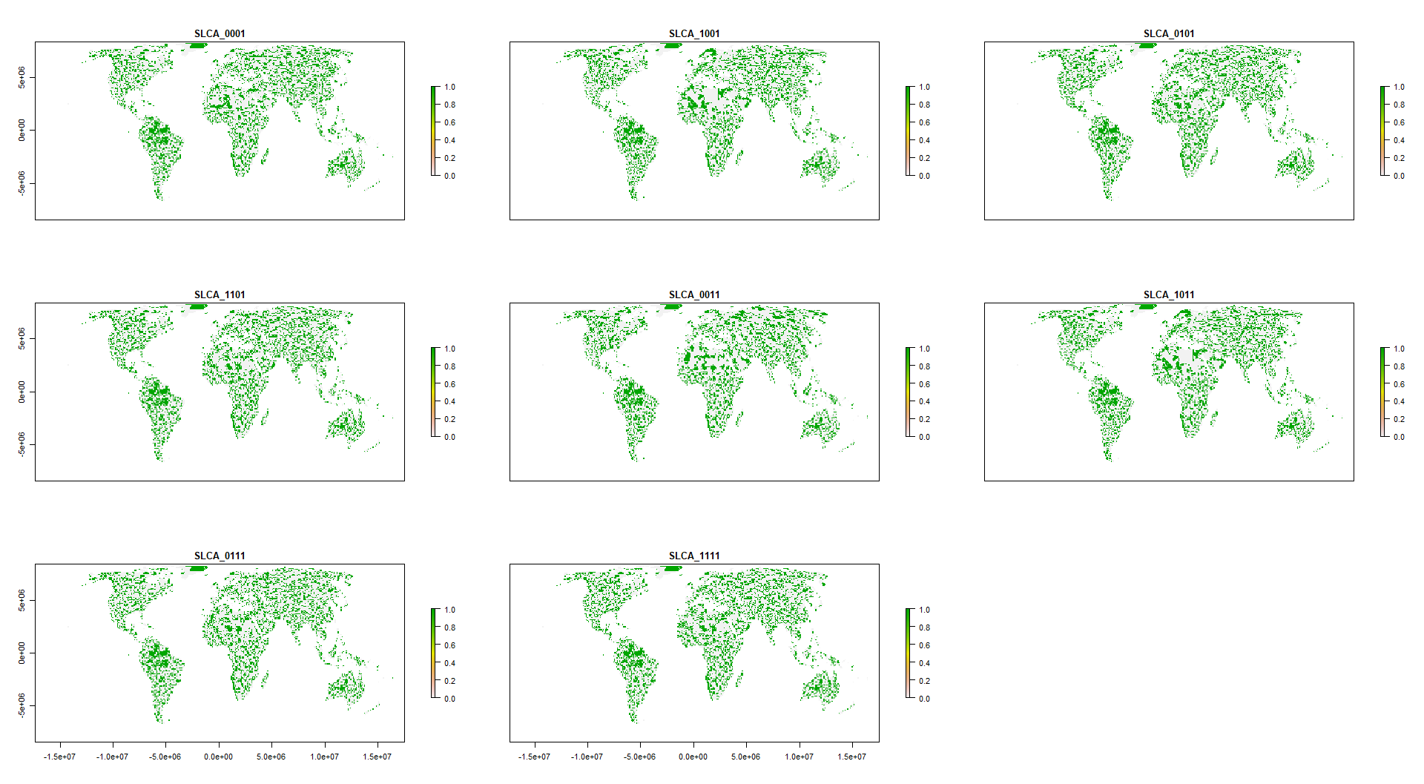

Figure 2: Scenario overlap. orange = protected areas. Color gradient from orange (one scenario) to dark blue (eight scenarios) = ovelap.

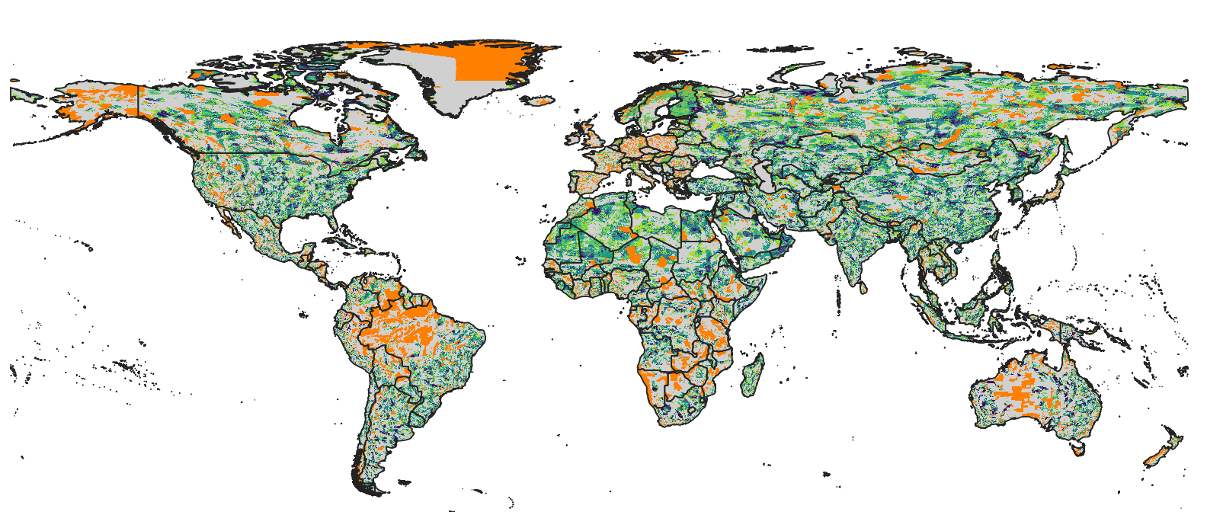

Figure 3: Spider plot biomes vs scenarios. % values are in relation to base value results. Could also do how much of each biome was selected, but that’s not very informative (see small figure below). I’m also not convinced that those spider plots are easy to read, might be better with x = biome, y = value and colors = scenarios plot. They do look nice though and are probably something Nature type journals like a lot.

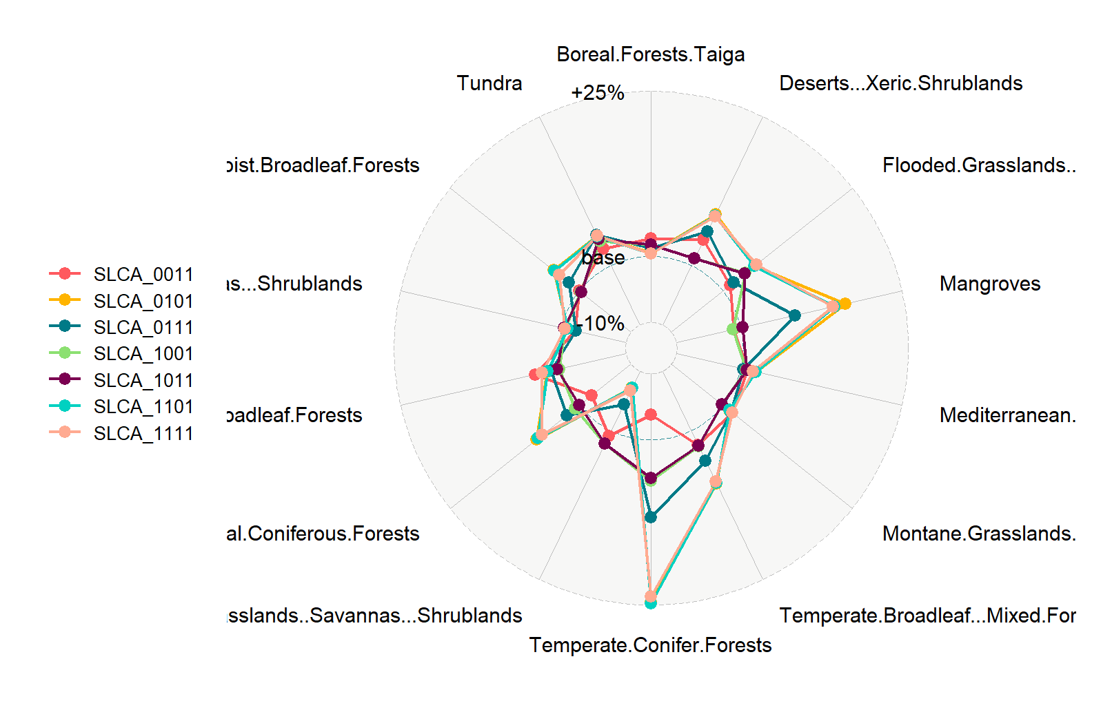

**Methods**

We used a multi-objective optimization approach that incorporated governance, land use and climate constraints to prioritize the conservation of 30,930 species. All scenarios we investigated were built on the current global protected area portfolio. We further set a target to protect 30% of the range of each species, based on current CDB discussions on post-2020 biodiversity targets.

*Species selection*

Our species lists were determined using the IUCN Red List of threatened species, following Pouzols et al. (2014). For mammal, amphibian and reptile species ranges, we used the IUCN Red List website (<http://www.iucnredlist.org/>, accessed 2019-11-14) and for birds we used the BirdLife International data zone webpage (<http://www.birdlife.org/datazone/home>, accessed 2019-11-14). We used these taxa because no analogous data are available for a lower proportion of species in other taxonomic groups such as insects10. These data have certain limitations, including possible underestimation of the extent of occurrence and overestimation of the true area of occupancy 9, but have been shown to be robust to commission errors as long as the focus is on species assemblages rather than single species, 11. They are currently the most frequently used and updated source for vertebrate species distributions 12.

For each taxonomic group, we restricted our analysis to species that fell into the presence category of ‘Extant’, the origin categories of ‘Native’ or ‘Reintroduced’ and the seasonality categories ‘Resident’, ‘Breeding Season’ or ‘Non-breeding Season’, thus only focusing on stationary periods of the life cycle of migratory species. This resulted in the following final numbers of amphibian, bird, mammal and reptile species ranges: 5660, 13375, 5442, 6153.

*Basic administrative delineations*

National boundaries were derived from the Global Administrative Areas database (<http://gadm.org/>, accessed 2019-10-31).

We obtained protected area boundaries from the World Database on Protected Areas (WDPA, [https://www.protectedplanet.net](https://www.protectedplanet.net/)). Following standard procedures for cleaning the protected area dataset13,14, we (i) projected the data to an equal-area coordinate (World Behrman) (ii) excluded reserves with unknown or proposed designations, (iii) excluded UNESCO Biosphere Reserves15, (iv) buffered sites represented as point localities to their reported area, (v) dissolved boundaries to prevent issues with overlapping areas, and (vi) removed slivers (code available at https://github.com/jeffreyhanson/global-protected-areas). After the protected area data, we overlaid the protected area boundaries with a 10 x 10 km grid covering the Earth. These spatial data procedures were completed using ArcMap (version 10.3.1) and python (version 2.7.8).

*Governance pressure*

Conservation risk due to governance can affect the outcomes of strategies, and effective governance can promote the resilience of conservation in the face of sociopolitical and economic shocks. We used worldwide governance indicators from the World Bank18 to capture these pressures. The indicators include six scaled measures: voice and accountability; political stability and absence of violence; government effectiveness; regulatory quality; rule of law; and control of corruption (see Table S4 for definitions). We chose these indicators because evidence suggests that protected area effectiveness16 and state investment and efforts for biodiversity conservation17 are reliably predicted by them. For each country, we used a mean of annual averages of all six measures17 (Figure S1).

*Land use pressure*

We used a recent global land systems mapped produced by Kehoe et al.5. This is based on a global land systems map for the year 200019 at a 9.25km2 resolution, but makes use of the most recent land-cover and land-use datasets and has a finer resolution of 1km2. Kehoe et al.5 further estimated the impact of land use and land use intensity on biodiversity, with data originating from the PREDICTS project20. They first matched their land-systems classes to varying intensity levels for each land-use type (for detailed conversion table, see ref21). This allowed Kehoe et al. to calculate average biodiversity loss per land system (relative to an unimpacted baseline) by taking the mean model estimates of biodiversity loss per land-use intensity class from previous work21. The result gives average relative biodiversity gain or loss per land system. Here, we used their modelled mean estimates (following Newbold et al.21) of relative percent biodiversity change for each Land System for species abundance as a measure of the land-use pressure (Figure S2).

*Climate pressure (text largely adopted from Frank’s paper)*

There is evidence that the increased exposure to extreme heat events (EHE) adversely affects human populations (Anderson & Bell Michelle, 2011; Battisti & Naylor, 2009; Guo et al., 2017; Mitchell et al., 2016) and natural systems within terrestrial (Harris et al., 2018; Maxwell et al., 2019) and marine environments (Garrabou et al., 2009; Wernberg et al., 2013). How the frequency and duration of EHE has changed over time has been explored primarily within terrestrial regions during the boreal and austral summers (Coumou & Robinson, 2013; Oswald, 2018), but there are examples that have considered other seasons of the year (Alexander et al., 2006). There are a number of climate indices that have been used to estimate the occurrence of extreme heat events (Fenner et al., 2019; Smith et al., 2013). These climate indices are often context specific and there is little consensus on 79 the most appropriate technique (McPhillips et al., 2018). Here, we define the occurrence of extreme heat events using a probabilistic framework that estimates the novelty of each event relative to historical year-to-year variation in temperature at each location. Specifically, we use detrended daily measures of minimum and maximum temperature to estimate when and where temperatures significantly exceed historical variation in temperature over a 71-year period (1948 to 2018). This approach provides a standardized measure of the novelty of climate extremes that allows for valid comparisons across space and time. We use this approach to determine how the frequency and duration of EHE have changed over time and the regions and seasons where these events are likely to have the most significant effects on natural systems and human populations now and into the future.

The metric we used here is the duration of each event within each year and pixel based on the number of consecutive days containing EHE. We extracted the maximum continuous duration of each event for each year and pixel. We selected the maximum because it provided improved distributional properties for analysis and identifies the most significant event for each year. We averaged the maximum duration of each event within each pixel across the 71-year period. We modeled the change in the maximum duration in each event over the 71-year period using Poisson regression (Lambert, 1992).

Figure S3

*Multi-objective optimization of pressure reduction*

We processed all data described before to a 10 x 10 km resolution and clipped data to the extent of land based on the global administrative areas database.

Here, we developed an extension on the minimum set problem, which has the goal to identify a set of sites within a planning area that represents all conservation targets in the fewest number of sites 22. Instead of including one objective we are expanding the formulation to include multiple objectives in the problem formulation. We use a hierarchical or lexicographic approach that assigns a priority to each objective, and optimizes for the objectives in decreasing priority order. At each step, it finds the best solution for the current objective, but only from among those that would not degrade the solution quality for higher-priority objectives. We considered up to three objectives in our prioritization scenarios, i) governance pressure, ii) land-use pressure, and iii) climate pressure. To compare different pressure scenarios we calculated solutions for each unique objective combination (n = 7), as well as one where we use a constant objective function as the base scenario.

For all scenarios we locked in current protected areas and used the same feature set of 30930 vertebrates. The target for each feature was set to 30% of their range. The optimality gap we use was 5% for each objective in the hierarchy. We started the hierarchy with the governance constraint, followed by the land use and climate constraints to reflect the immediacy of each pressure on current biodiversity (governance best predictor for success currently; land use higher current impact than climate). The order of the hierarchy does matter, which is why its important to specify and justify the importance of constraints in the hierarchy before running the analysis.

**Methods references**

**Acknowledgements**

V. Tulloch was supported by a Postdoctoral Research Grant from Environment and Climate Change Canada.

**Author contributions**

**Competing interest declaration**

**Table S1**. Global land area required to reach 30% target. S = governance, L = land use, C = climate, A = area.

|  |  |  |
| --- | --- | --- |
|  | % total | % increase |
| SLCA_0001 | 28.08 | 16.36 |
| SLCA_1001 | 28.43 | 16.71 |
| SLCA_0101 | 29.23 | 17.51 |
| SLCA_1101 | 29.19 | 17.47 |
| SLCA_0011 | 28.45 | 16.73 |
| SLCA_1011 | 28.43 | 16.71 |
| SLCA_0111 | 28.7 | 16.98 |
| SLCA_1111 | 29.17 | 17.45 |

**Table S2**. Summary of country specific results. Values are in relation to the baseline scenario (fraction of set aside in a country per scenarios over baseline), which represents a value of 1.

|  |  |  |  |  |  |
| --- | --- | --- | --- | --- | --- |
| scenario | mean | min | max | low | high |
| SLCA_1001 | 1.19 | 0.00 | 8.23 | 0.52 | 2.63 |
| SLCA_0101 | 1.13 | 0.21 | 4.38 | 0.75 | 1.52 |
| SLCA_1101 | 1.13 | 0.21 | 4.38 | 0.75 | 1.55 |
| SLCA_0011 | 1.04 | 0.11 | 3.10 | 0.84 | 1.47 |
| SLCA_1011 | 1.18 | 0.00 | 8.15 | 0.53 | 2.63 |
| SLCA_0111 | 1.09 | 0.39 | 4.38 | 0.79 | 1.47 |
| SLCA_1111 | 1.13 | 0.29 | 4.63 | 0.73 | 1.51 |

**Table S3**. CSV file with details for each country.

**Table S4.**

|  |  |
| --- | --- |
| **Indicator** | **Definition**  Source: World Bank, 2020 (<https://datacatalog.worldbank.org/dataset/worldwide-governance-indicators>) |
| Voice and accountability | “Voice and accountability captures perceptions of the extent to which a country's citizens are able to participate in selecting their government, as well as freedom of expression, freedom of association, and a free media.” |
| Political stability and absence of violence | “Political Stability and Absence of Violence/Terrorism measures perceptions of the likelihood of political instability and/or politically-motivated violence, including terrorism.” |
| Government effectiveness | “Government effectiveness captures perceptions of the quality of public services, the quality of the civil service and the degree of its independence from political pressures, the quality of policy formulation and implementation, and the credibility of the government's commitment to such policies.” |
| Regulatory quality | “Regulatory quality captures perceptions of the ability of the government to formulate and implement sound policies and regulations that permit and promote private sector development.” |
| Rule of law | “Rule of law captures perceptions of the extent to which agents have confidence in and abide by the rules of society, and in particular the quality of contract enforcement, property rights, the police, and the courts, as well as the likelihood of crime and violence.” |
| Control of corruption | “Control of corruption captures perceptions of the extent to which public power is exercised for private gain, including both petty and grand forms of corruption, as well as "capture" of the state by elites and private interests.” |

**Figure S1. Governance (green = good, red = bad)**

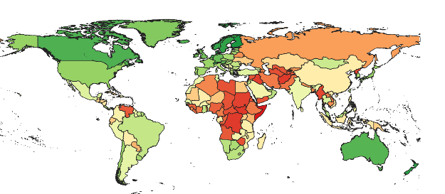

**Figure S2. Land use (green = good, red = bad)**

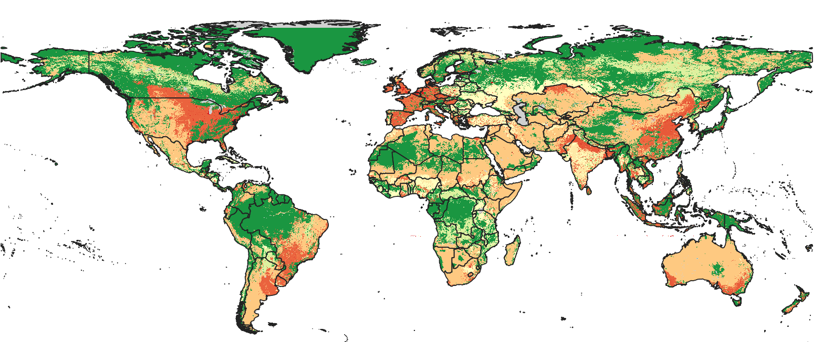

**Figure S3. Climate (extreme heat events) (green = good, red = bad)**

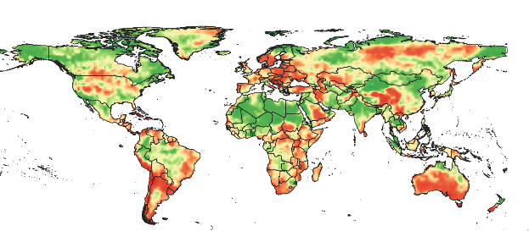

**Figure S4. Areas of high scenario overlap (>5 scenarios, red) compared to Meyers et al. biodiversity hotspots (blue).**

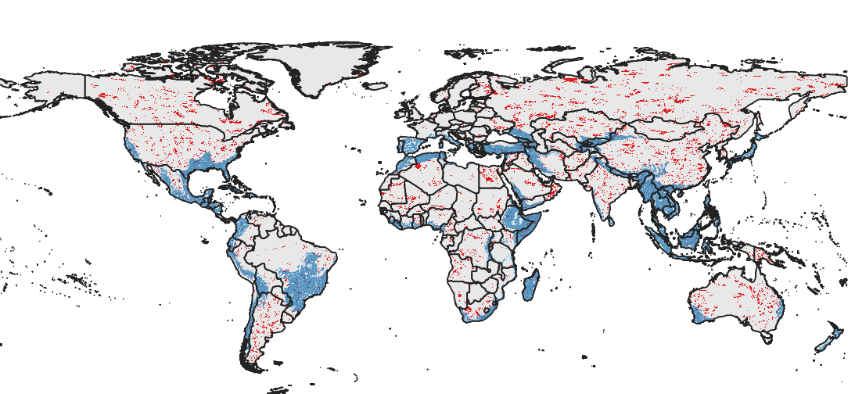

**Figure S5. Biomes**

