Title: **Biodiversity conservation** **in an uncertain world**

Authors: Richard Schuster a,b,*, Rachel Buxtona, Jeffrey Hansona, Allison Binleya, Jeremy Pittmanc, Vivitskaia Tullochd, Frank La Sortee, Raquel Garciaf, Peter H. Verburgg, Amanda D. Rodewalde,h, Scott Wilsoni, Peter Arcesed, Hugh Possinghamj,k, Joseph R. Bennetta

Affiliations:

a Department of Biology, 1125 Colonel By Drive, Carleton University, Ottawa ON, K1S 5B6 Canada.

b Ecosystem Science and Management Program, 3333 University Way, University of Northern British Columbia, Prince George BC, V2N 4Z9 Canada.

cSchool of Planning, University of Waterloo, 200 University Ave W, Waterloo, ON, N2T 3G1, Canada

d Department of Forest and Conservation Sciences, 2424 Main Mall, University of British Columbia, Vancouver BC, V6T 1Z4 Canada.

e Cornell Lab of Ornithology, Cornell University, Ithaca, NY 14850, USA

f Centre for Invasion Biology, Dept of Botany and Zoology, Stellenbosch Univ, South Africa

g Environmental Geography Group, VU University Amsterdam, Amsterdam, The Netherlands

h Department of Natural Resources, Cornell University, Fernow Hall, #111, Ithaca, NY 14853, USA.

i Wildlife Research Division, Environment and Climate Change Canada, 1125 Colonel By Drive, Ottawa, Ontario, Canada, K1S 5B6

j Centre for Biodiversity and Conservation Science, University of Queensland, St Lucia, Queensland, Australia

k The Nature Conservancy, Arlington, Virginia

*Corresponding author: Department of Biology, 1125 Colonel By Drive, Carleton University, Ottawa ON, K1S 5B6 Canada. Email: [richard.schuster@glel.carleton.ca](mailto:richard.schuster@glel.carleton.ca), Phone: +1 250 631 8324, ORCID: 0000-0003-3191-7869

First paragraph

The dynamic nature of biological, economic, social, and political systems means that predicting outcomes of biodiversity conservation investments includes a high degree of uncertainty. Curbing biodiversity loss in a rapidly changing global environment is a complex race against time1,2. Investing in conservation projects that try to minimize uncertainty while maximizing biodiversity gains may be the most feasible mechanism to buffer high biodiversity against future change. As climate change and land-cover change intensify in the coming decades, their interaction with socio-economic systems will influence the effectiveness of conservation tools such as protected areas and species management. Here we introduce a framework that can simultaneously incorporate a range of uncertainties and constraints into global biodiversity conservation planning. We highlight how incorporating these constraints can lead to more efficient and resilient conservation networks into the future. This represents an advancement over current practices, which identify areas crucial for conservation predominantly on the basis of measures of regional biodiversity or ecosystem services and do not incorporate multiple uncertainties at once. Our framework allows for robust conservation planning in an uncertain world.

**Main text**

As we lose biodiversity at an alarming rate2, protecting habitat is one of the best strategies for conservation3; however, human-caused change results in high uncertainty in the performance of protected areas in the future. Effective decision-making must operate within the context of climate change, land-use constraints, and complex interconnected socio-economic-ecological systems that interact and result in systemic environmental uncertainties primarily caused by the effects of human activities4. Investing in conservation projects that try to minimize uncertainty while maximizing biodiversity gains may be the most feasible mechanism to buffer areas of high biodiversity against future change.

The urgency of the biodiversity crisis and the many habitats and species at risk necessitate rapid targeted action that maximizes the chances to protect essential components of biodiversity. Since investments are high and hard to establish in current political environments, such targeting needs to balance urgency with maximizing the chance that the investments will deliver results. Likelihood for success is higher when protection measures are resilient against the impacts of land-use change, climate effects and socio-political risks and uncertainties.

To prioritize conservation investments, generally the most cost-effective actions are weighed against the biodiversity benefits. However, both cost and benefit will look much different in the future, making investing without any consideration of future conditions risky. We consider the following sources of uncertainty: political instability and corruption; weak governance; systemic crisis; climate change; and land use constraints. We group these uncertainties in three broad groups: i) socio-economic uncertainty; ii) climate uncertainty; iii) land use constraints. As climate change and land-cover change intensify in the coming decades, their interaction with socio-economic systems will influence the effectiveness of conservation tools such as protected areas and species management.

Here, we introduce a framework that strives to minimize multiple sources of uncertainty while maximizing biodiversity protection. We build on a classical problem formulation from the systematic conservation planning literature, the minimum set problem, where the goal is to minimize the cost of a solution while reaching feature targets. We expand this approach to include multiple objectives in the problem formulation at the same time. Each objective represents a measure of uncertainty that we want to account for. We include i) socioeconomic uncertainty, ii) land-use constraints, iii) climate uncertainty, while maximizing the protection of 30930 vertebrate species globally.

We created 8 planning scenarios using vertebrate species data from the IUCN Red List of Threatened Species and incorporating different combinations of the three uncertainty metrics from above, as well as one baseline scenario where we do not include a measure of uncertainty, representing the classical approach to solving these kinds of problems. As our scenarios were aimed at building on the current protected area portfolio globally, we forced protected areas to be part of the solution. For each scenario we set a 30% target for the vertebrate species, in line with developing guidelines from the IUCN (ref). We then compared the spatial representation of each scenario to each other at the global, as well as the country scale, to investigate the effects that the inclusion of one to all three of our uncertainty metrics has on the outcome, with the idea that the scenarios incorporating all three uncertainty metrics would be the most resilient to future change in terms of protecting biodiversity.

Last, we compared scenario results across the 14 terrestrial biomes of the world to investigate biome scale effects that accounting for our three uncertainty metrics would have. Exploring such constraints represents a critical step in conservation planning, given that human cultural history, values, and well-being can all affect conservation success and represent critical inputs into structured decisions about the most efficacious actions5–7. The framework we present here can be used for a wide variety of planning efforts, as it is highly flexible and can accommodate multiple objectives and features at the same time, introducing a way to allow for more resilient and effective conservation planning into the future.

**Results**

We found considerable variation in the spatial configuration of our scenario outcomes (Fig. 1). What was surprising and encouraging to us was that despite the spatial variation in outcomes, the total amount of land required to meet the 30% target for each species did not increase as much as we thought between the base scenario of not including any measure of uncertainty and any of the 7 variations of including uncertainty measures we tested (Table 1). The scenario that incorporated all three uncertainty metrics only required 1.09% more global area than the base scenario (29.17% vs 28.07%). This is encouraging because it means that we can account for these important measures of uncertainty to produce more effective and resilient conservation networks, while not needing to substantially increase the global area required to meet the 30% protection targets. In addition, we also found that all 8 scenarios investigated reached their goals without surpassing the 30% global area target that the Convention on Biological Diversity (CBD) is currently considering as post-Aichi targets. This means that incorporating socio-economic, climate, and land use uncertainties into protected area plans can operate within the parameters of the CBD area goals negotiated for 2030. There is also considerable spatial overlap between scenarios, with 10.1 million km2 being selected for addition to the current protected area portfolio in at least 5 scenarios and 2.21 million km2 in all 8 scenarios.

These are encouraging results at a global level, but what about the country level? On average and across scenarios, the results are comparable with mean values ranging from 4% to 19% additional area required per country (Table 2). There is however a wide range of differences for individual countries, ranging from no additional protection recommended in a country to expanding the protection level 8.2 fold. If we take a relatively large sized country that is currently suffering from conflict, but also has low values of land use change and climate uncertainty (Figures S1-3) like Libya (1.8 million km2 land size) as an example, the scenario only including socio-economic uncertainty would lead to a selection of only 11% of the base line scenario (Table S1). If the focus is on land use change or climate only, the number of selected cells would increase to 105% and 124% respectively, compared to the baseline scenario. Including all three metrics at the same time leads to 103% selection compared to baseline. In contrast, a country of similar size to Libya but low levels of internal conflict would be Indonesia (also 1.8 million km2 land size). The values of Indonesia only vary by 6% across scenarios (99% to 103%), compared to the 113% percent variation present in Libya.

Comparing prioritization results across the 14 global biomes revealed considerable variation of biome inclusion across scenarios (Figure 3). The most pronounced variation was found for temperate conifer forests with a total variation of 28.6%, ranging from a 3.8% reduction, compared to baseline, for the scenario only considering the climate constraint, to a 24.8% increase for the scenario incorporating socioeconomic and land use constraints. Mangroves have the second highest total variation of 17.4%, ranging from a 1.2% reduction for the scenario only considering socioeconomic constraints, to 16.2% increase for the scenario only considering the land use constraint. In contrast, Mediterranean forests or Montane Grasslands have a total variation of less than 2% across all scenarios.

**Discussion**

We introduce a conservation planning framework that can incorporate a range of uncertainties related to socio-economic factors, land-use change and climate change, that are likely to impact the effectiveness of biodiversity protection into the future. Our results show that at the global level, accounting for these uncertainties represents a more efficient way to safeguard the protected-area portfolio than with a strictly biodiversity-based approach, while not requiring substantially more land to be placed under protection. For individual countries, results will look very different depending on their current socio-economic circumstances, climate realities and land-use patterns. Individual countries don’t realistically have control over what the climate will look like in the future, other than being part of a global movement to reduce greenhouse gas emissions. Where countries do have opportunities to influence out global priorities for biodiversity protection are the land use change and socio-economic levers.

A main strength of our approach is that a range of constraints and uncertainties can be incorporated into the conservation planning effort at the same time, which leads to conservation planning solutions that should be more resilient to anticipated future changes due socioeconomic, land-use, and climate uncertainties. We would argue that this leads to more resilient and effective conservation plans into the future to help safeguard our planet’s biodiversity in the face of the current extinction and climate crises.

**Main references**

1. Brondizio, E. S., Settele, J., Díaz, S. & Ngo, H. T. Global assessment report on biodiversity and ecosystem services of the Intergovernmental Science-Policy Platform on Biodiversity and Ecosystem Services. *IPBES Secretariat* (2019).

2. Rosenberg, K. V. *et al.* Decline of the North American avifauna. *Science* **366**, 120–124 (2019).

3. Watson, J. E. M., Dudley, N., Segan, D. B. & Hockings, M. The performance and potential of protected areas. *Nature* **515**, 67–73 (2014).

4. Keys, P. W. *et al.* Anthropocene risk. *Nature Sustainability* **2**, 667–673 (2019).

5. Barrett, C. B. & Arcese, P. Are integrated conservation-development projects (ICDPs) sustainable? On the conservation of large mammals in sub-Saharan Africa. *World development* **23**, 1073–1084 (1995).

6. Ban, N. C. *et al.* A social–ecological approach to conservation planning: embedding social considerations. *Frontiers in Ecology and the Environment* **11**, 194–202 (2013).

7. Schwartz, M. W. *et al.* Decision Support Frameworks and Tools for Conservation. *Conservation Letters* **11**, e12385 (2018).

8. Pouzols, F. M. *et al.* Global protected area expansion is compromised by projected land-use and parochialism. *Nature* **516**, 383–386 (2014).

9. Venter, O. *et al.* Targeting Global Protected Area Expansion for Imperiled Biodiversity. *PLOS Biology* **12**, e1001891 (2014).

10. Le Saout, S. *et al.* Protected areas and effective biodiversity conservation. *Science* **342**, 803–805 (2013).

11. Coetzer, K. L., Witkowski, E. T. & Erasmus, B. F. Reviewing B iosphere R eserves globally: effective conservation action or bureaucratic label? *Biological Reviews* **89**, 82–104 (2014).

12. Baynham-Herd, Z., Amano, T., Sutherland, W. J. & Donald, P. F. Governance explains variation in national responses to the biodiversity crisis. *Environmental Conservation* **45**, 407–418 (2018).

13. Kehoe, L. *et al.* Biodiversity at risk under future cropland expansion and intensification. *Nature Ecology & Evolution* **1**, 1129–1135 (2017).

14. Asselen, S. van & Verburg, P. H. A Land System representation for global assessments and land-use modeling. *Global Change Biology* **18**, 3125–3148 (2012).

15. Hudson, L. N. *et al.* The PREDICTS database: a global database of how local terrestrial biodiversity responds to human impacts. *Ecology and Evolution* **4**, 4701–4735 (2014).

16. Newbold, T. *et al.* Global effects of land use on local terrestrial biodiversity. *Nature* **520**, 45–50 (2015).

17. Margules, C. R. & Pressey, R. L. Systematic conservation planning. *Nature* **405**, 243–53 (2000).

**Tables**

Table 1. Global land area required to reach 30% target. S = socioeconomic, L = land use, C = climate, A = area.

|  |  |  |
| --- | --- | --- |
|  | % total | % increase |
| SLCA_0001 | 28.08 | 16.36 |
| SLCA_1001 | 28.43 | 16.71 |
| SLCA_0101 | 29.23 | 17.51 |
| SLCA_1101 | 29.19 | 17.47 |
| SLCA_0011 | 28.45 | 16.73 |
| SLCA_1011 | 28.43 | 16.71 |
| SLCA_0111 | 28.7 | 16.98 |
| SLCA_1111 | 29.17 | 17.45 |

Table 2. Summary of country specific results. Values are in relation to the base line scenario (fraction of set aside in a country per scenarios over base line), which represents a value of 1.

|  |  |  |  |  |  |
| --- | --- | --- | --- | --- | --- |
| scenario | mean | min | max | low | high |
| SLCA_1001 | 1.19 | 0.00 | 8.23 | 0.52 | 2.63 |
| SLCA_0101 | 1.13 | 0.21 | 4.38 | 0.75 | 1.52 |
| SLCA_1101 | 1.13 | 0.21 | 4.38 | 0.75 | 1.55 |
| SLCA_0011 | 1.04 | 0.11 | 3.10 | 0.84 | 1.47 |
| SLCA_1011 | 1.18 | 0.00 | 8.15 | 0.53 | 2.63 |
| SLCA_0111 | 1.09 | 0.39 | 4.38 | 0.79 | 1.47 |
| SLCA_1111 | 1.13 | 0.29 | 4.63 | 0.73 | 1.51 |

**Figure legends (+ figures)**

Figure 1: multi-panel individual scenario results

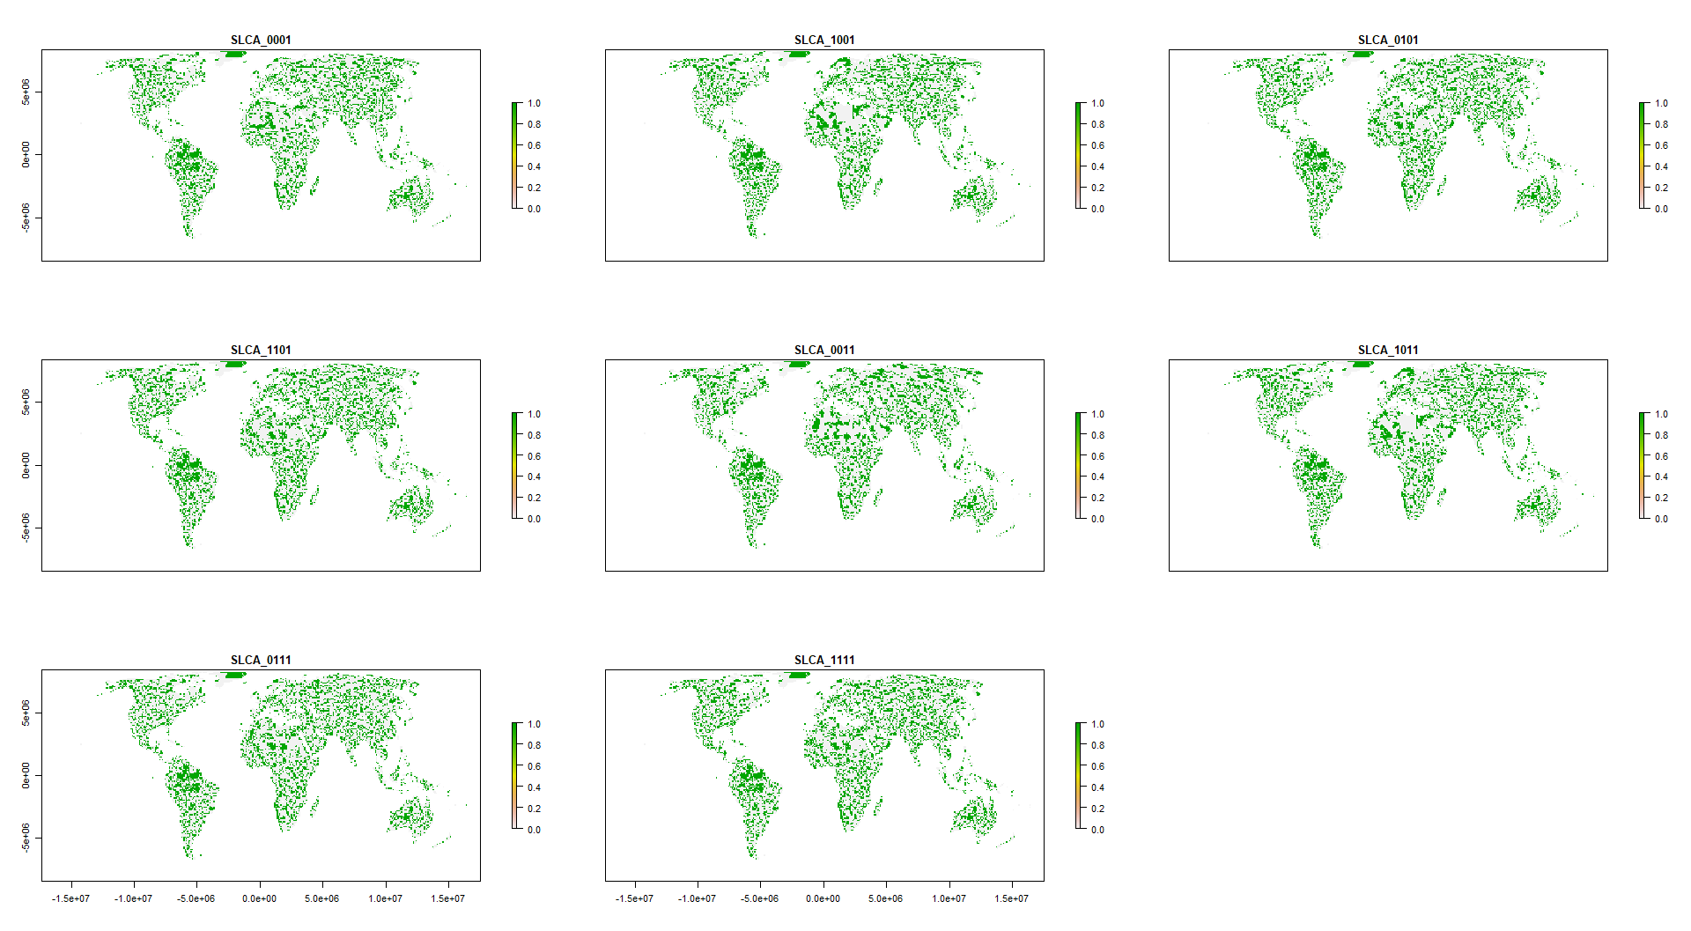

Figure 2: Scenario overlap. orange = protected areas. Color gradient from yellow (1 scenaris) to dark blue (8 scenarios) = ovelap.

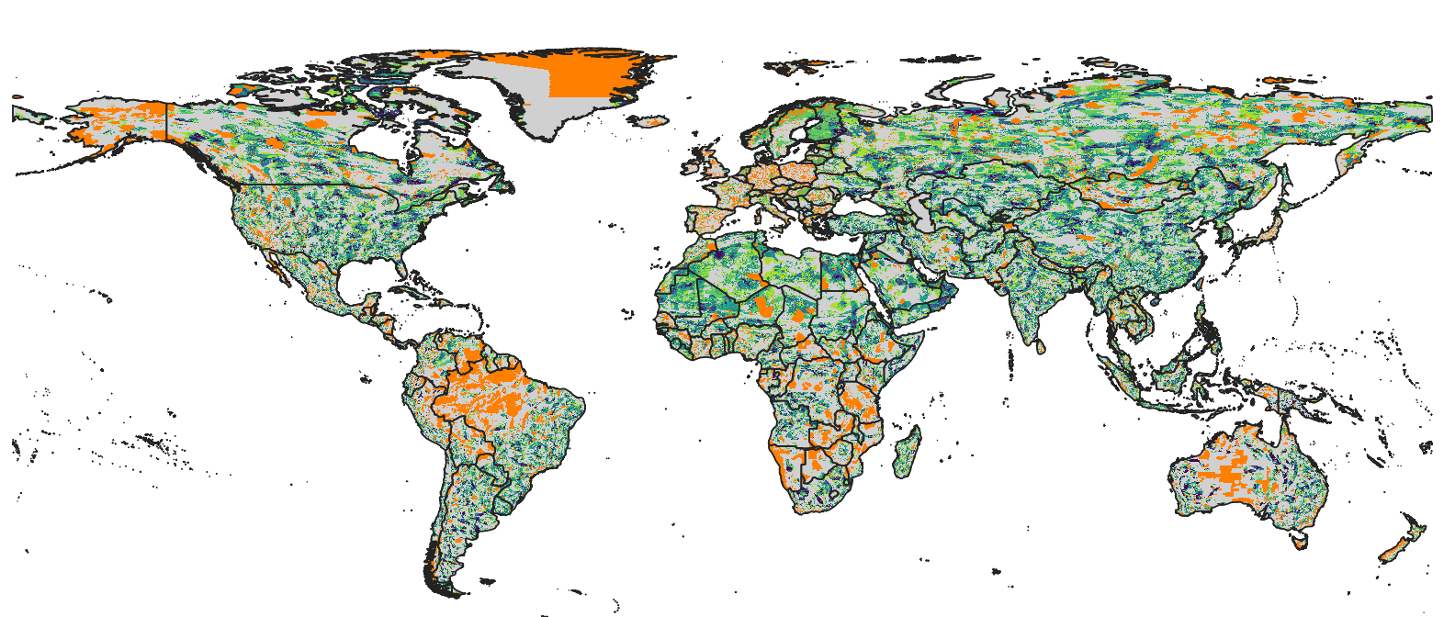

Figure 3: Spider plot biomes vs scenarios. % values are in relation to base value results. Could also do how much of each biome was selected, but that’s not very informative (see small figure below). I’m also not convinced that those spider plots are easy to read, might be better with x = biome, y = value and colors = scenarios plot. They do look nice though and are probably something Nature type journals like a lot.

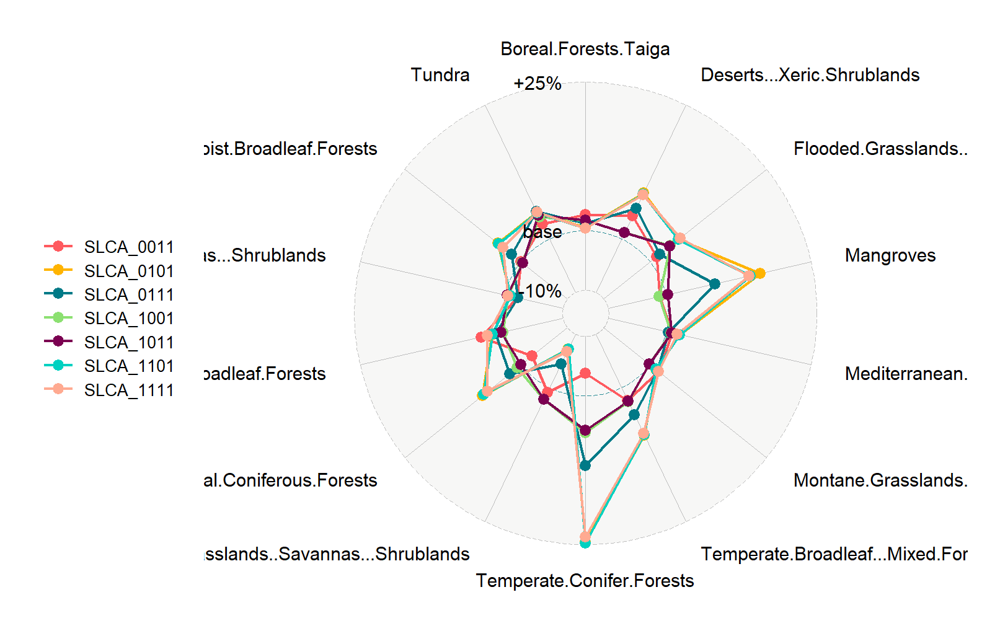

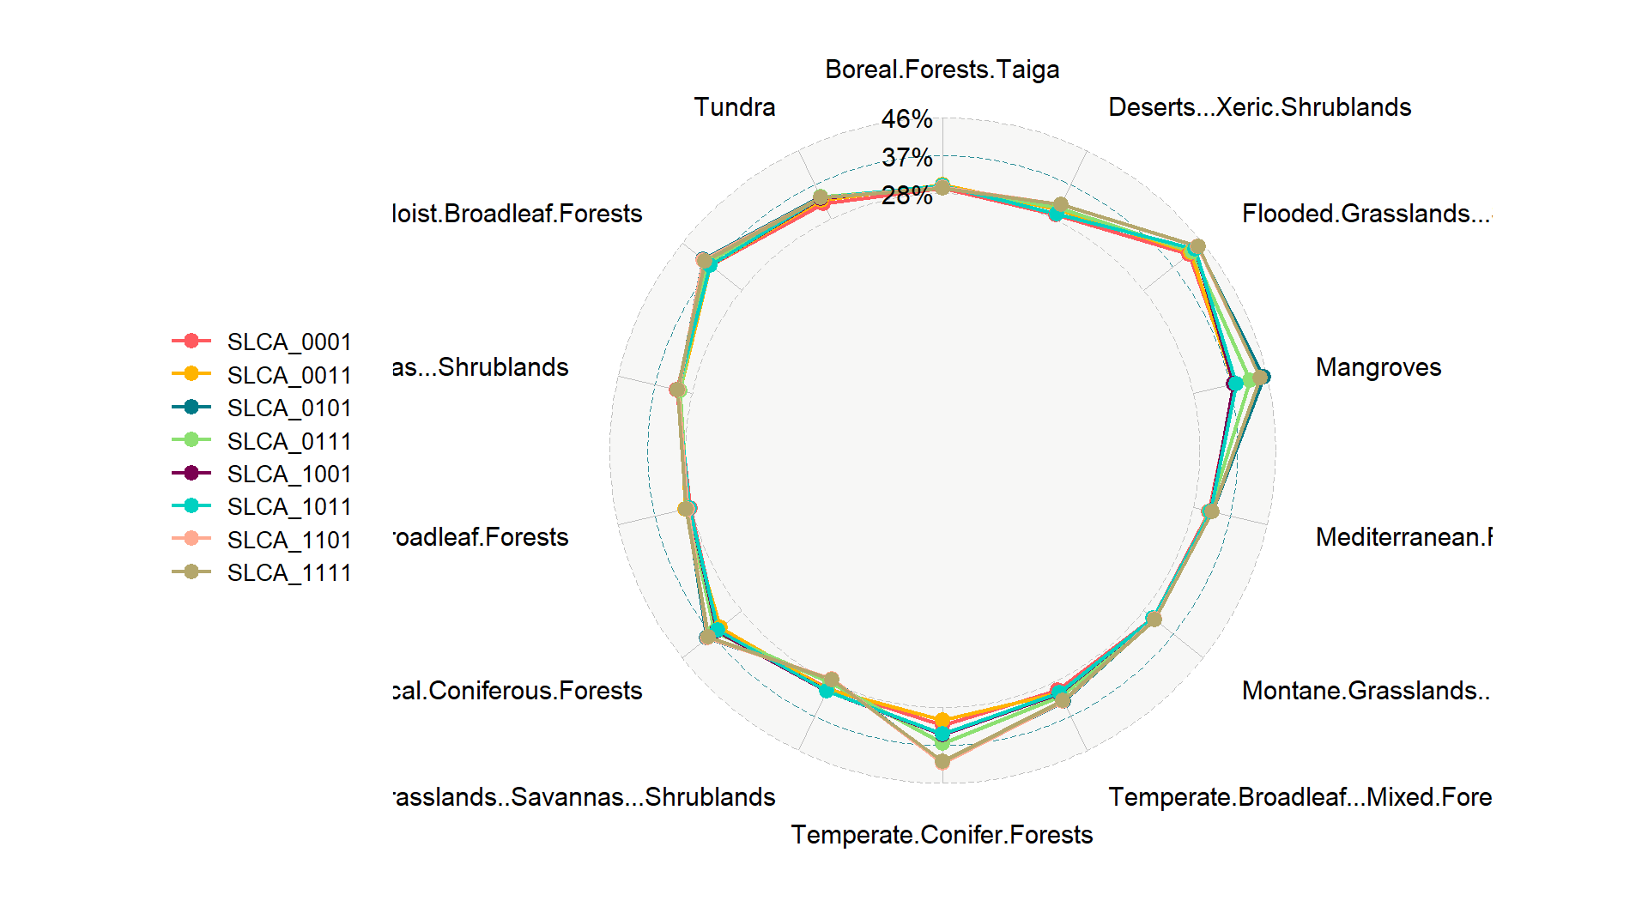

**Methods**

We used a multi-objective optimization approach that incorporated socioeconomic, land use and climate constraints to prioritize the conservation of 30,930 species. All scenarios we investigated were built on the current global protected area portfolio. We further set a target to protect 30% of the range of each species, based on current CDB discussions on post-2020 biodiversity targets.

*Species selection*

Our species lists were determined using the IUCN Red List of threatened species, following Pouzols et al. (2014). For mammal, amphibian and reptile species ranges, we used the IUCN Red List website (<http://www.iucnredlist.org/>, accessed 2019-11-14) and for birds we used the BirdLife International data zone webpage (<http://www.birdlife.org/datazone/home>, accessed 2019-11-14). We used these taxa because analogous data are available for a low proportion of species in other taxonomic groups. These data have certain limitations, including possible underestimation of the extent of occurrence and overestimation of the true area of occupancy 8, but have been shown to be robust to commission errors as long as the focus is on species assemblages rather than single species, 9. They are currently the most frequently used and updated source for vertebrate species distributions 10.

For each taxonomic group, we restricted our analysis to species that fell into the presence category of ‘Extant’, the origin categories of ‘Native’ or ‘Reintroduced’ and the seasonality categories ‘Resident’, ‘Breeding Season’ or ‘Non-breeding Season’, thus only focusing on stationary periods of the life cycle of migratory species. This resulted in the following final numbers of amphibian, bird, mammal and reptile species ranges: 5660, 13375, 5442, 6153.

*Basic administrative delineations*

National boundaries were derived from the Global Administrative Areas database (<http://gadm.org/>, accessed 2019-10-31).

We obtained protected area boundaries from the World Database on Protected Areas (WDPA, [https://www.protectedplanet.net](https://www.protectedplanet.net/)). Following standard procedures for cleaning the protected area dataset, we (i) projected the data to an equal-area coordinate (World Behrman) (ii) excluded reserves with unknown or proposed designations, (iii) excluded UNESCO Biosphere Reserves 11, (iv) buffered sites represented as point localities to their reported area, (v) dissolved boundaries to prevent issues with overlapping areas, and (vi) removed slivers (code available at https://github.com/jeffreyhanson/global-protected-areas). After the protected area data, we overlaid the protected area boundaries with a 10 x 10 km grid covering the Earth. These spatial data procedures were completed using ArcMap (version 10.3.1) and python (version 2.7.8).

*Socioeconomic constraints*

Socioeconomic risk can affect the outcome of conservation strategies, and political instability and strong governance can promote the resilience of conservation in the face of sociopolitical shocks. We use indicators of the quality of governance to characterize socioeconomic risk and conservation resilience, as evidence suggests that protected area effectiveness (Barnes et al. 2016) and state investment and efforts for biodiversity conservation (Baynham-Herd et al. 2018) are reliably predicted by governance indicators. We used worldwide governance indicators from World Bank (https://datacatalog.worldbank.org/dataset/worldwide-governance-indicators), including six scaled measures: voice and accountability; political stability and absence of violence; government effectiveness; regulatory quality; rule of law; and control of corruption. For each country, we used a mean of annual averages of all six measures.

12

<https://datacatalog.worldbank.org/dataset/worldwide-governance-indicators>

Figure S1

*Land use constraints*

We used a recent global land systems mapped produced by Kehoe et al.13. This is based on a global land systems map for the year 200014 at a 9.25km2 resolution, but makes use of the most recent land-cover and land-use datasets and has a finer resolution of 1km2. Kehoe et al.13 further estimated the impact of land use and land use intensity on biodiversity, with data originating from the PREDICTS project15. They first matched their land-systems classes to varying intensity levels for each land-use type (for detailed conversion table, see ref16). This allowed Kehoe et al. to calculate average biodiversity loss per land system (relative to an unimpacted baseline) by taking the mean model estimates of biodiversity loss per land-use intensity class from previous work16. The result gives average relative biodiversity gain or loss per land system. Here, we used their modelled mean estimates (following Newbold et al.16) of relative percent biodiversity change for each Land System for species abundance as a measure of the land-use change risk.

Figure S2

*Climate constraints (text largely adopted from Frank’s paper)*

There is evidence that the increased exposure to extreme heat events (EHE) adversely affects human populations (Anderson & Bell Michelle, 2011; Battisti & Naylor, 2009; Guo et al., 2017; Mitchell et al., 2016) and natural systems within terrestrial (Harris et al., 2018; Maxwell et al., 2019) and marine environments (Garrabou et al., 2009; Wernberg et al., 2013). How the frequency and duration of EHE has changed over time has been explored primarily within terrestrial regions during the boreal and austral summers (Coumou & Robinson, 2013; Oswald, 2018), but there are examples that have considered other seasons of the year (Alexander et al., 2006). There are a number of climate indices that have been used to estimate the occurrence of extreme heat events (Fenner et al., 2019; Smith et al., 2013). These climate indices are often context specific and there is little consensus on 79 the most appropriate technique (McPhillips et al., 2018). Here, we define the occurrence of extreme heat events using a probabilistic framework that estimates the novelty of each event relative to historical year-to-year variation in temperature at each location. Specifically, we use detrended daily measures of minimum and maximum temperature to estimate when and where temperatures significantly exceed historical variation in temperature over a 71-year period (1948 to 2018). This approach provides a standardized measure of the novelty of climate extremes that allows for valid comparisons across space and time. We use this approach to determine how the frequency and duration of EHE have changed over time and the regions and seasons where these events are likely to have the most significant effects on natural systems and human populations now and into the future.

The metric we used here is the duration of each event within each year and pixel based on the number of consecutive days containing EHE. We extracted the maximum continuous duration of each event for each year and pixel. We selected the maximum because it provided improved distributional properties for analysis and identifies the most significant event for each year. We averaged the maximum duration of each event within each pixel across the 71-year period. We modeled the change in the maximum duration in each event over the 71-year period using Poisson regression (Lambert, 1992).

Figure S3

*Multi-objective optimization of risk reduction*

We processed all data described before to a 10 x 10 km resolution and clipped data to the extent of land based on the global administrative areas database.

Here, we developed an extension on the minimum set problem, which has the goal to identify a set of sites within a planning area that represents all conservation targets in the fewest number of sites 17. Instead of including one objective we are expanding the formulation to include multiple objectives in the problem formulation. We use a hierarchical or lexicographic approach that assigns a priority to each objective, and optimizes for the objectives in decreasing priority order. At each step, it finds the best solution for the current objective, but only from among those that would not degrade the solution quality for higher-priority objectives. We considered up to three objectives in our prioritization scenarios, i) socioeconomic risk, ii) land-use change risk, and iii) climate risk. To compare different constraint scenarios we calculated solutions for each unique objective combination (n = 7), as well as one where we use a constant objective function as the base scenario.

For all scenarios we locked in current protected areas and used the same feature set of 30930 vertebrates. The target for each feature was set to 30% of their range. The optimality gap we use was 5% for each objective in the hierarchy. We started the hierarchy with the socioeconomic constraint, followed by the land use and climate constraints to reflect the immediacy of each risk on current biodiversity (socioeconomic best predictor for success currently; land use higher current impact than climate). The order of the hierarchy does matter, which is why its important to specify and justify the importance of constraints in the hierarchy before running the analysis.

**Methods references**

**Acknowledgements**

**Author contributions**

**Competing interest declaration**

**Figure S1. Socio-economic (green = good, red = bad)**

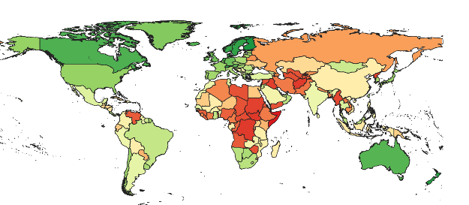

**Figure S2. Land use (green = good, red = bad)**

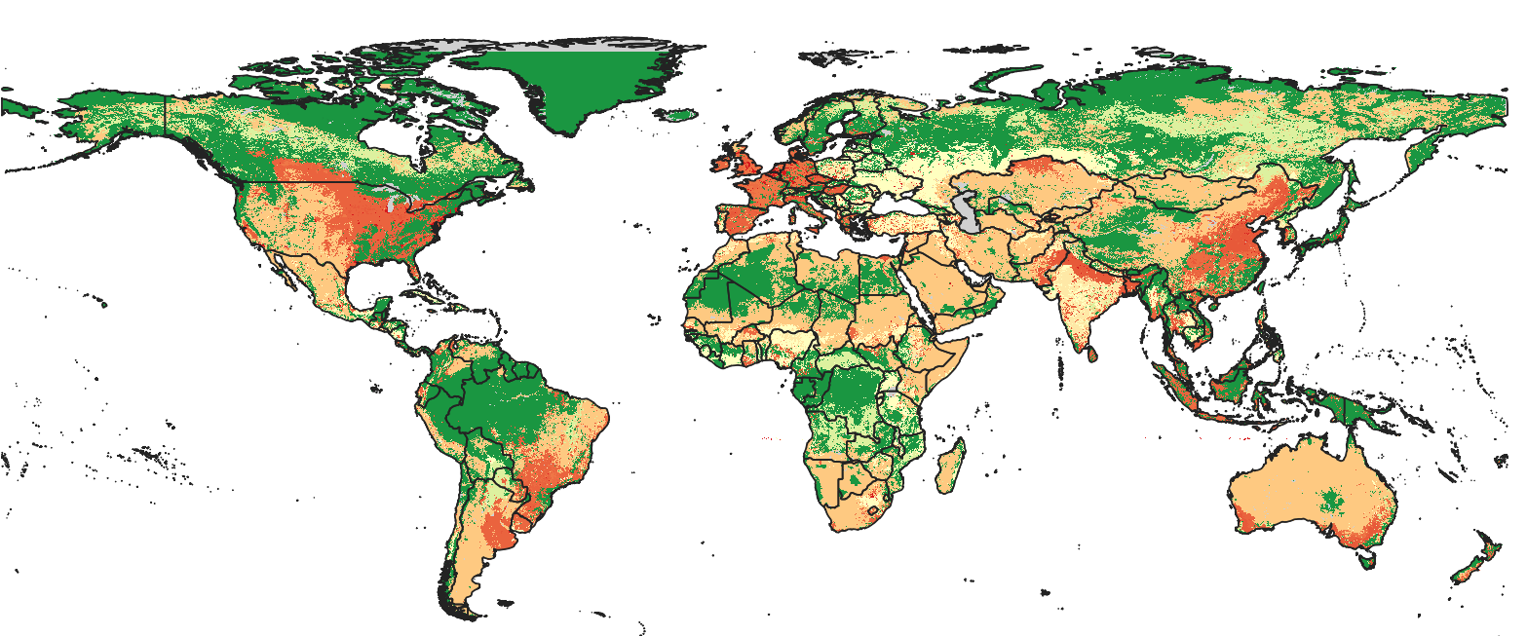

**Figure S3. Climate (extreme heat events) (green = good, red = bad)**

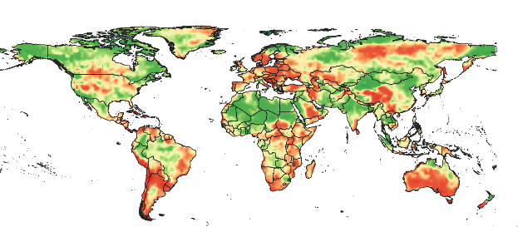

**Parking lot**

and current patterns of land use.

>>>tough one: while conservation is often aimed at reducing the risks of land use change in practice it is very difficult to ensure full conservation in regions that are facing high land use change pressures (example is Indonesia where logging moratorium did not fully work given the high oil palm pressure (some references: https://www.sciencedirect.com/science/article/pii/S1389934118304623