Title: **Biodiversity conservation** **in an uncertain world**

Authors: Richard Schuster a,b,*, Rachel Buxtona, Jeffrey O. Hansona, Allison Binleya, Jeremy Pittmanc, Vivitskaia Tullochd, Frank La Sortee, Raquel Garciaf, Peter H. Verburgg, Amanda D. Rodewalde,h, Scott Wilsoni, Peter Arcesed, Hugh Possinghamj,k, Joseph R. Bennetta

Affiliations:

a Department of Biology, 1125 Colonel By Drive, Carleton University, Ottawa ON, K1S 5B6 Canada.

b Ecosystem Science and Management Program, 3333 University Way, University of Northern British Columbia, Prince George BC, V2N 4Z9 Canada.

cSchool of Planning, University of Waterloo, 200 University Ave W, Waterloo, ON, N2T 3G1, Canada

d Department of Forest and Conservation Sciences, 2424 Main Mall, University of British Columbia, Vancouver BC, V6T 1Z4 Canada.

e Cornell Lab of Ornithology, Cornell University, Ithaca, NY 14850, USA

f Centre for Invasion Biology, Dept of Botany and Zoology, Stellenbosch Univ, South Africa

g Environmental Geography Group, VU University Amsterdam, Amsterdam, The Netherlands

h Department of Natural Resources, Cornell University, Fernow Hall, #111, Ithaca, NY 14853, USA.

i Wildlife Research Division, Environment and Climate Change Canada, 1125 Colonel By Drive, Ottawa, Ontario, Canada, K1S 5B6

j Centre for Biodiversity and Conservation Science, University of Queensland, St Lucia, Queensland, Australia

k The Nature Conservancy, Arlington, Virginia

*Corresponding author: Department of Biology, 1125 Colonel By Drive, Carleton University, Ottawa ON, K1S 5B6 Canada. Email: [richard.schuster@glel.carleton.ca](mailto:richard.schuster@glel.carleton.ca), Phone: +1 250 631 8324, ORCID: 0000-0003-3191-7869

First paragraph

Curbing biodiversity loss in a rapidly changing global environment is a complex race against time1,2. As climate and land-cover change intensify in the coming decades, their interaction with socio-economic systems will influence the effectiveness of conservation interventions, requiring targeted investment in projects that minimize uncertainty. Here we show how a range of uncertainties, including socio-political pressures, predicted land-use change and climate impacts can be incorporated into global biodiversity conservation planning. Doing so identifies different priority areas for conservation than conventional approaches, which identify areas predominantly based on measures of regional biodiversity or ecosystem services and do not incorporate multiple uncertainties. Areas such as [mention them] are identified as having relatively high biodiversity and low uncertainty, and may be priorities for developing protected area networks that are resilient to multiple aspects of anthropogenic change. We also identify key areas [mention them] that are indicated as priorities regardless of whether uncertainty is considered. Our general framework allows for management agencies to use their own measures of uncertainty into conservation planning.

**Main text**

Protecting habitat is one of the best strategies for stemming the alarming loss in biodiversity3. However, rapid human-caused change creates uncertainty regarding decisions for establishing protected areas. Climate change, pressure for land use intensification (for example, from agricultural mosaics to intensive agriculture), and socio-political uncertainty create an urgent need to protect areas to buttress against future biodiversity loss. However, all of these factors will also affect the potential performance of candidate protected areas. Effective decision-making for future protected areas must account for these pressures, in order to make effective use of limited resources.

Here, we show how accounting for socioeconomic uncertainty, land-use pressure and climate uncertainty can strongly influence decisions for conservation at a global scale. We also show how accounting for all of these constraints can identify key areas that may be most resilient to future pressures. In our analysis, we consider three broad categories of uncertainty: i) socioeconomic uncertainty, ii) land-use constraints, iii) climate uncertainty. For socioeconomic uncertainty, we use a national-scale metric that combines consider six governance indicators from Transparency International*. For land-use constraints, we use methods of Kehoe et al.* to estimate average biodiversity loss per land-use category*. For climate uncertainty, we use the predicted frequency of extreme heat events*, at [X] scale. We consider the influence of each of these on allocating protection decisions at a global scale for all 30930 known vertebrate species, and then consider them in combination, including solutions that account for all three types of uncertainty. Our methods provide a flexible framework with which conservation agencies can account for future constraints that may be most important to them.

To identify candidate areas for protection, we build on a classical problem formulation from the systematic conservation planning literature, the minimum set problem, where the goal is to minimize the cost of a solution while reaching feature targets. We expand this approach to include multiple objectives accounting for uncertainty in the problem formulation. [WHAT ABOUT A SENTENCE ON HOW WE DO THIS, SINCE METHODS HAVE TO BE STUCK AT THE END? COULD STATE THE OBJECTIVES CLEARLY TOO. MAKE SENSE?]

We created eight planning scenarios using vertebrate species data from the IUCN Red List of Threatened Species and incorporating different combinations of the three uncertainty metrics, as well as one baseline scenario where we do not include a measure of uncertainty, representing the classical approach to solving these kinds of problems (ref). As our scenarios were aimed at building on the current protected area portfolio globally, we incorporated current protected areas in our solutions. For each scenario we set a 30% protection target for vertebrate species, in line with guidelines from the IUCN (ref). To investigate the effects of including our three uncertainty metrics, we then compared the spatial representation of each scenario at the global and country scale. Last, we compared scenario results across the 14 terrestrial biomes of the world to investigate biome scale effects that accounting for our three uncertainty metrics would have.

We found that priority areas for conservation to meet the 30% target varied substantially among scenarios, despite relatively similar overall extent (Fig. 1; Table 1). At the national scale, results were very different among scenarios for some countries, but not others. For example, for Libya, which is suffering from conflict, but has low predicted land use change and climate uncertainty (Figures S1-3), the scenario including socio-economic uncertainty would lead to a selection of only 11% of land included in the baseline scenario (Table S1). If the focus is on land use change or climate only, the protected area required to meet the target would increase by 105% and 124% respectively, compared to the baseline scenario. Including all three metrics at the same time leads to 103% selection compared to baseline. In contrast, for Indonesia, a country of similar size to Libya but low levels of internal conflict the protected area needed to achieve the target only varied by 6% across scenarios (99% to 103%), compared to the 113% percent variation present in Libya.

inrepresentationdd

Despite differences in areas selected among scenarios, the scenario that incorporated all three uncertainty metrics required only 1.09% more global area than the base scenario to meet the 30% of home range protection target (29.17% vs 28.07% of global area). This is encouraging because it means that we can account for these important measures of uncertainty to produce more effective and resilient conservation networks, while not substantially increasing the global area required to meet the 30% protection targets. In addition, we found that all eight scenarios reached their goals of 30% of the range of each species, without surpassing the 30% global area target that the Convention on Biological Diversity (CBD) is currently considering as post-Aichi targets. This means that incorporating socio-economic, climate, and land use uncertainties into protected area plans can operate within the parameters of the CBD area goals negotiated for 2030.

Encouragingly, there was considerable spatial overlap among scenarios, with the same 10.1 million km2 being selected to expand the current protected area portfolio in at least five scenarios and 2.21 million km2 in all eight scenarios. Such overlaps provide examples of areas that could be targets for international agencies wishing to maximize the resilience of protected area networks. Given that socioeconomic change, land use pressure and climate change are all likely to exert a profound influence on ecosystems, we argue that considering the influence of all of these factors is vital to making effective decisions on protected area network expansion.

It is important to note that our specific metrics of future change are intended as examples, used to demonstrate the importance of considering socioeconomic, land use and climate change in combination. Our framework is flexible, allowing conservation agencies looking to set global or national or even smaller-scale priorities could using different metrics. It is also important to note that [SHOULD WE MENTION SOMETHING ABOUT UNCERTAINTY IN THE PARAMETERS THEMSELVES? IN OTHER WORDS, WE DEVISE PARAMETERS TO ACCOUNT FOR UNCERTAINTY BUT THE PARAMETERS THEMSELVES ARE SUBJECT TO UNCERTAINTY – WE HAVE NOT DONE A SENSITIVITY ANALYSIS. COULD WE INDICATE POTENTIAL UTILITY OF SENSITIVITY ANALYSIS TO INDICATE PARAMETERS THAT MOST INFLUENCE DIFFERENCES IN SOLUTIONS, SO INDIVIDUAL AGENCIES CAN DETERMINE WHICH ONES THEY MIGHT BE ABLE TO EITHER TRY TO INFLUENCE – E.G. LAND USE CHANGE, OR BUFFER AGAINST? ].[2 SENTENCES ON WHAT PREVIOUS ANALYSES HAVE DONE? SOME HAVE CONSIDERED EACH OF THESE THINGS SEPARATELY, NONE HAVE CONSIDERED ALLTOGETHER?] Our results show that protected area expansion decisions can be profoundly influenced by all three factors. Where data are on these or other factors that may affect the effectiveness of biodiversity protection are available and reasonably reliable, we argue that they should therefore be used together to support decisions for resilient protected area networks. Our framework and methods can allow management agencies to do so, and also to explore the influence of individual parameters on decisions.

A main strength of our approach is that a range of constraints and uncertainties can be incorporated into the conservation planning effort at the same time, which leads to conservation planning solutions are more resilient to anticipated future changes due socioeconomic, land-use, and climate uncertainties. We argue that this leads to more resilient and effective conservation plans into the future to help safeguard our planet’s biodiversity in the face of the current extinction and climate crises.

**Main references**

1. Brondizio, E. S., Settele, J., Díaz, S. & Ngo, H. T. Global assessment report on biodiversity and ecosystem services of the Intergovernmental Science-Policy Platform on Biodiversity and Ecosystem Services. *IPBES Secretariat* (2019).

2. Rosenberg, K. V. *et al.* Decline of the North American avifauna. *Science* **366**, 120–124 (2019).

3. Watson, J. E. M., Dudley, N., Segan, D. B. & Hockings, M. The performance and potential of protected areas. *Nature* **515**, 67–73 (2014).

4. Keys, P. W. *et al.* Anthropocene risk. *Nature Sustainability* **2**, 667–673 (2019).

5. McCarthy, D. P. *et al.* Financial costs of meeting global biodiversity conservation targets: current spending and unmet needs. *Science* **338**, 946–949 (2012).

6. Barrett, C. B. & Arcese, P. Are integrated conservation-development projects (ICDPs) sustainable? On the conservation of large mammals in sub-Saharan Africa. *World development* **23**, 1073–1084 (1995).

7. Ban, N. C. *et al.* A social–ecological approach to conservation planning: embedding social considerations. *Frontiers in Ecology and the Environment* **11**, 194–202 (2013).

8. Schwartz, M. W. *et al.* Decision Support Frameworks and Tools for Conservation. *Conservation Letters* **11**, e12385 (2018).

9. Pouzols, F. M. *et al.* Global protected area expansion is compromised by projected land-use and parochialism. *Nature* **516**, 383–386 (2014).

10. Venter, O. *et al.* Targeting Global Protected Area Expansion for Imperiled Biodiversity. *PLOS Biology* **12**, e1001891 (2014).

11. Le Saout, S. *et al.* Protected areas and effective biodiversity conservation. *Science* **342**, 803–805 (2013).

12. Coetzer, K. L., Witkowski, E. T. & Erasmus, B. F. Reviewing B iosphere R eserves globally: effective conservation action or bureaucratic label? *Biological Reviews* **89**, 82–104 (2014).

13. Baynham-Herd, Z., Amano, T., Sutherland, W. J. & Donald, P. F. Governance explains variation in national responses to the biodiversity crisis. *Environmental Conservation* **45**, 407–418 (2018).

14. Kehoe, L. *et al.* Biodiversity at risk under future cropland expansion and intensification. *Nature Ecology & Evolution* **1**, 1129–1135 (2017).

15. Asselen, S. van & Verburg, P. H. A Land System representation for global assessments and land-use modeling. *Global Change Biology* **18**, 3125–3148 (2012).

16. Hudson, L. N. *et al.* The PREDICTS database: a global database of how local terrestrial biodiversity responds to human impacts. *Ecology and Evolution* **4**, 4701–4735 (2014).

17. Newbold, T. *et al.* Global effects of land use on local terrestrial biodiversity. *Nature* **520**, 45–50 (2015).

18. Margules, C. R. & Pressey, R. L. Systematic conservation planning. *Nature* **405**, 243–53 (2000).

**Tables**

Table 1. Global land area required to reach 30% target. S = socioeconomic, L = land use, C = climate, A = area.

|  |  |  |
| --- | --- | --- |
|  | % total | % increase |
| SLCA_0001 | 28.08 | 16.36 |
| SLCA_1001 | 28.43 | 16.71 |
| SLCA_0101 | 29.23 | 17.51 |
| SLCA_1101 | 29.19 | 17.47 |
| SLCA_0011 | 28.45 | 16.73 |
| SLCA_1011 | 28.43 | 16.71 |
| SLCA_0111 | 28.7 | 16.98 |
| SLCA_1111 | 29.17 | 17.45 |

Table 2. Summary of country specific results. Values are in relation to the baseline scenario (fraction of set aside in a country per scenarios over baseline), which represents a value of 1.

|  |  |  |  |  |  |
| --- | --- | --- | --- | --- | --- |
| scenario | mean | min | max | low | high |
| SLCA_1001 | 1.19 | 0.00 | 8.23 | 0.52 | 2.63 |
| SLCA_0101 | 1.13 | 0.21 | 4.38 | 0.75 | 1.52 |
| SLCA_1101 | 1.13 | 0.21 | 4.38 | 0.75 | 1.55 |
| SLCA_0011 | 1.04 | 0.11 | 3.10 | 0.84 | 1.47 |
| SLCA_1011 | 1.18 | 0.00 | 8.15 | 0.53 | 2.63 |
| SLCA_0111 | 1.09 | 0.39 | 4.38 | 0.79 | 1.47 |
| SLCA_1111 | 1.13 | 0.29 | 4.63 | 0.73 | 1.51 |

**Figure legends (+ figures)**

Figure 1: multi-panel individual scenario results

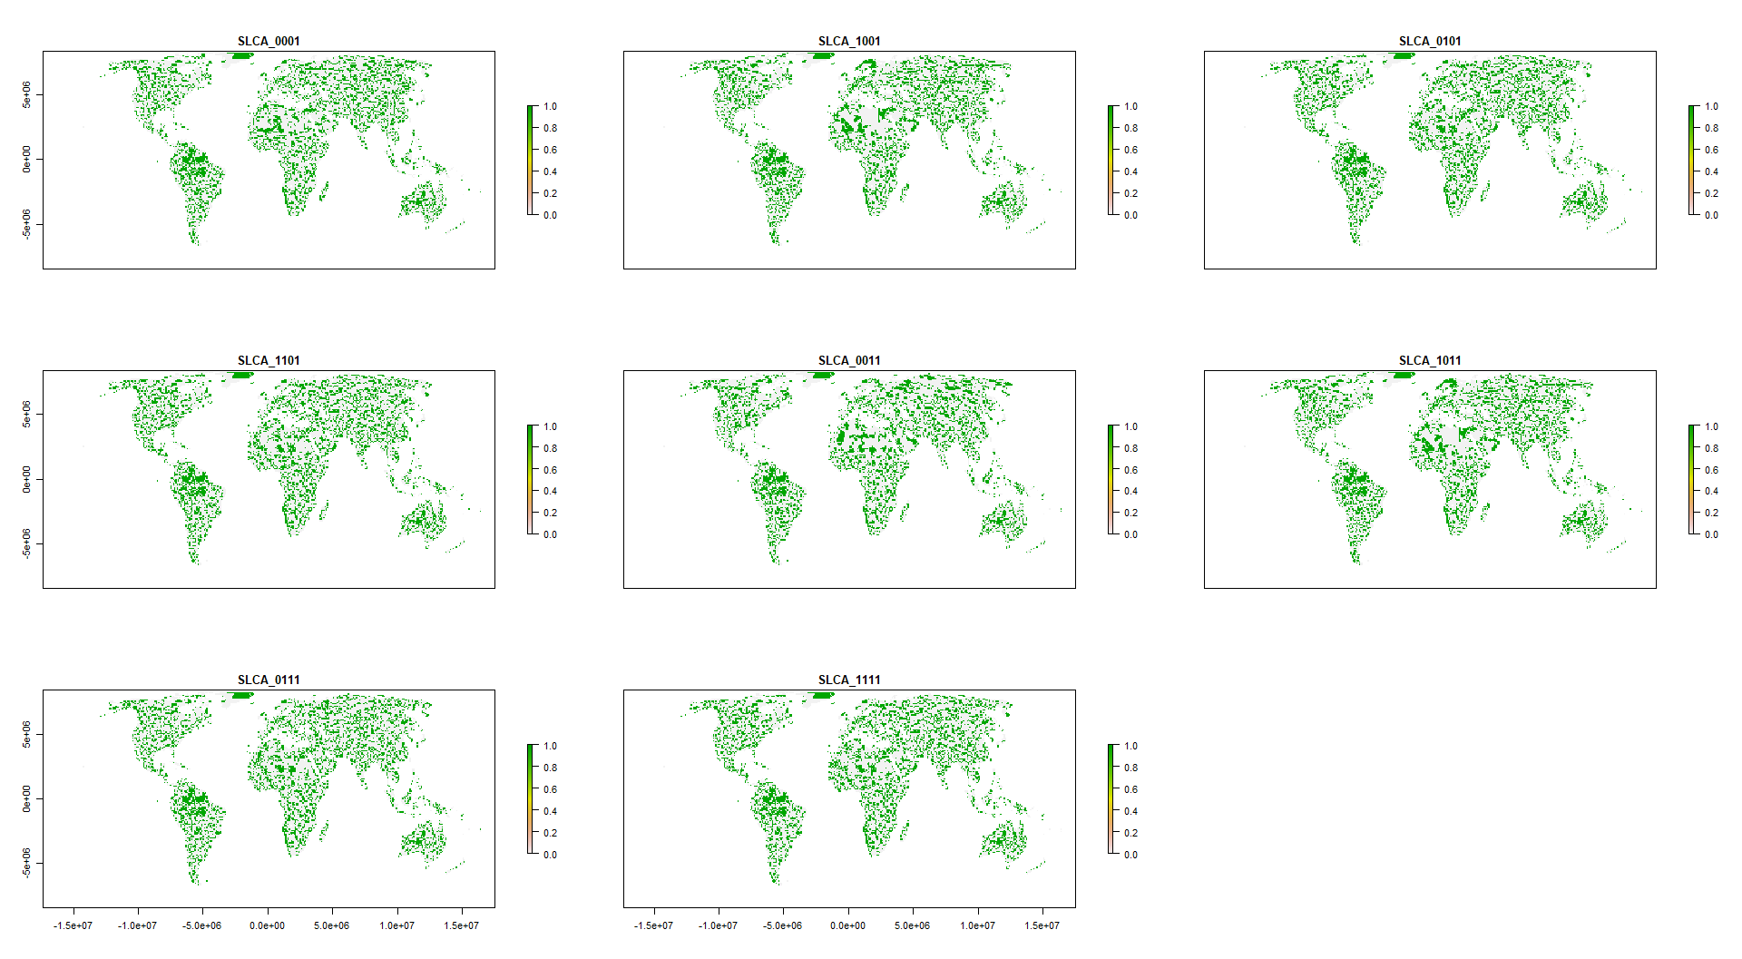

Figure 2: Scenario overlap. orange = protected areas. Color gradient from orange (one scenario) to dark blue (eight scenarios) = ovelap.

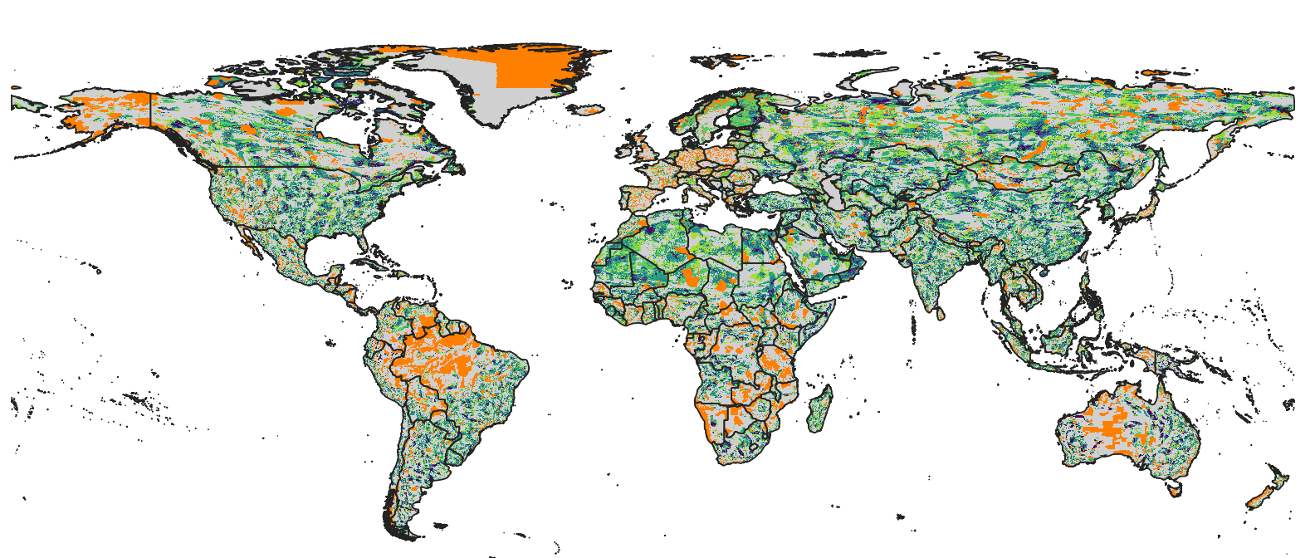

Figure 3: Spider plot biomes vs scenarios. % values are in relation to base value results. Could also do how much of each biome was selected, but that’s not very informative (see small figure below). I’m also not convinced that those spider plots are easy to read, might be better with x = biome, y = value and colors = scenarios plot. They do look nice though and are probably something Nature type journals like a lot.

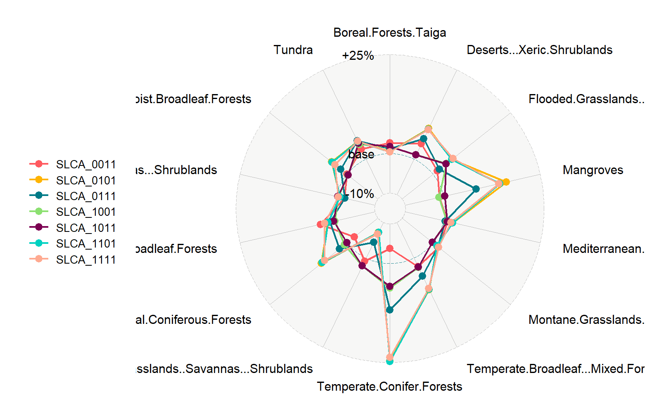

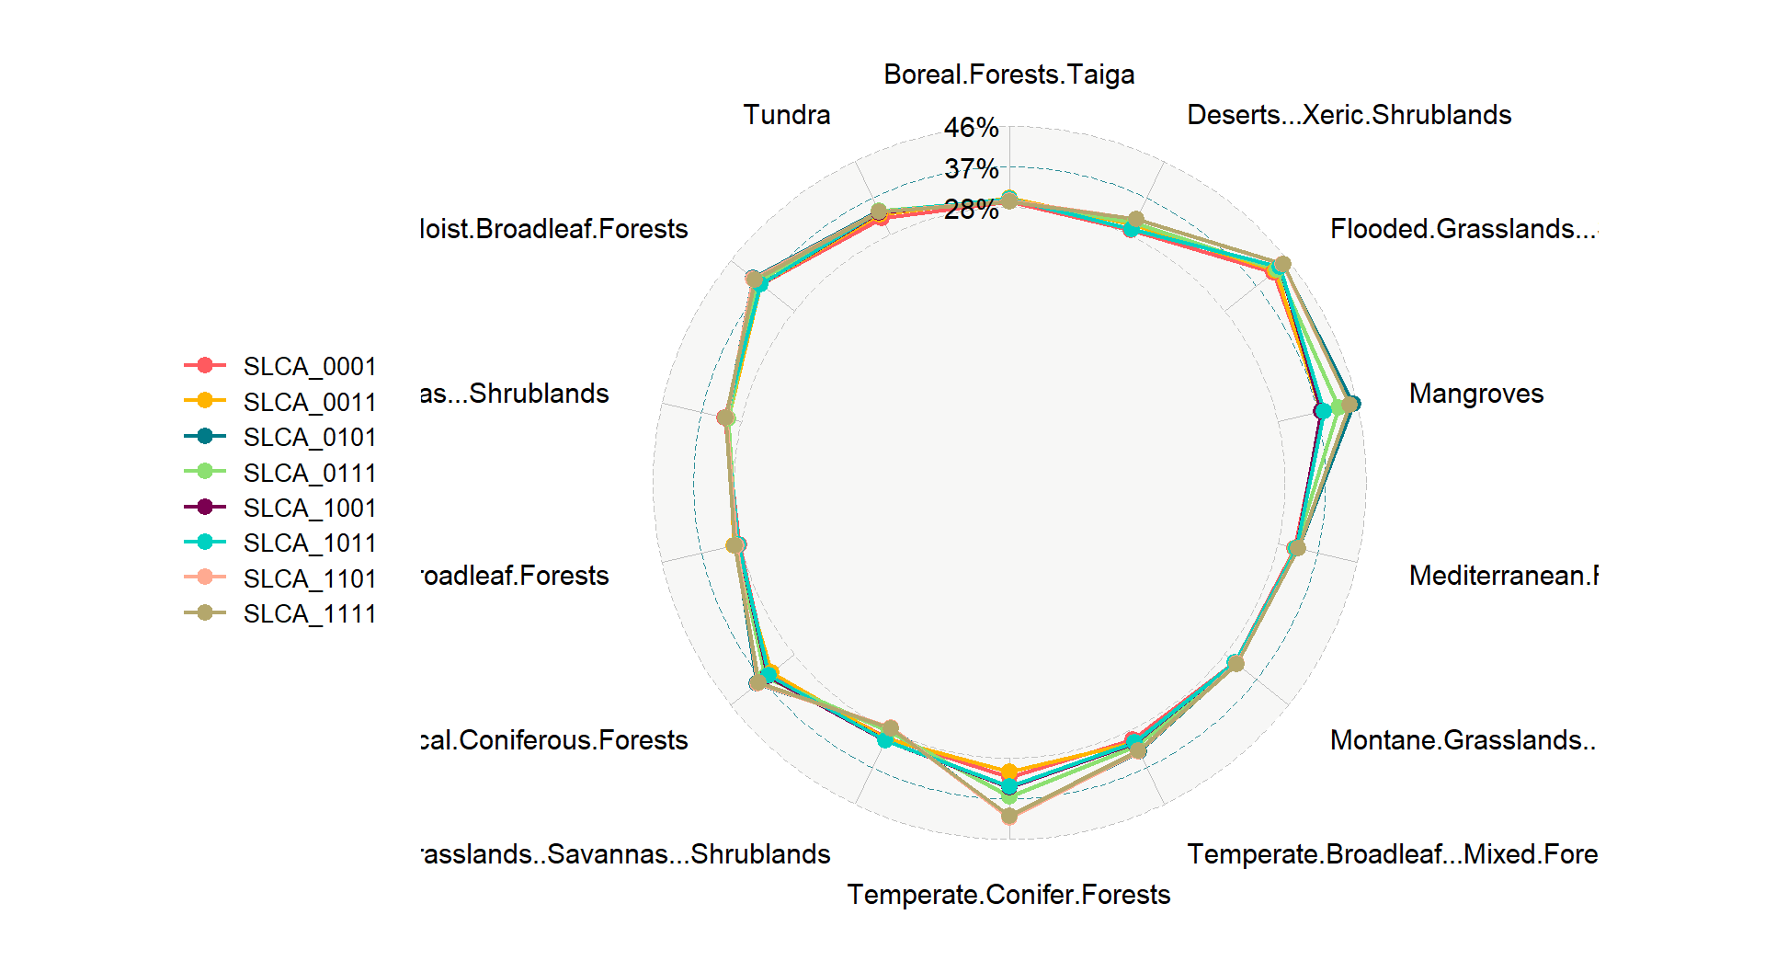

**Methods**

We used a multi-objective optimization approach that incorporated socioeconomic, land use and climate constraints to prioritize the conservation of 30,930 species. All scenarios we investigated were built on the current global protected area portfolio. We further set a target to protect 30% of the range of each species, based on current CDB discussions on post-2020 biodiversity targets.

*Species selection*

Our species lists were determined using the IUCN Red List of threatened species, following Pouzols et al. (2014). For mammal, amphibian and reptile species ranges, we used the IUCN Red List website (<http://www.iucnredlist.org/>, accessed 2019-11-14) and for birds we used the BirdLife International data zone webpage (<http://www.birdlife.org/datazone/home>, accessed 2019-11-14). We used these taxa because analogous data are available for a lower proportion of species in other taxonomic groups such as insects. These data have certain limitations, including possible underestimation of the extent of occurrence and overestimation of the true area of occupancy 9, but have been shown to be robust to commission errors as long as the focus is on species assemblages rather than single species, 10. They are currently the most frequently used and updated source for vertebrate species distributions 11.

For each taxonomic group, we restricted our analysis to species that fell into the presence category of ‘Extant’, the origin categories of ‘Native’ or ‘Reintroduced’ and the seasonality categories ‘Resident’, ‘Breeding Season’ or ‘Non-breeding Season’, thus only focusing on stationary periods of the life cycle of migratory species. This resulted in the following final numbers of amphibian, bird, mammal and reptile species ranges: 5660, 13375, 5442, 6153.

*Basic administrative delineations*

National boundaries were derived from the Global Administrative Areas database (<http://gadm.org/>, accessed 2019-10-31).

We obtained protected area boundaries from the World Database on Protected Areas (WDPA, [https://www.protectedplanet.net](https://www.protectedplanet.net/)). Following standard procedures for cleaning the protected area dataset, we (i) projected the data to an equal-area coordinate (World Behrman) (ii) excluded reserves with unknown or proposed designations, (iii) excluded UNESCO Biosphere Reserves 12, (iv) buffered sites represented as point localities to their reported area, (v) dissolved boundaries to prevent issues with overlapping areas, and (vi) removed slivers (code available at https://github.com/jeffreyhanson/global-protected-areas). After the protected area data, we overlaid the protected area boundaries with a 10 x 10 km grid covering the Earth. These spatial data procedures were completed using ArcMap (version 10.3.1) and python (version 2.7.8).

*Socioeconomic constraints*

Socioeconomic risk can affect the outcome of conservation strategies, and political instability and strong governance can promote the resilience of conservation in the face of sociopolitical shocks. We use indicators of the quality of governance to characterize socioeconomic risk and conservation resilience, as evidence suggests that protected area effectiveness (Barnes et al. 2016) and state investment and efforts for biodiversity conservation (Baynham-Herd et al. 2018) are reliably predicted by governance indicators. We used worldwide governance indicators from World Bank (https://datacatalog.worldbank.org/dataset/worldwide-governance-indicators), including six scaled measures: voice and accountability; political stability and absence of violence; government effectiveness; regulatory quality; rule of law; and control of corruption. For each country, we used a mean of annual averages of all six measures.13 <https://datacatalog.worldbank.org/dataset/worldwide-governance-indicators>

Figure S1

*Land use constraints*

We used a recent global land systems mapped produced by Kehoe et al.14. This is based on a global land systems map for the year 200015 at a 9.25km2 resolution, but makes use of the most recent land-cover and land-use datasets and has a finer resolution of 1km2. Kehoe et al.14 further estimated the impact of land use and land use intensity on biodiversity, with data originating from the PREDICTS project16. They first matched their land-systems classes to varying intensity levels for each land-use type (for detailed conversion table, see ref17). This allowed Kehoe et al. to calculate average biodiversity loss per land system (relative to an unimpacted baseline) by taking the mean model estimates of biodiversity loss per land-use intensity class from previous work17. The result gives average relative biodiversity gain or loss per land system. Here, we used their modelled mean estimates (following Newbold et al.17) of relative percent biodiversity change for each Land System for species abundance as a measure of the land-use change risk.

Figure S2

*Climate constraints (text largely adopted from Frank’s paper)*

There is evidence that the increased exposure to extreme heat events (EHE) adversely affects human populations (Anderson & Bell Michelle, 2011; Battisti & Naylor, 2009; Guo et al., 2017; Mitchell et al., 2016) and natural systems within terrestrial (Harris et al., 2018; Maxwell et al., 2019) and marine environments (Garrabou et al., 2009; Wernberg et al., 2013). How the frequency and duration of EHE has changed over time has been explored primarily within terrestrial regions during the boreal and austral summers (Coumou & Robinson, 2013; Oswald, 2018), but there are examples that have considered other seasons of the year (Alexander et al., 2006). There are a number of climate indices that have been used to estimate the occurrence of extreme heat events (Fenner et al., 2019; Smith et al., 2013). These climate indices are often context specific and there is little consensus on 79 the most appropriate technique (McPhillips et al., 2018). Here, we define the occurrence of extreme heat events using a probabilistic framework that estimates the novelty of each event relative to historical year-to-year variation in temperature at each location. Specifically, we use detrended daily measures of minimum and maximum temperature to estimate when and where temperatures significantly exceed historical variation in temperature over a 71-year period (1948 to 2018). This approach provides a standardized measure of the novelty of climate extremes that allows for valid comparisons across space and time. We use this approach to determine how the frequency and duration of EHE have changed over time and the regions and seasons where these events are likely to have the most significant effects on natural systems and human populations now and into the future.

The metric we used here is the duration of each event within each year and pixel based on the number of consecutive days containing EHE. We extracted the maximum continuous duration of each event for each year and pixel. We selected the maximum because it provided improved distributional properties for analysis and identifies the most significant event for each year. We averaged the maximum duration of each event within each pixel across the 71-year period. We modeled the change in the maximum duration in each event over the 71-year period using Poisson regression (Lambert, 1992).

Figure S3

*Multi-objective optimization of risk reduction*

We processed all data described before to a 10 x 10 km resolution and clipped data to the extent of land based on the global administrative areas database.

Here, we developed an extension on the minimum set problem, which has the goal to identify a set of sites within a planning area that represents all conservation targets in the fewest number of sites 18. Instead of including one objective we are expanding the formulation to include multiple objectives in the problem formulation. We use a hierarchical or lexicographic approach that assigns a priority to each objective, and optimizes for the objectives in decreasing priority order. At each step, it finds the best solution for the current objective, but only from among those that would not degrade the solution quality for higher-priority objectives. We considered up to three objectives in our prioritization scenarios, i) socioeconomic risk, ii) land-use change risk, and iii) climate risk. To compare different constraint scenarios we calculated solutions for each unique objective combination (n = 7), as well as one where we use a constant objective function as the base scenario.

For all scenarios we locked in current protected areas and used the same feature set of 30930 vertebrates. The target for each feature was set to 30% of their range. The optimality gap we use was 5% for each objective in the hierarchy. We started the hierarchy with the socioeconomic constraint, followed by the land use and climate constraints to reflect the immediacy of each risk on current biodiversity (socioeconomic best predictor for success currently; land use higher current impact than climate). The order of the hierarchy does matter, which is why its important to specify and justify the importance of constraints in the hierarchy before running the analysis.

**Methods references**

**Acknowledgements**

**Author contributions**

**Competing interest declaration**

**Figure S1. Socio-economic (green = good, red = bad)**

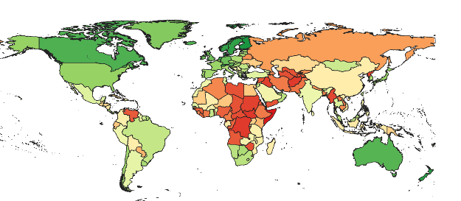

**Figure S2. Land use (green = good, red = bad)**

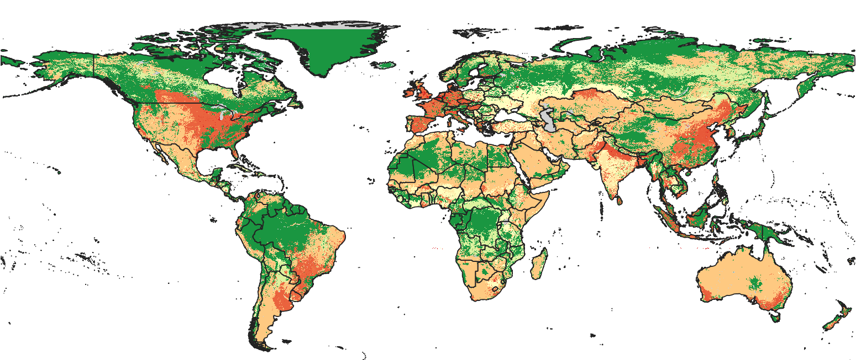

**Figure S3. Climate (extreme heat events) (green = good, red = bad)**

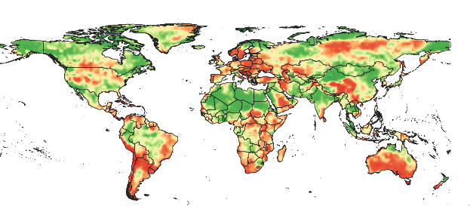

**Parking lot**

and current patterns of land use.

>>>tough one: while conservation is often aimed at reducing the risks of land use change in practice it is very difficult to ensure full conservation in regions that are facing high land use change pressures (example is Indonesia where logging moratorium did not fully work given the high oil palm pressure (some references: https://www.sciencedirect.com/science/article/pii/S1389934118304623