Microbiomes & One Health – Instructions for TP1 class (13/03/2026)

1 - Prepare for TP class 1 - Install R and RStudio
We will need R and RStudio for the TP1 class, so installing both in advance is mandatory. This will ensure that everyone is ready to follow the practical activities during the session.
Important: install R first, and only then install RStudio Desktop. R and RStudio Desktop can both be downloaded from Posit. RStudio requires R to already be installed.
https://posit.co/download/rstudio-desktop/

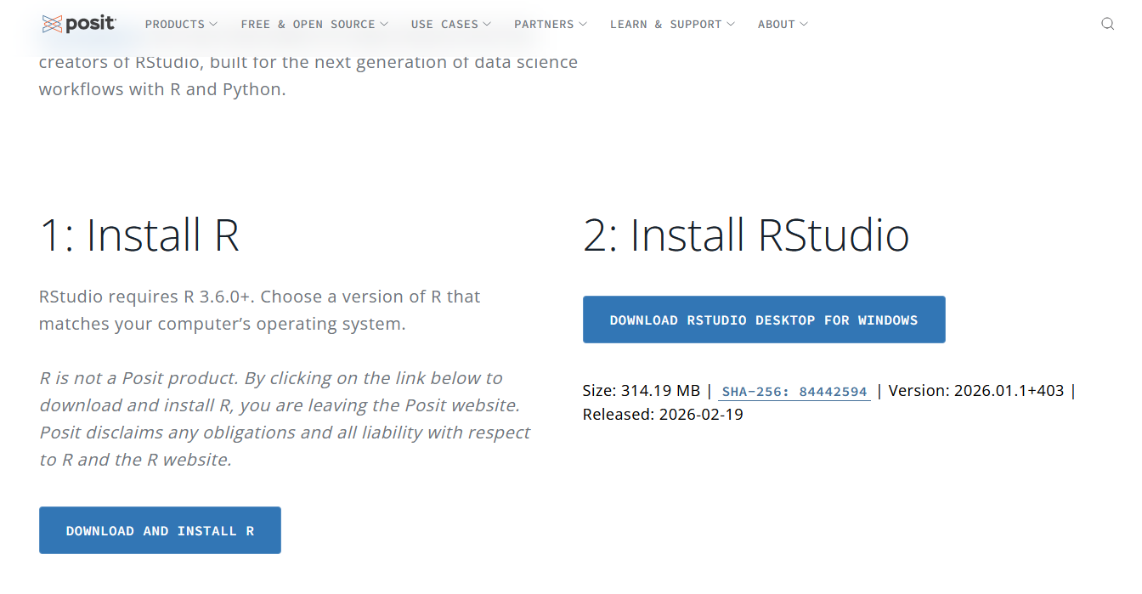

1.1 - For Windows
- Go to the posit.co page and download R for Windows.
- Open the installer and keep clicking Next using the default options.
- When R is installed, go to the Posit RStudio Desktop page.
- Download the Windows installer for RStudio Desktop.
- Run the installer and finish the installation with the default options.

1.2 - For Mac
- Go to the posit.co page and download R for macOS.
- Choose the installer that matches your Mac and macOS version, then install it normally.
- After R is installed, go to the Posit RStudio Desktop page.
- Download the macOS installer for RStudio Desktop.
- Open the downloaded file and move/install the application as requested.

Open RStudio.
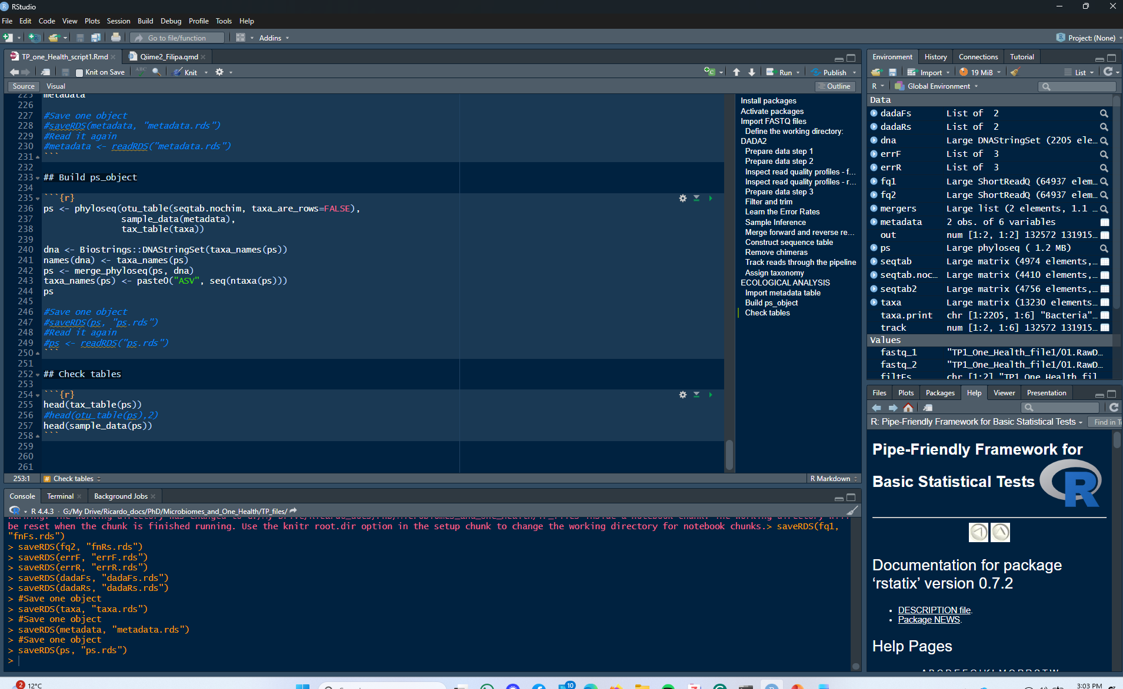 In the Console, run:
“version”
If R is correctly installed, RStudio should open and show your R version. RStudio uses the R installation detected on your computer.
The current RStudio Desktop documentation lists support for Windows 10+ and macOS 14+. For older macOS versions, Posit provides a compatibility table showing which older RStudio versions matched older Mac systems.

2 – Prepare R for TP class 1 – install packages
There are several R packages that we will need for the TP1 class. Installing them before the class will save time during the session.
After successfully installing R studio, open the file (click twice on the icon) called “TP_One_Health_install_R_packages.RMD”
Then, inside R studio run the code chunk called # Install packages
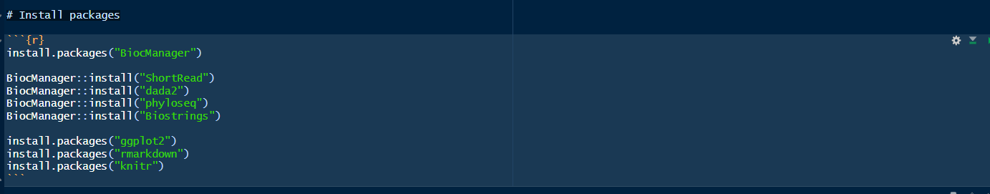
By pressing the green triangle on the top right 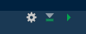 or by placing the cursor at the beginning of each code line and pressing Ctrl+Enter. All packages should be successfully installed.

