Microbiomes & One Health – Instructions for TP2 class (20/03/2026)

Good morning, students! Now that you have all survived the first TP class and bioinformatics has no secrets from you, it's time to delve into Microbiome data analysis in TP2. For this, we will continue to use R and R Studio. Here are some instructions to help ensure everything runs smoothly. If you encounter trouble with any step in the process, please come 30 minutes earlier to TP2 class so we can resolve it and be ready for the class.

1 - Instructions to open and use the file TP2_script_data_analysis.Rmd
You will receive a zipped folder called TP2_files.
- Extract the zipped folder
  - Download the TP2_files.zip file
  - Locate the file TP2_files.zip on your computer.
  - Extract or unzip it.
  - After extraction, open the folder TP2_files.
- Find the script file
  - Inside the folder TP2_files, locate the file TP2_script_data_analysis.Rmd.
- Open the file directly
  - Double-click on TP2_script_data_analysis.Rmd.
  - The file should open automatically in RStudio.
- Check that the file opened correctly
  - The name “TP2_script_data_analysis.Rmd” should appear in a tab in the editor window of RStudio.
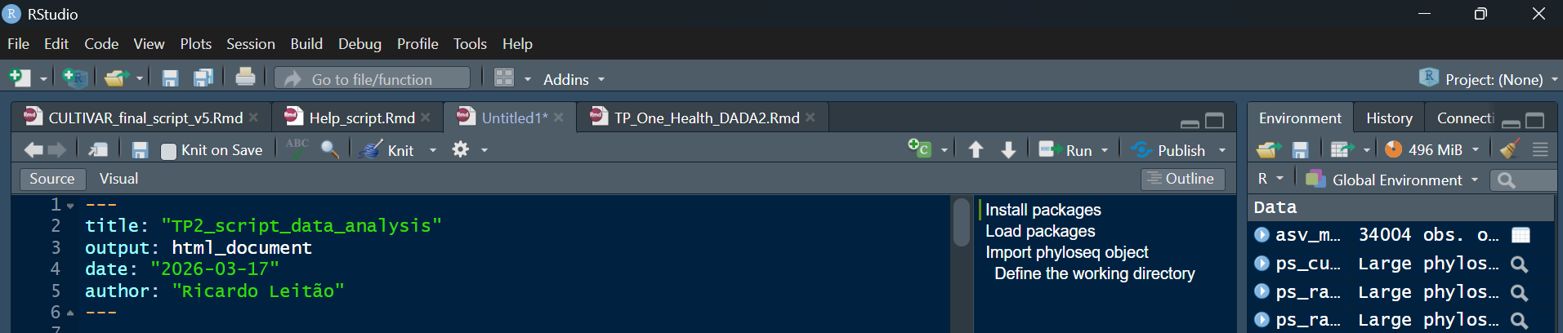
  - If it opened correctly, you are ready to follow and run the script.

Alternative option
If the file does not open by double-clicking:
- Open RStudio first.
- In the top menu, click File > Open File...
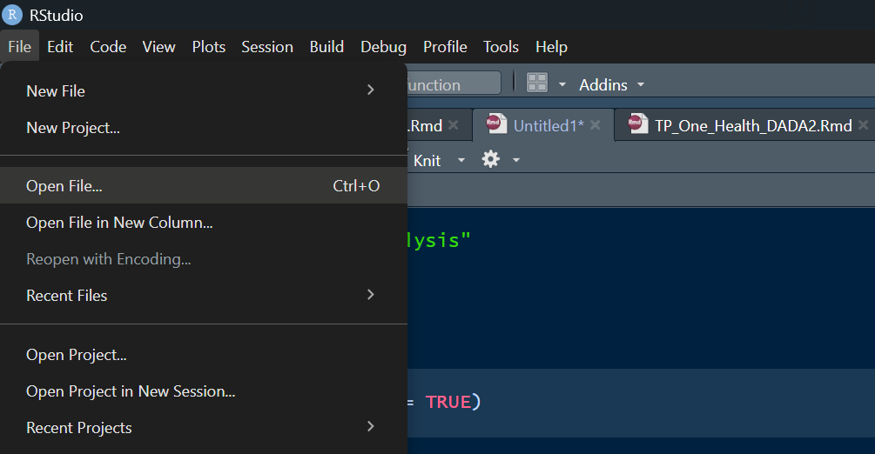
- Open the folder TP2_files.
- Select TP2_script_data_analysis.Rmd.
- Click Open.
Important recommendation
- Keep TP2_script_data_analysis.Rmd and all the other files in the TP2_files folder.
- Do not rename files.
2 – Instructions to test the script
Now let's test whether the script is correct, and the first steps have been completed.

Basic notes about R Markdown in RStudio
- The file TP2_script_data_analysis.Rmd is an R Markdown file.
This type of file can contain:
Element Meaning
Normal text Instructions, explanations, and comments
Code chunks Blocks of R code that can be run inside the document
Output Results produced after running the code

How to recognise a code chunk:
In an .Rmd file, R code appears inside a code chunk, like this:
```{r}
code
```
To run the code:
- To run the code chunk press the green arrow facing right on the top right of the code chunk. (Run Current Chunk)
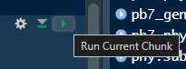
- Wait until the commands finish running.
- You can also run each line of code individually; for that, just press Ctrl+Enter at the beginning (or end) of the code line
- Inside each code chunk, whenever there is an #, it won’t be read. So, it’s a strategy to include code in the script that may be needed but isn't currently being read, like a code store.
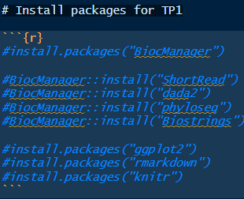

  - Run the # Install packages for TP2 code chunk
Similar to the TP1 class, we will need to install some new packages. After opening TP2_script_data_analysis.Rmd in RStudio, start by running the first code chunk called # Install packages for TP2 to install the new packages.
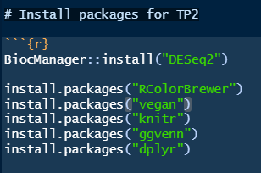
You should now see a message with the successful installation of the packages

  - Run the # Load packages code chunk
Then run the code chunk # Load packages to active the old and the new packages
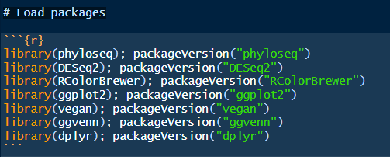
What should happen
- RStudio should load the packages.
- The version number of each package should appear in the Console.
Important note
If an error appears saying that a package is not installed, stop here and install the missing package before continuing.

  - Run the # Define working directory code chunk
One of the main difficulties when working with R Studio is defining the working directory, which is the directory where R Studio will import files and save outputs. This next code chunk will check the current working directory and then help you select the correct one. What you will see is the path of the directory. The path is the group of directories where the current directory is located, starting at the hard drive. Check this example of a path:
G:/My Drive/Ricardo_docs/PhD/Microbiomes_and_One_Health/TP2/TP2_files
Here, the path begins at Google Drive and then proceeds to the final directory TP2_files. Each student will have a unique path based on how their PC is organized. This next code segment checks the current working directory, and if it doesn't end in the TP2_files directory, you need to update it by entering the correct path. Be careful with the slashes; they should face right ( / ).

Run the code chunk
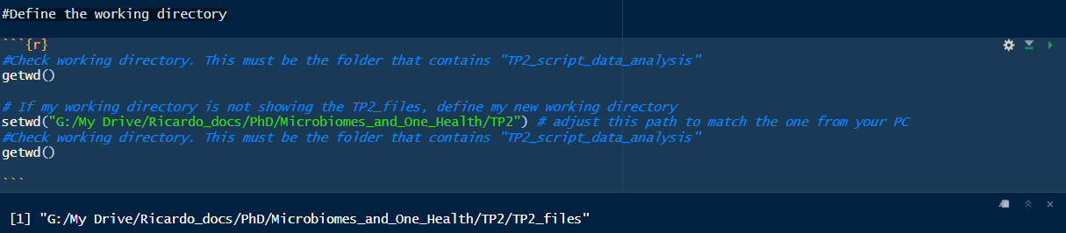
You should now see a message with the working directory finishing in ../TP_files2

  - Run the # Import phyloseq object code chunk
Run the code chunk
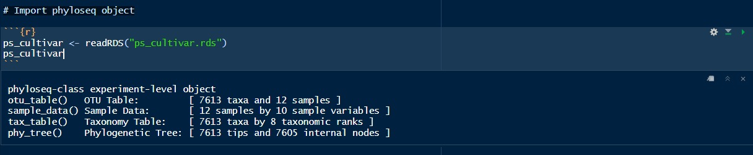
You should now see a message with the ps_cultivar object description.

Remember, the ps_cultivar object is a complex R pyloseq object composed of 3 tables, metadata, out_table and tax_table. It will be our base object for the work in TP2 class
To check each table, run the next code chunk # Check ps_object tables
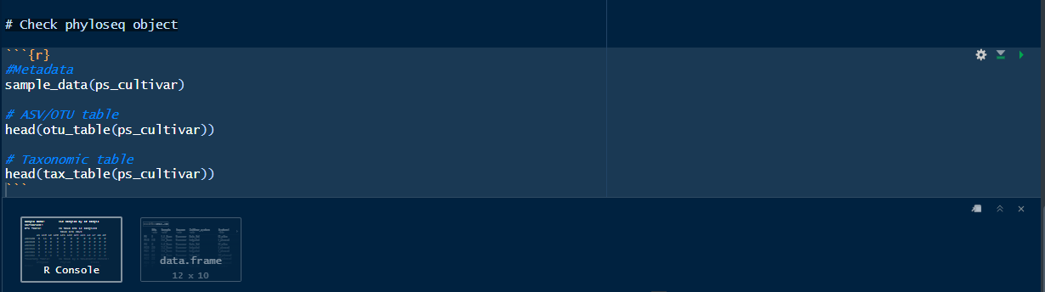
Stop here. We will explore the rest of the script during TP2 class.

Good luck!

