Looking at the data set is vital in order or understand what to clean up

Data cleaning was conducted in Python 3.9

First let's look at what is in each column

hotel 119390
is_canceled 119390
lead_time 119390
arrival_date_year 119390
arrival_date_month 119390
arrival_date_week_number 119390
arrival_date_day_of_month 119390
stays_in_weekend_nights 119390
stays_in_week_nights 119390
adults 119390
children 119386
babies 119390
meal 119390
country 118902
market_segment 119390
distribution_channel 119390
is_repeated_guest 119390
previous_cancellations 119390
previous_bookings_not_canceled 119390
reserved_room_type 119390
assigned_room_type 119390
booking_changes 119390
deposit_type 119390
agent 103050
company 6797
days_in_waiting_list 119390
customer_type 119390
adr 119390
required_car_parking_spaces 119390
total_of_special_requests 119390
reservation_status 119390
reservation_status_date 119390

We notice 3 columns are missing data

country 118902

agent 103050

company 6797

Some of this data that missing might be expected, so as a direct from consumer booking ( in relation to the company field)

Now we can count nulls, the same 3 columns have a number of nulls

country 488

agent 16340

company 112593

overall, the shape of the array is
rows vs column
(119390, 32)

It is also important to find any fields that are highly correlated or highly negatively correlated

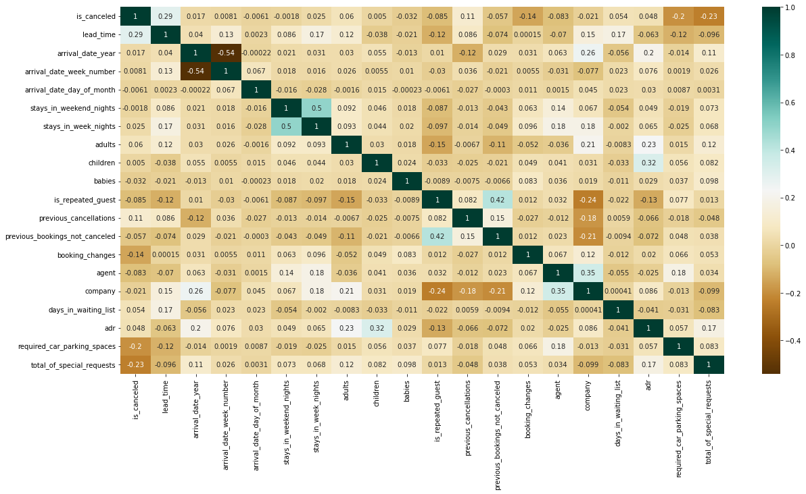

Everything looks withing in reason

\
Now lets deal with some of the missing values and data

We replace any nulls / blank in
Children with 0
Country with Unknown
Agent with 0
Company with 0
Meal (undefined replaced with SC)

Now – since we are looking at booking, a reservation should have a number of humans. So each row should have either an adult, children, or baby – and any row that doesn’t have at least one of these should be removed.

missing_guests = list(data3.loc[data3["adults"] + data3["children"] + data3["babies"]==0].index)
data3.drop(data3.index[missing_guests], inplace=True)

which now brings us down to 119210 row ( from 119390)

-

IDR / IQR is important to look for out layer - does one person want 500 car space? Does one booking have a 100 people per single room?
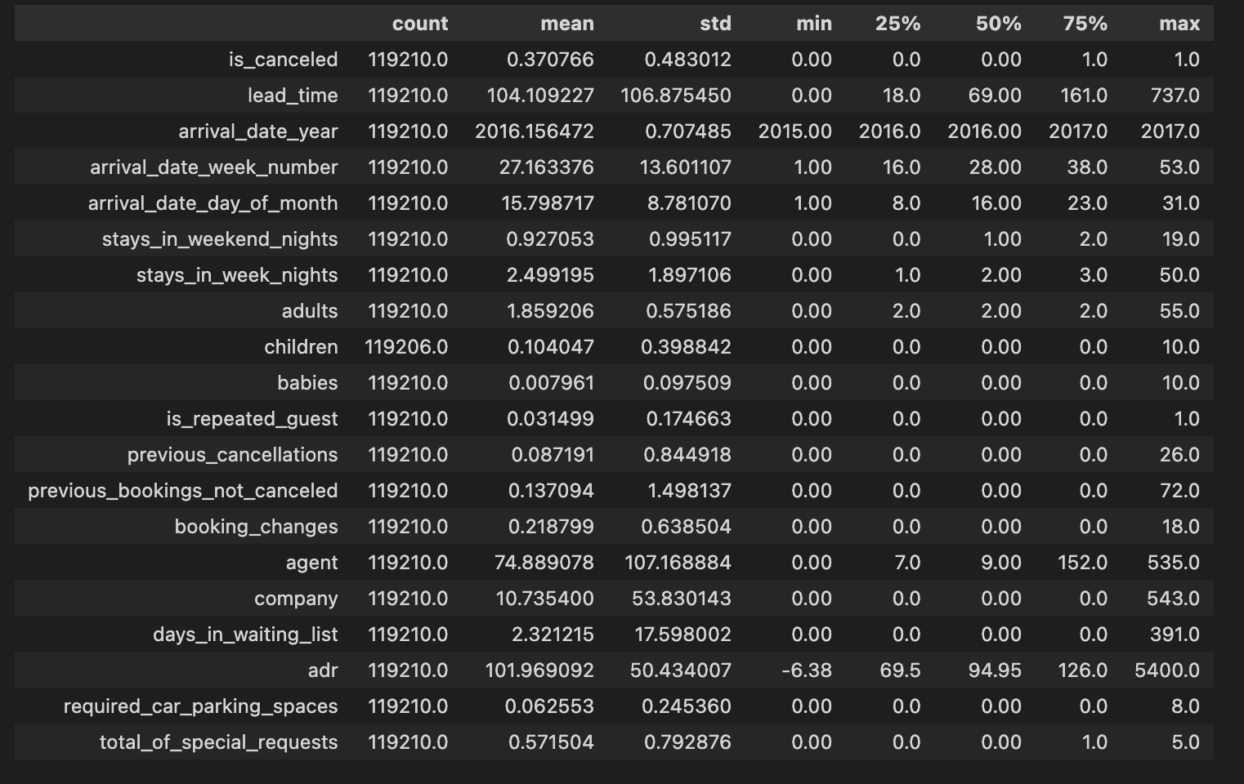

Some notable outliers ( but not corrected- because unsure if they are errors or not)

8 Parking spaces are required for a booking
ADR of 5400 – when the 50% range is 126
Adult Max per booking = 55 adults
Children Max per booking = 10
Babies Max per booking = 10
Also – Previous Cancelling = 26

Each one of these data elements could be discuss and reviewed in detail and possible cleaned up, but for now I am leaving them in because I am unsure what to remove.

Lets look at some of the top value ( most common value)
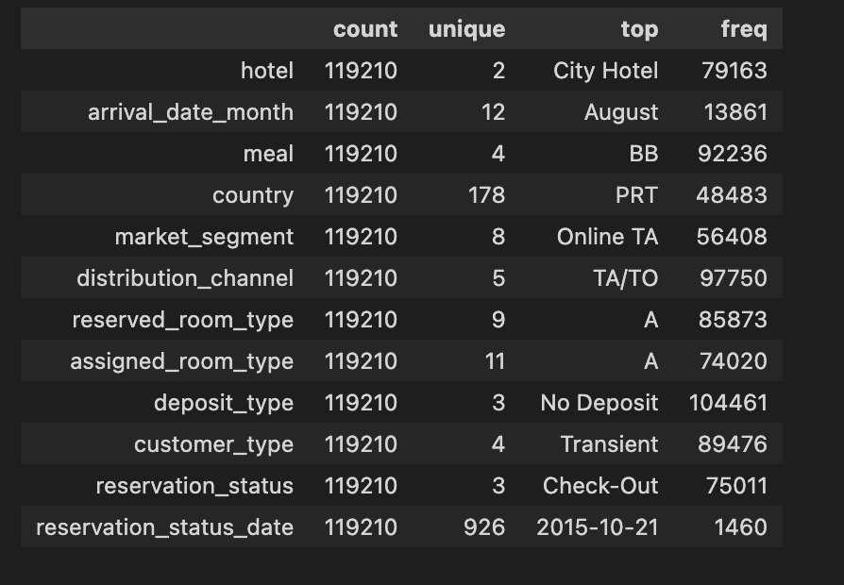

Now one final data cleaning point – the arrival data is split up between 3 fields ( year, month, day of month) – let merge those in to a new field for easier analysis.

data3['arrv_date'] = pd.to_datetime(data3.arrival_date_year.astype(str) + '-' + data3.arrival_date_month.astype(str) + '-' + data3.arrival_date_day_of_month.astype(str))

