**Case Study on**

**Applied Discrete Mathematics**

Role of Discrete Mathematics in Real Time Applications

**Name :** Riddhi Pawar

**GR No:** 22020020

**Roll No:** 232071

**Subject:** Discrete Mathematics

* **Title:**

Role of Discrete Mathematics in Business and Economics.

# Application Area:

# Business and Economics

# Introduction to Business and Economics:

# Components Of Business Economics Including Budget Accounting | PowerPoint Templates Backgrounds | Template PPT Graphics | Presentation Themes Templates

Business economics is a field of [applied economics](https://www.investopedia.com/terms/a/applied-economics.asp), that studies the financial, organizational, market-related, and environmental issues faced by corporations. It is an applied science in the sense of a tool of managerial decision-making and forward planning by management. In other words, business economics is concerned with the application of economic theory to business management.

Business economics focuses on the economic issues and problems related to business organization, management, and strategy.

Issues and problems include an explanation of:

-why corporate firms emerge and exist

-why they expand: horizontally, vertically and spacially

-The role of entrepreneurs and entrepreneurship

-The significance of organizational structure

-The relationship of firms with employees, providers of capital, customers, and government

-Interactions between firms and the business environment

# The field of business economics addresses economic principles, strategies, standard business practices, the acquisition of necessary capital, profit generation, the efficiency of production, and overall management strategy. Business economics also includes the study of external economic factors and their influence on business decisions such as a change in industry regulation or a sudden price shift in raw materials.

# Introduction to Game Theory:

# 

# The key pioneers of game theory were mathematician John Neumann and economist Oskar Morgenstern in the 1940s. Mathematician John Nash is regarded by many as providing the first significant extension of the Neumann and Morgenstern work.

# Game theory is a theoretical framework for conceiving social situations among competing players. In some respects, game theory is the science of strategy, or at least the optimal decision-making of independent and competing actors in a strategic setting.

# The focus of game theory is the game, which serves as a model of an interactive situation among rational players. The key to game theory is that one player's payoff is based on the strategy implemented by the other player. The game identifies the player’s identities, preferences, and available strategies and how these strategies affect the outcome.

# What is a Game?

# Game is any set of circumstances that has a result dependent on the actions of two or more

# decision-makers (players).

# All games have the following:

# Rules, which govern conduct of the players

# Pay-offs, such as win, lose or draw

# Strategies, which influence the decision making process.

# Game Theory attempts to determine mathematically and logically the actions that “players” should take to secure the best outcomes for themselves in a wide array of “games”. All the games share the common feature of interdependence. That is, the outcome for each participant depends on the choices (strategies) of all.

# 

# Games includes zero-sum games in which one person’s gain is always another’s loss. And some games which have potential for either mutual gain (positive sum) or mutual loss (negative sum), as well as some conflict.

# In these games the players choose their actions separately, but their links to others involve possibility of both conflict/competition and cooperation.

# 2. What is a Player?

# Player is a strategic decision-maker within the context of the game. In a sequential-move game each player needs to figure out how the other players will respond to his current move and how he will respond in turn.

# In a simultaneous-move game, players act at the same time, each ignorant of the others actions. When thinking about how others will respond, he must put himself in their shoes and think as they would. a game with simultaneous moves involves a logical circle. Each must be aware that there are other players who are similarly aware. Each picks his best response to what the others do.

# 

# Players use different strategies like:

# 1) Mixing moves - In some situations of conflict, any systematic action will be discovered and exploited by the rival. Therefore, it is important to keep the rival guessing by mixing your moves. Eg. in sports, whether to run or to pass in a particular situation in football.

# 2) Bargaining - Two players decide how to split a pie. The player more impatient to reach agreement gets a smaller share.

# 3) Strategic moves - A player can use threats and promises to alter other players expectations of his future actions, and thereby induce them to take actions favorable to him or deter them from making moves that harm him. The Strategy of Conflict, brinkmanship can also be used.

# Applying Game Theory in Business Economics:

# In business, game theory is beneficial for modeling competing behaviors between economic agents. This may involve how two competitor firms will react to price cuts by the other, if a firm should acquire another, or how traders in a stock market may react to price changes.

# In applying game theory to the behaviour of firms, we can suggest that firms face a number of strategic choices i.e. dilemmas which govern their ability to achieve a desired pay-off. Game Theory helps businesses to the predict most likely outcomes.

# These strategic choices includes decisions on price and output, such as whether to:

# 1) Raise or Lower or Hold, decisions on products, such as whether to:

# Keep existing products

# Develop new ones

# 2) Decisions on promoting products, such as whether to:

# Spend more on advertising

# Spend less

# Keep spending constant

# 3) Firms could derive a range of possible pay-offs from their strategy choices, including:

# More profits for shareholders

# Greater market share



# Improved chances of survival

# Getting rid of a rival

# The Prisoner’s Dilemma:

# The [Prisoner's Dilemma](https://www.investopedia.com/terms/p/prisoners-dilemma.asp) is the most well-known example of game theory. It illustrates the choices facing oligopolies i.e. a market or industry which is dominated by a small group of large sellers.

# The scenario

# Robin and Tom are prisoners. They have been arrested for a petty crime, of which there is good evidence of their guilt – if found guilty they will receive a 2 year sentence. During the interview the police officer becomes suspicious that the two prisoners are also guilty of a serious crime, but is not sure as he has no evidence.

# So, Robin and Tom are placed in separate rooms and cannot communicate with each other. The police officer tries to get them to confess to the serious crime by offering them some options, with possible pay-offs. Each can confess or keep silent.

# 

The dilemma is that their own ‘pay-off’ is wholly dependent on the behaviour of the other prisoner. To avoid the worse-case scenario (10 years), the safest option is to confess and get 3 years. If collusion is possible they can both agree to deny (and get 2 years), but there is a very strong incentive to cheat because, if one denies and the other confesses, the best outcome of all is possible – that is 1 year. Fearing that the other may cheat, the safest option is to confess.

The Nash equilibrium suggests that in a prisoner's dilemma, both players will make the move that is best for them individually but worse for them collectively.

**Tit for Tat Strategy**

In above situations, cooperative behavior can be achieved in repeated plays of the game because the temporary gain from cheating (confession) can be outweighed by the long-run loss due to the breakdown of cooperation.

Strategies such as Tit-for-Tat are determined to be the optimal strategy for optimizing a prisoner's dilemma. It is a strategy in which each participant in an iterated prisoner's dilemma follows a course of action consistent with their opponent's previous turn.

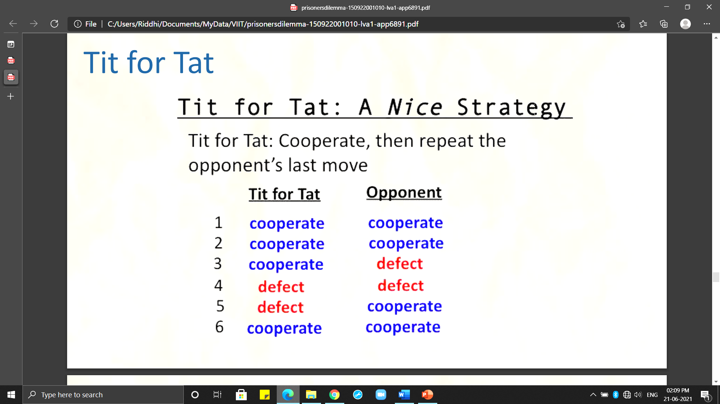

There are several games that game theory analyses like Prisoner’s Dilemma. Some of them are Dictator Game, Volunteer’s Dilemma etc.

* **Conclusion:**

Recent advances in game theory have succeeded in describing and prescribing appropriate strategies in several situations of conflict and cooperation that can provide most favourable outcomes. Despite its many advances, game theory is still a young and developing science. As Game Theory is far from complete, the design of successful strategy still remains an Art.

* **References:**
* <https://www.economicsonline.co.uk/Business_economics/Prisoners_dilemma.html>
* <https://en.m.wikipedia.org/wiki/Business_economics>
* <https://www.investopedia.com/terms/b/business-economics.asp>
* <https://www.slideshare.net/tjgokcen/prisoners-dilemma-53040551>
* <https://www.investopedia.com/terms/g/gametheory.asp>
* <https://www.analyticssteps.com/blogs/essence-game-theory-artificial-intelligence-5-types-game-theory-and-nash-equilibrium>
* <https://youtu.be/YgqC8_WOZyY>
* <https://youtu.be/sCKRV8Yps-Y>
* <https://youtu.be/MPM_KgaXij0>