Server installation:

Check if the following Redistributable Packages are installed:

* Visual C++ 2008 Redistributable Package(x86, x64)
* Visual C++ 2010 Redistributable Package(x86, x64)
* Visual C++ 2012 Redistributable Package(x86, x64)
* Visual C++ 2015 Redistributable Package(x64)

Check if the following IIS services are set:

* IIS Admin Service
* WWW Publishing Service
* Web Management Service
* Application Host Helper Service
* Windows Process Activation Service

Install Neurotechnology SDK:

* Neurotec Biometric 9 0 SDK (2016-12-06)
* Set PATH environment variable to

C:\Program Files (x86)\  
Neurotechnology\Neurotec Biometric 9.0 SDK\Bin\Win64_x64;

* Install the following biometric licenses:
  + FingerFastExtractor,
  + FingerFastSegmenter,
  + FingerFastMatcher,
  + Biometric Standards for VeriFinger.lic

Using IIS management console, install the following WCF applications:

* CommonService
* BiometricService
* MemoryCacheService

Client installation:

Check if the following Redistributable Packages are installed:

* Visual C++ 2005 Redistributable Package(x86, x64)
* Visual C++ 2008 Redistributable Package(x86, x64)
* Visual C++ 2010 Redistributable Package(x86, x64)
* Visual C++ 2015 Redistributable Package(x86, x64)

Install Neurotechnology SDK:

* Neurotec Biometric 9 0 SDK (2016-12-06)
* Set PATH environment variable to

C:\Program Files (x86)\  
Neurotechnology\Neurotec Biometric 9.0 SDK\Bin\Win64_x64;

* Install the following biometric licenses:
  + FingerClient

Install the scanner drivers:

* Futronic FS 50 (Futronic.zip)
* AFS 510 (pr-fps-2.1.5-26.zip)

Install the following Windows applications:

* PassportReader
* PSCBioIdentification

Windows Firewall:

* Set inbound rule of World Wide Web Services (HTTP Traffic-In) to  
   Allow Connection

Microsoft SQL Server:

Modify the Egy_T_FingerPrint table definition using the following ALTER TABLE Transact SQL statements:

USE [MCCS_FP]

alter table [Egy_T_FingerPrint] add li varbinary(max) null

alter table [Egy_T_FingerPrint] add lm varbinary(max) null

alter table [Egy_T_FingerPrint] add lr varbinary(max) null

alter table [Egy_T_FingerPrint] add ll varbinary(max) null

alter table [Egy_T_FingerPrint] add ri varbinary(max) null

alter table [Egy_T_FingerPrint] add rm varbinary(max) null

alter table [Egy_T_FingerPrint] add rr varbinary(max) null

alter table [Egy_T_FingerPrint] add rl varbinary(max) null

alter table [Egy_T_FingerPrint] add lt varbinary(max) null

alter table [Egy_T_FingerPrint] add rt varbinary(max) null

Install ExtractFingerRecords console application on the server computer.  
The ExtractFingerRecords splits a WSQ image into 10 fingerprint templates,

it requires 2 parameters,  
the first one is an offset of a chunk from the beginning of Egy_T_FingerPrint table,  
the second is an number of chunks.  
One chunk is 10000 records. The splitting process is quite lengthy, so it is recommended to run the program with no more than two chunks.

To set a proper database connection string edit the ExtractFingerRecords.exe.config file.

Run Command prompt:

cd C:\Program Files\PSC\ExtractFingerRecords

ExtractFingerRecords 0 1

Licenses activation wizard:

Run ActivationWizard(x64) application, press Add Licenses button, paste a license serial number or add a license from a file.

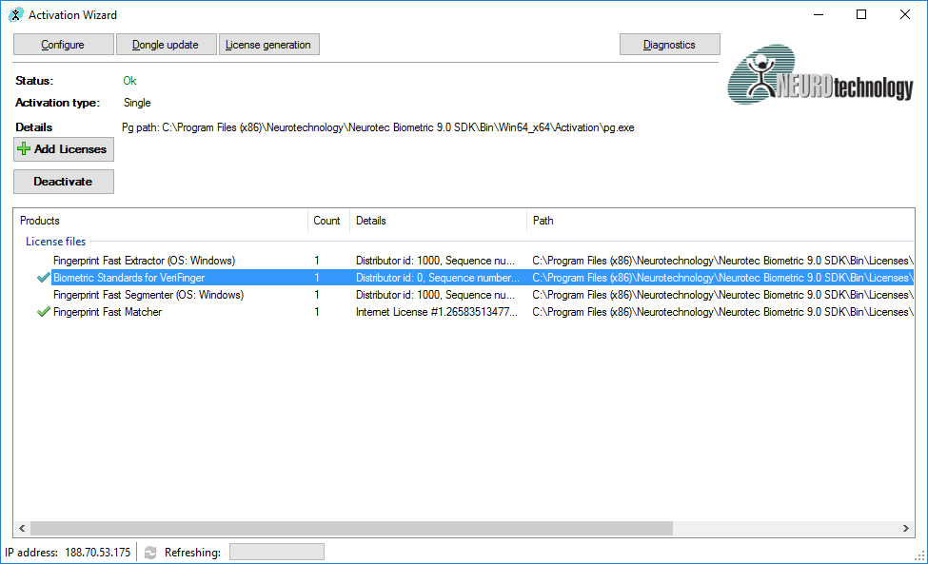

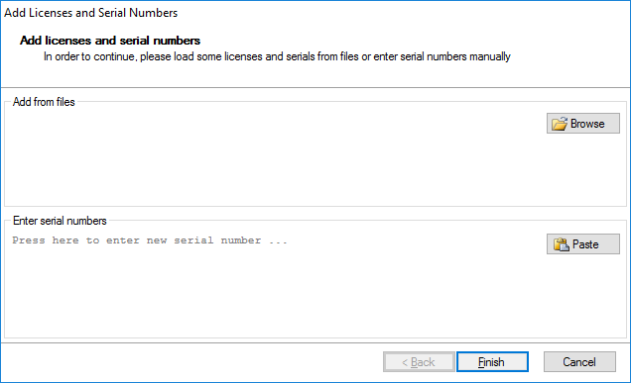

WCF applications installation:

Right click the Default Web Site node, select Deploy item, click Import Application and follow the Import Application wizard.

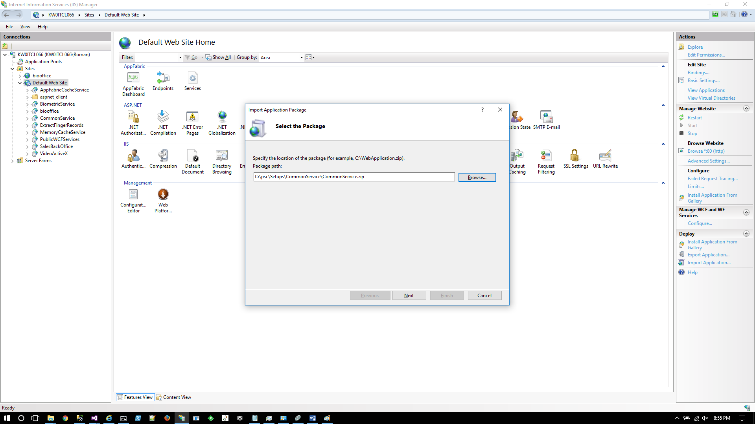

Click Next. Click Next

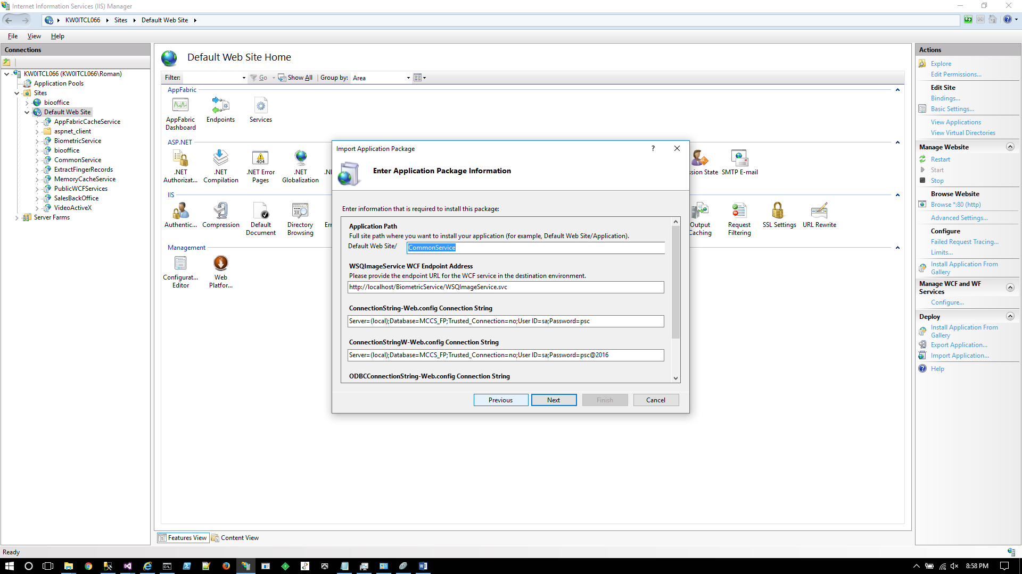

A database connection string can be set here. Click Next

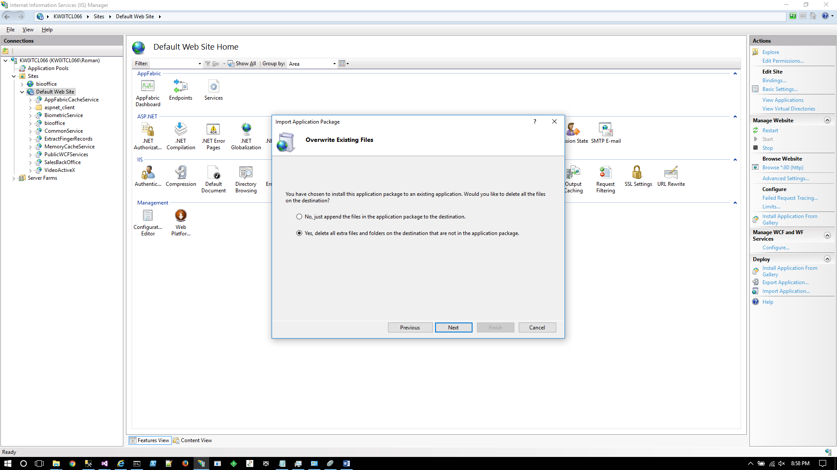

Click Next. Click Finish

Note:

Add net.tcp protocol to the list of enabled protocols for MemoryCacheService WCF application.

WCF applications:

WCF server application endpoints expose services to be consumed by WCF clients:

CommonService provides the following services:

* ConfigurationService - Web.config file contains all configuration settings including a database connection string. All other services have a reference to this service.
* MemoryCacheService provides public utility methods;

BiometricService provides the following services:

* WSQImageService operates on WSQ standard images;

MemoryCacheService provides the following services:

* PopulateCacheService retrieves the data from a database and fill an internal memory cache;
* MatchingService iterates through the internal memory cache looking for an identification of the probe templates.

Windows PassportReader application:

The application scans up to four fingers and save them in a database. The database connection string is located in app.config file.

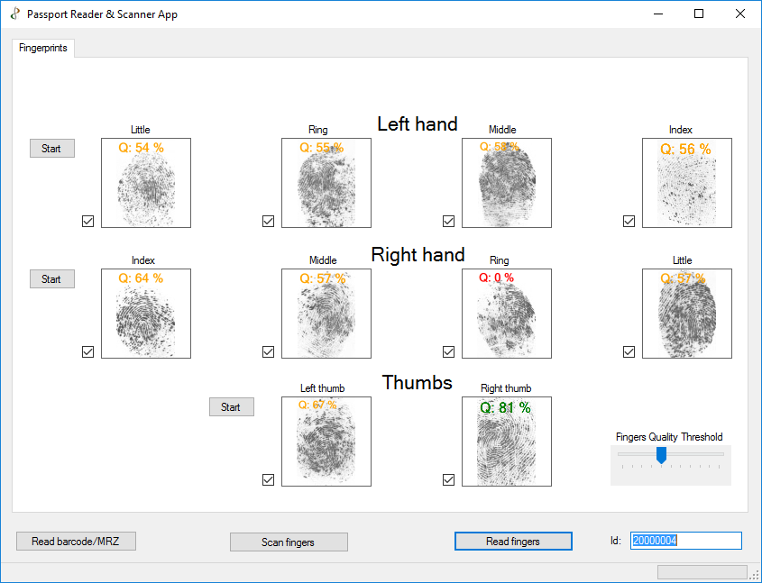

Windows PSCBioIdentification application:

The client application provides the means for fingerprint verification and identification.  
It consumes services provided by WCF server application.  
app.config file contains an application settings section with a key named “endPointHost” which points to a WCF server.

<add key="endPointHost" value="www.emefingerprinttest.psc.com.kw" />

