Cleaning

Maintenance

Repair

Martinique

Pool & Spa Services

Restoration

Keeping your pool or spa sparkling, safe, and clean



Full Service

Weekly or Bi-Weekly

* Brush and vacuum
* Empty filters
* Leaf & debris maintenance
* Water testing
* Basic chemistry

Chemical Service Only

* Chlorine levels
* pH balance
* Algae prevention
* Basic chemistry

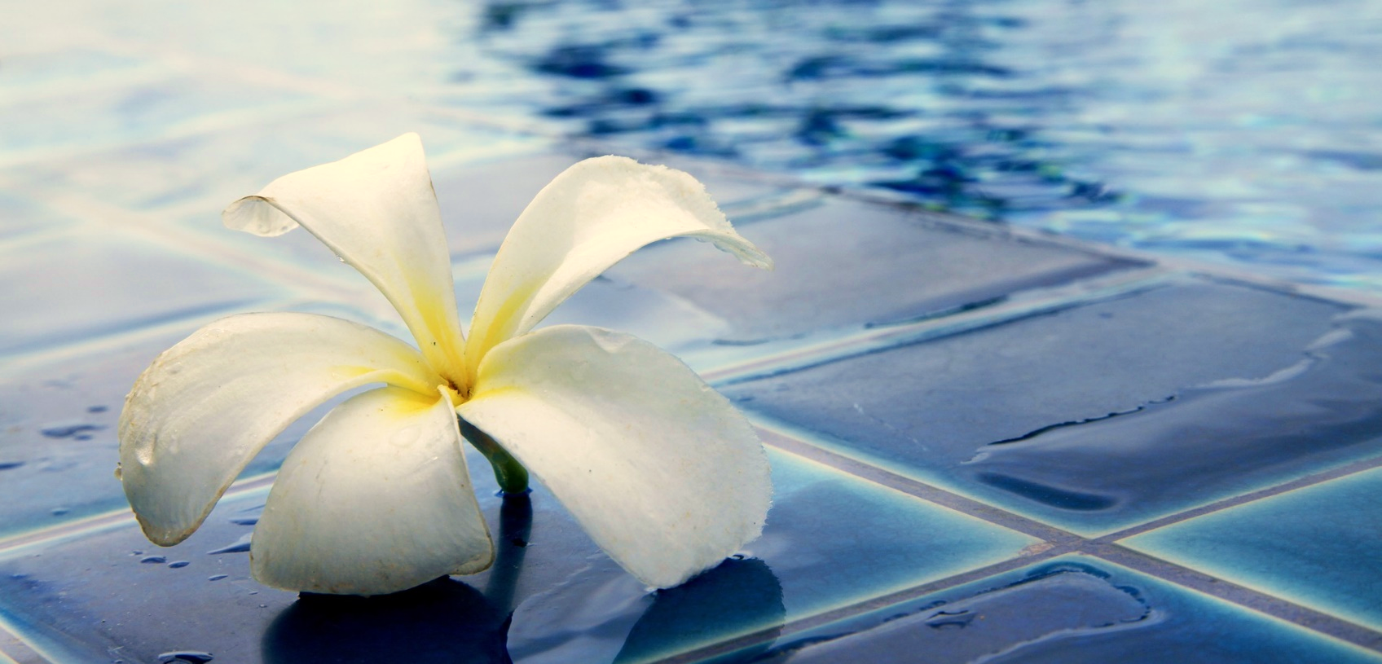



Martinique

Pool & Spa Services

Maintenance

Cleaning

Repair

Restoration

Keeping your pool or spa sparkling, safe, and clean

Salt Water Pool & Spa Maintenance

* Salinity monitoring
* pH balance
* Corrosion prevention
* Clean salt cells
* Alkalinity Levels
* Calcium Levels
* Stabilizer Levels
* Dissolved Solids

Monthly Testing

