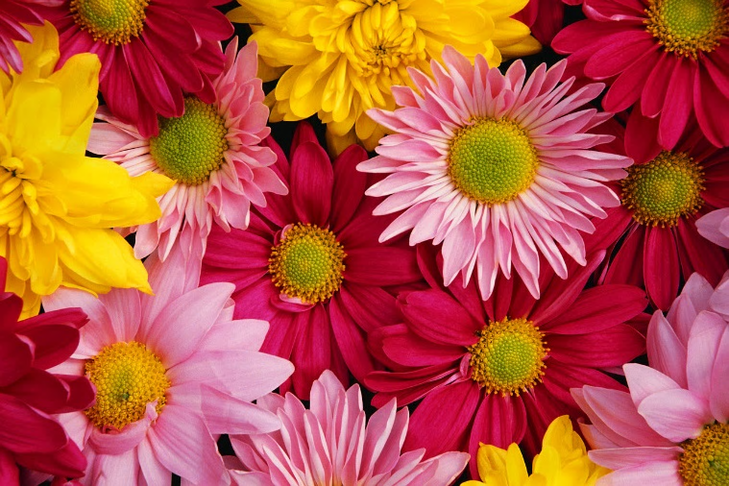

**Blaine Flower &**

**Garden Festival**

Blaine Central

Park

May

17-19

*Celebrating the beauty of Central California*

**Grand Parade**

**May 18, 10:00 am**

**Displays**

Floral design

Landscape design

Hardscape/architecture

Orchids & exotics

**Just for Kids**

Beginners’ planting

Floral arts & crafts

Scavenger hunt

Story time

**Demos/Classes**

Gardening & planting

Floral arrangement

Beginners’ bonsai clinic

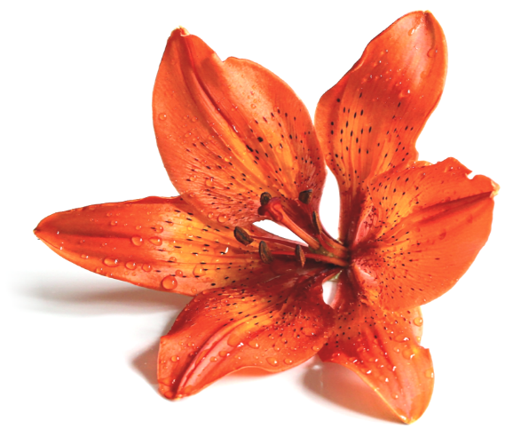

Presented by

Pacific Coast Festival Association | www.pacificcoastfestivals.com

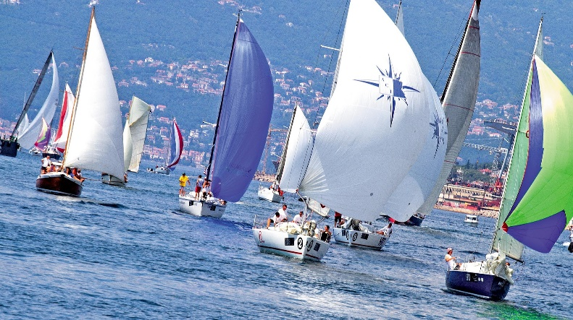

**WINDWARD SAILING FESTIVAL**

SKIPPERS’ BRIEFING 8:30 AM

**SEPTEMBER 5 -7TH**

**SAN FRANCISCO BAY**

Presented by

Pacific Coast Festival Association | www.pacificcoastfestivals.com

**Races**

Marine Junior Match Race

Day Sailer Regatta

Five Mile Fleet Race

Pro Team Race

Offshore Yacht Race

**Just for Kids**

Dinghy Flotilla

Knot Tying Class

Paint Your Own Sailboat

Sandcastle Competition

**Vendors**

Bosun Sailing Gear

Latte-Da Coffee

Salt & Sand Apparel

Max’s Sandwich Shop