Desciption of the DataBase that used in the exercice

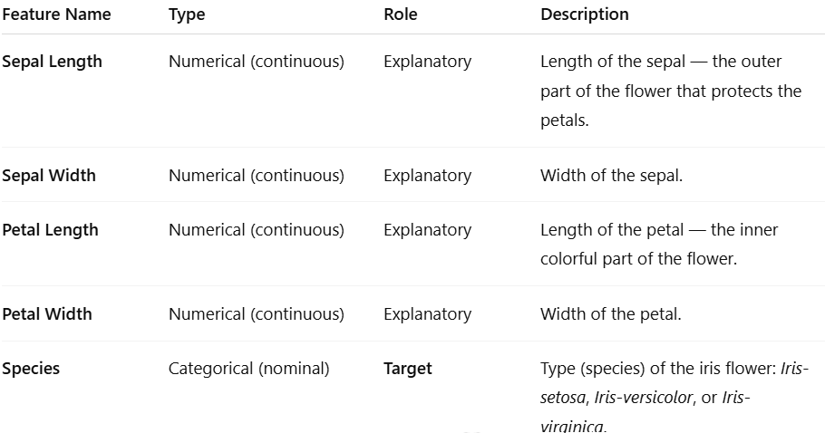

Question 1 : Load and Explore the Iris Dataset
Load the Iris dataset from the sklearn.datasets library into a pandas DataFrame.
##
from sklearn.datasets import load_iris
iris = load_iris(as_frame=True)
##
Display the first few rows of the dataset to understand its structure and check the unique values of the target variable.
Export the dataset to a CSV file named Your_Name_IrisDatabse.csv (use ; as the separator and do not include the index).

Question 2 : Describe the Data
Perform an initial data exploration to better understand the dataset.
- Display basic information (df.info() and df.describe())
- Count the number of samples for each target class
- Verify if there are any missing values

Question 3 : Split the Dataset

Split the dataset into training and testing subsets (80% / 20%) while maintaining class balance using the stratify parameter.
For example, if the class Iris-setosa represents 30% of the samples in the original dataset, this proportion should also be preserved in both the training and test subsets.

Question 4 : Build the Decision Tree
Train a Decision Tree Classifier on the training data using default parameters.
Then, evaluate it on the test data and display the accuracy score

Question 5 : Model Evaluation and Interpretation
Evaluate the model more thoroughly using a confusion matrix to analyze which classes are well or poorly predicted.

Question 6 : Controlling Model Complexity
Experiment with the following Decision Tree hyperparameters:
max_depth
min_samples_split
min_samples_leaf
criterion ('gini' or 'entropy')
Train different trees and observe how changing these parameters affects accuracy and overfitting.

Question 7 : Cross-Validation and Model Selection
Use cross-validation (cross_val_score) to evaluate the stability of your Decision Tree model for different parameter values.
Compare models with different max_depth or ccp_alpha values to choose the most reliable one.

