ID: 14661
NAME: RIDA BILAL
DEPARTMENT: BS(SE)
SEMESTER: 5th

ASSIGNMENT
Activity: 01 & Activity 02
1.
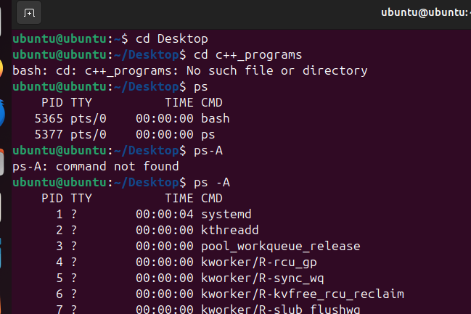

2.
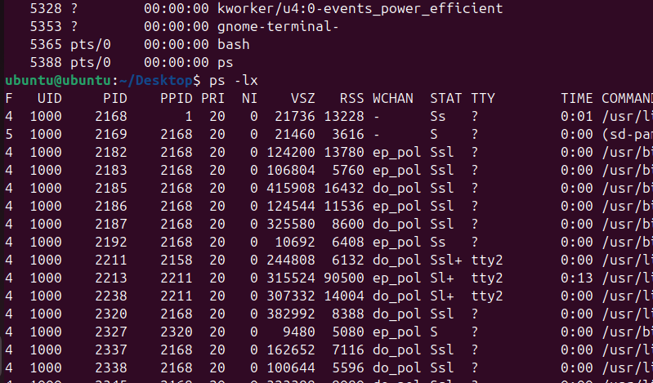

3.
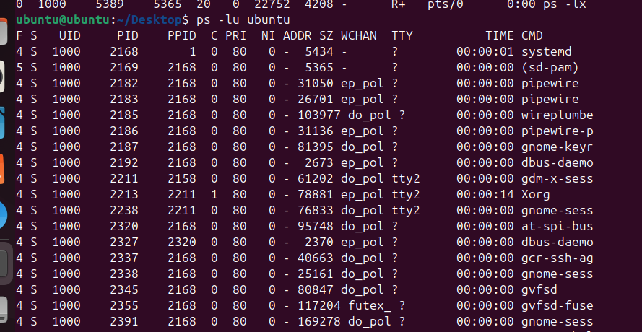
4.
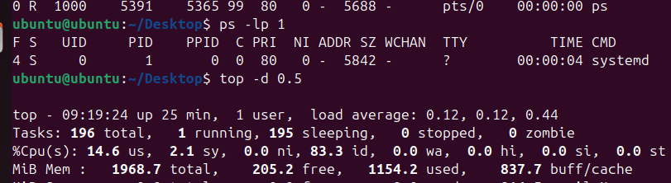
5.
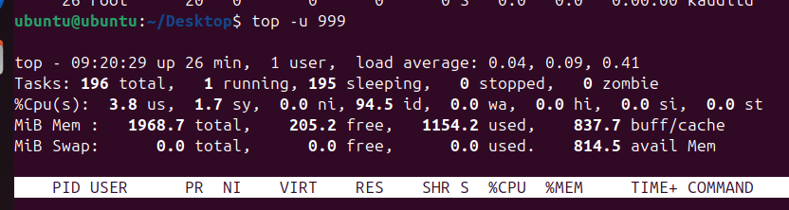

6.

7.
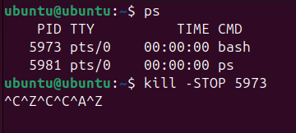
8.

9.
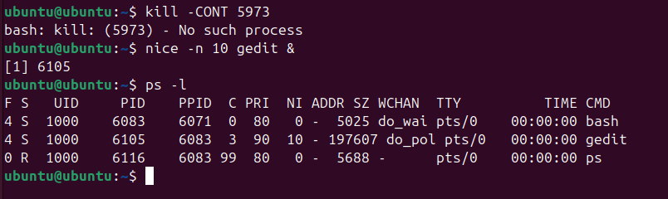
10.
