ASSIGNMENT: 02

ID: 14661
NAME: RIDA BILAL
SECTION: D
DEPARTMENT: BS-SE

Project Title: Front-End Development Scenario Analysis: "Page Turner" Online Bookstore

Prepared for: Mohsin Company Leadership & Development
Prepared by: Rida Bilal, Front-End Developer
Date: 16 November, 2025

Executive Summary:
This assignment outlines a comprehensive plan for developing the front-end of a responsive, accessible, and user-friendly website for "Page Turner," a new online bookstore. The plan covers the entire development lifecycle from initial HTML structure and semantic design to advanced CSS layout techniques, dynamic JavaScript interactivity, and rigorous accessibility and responsiveness testing. The goal is to create a digital storefront that is not only visually appealing and easy to use on any device but also built on a foundation of modern, maintainable, and inclusive web standards.

Project Overview & Core User Stories
1.0 Project Vision
To create a minimum viable product (MVP) for an online bookstore that provides a seamless and enjoyable shopping experience for users across all devices, driving initial user acquisition and retention.
1.1 Defined User Stories
The website's functionality is driven by the following core user stories:
- As a User, I want to browse books by category (e.g., Fiction, Mystery, Science Fiction), so that I can discover new books in genres I enjoy.
- As a User, I want to search for books by title or author name, so that I can quickly find a specific book I have in mind.
- As a User, I want to add books to a virtual shopping cart, so that I can collect my desired purchases before checking out.
- As a User, I want to view a summary of the items in my cart and see the updated total price, so that I can manage my budget and review my selections before proceeding to payment.
These user stories form the basis for all technical decisions outlined in this assignment.

Q1 & Q2: HTML Structure & Semantic Foundation
2.0 The Importance of a Solid HTML Foundation
HTML (HyperText Markup Language) is the skeleton of our website. A well-structured, semantic HTML document is crucial for accessibility, search engine optimization (SEO), and long-term maintainability. It ensures that the content is meaningful even without any styling or scripting.

2.1 High-Level Page Structure
The main page will be structured using the following semantic elements, which create a logical document outline:
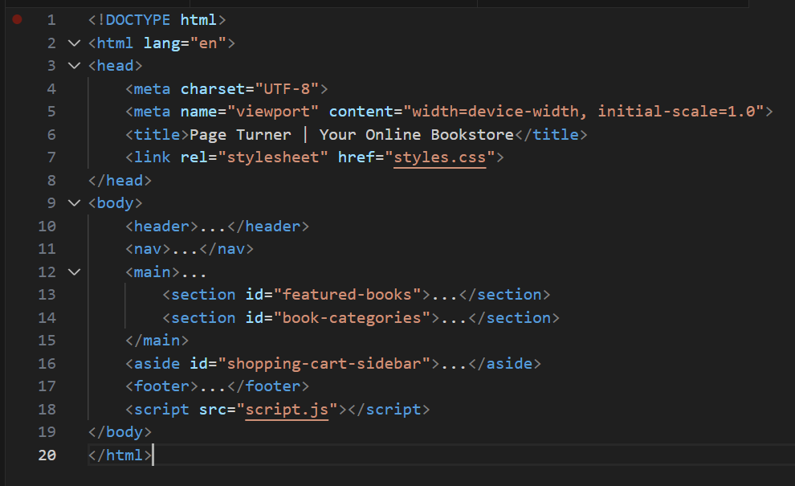

Detailed HTML Breakdown & Semantic Tags
2.2 Detailed Structural Breakdown
- <header>: This element represents introductory content. Ours will contain:
  - A logo (wrapped in an <h1> for the highest level of heading, linking to the homepage).
  - A tagline (e.g., "Discover Your Next Favorite Read").
- <nav>: This section is dedicated to navigation. It will contain:
  - An unordered list (<ul>) of categories (<li><a href="#fiction">Fiction</a></li>).
  - A search form (<form role="search">) with a search input and button.
  - A prominent link/button to the shopping cart, including an icon and an item count badge.
- <main>: The primary content of the page. Within <main>, we will use:
  - <section>: To group thematically related content, such as "Featured Books" and "Browse by Category."
  - <article>: For each individual book listing. The <article> tag is perfect as each book is a self-contained, independently distributable piece of content.
  - <h1> through <h6>: To create a clear and logical heading hierarchy.
- <aside id="shopping-cart-sidebar">: Used for content indirectly related to the main content—the shopping cart summary. It will contain a list of items, subtotal, and a checkout button.
- <footer>: Contains copyright information, links to "About Us," "Contact," "Privacy Policy," and social media icons.

2.3 Why Semantic HTML is important?
- Accessibility: Screen readers use these elements to help visually impaired users navigate the page (e.g., "navigation," "main," "banner").
- SEO: Search engine crawlers prioritize content within semantic tags, understanding its context and relevance.
- Maintainability: It makes the codebase easier for developers to read and understand, simplifying debugging and feature additions.

Q3 & Q4: Visual Design & Styling Philosophy
3.0 Crafting a Visually Appealing Experience
The visual design aims to evoke the warmth and intellectual curiosity of a physical bookstore while maintaining the cleanliness and usability of a modern web application. Our design philosophy is "Content-First, Elegantly Simple."
3.1 Color Palette
We will use a carefully selected color palette to create a trustworthy and inviting atmosphere.
- Primary Color: Deep Navy Blue (#2C3E50). Used for headers, primary buttons, and the navigation bar. It conveys trust and stability.
- Secondary/Accent Color: Warm Terracotta (#E67E22). Used for "Add to Cart" buttons, sale badges, and interactive highlights. It provides a clear call-to-action and energy.
- Neutral Background: Off-White (#FDFEFE). Easy on the eyes for long reading sessions.
- Text Color: Dark Charcoal (#2C3E50). High contrast against the off-white background for optimal readability.
- Surface/ Card Color: Pure White (#FFFFFF). Used for book cards and the cart sidebar to create a layered, clean look.

Typography & Layout Systems
3.2 Typography Hierarchy
Typography is critical for readability and establishing brand voice.
- Headings (H1-H3): "Merriweather" (Serif). This classic, literary serif font evokes a feeling of tradition and authority, perfect for a bookstore.
- Body Text & UI: "Inter" (Sans-Serif). A highly readable, modern, and neutral sans-serif font that ensures clarity for all user interface text and book descriptions.
- Font Sizing: We will use a rem-based scaling system for responsiveness (e.g., html { font-size: 100%; }, h1 { font-size: 2.5rem; }, p { font-size: 1rem; }).
3.3 Layout Systems: Flexbox and Grid.
CSS Flexbox (One-Dimensional Layouts):
  - Navigation Bar: To horizontally align the logo, category links, and search/cart icons.
  - Book Cards: To manage the internal alignment of the book image, title, author, price, and button, ensuring they are consistently spaced.
  - Footer Columns: To create equal-width columns for links and information.
- CSS Grid (Two-Dimensional Layouts):
  - Main Book Listings Gallery: The primary use case. We will define a grid container for the book listings, allowing us to create a fluid, responsive grid that automatically adjusts the number of columns based on available screen width.
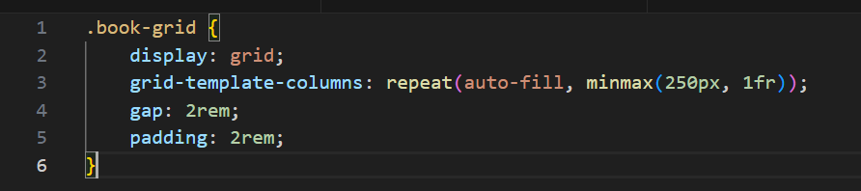

Q5: JavaScript: Architecting Interactivity
4.0 The Role of JavaScript
JavaScript (JS) will transform our static HTML and CSS into a dynamic, single-page application-like experience. It will handle all user interactions without requiring full page reloads.
4.1 Data Structure
We will start by defining our data. A simple array of objects is ideal for this MVP.
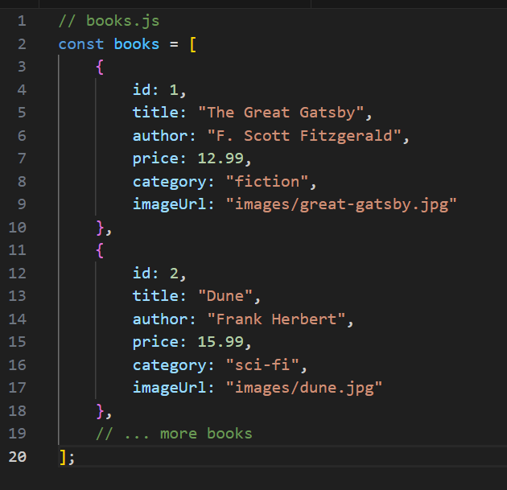

JavaScript: Search Functionality
4.2 Implementing Real-Time Search
The search will be fast and intuitive, filtering results as the user types.
Algorithm:
- Target Elements: Get references to the search input and all book article elements.
- Listen for Input: Attach an event listener to the search input for the 'input' event.
- Normalize Text: Convert the user's search term and the book's text content to lowercase to ensure case-insensitive matching.
- Filter & Display: Loop through each book element. Check if the search term is included in the book's title or author text content.
- If it is, set display: block; (or grid).
- If it isn't, set display: none;.
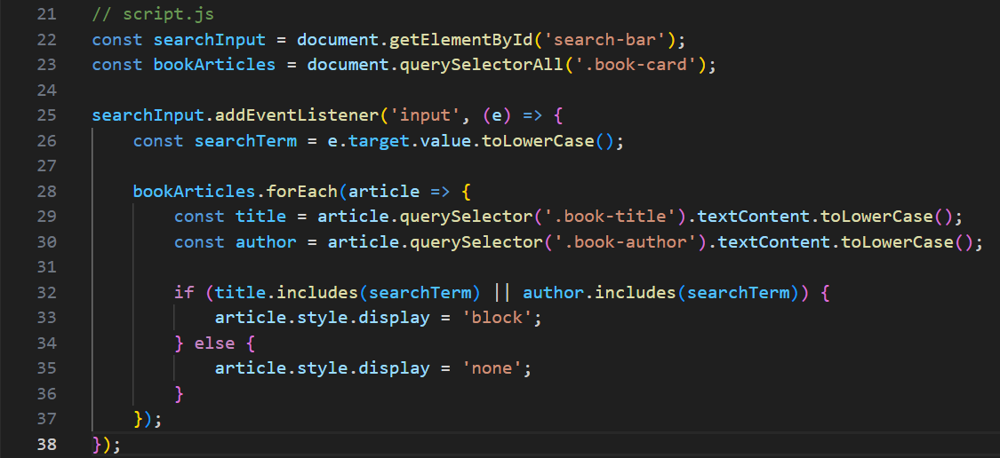

JavaScript: Shopping Cart Logic - Part 1
4.3 The Shopping Cart System
The cart is the core of the e-commerce experience. We will manage it using a stateful array and DOM manipulation.
Core Concepts:
- State (cartArray): A JavaScript array that holds the current state of the user's cart. Each item in the cart will be an object containing the book's id, title, price, and quantity.
- Data Attributes: We will use HTML data-* attributes (e.g., data-id, data-price) on the "Add to Cart" buttons to store information about the book, which can be easily accessed by JavaScript.
Adding an Item to the Cart:
- Attach a click event listener to every "Add to Cart" button.
- When clicked, the handler function:
a. Gets the book's id, title, and price from the button's dataset.
b. Checks if an item with that id already exists in cartArray.
c. If it does, it increases the quantity. If not, it pushes a new item object into the array.
d. Calls the updateCartUI() function to reflect the change in the user interface.
e. Updates the cart item count badge in the navigation.

JavaScript: Shopping Cart Logic - Part 2
Updating the Cart UI and Calculating Total:
The updateCartUI() function is responsible for synchronizing the cartArray state with what the user sees on the screen.
Algorithm for updateCartUI():
- Target the Container: Get a reference to the <ul> inside the cart sidebar.
- Clear Previous Content: Set container.innerHTML = ''; to start fresh.
- Loop & Build: Iterate over cartArray. For each item:
  - Create a new <li> element.
  - Populate it with the item's title, quantity, price, and a "Remove" button.
  - The "Remove" button will have its own event listener that calls a removeFromCart(item.id) function, which splices the item from the array and calls updateCartUI() again.
  - Append the <li> to the container.
- Calculate Total: Call calculateTotalPrice().
- Display Total: Insert the calculated total into a designated element in the DOM.

PART-1
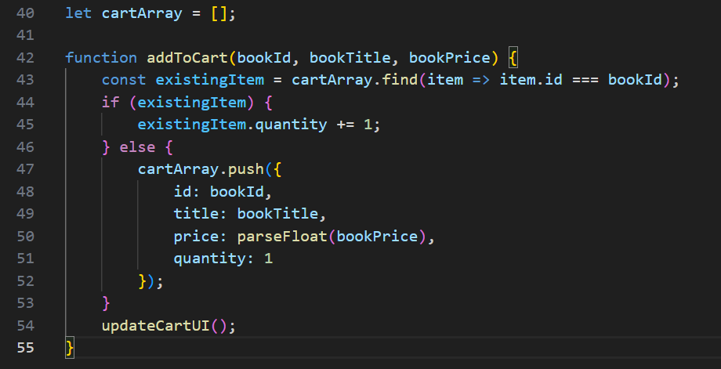
PART: 2
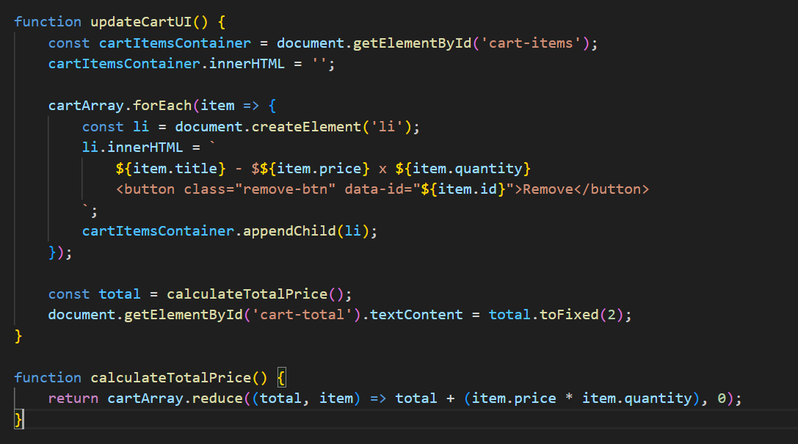

Q6: The Central Role of DOM Manipulation
5.0 DOM Manipulation: The Bridge Between Data and Display
The Document Object Model (DOM) is a programming interface for HTML and XML documents. It represents the page as a tree of objects, which JavaScript can manipulate to change the document's structure, style, and content.
5.1 Importance in this Scenario:
In the "Page Turner" bookstore, DOM manipulation is the engine of interactivity. It allows us to create a dynamic, app-like experience:
- Dynamic Content Rendering: We can use JavaScript to generate the entire grid of book cards from our books array, making the site easier to update and manage.
- Real-Time Search Feedback: By manipulating the display property of book cards, we provide instant visual feedback to the user's search query.
- Stateful UI Updates: The shopping cart is the prime example. The cartArray is our single source of truth (the state). The updateCartUI() function's sole job is to look at that state and manipulate the DOM to reflect it perfectly—showing the correct items, quantities, and total price.
Without DOM manipulation, our website would be a static brochure. With it, it becomes an interactive storefront.

Q7: Responsive Design Strategy
6.0 What is Responsive Design?
Responsive Web Design (RWD) is an approach to web design that makes web pages render well on a variety of devices and window or screen sizes. The core tenets are Fluid Grids, Flexible Images, and CSS Media Queries.
6.1 Our Approach: Mobile-First
We will adopt a "Mobile-First" design philosophy. This means we will first write CSS styles for mobile devices (small screens). Then, we will use media queries to add or override styles for progressively larger screens (tablets, desktops).
Why Mobile-First?
- It forces a focus on core content and functionality.
- It typically results in better performance, as mobile devices (often on slower networks) aren't loading complex desktop-specific CSS.
- It's easier to scale a design up than to simplify a complex desktop design down.

Q8 : Implementing Responsiveness
6.2 Key Techniques and Breakpoints
We will use a combination of techniques to achieve responsiveness:
- Fluid Layouts: Using % and vw/vh units for widths and heights instead of fixed px.
- Flexible Images: Setting max-width: 100%; and height: auto; on images to ensure they scale within their containers.
- CSS Grid and Flexbox: These layout models are inherently fluid and responsive, making them our primary tools.
- Media Queries: Our primary tool for applying conditional styles. We will use min-width queries.
Proposed Breakpoints:
- Default Styles: Mobile ( portrait, < 768px). Single-column layout.
- @media (min-width: 768px): Tablet. The book grid becomes 2 columns. The cart sidebar might be more prominent.
- @media (min-width: 1024px): Desktop/Laptop. The book grid becomes 3 or 4 columns. The navigation is fully expanded.
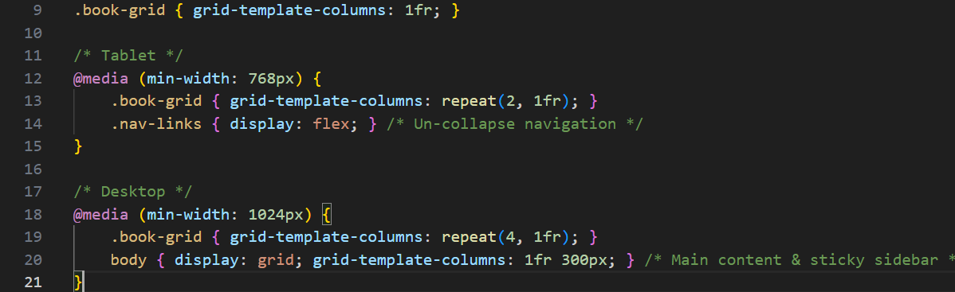
6.3 Framework Consideration: Tailwind CSS
For a project like this, using a utility-first CSS framework like Tailwind CSS would significantly speed up development. Tailwind provides a vast set of low-level utility classes for building custom designs directly in your HTML, with built-in responsiveness (e.g., md:grid-cols-2, lg:grid-cols-4). It enforces consistency and makes the CSS bundle highly purgable for production.

Q9: Accessibility: A Core Principle
7.0 Why Accessibility Matters
Web accessibility means that websites, tools, and technologies are designed and developed so that people with disabilities can use them. It's not just a moral imperative; in many places, it's a legal requirement. An accessible website also has better SEO and reaches a wider audience.
7.1 Best Practice 1: Semantic HTML & ARIA Landmarks
As discussed, using the correct HTML elements (<header>, <nav>, <main>, <button>) is the first and most important step. When native semantics aren't enough, we use ARIA (Accessible Rich Internet Applications) attributes to enhance meaning.
- Example: Our search form: <form role="search"> explicitly tells assistive technology that this is a search form.
- Example: Our cart sidebar update area: <div id="cart-total" aria-live="polite" aria-atomic="true">. The aria-live attribute tells screen readers to announce updates to this region, which is crucial for dynamically updated content like the cart total.

Accessibility: Keyboard & Screen Reader Support
7.2 Best Practice 2: Robust Keyboard Navigation
All interactive functionality must be operable through a keyboard alone.
- Focus Management: Ensure all buttons, links, and form controls are focusable (using the Tab key) and have a clear, visible focus indicator (styled with :focus pseudo-class).
- Logical Tab Order: The tab order should follow the visual flow of the page.
- Skip Links: Provide a "Skip to Main Content" link at the very top of the page, allowing keyboard users to bypass the navigation.
- Interactive Elements: The "Add to Cart" and "Remove" buttons must be fully operable with the Enter or Space key.
7.3 Best Practice 3: Descriptive Text Alternatives
- Alt Text for Images: Every meaningful image, especially book covers, must have descriptive alt text.
  - Good: <img src="gatsby.jpg" alt="Cover of The Great Gatsby by F. Scott Fitzgerald">
  - Bad: <img src="gatsby.jpg" alt="book cover"> or worse, no alt attribute.
- Form Labels: Every form input (like the search bar) must have a associated <label> element. If a visual label isn't desired, it can be hidden visually but remain available to screen readers using CSS (e.g., .sr-only class).

Performance & Future Considerations
8.0 Performance Optimizations
A fast website is a usable website. Key optimizations for the MVP and beyond:
- Image Optimization: Use modern formats (WebP) and serve appropriately sized images for different viewports.
- Code Minification: Minify CSS and JavaScript files for production.
- Efficient JavaScript: Avoid long-running loops and use event delegation where possible (e.g., a single event listener on the book grid container for all "Add to Cart" clicks, instead of one per button).
8.1 Potential for a Front-End Framework
While this MVP is built with vanilla JS, as the application grows in complexity (e.g., user accounts, wish lists, complex filtering), migrating to a framework like React, Vue, or Svelte would be highly beneficial. These frameworks provide a structured, component-based architecture that makes managing complex state and UI updates more predictable and maintainable.

Conclusion
The successful front-end development of the "Page Turner" online bookstore hinges on a thoughtful integration of structure (HTML), presentation (CSS), and behavior (JavaScript). By adhering to the principles outlined in this document—semantic HTML, a mobile-first responsive design, dynamic JavaScript interactivity, and rigorous accessibility standards—we are positioned to build a high-quality, inclusive, and scalable web application.
This project will not only serve as a functional MVP for the startup but also establish a robust and maintainable codebase ready for future expansion and feature development. The user's experience, from discovery to purchase, will be seamless, engaging, and accessible to all.

