Rida Bilal

14661

QUIZ

Task 1: Feature Documentation

Selected New Feature
Time-Locked Attendance Marking with Automatic Timestamped CSV Export
This feature ensures that:
- Attendance cannot be marked for the first 2 minutes after the first marking attempt.
- Every CSV export creates a new file with a unique timestamped name.

Functional Requirements
- The system shall start a 2-minute timer when the user attempts to mark attendance for the first time.
- The system shall block attendance marking before 2 minutes have passed.
- The system shall allow attendance marking only after 2 minutes.
- The system shall display a lock message while attendance is blocked.
- The system shall generate a new CSV file on every export.
- The CSV filename shall follow this format:
Att-YYYY-MM-DD-HH-MM-SS.csv
- The system shall store:
  - Student name
  - Attendance status (Present/Absent)

Non-Functional Requirements
- Reliability: Attendance data must not be lost during export.
- Performance: CSV export must complete within 1 second for small datasets.
- Portability: The program must work on standard C++ compilers.
- Maintainability: The code must remain simple and readable.

Task 2: Compatibility Assurance

Impacted Functions, Classes & Data Formats

Impacted Class:
- AttendanceSystem

Impacted Functions:
- canMarkAttendance() → Controls 2-minute lock
- markPresent() → Restricted by time
- exportToCSV() → Changed to timestamped filenames
- main() → Updated menu logic for time checking

Impacted Data Formats:
Type | Before | After
CSV File Name | attendance.csv | Att-YYYY-MM-DD-HH-MM-SS.csv
CSV Content | Name, Status | Same (Unchanged)

Backward Compatibility Test Cases

Test Case 1: Old CSV Content Compatibility
Objective: Ensure old CSV parsers still work.
Steps:
- Export a CSV using the new system.
- Open it in Excel or Notepad.
- Verify format.
Expected Result:
Old software can still read the file correctly.

Test Case 2: Attendance Marking After Lock
Objective: Ensure original marking logic still works.
Steps:
- Wait 2 minutes.
- Mark attendance.
Expected Result:
Attendance marking works normally.

Task 3: Regression Testing

Regression Test Case 1: Adding Student
Step | Action
1 | Add student "Ali"
2 | Display students
Before Feature: Pass
After Feature: Pass
Result: No break in functionality

Regression Test Case 2: CSV Export
Step | Action
1 | Export CSV
2 | Check filename
Before Feature: One fixed file overwritten
After Feature: New timestamped file created
Result: Feature working successfully

Regression Test Case 3: Attendance Lock
Step | Action
1 | Try to mark attendance immediately
2 | Wait 2 minutes
3 | Try again
Before Feature: Immediate marking was allowed
After Feature: Locked for 2 minutes
Result: Feature working correctly

Task 4: Migration Plan

Version Upgrade
Old Version: v1.1
New Version: v1.2

Migration Note (One Page)

Purpose of Migration
The migration introduces:
- A 2-minute security lock on attendance marking.
- A timestamp-based automatic CSV export system.
These improvements:
- Prevent early or unauthorized attendance marking.
- Prevent file overwriting during CSV export.

Changes Implemented
Area | Change
Attendance Marking | Locked for first 2 minutes
CSV Export | Timestamped filenames
Security | Time-based access control
File Handling | No file deletion

Data Impact
- No database changes required
- Old CSV formats still supported
- No data loss occurs

Rollback Plan
If errors occur:
- Restore version v1.1
- Remove time lock
- Revert CSV naming

Post-Migration Verification
- Attendance locks correctly
- CSV files auto-generate with correct format
- No crash or data loss

SCREENSHOTS
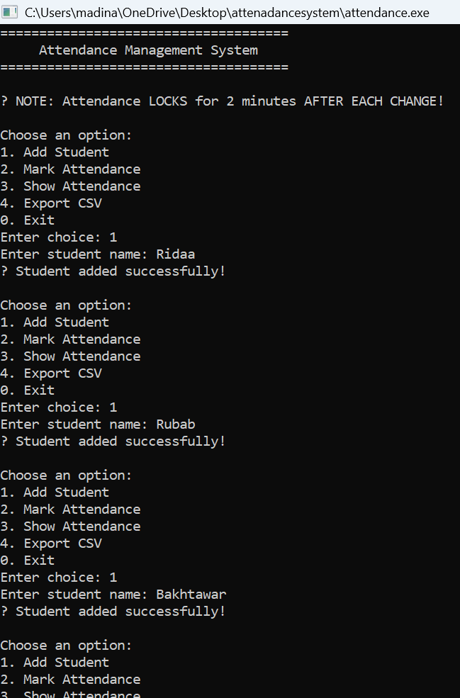
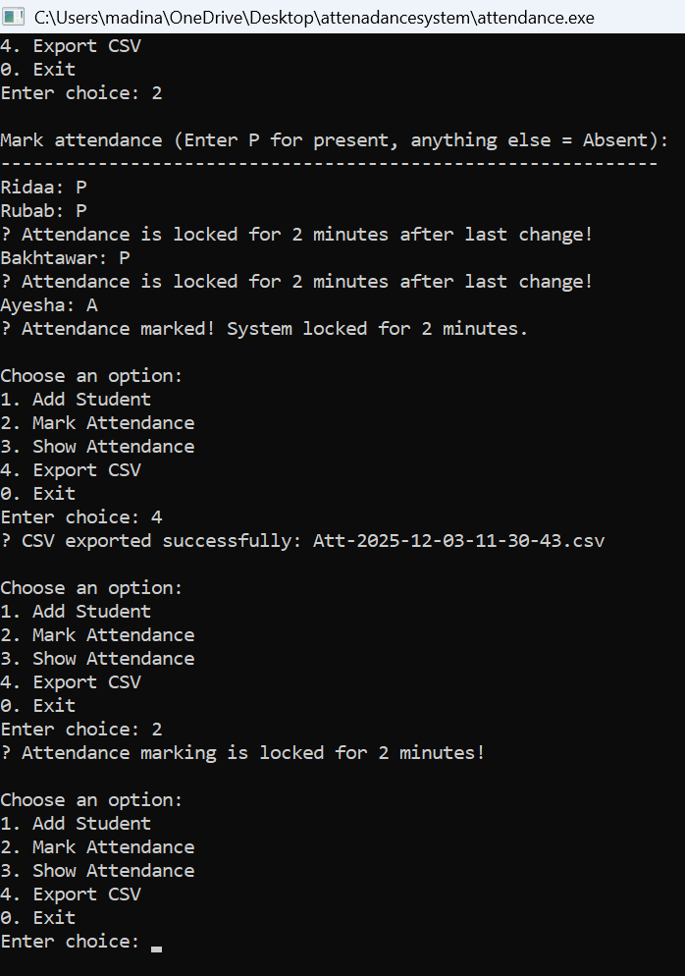

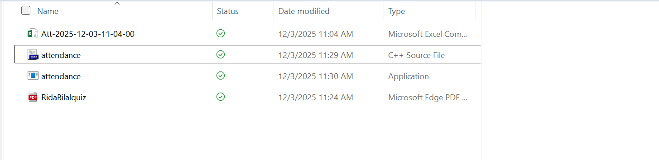
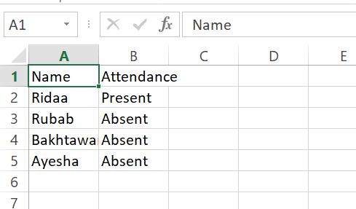

CODE:
#include <iostream>
#include <vector>
#include <string>
#include <fstream>
#include <ctime>

using namespace std;

/* ============================================================
SIMPLE & CLEAN ATTENDANCE SYSTEM (FINAL FIXED VERSION)
============================================================ */

class AttendanceSystem {
private:
vector<string> students;
vector<bool> attendanceRecord;

time_t lastEditTime; // Time of last change
bool isLocked; // Lock state

public:

// ? Constructor
AttendanceSystem() {
isLocked = false;
lastEditTime = 0;
}

// ? Add a new student
void addStudent(const string &name) {
students.push_back(name);
attendanceRecord.push_back(false);
cout << "? Student added successfully!\n";
}

// ? Check if editing is allowed (2 min rule)
bool canMarkAttendance() {
if (!isLocked)
return true;

double secondsPassed = difftime(time(0), lastEditTime);

if (secondsPassed >= 120) { // ? 2 minutes = 120 seconds
isLocked = false;
return true;
}
return false;
}

// ? Mark student present (STARTS TIMER)
void markPresent(int index) {
if (!canMarkAttendance()) {
cout << "? Attendance is locked for 2 minutes after last change!\n";
return;
}

if (index >= 0 && index < attendanceRecord.size()) {
attendanceRecord[index] = true;
lastEditTime = time(0); // ? TIMER STARTS HERE
isLocked = true;
}
}

// ? Show attendance
void showAttendance() {
cout << "\n===== Attendance Record =====\n";
if (students.empty()) {
cout << "No students found.\n";
return;
}

for (int i = 0; i < students.size(); i++) {
cout << i + 1 << ". " << students[i]
<< " --> " << (attendanceRecord[i] ? "Present" : "Absent") << "\n";
}
cout << "==============================\n";
}

vector<string> getStudents() { return students; }
vector<bool> getAttendance() { return attendanceRecord; }

/* ============================================================
? EXPORT TO CSV WITH DATE-TIME NAME
Format: Att-YYYY-MM-DD-HH-MM-SS.csv
============================================================ */
bool exportToCSV() {
time_t now = time(0);
tm *ltm = localtime(&now);

char filename[50];
strftime(filename, sizeof(filename),
"Att-%Y-%m-%d-%H-%M-%S.csv", ltm);

ofstream file(filename);

if (!file.is_open()) {
cout << "? Error: Could not create CSV file.\n";
return false;
}

file << "Name,Attendance\n";
for (int i = 0; i < students.size(); i++) {
file << students[i] << ","
<< (attendanceRecord[i] ? "Present" : "Absent") << "\n";
}

file.close();
cout << "? CSV exported successfully: " << filename << endl;
return true;
}
};

/* ============================================================
? UPDATED REGRESSION TESTS
============================================================ */

bool test_addStudent() {
AttendanceSystem sys;
sys.addStudent("Ali");
return sys.getStudents().size() == 1;
}

bool test_attendanceLockAfterMark() {
AttendanceSystem sys;
sys.addStudent("Ali");
sys.markPresent(0);

return sys.canMarkAttendance() == false; // ? Should be locked
}

bool test_exportToCSV() {
AttendanceSystem sys;
sys.addStudent("Ali");
sys.markPresent(0);
return sys.exportToCSV();
}

/* ============================================================
? MAIN MENU
============================================================ */

int main() {
AttendanceSystem system;
int choice;

cout << "=====================================\n";
cout << " Attendance Management System \n";
cout << "=====================================\n";
cout << "\n? NOTE: Attendance LOCKS for 2 minutes AFTER EACH CHANGE!\n";

do {
cout << "\nChoose an option:\n";
cout << "1. Add Student\n";
cout << "2. Mark Attendance\n";
cout << "3. Show Attendance\n";
cout << "4. Export CSV\n";
cout << "0. Exit\n";
cout << "Enter choice: ";
cin >> choice;

if (choice == 1) {
string name;
cout << "Enter student name: ";
cin >> name;
system.addStudent(name);
}

else if (choice == 2) {
if (!system.canMarkAttendance()) {
cout << "? Attendance marking is locked for 2 minutes!\n";
continue;
}

vector<string> stds = system.getStudents();

if (stds.empty()) {
cout << "No students available to mark.\n";
continue;
}

cout << "\nMark attendance (Enter P for present, anything else = Absent):\n";
cout << "-------------------------------------------------------------\n";

for (int i = 0; i < stds.size(); i++) {
cout << stds[i] << ": ";
string att;
cin >> att;

if (att == "P" || att == "p")
system.markPresent(i);
}

cout << "? Attendance marked! System locked for 2 minutes.\n";
}

else if (choice == 3) {
system.showAttendance();
}

else if (choice == 4) {
system.exportToCSV();
}

} while (choice != 0);

cout << "Program ended.\n";
return 0;
}

