CORRELATION BETWEEN CERVICAL PROPRIOCEPTION AND DIGITAL EYE STRAIN AMONG UNDERGRADUATE STUDENTS OF CITY UNIVERSITY OF SCIENCE AND INFORMATION TECHNOLOGY PESHAWAR



By
AIMAL SHAKIR (Reg. No. CUP-21FL-0266 13035)
AYESHA (Reg. No. CUP-21FL-0266 12555)
EMAN SHABIR (Reg. No. CUP-21FL-0266 12889)
MAGHAZ UR RAHIM (Reg. No. CUP-21FL-0266 13451)
SUPERVISED BY
DR. HAFIZ YASEEN KHAN (PT)

DOCTOR OF PHYSICAL THERAPY

DEPARTMENT OF ALLIED HEALTH SCIENCE
CITY UNIVERSITY OF SCIENCE & INFORMATION TECHNOLOGY
PESHAWAR-PAKISTAN
SESSION 2021-2026

CORRELATION BETWEEN CERVICAL PROPRIOCEPTION AND DIGITAL EYE STRAIN AMONG STUDENTS OF CITY UNIVERSITY OF SCIENCE AND INFORMATION TECHNOLOGY PESHAWAR


BY
AIMAL SHAKIR (Reg. No. CUP-21FL-0266 13035)
AYESHA (Reg. No. CUP-21FL-0266 12555)
EMAN SHABIR (Reg. No. CUP-21FL-0266 12889)
MAGHAZ UR RAHIM (Reg. No. CUP-21FL-0266 13451)

SUPERVISED BY
Dr. HAFIZ YASEEN KHAN (PT)

A thesis submitted in partial fulfilment of the requirements for degree of

DOCTOR OF PHYSICALTHERAPY

DEPARTMENT OF ALLIED HEALTH SCIENCES
CITY UNIVERSITY OF SCIENCE & INFORMATION TECHNOLOGY
PESHAWAR-PAKISTAN
SESSION 2021-2026

APPROVAL SHEET

SUBMISSION OF RESEARCH DEGREE THESIS
The following statement is to be signed by the candidates ‘supervisor (s), Dean/ HOD and must be received by the COE, prior to the dispatch of the thesis to the approved examiners.
Candidate’s Name & Reg. #:
- AIMAL SHAKIR (Reg. No. CUP-21FL-0266 13035)
- AYESHA (Reg. No. CUP-21FL-0266 12555)
- EMAN SHABIR (Reg. No. CUP-21FL-0266 12889)
- MAGHAZ UR RAHIM (Reg. No. CUP-21FL-0266 13451)
Programme Title: Doctor of Physical Therapy
Faculty/Department: Department of Health Sciences
Thesis Title: Correlation Between Cervical Proprioception and Digital Eye Strain Among Students of City University of Science and Information Technology, Peshawar

I hereby certify that the above candidate’s work, including the thesis, has been completed to my satisfaction and that the thesis is in a format and of an editorial standard recognized by the faculty/department as appropriate for examination. The Thesis has been checked through Turnitin for plagiarism (test report attached).
Signature (s):
Supervisor: Dr.Hafiz Yaseen Khan
Signature: ____________
The undersigned certify that:
- The candidate presented at a pre-completion seminar, an overview and synthesis of major findings of the thesis, and that the research is of a standard and extent appropriate for submission as a thesis.
- I have checked the candidate’s thesis and its scope, format, and editorial standards are recognized by the faculty/department as appropriate.
- The plagiarism check has been performed. Report is attached
Signature (s):
HoD: Dr.Raisa Bano
Signature: ______________

DECLARATION OF AUTHENTICATION

I certify that the research work presented in this thesis is to the best of my knowledge my own. All sources used and any help received in the preparation of this dissertation have been acknowledged. I hereby declare that I have not submitted this material, either in whole or in part, for any other degree at this or any other institution.
AIMAL SHAKIR Signature of Student _________
(Reg. No. CUP-21FL-0266 13035)
AYESHA Signature of student__________
(Reg. No. CUP-21FL-0266 12555)
EMAN SHABIR Signature of student__________
(Reg. No. CUP-21FL-0266 12889)
MAGHAZ UR RAHIM Signature Of student_________
(Reg. No. CUP-21FL-0266 13451)

ACCEPTANCE CERTIFICATE

Correlation Between Cervical proprioception and Digital Eye Strain Among Students Of City University Of Science And Information Technology Peshawar
By

AIMAL SHAKIR (Reg. No. CUP-21FL-0266 13035)
AYESHA (Reg. No. CUP-21FL-0266 12555)
EMAN SHABIR (Reg. No. CUP-21FL-0266 12889)
MAGHAZ UR RAHIM (Reg. No. CUP-21FL-0266 13451)

A thesis submitted in partial fulfilment of the requirements for the degree of

Doctor Of Physical Therapy

We accept this thesis as conforming to the required standard

Supervisor: Dr.Hafiz Yaseen Khan (Sig)_____________________

External Examiner: Dr Hassan (Sig)_____________________

FYP Coordinator Dr Baz Meer (Sig)_____________________

HOD Health Sciences Dr Raisa Bano (Sig)_____________________

ACKNOWLEDGMENTS
All praises belong to Almighty Allah for His divine blessings, and our highest compliments go to Hazrat Muhammad (PBUH), the ultimate source of guidance. We express our profound gratitude to our supervisor, Dr. Hafiz Yaseen Khan (PT), for his unwavering mentorship and the invaluable insights that shaped this thesis.
We also thank Dr. Raisa Bano (HoD DPT) and Dr. Baz Meer Afridi, Research Coordinator, for their professional support and coordination.
Our sincere appreciation goes to our peers for their constant encouragement, and above all, we are eternally grateful to our parents, whose unending prayers and spiritual support remain the foundation of our success.

AIMAL SHAKIR
AYESHA
EMAN SHABEER
MAGHAZ UR RAHIM

DEDICATION

This work is affectionately dedicated to our beloved parents,
whose endless prayers, sacrifices, and spiritual support
laid the foundation for our achievements;
And to our esteemed teachers,
whose guidance and wisdom continue to light our academic journey.

Table of Contents
CHAPTER 1 1
INTRODUCTION 1
1.1 Background 1
1.2 Research Gap 5
1.3 Problem Statement 6
1.4 Objectives of the study 6
1.5 Research questions 7
1.6 Scope of the study 7
1.7 Impact on Achieving Sustainable Developmental Goals (SDGs) 8
1.8 Significance of the study 8
1.8.1 For Students 8
1.8.2 For Clinicians and Physiotherapists 8
1.8.3 For Preventive Health and Universities 9
1.9 Definition of Study Variable 9
CHAPTER 2 10
LITERATURE REVIEW 10
CHAPTER 3 16
RESEARCH METHODOLOGY 16
3.1 Ethical Considerations: 16
3.2 Research Design: 16
3.2.1 Study Design: 16
3.2.2 Study Setting: 16
3.2.3 Time Horizon: 17
3.2.4 Research Intervention: 17
3.3 Population and Sampling: 17
3.3.1 Population: 17
3.3.2 Sampling Technique: 17
3.3.3 Sample Size: 17
3.4 Data Collection: 18
3.5 Instruments/Scales: 19
3.5.1 Computer Vision Syndrome Questionnaire (CVS-Q) 19
3.5.2 Joint Position Error Test (JPE): 19
3.7 Validity and Reliability of the Instruments: 20
3.8 Statistical Analysis: 21
3.8.1 Missing Data: 21
3.8.2 Control Variables: 21
3.9 Data Analysis: 21
CHAPTER 4 23
RESULTS 23
4.1 Introduction 23
4.2 Descriptive Statistics 23
4.3 Demographic Characteristics 23
4.3.1 Gender Distribution 23
4.3.2 Department Distribution 24
4.4 Normality Testing 25
4.5 Correlation Analysis 30
4.5.1 Direction Wise Correlation Analysis 31
4.7 Multiple Linear Regression Analysis 35
4.8 Summary of Findings 37
DISCUSSION 38
CHAPTER 6 44
CONCLUSION 44
6.1 Limitations of the Study 44
6.2 Recommendations 44
REFERENCES 46

LIST OF TABLES
1. Table 3.1: Scale No. Of Items/Movements 20
2. Table 4.1: Descriptive Statistics of Continuous Variables 23
3. Table 4.2: Gender Distribution 24
4. Table 4.3: Department Distribution 24
5. Table 4.4: Tests of Normality 25
6. Table 4.5: Spearmen Correlation 30
7. Table 4.6: Direction Wise Correlation 31
8. Table 4.7: Gender-wise Comparison of Digital Eye Strain (Mann–Whitney U Test) 32
9. Table 4.8: Mann–Whitney U Test Statistics for DES by Gender 32
10. Table 4.9: Multicollinearity Diagnostics 33
11. Table 4.10: Model Summary of Multiple Linear Regression Analysis 36
12. Table 4.11: ANOVA for Multiple Linear Regression Analysis 36
13. Table 4.12: Multiple Linear Regression Coefficients Predicting Digital Eye Strain 37

LIST OF FIGURES
Fig 3.1 Sample Size Calculation by Raosoft 1 18
Figure 4.1 Department Distribution 1 25
Figure 4.2: Histogram of Digital Eye Strain 1 26
Fig 4.5 Digital Eye Strain 1 30
Figure 4.6: Scatter Plot of JPE_Total 1 31
Figure 4.7: Histogram of Standardized Residual 1 33
Figure 4.8: Normal P–P Plot of Standard 1 34

ABBREVIATIONS

COR | Cervico Ocular Reflex
CVS | Computer Vision Syndrome
CVS-Q | Computer Vision Syndrome Questionnaire
DES | Digital Eye Strain
JPE | Joint Position Error
JPET | Joint Position Error Test
VOR | Vestibulo- Ocular Reflex

ABSTRACT

The widespread use of digital devices in an academic environment led to a rise in digital Eye strain (DES) and musculoskeletal issues among students. This study explored the relationship between cervical proprioception the neuromuscular systems' ability to detect head-position and severity of DES among undergraduate students. The primary aim of this study was to determine the statistical relationship between Joint Position Error Test (JPET) measurements and Digital Eye Strain (DES) severity scores among undergraduate students at CUSIT.A Cross-sectional correlation study was conducted at City University of Science and Information Technology (CUSIT), Peshawar, involving 351 undergraduate students aged 18-25 years. DES as assessed using the standardized Computer Vision Syndrome Questionnaire (CVS-Q). Cervical proprioception was evaluated through the Joint Position Error Test (JPET) using a laser-pointer method to measure head repositioning accuracy. The mean DES score was 6.72 ± 4.43, indicating moderate symptoms, with female students showing significantly higher score ( p=0.001). The mean Joint Position Error Test (JPET) was 10.76± 5.36cm, suggesting that prolonged device use may impair proprioceptive function. Statistical analysis revealed a weak but significant negative correlation (r= -0.169, p= 0.001) between cervical proprioception and DES severity. Regression analysis indicated that gender was a significant predictor of DES, while age had no major effect. The findings suggest that while DES is multifactorial, cervical sensorimotor function has a significant connection to visual discomfort during prolonged screen use. Integrating postural correction and cervical sensorimotor training with standard ocular care may help manage symptoms in high-risk students’ population. The result emphasize that increasing screen exposure without adequate ergonomic awareness may contribute to both visual and cervical sensorimotor complaints in university students. These findings support the integration of educational programs focusing on healthy digital device use, appropriate posture, workstation ergonomics, scheduled rest breaks following 20-20-20 rule, and simple neck mobility and proprioceptive exercises. Such preventive interventions may reduce symptom severity, improve functional performance, and enhace students productivity and quality of life. Further studies with larger and more diverse population are recommended to confirm these findings, explore casual relationships, and evaluate the effectiveness of targated physiotherapy based interventions in preventing DES.
Keywords: Cervical proprioception, Computer Vision Syndrome, CUSIT, Digital Eye Strain, Joint Position Error, Undergraduate students.

CHAPTER 1

INTRODUCTION

1.1 Background
Cervical proprioception is the capacity of the neuromuscular system to detect the position and motion of the head and neck with the help of mechanoreceptors found in the cervical muscles, joints, and ligaments (Peng et al., 2021). These proprioceptive signals are very important in the maintenance of posture, stabilization of gaze, coordination of eye-head motions and combination of visual and vestibular signals. The correct sensorimotor integration is what makes the (COR) cervico-ocular reflex, (VOR) the vestibulo-ocular reflex and the process of visual fixation jointly stabilize the vision when performing dynamic activities (Campbell et al., 2023). Recent neurophysiological evidence suggested that cerebellum plays a critical role by constantly weighing “expected” head position with actual sensory feedback. However, in frequent digital device users, “Mismatch” between stiff, strained neck posture and intense visual input can affect these neural pathways (Mildren et al., 2025) . This disruption “reconfigures” how the brain processed head position in space leading to chronic sensory imbalance.
Alterations in this integration, specially the failure of the proprioceptive input, may lead to impaired oculomotor control, postural instability and distorted spatial orientation. Studies indicate that forward head posture, muscle fatigue and sustained neck flexion may have adverse effects on the sense of cervical joint position (Torkamani et al., 2023). Specifically prolonged screen use in a sustained neck flexed (text neck) posture has been found with a marked reduction in cervical joint position accuracy(CJPA) and highest level of error observed in students who use screen more than 4 hours (Purushothaman et al., 2025). The mechanoreceptors in upper cervical region especially the muscle spindles within suboccipital muscles exhibit the high density in human body. Prolong static contraction of these muscles typical during long study sessions leads to muscle fatigue that generates (interference) in proprioceptive input causing notable Joint Position Error (JPE).

These impairments can have an effect on oculomotor performance, since cervical afferents are directly involved in the control of eye movement via the COR pathway. Beyond simple posture, modernization of biomechanical effect has been impended in academic life. The combination of high intensity cellphone usage and work creates a cycle of (Digital Dependence)) blurring the lines of work and play. Transitioning from physical textbooks to digital PDFs demands the cervical spine to support a constant thrust in scalar loading for altered target distance and head posture for reading leading to sustained (micro-overturning) and cervical ligament straining. Recent 2024 studies revealed that this was not only muscular problem but reflects a sensorimotor imbalance, with the brain dependency more on visual references rather than neck proprioception, creating vision dominant state that increase the risk of strain (Mildren et al., 2025) .
The growing dependency on digital technology has brought about anxiety and musculoskeletal as well as visual health among the students in the university. In the modern academic environment, academic activities demand extensive usage of laptops, tablets and smartphones to study, communicate and entertain. There is a correlation between prolonged screen time and lowering the rate of blinking, prolonged near-focus need, heightened cervical flexion and overworking the deep cervical muscles (Almutairi et al., 2024). Forward head posture and neck muscle fatigue may be considered among the most common, not only in student populations but also among the most commonly reported outcomes of prolonged device usage, so such biomechanical strains can overwhelm the cervical proprioceptive system and this can led to interruption of sensorimotor control and stability of the visual system.
Computer Vision Syndrome is also known as DES, which is a set of ocular and extra-ocular symptoms that occur due to excessive use of digital screens. The most frequent symptoms are blurred vision, eye strain, headaches, inability to focus, dryness, photophobia,, and pain in the neck or shoulders (Pavel et al., 2023). As per latest long-term data, students who are plugged into their digital devices for more than 241 minutes per day have high risk with eye fatigue affecting over 50% and blurred vision by 38% (Chu et al., 2023). The physiological mechanism involves overused ciliary and extra ocular muscles, which maintain constant contraction during near vision tasks. This eye strain is interlinked with the cervical spine via Oculo-Cephalic Reflex. So that fatigued eyes triggered involuntary neck muscles tension to provide a stable visual platform (Piruta & Kułak, 2025). This indicated that in every ten students have blurry vision, eight probably Experiencing cervical issues, even the connection may not be noticeable to them. The Prevalence of the DES is between 50% and 90% among the users of digital devices worldwide, and university students are always regarded as a risk population. In a thorough analysis, it was noted that DES has become a common health problem of the population, especially in young adults who spend 6-10 hours a day on screens(Kaur et al., 2022). Worldwide the prevalence associated with musculoskeletal conditions, including neck pain, estimated at 84% in these users (Piruta & Kułak, 2025) . Several studies show high prevalence of digital eye strain among different populations. In United States a survey of 10000 respondents was held, in which about 65% of females had symptoms of DES that showed that those who used more than two devices were more affected. In Spain, a cross-sectional study reported 76% Prevalence of DES among university students with common symptoms of headache and itching. A study in Malaysia was conducted which showed prevalence of 89.9% among university students. Individuals using computers for more than 2 hours were frequently reported with symptoms like headache and eye strain. In Pakistan, about 67.8% students experience headaches and 48% reported eye strain. Recent data from 2024 specifically targeting Pakistani undergraduate students report a 70.45% prevalence of CVS emphasizing usage of screen beyond 3 hours factors such as inconsistent lighting and use of low-resolution mobile screens for academic work may exacerbate these symptoms compared to students in western settings (Jameel et al., 2024). A descriptive study in Peshawar reported eye fatigue (71.8%) back/neck pain (70.1%) and headache (42.3%) as the most common complaints among university students mostly who use screen more than 5 hours. These findings show significant prevalence of DES in various populations, mostly among students and prolong digital device users (Haider et al., 2023). These findings show significant prevalence of DES in various populations, mostly among students and prolonged digital device users. The gender-related variations in symptoms point out another significant concern. Studies consistently indicated that female's students experienced greater levels of both cervical pain and DES. These findings may be linked due to anatomical differences in cervical muscles or diverse habits of screen usage, such as frequent engagement with social media and communication platforms that demand continuous scrolling and constant visual focus (Chu et al., 2023). Within a diverse educational environment where students are involved in different Tech-programs, the academic workload may influence the symptoms. For example, students involved in computer programing and Digital design experience more visuals symptoms while those who rely on tablets for notes making are more prone to cervical proprioception impairments due to prolonging “Head - down” posture. The difference indicates preventive approaches should be adapted according to the specific digital usage patterns of different faculties.

In the current studies, there is a potential indication of interdependence between cervical sensorimotor and visual strain in digital users. The research proves that patients with neck pain or poor neck posture have poor proprioceptive accuracy, distorted joint position sense (JPS), and worse neuromuscular control (Rahnama et al., 2017). Recent evidence highlights a (cycle), where accommodative strain resulting from prolong screen focus led to electromyographic activation in trapezius muscles, proving that eye strain can directly contributes to cervical muscle tightness (MDPI Applied Sciences) (Lérida-Ponce et al., 2025) . This cross communication between the visual pathways and cervical spinal nerves implies that both the systems are closely interlinked with digital ergonomics. Such proprioceptive impairments can disrupt oculomotor functions because neural pathways that relate to the cervical spine and visual system are interrelated. The theoretical basis of such a relationship is the sensorimotor integration model which states that cervical afferent input alters the eye movement behavior and visual perception. In case of the loss of cervical proprioception, the brain is provided with false information regarding the head position that may influence the visual focus, gaze stability and eye-head coordination. It shows that DES and cervical proprioceptive dysfunctions are not likely to be solitary conditions but parts of an interdependent neuromuscular-visual system, influenced using digital devices over a long period of time.
Nonetheless, little is known with regard to the combined impact of digital eye strain and cervical proprioceptive impairment despite this emerging evidence. The majority of researchers have studied DES or neck dysfunction in isolation, and few research studies have explored the relationship between cervical joint position error (JPE), which is a valid measure of proprioception and severity of the DES. This disjunction is especially applicable to the case of Pakistani students who are becoming more dependent on digital devices but under-represented in sensorimotor research. While worldwide research provides a broad framework, the local environmental circumstances in Pakistan including, screen brightness adjustment during load shedding, the higher preference for mobile internet access, and existing ergonomic practices in university libraries demand focused studies. The establishment of the association between cervical proprioception and DES would help to obtain new knowledge on the multifactorial processes involved in the genesis of visual discomfort and neck dysfunction among young digital users. This research is not only beneficial for healthcare professionals but also for educational institutions, for developing beneficial and more effective ergonomic policies and Digital health protocols for today’s students.

1.2 Research Gap
As a result of extensive use of computers in studies by students, digital eye strain is an important public health issue in this group of people, with signs that range from eye irritation and blurry vision to headaches and neck pain. The current research confirms that digital eye strain often involves neck pain and that neck pain is directly connected to disturb cervical proprioception, but some of the researchers did not investigate visual fatigue or screen use. They only focus on musculoskeletal symptoms without inquiring the primary proprioceptive mechanism.
Existing research on digital device usage remains fragmented for three specific reasons. First, prior studies have predominantly assessed Digital Eye Strain (DES) and cervical posture as isolated entities, often focusing on independent prevalence rates rather than the complex neurophysiological interrelationships between cervical proprioceptive input and visual disturbances (VA et al., 2026). Second, no Pakistani study has evaluated Joint Position Error (JPE) and DES together; while recent local research identifies a high prevalence of Computer Vision Syndrome and poor ergonomics among students in regions like Gilgit Baltistan, it fails to measure the direct correlation with proprioceptive mechanisms (Hussain et al., 2026) . Finally, no study to date has used objective proprioception measurements (such as JPE) alongside the standardized CVS-Q specifically in an undergraduate population. Recent studies either rely on subjective musculoskeletal surveys or focus on different demographics, leaving a methodological gap in the integrated assessment of undergraduate students (Park et al., 2025).

1.3 Problem Statement
One of the most influential users of digital screens are the university students who can sometimes go beyond the boundaries that are recommended on a daily basis because of their academic and personal requirements. Due to that, they become especially susceptible to acquiring digital eye strain and cervical dysfunction. Worldwide prevalence of DES ranges from 5% to 65% in the pre-COVID era with substantial increase discover during the pandemic phase because of expedited digitalization of education. Across Pakistan, a study executed in Sialkot among 550 university students and teachers reported a CVS prevalence of 62.7% using the standardized Computer Vision Syndrome questionnaire. Research executed at Sarhad University, Peshawar, focused on muscular asthenopia among 351 allied health sciences students, documenting that 53.8% reported 4-6 hours of daily mobile usage and 51.3% suffered from muscular asthenopia, highlighting the considerable impact of digital device related symptoms. Limited research has been conducted to measure the presence or association of impaired cervical joint position sense and the severity of the symptoms of DES.

1.4 Objectives of the study
- To assess cervical proprioception function by calculating cervical joint position error during flexion, extension, right rotation, and left rotation using the Joint Position Error Test (JPET).
- To assess the severity of Digital eye strain symptoms among undergraduate CUSIT students using Computer Vision Syndrome Questionnaire (CVS-Q).
- To determine the statistical relationship between cervical joint position error measurements and Digital Eye Strain severity scores among undergraduate students.

1.5 Research questions

The purpose of this study was to find answers to the following questions:
- What is the severity of Digital Eye Strain (DES) among undergraduate students with prolonged digital device use?
- What is the levelproprioception impairment (JPE) among undergraduate students with prolonged digital device use at CUSIT?
- Is there a significant correlation between cervical proprioception impairments and Digital eye strain severity in undergraduate students at CUSIT?

1.6 Scope of the study

The research was carried out among students between the ages of 18 and 25 years at the City University of Science and Information Technology (CUSIT). The age group is chosen due to the fact that young adults are usually highly exposed to the use of digital devices and thus they are more vulnerable to DES and cervical strain. The respondents were people who used smartphones, laptops, or tablets for at least three hours a day.
The exclusion criteria involved any participant who has a history of neurological conditions, any form of vestibular disorder, cervical trauma or known ophthalmic diseases like uncorrected refractive errors or former eye surgery, which may confound proprioceptive and visual results.
A cross-sectional design was implemented in the study where cervical proprioception (measured through JPE) and DES symptoms will be measured at one time point. Although this design can be used to determine the associations, causality is not ascertained. The results were mostly applicable to the group of university students possessing the same pattern of digital consumption and demographic profile.

1.7 Impact on Achieving Sustainable Developmental Goals (SDGs)
This study contributes to the achievement of the following United Nations Sustainable Development Goals (SDGs):
1.7.1 SDG 3: Good Health and Well-Being
This study contributes to SDG 3 by focusing on for university studentsthe relationship between cervical proprioception and digital eye strain among undergraduate students. Prolonged use of digital device combined with improper neck posture may lead to musculoskeletal discomfort and visual fatigue, which can adversely affect daily functioning. Understanding this phenomenon can help in identifying early warning signs and in stressing the need for preventive measures. The result from this study can be used to develop methods of ergonomics consciousness and posture trainingin order to create comfortable condition.

Significance of the study
The results of this research have several academic, clinical and population health implications:

1.8.1 For Students
The results would made students aware of the way in which unfavorable neck positions and online habits can affect both visual and cervical well-being. A higher level of awareness would potentially promote the idea of a more ergonomic approach, more relaxed screen time and healthier lifestyle choices.

1.8.2 For Clinicians and Physiotherapists
In case of a meaningful correlation, the study emphasized the need to incorporate the uses of proprioceptive training, cervical rehabilitation, and postural correction into the management of the symptoms associated with DES. This can help interdisciplinary methods involving the integration of visual ergonomics and physiotherapy interventions.

1.8.3 For Preventive Health and Universities
The findings used to help schools formulate ergonomic principles, establish screen time management initiatives and adopt preventative interventions that will minimize the digital fatigue and musculoskeletal pain experienced by students.

Definition of Study Variable

- Cervical Proprioception
Cervical proprioception refers to the neuromuscular system’s ability to detect the position and movement of the head and neck. Operationally, it is defined as the accuracy of head repositioning measured through the Joint Position Error (JPE) test, where greater deviation indicates poorer proprioceptive function(Khan et al., 2025).
2 Joint position error test:
Cervical proprioception was assessed using the Joint Position Error Test. JPE is the quantifiable difference between the initial neutral head position and the position to which the participant returns to after active cervical movement with eyes closed. Operationally, it is measured in centimeters using a laser-mounted repositioning test with higher JPE values representing impaired proprioceptive accuracy(AlDahas et al., 2023).

3.Digital Eye Strain
DES refers to the cluster of ocular and peri-ocular symptoms resulting from prolonged digital screen use, such as eye fatigue, dryness and blurred vision. Operationally, DES is identified using the Computer Vision Syndrome Questionnaire (CVSQ), with a total score 6 indicating the presence(Pucker et al., 2024).

CHAPTER 2

LITERATURE REVIEW

This chapter represents a comprehensive review of existing literature related to cervical proprioception and Digital Eye Strain (DES) among undergraduate university students with prolong digital device use. Firstly, this chapter discusses the prevalence, risk factors, and effects of Digital Eye Strain associated with excessive screen exposure among students. Secondaly it brings into focus the importance of cervical proprioception, joint position error, neck positioning, and their interaction with excessive use of digital devices and musculoskeletal disorders. Thirdly, the chapter provides a summary of what is currently known about the link between visual fatigue, cervical dysfunction, and sensory motor deficits.
Setiawan et al., (2022) examined the link between Computer Vision Syndrome and cervical movements in office workers who used computers on a daily basis during their work schedule. In this study, a cross-sectional study design was used with 156 subjects, and a Computer Vision Syndrome questionnaire was combined with an assessment of cervical ROM using goniometry. Results showed a statistically significant correlation between Computer Vision Syndrome and restricted cervical ROM. Subjects with more severe symptoms of visual fatigue demonstrated decreased ability to perform neck movements, implying that excessive exposure to screens is a risk factor for both visual impairment and cervical dysfunction. (Setiawan et al., 2022).
Mataftsi et al., (2023) published a systematic review investigating the prevalence, risk factors, and prevention strategies of digital eye strain (DES) among children and adolescents have been examined in a systematic paper published in Preventive Medicine. This paper employed a systematic review methodology in its search of different databases for articles related to DES conducted among children and adolescents in school, community, and clinic contexts in different parts of the world. Over 40 studies were analyzed in the review process, all involving more than one thousand young subjects. The most of the included studies in the paper are cross-sectional in nature, mostly depending on self-reported questionnaires in assessing symptoms like eye strain, dryness, headaches, blurred vision, and neck pain as a result of excessive screen use. As can be observed, this paper adopted clear inclusion and exclusion criteria in the selection of articles, with the method comprising data extraction and quality appraisal in addition to qualitative synthesis of evidence. The paper reveals a high prevalence of DES, particularly among those with longer screen times, poor posture, and less outdoor activities. Nevertheless, a number of limitations have also been observed in the paper, including the following: heterogeneity in study designs; inconsistent definitions of DES; lack of standard diagnostic criteria; dependency on subjective reports of DES; small or unrepresentative sample size; and lack of longitudinal designs. A key research gap highlighted is the lack of studies examining the relationship between digital eye strain and musculoskeletal or proprioceptive factors, particularly cervical proprioception among undergraduate students, which supports the need for further research in this area. (Mataftsi et al., 2023) .
Khokhar et al.,2023 conducted a cross-sectional study to assess cervical proprioception by measuring joint position sense error in a healthy young population. The study used a cross‑sectional design and was conducted at university settings in Islamabad, Pakistan, involving a sample of 400 healthy young adults aged 18–30 years who were recruited using a non‑probability convenience sampling technique. Cervical proprioception was measured using a laser‑pointer head‑repositioning accuracy test with a circular grid, in which participants were asked to relocate their head to a neutral target following movements in flexion, extension, side‑bending, and rotation, and the joint position error (JPE) was calculated. Descriptive and comparative statistical analyses were used to estimate average JPE across different directions of cervical motion. The results revealed that joint position errors differed depending on the movements made with the participants making larger errors, particularly during rotation and sideways motion, indicating differences in proprioceptive sensitivity between various planes of cervical movement even among healthy young adults. Nevertheless, there were some limitations to this study such as the lack of control group comprising of patients with neck pain for comparison purposes, lack of randomization since the participants used were from a convenient sample and therefore cannot be generalized to all undergraduate students, lack of longitudinal aspect of the study, and possible errors inherent in the use of the laser pointer technique in measurements. Despite providing normative data on cervical joint position error in healthy adults, this study did not explore how impairments in cervical proprioception relate to functional symptoms such as digital eye strain, a prevalent issue among undergraduate students with extensive screen exposure, highlighting the need for further research to examine whether cervical proprioceptive deficits correlate with visual symptoms and digital eye strain in student populations (Khokhar et al., 2023)
Almutairi et al., (2024) conducted a study at Majmaah University, which investigated the correlation between the use of digital devices, visual problems, and neck pain among university students. In this study, 263 university students aged between 18 to 25 years were involved, whereas those with neurological or musculoskeletal disorders were not considered for inclusion. Information was gathered from questionnaires concerning neck pain and disability, which was analyzed using the SPSS program. The results showed that students utilizing digital devices for over five hours a day had higher chances of suffering from neck pain and vision issues. It could be argued that excessive usage of screens is related to visual problems and neck pain among university students (Almutairi et al., 2024).
Maneea et al., (2024) performed a cross-sectional, retrospective analysis to assess the prevalence of Digital Eye Strain, the risk factors related to it, and its effects on the quality of life of university students in Riyadh, Saudi Arabia. The study included 209 undergraduate students, and data were collected through an online questionnaire assessing demographic characteristics, digital device usage patterns, DES symptoms, and quality-of-life indicators. The findings showed that eye dryness, headache, and eye redness were the most frequently reported symptoms. Increased screen time, poor adherence to the 20-20-20 rule, electronic learning, and pre-existing eye diseases were significantly associated with greater symptom severity. The authors concluded that prolonged exposure to digital screens increases both the prevalence and severity of Digital Eye Strain and negatively affects students' productivity and daily functioning, emphasizing the importance of awareness and preventive strategies (Maneea et al., 2024) .
Noonari et al., (2024) conducted an observational cross-sectional study to investigate the association between computer vision syndrome (CVS) and poor neck posture among university students. The study used an observational cross-sectional design and was conducted among undergraduate IT students at universities in Pakistan. It was found that 88% of the students, or 264 out of 300, suffered from computer vision syndrome, and there is an association between the latter and abnormal postures. The results suggested that prolonged use of digital devices contributes to postural changes affecting the neck and upper body, which may lead to musculoskeletal discomfort and visual symptoms. Although this study identified significant association between computer vision syndrome and neck posture, it did not evaluate cervical proprioception or sensorimotor control of the cervical spine. Therefore, there is limited evidence regarding how cervical proprioception may correlate with digital eye strain among undergraduate students, indicating the need for further research exploring this relationship (Noonari et al., 2024) .
Suhail et al., (2024) carried out a study to investigate the impact of excessive smartphone usage on cervical proprioception among young adults. The findings demonstrated that excessive smartphone use was significantly associated with impaired cervical proprioception, increased neck pain, poor posture, and reduced cervical sensorimotor control. Increased screen usage led to an increase in joint position error, which suggested impaired cervical proprioception due to constant neck flexion and the extended use of phones. It is important to note that the focus of the research was only on cervical proprioception deficiencies caused by excessive smartphone use. Therefore, a research gap exists regarding the direct association between cervical proprioception and digital eye strain in university students, highlighting the need for future studies using objective cervical assessments and standardized digital eye strain measurement tools to better understand this relationship (Suhail et al., 2024) .
De Assis et al., (2025) conducted a Case-control study was conducted to investigate the relationship between posture habits, visual problems, and chronic neck pain among adults. The study was carried out in a clinical and community-based setting and included participants divided into chronic neck pain and healthy control groups, with data collected from approximately more than 100 individuals. The methodology employed in the research entailed the application of a case-control study design coupled with self-administrative questionnaire surveying posture behavior while using screens, symptoms of vision disturbance, regular activities, and chronic neck pain. It further included analysis of comparisons made between posture habits and vision symptoms in subjects with and without chronic neck pain in an attempt to find an association between the two. From the study results, there was an association between poor posture behavior and visual impairment with the prevalence of chronic neck pain. Consequently, it was indicated that there is the possibility of interaction between visual strain and musculoskeletal dysfunction in causing chronic neck pain. The conclusion from the study indicates that posture behavior while using digital devices and visual problems cause and contribute to the progression of neck pain. Nevertheless, several limitations can be observed in the study, including the fact that the use of self-reporting method makes the data collected subjective and prone to recall bias; the inability of the study to prove causality owing to its observational nature; limited generalizability of the results as a result of insufficiently diverse sample size and lack of validated means for evaluating visual disturbances and cervical proprioception. Additionally, the study did not explicitly explore the issue of digital eye strain among undergraduate students despite analyzing posture habits and neck pain prevalence. This indicates that there is a research gap with regards to association between cervical proprioception and digital eye strain among university students. (de Assis et al., 2025) .
Almuqraishi et al., (2025) conducted a cross-sectional study among students in universities of Oman that has been published on the BMC Public Health journal regarding the prevalence and possible risk factors for computer vision syndrome among undergraduate students. The study concluded that excessive digital device use has a substantial negative impact on students’ visual and physical health and recommended educational awareness programs, ergonomic modifications, and healthy screen habits to reduce CVS symptoms. Additionally, the study mainly focused on visual symptoms and associated behavioral factors without objectively assessing cervical proprioception or cervical musculoskeletal function. Therefore, a research gap exists regarding the association between cervical proprioception and digital eye strain among undergraduate students, highlighting the need for future studies using objective cervical assessment tools alongside standardized digital eye strain measures to better understand their relationship (Almuqrashi et al., 2025) .
Khan et al., (2025) conducted a cross-sectional study to assess cervical proprioception and its relationship with neck pain among undergraduate students in Peshawar, Pakistan. The findings revealed that 66% of participants reported no neck pain, while 15.9% had mild pain and 18.2% had moderate pain, and impaired cervical proprioception was observed in 43.5%–48.1% of students. Statistically significant correlation was established between poor proprioception of the neck during rotation in both right and left directions and neck pain, but there was no statistically significant correlation in the case of neck movement in flexion and extension. Despite the fact that this study looked at the correlation between poor cervical proprioception and neck pain among undergraduates, there was no attempt made to look at poor cervical proprioception and digital eye strain among undergraduate students.. Therefore, further research is needed to examine the correlation between cervical proprioception and digital eye strain among undergraduate students, particularly in populations with high digital device exposure (Khan et al., 2025) .
VA et al. (2026) conducted a review study to evaluate those peoples who used, phones, computers, and other digital devices for long hours. Because of this, problems like neck pain and eye problems are becoming more common in This review studied whether neck posture and neck muscle strength are linked to vision problems caused by digital device use. The studies found that people who have neck pain often also have more eye problems. Poor neck posture and weak neck muscles can affect how the eyes move and focus. People with neck pain also showed problems like difficulty focusing, eye strain, and trouble with eye coordination. The research also showed that the worse the neck pain, the worse the eye symptoms.in conclusion the poor neck posture and weak neck muscles during device use may increase eye problems (VA et al., 2026)
The current study is based on the concept of sensorimotor integration, which explains the relationship between cervical proprioception and visual function during prolonged digital device use. Cervical proprioception is essential for maintaining posture, head position, gaze stability, and eye–head coordination, while impairment in cervical sensorimotor control may contribute to visual discomfort and Digital Eye Strain (DES). Although previous studies have separately investigated Digital Eye Strain, neck pain, posture, and cervical proprioception, limited research has examined the direct relationship between cervical proprioception and DES among undergraduate students. Therefore, the current study aims to investigate the relationship between cervical proprioception and DES among undergraduate students of CUSIT.

CHAPTER 3

RESEARCH METHODOLOGY

In this chapter, the research design, variables, type of study, demographics, sample size, research instruments, and data analysis techniques are described. These elements are further elaborated and interpreted in the results and discussion chapters.

3.1 Ethical Considerations:
Ethical approval was obtained from the CUSIT Ethics/Research Committee, and all participants were given written informed consent before taking part in the study. Participants were voluntary, and all data were kept confidential and used only for research purposes.

3.2 Research Design:
This study used a cross-sectional correlation design to investigate the relationship between cervical proprioception and digital eye strain among CUSIT students. This design was appropriate to determine the prevalence and association between these factors at a single point in time.

3.2.1 Study Design:
This was an analytical cross-sectional correlational study conducted to determine the association between cervical proprioception and digital eye strain among undergraduate university students.

3.2.2 Study Setting:
The study was conducted at City University of Science and Information Technology (CUSIT), Peshawar.

3.2.3 Time Horizon:
Data for this study were collected over a period of three months, from January 2026 to June 2026. Participants were assessed at a single point in time using on-site data collection procedures. Initially, the Cervical Joint Position Error Test (JPET) was performed, after which each participant completed the Computer Vision Syndrome Questionnaire (CVS-Q). Responses were collected immediately after the assessments to ensure accuracy, consistency, and reliability of the data.

3.2.4 Research Intervention:
This study was observational in nature, and no therapeutic or experimental intervention was provided to the participants. Data were collected by assessing cervical proprioception through the Joint Position Error (JPE) test using a laser- pointer method and by administering the CVS-Q. The study used a cross-sectional design; participants voluntarily took part in the research, and no interference was made by the researchers during data collection.

3.3 Population and Sampling:

3.3.1 Population:
The target population of this study comprised undergraduate students of City University aged 18-25 years. This population was selected because students in this age group commonly spend a large proportion of their time using digital screens for academic and entertainment purposes, which may influence digital eye strain and disturb cervical proprioception.

Sampling Technique:
A non-probability convenience sampling technique was applied to recruit participants who met the inclusion criteria. This technique was selected because it is a highly feasible, time efficient, and cost-effective method for a university-based setting.

Sample Size:
The required sample size was 351 participants, calculated at a 95% confidence interval, assuming a 50% hypothesized proportion of the outcome factors in the population (p=0.5), Sample size was determined by using Raosoft online sample size calculator. This was done taking the population size to be 4000 undergraduate students.
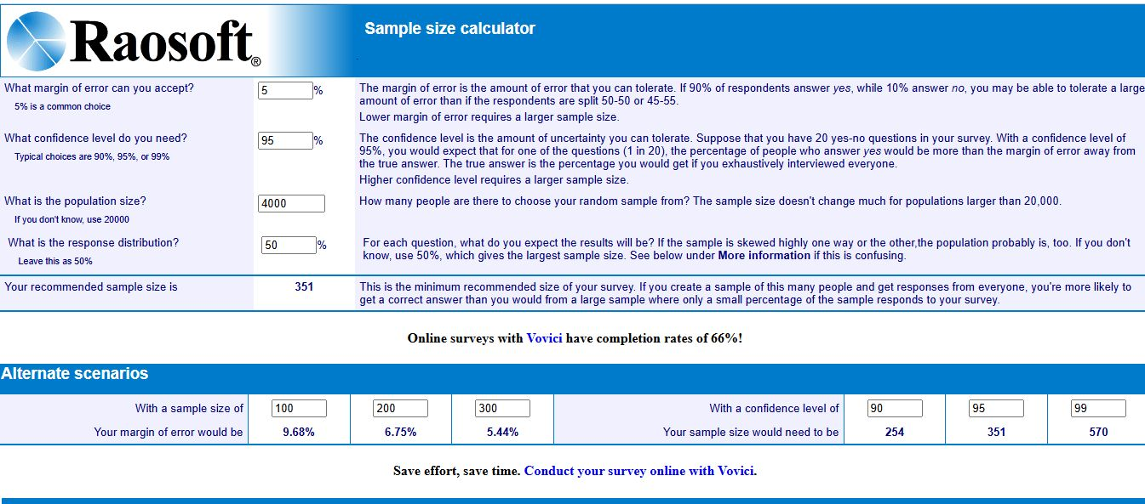
Fig 3.1 Sample Size Calculation by Raosoft 1

Data Collection:
The information was gathered directly from undergraduate students in universities physically and by filling of questionnaires at CUSIT. Prior to the gathering of information, the participants were made aware of the aim and objective of the study.
First, cervical proprioception was assessed using the JPE test. After completion of the proprioception assessment, participants were asked to complete the standardized CVS-Q. The data collection tool consisted of two sections: the first section included sociodemographic information such as age, gender, academic year, and daily screen time; the second section consisted of items related to digital eye strain symptoms assessed through the CVS-Q. All responses were collected immediately after assessment to maintain consistency and reliability of the data.

3.5 Instruments/Scales:
The following standardized instruments were used to collect data in this study.

Computer Vision Syndrome Questionnaire (CVS-Q)
Digital eye strain (DES) was measured using the Computer Vision Syndrome Questionnaire (CVS-Q), a standardized and validated instrument for assessing visual symptoms related to digital device use. The CVS-Q consists of 16 items assessing symptoms such as eye fatigue, itching, burning sensation, dryness, blurred vision, double vision, headache, and neck pain. It measures both frequency and intensity of the symptoms and has shown acceptable psychometric properties, with sensitivity and specificity over 70%, Cronbach's alpha 0.78 and ICC 0.80. It is a good test-retest repeatability, indicating that it is a valid and reliable tool for monitoring visual health in digital device users (Cantó-Sancho et al., 2024). The CVS-Q assesses 16 ocular and visual symptoms, with each symptom rated according to its frequency (never = 0, occasionally=1 intense= 2). The frequency and intensity scores are combined according to the original CVS-Q scoring method to obtain a total score. A total score of 6 or more indicated in the presence of DES, while a score below 6 indicates the absence of clinically significant symptoms. Higher scores represent greater severity of DES.

Joint Position Error Test (JPE):
Cervical proprioception was assessed using the Joint Position Error Test (JPE) with a head-mounted laser pointer method, adapted from prior studies evaluating cervical proprioception. Participants were seated 90 cm from a wall with a target chart. A laser pointer was mounted on a headband. From a neutral head position, participants focused the laser on the center of the target with eyes open. Then they closed their eyes and performed active cervical movements (flexion, extension, left rotation, and right rotation) and attempted to return to their original neutral position. The distance (in centimeters) between the starting point and the relocated point was recorded as the JPE. Three trials were performed for each movement's direction, and the mean value was calculated. Previous studies and systematic reviews have demonstrated good reliability and validity of Cervical JPE test, with ICC values ranging from 0.72 and Cronbach's alpha value of 0.79 with sensitivity of 72% and specificity of 75%. The JPE test using a laser pointer has demonstrated good reliability and validity as a clinical measure of cervical proprioception in both asymptomatic individuals and those with neck pain. For interpretation in this study, a mean JPE value greater than 6 cm in any movement direction was considered indicative of abnormal cervical proprioception (AlDahas et al., 2024).
Table 3.1: Scale No. Of Items/Movements
S. No. | Scales | No. Of items/movements
1. | CVS-Q | 16
2. | JPE | 4 movements ( flesion, extension. Left rotation, right rotation)

3.6 Inclusion And Exclusion Criteria
3.6.1 Inclusion criteria
- University students of age 18-25
- Screen time >3 hours a day (Anbesu and lema, 2023)
- Willing and able to attendant testing sessions and perform cervical proprioception tests and Complete CVS-Q
3.6.2 Exclusion criteria
- Current / Recent neck trauma or surgery (past 6 months)
- Neurological disorders effecting proprioception or balance
- Vestibular and active ocular diseases

3.7 Validity and Reliability of the Instruments:
Content and face validity of the instruments in this study were established by a panel of experts, including physiotherapists and optometrists, who reviewed the times for relevance, clarity, and coverage of key constructs. The panel confirmed that all 16 CVS-Q items adequately represented common digital eye strain symptoms such as eye fatigue, blurred vision, dryness, and headache. The CVS-Q itself is a validated questionnaire originally developed to measure visual symptoms related to computer and digital device use. It assesses the frequency and intensity of 16 symptoms and has demonstrated acceptable psychometric properties, including sensitivity and specificity above 70%, good test-retest reliability (ICC 0.80) and good internal consistency, confirming its validity and reliability for assessing Computer Vision Syndrome in working and students population(Cantó-Sancho et al., 2024).
For cervical proprioception, the laser-pointer JPE test has been widely used and has shown good reliability (interclass correlation coefficients typically in the good range) and acceptable validity when compared with inertial measurement units and other objective measures of cervical movement. Systematic review evidence also reports that measurement of cervical JPE shows sufficient reliability and validity as an assessment of neck proprioception(AlDahas et al., 2024).

3.8 Statistical Analysis:

3.8.1 Missing Data:
The dataset was examined using frequency distribution to identify missing data and potential outliers. If any missing data were found, appropriate actions were taken, including list-wise deletion of incomplete questionnaires. A total of 351 questionnaires were distributed, and any incomplete responses were excluded from the final analysis.

3.8.2 Control Variables:
Based on demographic factors used in the study (age, gender, daily screen hours, year of study, and faculty), one-way ANOVA was employed to explore differences in the dependent variables (digital eye strain severity scores and JPE values). Factors that showed significant differences were subsequently treated as control variables in the correlation analysis to reduce confounding effects.

3.9 Data Analysis:
IBM SPSS Version 27 for Windows was used for all statistical analysis. Descriptive statistics, including means and standard deviations, were calculated for continuous variables (JPE values in flexion, extension, left rotation, and right rotation; and total CVS-Q scores) as well as for sociodemographic variables (age, daily screen hours). Frequency and percentages were used to summarize categorical variables such as gender, faculty, and year of study.
The Spearman’s rank correlation test was employed for conducting inferential statistics analysis by establishing the association between cervical joint position error measurements and the severity of digital eye strain measured using the CVS-Q questionnaire. 95% confidence intervals were calculated for key estimates. All statistical tests were performed at a significance level of p<0.05.

CHAPTER 4

RESULTS

4.1 Introduction
In this chapter, the statistical data of undergraduate students in CUSIT were analyzed. Descriptive statistics, normality tests, and correlation analysis were performed to determine correlation between cervical proprioception and digital eye strain.

4.2 Descriptive Statistics
The sample consists of 351 participants. Descriptive statistics of variables are presented in Table 4.1.
The mean age of the participants is 20.77 ± 1.54. From these results, we concluded that our sample consists of young participants. The mean score for the digital eye strain test was 6.72 ± 4.43, implying that there was a relatively moderate level of eye strain among our participants. The mean value of cervical joint position error (JPE_Total) was 10.76 ± 5.36, showing variable accuracy in proprioception among participants.
Table 4.1: Descriptive Statistics of Continuous Variables
Variable | N | Minimum | Maximum | Mean | Std. Deviation
Age (years) | 351 | 18 | 25 | 20.77 | 1.54
Digital Eye Strain | 351 | 0 | 26 | 6.72 | 4.43
JPE_Total | 351 | 3.13 | 54.9 | 10.76 | 5.36

4.3 Demographic Characteristics

4.3.1 Gender Distribution
The gender composition showed majority to be males (61.3%) compared to females (38.7%).

Table 4.2: Gender Distribution
Gender | Frequency | Percentage
Male | 215 | 61.30%
Female | 136 | 38.70%
Total | 351 | 100%

4.3.2 Department Distribution
There were several departments participating in this survey; the largest proportion of participants are from DPT (22.8%) and CS (16.2%) departments, followed by Nursing (11.1%).
Table 4.3: Department Distribution
Department | Frequency (n) | Percent (%)
BBA | 7 | 2
BS.AI | 6 | 1.7
BS.ANES | 11 | 3.1
BS.ENG | 24 | 6.8
BS.RAD | 37 | 10.5
BS.SE | 21 | 6
BSCARDIO | 8 | 2.3
BSN | 39 | 11.1
C.ENG | 7 | 2
CS | 57 | 16.2
DENTAL | 41 | 11.7
DPT | 80 | 22.8
MLT | 2 | 0.6
PHARM.D | 11 | 3.1
Total | 351 | 100
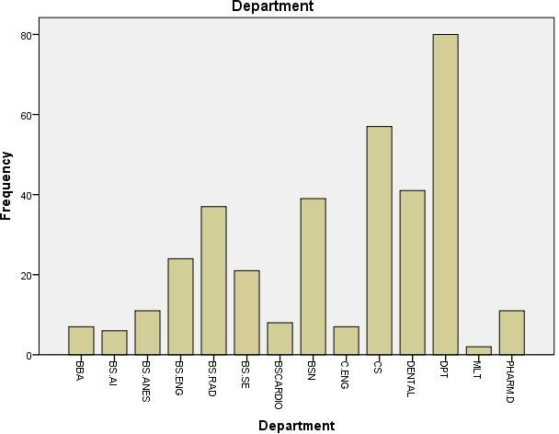
Figure 4.1 Department Distribution 1

4.4 Normality Testing
The normality of continuous variables was assessed using the Shapiro-Wilk test, as shown in Table 4.4.
From the results of the tests of normality, it was evident that neither of the two variables: JPE_Total and Digital Eye Strain exhibited a p-value less than 0.05. It means that the variables showed a failure to meet the criteria of normality. As such, use of non-parametric methods was deemed to be appropriate.

Variable | Kolmogorov–Smirnov  Statistic | df | Sig. | Shapiro–Wilk  Statistic | df | Sig.
JPE_Total | 0.11 | 351 | 0 | 0.824 | 351 | 0
Digital_eye_strain | 0.092 | 351 | 0 | 0.958 | 351 | 0
Table 4.4: Tests of Normality

The graph revealed a clear picture of data skewed on the right side instead of having a typical bell shape as shown in Gaussian distribution. The majority of the 351 participants had a low DES severity score, with the mean being 6.72±4.43. This structural presentation of the data gave a visual indication that the majority of the undergraduate students experience digital eye strain at mild-to-moderate levels. From there, the frequency of tapers showed a prolonged tail representing participants with sever digital eye strain. The result agreed with the findings of the statistical Shapiro-Wilk and Kolmogorov-Smirnov tests (p<0.05) which confirm the non-normal distribution of the data.
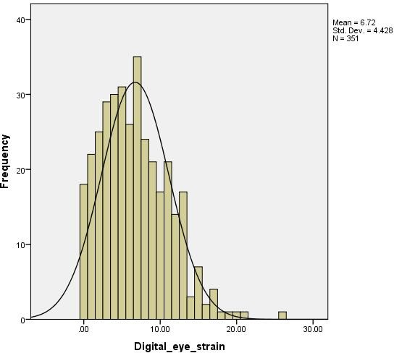
Figure 4.2: Histogram of Digital Eye Strain 1
The graph revealed distribution of the cumulative Cervical Joint Position Error (JPE_Total) scores across the sample of 351 participants. The distribution displayed a distinct right-sided skew, indicating that while a clustering of students maintained a JPE near normative clinical boundaries, a substantial subset demonstrates markedly elevated repositioning errors. The sample displayed a mean JPE value of 10.76 ± 5.36 cm, indicating overall compromised cervical sensorimotor performance likely linked to cumulative postural stress. This non-normal distribution patterns aligns with the statistical findings generated by the Shapiro-Wilk and Kolmogorov-Smirnov diagnostic checks (p < 0.05).

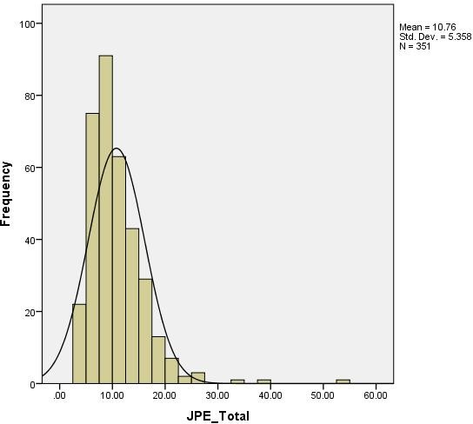

The normal Q-Q plot showed there is divergence from the normal line that
Indicate a non-normal distribution.
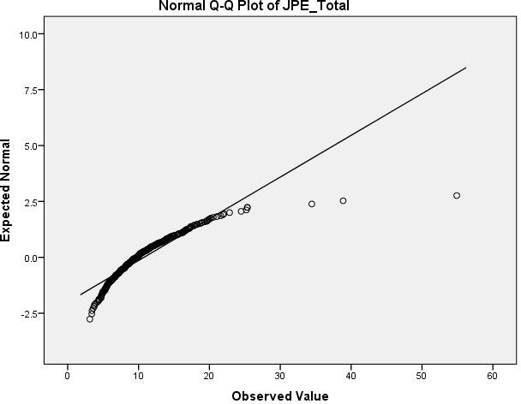

The detrended Q-Q plot showed a systematic deviation from zero, which further confirmed that data is not normally distributed.

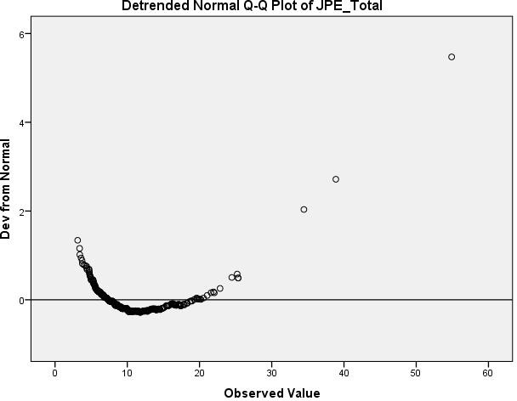

Additionally, the box plot highlighted the presence of outliers, showing variation in cervical proprioception among participants.

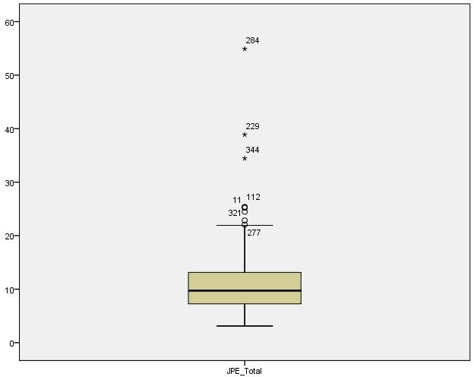
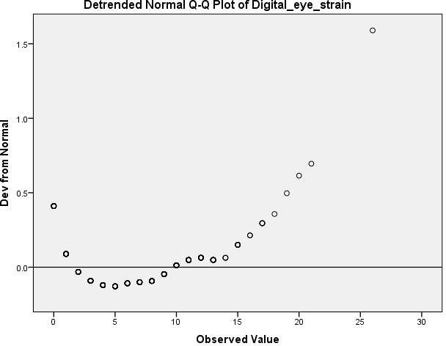
Visual and statistical assessment confirmed non-normal distribution of both variables, supporting the use of non-parametric tests.
Figure 4.4 JPE Total

The box plot indicated that most of the participants had mild to moderate DES, with few outliers indicating higher levels of symptoms.
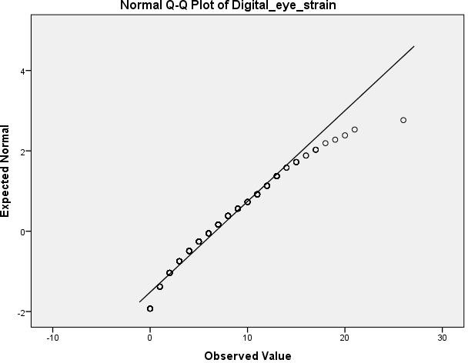

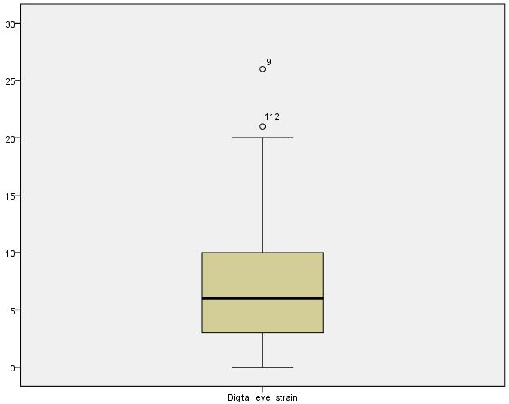
Fig 4.5 Digital Eye Strain 1

4.5 Correlation Analysis
Spearman’s rank correlation was used to assess correlation between cervical proprioception and digital eye strain.
Spearman’s rank correlation was used due to non-normal distribution of variables and ordinal/continuous nature of data. The analysis showed a weak negative correlation (r= -0.169) between two variables, which was statistically significant (p=0.001. The correlation indicated a weak negative correlation between cervical proprioception and digital eye strain, suggesting minimal but statistically significant relationships. However, the strength of correlation is very weak, suggesting that cervical proprioception has a limited association with DES.
Table 4.5: Spearmen Correlation
Variables | JPE_Total | Digital Eye Strain
JPE_Total | 1 | -0.169**
Sig. (2-tailed) | — | 0.001
N | 351 | 351
Digital Eye Strain | -0.169** | 1
Sig. (2-tailed) | 0.001 | —
N | 351 | 351

4.5.1 Direction Wise Correlation Analysis
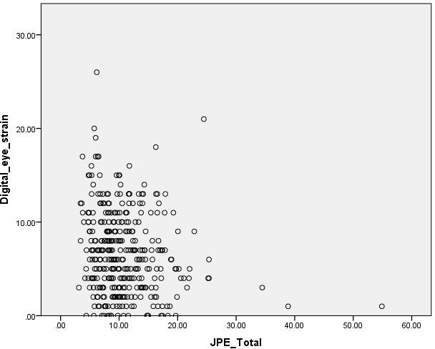
Figure 4.6: Scatter Plot of JPE_Total 1
Spearman correlation was also performed for individual cervical movements.
Extension and right rotation showed statistically significant weak negative correlations with digital eye strain, while flexion and left rotation were not significant.
1. Table 4.6: Direction Wise Correlation
Movement | rₛ | p-value | Interpretation
Flexion | -0.089 | 0.094 | Not significant
Extension | -0.162 | 0.002 | Significant (weak)
Right Rotation | -0.117 | 0.029 | Significant (weak)
Left Rotation | -0.061 | 0.257 | Not significant

Gender Wise Comparison Of DES

A Mann–Whitney U test was performed to examine differences in Digital Eye Strain (DES) between male and female participants. The test was selected due to the non-normal distribution of DES scores.
The results showed a statistically significant difference in DES scores between genders (U = 11437.00, Z = -3.446, p = .001). The mean rank indicated that female participants (Mean Rank = 199.40) had higher DES scores compared to male participants (Mean Rank = 161.20), suggesting that females experienced greater digital eye strain than males in the present study sample.

Table 4.7: Gender-wise Comparison of Digital Eye Strain (Mann–Whitney U Test)
Gender | N | Mean Rank | Sum of Ranks
Male | 215 | 161.2 | 34657
Female | 136 | 199.4 | 27119

The findings concluded that female students exhibited significantly higher levels of digital eye strain compared to male students. Thus, possible gender-related disparities in behavior regarding prolonged digital screens usage, visual perception abilities, in posture adopted during screen time might be presumed.
Table 4.8: Mann–Whitney U Test Statistics for DES by Gender
Test Statistic | Value
Mann–Whitney U | 11437
Wilcoxon W | 34657
Z | -3.446
p-value | 0.001

4.6 Regression Analysis
As the preparation stage for the Multiple Linear Regression (MLR) analysis, regression assumptions was verified. Multicollinearity check showed that there was no multicollinearity of the predictors as tolerance and Variance Inflation Factors (VIF) had reasonable values (Tolerance: 0.983 - 1.000; VIF: 1.000 - 1.017); therefore, all requirements concerning this matter have been met. At the same time, the Durbin-Watson test showed acceptable correlation in standardized residuals (DW = 1.732), meaning that there is no autocorrelation problem. Additionally, a histogram, P-P plot, and scatter plot indicated approximate normality and homoscedasticity of residuals which mean that the assumptions of multiple linear regression analysis have been fulfilled properly.

Table 4.9: Multicollinearity Diagnostics
Predictor | Tolerance | VIF
Age in years | 0.983 | 1.017
Gender | 0.983 | 1.017
JPE_Total | 1 | 1

A histogram of standardized residuals obtained from Multiple Linear Regression model predicting Digital Eye Strain (DES) experience (JPE_total), age, and gender. There are no major sign by total job positions of skewness or deviations of residuals distribution from normality. As it can be seen, the distribution has a bell-shaped curve that is centered around zero, which is typical for normally distributed residual
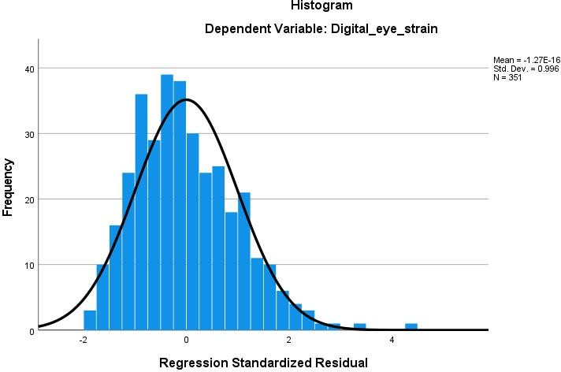
Figure 4.7: Histogram of Standardized Residual 1

The Normal Probability-Probability (P-P) Plot of standardized residuals for a regression model. The graph showed a perfect match between empirical and theoretical probabilities of the distribution of standardized residuals. All points follow the reference line, except for minor deviations that are acceptable when assessing the validity of the normality assumption of residuals.
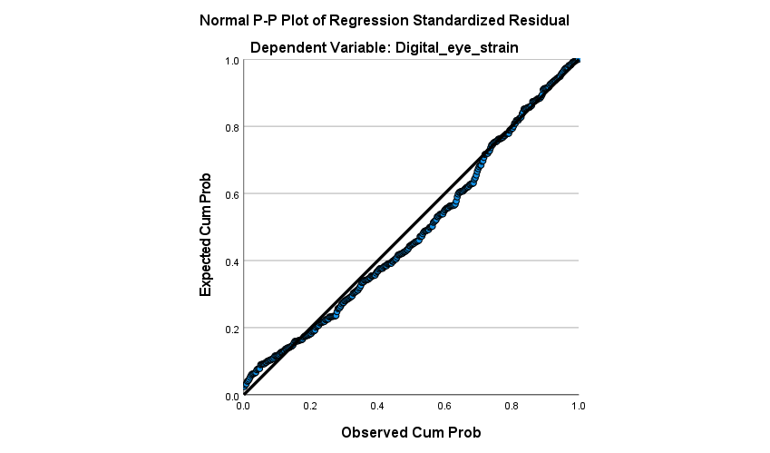
Figure 4.8: Normal P–P Plot of Standard 1
A scatterplot of the regression standardized residuals vs. regression standardized predicted values for the Multiple Linear Regression Model. The data points do not demonstrate any funneling, expansion, or geometric forms of patterning, but rather form a random scatter in a uniform rectangular cloud across the vertical line. Thus, the homoscedasticity assumption is valid, as there is a constant variance of errors across independent predictor variables' range of levels (N=351).
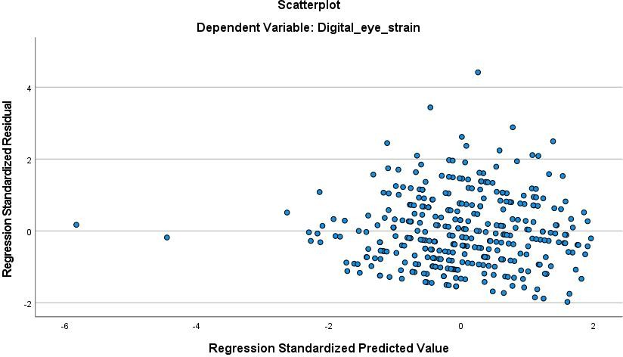
Figure 4.9: Scatterplot of Standardized 1

4.7 Multiple Linear Regression Analysis

A multiple linear regression analysis was performed to evaluate the predictive value of cervical proprioception (JPE Total), age, and gender in relation to Digital Eye Strain (DES) among undergraduate students. The model yielded an overall statistically significant result, F(3,347) = 7.727, p < .001. This means that the dependent variables in the present analysis have successfully predicted DES scores. The model explains 6.3% of the DES variance (R²=.063, Adjusted R²=.055), suggesting a relatively small predictive effect. Within the predictors in the model, JPE Total showed to be a statistically significant predictor of DES score (B= −0.149, β = −.180, p = .001). These results indicated the presence of a weak negative association between cervical joint position errors and DES score, implying that high JPE is related to low DES score. On the other hand, gender proved to be a statistically significant predictor of DES (B = 1.580, β = .174, p = .001). This finding revealed that there was a significant variation in DES scores between males and females participating in the study. Age does not appeared to be a statistically significant predictor of DES scores in the present study (B = 0.173, β = .061, p = .249). All in all, while the regression model yielded statistically significant results, its relatively low predictive effect size may imply that some other factors (besides the independent variables included in the model) are involved in the prediction of DES.
The model summary of the multiple linear regression analysis used to predict DES. Based on the data from the graph, it can be determined that the independent variables (namely age, gender, and total cervical joint position error (JPE_Total)) in the model are associated with 6.3% of DES variance (Coefficient of determination, R² =0.063; Adjusted R²=0.055). Moreover, the overall regression model is considered statistically significant, which means that the independent variables successfully predicted DES scores. Finally, it is important to note that the lack of critical residual autocorrelation (Durbin-Watson statistic=1.732) proves that the linear regression model is correct and follows the main baseline assumptions.

Table 4.10: Model Summary of Multiple Linear Regression Analysis
R | R² | Adjusted R² | Std. Error of  Estimate | Durbin–Watson
0.25 | 0.063 | 0.055 | 4.305 | 1.732

The table below summarized the overall statistical significance of the multiple linear regression model predicting DES. The data revealed that the combined value of independent variables, including total Cervical Joint Position Error (JPE_Total), age, and gender, is associated with the overall variation in DES score (F(3,347)=7.727, p<0.001). Thus, this ANOVA test result supports the idea that DES scores can be reliably predicted by the aforementioned set of independent variables. It should be noted that the very low p-value of the F-test (less than 0.05) confirms that the variation explained by regression sum of squares (429.688) is highly unlikely to have occurred by chance.
Table 4.11: ANOVA for Multiple Linear Regression Analysis
Source | Sum of  Squares | df | Mean  Square | F | p-value
Regression | 429.688 | 3 | 143.229 | 7.727 | < .001
Residual | 6431.822 | 347 | 18.536
Total | 6861.51 | 350

This table displayed the regression coefficients, standard errors, t-statistics, and corresponding significance values for the multiple linear regression model predicting Digital Eye Strain (DES). The analysis showed cumulative Cervical Joint Position Error (JPE_Total) is a statistically significant negative predictor of DES scores (β=−0.180,B=−0.149,t=−3.467,p=0.001), indicating aweak inverse relationship when accounting for covariates. Gender also emerged as a significant predictor (β=0.174,B=1.580,t=3.322,p=0.001), mathematically confirming that female students experience higher DES severity scores than males within this model. Conversely, age demonstrated no statistically significant predictive effect on digital visual strain parameters (p=0.249).
Table 4.12: Multiple Linear Regression Coefficients Predicting Digital Eye Strain
Predictor | B | SE B | Β | t | p-value | 95% CI
Constant | 2.524 | 3.301 | — | 0.765 | 0.445 | [-3.968,  9.017]
JPE_Total | -0.149 | 0.043 | -0.18 | -3.467 | 0.001 | [-0.233,  -0.064]
Age in years | 0.173 | 0.15 | 0.061 | 1.156 | 0.249 | [-0.122,  0.468]
Gender | 1.58 | 0.476 | 0.174 | 3.322 | 0.001 | [0.644,
 |  |  |  |  |  | 2.516]

4.8 Summary of Findings

Mean DES score indicated moderate symptoms among students. Both variables were not normally distributed. A weak but significant negative correlation was found. The regression model was significant but weak in predictive strength. Gender influenced digital eye strain significantly, and Age had no effect.

CHAPTER 5

DISCUSSION

The present study was conducted to determine the relationship between cervical proprioception and Digital Eye Strain (DES) among undergraduate students of City University, Peshawar. A total of 351 students aged 18-25 years participated in this cross-sectional correlational study. The increasing dependence on digital devices for academic, social, and recreational activities has raised concerns regarding both visual and musculoskeletal health among university students. Prolonged screen exposure is commonly associated with symptom of DES such as headache, blurred vision, eye fatigue, dryness and neck discomfort. Similarly, sustained forward head posture and prolonged cervical flexion during device use may impair cervical proprioception and sensorimotor control. DES was assessed using CVS-Q and Cervical Proprioception was evaluated through the Joint Position Error Test (JPET). Statistical analysis revealed a statistically significant but weak negative correlation between cervical proprioception and DES. Female's students show higher DES scores compared to males, while age had no significant effect. The findings suggest that prolonged digital device use may affect both visual health and sensorimotor function among university students.

Participants were young adults (mean age 20.77±1.54 years) with 61.3% males and 38.7% females . The population (18–25 years, ≥3 h/day screen use) was deliberately chosen because young adults are highly exposed to digital devices and thus more vulnerable to DES and cervical strain. Male participants were more common in study while female participants were reported high for DES. These findings suggest that university students, particularly females and students with high screen exposure are at greater risk of developing visual and musculoskeletal symptoms related to prolonged digital device use. The literature review similarly emphasized that university students are a high‑risk group for DES and neck problems due to long daily screen time and academic digital dependence (Kaur et al., 2022). Thus, the chosen demographics are directly aligned with Chapter 2 evidence and justify targeting undergraduates to examine cervical–visual interactions.
The current study found that many undergraduate students experience Digital Eye Strain (DES) at a moderate level. The mean DES score of 6.72±4.43. Box plots showed most participants had mild to moderate DES, with some high‑symptom outliers , showing that a large number of students had symptoms that could be considered clinically significant due to long periods of using digital devices. These results match what was found in earlier studies by Maneea et al. and Mataftsi et al. , which also noted a high rate of DES among young people who use digital devices a lot. Chapter 2 reported DES prevalence of 50–90% in digital users, particularly university students spending 6–10 hours per day on screens, with common symptoms of eye fatigue, headaches, dryness, and neck pain (Kaur et al., 2022).Pakistani studies reported DES/CVS prevalence around 62–70% with long screen exposure and poor ergonomics (Jameel et al. , 2024), where spending too much time looking at screens led to problems like eye fatigue, headaches, blurry vision, and neck pain among university students. Also, women in this study had higher DES scores than men, which aligns with the findings of (Chu et al., 2023).
DES is common because of multiple reasons that are Prolonged near focus and screen time reduce blink rate and overload ciliary and extraocular muscles, causing fatigue and blurred vision (Almutairi et al., 2024). Forward head posture and neck muscle fatigue during device use contribute to both ocular and musculoskeletal symptoms (Pavel et al., 2023). Digital dependence in higher education leads to continuous academic and leisure screen use, increasing cumulative visual load (Mildren et al., 2025). In Pakistan, inconsistent lighting and low‑resolution mobile screens for academic work may exacerbate DES compared to Western settings (Jameel et al., 2024).
This study found that there is a lot of difference and some problems with how well undergraduate students can sense the position of their neck. The mean JPE value of 10.76±5.36cm, indicating substantial variability and generally elevated joint position error among students compared to the 6 cm cut‑off for abnormal proprioception used in this study. Outliers in box plots and non‑normal distribution further reflected heterogeneous cervical sensorimotor accuracy in the sample. These results suggest that using digital devices for long periods and keeping the neck in one position for too long might hurt the ability to sense neck movement. This matches what other studies like those by Khokhar et al. and Suhail et al. found, where young adults who use smartphones and screens a lot had more trouble sensing their neck's position. In this study, it was also found that movements like neck extension and right rotation were linked to Digital Eye Strain, but movements like neck flexion and left rotation were not. This is partly supported by Khan et al., who found that students had more issues with sensing their neck when they moved it in rotational directions. The literature explains cervical proprioception impairment by, high density of muscle spindles in upper cervical and suboccipital muscles, which provide precise head position sense but become fatigued during prolonged static postures, generating noisy proprioceptive input and increased JPE (Mildren et al., 2025), Text‑neck posture (sustained neck flexion) during long screen use reduces cervical joint position accuracy, with greatest error in students using screens >4 hours daily (Purushothaman et al., 2025). At the central level, the cerebellum integrates vestibular and proprioceptive signals; mismatch between stiff neck posture and intense visual input in frequent digital users may “reconfigure” head‑position processing and lead to chronic sensory imbalance (Mildren et al., 2025). These mechanisms support why the sample showed generally elevated JPE_Total.
The central objective was to test the correlation between JPE_Total and DES. A weak negative correlation (r = –0.169, p = 0.001) was found; movement wise, extension and right rotation showed significant but weak negative correlations, while flexion and left rotation were not significant. Multiple regression confirmed JPE_Total as a weak negative predictor of DES (β = –0.180) and the model explained only 6.3% of DES variance. This partially supports the idea that cervical proprioception helps with eye-head coordination and keeps vision stable. Similar connections between visual problems, neck posture, and neck issues have been seen in other studies, like those by Noonari et al., Almutairi et al., and VA et al.. However, this study found a weak negative link, which is different from previous research that suggested a positive connection. Several possible reasons help explain this contradiction and weak effect,
The theoretical framework had suggested poor neck proprioception would worsen eye strain; the study actually captured a weak inverse relationship (r = –0.169). This unexpected negative direction could be explained by several clinical and behavioral factors. First, DES was highly complex. Multifactorial issues that were predominantly driven by local visual factors such as dry environment, glare and reduced blink rate mean neck proprioception was only one small piece of puzzle. Second, there was a natural mismatch between the measurement tools the CVS-Q captured student's subjective feelings of eye strain, whereas, the JPE test measured objective physical motor errors, and these two elements did not always mirror each other perfectly in a healthy student population. Additionally, students with poor neck awareness high JPE might have unconsciously adapted by slumping into a complete head down position over their screens. While this faulty posture severely worsened their neck joint errors, it changed their focal viewing angle in a way that may have temporarily eased the workload on their eye muscles, leading to lower reported eye strain scores at that specific moment. DES has many non‑proprioceptive causes, reviews emphasize that DES is mainly driven by ocular surface and visual factors: reduced blink rate and completeness, uncorrected refractive error, accommodative/vergence anomalies, screen brightness, glare, and task cognitive demand, rather than cervical input alone. Because DES is multifactorial, cervical proprioception is only one small contributor among many, which naturally produces a weak overall correlation. In this study, DES was measured with a subjective questionnaire, whereas JPE is an objective, performance‑based measure. In visual research, discordance between subjective symptom scores and objective findings is well documented: correlations are often weak, and patients can report many symptoms despite near‑normal tests, or vice versa. This subjective–objective mismatch likely reduced the strength of the observed correlation between CVS‑Q (symptom perception) and JPE (motor accuracy) (Sheppard & Wolffsohn, 2018) .
Both DES and cervical JPE were assessed at a single time point in a cross‑sectional design. Such designs cannot determine whether impaired proprioception precedes and contributes to DES or whether DES‑related behaviours (e.g., more head‑down use) gradually alter proprioception. Similar cross‑sectional proprioception studies acknowledge that this design cannot establish causality between CPE and functional outcomes. Without temporal data, any true directional relationship may be obscured and appear as a small linear association(Acet & Begen, 2025).
The sample consisted of young adults with moderate DES but not a clinical neck‑pain population. Evidence from older or symptomatic groups shows stronger links between JPE and functional balance or pain. In contrast, one study found no meaningful JPE differences in patients with only mild neck disability compared with controls, suggesting that strong sensorimotor correlations emerge mainly in more severe conditions. In a young student population with relatively low disability, the cervical–visual coupling may naturally be weak (Raizah et al., 2023). JPE reflects static head‑reposition accuracy over a few trials, while DES reflects cumulative visual discomfort over many hours of device use. Objective DES‑related measures (blink rate, accommodation, etc.) also do not consistently align with symptom severity. It is plausible that the relationship between cervical proprioception and DES is non‑linear or threshold‑based (e.g., only above certain pain/posture loads), which a simple Spearman correlation and linear regression cannot capture, again resulting in a weak apparent association(Sheppard & Wolffsohn, 2018). There could be several reasons for this difference, Firstly, DES is caused by many factors like long screen time, bright lights, poor lighting, not blinking enough, stress, eye problems, sleep issues, and how people sit while using devices. Therefore, cervical proprioception may only play a minor role. Second, the cross-sectional design and possible behavioral adaptations, including limited screen exposure and regular breaks in students reporting cervical complaints, may influence the results of the study. Moreover, possible variations in the test for JPE and self-reports for DES could influence the results. Besides, the study failed to consider other potentially influencing factors like duration of screen exposure, sitting posture, device types, degree of neck pain severity, and use of spectacles. The regression revealed that the model accounted for only 6.3% of the variance in DES scores. That means that numerous other variables contribute to the problem. Gender turned out to be a statistically significant factor influencing DES; however, the age did not have any major effect on DES scores. Thus, despite the relatively weak correlation between DES and cervical sensorimotor functions, the obtained results allow concluding that some relation can still exist between the two parameters in students using digital devices extensively.
Female students were shown to have significantly higher DES scores than males (p = 0.001) and gender remained a statistically significant positive predictor of DES in the regression (β = 0.174, p = 0.001). As noted in Chapter 2, female students were more likely to report DES and cervical pain in various populations due to potential physiological differences (anatomical, hormonal, behavioral) associated with increased frequency of social media usage and sustained near focus.(Chu et al., 2023). Surveys conducted internationally revealed higher rates of DES in women, specifically those using several digital devices and for extended periods of time. Possible explanations for higher female DES include;Greater cumulative near work (academic + social media), leading to more visual fatigue. Potential higher symptoms reporting and health awareness. Differences in ocular surface and tear film stability, suggested in DES literature (though not directly measured here).
The present findings therefore reinforce existing evidence that female students represent a higher risk group for DES and should be prioritized in screening and prevention programs.
Increased JPE_Total and DES prevalence require combined evaluation of cervical proprioception and visual discomfort in patients experiencing neck pain or ocular strain. Although the correlation is weak, incorporation of postural modification, cervical sensorimotor training, and ergonomic counseling together with usual ocular examination may be beneficial.
The findings highlight the importance of promoting educational strategies aimed at proper digital use practices among students: minimizing screen exposure, following the 20-20-20 rule, adjusting viewing distance and illumination, and avoiding prolonged head-down position.
The data supports institutional policies in terms of ergonomic setup of computer workstations within laboratories and libraries, as well as educational campaigns on DES and cervical issues, as well as introducing information related to digital health into the curriculum or health orientation course. Simple programs of screening using CVS-Q, along with basic cervical examination, can determine who should be referred to physiotherapists or ophthalmologists.
First study in Pakistan assessing the relationship between cervical JPE and DES in undergraduate students as per the identified gaps from the literature.(Maneea et al., 2024). Employment of reliable and valid measurements such as CVS-Q for DES assessment and laser-pointer JPE test for cervical proprioception (Cantó-Sancho et al).

CHAPTER 6

CONCLUSION

In conclusion, it can be stated that there is a statistically significant negative correlation between cervical proprioception accuracy and the degree of Digital Eye Strain experienced by university students (r = -0.169, p = 0.001). Moreover, it becomes apparent that students, especially women, and those who frequently use screens, run a higher risk of experiencing vision and neck disorders simultaneously.
In light of the significant levels of JPE recorded among subjects, this indicates that extended periods of "head down" and neck flexion while using the device adversely affect the sensory-motor integration of the body. Even though DES is affected by a variety of factors, including lighting and screen usage, cervical proprioception is a relatively minor aspect that nonetheless has a role in eye-head integration and visual stability. Thus, in clinical management of digital-induced fatigue, there is need for multidisciplinary treatment involving both visual ergonomics and neck physiotherapy.

6.1 Limitations of the Study

The cross-sectional design of this study makes drawing causal relations between impaired cervical JPE and DES difficult. Limited external validity due to convenience sample from a single institution and a single country
(Khan et al., 2025) .Use of self-reporting for DES, as well as absence of objective visual measurement instruments (such as refractive error and tear tests). Possible lack of complete coverage of dynamic cervical functions using JPE_Total variable. Unaccounted confounding variables include light exposure and specific nature of cognitive stress.

6.2 Recommendations

Longitudinal and interventional studies aim to test the possibility of reducing DES by improving cervical proprioceptive skills. Use multi-center sampling and consider various faculties in order to enhance external validity and compare outcomes across the programs. Include objective measures related to vision (for example, tear tests, refraction), as well as ergonomic variables (distance and brightness of screen and seating time) when creating future models in order to explain a higher proportion of the variability in DES.

REFERENCES

Acet, N., & Begen, S. (2025). The proprioceptive puzzle: An observational study investigating the effects of cervical proprioceptive errors on quantitative sensory testing and body awareness in young individuals. PloS one, 20(4), e0321645.
AlDahas, A., Devecchi, V., Deane, J. A., & Falla, D. (2023). Measurement properties of cervical joint position error in people with and without chronic neck pain. PLoS One, 18(10), e0292798.
AlDahas, A., Heneghan, N. R., Althobaiti, S., Deane, J. A., Rushton, A., & Falla, D. (2024). Measurement properties of cervical joint position error in people with and without neck pain: a systematic review and narrative synthesis. BMC Musculoskeletal Disorders, 25(1), 44.
Almuqrashi, A., Al-Noumani, H., Al-Abri, F., Al-Hinai, H., & Bani Oraba, H. (2025). The prevalence of computer vision syndrome and associated factors among university students in oman: a cross-sectional study. BMC Public Health, 25(1), 2668.
Almutairi, H., Alhammad, L., Aldossari, B., & Alonazi, A. (2024). Prevalence and interrelationships of screen time, visual disorders, and neck pain among university students: A cross-sectional study at Majmaah University. Healthcare,
Campbell, D., Murphy, B. A., Burkitt, J., La Delfa, N., Sanmugananthan, P., Ambalavanar, U., & Yielder, P. (2023). Cervico-Ocular and Vestibulo-Ocular Reflexes in Subclinical Neck Pain and Healthy Individuals: A Cross-Sectional Study. Brain Sciences, 13(11), 1603. https://www.mdpi.com/2076-3425/13/11/1603
Cantó-Sancho, N., Linhares, J., Ronda-Pérez, E., Franco, S., Perales, E., & Seguí-Crespo, M. (2024). Cross-cultural validation into Portuguese of a questionnaire to assess computer vision syndrome in workers exposed to digital devices. Arquivos Brasileiros de Oftalmologia, 87, e2022-0256.
Chu, G. C., Chan, L. Y., Do, C.-w., Tse, A. C., Cheung, T., Szeto, G. P., So, B. C., Lee, R. L., & Lee, P. H. (2023). Association between time spent on smartphones and digital eye strain: A 1-year prospective observational study among Hong Kong children and adolescents. Environmental Science and Pollution Research, 30(20), 58428-58435.
de Assis, S. J., Sanchis, G. J., Meziat-Filho, N., de Souza, C. G., & Roncalli, A. (2025). Association of self-reported posture habits and vision problems with chronic neck pain: A case-control study. Journal of Bodywork and Movement Therapies.
Haider, I., Osama, M., Gul, N., & Khattak, A. R. (2023). Impact of screen time on digital eye strain and visual acuity among medical students in Peshawar, Pakistan. Khyber Medical University Journal, 15(4), 229-234.
Hussain, R. D., Ahmad, P., Niazi, M. P., Rafiq, M., & Yasin, S. (2026). Assessing knowledge about computer vision syndrome among students of Karakoram international university of Gilgit Baltistan, Pakistan. NUST Journal of Natural Sciences, 11(1), 1-13.
Jameel, H., Tariq, S., Sarwar, R., Yaqoob, M., Athar, T., & Tariq, I. (2024). Prevalence and Associated Risk Factors of Myopia in Computer Vision Syndrome Among Undergraduate Students in Pakistan: Myopia and CVS Among Students in Pakistan. Journal of Health and Rehabilitation Research, 4(3).
Kaur, K., Gurnani, B., Nayak, S., Deori, N., Kaur, S., Jethani, J., Singh, D., Agarkar, S., Hussaindeen, J. R., & Sukhija, J. (2022). Digital eye strain-a comprehensive review. Ophthalmology and therapy, 11(5), 1655-1680.
Khan, H. Y., Shahzad, M., Shah, S. M., Samad, A., Ayaz, T., & Sikandar, M. S. (2025). Evaluation of Cervical Proprioception and Its Association with Neck Pain Among Undergraduate Students of University in Peshawar: A Cross-Sectional Study. The Healer Journal of Physiotherapy and Rehabilitation Sciences, 5(1), 124-133.
Khokhar, A. R., Ahmad, F., Athar, U., Hussain, S. A., Afzal, R., & Khan, N. (2023). Cervical joint position sense error in healthy young adults. Journal of Nursing and Allied Health, 1(04).
Lérida-Ponce, M. Á., Lérida-Ortega, M. Á., Sedeño-Vidal, A., & Ibáñez-Vera, A. J. (2025). Associations Between Visual Accommodation and Cervical Muscle Activity and Symptomatology: A Systematic Review. Journal of Functional Morphology and Kinesiology, 10(3), 252.
Maneea, M. W. B., Alamawi, H. O., Almuqbil, A., Abukhlaled, J. K., Alsuwailem, G., Alabdulminaim Jr, J., Aladawi, A. M. M., Alshangiti, A. Y., & Aladawi, A. M. (2024). Digital eye straining: Exploring its prevalence, associated factors, and effects on the quality of life. Cureus, 16(5).
Mataftsi, A., Seliniotaki, A. K., Moutzouri, S., Prousali, E., Darusman, K. R., Adio, A. O., Haidich, A.-B., & Nischal, K. K. (2023). Digital eye strain in young screen users: A systematic review. Preventive Medicine, 170, 107493.
Mildren, R. L., Gómez, L. J., & Cullen, K. E. (2025). Convergence of vestibular and proprioceptive signals in the cerebellar nodulus/uvula enhances the encoding of self-motion in primates. Curr Biol, 35(3), 468-482.e463. https://doi.org/10.1016/j.cub.2024.11.063
Noonari, M. H., Noonari, S. B., & Samejo, B. (2024). Investigating the Association of Computer Vision Syndrome with Forward-Headed and Kyphotic Posture among Undergraduate Information Technology Student. Journal of Modern Rehabilitation.
Park, M. W., Seong, M. Y., Song, Y. S., Youn, K., Yang, K. Y., Lee, J., Chung, S. G., & Kim, K. (2025). Comparison of cervical spine kinematics and clinical neck symptoms between mobile device and desktop computer use. Sensors, 25(5), 1438.
Pavel, I. A., Bogdanici, C. M., Donica, V. C., Anton, N., Savu, B., Chiriac, C. P., Pavel, C. D., & Salavastru, S. C. (2023). Computer vision syndrome: an ophthalmic pathology of the modern era. Medicina, 59(2), 412.
Peng, B., Yang, L., Li, Y., Liu, T., & Liu, Y. (2021). Cervical proprioception impairment in neck pain-pathophysiology, clinical evaluation, and management: a narrative review. Pain and therapy, 10(1), 143-164.
Piruta, J., & Kułak, W. (2025). Physiotherapy in text neck syndrome: A scoping review of current evidence and future directions. Journal of Clinical Medicine, 14(4), 1386.
Pucker, A. D., Kerr, A. M., Sanderson, J., & Lievens, C. (2024). Digital eye strain: updated perspectives. Clinical optometry, 233-246.
Purushothaman, V. K., Ramalingam, V., Maruthey, N., Subramaniam, A., Subbarayalu, A. V., Janakiram, M. K. S., & Vediappan, V. (2025). Influence of Text Neck Syndrome on Postural Sway and Cervical Proprioception in Adults with and Without Neck Pain. Journal of Health Science and Medical Research, 43(4), 20251140.
Rahnama, L., Abdollahi, I., Karimi, N., Akhavan, N., Arab-Khazaeli, Z., & Bagherzadeh, M. (2017). Cervical position sense in forward head posture versus chronic neck pain: A comparative study. Journal of Clinical Physiotherapy Research, 2(1), 39-42.
Raizah, A., Reddy, R. S., Alshahrani, M. S., Gautam, A. P., Alkhamis, B. A., Kakaraparthi, V. N., Ahmad, I., Kandakurti, P. K., & ALMohiza, M. A. (2023). A cross-sectional study on mediating effect of chronic pain on the relationship between cervical proprioception and functional balance in elderly individuals with chronic neck pain: mediation analysis study. Journal of Clinical Medicine, 12(9), 3140.
Setiawan, C., Ernawati, T., & Nugroho, N. (2022). Computer Vision Syndrome and Neck Range of Motion in Office Employees. Journal of Widya Medika Junior, 3(2), 104-109.
Sheppard, A. L., & Wolffsohn, J. S. (2018). Digital eye strain: prevalence, measurement and amelioration. BMJ open ophthalmology, 3(1).
Suhail, S., Batool, A., & Shehzadi, F. (2024). Relationship Between Smartphone Overuse and Cervical Proprioception Deficits in Young Adults. Journal of Precision Medicine and Health Research, 1-5.
Torkamani, M. H., Mokhtarinia, H. R., Vahedi, M., & Gabel, C. P. (2023). Relationships between cervical sagittal posture, muscle endurance, joint position sense, range of motion and level of smartphone addiction. BMC musculoskeletal disorders, 24(1), 61.
VA, F. H., Rai, S., Anupriya, P., & KB, R. B. (2026). The Role of Neck Muscle Strength and Posture in Digital Device-related Visual Disturbances: A Scoping Review. Asian Journal of Medicine and Health, 24(1), 107-119.

APPENDICES
ANNEXE:
Consent Form Of Participation In Study
Study Title:
Correlation Between Cervical Proprioception And Digital Eye
Among Undergraduate Students Of City University Of Science
And Information Technology, Peshawar
This research study is being conducted to evaluate the correlation.
Between cervical proprioception and Digital eye strain among
Undergraduate CUSIT students.
The assessment procedure includes:
- Computer Vision Syndrome Questionnaire (CVS-Q)
- Cervical Joint Position Error (JPE) Test
All data collected will remain confidential. Your identity will be coded and will not be disclosed. Participation is voluntary. You may withdraw at any time without any penalty. By signing below, you confirm that you have read and understood this form and agree to voluntarily participate in this study.

Participant's Signature:____________________
Date:____________________

Annexure : 1

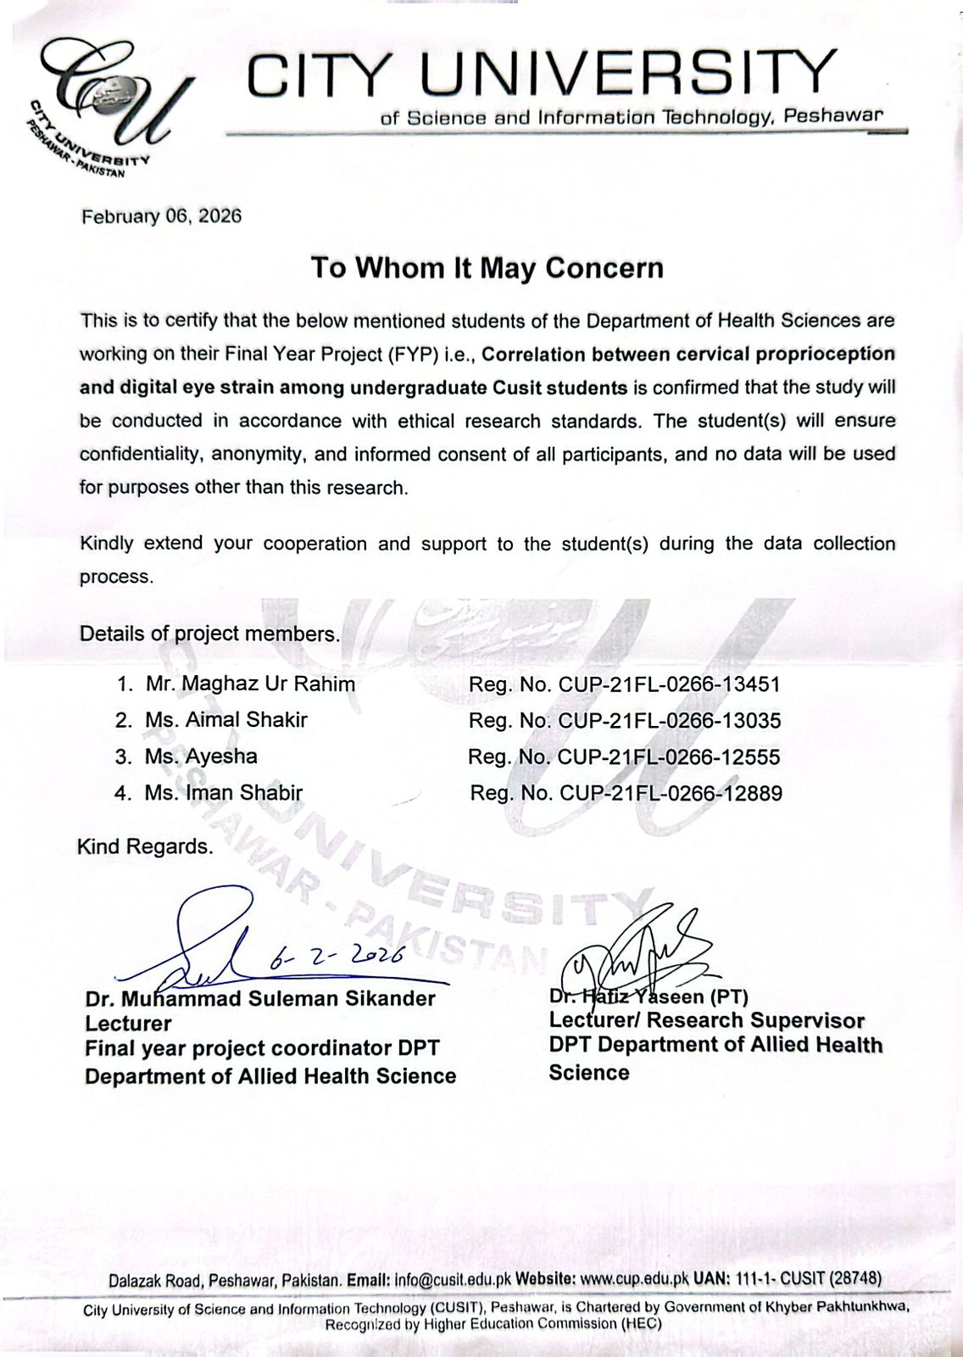

Annexure 2

Cervical joint proprioception (JPE)Assessment Sheet

The assessment of cervical Proprioception was done using the joint position error test, referred to as the JPE test, using a laser pointer with the head. For the test, subjects sat at 90 cm away from a wall with a chart for a target, while a laser pointer was attached to the headband. Starting from the neutral position of the head, participants would aim the laser at the center of the target using eyes open.
Once participants closed their eyes, they would move their heads actively through flexion, extension, left rotation, and right rotation and then attempt to regain their neutral position.
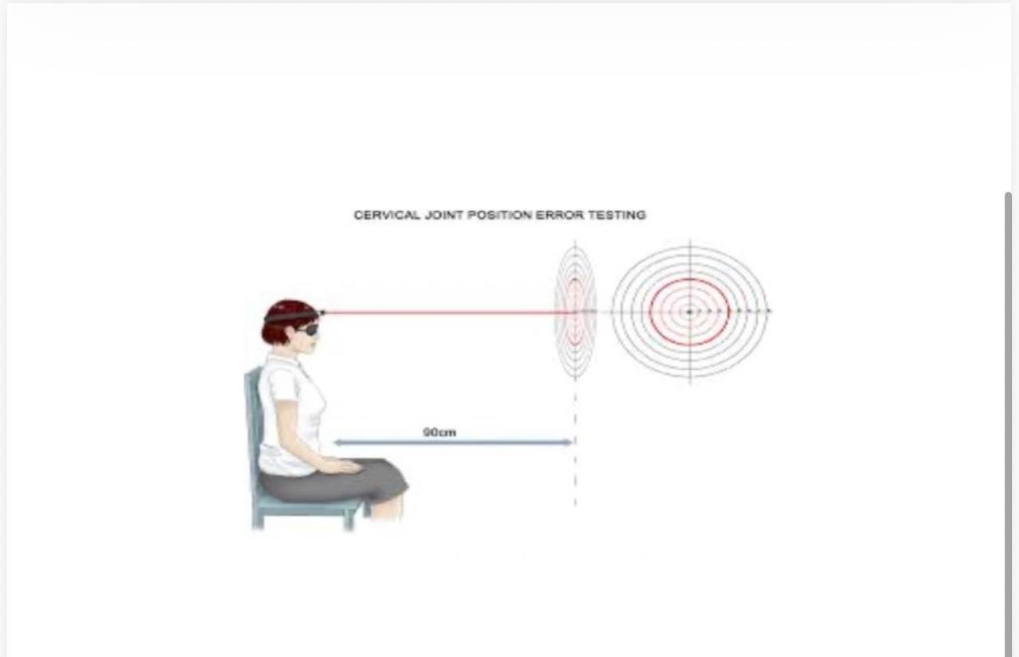

Digital eye strain questionnaire

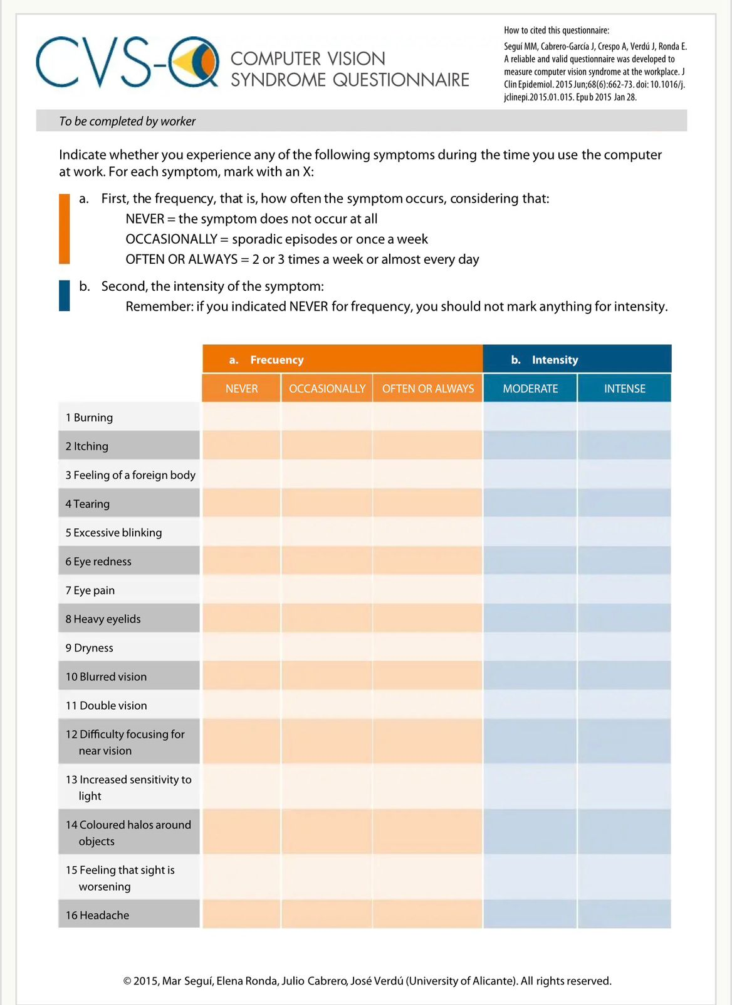
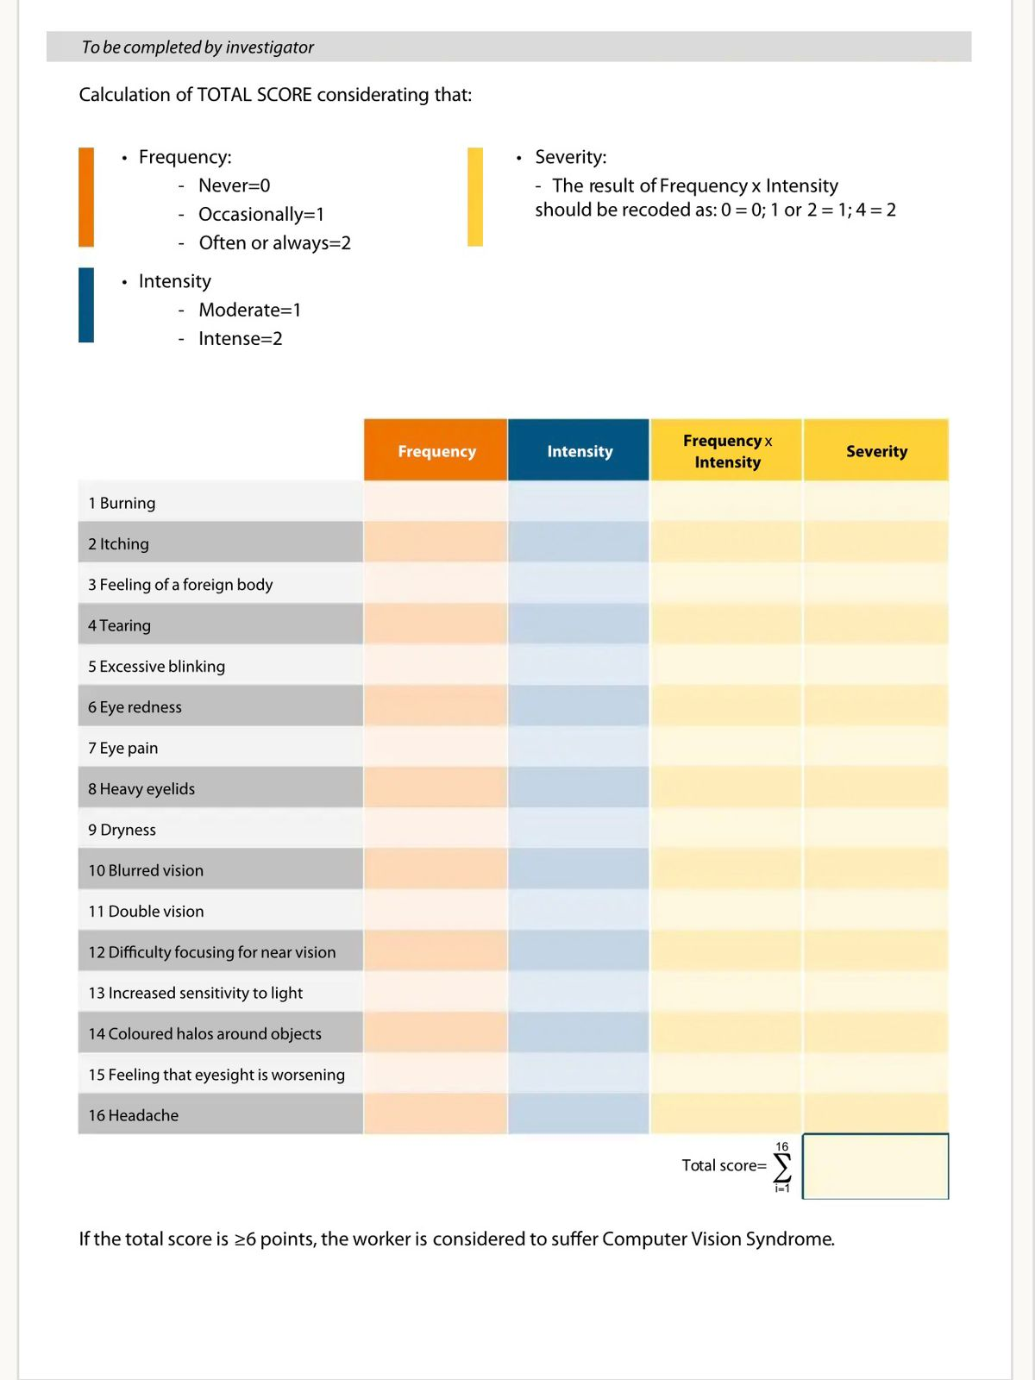

Plagiarism report

