

**Fatima Jinnah Women University**

***Department of software engineering***

**Name**: Rida Fatima (17-Bse-058)

**Submitted to**:Maam Mehreen Sirshar

**Subject**: Introduction to Data Science

**Semester**: Sixth

**Section:** B

**Date**: 08-06-2020

**Covid_19 visualizations:**

In these tensed days of covid-19, Pakistan and worldwide countries are facing the great pandemic and thousands of people have died fighting this deadly virus. I have tried finding out some useful insights that might help understanding the nature of virus and its effect over Pakistan. These insights have been found out using dataset form kaggle.it specifically contains data about covid-19 situation in Pakistan. The insights found are made using dataset dated: 1-may-2020 though the dataset updates daily. Data has been cleaned on jupyter notebook, where null values and columns have been remaned.Data has been cleaned to improve results for visulaization.These insights have been uploaded to git hub. Blog related to these visualization

**Following are the links:**

***Dataset:*** <https://www.kaggle.com/mesumraza/corona-virus-pakistan-dataset-2020>

***Git hub/data cleaning***: <https://github.com/ridafjwu/Covid-19_Dataset-_Visualizations.git>

Link to blog: https://medium.com/@ridafatimarrrfff/in-these-tensed-days-of-covid-19-pakistan-and-worldwide-countries-are-facing-the-great-pandemic-8dd84b1cb57c

**Dashboard 1 for visualization:**

Link for visualization:https://public.tableau.com/profile/rida.fatima#!/vizhome/Covid-19_visualization/Dashboard1

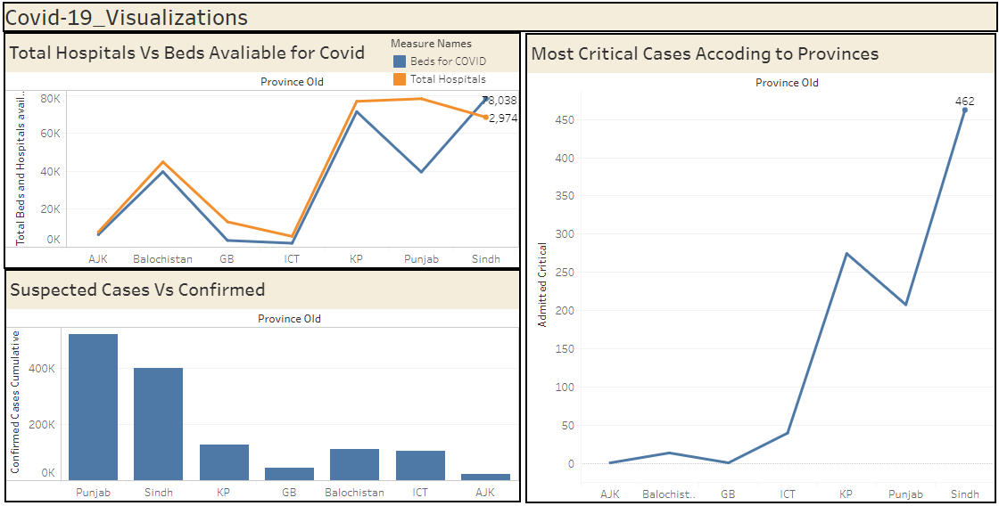

In my first insight I have shown a graph for the total hospitals and the amount of beds available for covid-19.it can be seen that Sindh being the largest province has largest amount of beds available for covid. Another useful insight in accordance to covid-19 is most critical cases reported in all provinces of Pakistan. It can be seen in the graph that there is a sudden increase in critical cases in Sindh. A peak in KP also demonstrate higher critical cases reported there where as AJK and GB is seen with lowest critical cases.

**Dashboard 2 For Visulaization:**

***Link for dashboard 2***: https://public.tableau.com/profile/rida.fatima#!/vizhome/covid-19_dashboard1/Dashboard1

Dashboard 2 contains three visualizations regarding covid-19.

**Provincial view for death rate**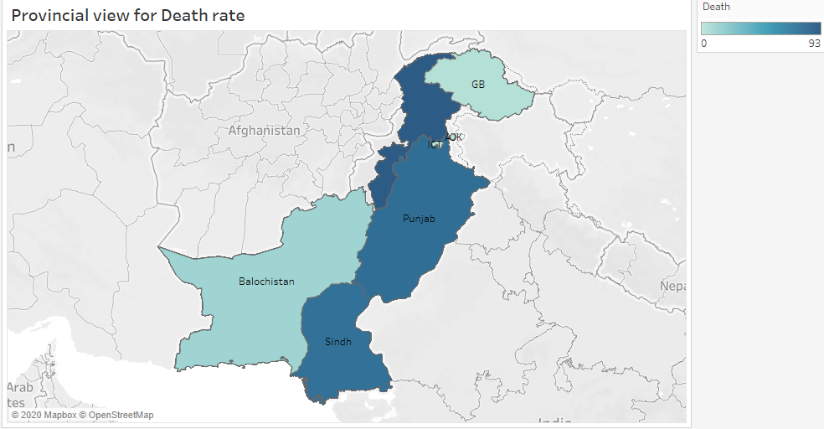  
In the above visualization a clear view can be analysed from provincial perspective.according to the dataset of may greatest death rate can be seen in KP.where as lowest deathrate can be seen in province of Balochistan and Gilgit Baltistan.

**Number of Test Conducted Vs Positive Reported**

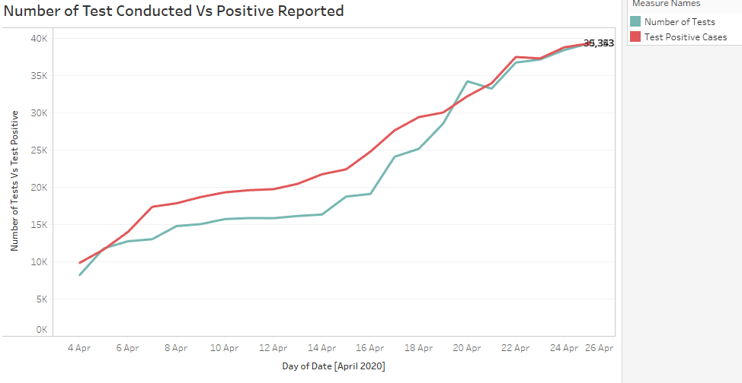

This visualization also shows a useful insight that is the number of tests conducted Vs those who resulted in positive covid-19.as from above visualizatiion it can be seen that positive are more than those tested.

**Comparision for Death Vs Recovered:**

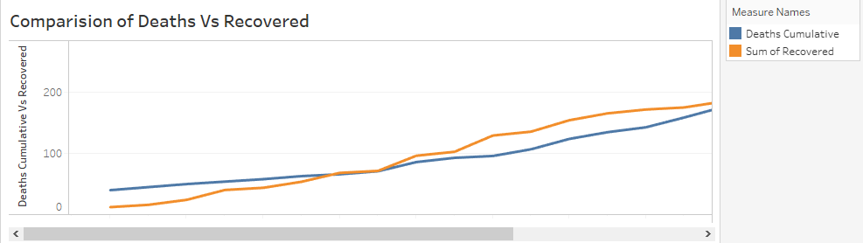

It is another useful insight as it helps understand ratio of death to recovery of covid-19 patients.it can be seen that initially there was increased death rate but eventually it can be seen that number of recovered patients increased.

**Dashboard 3 Visualization:**

***Link for dashboard:*** <https://public.tableau.com/profile/rida.fatima#!/vizhome/Covid-19_Dashboard_2/Dashboard1>

**Expired Vs. Discharged:**

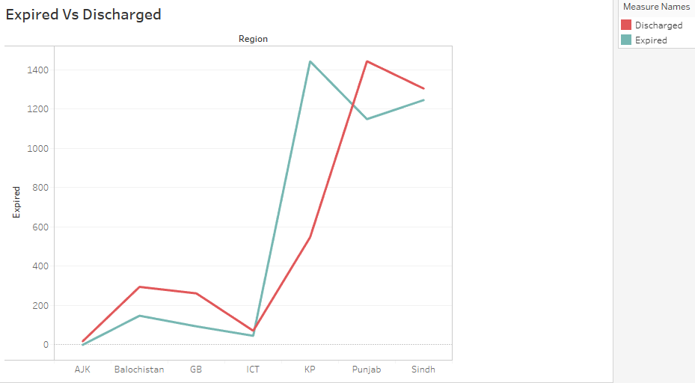

This visualization is useful because it gives a clear view to differentiate between the rates of discharged and expired.it can be interpreted from graph that except for KP all other provinces have higher discharge rate than death rate whereas according to the dataset of May KP has higher death rate.

**Most Effected Province:**

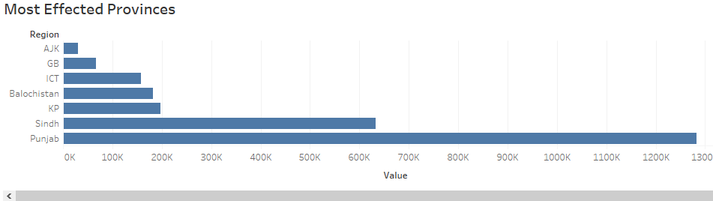

This visualization also provides a useful insight as it shows that worst hit region is Punjab and least hit region is AJK.whereas Singh stands second to Punjab being second worst hit region.

**Death Rate in Different Provinces:**

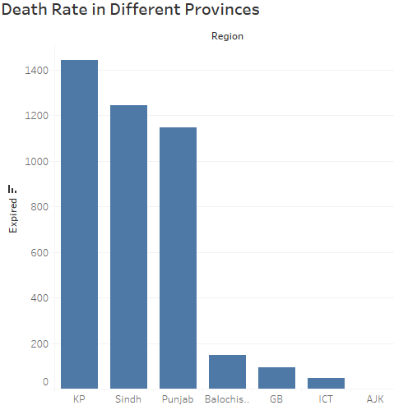

This is a simple but informative visualization.it gives useful insight for finding highest death rate in different provinces.