**Placing the order via adding an item into the cart and then proceeding with the checkout option.**

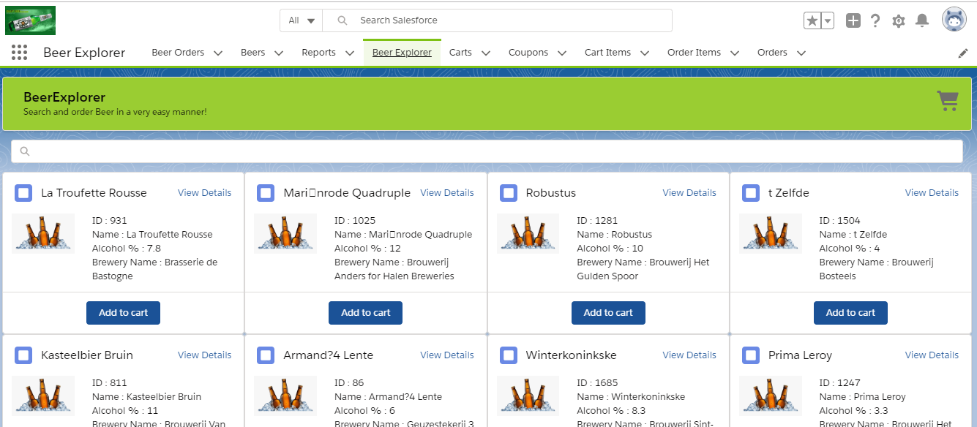

Search box. To search for beers.If nothing is searched, the page will display at arbitrary10 records.

Header Component that displays the Title and the message.

Cart. To view the items user have added in the cart with the further detail such as total billing amount.

View Details. To view the detail of a beer.

Add to cart button is clicked when user wants to add a beer to the cart.

User can apply for coupon by clicking here.

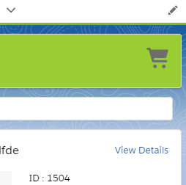 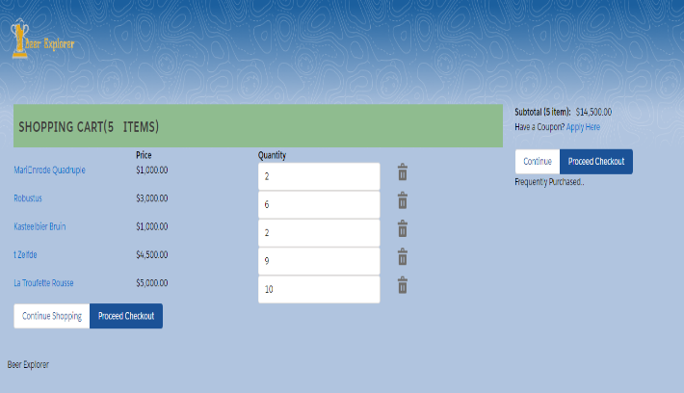

User will be redirected back to the first page where they can choose more beers to add to the cart.

List of beers added to the Cart along with its price and quantity of beer.

On clicking this icon

By clicking here user will be redirected to address detail page.

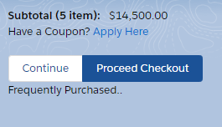 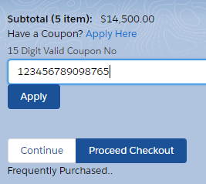 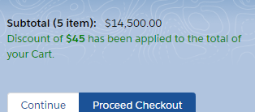

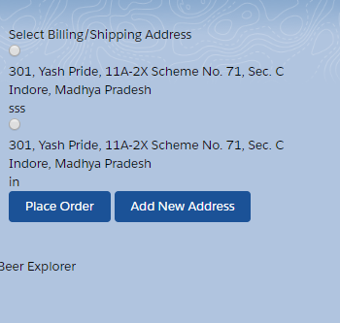 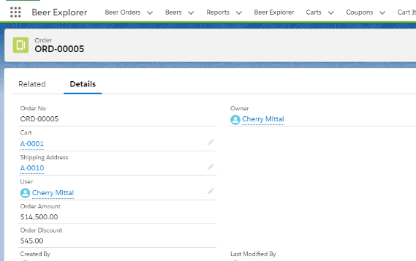

The order has been placed.

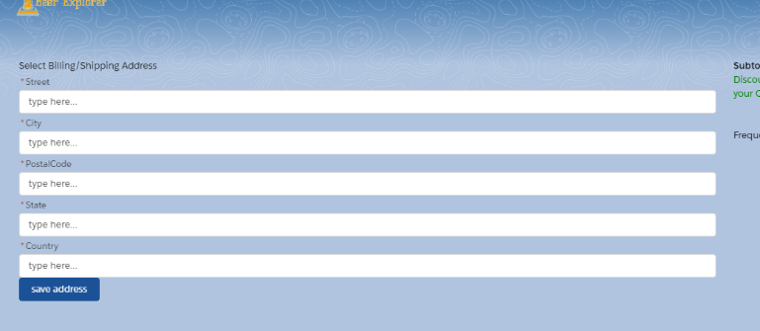

Address will go in here. Which will then be saved in the users data so that if the same user orders beer again, he/she doesn’t need to fill the address again.

**Placing the order from the view details button displayed at each of the displayed beer components**

This button onclick takes the user to another page where we need to enter the address of delivery.

On clicking the View Details button on the specific beer the navigation takes us to this Overlay Library which displays the details of a beer.

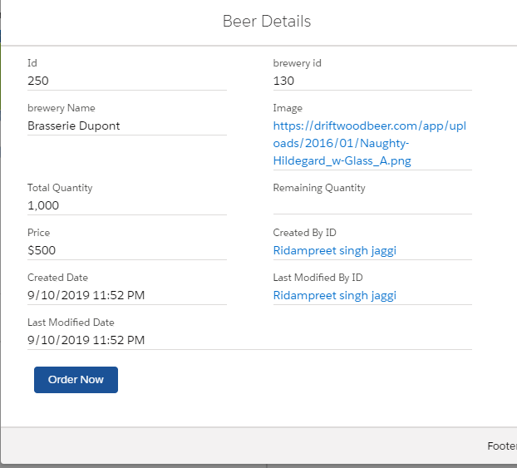

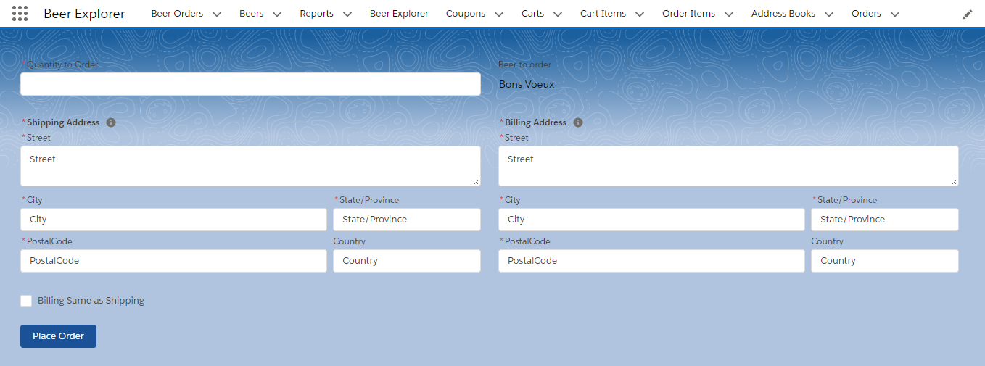

Here you can enter the Billing Address for the beer order or you can also select the checkbox for Billing same as Shipping

Enter the Shipping Address of the beer order

Enter the quantity of beers

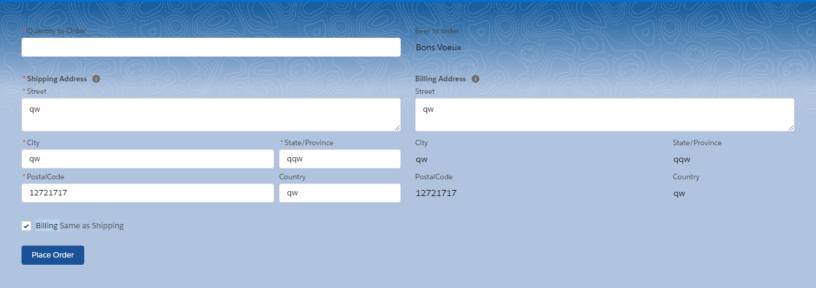

After selecting the checkbox for billing same as shipping we can see that the address we had entered in the shipping address fields has been autofilled.

As you can see we have filled the billing address as a random dataset and this same address can be used as billing address by clicking on the checkbox given below which is ticked at the moment

On clicking Place Order the button will place an order and will redirect you to a page.

This represents the order number.

Conformation that the order has been placed.

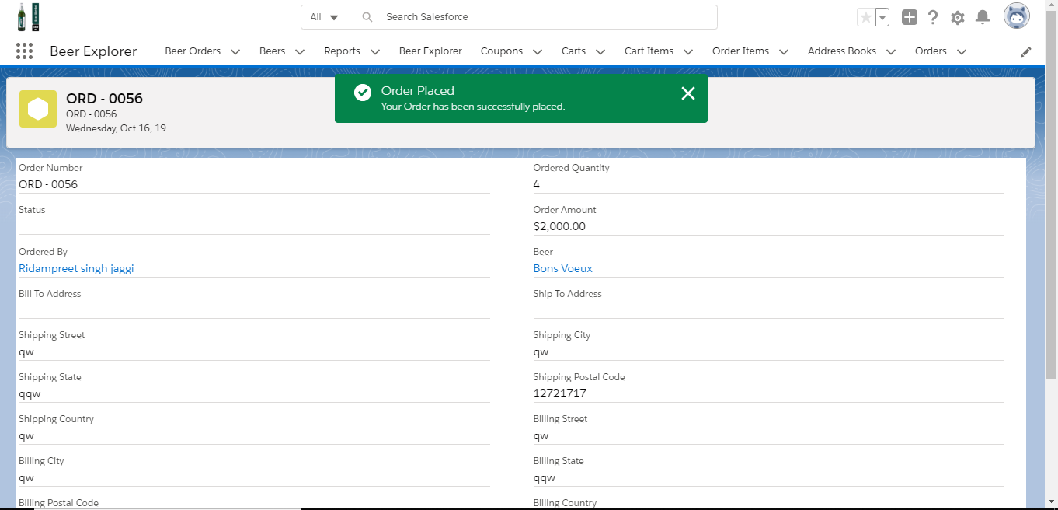

Now this page contains all the information regarding the order such as the number of the order and the address at which the order has to be delivered and the quantity of the beer.