Logistics Data Analysis and Visualization
  - Week 3 Advanced Data Analysis and Visualization in Logistics
Logistics Data Analyst Intern
Prepared by Rida Sahin
23 October 2026

1 Executive summary
The analysis identifies delivery transit, destination differences, and a long delivery-time tail as priorities for investigation in a hypothetical ecommerce marketplace. It uses the order-level data prepared in Week 2 as a historical benchmark and a separate, explicitly simulated shipment dataset to demonstrate transportation-cost analysis.
Of 96,470 eligible completed orders, 89,936 arrived on or before the promised calendar date, giving an on-time rate of 93.23%. The typical delivery cycle was 10.22 days, but 4,550 orders took more than 30 days. Transit accounted for 74.21% of mean elapsed time in the subset with valid sequential milestones. These findings identify where to investigate; they do not establish the causes of delay.
Key result | Value | Analysis population
Completed-order on-time delivery | 93.23% | 96,470 orders
Median purchase to delivery cycle | 10.22 days | 96,470 orders
90th percentile delivery cycle | 23.10 days | 96,470 orders
SP and RJ share of all late orders | 50.73% | 6,534 late orders
Mean hypothetical transport cost | BRL 39.53 | 2,000 simulated shipments

Purpose and scope
The business question is how an operations team should prioritize delivery investigations, prepare for demand variation, and assess potential cost drivers. The work includes central tendencies, dispersion, distributions, time trends, geographic comparisons, stage analysis, correlations, eight embedded visualization outputs, Python excerpts, and actionable recommendations.
Historical freight amounts represent recorded customer charges, not measured carrier operating costs. The hypothetical experiment therefore uses its own disclosed cost formula. Observed and simulated records are never pooled. No predictive model, route optimization, or operational intervention was implemented in this exploratory stage.
Reading guide: Sections 2–4 define the data and methods; Sections 5–11 interpret the historical charts; Sections 12–13 analyze the hypothetical shipments; Sections 14–17 provide recommendations, code, reproducibility details, and references.

2 Dataset structure and provenance
The hypothetical marketplace coordinates independent sellers and delivery partners. Its historical reference is Olist’s official public repository [1]. Week 2 joined four tables at order level: 99,441 orders, 112,650 order-item records, 99,441 customer records, and 32,951 product records. Item-level monetary amounts and product measurements were aggregated before joining, preventing an order from being counted once per item.
The reference snapshot is fixed at commit d9e49802f3e92d09ee94ab9ccc5e457f207a8959 and was retrieved on 22 October 2026. Purchase timestamps span 4 September 2016 to 17 October 2018. The source manifest stores original URLs, byte sizes, and SHA-256 checksums. The audit table preserves all 99,441 unique order identifiers.
Field or group | Definition and analytical use
order_id and order_status | One record per order; delivered status defines completed-order eligibility.
purchase and milestone timestamps | Purchase, approval, carrier handover, customer delivery, and estimated delivery dates.
cycle_days | Customer delivery minus purchase, expressed in days.
approval_wait_days | Approval minus purchase; measures the initial waiting interval.
dispatch_days and transit_days | Approval to carrier handover; carrier handover to customer delivery.
on_time | Actual delivery calendar date is no later than the promised calendar date.
freight_brl and order_value_brl | Sum of item freight charges and merchandise prices per order, in Brazilian reais.
item_count and seller_count | Order-item record count and distinct seller count per order.
weight_kg and volume_litres | Summed catalogue product weight and volume converted from grams and cubic centimetres.
customer_state and purchase month | Destination-state grouping and monthly purchase-cohort grouping.

Order counts and item counts measure demand in this benchmark. They are not verified physical parcel counts, truck loads, or vehicle trips. Summed product volume is a size proxy, not measured packed parcel volume. The separate simulation in Section 12 has an explicit shipment-level structure, including transportation costs and item units.
All monetary comparisons remain in BRL. No conversion to another currency or inflation adjustment is applied. Source timestamps lack timezone offsets, so elapsed times retain the source wall-clock convention.

3 Methodology and valid populations
The workflow loads the preserved audit table, verifies unique order identifiers, selects a valid population for each KPI, calculates descriptive statistics and associations, creates figures, and independently reconciles the saved results. Python 3.12.14, pandas 3.0.1, NumPy 2.3.5, and ReportLab 4.4.9 were used. ReportLab generates the charts; Poppler converts them to the embedded PNG images.
Analysis | Eligible records | Rule
Master audit | 99,441 | All source orders retained
Cycle and on-time KPIs | 96,470 each | Delivered with valid cycle; on-time additionally requires promise evidence
Additive stage comparison | 95,082 | Delivered; all three nonnegative stage intervals
Six-variable correlations | 96,448 | Completed cycle; all six variables observed
Monthly purchased orders | 86,288 | Purchases from Jan 2017 through Jun 2018
Monthly delivery-time observations | 83,696 | Eligible completed cycles within that window

There are 96,478 orders marked delivered, but eight lack usable cycle evidence. The 2,963 orders with other statuses are excluded from completed-delivery KPIs, so the 93.23% on-time rate is not an all-orders fulfillment rate. Stage analysis excludes 1,396 delivered orders with absent or inconsistent stage evidence. Its slightly different total mean must not be substituted for the broader cycle mean.

Treatment of quality issues and extreme values
Week 2 preserved original timestamps and masked invalid derived intervals. Week 3 uses these observed, unscaled fields, not median-imputed or normalized model inputs. Missing weight affects 22 completed orders; missing volume affects 16. Complete-case correlations use one common population rather than silently changing the denominator for each cell.
Plausible extremes are retained. For example, the maximum observed completed cycle is 209.63 days. The distribution figure limits its visible axis to 60 days for readability and explicitly discloses the 306 records beyond that range. Those observations still contribute to means, percentiles, and tail counts.
Means, medians, sample standard deviations, quartiles, and 90th percentiles describe the distribution [2]. Spearman correlations use Pearson correlations of average ranks, handling tied values; Pearson results are also saved [3]. No significance tests or causal estimates are claimed. The monthly window ends in June 2018 to allow longer follow-up before the source’s October 2018 endpoint, although completed-only selection remains a limitation.

4 Descriptive analysis and central tendencies
The table reports observed values within the eligible completed-cycle population. Counts vary only where a specific measurement is missing. Standard deviation uses the sample definition with n minus 1 in the denominator. P90 is the value at or below which approximately 90% of observed records fall.
Measure | n | Mean | Median | Std dev | P90
Delivery cycle days | 96,470 | 12.56 | 10.22 | 9.55 | 23.10
Freight charge BRL | 96,470 | 22.83 | 17.19 | 21.74 | 39.47
Order value BRL | 96,470 | 137.04 | 86.50 | 209.05 | 269.00
Items per order | 96,470 | 1.14 | 1.00 | 0.54 | 1.00
Product weight kg | 96,448 | 2.39 | 0.75 | 4.77 | 6.55
Product volume litres | 96,454 | 17.33 | 7.25 | 30.14 | 42.98

Interpretation of the typical order
The delivery-cycle mean is 12.56 days, above the median of 10.22 days. The middle half of completed orders lies between 6.77 and 15.72 days. Positive skewness of 3.83 confirms a long right tail. A single average therefore understates the experience of slower deliveries; the median and P90 should be monitored together.
Freight charges are also right-skewed: the mean is BRL 22.83, the median BRL 17.19, and P90 BRL 39.47. The maximum is BRL 1,794.96. High values may correspond to large or multi-item orders and should be reviewed against source records before being classified as errors. There is no automatic deletion based only on a high monetary amount.
The mode and median of item count are both one, while the mean is 1.14 and the maximum is 21. A count-based mode is informative here because most orders have the same small discrete count. For continuous time and charge measurements, the median is more useful than a mode tied to rounding precision.

Operational meaning
A dashboard should pair the on-time percentage with absolute late counts, delivery median, delivery P90, and valid-record coverage. Staffing estimates also need demand counts. Freight-charge summaries help identify segments for pricing or invoice review, but cannot establish profitability without actual carrier invoices and handling costs.
The full table, including minima, maxima, quartiles, and skewness, is supplied in descriptive_statistics.csv. Figures and interpretations in the next sections use these same saved results.

5 Monthly demand and delivery trends
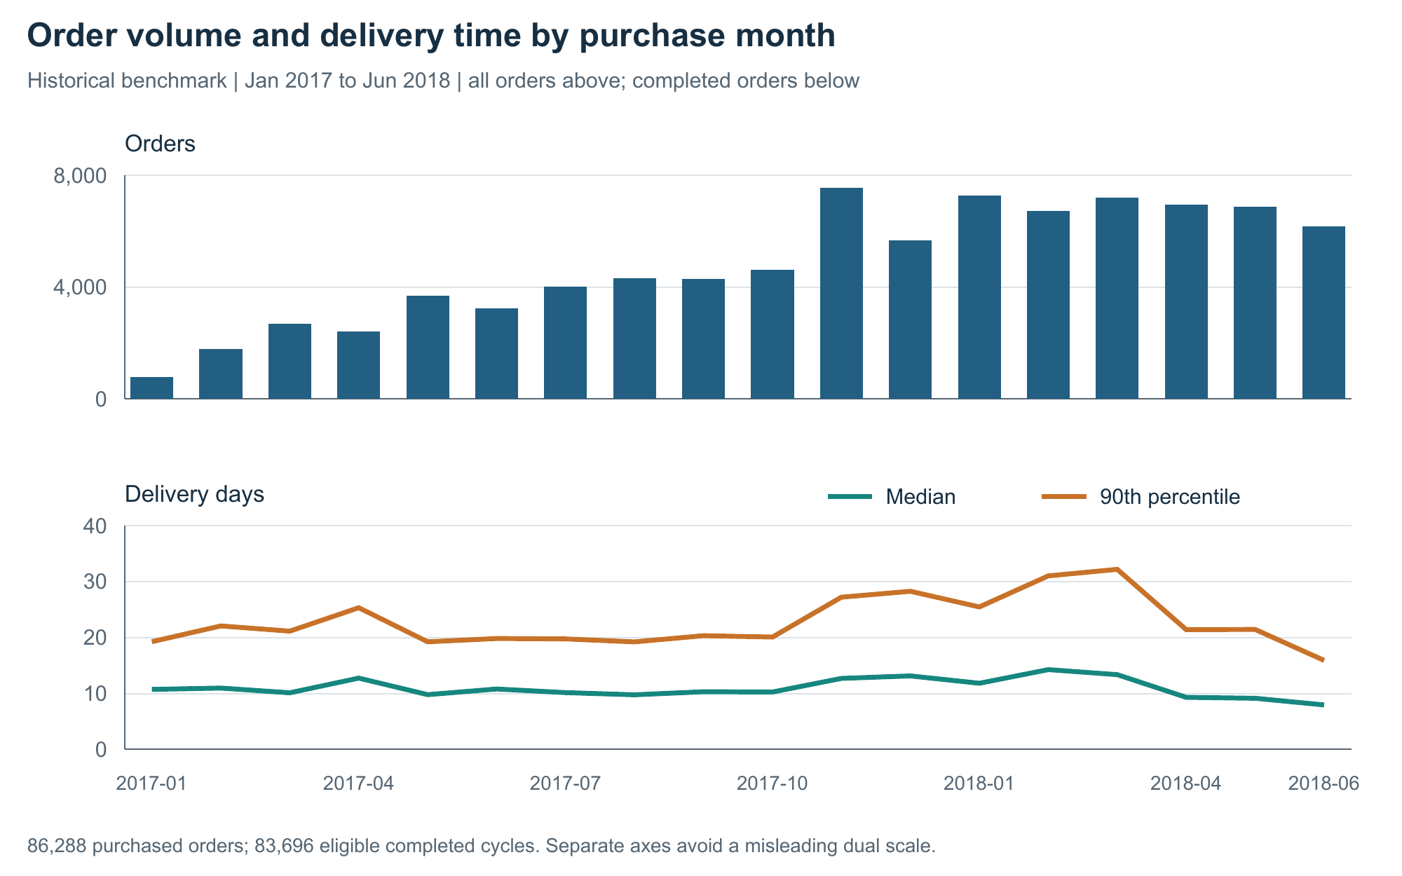
Figure 1. Monthly purchased orders and completed-order cycle times. Bars use all orders in the selected purchase window; duration lines use eligible completed orders within each month.
Why this chart: Aligned bars and lines preserve time order while separating demand volume from duration units. The two panels make simultaneous changes visible without placing unrelated quantities on a single vertical scale.
Finding: Orders rose from 4,631 in October 2017 to 7,544 in November, a 62.90% increase. Over the same purchase cohorts, median delivery time rose from 10.26 to 12.70 days and P90 from 20.09 to 27.21 days. March 2018 had the highest P90 in this window, 32.19 days; June 2018 had a median of 7.96 days and P90 of 15.91 days.
Interpretation and action: The late-2017 pattern is consistent with a capacity-pressure hypothesis, but demand, destination mix, and service policies may change together. Review staffing, carrier handover, and destination mix around peaks before attributing slower delivery to volume. Monitor monthly coverage as well: eligible completed observations range from 92.87% to 98.85% of purchased orders across these months.
The chart describes historical purchase cohorts, not current demand or a forecast. No holiday or disruption cause is inferred from the calendar alone.

6 Delivery distribution and slow deliveries
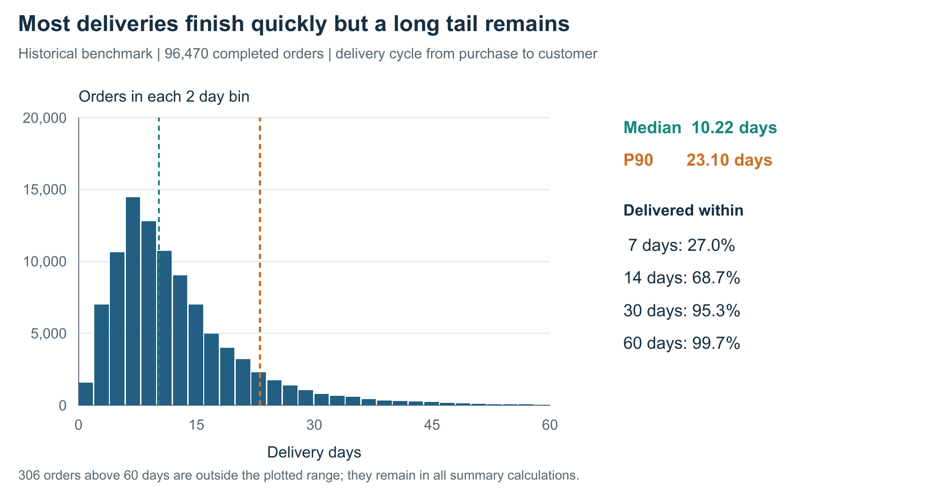
Figure 2. Two-day-bin histogram and cumulative delivery shares for 96,470 eligible completed orders. The median and P90 markers summarize different parts of the distribution.
Why this chart: A histogram reveals concentration, asymmetry, and long tails that an average conceals. The cumulative percentages connect the distribution to practical service windows such as two weeks or one month.
Finding: The median is 10.22 days and P90 is 23.10 days. About 68.7% of completed deliveries finished within 14 days. A total of 4,550 orders, or 4.72%, exceeded 30 days; 306, or 0.32%, exceeded 60 days. The maximum of 209.63 days remains in the statistics even though it lies outside the plotted range.
Interpretation and action: A typical delivery is substantially faster than a slow-tail delivery. Use a separate exception queue to inspect unusually long open orders and missing milestone updates. A fixed 30-day flag is an exploratory review rule, not a universal late-delivery definition: contractual lateness still depends on the promised date for each order.
Track the share of orders beyond agreed review thresholds alongside P90. Before changing customer promises, compare destinations and services, examine long-duration source records, and distinguish real delays from delayed or incorrect milestone capture.

7 Regional on time performance
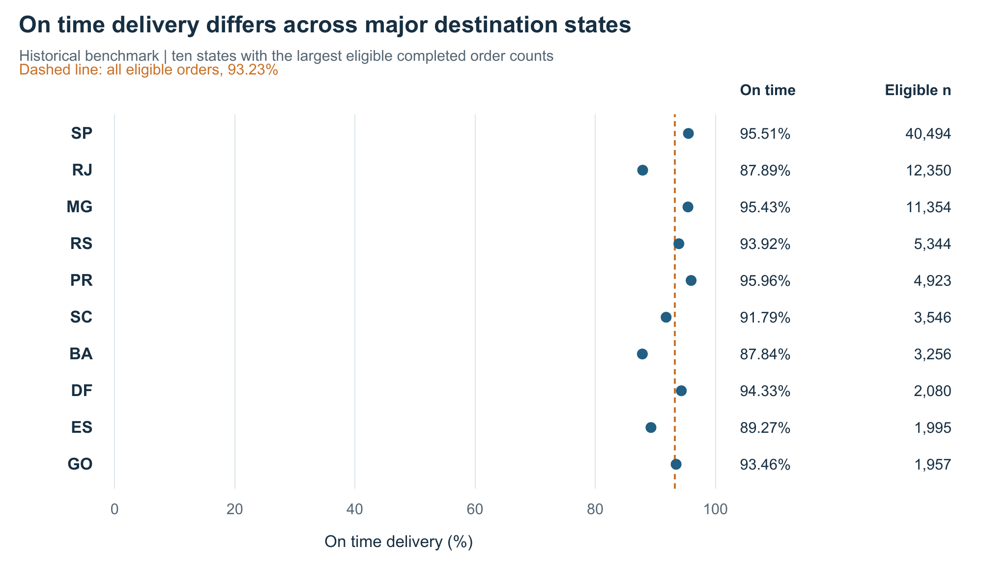
Figure 3. On-time delivery rates for the ten largest destination states by eligible completed orders. The overall 93.23% reference includes all 27 destination states.
Why this chart: A dot plot compares rates on a common 0–100% scale, while adjacent denominators show how much evidence each rate represents. Selecting states by volume avoids choosing only the most extreme percentages.
Finding: Sao Paulo (SP) achieved 95.51% on time over 40,494 eligible orders. Rio de Janeiro (RJ) achieved 87.89% over 12,350, a 7.61 percentage-point gap. Bahia (BA) was also lower at 87.84%, while Parana (PR) reached 95.96%. These are descriptive rates for this historical snapshot.
Interpretation and action: RJ merits investigation because it combines lower on-time performance with substantial order volume. Break results down by seller origin, carrier, service, order size, and promised lead time before deciding which process to change. State is a destination segment; it is not itself an operational cause. Section 11 adds absolute late counts to this rate comparison.
Other labels: MG Minas Gerais; RS Rio Grande do Sul; SC Santa Catarina; DF Distrito Federal; ES Espirito Santo; GO Goias. Percentages are not adjusted for different route or product mixes.

8 Delivery stage bottlenecks
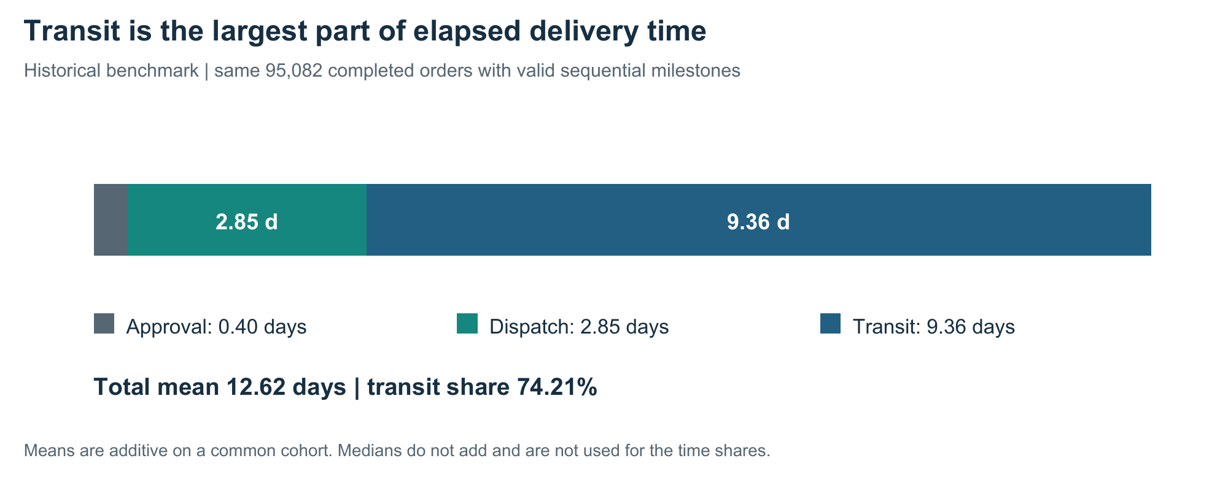
Figure 4. Additive mean durations for 95,082 delivered orders with valid sequential milestone evidence. The total is calculated before rounding component values.
Stage | Mean days | Median days | P90 days
Purchase to approval | 0.40 | 0.01 | 1.39
Approval to carrier | 2.85 | 1.85 | 6.02
Carrier to customer | 9.36 | 7.11 | 18.95

Why this chart: A stacked mean-duration bar makes the contribution of each sequential stage visible. All stages use exactly the same orders, so their means add to the mean total. Median stages would not add correctly and are shown only as separate summaries.
Finding: Mean approval, dispatch, and transit times are 0.40, 2.85, and 9.36 days respectively, totaling 12.62 days before rounding. Transit contributes 74.21% of this mean elapsed time and has a P90 of 18.95 days. Dispatch P90 is 6.02 days, so seller preparation and handover still warrant attention.
Interpretation and action: Inspect transit visibility, handover confirmation, and route-level service differences first, alongside dispatch exceptions. The longest stage is a candidate bottleneck, not proof of avoidable delay: geographic travel requirements can naturally make transit longer. Obtain carrier scans and route or service data before setting reduction targets.

9 Freight charges and product weight
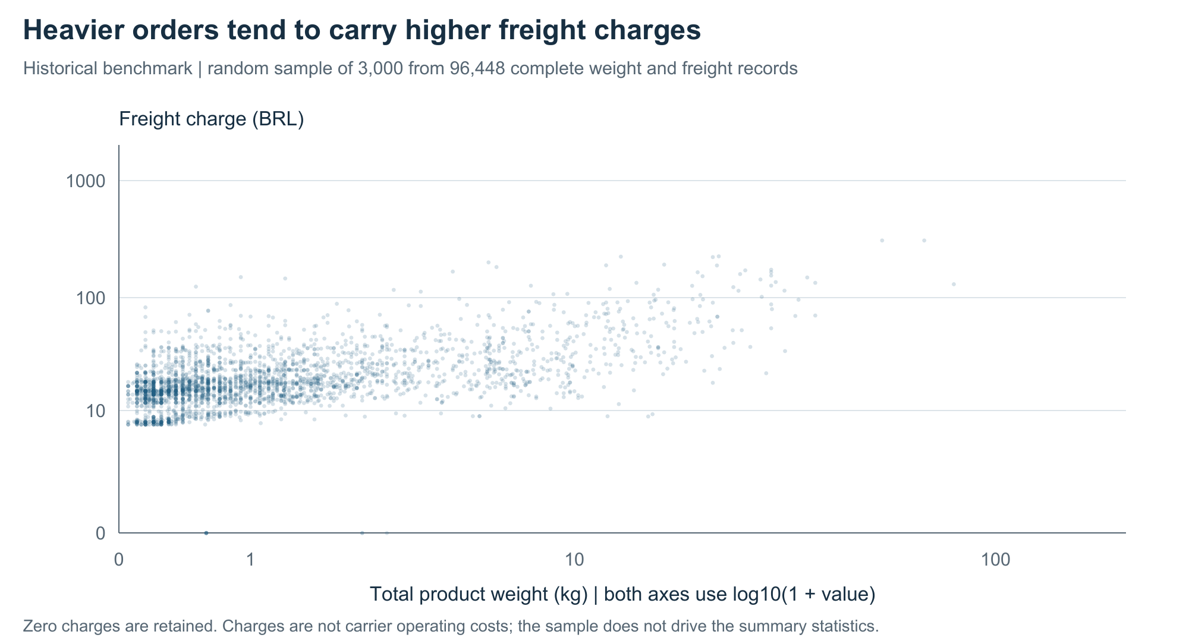
Figure 5. Seeded random visual sample of 3,000 orders from 96,448 completed orders with observed weight and freight. All records, including 336 zero-charge orders, contribute to the full-population analysis.
Why this chart: A scatter plot reveals both an overall association and variation among orders of similar weight. The log10(1 + value) axes compress extremes while retaining zero charges. Axis labels show original units. Sampling controls overplotting; reported statistics use the full valid population.
Finding: The complete-case Spearman correlation between weight and freight is 0.492. Median freight rises from BRL 15.10 for orders up to 0.25 kg to BRL 49.80 for orders above 10 kg. The latter group contains 5,268 orders; its middle half ranges from BRL 31.19 to BRL 77.82. Weight alone therefore does not explain the charge.
Interpretation and action: Review high-charge orders within comparable weight, destination, and service groups. Request actual carrier charges and measured parcel dimensions before estimating savings. Packaging changes may reduce billable volume, but the available catalogue measurements do not establish actual parcel dimensions or the carrier’s charging rule.
Freight is a customer charge; no margin, fuel efficiency, cost per kilometre, or realized transport saving is inferred from this historical scatter plot.

10 Correlations among logistics variables
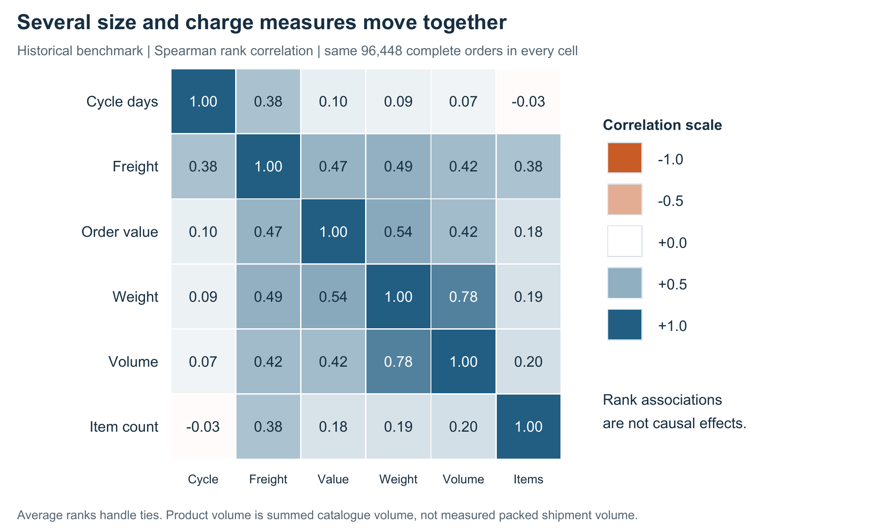
Figure 6. Spearman correlations on a common complete-case population of 96,448 orders. Values range from negative one to positive one; diagonal values equal one by definition.
Why this chart: An annotated heatmap compares many relationships consistently. Spearman ranks reduce dependence on linear scale and are suitable for these skewed quantities. A common population makes cells directly comparable; ties receive average ranks.
Finding: Freight correlates with weight at 0.492, order value at 0.469, product volume at 0.425, and cycle time at 0.381. Weight and volume correlate at 0.781, indicating overlapping size information. Cycle time has much weaker rank relationships with weight (0.087) and volume (0.069). Pearson matrices are also supplied for linear-association comparison.
Interpretation and action: Size and value are useful segmentation variables for freight review. Including weight and volume together in future models may create redundant information, so validate their added predictive value. Higher freight is associated with longer delivery, but this does not show that charging more causes delay; unobserved distance, service, and route complexity may influence both.
These correlations describe this sample. They are not causal estimates, model accuracy scores, or evidence that changing one input will create a stated business improvement.

11 Prioritizing the late order workload
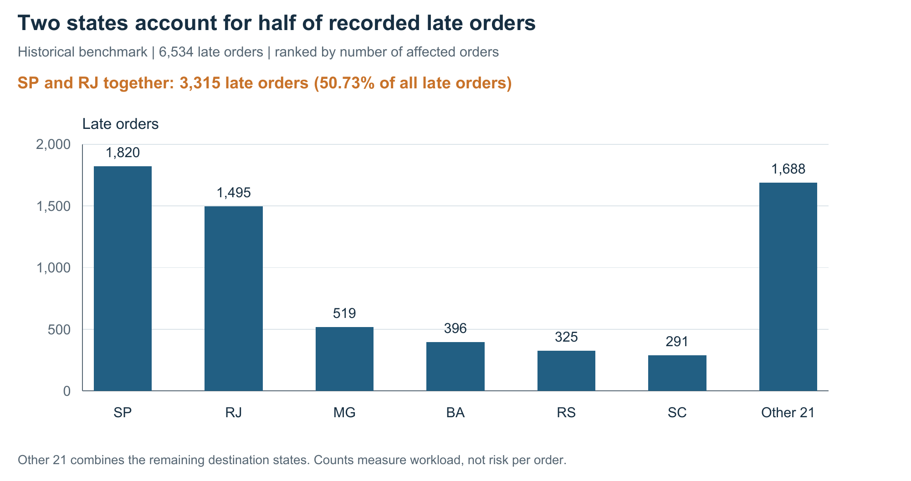
Figure 7. Late-order counts for the six largest contributors, plus all remaining states combined. Lateness uses the promised calendar date rather than a fixed delivery-duration threshold.
Why this chart: Absolute counts quantify investigation workload and customer impact. They complement the rate comparison in Figure 3: a high-volume segment can generate many late orders despite a relatively good on-time rate. The residual bar makes the total reconcile to all 6,534 late orders.
Finding: SP contributes 1,820 late orders and RJ 1,495. Together they account for 3,315 cases, or 50.73% of all observed late orders. MG contributes 519, BA 396, RS 325, and SC 291. The other 21 states contribute 1,688 collectively.
Interpretation and action: Begin an exception-review pilot with SP and RJ, using separate goals. RJ offers a large rate gap to investigate; SP offers a large absolute workload. Do not allocate resources only to the lowest percentage or only to the largest state. Estimate the cases an intervention could actually prevent, its handling time, and its operating cost before expanding it.
The historical counts indicate where to investigate; they do not predict next month’s case counts. A live queue would require recent timestamps, an agreed review capacity, and checks that the intervention does not worsen performance elsewhere.

12 Hypothetical shipment dataset
A separate dataset of 2,000 simulated shipments demonstrates an analysis where transportation cost is explicitly available. The scenario is one marketplace operating during July 2026. Each row represents one shipment; it contains a shipment identifier, dispatch date, item units, distance, weight, extra delay, delivery time, promised duration, and modeled transportation cost. These records are generated for an exercise and are not historical Olist observations.
Input | Generation rule or assumption
Random generator | NumPy default_rng with seed 20261022; 2,000 records.
Dispatch date | Uniform integer day offset from 0 to 30 after 1 July 2026.
Distance km | Independent uniform draw between 50 and 1,200 km.
Weight kg | Lognormal draw with log mean ln(2) and log standard deviation 0.8; clipped to 0.2–30 kg.
Item units | Independent uniform integer from 1 to 5 per shipment.
Extra delay days | Draw from 0, 1, 2, 4 with probabilities 65%, 20%, 10%, 5%.
Delivery days | 1 + distance_km / 300 + extra_delay_days.
Promised days | ceil(1 + distance_km / 300) + 1; on time if delivery_days is no greater.
Transport cost BRL | 12 + 0.035 × distance_km + 1.2 × weight_kg + 4 × extra_delay_days.

The fixed fee, distance rate, weight rate, and extra-delay charge are assumed solely to illustrate a transparent cost model. Distances and delays are not derived from the historical data. Item units describe shipment demand; they do not directly enter the cost formula, so no item-count cost effect is implied.
The generated records contain 5,947 item units across 2,000 shipments, averaging 64.52 shipments per day over 31 days. Uniform date generation does not model seasonality or weekday demand. Inputs are deliberately complete and valid, so this scenario tests analysis and sensitivity rather than real-world data quality problems.
The exact generation sequence is in analyze.py and the full simulated data is in hypothetical_shipments.csv. The saved seed, distributions, coefficients, and Python package versions allow the experiment to be reproduced.

13 Hypothetical transportation cost analysis
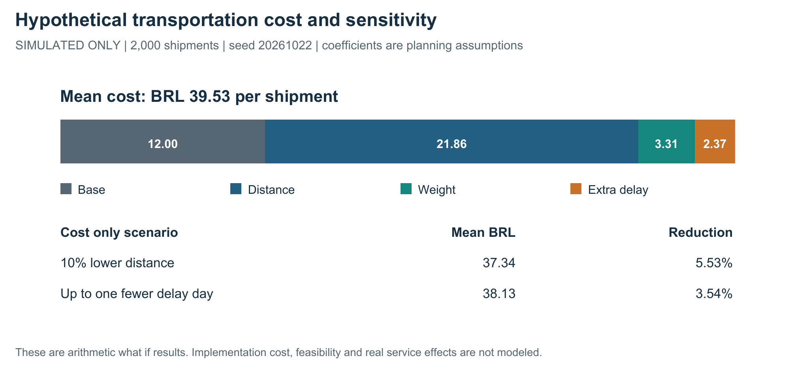
Figure 8. Mean modeled transportation-cost components and two separate cost-only sensitivity scenarios for the 2,000 hypothetical shipments. All coefficients are assumptions.
Why this chart: The stacked bar explains how an explicit cost formula produces the total. The scenario comparison shows sensitivity in the same BRL-per-shipment unit, with percentages relative to the unchanged baseline.
Finding: Mean modeled cost is BRL 39.53, median BRL 39.16, sample standard deviation BRL 12.71, and P90 BRL 55.69. Mean delivery time is 3.67 days, median 3.60 days, and P90 5.56 days. The generated on-time rate is 84.65%. These results describe the hypothetical rules, not the marketplace’s observed service.
The distance component averages BRL 21.86, or 55.29% of total modeled cost. A 10% decrease in every distance input lowers mean cost by BRL 2.19, or 5.53%. Removing up to one extra-delay day per shipment lowers it by BRL 1.40, or 3.54%. The scenarios are calculated separately, holding all other inputs fixed; they do not update promised or actual service times.
Interpretation and action: Distance sensitivity is larger under these assumed rates, which motivates collecting route distances and actual invoices for a future feasibility study. The distance–cost Pearson correlation of 0.918 largely follows from the imposed formula. It is not independently discovered evidence. No realized saving is claimed, and implementation costs, routing constraints, vehicle capacity, and service effects must be assessed before action.

14 Recommendations and limitations

Prioritized actions for a future operational pilot
- Investigate carrier transit and dispatch exceptions. Operations should review long intervals, carrier scan gaps, and seller handover records. Track median and P90 stage time plus milestone completeness; 74.21% transit share is a diagnostic starting point, not an achievable saving.
- Review SP and RJ separately. A service team should sample late cases by seller, route, and service type. Measure on-time percentage, late counts, and review effort together. Compare an intervention group with a contemporaneous control before claiming improvement.
- Prepare for demand peaks using recent order forecasts and capacity records. Track volume, backlog, dispatch age, and completion coverage together. The 2017–2018 pattern is a historical signal and cannot establish present staffing needs.
- Build a real transport-cost dataset. Finance and logistics should join carrier invoices, distance, service class, parcel weight and dimensions, handling charges, and intervention costs. Replace the hypothetical coefficients before evaluating financial returns.
- Improve milestone data capture. Assign owners to missing or reversed timestamps, retain raw values and audit flags, and publish KPI denominators. An apparently improved delivery average can result from excluding difficult cases.

Limits of the evidence
The historical data represents an older marketplace snapshot, not current operations. Completed-order KPIs exclude unfinished and other-status orders and can be optimistic relative to an all-orders view. State differences are not adjusted for route, seller, service, product mix, or promise policy. Correlations cannot resolve these confounders. Customer freight charges and catalogue volume cannot establish actual transport costs or packed shipment dimensions.
The hypothetical shipment experiment uses independent draws and assumed rates. It does not simulate operational feedback, stock constraints, route feasibility, labor capacity, real customer behavior, or intervention costs. Its sensitivities describe arithmetic under the stated assumptions. Future gains require a feasible intervention and a controlled comparison using fresh data.

Conclusion
The completed exploratory workflow establishes transparent service KPIs, shows where delivery variability is concentrated, and separates regional risk from workload. It provides a practical basis for targeted investigation and for collecting the missing cost and route data. The next step is to validate operational explanations and test a limited intervention, then evaluate service and cost effects against an agreed baseline.

15 Python analysis excerpts
The complete executed scripts are supplied with the project. These excerpts illustrate the core calculations; d is the prepared audit table, with Boolean eligibility fields and numeric durations. Functions such as describe, quantile, groupby, and corr are used for reproducible summaries [2, 3].
import pandas as pd
import numpy as np
d = pd.read_csv("data/orders_audit.csv.gz")
c = d.loc[d.eligible_cycle].copy()
o = d.loc[d.eligible_otd].copy()
on_time_rate = 100 * o.on_time.astype(bool).mean()
cycle_summary = c.cycle_days.describe(
percentiles=[.25, .5, .75, .9])
late_n = int((~o.on_time.astype(bool)).sum())

Eligibility is defined before calculation. The full script also checks unique order identifiers, normalizes Boolean fields when loading, and asserts that all eligible on-time flags are present. It preserves the distinction between missing measurements and genuinely observed zero values.
d["weight_kg"] = d.total_weight_g / 1000
d["volume_litres"] = d.total_volume_cm3 / 1000
cols = ["cycle_days", "freight_brl", "order_value_brl",
"weight_kg", "volume_litres", "item_count"]
complete = d.loc[d.eligible_cycle, cols].dropna()
spearman = complete.rank(method="average").corr()
pearson = complete.corr(method="pearson")
spearman.to_csv("results/spearman_correlations.csv")

Using one complete-case table gives every matrix cell the same denominator. The Pearson correlation of average ranks is the Spearman coefficient, including tie handling. The unranked Pearson matrix is retained as a separate linear-association view.
stage_cols = ["approval_wait_days", "dispatch_days",
"transit_days", "cycle_days"]
stages = d.loc[d.order_status.eq("delivered"),
stage_cols].dropna()
assert np.allclose(stages[stage_cols[:3]].sum(axis=1),
stages.cycle_days)
means = stages.mean()
transit_share = 100 * means.transit_days / means.cycle_days

All reported figures and tables are produced from saved calculations, not manually invented values. The numerical verification checks were run independently of the analysis script.

16 Python visualization and simulation excerpts
ReportLab is the Python graphics library used to generate the eight vector figures [4]. The Word report embeds PNG versions of those actual outputs. The example below draws the same two-day histogram calculation with explicit axis scaling; make_charts.py adds the titles, axes, labels, percentile markers, and tail annotation.
from reportlab.graphics.shapes import Drawing, Rect
from reportlab.graphics import renderPDF
from reportlab.lib.colors import HexColor
counts, edges = np.histogram(c.cycle_days,
bins=np.arange(0, 62, 2))
chart = Drawing(720, 380)
for count, left in zip(counts, edges[:-1]):
chart.add(Rect(60 + left / 60 * 360, 70,
2 / 60 * 360 - 1, count / 20000 * 220,
fillColor=HexColor("#225F83"),
strokeColor=None))
renderPDF.drawToFile(chart, "histogram_example.pdf")

This excerpt illustrates the plotting mechanism. The complete figures, including annotations and readability settings, are generated by make_charts.py from the saved tables.
# sim contains the independently generated shipment inputs.
sim["transport_cost_brl"] = (
12 + .035 * sim.distance_km + 1.2 * sim.weight_kg
+ 4 * sim.extra_delay_days)
sim["cost_distance_minus10pct_brl"] = (
sim.transport_cost_brl - .1 * .035 * sim.distance_km)
sim["cost_delay_minus1day_brl"] = (
sim.transport_cost_brl
- 4 * np.minimum(sim.extra_delay_days, 1))

The second scenario removes at most one day, so a shipment with no extra delay receives no reduction. This explains why the mean reduction is BRL 1.40 rather than BRL 4.00 for every shipment. The code changes cost only and does not imply a real route or service intervention.

Reproducibility and numerical validation
The supplied project contains the compressed audit input, the synthetic dataset, eight PNG figures and their PDF versions, result tables, scripts, source attribution, the Word report, and submission text. A separate verifier recomputed the saved results without importing analyze.py; all 543 numerical checks passed. These checks cover cohorts, descriptive statistics, monthly and state totals, correlations, histogram tails, and simulation formulas. They do not validate operational causality.

17 Sources and deliverable guide
Primary sources support the dataset provenance and software methods. All historical numerical findings in this report are calculations from the retained snapshot. Hypothetical coefficients and generation rules are explicitly stated in Section 12 and are not attributed to the data provider.

1 Olist official dataset repository
https://github.com/olist/work-at-olist-data/tree/d9e49802f3e92d09ee94ab9ccc5e457f207a8959
Original orders, order items, customers, and products; repository README and MIT license. Retrieved 22 October 2026.

2 pandas descriptive statistics
https://pandas.pydata.org/docs/reference/api/pandas.DataFrame.describe.html
Reference for descriptive summaries, numeric counts, central tendency, and percentiles. Accessed 22 October 2026.

3 pandas correlation methods
https://pandas.pydata.org/docs/reference/api/pandas.DataFrame.corr.html
Reference for Pearson and rank correlation methods. Accessed 22 October 2026.

4 ReportLab graphics documentation
https://docs.reportlab.com/reportlab/userguide/ch11_graphics/
Reference for drawings, chart elements, and graphics rendering. Accessed 22 October 2026.

Files for review and reproduction
File or folder | Purpose
Word report | Submission document with analysis, figures, explanations, and code excerpts.
Submission description | At least 200 words to paste into the portal description field.
analyze.py and make_charts.py | Executed analysis, simulation, and visualization scripts.
verify_outputs.py | Independent numerical checks for saved analysis results.
data and results | Compressed historical audit data, attribution, simulated shipments, and summary tables.
figures and README.md | Eight embedded chart outputs and instructions for rerunning and publishing the project.

Figures are embedded as high-resolution images and can be viewed directly in this report. The supporting project contains their individual files. GitHub publication is a separate upload step; no repository URL is invented or claimed.

