Predictive Modeling and Optimization in Logistics Systems
  - Week 4 Logistics Data Analyst Internship
Prepared by Rida Sahin
23 October 2026

1 Executive summary
This project predicts the number of days from order approval to customer delivery and uses those predictions to prioritize a limited daily review queue for a hypothetical ecommerce marketplace. It completes the workflow from prepared data through model comparison, chronological validation, final testing, and a worked allocation strategy. A separate simulated shipment experiment demonstrates the same prediction task on a fully specified hypothetical dataset.
Histogram gradient boosting with 15 leaves achieved the lowest validation mean absolute error among ten candidates. On 19,654 eligible completed test orders, its mean absolute error was 4.67 days, a 13.52% reduction from the training median baseline. Its R squared was 0.257. The model offers a useful benchmark, but substantial error remains, especially for unusually slow deliveries.
Measured result | Value | Meaning
Test mean absolute error | 4.67 days | Average absolute forecast error
Test root mean squared error | 6.64 days | Greater penalty for large errors
Test 90th percentile absolute error | 9.03 days | Descriptive error percentile
Late orders selected at 100 reviews a day | 428 versus 355 | Model priority versus FIFO
Separate simulated test MAE | 0.80 days | 396 hypothetical shipments

At the assumed capacity of 100 reviews per active day, both policies select 8,765 orders. Model priority captures 51.75% of known late outcomes, compared with 42.93% for first in first out. This is retrospective identification of late deliveries. No operational intervention was conducted, and no prevented delays or cost savings are claimed.

How to read the report
Sections 2 to 7 explain selection, data, simulation, and evaluation. Sections 8 to 10 interpret test errors and model reliance. Sections 11 to 13 develop allocation and recommendations. Sections 14 to 16 provide Python examples, reproducibility instructions, and references. Six genuine chart images are embedded in Sections 2, 6, 8, 9, 10, and 12.

2 Model comparison and selected approach
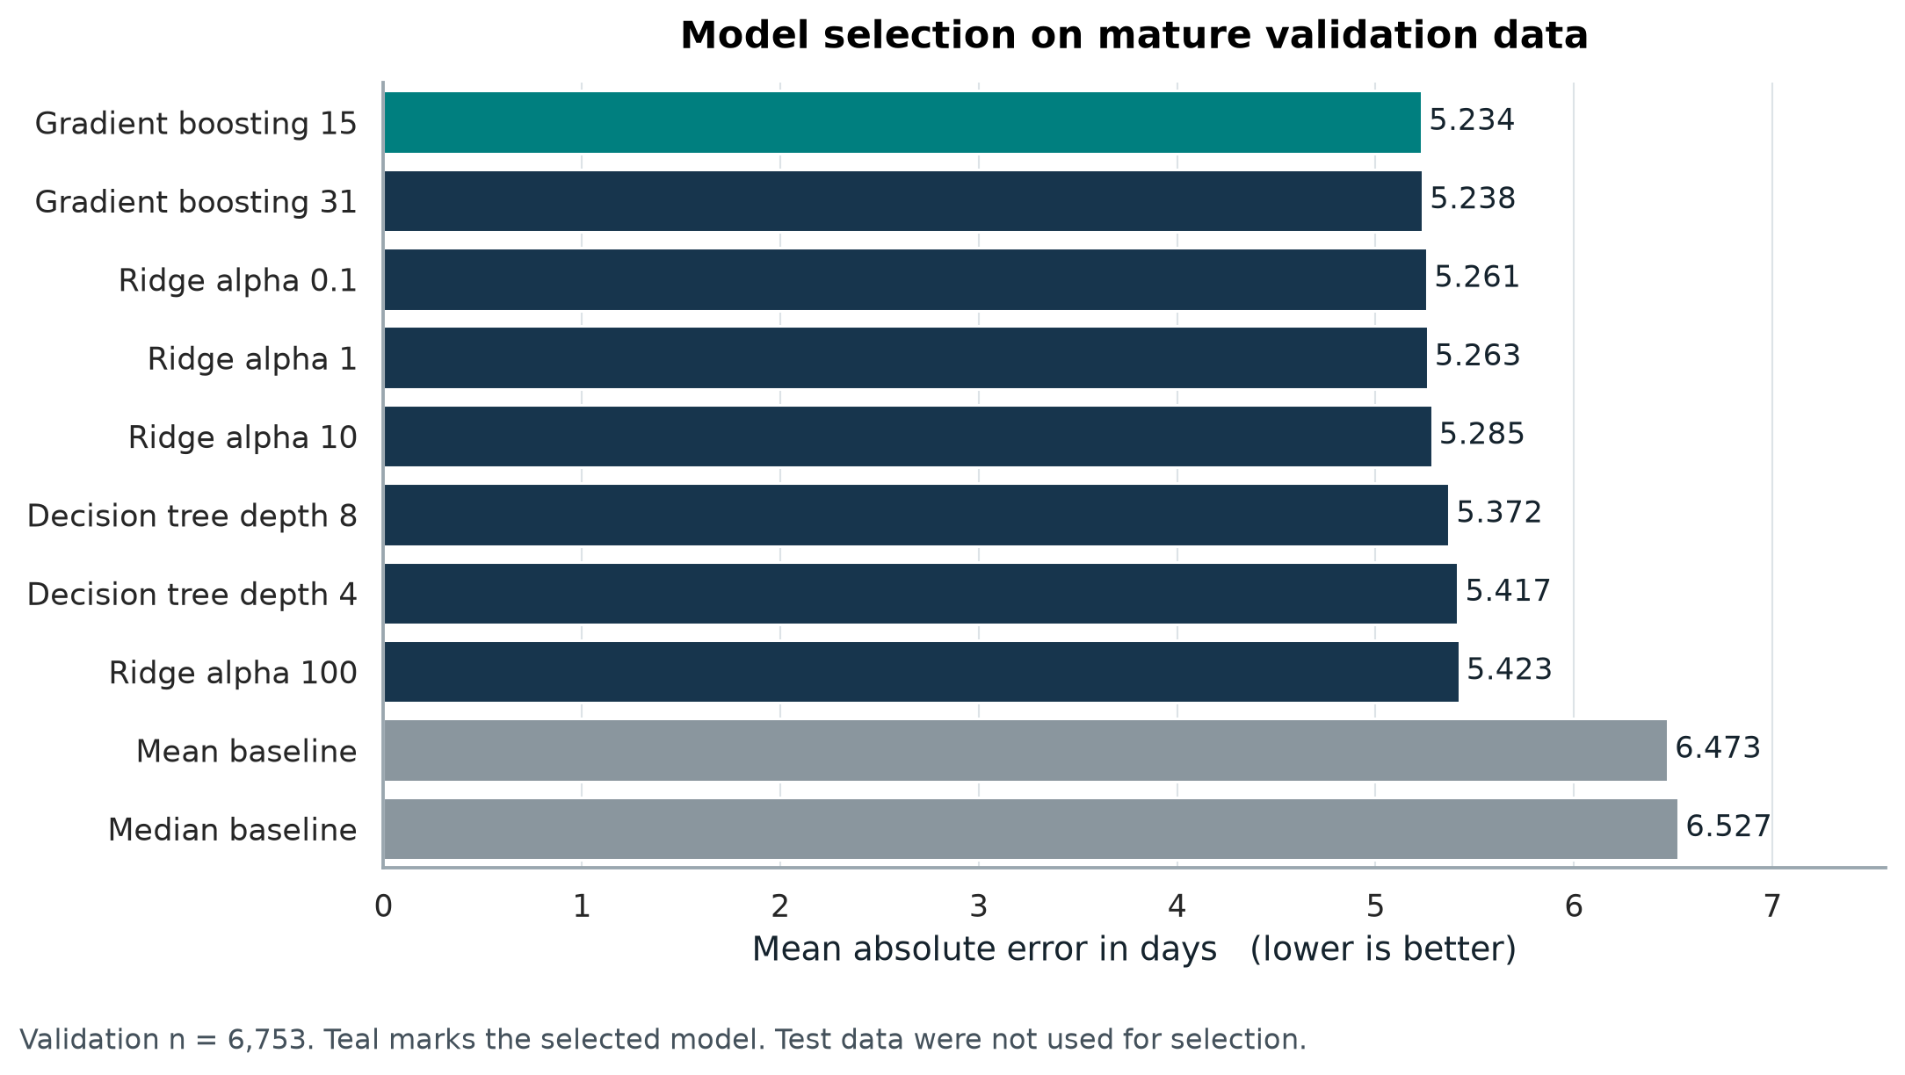
Figure 1. Validation MAE for ten candidate models, generated with Matplotlib and Seaborn. Every candidate is evaluated on the same 6,753 mature, eligible validation orders.
The 15-leaf gradient boosting model has validation MAE of 5.234 days, compared with 6.527 days for the training median baseline, a 19.82% reduction. It passes the Week 1 provisional requirement of at least 10% improvement over that baseline before final testing. Selection uses validation MAE only; test results do not choose the model.
The advantage over Ridge with alpha 0.1 is only 0.027 days, and the advantage over the 31-leaf model is 0.005 days. These small differences do not establish statistically significant superiority. Ridge remains a credible simpler alternative for a future deployment study. The selected model is retained here according to the declared selection rule.
The horizontal bar chart makes close candidate differences and baseline comparisons visible on a common scale. The teal bar identifies the selected model. The chart reports prediction error in days rather than an ambiguous percentage accuracy.

3 Prediction problem and historical data
Decision point: immediately after an order is approved. Target: remaining_delivery_days, calculated as customer delivery timestamp minus approval timestamp, divided by 86,400 seconds. Forecasts describe delivery duration among orders with valid observed completion outcomes. They do not model cancellation probability or time to delivery for every unresolved order.
The hypothetical marketplace uses Olist public records as a historical benchmark [1]. The Week 2 preparation combines 99,441 orders, 112,650 item records, 99,441 customer records, and 32,951 products. Aggregation precedes joining to maintain one row per order. The fixed source commit is d9e49802f3e92d09ee94ab9ccc5e457f207a8959, retrieved on 22 October 2026. Original file hashes and the source license are included with the project.
Input group | Definition at the approval decision
Order value and freight | Sum of item prices and freight charges, in BRL. Freight is a recorded charge, not the carrier operating cost.
Item and seller counts | Number of item records and distinct sellers associated with the order.
Total weight and volume | Aggregated product weight in grams and volume in cubic centimetres.
Promised duration | Days from approval until the end of the originally promised delivery date.
Approval waiting time | Days from purchase to approval; already elapsed when the decision is made.
Destination and weekday | Customer state and approval weekday, represented as categorical features.

The prepared matrix has 86,484 eligible approval records and 54 numeric columns: eight numeric features with scaled values and missingness flags, plus one-hot state and weekday categories. Missing numeric values use training medians; nonnegative skewed value, freight, weight, and volume fields use log1p before scaling. Minima, maxima, category lists, and imputation values were fitted on pre-January 2018 approval features only.
Invalid negative time intervals are masked and retained in the audit trail. Outcome values are not imputed, winsorized, or capped. Delivery timestamps, dispatch duration, transit duration, final status, and on-time outcome are excluded from predictive features. Order identifiers align records but are not model inputs.
Availability assumption: order attributes and the original promise are assumed to be available at approval. The public extract does not provide versioned operational snapshots, so this assumption must be verified before real deployment.

4 Chronological validation and outcome maturity
Random splitting can let later operating conditions influence an earlier forecast and can conceal incomplete outcomes near a cutoff. This project uses fixed chronological windows, then requires at least 60 days between approval and each outcome cutoff. The final test period remains untouched during candidate selection.
Cohort | Eligible approval dates | Mature approvals | Usable labels | Outcome cutoff
Training | Before 2 Nov 2017 | 32,220 | 30,932 | 1 Jan 2018
Validation | 1 to 30 Jan 2018 | 6,962 | 6,753 | 1 Apr 2018
Test | 1 Apr to 30 Jun 2018 | 20,008 | 19,654 | 1 Sep 2018

All boundaries use timestamps and exclusive upper bounds. A usable label also requires an eligible completed delivery recorded before its cohort outcome cutoff and a nonnegative target. Among mature approvals, 1,288 training records, 209 validation records, and 354 test records have no usable label. These records remain visible in coverage reporting and are not assigned invented outcomes.

Why the maturity rule matters
The initial January to March validation window contains 21,181 approvals but only 16,837 usable delivery labels by 1 April. Later approvals have less opportunity to complete. A diagnostic MAE over those observed labels is 5.035 days, versus 5.234 days in the mature selection cohort. That difference cannot be treated as improved forecasting because the evaluated populations differ.
Sixty days reduces this censoring problem without eliminating it. The test data include 28 observed deliveries longer than 60 days and a maximum duration of 108.11 days. Unobserved or invalid outcomes can still bias completed-order accuracy. A future survival model or a separate completion-risk model should be evaluated for unresolved orders.

Tuning and leakage controls
Ten prespecified candidates are trained on the same 30,932 labels. Hyperparameters are selected with mature validation MAE. No random k-fold cross-validation is used. Gradient boosting early stopping is disabled to avoid an automatic internal random holdout. The chosen training model is frozen without a train-plus-validation refit before testing.
The inherited preprocessing parameters use all 45,295 eligible pre-January 2018 approval feature rows, including some approvals excluded from mature model training. Those features were available before validation begins; no validation or test data fit preprocessing. This distinction is preserved in the source code and provenance.
Limitation: a single mature January validation window is narrower than repeated time-based evaluation. Rolling origin validation with the same outcome-maturity rule is recommended before operational use, but was not performed in this report.

5 Hypothetical dataset and simulation design
A separate dataset of 2,000 hypothetical shipments represents a courier planning deliveries during July 2026. It is reused from Week 3 with fixed random seed 20261022. Each row is one shipment. It is analyzed separately from Olist; no simulated records enter the historical benchmark.
Variable | Generation or role
dispatch_date | Random calendar date from 1 to 31 July 2026. Used for chronological splitting.
distance_km | Uniform between 50 and 1,200 km; known at dispatch.
weight_kg | Lognormal with log-mean log(2), standard deviation 0.8; bounded to 0.2 to 30 kg.
item_units | Random integer from 1 to 5; known at dispatch.
extra_delay_days | Values 0, 1, 2, 4 with probabilities 0.65, 0.20, 0.10, 0.05. Hidden from the model.
delivery_days | Target: 1 + distance_km / 300 + extra_delay_days.
Promise and cost fields | Promised days = ceil(1 + distance/300) + 1. Cost = 12 + 0.035 × distance + 1.2 × weight + 4 × extra delay, in assumed BRL. Excluded from prediction.

The prediction features are distance, weight, and item units. The generated delay, transport cost, delay cost, and on-time flag reveal or depend on future outcomes, so they are deliberately excluded. The invented cost formula illustrates a scenario; it is not an estimate of actual carrier expenditure.

Simulation and model pseudocode
rng = np.random.default_rng(20261022)
distance = rng.uniform(50, 1200, 2000)
# Other draws follow the documented fixed generator order.
delay = rng.choice([0, 1, 2, 4], 2000,
p=[0.65, 0.20, 0.10, 0.05])
delivery_days = 1 + distance / 300 + delay
features = ["distance_km", "weight_kg", "item_units"]
# Actual modeling reads the saved Week 3 simulation CSV.
model = Ridge(alpha=1).fit(X_train, y_train)

Ridge alpha 1 is fixed in advance. Training uses 1 to 19 July, validation uses 20 to 25 July, and testing uses 26 to 31 July. The samples contain 1,207, 397, and 396 shipments respectively. This is a retrospective demonstration with fully generated labels, not a live model trained before every delivery had completed.

6 Results from the hypothetical experiment
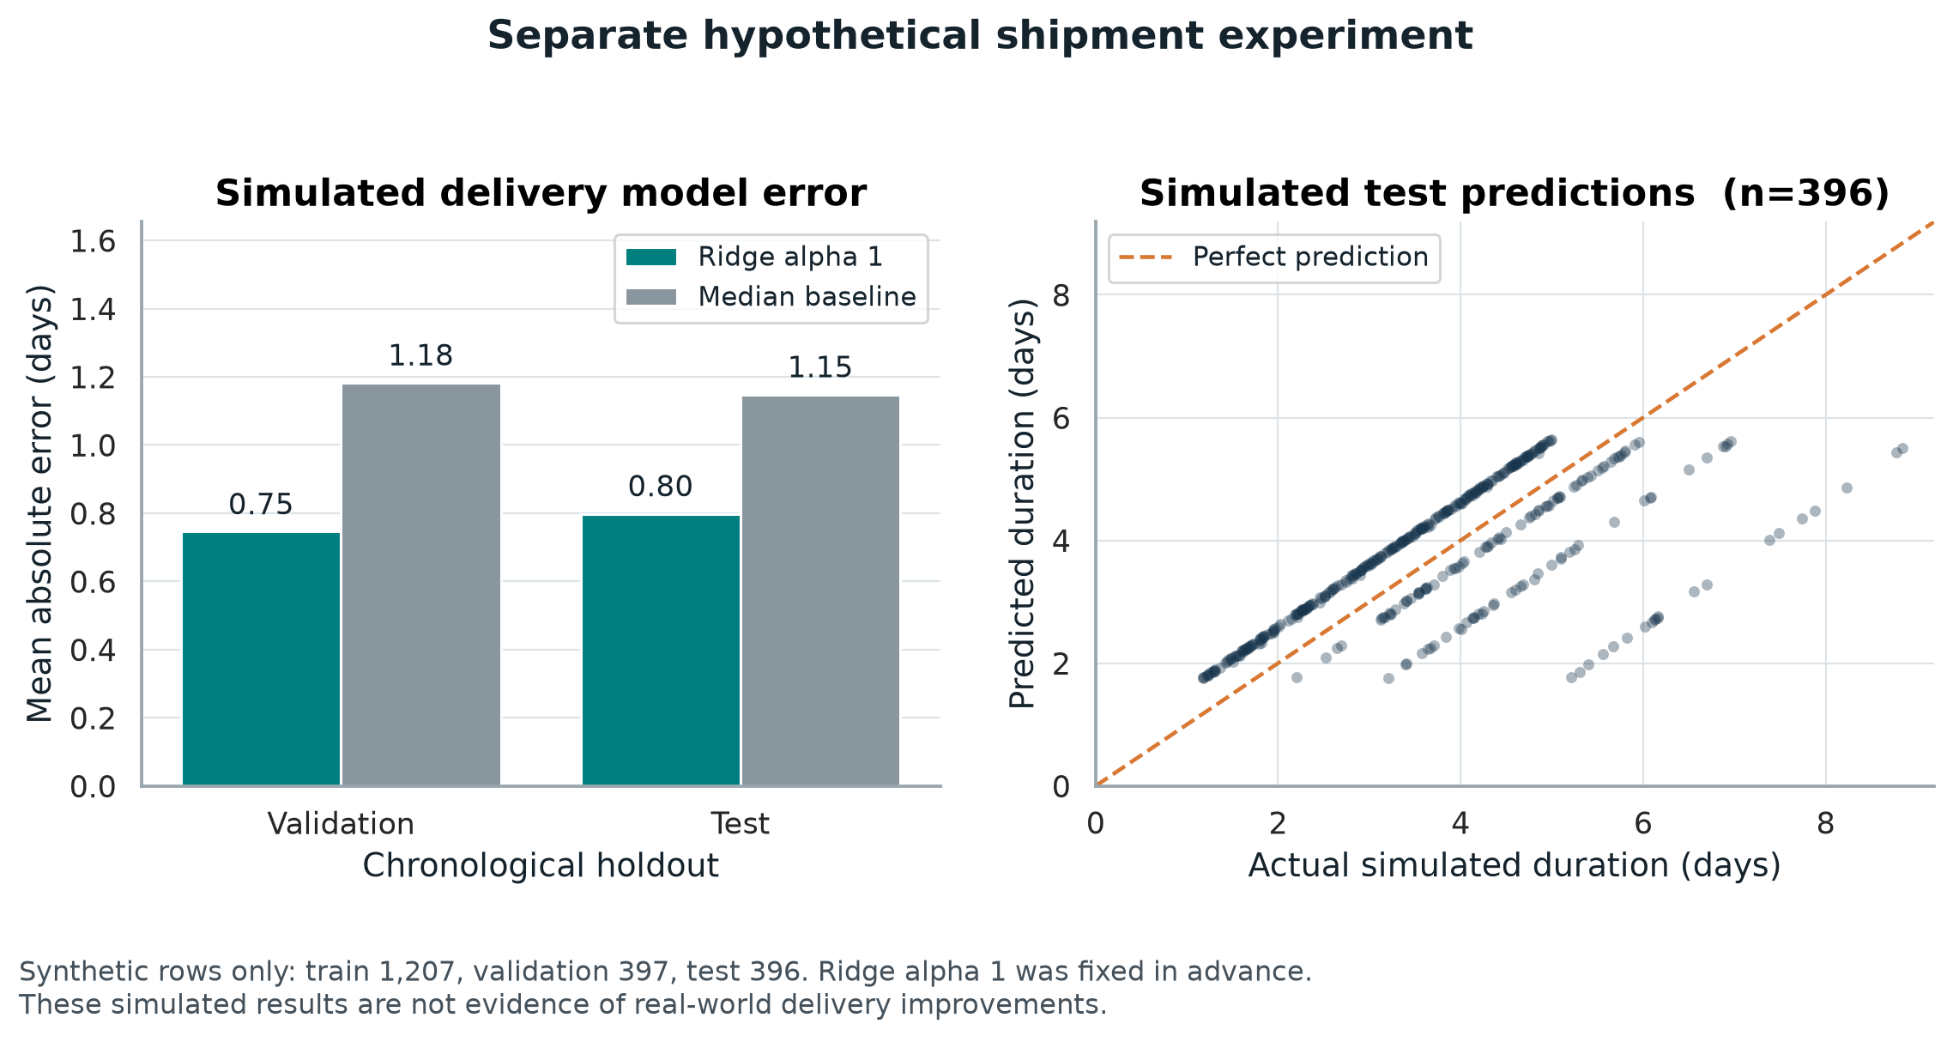
Figure 2. Separate simulated shipment experiment. Bar charts compare Ridge and the training median baseline; the scatterplot shows all 396 synthetic test shipments.
Model and cohort | MAE days | RMSE days | R squared
Ridge validation | 0.746 | 0.921 | 0.614
Ridge test | 0.798 | 1.043 | 0.471
Median baseline test | 1.148 | 1.444 | -0.013

Distance has an estimated coefficient of 0.00340 days per kilometre, close to the generator value of 1/300. Weight and units have small fitted coefficients because the simulated target does not depend on them. Remaining error is largely driven by the deliberately unobserved extra delay.
The bar chart shows that the regression captures the simulated distance relationship. The scatterplot shows underprediction for shipments with large added delays. These results demonstrate correct implementation under the chosen assumptions; they cannot establish accuracy or savings for a real courier.

7 Model rationale and evaluation metrics
Model family | Settings compared | Reason for inclusion
Constant baselines | Training median and training mean | Check whether features add value beyond one fixed forecast.
Ridge regression | Alpha 0.1, 1, 10, 100 | Regularized linear relationship; simple comparison with nonlinear methods [2].
Decision tree | Maximum depth 4 or 8; minimum leaf size 50 | Capture thresholds and interactions while controlling small leaves.
Histogram gradient boosting | 15 or 31 maximum leaves; 200 iterations; learning rate 0.05; minimum leaf size 50; L2 penalty 1 | Sequential trees capture nonlinear effects and interactions; histogram binning supports efficient fitting [3].

Tree methods use random seed 20261023. All candidate predictions are clipped below zero because elapsed time cannot be negative; no upper clipping is applied. Ridge and the tree ensembles fit squared-error objectives. MAE is the operational selection metric, while RMSE checks larger misses. Absolute-error or quantile training is a future alternative rather than an experiment already completed.

Metrics and interpretation
For n evaluated orders, actual duration y and prediction p, the residual e is p minus y. MAE = sum of |e| / n. RMSE = square root of sum of e squared / n. R squared = 1 minus sum of e squared divided by sum of squared deviations of y from its evaluated-sample mean [4].
MAE gives average error in days. RMSE weights large errors more heavily. R squared compares squared error with a constant equal to the evaluated sample mean; it can be negative and is not a percentage accuracy. Bias is the mean residual: positive means forecasts are too long on average. The 90th percentile absolute error describes the observed error distribution and is not a calibrated prediction interval.

Training versus validation
The selected model has training MAE of 4.295 days and mature validation MAE of 5.234 days, a gap of 0.939 days. This is consistent with reduced performance on later unseen observations, potentially reflecting both model fitting and temporal change. It does not isolate either cause. Larger trees reduce training error but do not improve the chosen validation metric.
Only the selected model and the two prespecified constant baselines are evaluated on the final test. Feature permutation and the promise-removal diagnostic use validation data. No thresholds or capacity values are chosen by optimizing final test outcomes.

8 Final test performance and residuals
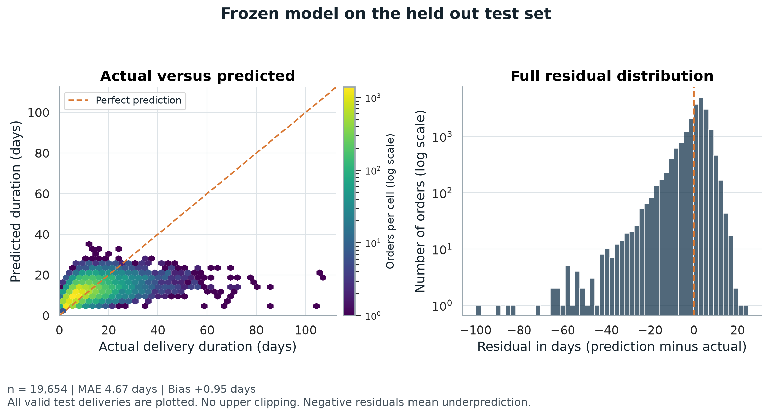
Figure 3. Held-out historical test diagnostics. The density plot and logarithmic-count histogram preserve all 19,654 eligible outcomes, including the long tail.
Model | MAE days | RMSE days | R squared | Bias days
Selected boosting model | 4.667 | 6.641 | 0.257 | +0.951
Training median baseline | 5.397 | 7.709 | -0.002 | -0.307
Training mean baseline | 5.920 | 7.834 | -0.034 | +1.427

The selected model reduces MAE by 0.730 days, or 13.52%, relative to the median baseline. Median absolute error is 3.62 days and the 90th percentile is 9.03 days. Average bias of +0.95 days indicates overprediction overall, even though the longest deliveries are underpredicted.
The diagonal represents perfect prediction. The concentration below it for very slow deliveries shows that an average-duration forecast cannot adequately identify every extreme delay. Logarithmic cell and count scales make both dense regions and rare tail errors visible; no tail records are hidden by display clipping.

9 Performance across operational cohorts
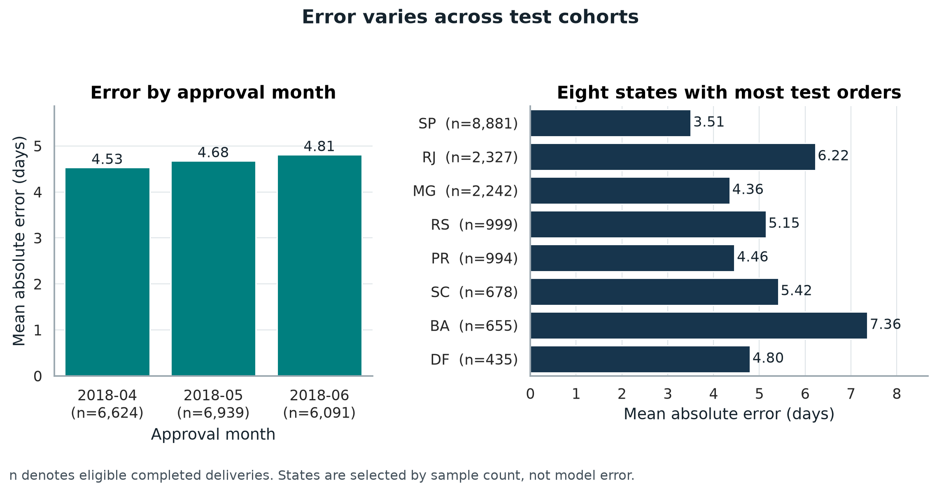
Figure 4. Test MAE by approval month and the eight destination states with the most eligible test orders. Sample sizes are displayed to support comparison.
Actual duration band | Orders | MAE days | Bias days
Up to 14 days | 15,247 | 3.77 | +3.22
More than 14 through 30 days | 3,919 | 5.82 | -4.83
More than 30 days | 488 | 23.39 | -23.39

Monthly MAE rises from 4.53 days in April to 4.81 days in June. June bias is +3.28 days and R squared is only 0.023, so a single pooled score conceals an important calibration change. This warrants checking promise practices, service mix, and data drift before relying on the model.
Duration-band analysis is diagnostic: actual duration becomes known after delivery and cannot be used to choose a live queue. The 488 deliveries longer than 30 days are consistently underpredicted. State comparisons also mix different distances, sellers, and service conditions; higher error does not establish a causal location effect.

10 What the model relies on
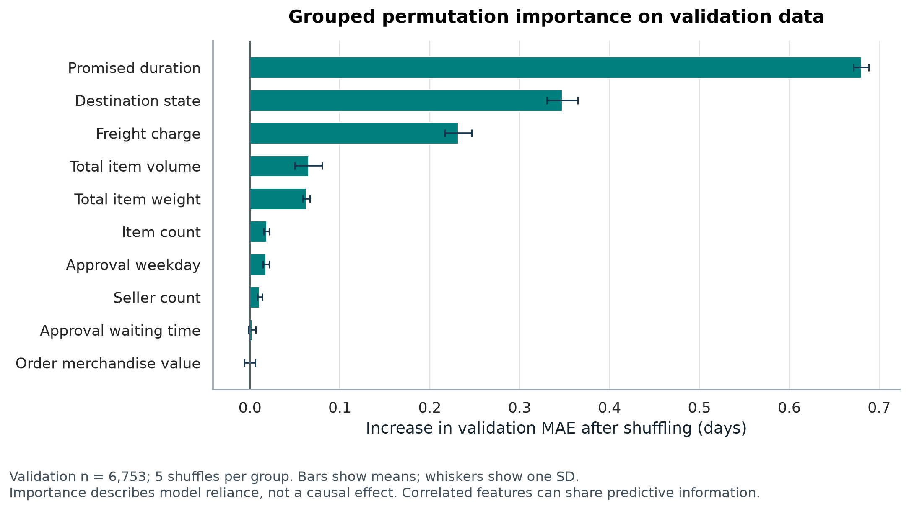
Figure 5. Grouped permutation importance on mature validation data. Each raw feature group is shuffled together five times, preserving the internal consistency of its encoded columns.
Shuffling promised duration increases validation MAE by 0.680 days, destination state by 0.348 days, and freight by 0.232 days. These are the strongest measured dependencies of this fitted model. The error bars show variation across five shuffles, not confidence intervals for a causal effect [5].
The promise date is an existing operational estimate. A training-cohort refit without the promise features, evaluated only on validation, gives MAE of 5.431 days, compared with 5.234 days with them. The model therefore supplements an existing estimate rather than learning solely from physical shipment characteristics.
Correlated features can substitute for each other, so low permutation importance does not mean a variable is operationally irrelevant. Merchandise value has approximately zero importance in this fitted model; it should not be interpreted as proof that valuable orders never require attention. Model reliance does not show that changing freight charges or promises would reduce actual delivery time.
The chart supports a practical priority: validate original promise availability and state coding before deployment. Replacing an original promise with a later revised value would change the meaning of the forecast and could introduce leakage.

11 Resource allocation formulation
The worked optimization assigns a fixed daily number of order reviews. For each approved order i, score s_i = predicted remaining delivery days minus the original promised remaining days. A higher score means less predicted slack relative to the promise. This score is a ranking signal in days, not a calibrated probability of lateness or an estimate of intervention benefit.
For each approval day d with N_d orders, choose binary x_i to maximize the sum of s_i × x_i, subject to sum of x_i = min(100, N_d). Each selected order consumes one equal review slot. Sorting scores from highest to lowest is an exact solution to this simple additive, equal-cost allocation problem. More complex vehicle routing or unequal review effort would require a different optimization model.
If an original promise is missing or invalid, the order receives manual promise validation first; remaining slots use score ranking. No such records occur in this test cohort. Ties use order_id. The equality constraint fills the available quota even if all remaining scores are negative. A rule that allows unused slots would require a benefit or minimum-score threshold and is not the policy evaluated here.

Implemented allocation excerpt
t["priority_score"] = (
t["prediction_days"] - t["promise_days"]
).fillna(0)
ranked = t.sort_values(
["approval_day", "missing_promise",
"priority_score", "order_id"],
ascending=[True, False, False, True]
)
review_queue = ranked.groupby("approval_day").head(100)
fifo_queue = t.sort_values(
["approval_day", "order_approved_at", "order_id"]
).groupby("approval_day").head(100)

Selection is made across all 20,008 test approvals, including 354 without eligible completed outcomes. This avoids selecting only orders whose later outcomes are known. FIFO reviews earliest approvals first within the same day and receives exactly the same daily capacity.
This is a retrospective end-of-day batch planning simulation over 88 active days in a 91-calendar-day period. Eighty-five active days exceed 100 approvals. A live queue would additionally need arrival-time scheduling, current open-order status, staffing availability, and rules for already completed orders; those histories are not reconstructed by this extract.

12 Allocation results and capacity sensitivity
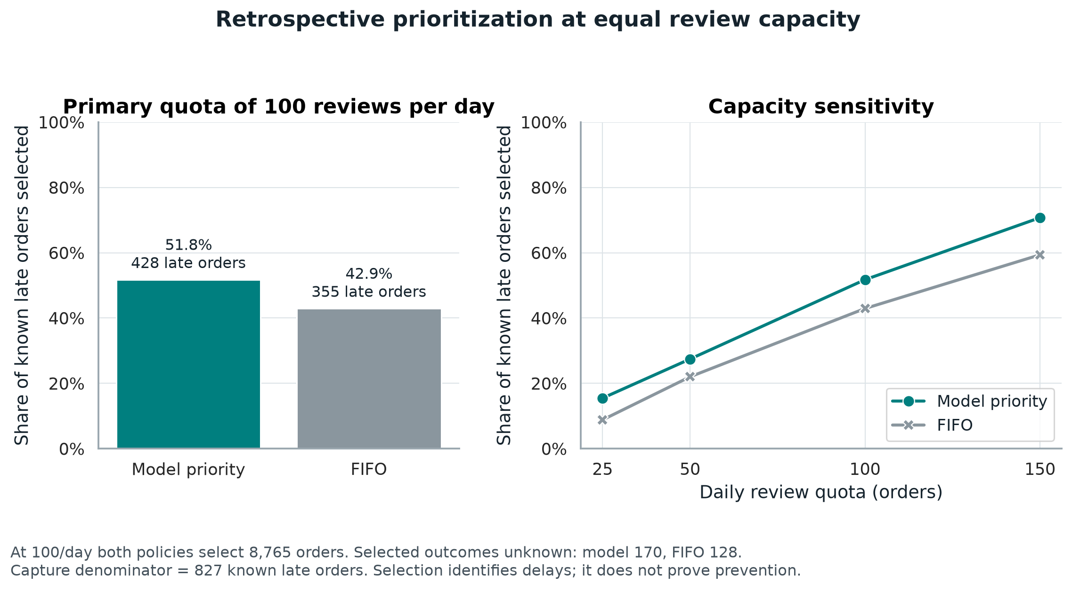
Figure 6. Retrospective allocation at equal review capacity. The capture denominator is 827 known late deliveries; the sensitivity analysis uses prespecified quotas of 25, 50, 100, and 150 reviews per day.
Measure at 100 reviews a day | Model priority | FIFO
Orders selected | 8,765 | 8,765
Selected with evaluable outcomes | 8,595 | 8,637
Selected with unknown outcomes | 170 | 128
Known late orders selected | 428 | 355
Late capture | 51.75% | 42.93%
Late precision among evaluable selections | 4.98% | 4.11%

Capture equals selected known late orders divided by all 827 known late orders. Precision equals selected known late orders divided by selected orders with evaluable outcomes. Model priority identifies 73 more known late orders, an 8.83 percentage-point capture gain. However, most reviewed orders are not late, so review effort and intervention value require a pilot.
Only 7 of the 20,008 scores are positive; the other 8,758 selected orders have negative predicted-minus-promised duration. The queue ranks limited slack, rather than classifying every selection as late. Overall observed lateness is 4.21%, versus 4.98% among evaluable model selections. Increasing capacity raises capture and workload together; no causal prevention or financial savings are established.

13 Recommendations and decision limits

Pilot review prioritization with equal staffing
The operations manager should compare model priority with FIFO in a controlled pilot using the same review hours. Record review completion, the action taken, contact effort, eventual delivery, cancellation, and cost. Allocate comparable days or teams prospectively and preserve assignment logs. A larger retrospective late capture alone is insufficient evidence to expand staffing.

Improve data and extreme delay handling
The data owner should retain approval-time snapshots of order attributes and the original promise, with later revisions stored separately. Track missing labels and open orders alongside completed-order metrics. The analytics owner should investigate the extreme-delay cohort, assess a completion-risk or survival model, and test quantile forecasts with rolling time validation and label maturity.

Monitor calibration before changing promises
The analytics team should review MAE, bias, late capture, selected-outcome coverage, and state sample counts every month after outcomes mature. June overprediction indicates that recalibration or retraining may be needed. Establish tolerances prospectively with operations and evaluate any revised model on a new future holdout. Do not retune on this final test period.

Measure economic value before cost decisions
A proposed pilot value equation is: verified intervention-attributable avoided delays × value per avoided delay, minus review hours × hourly cost, minus intervention costs. Those inputs are not measured in the public records, so this project reports no monetary savings. Freight charges should not be substituted for carrier costs. Real route optimization additionally needs stops, vehicle capacities, travel times, and service constraints.

Limitations and conclusion
Results depend on historical Brazilian marketplace records, assumed approval-time feature availability, a narrow mature validation window, and observable completed deliveries. The maturity rule reduces unequal follow-up but cannot remove selection bias. No uncertainty intervals or significance tests establish that small model differences will persist. The simulated shipment results reflect an invented generator and cannot validate historical or future operational performance.
Week 4 delivers an executed predictive workflow, quantified testing, six embedded visualizations, and a capacity-constrained allocation example. The evidence supports a carefully measured pilot and better operational data collection. It does not support autonomous changes to delivery promises, claimed delay prevention, or claimed cost reductions.

14 Python preparation training and testing
The full model.py script in the supporting project performs record alignment, cohort construction, candidate fitting, metric calculation, allocation, and result export. The following excerpts show the central sequence; surrounding imports and file loading are provided in that script.

Prepare aligned mature cohorts
audit = pd.read_csv("data/orders_audit.csv.gz")
X = pd.read_csv("data/prepared_features.csv.gz")
labels = pd.read_csv("data/feature_index_and_labels.csv.gz")
m = labels.merge(audit, on="order_id", how="left",
validate="one_to_one", suffixes=("_label", ""))
assert m.order_id.tolist() == labels.order_id.tolist()
m["order_approved_at"] = pd.to_datetime(m.order_approved_at)
y = m.remaining_delivery_days.to_numpy(float)
masks = {}
for split, cutoff in PLAN["cutoffs"].items():
mature = m.order_approved_at.lt(
pd.Timestamp(cutoff) - pd.Timedelta(days=60))
masks[split] = (m.split.eq(split) & mature
& m.label_eligible).to_numpy()
assert np.isfinite(X.to_numpy()).all()

Train select freeze and test
train, val, test = [masks[k] for k in
["train", "validation", "test"]]
# candidates contains both baselines and the declared grid.
scores = {}
for name, model in candidates.items():
model.fit(X.loc[train], y[train])
p_val = np.maximum(model.predict(X.loc[val]), 0)
scores[name] = mean_absolute_error(y[val], p_val)
winner = min(scores, key=lambda k: (scores[k], k))
selected = candidates[winner] # No refit on validation.
p_test = np.maximum(selected.predict(X.loc[test]), 0)
mae = mean_absolute_error(y[test], p_test)
rmse = np.sqrt(mean_squared_error(y[test], p_test))
r2 = r2_score(y[test], p_test)

All dates, model settings, and capacities are declared in analysis_plan.json before fitting. The fitted estimator, feature order, and plan are saved in trained_model.joblib. CSV outputs retain individual predictions and the denominators needed to verify the reported results.

15 Visualization code and reproducibility
The six embedded figures are actual PNG exports from make_charts.py. The script uses Seaborn for statistical chart functions and styling, and Matplotlib for axes, labels, residual plots, layouts, and file export. The images are embedded in the Word file, so they do not depend on external image links [6, 7].
import matplotlib
matplotlib.use("Agg")
import matplotlib.pyplot as plt
import seaborn as sns

sns.set_theme(style="whitegrid")
comparison = pd.read_csv("results/validation_model_comparison.csv")
fig, ax = plt.subplots(figsize=(10, 5.7))
sns.barplot(data=comparison, x="mae_days", y="model",
color="#17354D", errorbar=None, ax=ax)
ax.set(xlabel="Mean absolute error in days", ylabel="")
fig.tight_layout()
fig.savefig("validation_comparison.png", dpi=220)

Run the supplied project
Extract the supporting ZIP and open its project folder. The prepared CSV files are compressed; pandas reads them directly. Install the listed dependencies, then run the modeling and visualization commands below. The supplied results and figures can also be inspected without rerunning the analysis.
python -m pip install -r requirements.txt
python model.py --data data --output results
python make_charts.py --results results --output figures
python verify_results.py --data data --results results

The results folder contains the analysis plan, selected parameters, candidate comparison, cohort counts, validation and test predictions, monthly and state metrics, permutation importance, allocation results, and synthetic experiment metrics. The data folder includes source lineage, checksums, the original source license, and Week 2 preprocessing parameters. The preparation folder retains the data acquisition and preparation scripts.
Analysis environment: Python 3.12.14, pandas 3.0.1, NumPy 2.3.5, scikit-learn 1.9.1, Matplotlib 3.11.2, Seaborn 0.13.2, SciPy 1.18.1, and joblib 1.6.0. Historical model seed is 20261023; simulation seed is 20261022. The README explains the work and browser-based GitHub upload steps for a first-time user.
Submission files: this Word report, a separate description exceeding 200 words, and a supporting project ZIP. Upload the Word file to the internship portal and paste the description text. The ZIP is a project package; it is not itself a published GitHub repository.

16 References and objective coverage
[1] Olist official public source repository. Pinned commit d9e49802f3e92d09ee94ab9ccc5e457f207a8959; data retrieved 22 October 2026.
https://github.com/olist/work-at-olist-data
[2] Scikit-learn. Linear models and Ridge regularization.
https://scikit-learn.org/stable/modules/linear_model.html
[3] Scikit-learn. Ensemble methods and histogram gradient boosting.
https://scikit-learn.org/stable/modules/ensemble.html
[4] Scikit-learn. Metrics and scoring for model evaluation.
https://scikit-learn.org/stable/modules/model_evaluation.html
[5] Scikit-learn. Permutation feature importance and interpretation limits.
https://scikit-learn.org/stable/modules/permutation_importance.html
[6] Matplotlib documentation.
https://matplotlib.org/stable/
[7] Seaborn documentation.
https://seaborn.pydata.org/
Software references consulted 23 October 2026. Numerical findings are calculated from the supplied project outputs. The source license is preserved in the project package.

Coverage of the Week 4 requirements
Required component | Report location
Problem definition and hypothetical data | Sections 3, 5, and 6
Model selection and implementation | Sections 2, 7, and 14
Preparation training and testing code | Sections 3, 4, 14, and supplied scripts
MAE RMSE R squared and validation | Sections 4, 7, 8, and 9
Hyperparameter tuning and validation strategy | Sections 2, 4, and 7
Optimization and actionable recommendations | Sections 11, 12, and 13
Interpretations and visualization outputs | Figures 1 to 6 and Sections 8 to 10
Code documentation and reproducibility | Sections 14 and 15 and project README

