DESIGN AND IMPLEMENTATION OF A SCALABLE HUMAN RESOURCE MANAGEMENT SYSTEM USING SERVERLESS CLOUD ARCHITECTURE
BY
BALOGUN, RIDWAN BABATUNDE
249074001
A PROJECT SUBMITTED TO THE
DEPARTMENT OF COMPUTER SCIENCES,
UNIVERSITY OF LAGOS, NIGERIA
IN PARTIAL FULFILMENT OF THE REQUIREMENTS FOR THE AWARD OF THE DEGREE OF MASTERS IN INFORMATION TECHNOLOGY (MIT)
COURSE: MIT899
SUPERVISOR: PROF. C. O. UWADIA
CO-SUPERVISOR: DR. R. A. KOLEOSO

OCTOBER, 2026

CERTIFICATION
This is to certify that this project, titled Design and Implementation of a Scalable Human Resource Management System Using Serverless Cloud Architecture, was carried out by Balogun, Ridwan Babatunde (Matriculation Number: 249074001) in the Department of Computer Sciences, University of Lagos, under the supervision of Prof. C. O. Uwadia (Supervisor) and Dr. R. A. Koleoso (Co-Supervisor).
……………………………………… ……………………
Balogun, Ridwan Babatunde Date
(Student)
……………………………………… ……………………
Prof. C. O. Uwadia/Dr. R. A. Koleoso Date
(Supervisors)
……………………………………… ……………………
Prof. F. A. Oladeji Date
(Head of Department)
DEDICATION
This project is dedicated to Almighty God, and to my family, whose patience and support carried me through this programme.
ACKNOWLEDGEMENTS
I am grateful to Almighty God for life, health and the strength to complete this work.
My sincere thanks go to my supervisor, Prof. C. O. Uwadia, who supervised this project from the proposal stage, and to my co-supervisor, Dr. R. A. Koleoso, who guided it through to completion. I am grateful to them both for their corrections and the time they gave to this work. Their directions shaped both the system and this report.
I thank the Head of Department, Prof. F. A. Oladeji, and the academic and non-academic staff of the Department of Computer Sciences, University of Lagos, for the teaching and support I received throughout the Master of Information Technology programme.
I appreciate my colleagues in the MIT class for the discussions and encouragement we shared, and my lecturers for their time.
Finally, I thank my family, Obatade Barakat and Busari Aaliyah, for their understanding, prayers and support during the long hours this work required.
ABSTRACT
Many small and medium sized businesses (SMBs) in Nigeria are still using HR and payroll offline with many fragmented software tools spread out across spreadsheets. The cloud-based HRM systems for this problem typically use provisioned servers that are expensive and require staff which small organisations are unable to afford. This project is designed and implemented as an all serverless cloud based Multi-tenant HRMS (Human Resource Management System) that has an integrated Nigerian statutory payroll engine. The system was developed based on design science research and an incremental Agile process and was composed of Cloudflare Workers (an Application Programming Interface (API)), Cloudflare D1 (for relational data) and Cloudflare R2 (documents) and React.js (front-end). A role-scoped AI assistant, with tools that re-check the caller’s authorisation, was added, as was tenant isolation at the data-access layer. The system was tested using an automatic test and response time was estimated on the deployed platform and a cost model. 911 automated test cases were successfully passed and the number of warm interactive requests that were sent from Lagos, Nigeria, came back in 198-271 milliseconds, while a cold start required ten seconds, and a payroll representing fifty employees was submitted in 415 milliseconds. The price of modeled platform was $5 per month, up to 5,000 employees, as compared to that of minimal provisionsed platform, which was $32.15 per month prior to traffic. The study found that the fixed cost and server maintenance of an HRMS can be eliminated within definite boundaries, by using serverless architecture. The two prominent ones are size and single threaded shared D1 database, as well as the network distance between any Nigerian user and the nearest data region.
TABLE OF CONTENTS
Certification ii
Dedication iii
Acknowledgements iv
Abstract v
List of Figures viii
List of Tables ix
CHAPTER ONE: INTRODUCTION 1
1.1 Background of the Study 1
1.2 Statement of the Problem 2
1.3 Aim and Objectives 3
1.4 Justification of the Study 4
1.5 Scope of the Study 4
1.6 Methodology 5
1.7 Significance of the Study 5
1.8 Project Outline 5
CHAPTER TWO: LITERATURE AND EMPIRICAL REVIEW 7
2.1 Introduction 7
2.2 Human Resource Management Systems: Concept and Development 7
2.3 Cloud Computing and its Application to HR Systems 8
2.4 Serverless and Edge Computing 9
2.5 Multi-Tenancy, Isolation and Authentication 10
2.6 Payroll Automation and Statutory Compliance 10
2.7 Artificial Intelligence and Large Language Models in HR 11
2.8 Review of Existing HR Management Systems 11
2.9 Synthesis and Research Gap 12
CHAPTER THREE: METHODOLOGY 15
3.1 Introduction 15
3.2 Research and Development Approach 15
3.3 System Architecture 16
3.4 System Requirements 17
3.5 System Design 18
3.5.1 Actors and Use Cases 18
3.5.2 Data Flow Diagrams 20
3.5.3 Entity Relationship Diagram 21
3.5.4 Request Pipeline 22
3.6 Database Design 23
3.7 Payroll Computation Design 24
3.8 Interface Design 27
3.9 Security Design 27
3.9.1 Authentication and Authorisation 27
3.9.2 Isolation, Transport and Files 28
3.9.3 Audit and Data Protection 28
3.9.4 AI Assistant Security Boundary 28
3.9.5 Legacy Authentication Fallback 30
3.10 Evaluation Design 30
CHAPTER FOUR: RESULTS AND DISCUSSION 32
4.1 Introduction 32
4.2 Development Environment 32
4.3 Implementation of the System 33
4.3.1 Tenancy, Authentication and Access Control 33
4.3.2 Core HR Modules 34
4.3.3 Extended Modules and Control Centre 34
4.3.4 Payroll and Statutory Compliance 35
4.3.5 AI Assistant 36
4.4 Testing Results 37
4.4.1 Test Results 37
4.4.2 Coverage Boundary 38
4.4.3 Security-relevant Tests 38
4.5 Response-Time Results 38
4.6 Cost Results 40
4.7 Platform Constraints Identified 42
4.8 Discussion against the Objectives 43
CHAPTER FIVE: SUMMARY, CONCLUSION AND RECOMMENDATIONS 45
5.1 Summary of the Study 45
5.2 Problems Encountered and Limitations 45
5.3 Conclusion 46
5.4 Recommendations 47
5.5 Suggestions for Future Work 47
REFERENCES 49
APPENDIX A: FUNCTIONAL AND NON-FUNCTIONAL REQUIREMENTS 53
A.1 Functional Requirements 53
A.2 Non-Functional Requirements 58
APPENDIX B: ADDITIONAL DESIGN DIAGRAMS AND SYSTEM SCREENS 60
APPENDIX C: PRINCIPAL DATABASE TABLE COLUMNS 71
LIST OF FIGURES
Figure 1: Intersection of literature streams and the research gap addressed by this project 14
Figure 2: High-level system architecture 16
Figure 3: Use case diagram of the ZenHR system 19
Figure 4: Context-level data flow diagram 20
Figure 5: Level 1 data flow diagram for the payroll process 21
Figure 6: Core entity relationship diagram 22
Figure 7: Request processing pipeline within the Worker 23
Figure 8: Gross-to-net payroll computation sequence 26
Figure 9: AI assistant request sequence with authorisation re-derivation 29
Figure 10: Payroll run preview with pre-run exceptions 35
Figure 11: Generated payslip and statutory compliance calendar 36
Figure 12: AI assistant showing (a) a scoped answer and (b) an authorisation refusal 37
Figure 13: Cold-start and warm-path response times by operation category 40
Figure 14: Monthly platform cost against request volume, usage-based versus provisioned 42
Figure 15: Architectural evolution of human resource management systems 60
Figure 16: Conceptual framework of the proposed system 60
Figure 17: Layered architecture of the Workers backend 61
Figure 18: Role-scoped interface views 62
Figure 19: Login and forced password change on first sign-in 63
Figure 20: Employee directory and consolidated employee profile 64
Figure 21: Offboarding clearance board showing per-function sign-off 65
Figure 22: Attendance clock-in with punctuality classification 66
Figure 23: Leave balances and request approval 67
Figure 24: Recruitment pipeline and interviewer scorecard 68
Figure 25: Public careers page for an open requisition 68
Figure 26: Performance review cycle configuration 69
Figure 27: Terminal output of the backend and frontend test suites 70
LIST OF TABLES
Table 1: Cloud service delivery models compared 8
Table 2: Comparison of existing HR management systems with this project 12
Table 3: Synthesis of reviewed studies 12
Table 4: Mapping of objectives to methodology and results 15
Table 5: Summary of functional requirements 17
Table 6: System actors and their principal capabilities 18
Table 7: Tenant isolation models evaluated for this system 23
Table 8: Statutory deduction treatment and remittance 26
Table 9: Assistant tool set and authorisation rules 29
Table 10: Development toolchain and platform services 32
Table 11: Automated test suite execution results 37
Table 12: Response-time measurements for representative operations (milliseconds) 38
Table 13: Platform rate card (Workers Paid plan) 40
Table 14: Modelled monthly platform cost at three scales 41
Table 15: Achievement of objectives 43
Table 16: Principal columns of the employees table 71
Table 17: Principal columns of the attendance_records table 71
Table 18: Principal columns of the leave_requests and leave_balances tables 71
Table 19: Principal columns of the payslips table 72

CHAPTER ONE: INTRODUCTION

1.1 Background of the Study

Human Resource Management (HRM) encompasses the processes and activities of an organisation to maintain the employment relationship, starting from hiring, induction and training to the compensation and performance review and ending in termination of the relationship (offboarding). Records are generated by each of these activities and the more people the more records there will be: personnel records, attendance sheets, leave balances, appraisal ratings, payroll calculations, contracts, ID documents, etc. But even in these spreadsheets, paper files and other disparate tools, these records are still retained by many small and medium-sized organisations, including Nigerian private employers. Both contain a section of the same image of an employee.

Digitalisation of the human resource (HR) function has been the response to this fragmentation. Vu (2024) categorizes it as going from three dimensions; digital tools for administration, tools supporting an existing HR strategy, and the tools that initiate the development and formation of an HR strategy. Also in the same review it is noted that the transition has resulted in other sources of work-related stress. An HR system is not “neutral automation”, however. It establishes rules on how to represent HR and who should.

Cloud computing provided a lot of the backbone of this shift. An organisation does not own the servers and just rents the computing space and provisions it accordingly as needs evolve. Cost efficiency or cost-saving was reported to be the 2nd most common outcome following operational efficiency out of the 90 research studies conducted on cloud adoption by Small and Medium-sized enterprises (SMEs) (Mkhize et al., 2025). Even though the enthusiasm of individual managers is important, for HR software at least, Milhem et al. (2025) revealed that factors related to the technology, the organisation and the environment rather than the passion of individual managers determine whether an SME makes the transition to cloud HRM. But with a conventional cloud Human Resource Information System (HRIS) a lot of virtual machines or containers are still running, and they have to be sized, patched, maintained and paid for, whether or not they’re accepting requests. Serverless computing takes it one step further: Whenever there is a request, the provider allocates some compute, and only charges for execution time, not for reserved capacity (Wen et al., 2023). The most popular disadvantage is cold-start latency, which is the startup time required to respond to requests after the system has been idle for a while (Golec et al., 2024). This code is deployed in a data centre near the user and that makes network latency to not become the dominant part of the response time (Raith et al., 2023). This is how Cloudflare Workers, the platform chosen for this project, works, as well (Cloudflare, 2026a).

There are two other factors that inform the project. The first one is Nigerian statutory payroll. An employer must employ progressive Pay-As-You-Earn (PAYE) income tax and make pension and National Housing Fund (NHF) contributions in accordance with their remittance dates and bases; and pay employer levies to the Nigeria Social Insurance Trust Fund (NSITF) and the Industrial Training Fund (ITF) with corresponding bases and remittance dates. In Nigeria, digital tax administration has been correlated with better compliance (Falana et al., 2024) which is the principle reason they have placed the rules in the payroll engine rather than the payroll officer. The latter is more recent. Large Language Models (LLMs) are beginning to make their way into HR technology, but their governance and accountability remain unclear (Budhwar et al., 2023; Dasaklis et al., 2026). According to OWASP (2025), two of the top threats for LLM applications are prompt injections and excessive agency. When an assistant can access salary and leave records, both risks become real.

This project generates such threads and pulls them together into a single multi-tenant Human Resource Management System (HRMS) and payroll platform called ZenHR. It is powered by Cloudflare’s serverless platform. The frontend is built using React.js, while R2 stores documents and Workers AI is the artificial intelligence (AI) assistant.

1.2 Statement of the Problem
The problems that arise when there’s a bunch of disconnected tools or a legacy HRIS server, running HR system and payroll system are cumulative.The issues that come with running HR system and payroll system on a set of disconnected tools or a traditional HRIS server compound.
The first one is broken-out employee data. Each employee’s record, attendance, leave and salary configuration and performance record is stored individually, a payroll run is therefore not possible until someone has checked whether they have been matched up manually. The reasons given for the difficulties and the obstacles in HRMS implementation by Destriani et al. (2024) are continuous ones: integration difficulty and limited technical skill in-house. Worse by splitting records.
The second problem is statutory payroll. PAYE bands and reliefs, pension, NHF and the employer levy are easily computed by hand and often easily missed, especially when not set to a time cycle. Regulatory as well as financial implications of errors here.
A limited size is not good for HR need. There is bursty traffic in HR activity: A payroll run at the end of the month, recruitment or appraisal cycle, brings a spike with little traffic between. Paying for provisioned servers at down times between peaks, as they need to be sized for peak requirements. If the platform is a multiparagraph platform with several client organisations (tenants) it is necessary that the servers have been dimensioned for the maximum load of all the tenants, or otherwise the load of one tenant will affect the other tenants (Hattab & Belalem, 2023). The smaller organisations, which would benefit the most from a consolidated system are the ones that are the least capable of employing staff to maintain and size, patch and monitor their servers (Destriani et al., 2024).
Multi-tenancy and AI bring security issues. No other tenant’s information can be accessible to another tenant’s session, and within a tenant, the administrator wants to see different information from the manager, who would want to see different information from the payroll officer, who in turn would want to see different information from the employee. By default, an LLM assistant does not include any of the application’s authorisation logic (OWASP, 2025).
Although, the operational and cost issues are solved by design when it comes to serverless architecture, as there’s no server sitting idle that needs to be paid to run it. It has been primarily investigated for general workloads, like data pipelines and machine-learning inference (Ghorbian et al., 2024; Wen et al., 2023). It has never been tested with a business system that includes the approval workflow, document storage, strict tenant isolation, as well as relational records. So the challenge for this project is how to design build, and test such a system without compromising tenant isolation, role-based access or payroll compliance with a fully serverless architecture.

1.3 Aim and Objectives
The aim of this project is to design and implement a scalable, multi-tenant Human Resource Management System with an integrated Nigerian statutory payroll engine on serverless cloud architecture (Cloudflare Workers, D1 and R2, with a React.js frontend), removing the fixed infrastructure cost and operational overhead of a provisioned deployment while keeping tenant isolation, role-based access and auditable compliance.
The objectives are to:
- Review the literature on cloud and serverless architecture, multi-tenant software design, HR information systems, payroll automation and LLMs in HRM, and identify the gap this project addresses.
- Design a serverless system architecture and a multi-tenant relational data model on Cloudflare Workers, D1 and R2, with token-based authentication and layered role-based authorisation.
- Implement the HRMS modules on this architecture, including a statutory payroll engine for Nigerian PAYE, pension, NHF, NSITF and ITF.
- Integrate a role-scoped AI assistant whose tools re-check the caller’s authorisation instead of trusting the model.
- Evaluate the system through automated testing, response-time measurement on the deployed platform and a cost comparison with a provisioned-server deployment.
Objective 1 is met in Chapter Two. Each of Objectives 2 to 5 has a named design step in Chapter Three and a reported result in Chapter Four.

1.4 Justification of the Study
There are three reasons for the study’s timeliness. The first one is that it is the organisations that cannot afford the cost of running HR software that bear the brunt of the cost. Among the primary challenges for small businesses to adopt the cloud are data security and migration costs (Mkhize et al., 2025), while limited technical skill is a recurring obstacle in HRMS projects (Destriani et al., 2024). The lack of a server component and the absence of charging fees at inactivity are both undermined by such a system, and it is particularly advantageous for bursty workloads, like payroll (Liu & Niu, 2023).
Secondly, Nigerian payroll regulations and laws are evolving. The Nigeria Tax Act 2025, which became effective from 1 January 2026, amended the personal income tax bands and reliefs (PwC, 2026), while the Nigeria Data Protection Act 2023 imposes new obligations on any organisation that is doing processing of employee data (Federal Republic of Nigeria, 2023). However, employers that still process payroll manually will have to implement such changes manually and the compliance risk is that digital processing has been shown to lower (Falana et al., 2024).
Thirdly, the evidence is incomplete. To date, serverless computing has only been assessed for infrastructure workloads (Ghorbian et al., 2024; Wen et al., 2023) and none of the HR systems discussed in Chapter two is operating on it. Whether the architecture is appropriate for a multi-tenant business system that relies on a relational data model, documents, approval workflows and statutory payroll remains an open question and justifying this project is the act of building it and measuring the appropriateness.

1.5 Scope of the Study
- The project covers a working multi-tenant HRMS and payroll platform with the following functional areas: tenancy, authentication and six user roles with optional custom permissions; employee records and organisational structure; onboarding and offboarding checklists; attendance and overtime; leave; recruitment with a public careers page; payroll with Nigerian statutory deductions, remittance tracking and export files; performance reviews and goals; benefits, wellness, learning, assets, surveys and an internal helpdesk; an administrative control centre with an audit log; and a read-only AI assistant. The evaluation covers automated backend and frontend tests, response-time measurement and an analytical cost model.
The following limits apply:
- The system computes net pay and produces bank and remittance files but does not move funds.
- No concurrent or burst load testing was carried out, so scalability is argued from the platform’s per-request model and supported by single-request measurements.
- Only the messaging (Slack) integration is live; other integration and automation entries are configuration only.
- No penetration test or formal security certification was undertaken.
- Automated tests run against mocked dependencies, and there are no end-to-end tests or deployment pipeline.
- The AI assistant can read but cannot create, change or delete records.

1.6 Methodology
The research follows the design science research paradigm, as the primary contribution of the project is a working artefact. An artefact is designed, built and evaluated against an aim as the problem is identified and literature reviewed. The software has been built incrementally following the Agile approach organised around vertical slices, where each increment provided a complete feature, which involved the entire database table and entire user interface and included tests. Chapter Three describes both in detail.

1.7 Significance of the Study
The project provides a viable solution for organisations to replace the provisioned-server approach used by many cloud HR applications. For Nigerian SMEs and public institutions that can’t manage their own platform, a platform that charges based on requests and not server idle time reduces the cost of adopting a consolidated HR system. Payroll practice also gains from this. All figures generated by the engine are logged in real-time system data, and remittance payment deadlines are converted to logged tasks, both of which are functionalities of the digital administration associated with improved compliance as reported by Falana et al. (2024). Researchers can now use the project to explore an evaluated implementation of a serverless edge architecture designed for a cross-curricular business system with high data and workflow intensity, which has been very little studied in the serverless literature (Lee et al., 2023; Wen et al., 2023). It also records a pattern of embedding an LLM ahead of vulnerable records that doesn’t impact access control in the system.

1.8 Project Outline
The study is introduced, the problem is formulated, aim and objectives of the study are stated, the justification of the study is explained and the scope, methodology and significance of study are explained in the chapter one.
The literature review is presented in Chapter Two, the second chapter, followed by the cloud and serverless computing literature, multi-tenancy literature, payroll compliance literature, literature on artificial intelligence usage in HRM and finally a synthesis table and the research gap.
In Chapter Three, the methodology is presented, such as the research and development approach, system architecture, requirements, use case, data flow and entity relationship diagram, database design, payroll design, security design and Evaluation design.
Chapter Four discusses, reports, and tests results for the implementation, response-time, and cost, and compares them to the goals.
The study is summarised, problems faced are mentioned and conclusions, recommendations and suggestions for further research are included in Chapter Five.

CHAPTER TWO: LITERATURE AND EMPIRICAL REVIEW

2.1 Introduction
This chapter summarizes the literature that is relevant to the topic of a multi-tenant HRMS with a statutory payroll engine on the serverless server architecture. It transitions from HR systems to cloud and serverless, multi-tenancy, payroll compliance and AI in the HR domain, and then looks at existing systems. In each theme, the studies are ordered from oldest to newest. The majority of the sources are recent (last three years). If an older work is used, it is for historical purposes only, and so it is also stated. The chapter concludes with a synthesis table, which highlights the existing studies and gaps.

2.2 Human Resource Management Systems: Concept and Development
HR administration was used to be managed at a manual level. Personnel files, leave registers and payroll sheets were paper records, and if there was a computer it typically was used to run a payroll package that was shared with no other. Organisations then purchased different packages for payroll and benefits, and recruitment and appraisal were only added on much later. This is history and not the way that firms operate now. However, it has some drawbacks when a spreadsheet is the system of record. No one record of employees exists. Calculations are manual, prone to error, the hardware is on-site and locked and no cross-departmental process such as offboarding clearance functions unless someone is on the case.
There are two words in the literature. Human Resource Information System (HRIS) is a system that stores and manages employee data, while an HRMS also processes workflows that are triggered by data, such as payroll, attendance, leave, recruitment and performance. As this project involves the entire employee life cycle, the term HRMS is used.
Maqueira Marín et al. (2022) conducted a review of the literature related to cloud computing and HRM. Most of this, they discovered, concerned drivers of adoption, and organizational outcomes, and few questioned how these systems should be constructed. From the implementation side, Destriani et al. (2024) reached a similar conclusion, where the challenges that emerged repeatedly in HRMS projects were integration difficulty, cost, and limited technical capability. Both reviews fail to take into account whether an alternate architecture could lessen that technical burden. Both assume infrastructure overheads. Vu (2024) cautions from the organisational perspective: digital HRM has shifted from an administrative function to an integrated function, improved efficiency, new stress has emerged, and communication is becoming weaker in some contexts. This is why it’s known that HRMS should have a set of functions. The construction of one, its cost and its impact on those over whom it governs are less certain questions. In this project, the architectural component of them is taken up, and the human judgment is retained in decisions like hiring, appraisal etc., as in Vu (2024).

2.3 Cloud Computing and its Application to HR Systems
Cloud computing provides servers, storages, databases and networking, all of these on demand over the internet. It is delivered through three established models, and serverless computing has been added as a fourth, as Table 1 summarises.
Table 1: Cloud service delivery models compared
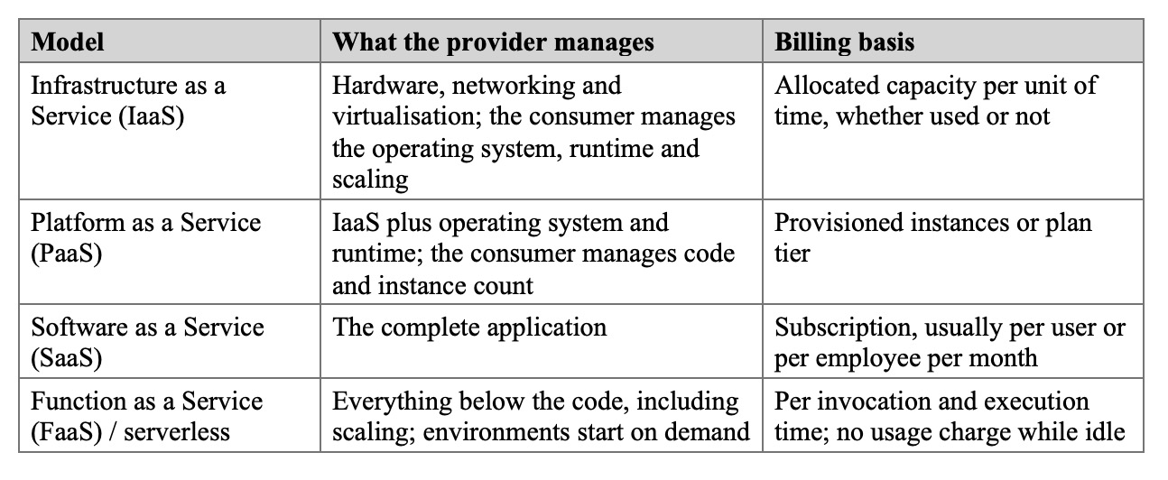
Zhao and Rabiei (2023) have studied the possibility of using a cloud-based payroll system and found that reduction of maintenance, elimination of local infrastructure cost and improved accessibility are the primary reasons. They also noted payroll suits cloud delivery due to its periodic demand runs. Ammupriya et al. (2025) took it a step further and proposed an MTC multi-tenant cloud HR platform, where each organisation has its own compliance rules, hierarchies and scaling behaviour. According to Milhem et al. (2025), 280 managers and HR specialists in Bahraini SMEs were surveyed, revealing that technological, organisational and environmental factors contributed to the adoption of cloud HRM, whereas the personal innovativeness of managers did not have a significant impact. In their review of 90 SME studies, Mkhize et al. (2025) mentioned operational efficiency and cost savings as key benefits and data security and migration cost as the most prevalent barriers respectively.
Taken together, these studies show that, particularly in the presence of appropriate organisational conditions, the adoption of cloud delivery is most advantageous for smaller organisations. That is significant in Nigeria where the cost-consciousness takes over from SMEs and public institutions and do not have infrastructure experts on staff. The only thing they have in common is a drawback. All of the platforms they talk about are provisioning virtual machines or containers and scalability is about adding more reserved capacity. The closest work to this project is conducted by Ammupriya et al. (2025) but they also make an assumption of conventional infrastructure. Currently, no HR-specific studies are focused on evaluating a serverless backend..

2.4 Serverless and Edge Computing
In serverless computing resources are charged per execution, no matter how much you reserve, and resources are allocated on-demand when an invocation is made. Shafiei et al. (2022) have performed an analysis of its applications and then listed the workloads to which it had been applied, primarily event processing, data pipelines and scientific computing. Wen et al. (2023) explains the evolution of serverless to a mainstream architecture that has three features; it is event-driven, it is automatically scaled, and it is usage-based billed. The economic claim was put to the test by Liu and Niu (2023). Their reply was that the saving is dependent on the workload shape. Low duty cycles and irregular arrivals gain; sustained high utilisation may not. For this project the qualification is important. HR traffic is episodic and has the highest return on per-execution billing, and on payroll, recruitment and appraisal.
The literature is as careful about the costs as about the benefits. Ghorbian et al. (2024) conducted a survey of scheduling in serverless platforms and concluded that there is no single winner. Golec et al. (2024) identified mitigations for cold starts ranging from "warming up" functions to running in "lighter" execution environments, and determined that they each come with a tradeoff of increased cost or increased complexity for lower latency. On the edge side, Raith et al. (2023) pointed out that running code near the users eliminates network latency, which in turn results in a response time dominated by network latency. Not that distributed state isn’t difficult to maintain, or that each invocation has strict resource bounds, they note.
This is an edge platform such as Cloudflare Workers. It executes code within V8 isolates in the same process instead of new processes for every request (Cloudflare, 2026a). The vendor and practitioner claim that isolates start faster than containers, for the most part. A first step towards comparing public providers of Function-as-a-Service was taken by Ekwe-Ekwe and Amos (2024), but there are still few independent measures of isolate-based edge platforms. The measurements in Chapter Four add a little to that evidence.
Another requirement that is subjective when deciding on an architecture are the conflicting goals of cost, latency and isolation. Other engineering areas make such decisions explicitly and do not reduce them to a single ranking. For instance, Ajayi et al. (2026) proposed an evolutionary algorithm (NSGA-III) for solving a multi-objective power dispatch problem. We have no answer to that one, since it focuses on energy systems, not on HR software. It did make one decision in this project, however. Chapter Four presents the cost and response time separately rather than as a single score.
To sum up, the advantages of serverless (less idle capacity, automatic scaling, shorter network paths at the edge) are offset by the disadvantages (cold starts, distributed state, limited resources per invocation). The majority of its evidence is sourced from infrastructure-level workloads. It has never been deployed on a business system that integrates relational data, business files, workflows and payroll computation like an HRMS.

2.5 Multi-Tenancy, Isolation and Authentication
If one deployment is in use by multiple organisations, there needs to be a way to ensure that their data is separated. Hattab and Belalem (2023) modeled multi tenant services using multi level Petri nets and highlighted the main conflict as sharing vs isolation. Typically there are three positions described. The most isolation, and highest operation cost is the silo, which is an individual database for each tenant. A bridge allows tenants to be distributed across different databases using different schemas. All pools share the same database and schema and each row contains a tenant identifier. Pooling is the least expensive and easiest to maintain. The downside of this is that it is weak in the sense that if the tenant filter is omitted from any query, it is a data leak.
In the pool model, the security guidance recommends that the tenant context be obtained from a verified credential rather than from a value supplied by the client and that the tenant identifier be used in all queries (OWASP, 2025). Stateless compute layer is an excellent fit with a stateless token authentication. Dalimunthe, et al., (2023) conducted a test on JSON Web Tokens (JWT) signed with HMAC on session management for a Representational State Transfer (REST) Application Programming Interface (API). The tokens functioned well, except that it was difficult to revoke a signed token before its expiration. This project is not included in either of the studies. Hattab and Belalem (2023) formalise the trade-off and Dalimunthe et al. (2023) consider authentication in isolation, not in the context of a multi-tenant system. With ZenHR the two concerns come together, as tenant scoping is done based on the identifier of the company within a verified token.

2.6 Payroll Automation and Statutory Compliance
Zhao et al. (2023) advocated cloud payroll. As in most of the payroll literature, however, they equated compliance with a correct arithmetic. The Nigerian commitment goes beyond that. Employers are required to apply progressive PAYE, with statutory reliefs, and to deduct employee pension, NHF and account for employer pension, NSITF and ITF. All of them will be submitted by their own deadlines and in their own format. If a system is set up to correctly process the net pay but the remittance dates are left up to memory, then only half of the task is automated.
Falana et al. (2024) report that digital tax administration in Nigeria raised compliance and lowered its cost, for taxpayers and for the revenue authority alike. Together with Zhao and Rabiei (2023), this indicates a certain design. The following are statutory rules which should appear within the computation: Deductions should be captured from the live records, and not re-keyed. Once a payroll run has been completed, each payroll remittance obligation must be turned into a task with a date. Auditability imposes an additional condition: all the deductions are kept separate from each other and at the moment of computation, so that, if a disputed payslip is raised several months later, one can still explain which deduction was called into question.

2.7 Artificial Intelligence and Large Language Models in HR
Budhwar et al. (2023) consider the potential benefits and risks of generative AI in HRM, and the issues the issues raise are those of bias, transparency and accountability. To summarize, 120 articles related to AI in recruitment were reviewed by Mori et al. (2025) and the area was categorised under efficiency, fairness, and rights. They found evidence that selection algorithms trained on unrepresentative data can discriminate against protected groups, but that candidates would prefer to have a human remain involved. Dasaklis et al. (2026) identified governance as the least developed application of LLM in the recruitment, training and performance evaluation.
Security research points the same way. The most serious threats to LLM applications are prompt injection, where the model deviates from its instructions due to crafted prompts, and excessive agency, where a model has more permissions than necessary for its task (OWASP, 2025). Alli et al. (2026) surveyed AI for autonomous cyber defence and observed that attackers are now exploiting AI and adversarial learning to be able to evade fixed defences; they identified the need for resilience against an adaptive adversary and human-AI collaboration as open problems. A defence in the model’s instructions would be ineffective if adversaries learn the model. For an HR assistant it means that the authorisation has to be applied in code that the model can’t affect.
While the works concur on the risks, they provide little indication of how to hook an assistant into an existing permission model. Another decision in this project is that while the recruitment module structures and records human hiring decisions, it does not automatically rank or screen candidates.Another decision in this project concerns the fact that the recruitment module structures and records human hiring decisions, but it does not automatically rank or screen candidates (Mori et al., 2025).

2.8 Review of Existing HR Management Systems
There are two types of Academic HR systems. The first is design-and-implementation studies of a single or two functions, usually attendance, leave or payroll, using a three-tier web stack (with a single tenant database on a provisioned server). They typically report quicker processing and fewer errors than the manual baseline, but they do cover part of the lifecycle, and they take the deployment model for granted, rather than examining it. The second group are platform and review studies, discussed above (Ammupriya et al., 2025; Destriani et al., 2024; Zhao & Rabiei, 2023).
Commercial HRMS products are purposefully wide-ranging and are offered as a multi-tenant SaaS. These products contain the payroll rules for a specific country. They do not publish their architecture in a way that enables academic comparison, however, they charge per employee per month, which obscures the cost structure of the infrastructure beneath their surface. Table 2 shows a comparison of these groups with the present project.
Table 2: Comparison of existing HR management systems with this project
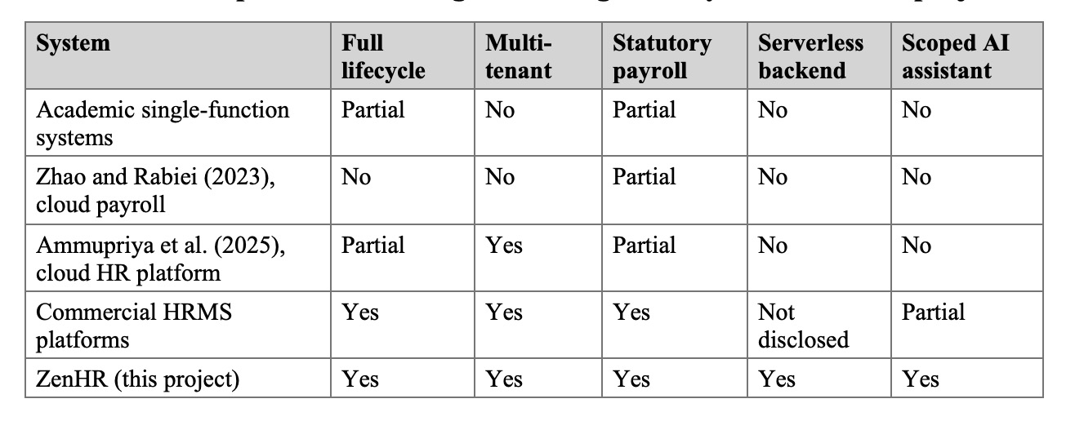
Each element exists somewhere, but there is no reviewed system combines them, and none publishes an evaluation of a serverless HRMS.

2.9 Synthesis and Research Gap
Table 3 summarises the reviewed studies in chronological order, with the gap each leaves for this project.
Table 3: Synthesis of reviewed studies
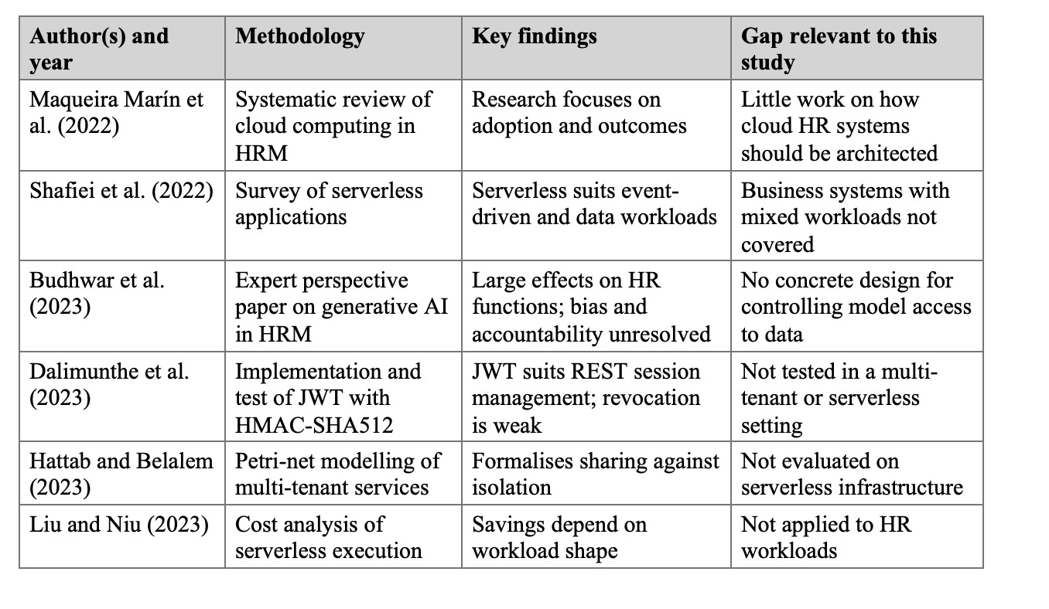
The review shows that HR functionality is very well known, serverless edge computing is well understood as a generic model, Nigerian payroll guidelines are legally codified, and risks associated with LLM usage of sensitive data are enumerated. What has not been built and evaluated is a full-lifecycle, multi-tenant HRMS system powered by a payroll system that adheres to the legislation, combined with an AI assistant that is usable in just a single part of the system, and running completely on serverless edge infrastructure with performance and cost optimisation evaluated. This is where the goals in Section 1.3 come in.
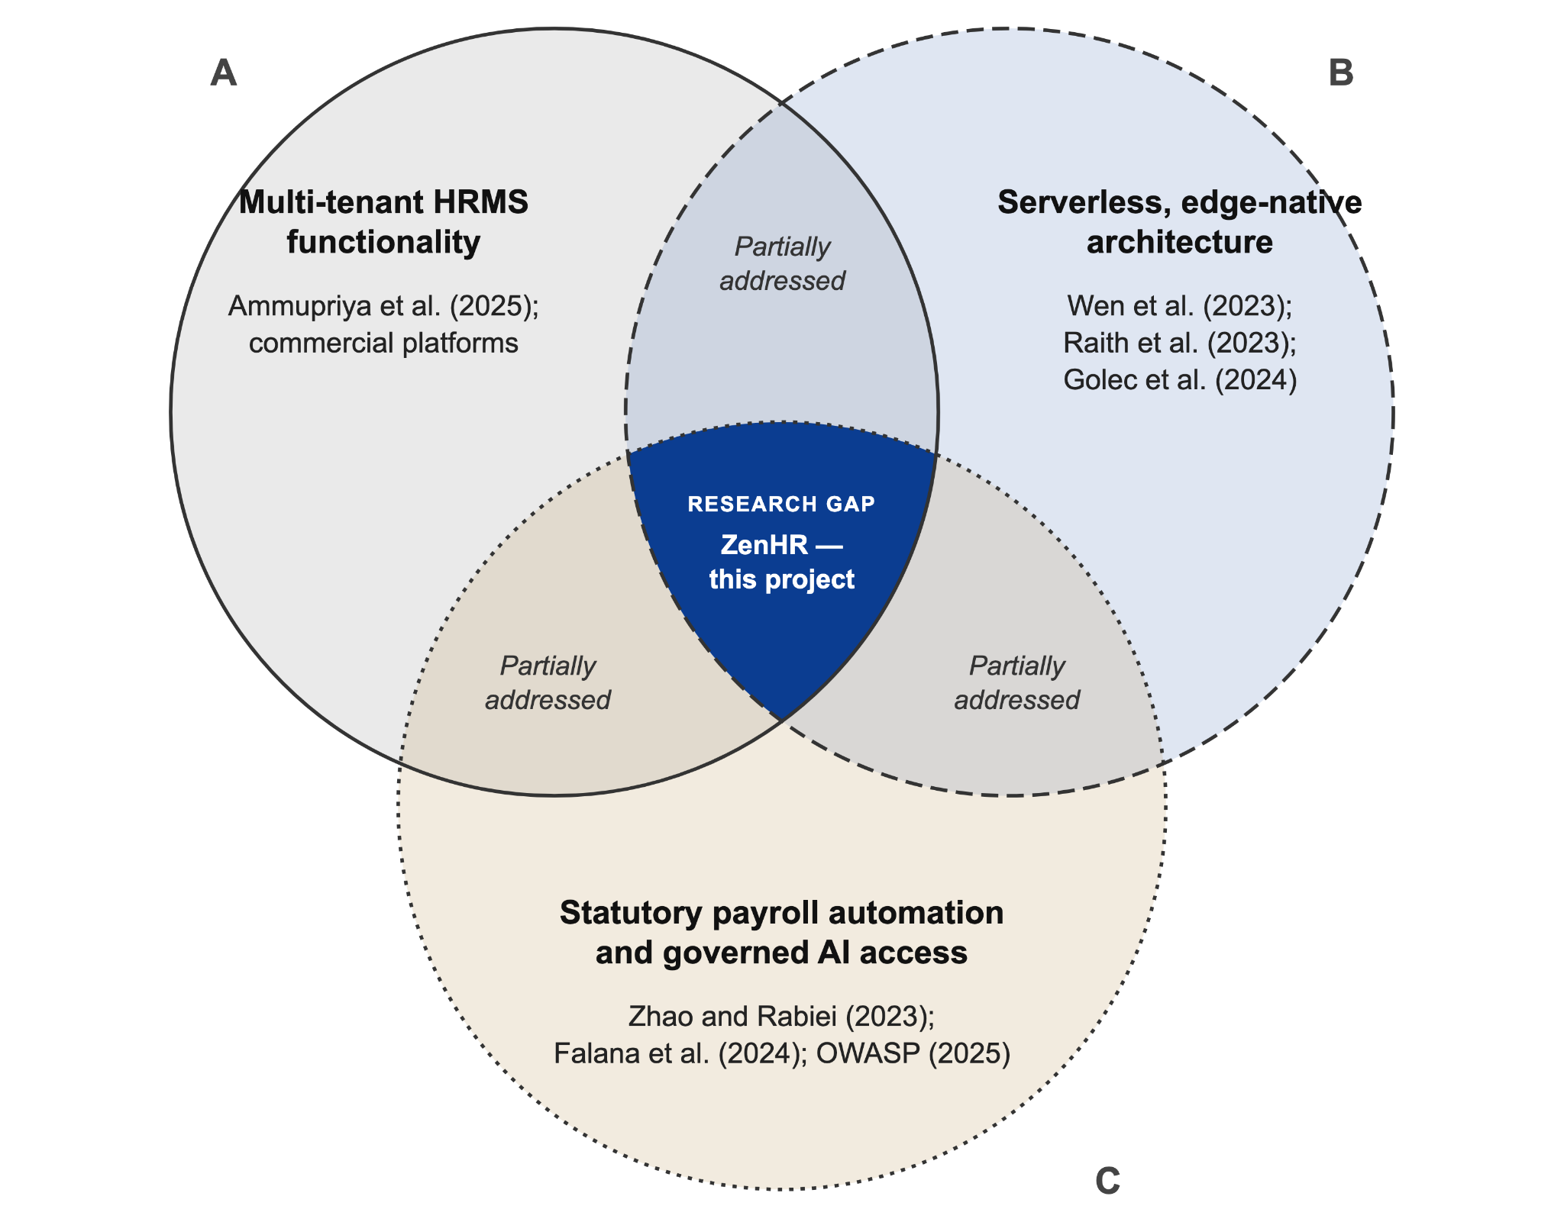
Figure 1: Intersection of literature streams and the research gap addressed by this project

CHAPTER THREE: METHODOLOGY

3.1 Introduction
The design and implementation of the study are presented in this chapter. The research and development approach is described in section 3.2. The architecture, requirements, system models and the database, payroll, interface and security design are detailed in sections 3.3 to 3.9, respectively, and Section 3.10 outlines the evaluation of the system. Table 4 indicates the objective(s) in Section 1.3 (Vision 2025) that will be met by each objective.
Table 4: Mapping of objectives to methodology and results
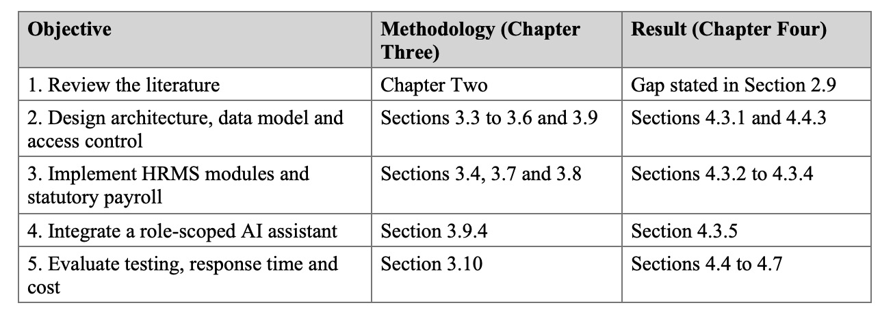

3.2 Research and Development Approach
The study used design science research (DSR) method, where the working artefact is the primary research product. The following steps were followed: Identification of the problem (Section 1.2); Review of the literature to identify gap and inform design decisions (Chapter Two); Design of the system (this chapter) and construction (Chapter Four); End-to-end exercise of each module; Testing, response-time measurement and cost modelling of the system; Report of the results (this document).
The software development was done incrementally in Agile style with vertical slices. An increment was intended as a completed feature in each layer including the database table, the service containing the business logic, the route and the React screen and finally the tests. This was appropriate for the project in two ways. The features exist in modules which are mostly independent and, on a serverless platform, a new route or table can become active without rebuilding a monolithic server. Orders of work were prioritized according to risk. The authentication, multi-tenancy and the employee record were built and hardened first, as every other module will rely on it, followed by attendance and leave, then payroll, and last but not least, the more specialised modules.

3.3 System Architecture
The system is a two-tier client-server application system deployed entirely on Cloudflare’s serverless platform, as shown in Figure 2. The two tiers are deployed independently and they communicate only through Hypertext Transfer Protocol Secure (HTTPS) requests carrying JavaScript Object Notation (JSON).
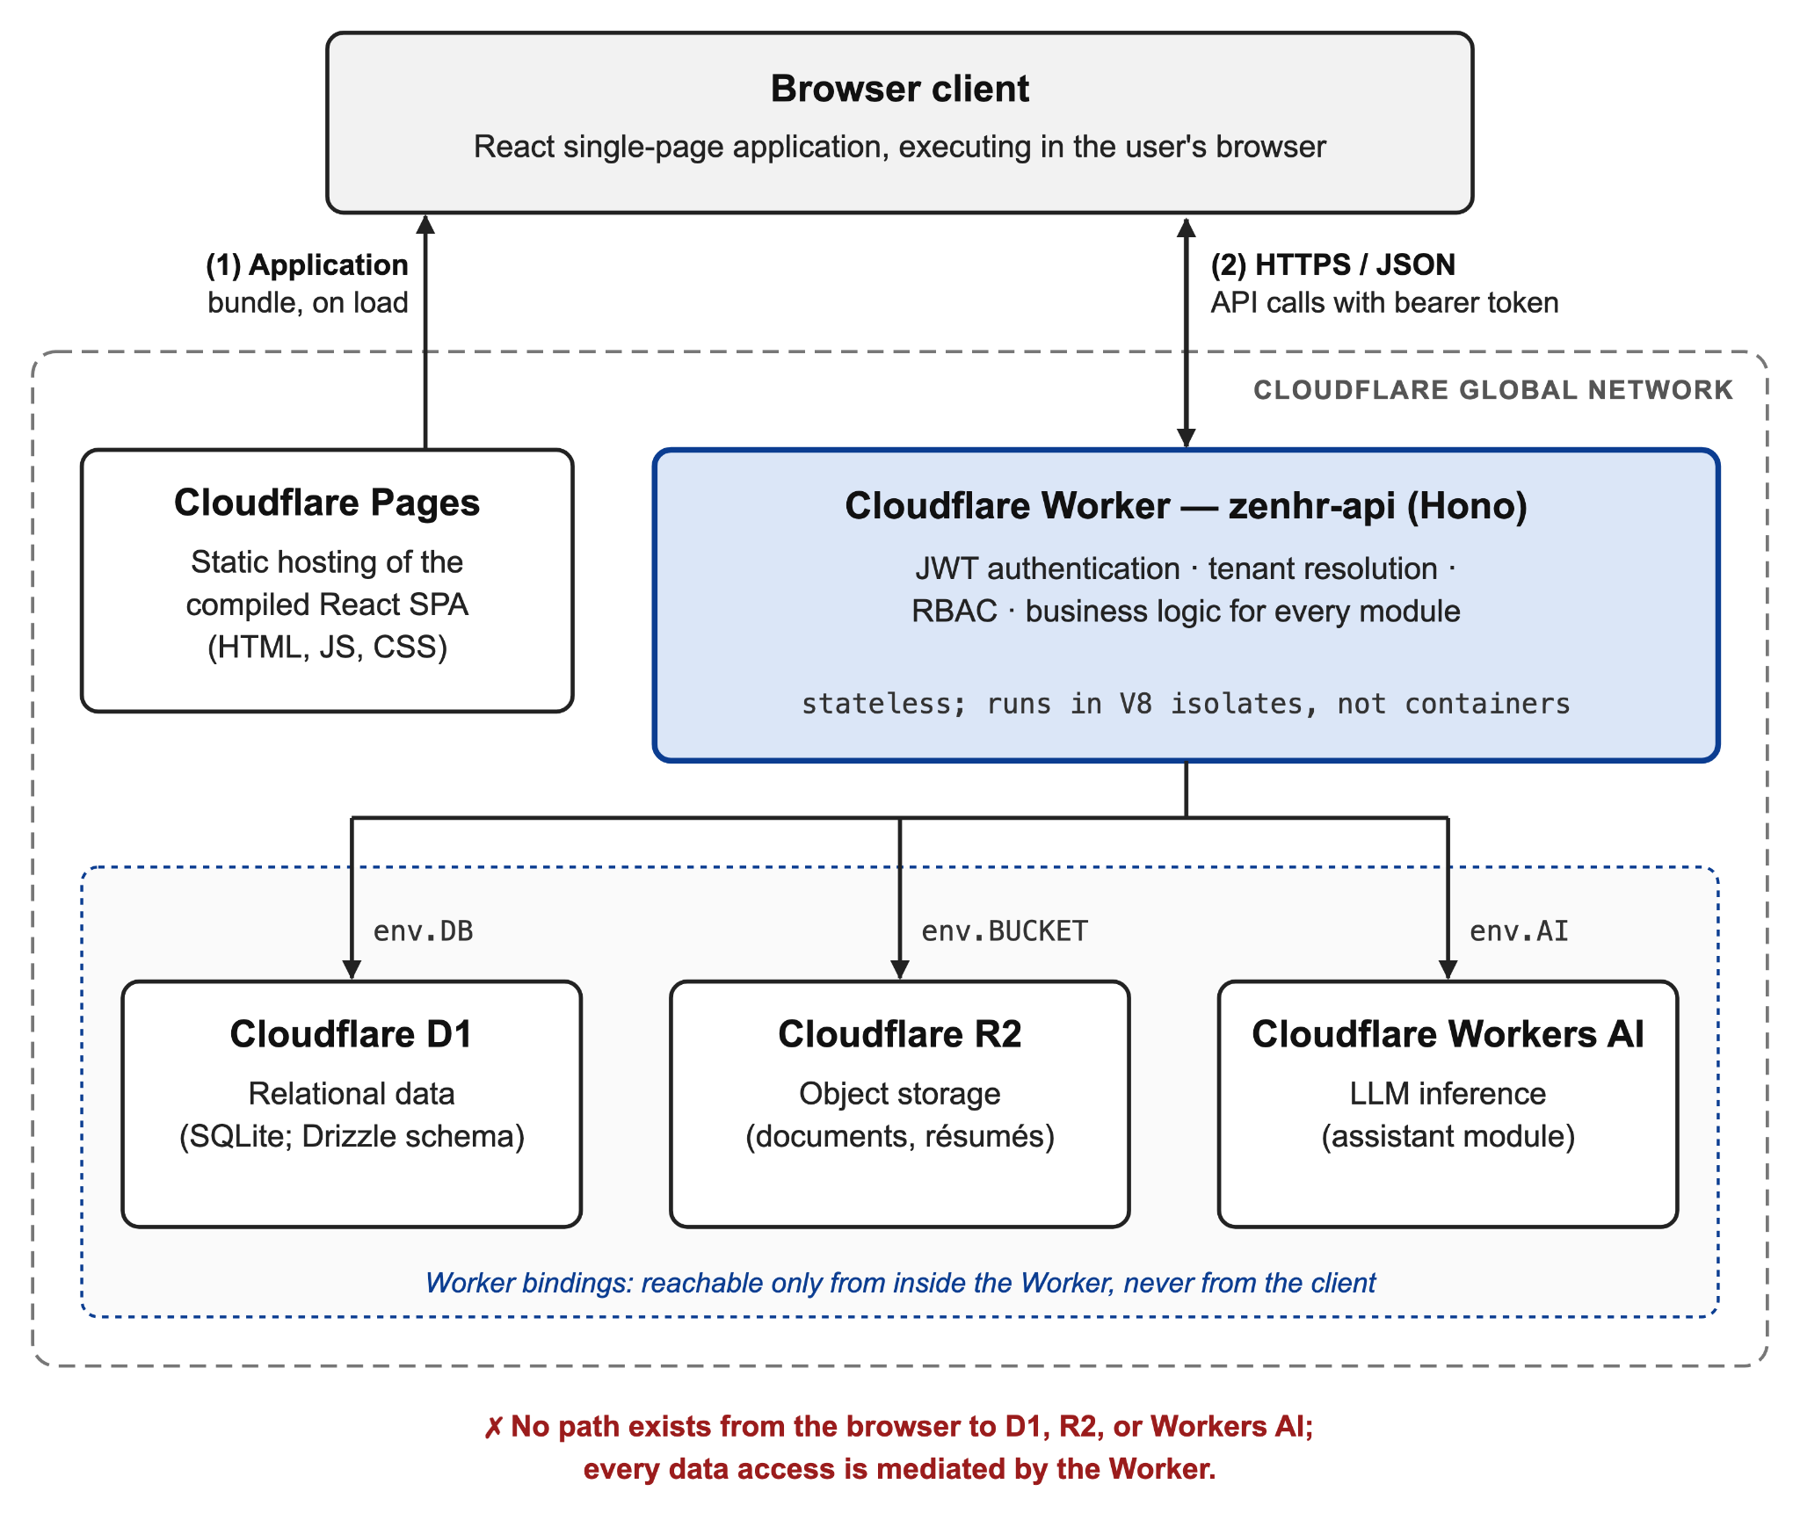
Figure 2: High-level system architecture
The presentation tier is a single-page application using Vite that serves static files with Cloudflare Pages. It does not directly relate to the database or file storage. The application tier consists of a stateless API developed in Hono framework and deployed as a Cloudflare Worker. Instead of being processed on a provisioned server (Cloudflare, 2026a), each request is processed in a V8 isolate on Cloudflare’s network. All authentication, tenant resolution, authorisation and business logic is the Worker’s responsibility. Cloudflare D1, a serverless Structured Query Language (SQL) database built on SQLite, holds all structured data (Cloudflare, 2026b). Documents, like contracts, curricula vitae (CVs) and payroll files are stored in Cloudflare R2, an S3 equivalent object store that does not charge for egress, and each document is referenced from a row (Cloudflare, 2026c) in a D1 table that stores the key. Workers AI’s hosted LLM inference is used for the assistant, and is invoked from the same Worker, meaning the same security pipeline applies. The Worker accesses D1, R2 and Workers AI via platform bindings, which are not accessible by the browser.
The code in the Worker is organized into a 5-layer structure. Routes bind each Uniform Resource Locator (URL) and Hypertext Transfer Protocol (HTTP) method to a chain of middleware and a controller. Middleware authenticates, resolves tenants and authorises. A controller processes the request, calls one service and formats the response. All business logic, including the Payroll engine, is encapsulated in the services. Table definitions are stored in the models layer in Drizzle Object-Relational Mapping (ORM). The logic is contained in the services only, thus the payroll engine can be unit tested against a mocked database. Having table shapes in models only has another advantage: as the schema changes, any impacted query cannot be compiled. There was one discrepancy accepted. The settings and control-centre routes do not call the controller but instead call their services directly as they are only concerned with reading and writing the settings.
All options were considered for all components. There are no idle payments with Workers, no patching or sizing up of a server. It addresses the operational burden reported by Destriani et al. (2024) and it is compatible with the bursty HR workload as reported by Liu & Niu (2023). It has narrow central processing unit (CPU) and memory restrictions per request, and a reliance on the runtime of one vendor. The choice of D1 over a managed PostgreSQL/MySQL instance was due to its cost-efficient pricing model, which is based on the number of rows read or written in the instance rather than on the number of hours it runs. The cost is a D1 database can be small and can only handle one query at a time (Cloudflare, 2026d); Section 4.7 explores both limits. Where payslips and contracts are accessed frequently, R2 will not incur egress charges. Use the query-caching layer to provide a responsive interface when using an ordinary REST API. The primary maintainability risk of this combination is vendor lock-in, although using plain TypeScript services that do not rely on Cloudflare-specific interfaces can help to mitigate this risk.

3.4 System Requirements
The functional requirements were derived from the scope in Section 1.5 and they are summarised in Table 5. The full list of 66 functional requirements (FR1 to FR66) and 18 non-functional requirements (NFR1 to NFR18) is given in Appendix A.
Table 5: Summary of functional requirements
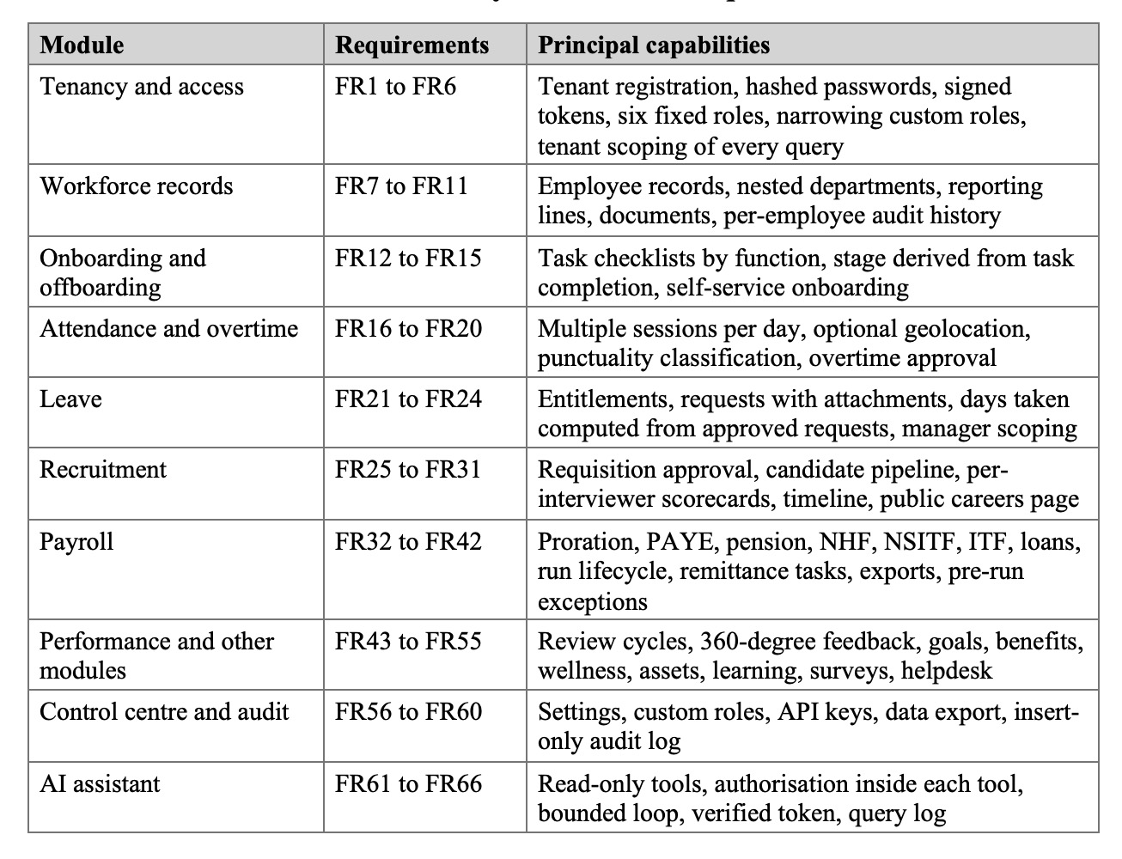
The non-functional requirements consist of 5 qualities. Compute should scale per request without manual provisioning (NFR1), interactive reads should return in a time that would be acceptable to a self-service tool (NFR2), the tool should scale to accommodate a growing number of requests (NFR3), and the service should scale to accommodate a large number of reads (NFR4). No company’s data should be accessible from another company’s session (NFR5-7: scoping at the data-access layer). To do this, traffic needs to be encrypted, passwords kept only as salted hashes, access needs to be granted by least privilege and re-checked at the server, and audit entries need to be written via an insert-only path (NFR8 to NFR12). Cost: no compute charge should be incurred when the compute instance is not used (NFR13). Business logic should be testable independently, it should be possible to add a tenant to the deployment without redeployment, migrations should be versioned, and the interface should display only what the user can see based on his role (NFR14 to NFR18).

3.5 System Design

3.5.1 Actors and Use Cases
Six roles interact with the system (Table 6). A role is a fixed attribute of the employee record. A user becomes a manager in practice when other employees’ manager reference points to them, so no separate hierarchy table is needed.
Table 6: System actors and their principal capabilities
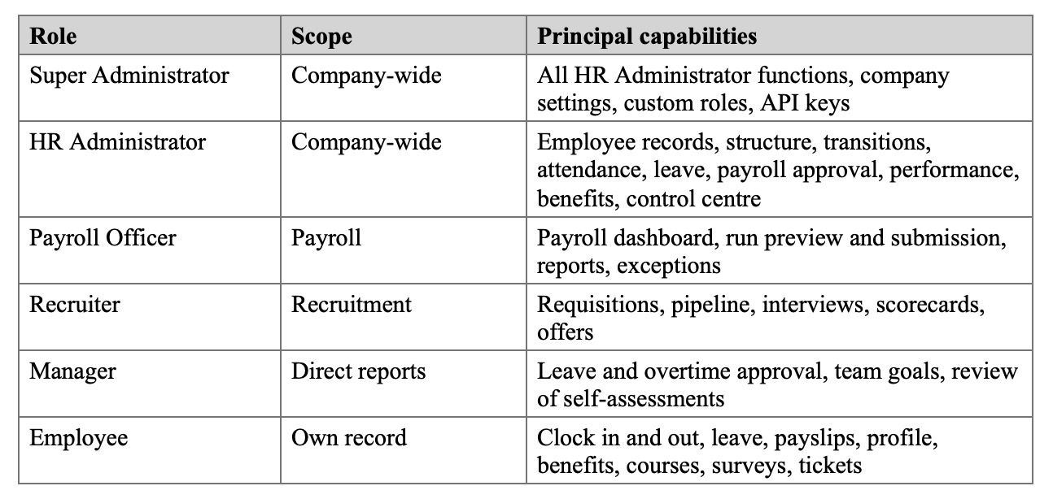
Figure 3 above shows the main use cases for each actor. There is also a 7th actor, the external job applicant, whose only point of contact is the public careers page.
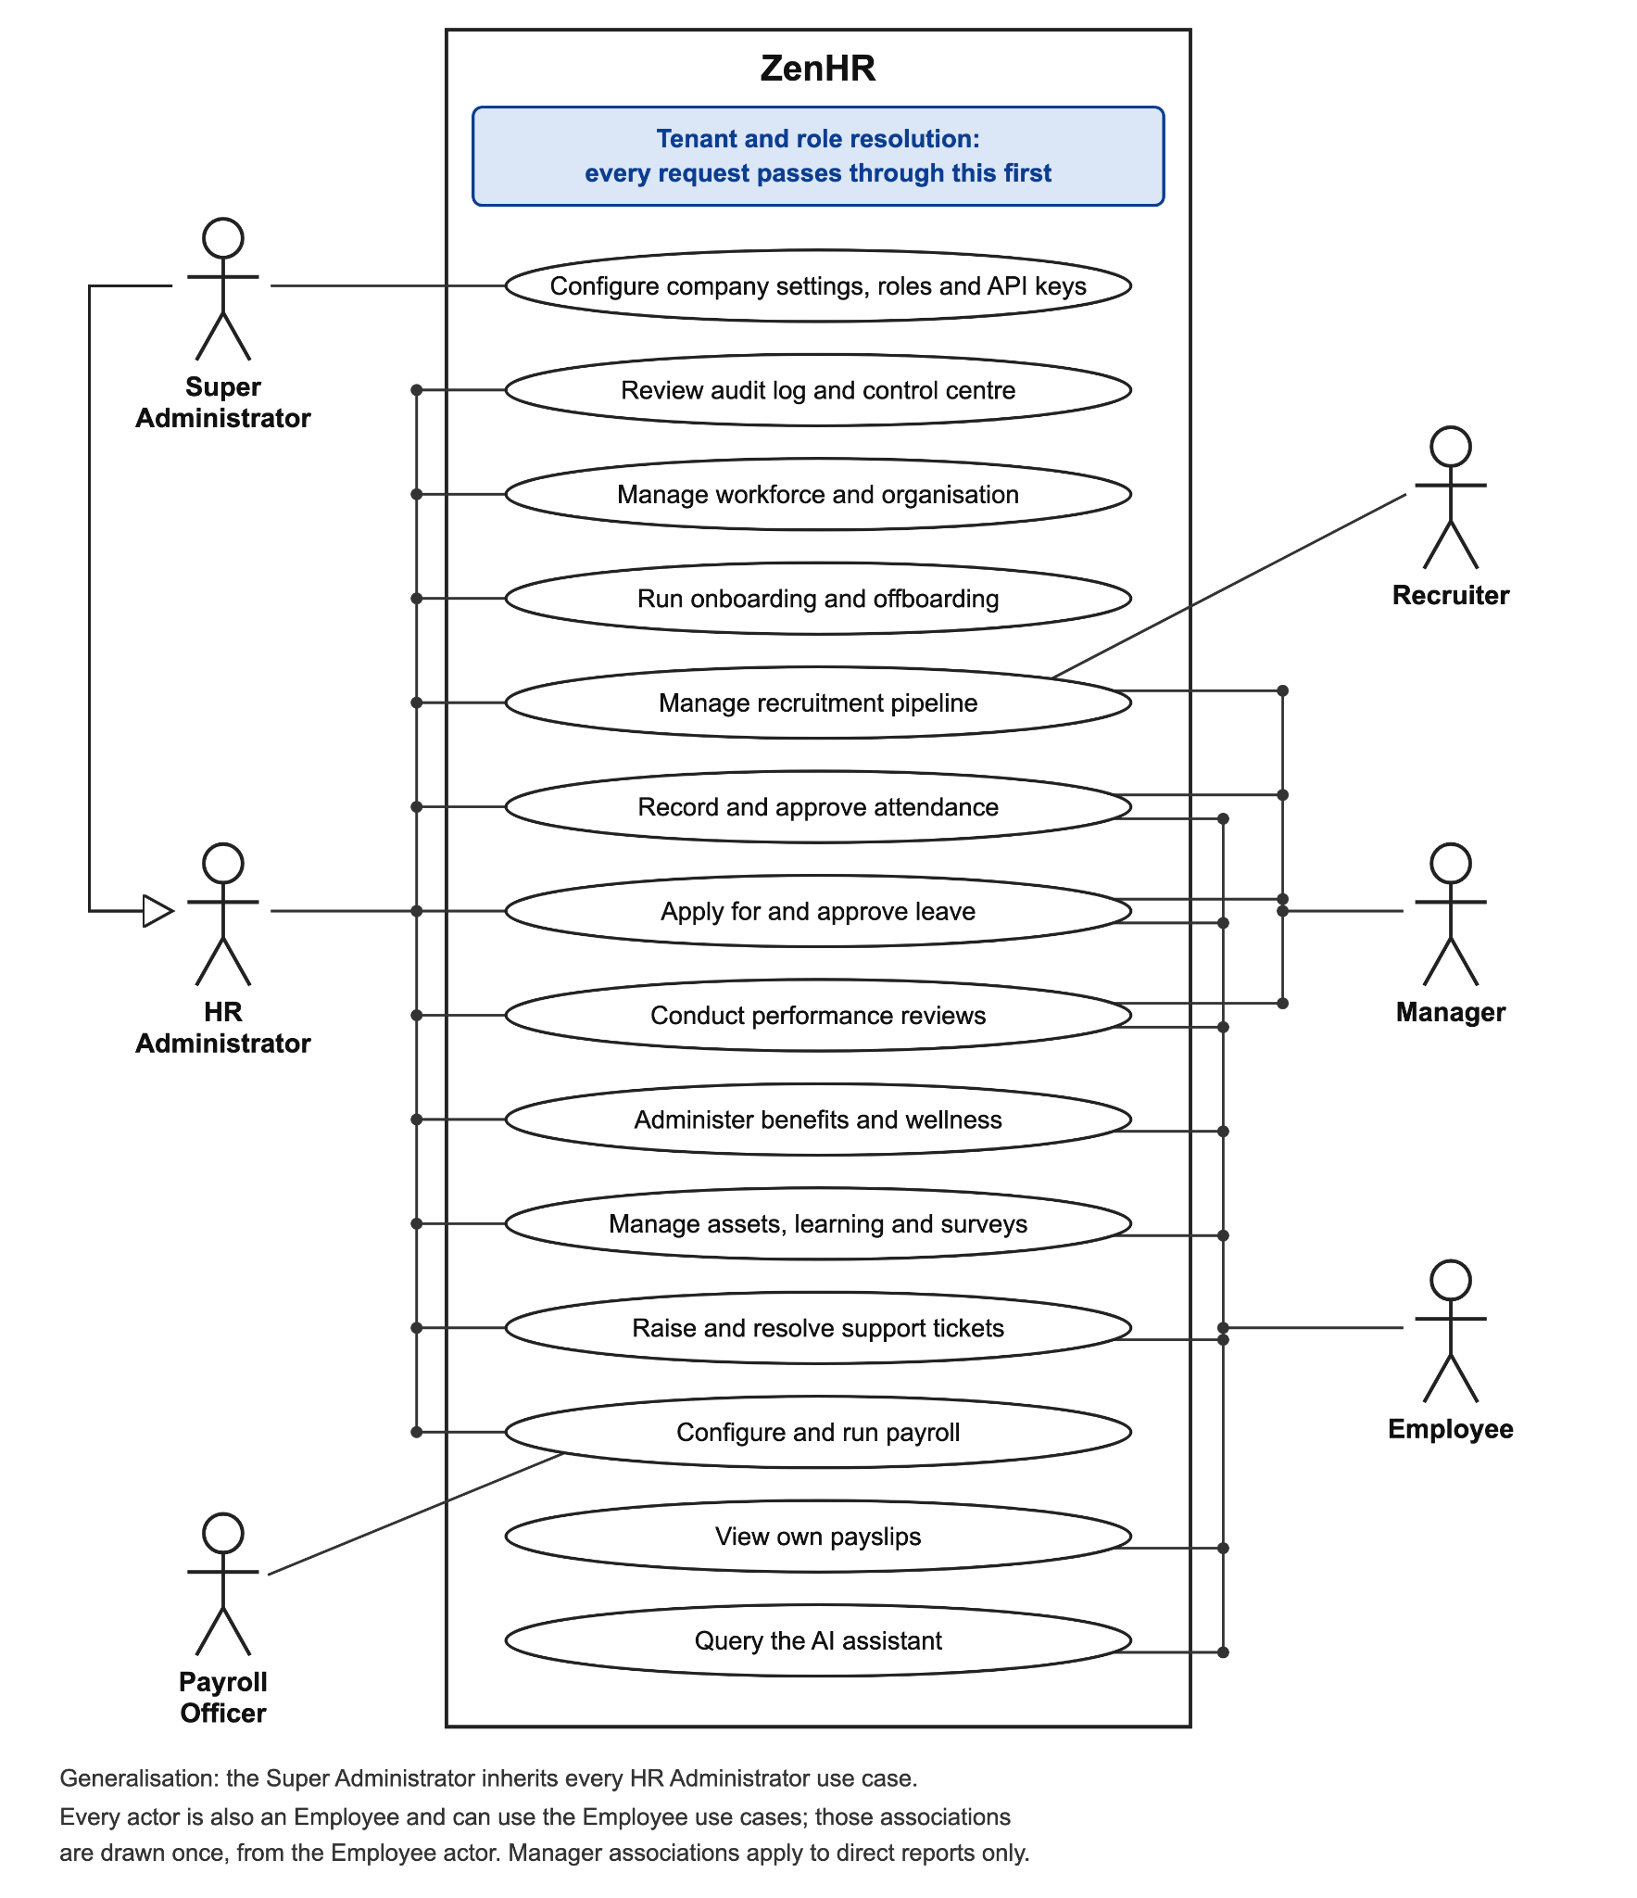
Figure 3: Use case diagram of the ZenHR system

3.5.2 Data Flow Diagrams
Figure 4 below gives the context-level data flow diagram (DFD), in which the whole system is a single process. It exchanges data with the 6 roles, with external applicants and with the hosted inference service. Into the system go configuration, requests, attendance events and applications. Out come records, payslips, export files and reports.
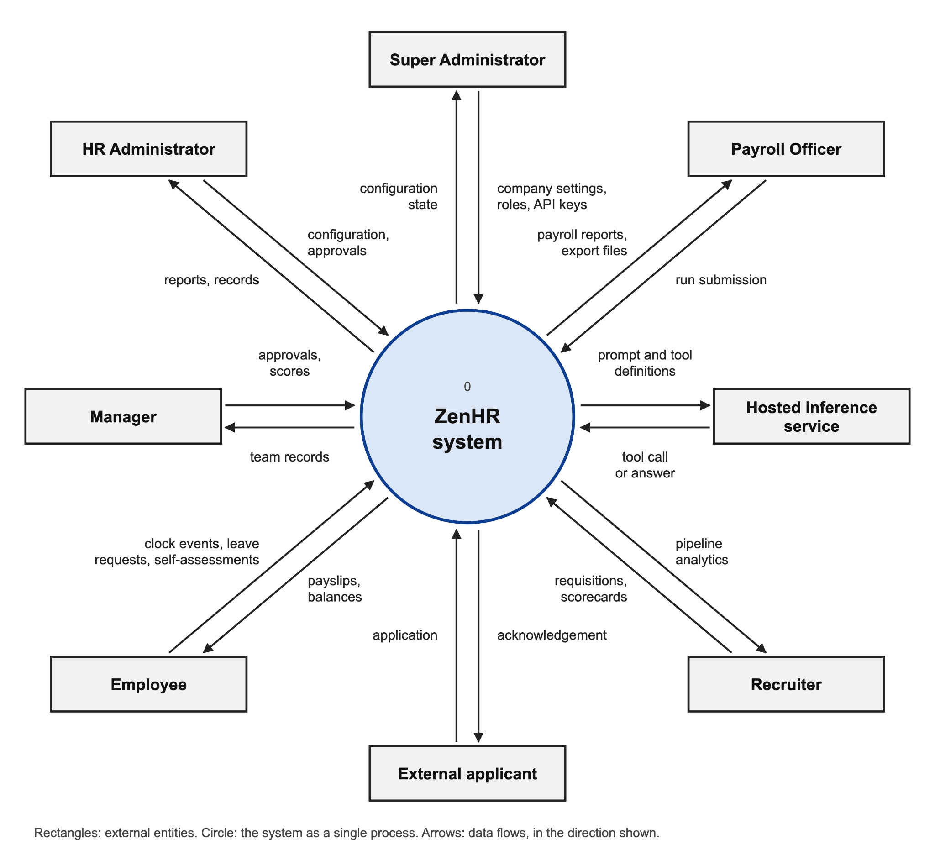
Figure 4: Context-level data flow diagram
Payroll is the most data-intensive process, so it is broken down in Figure 5. The operator selects a time period. The system then reads the employees, salary configuration, statutory rates, tax bands and active loans, calculates a payslip for each employee and displays a preview, but nothing is saved at this stage. On submission the run and its payslips are written. The run is marked as paid, which starts the rest; the balances of loans reduce, remittance tasks are created with due dates and the export files are released.
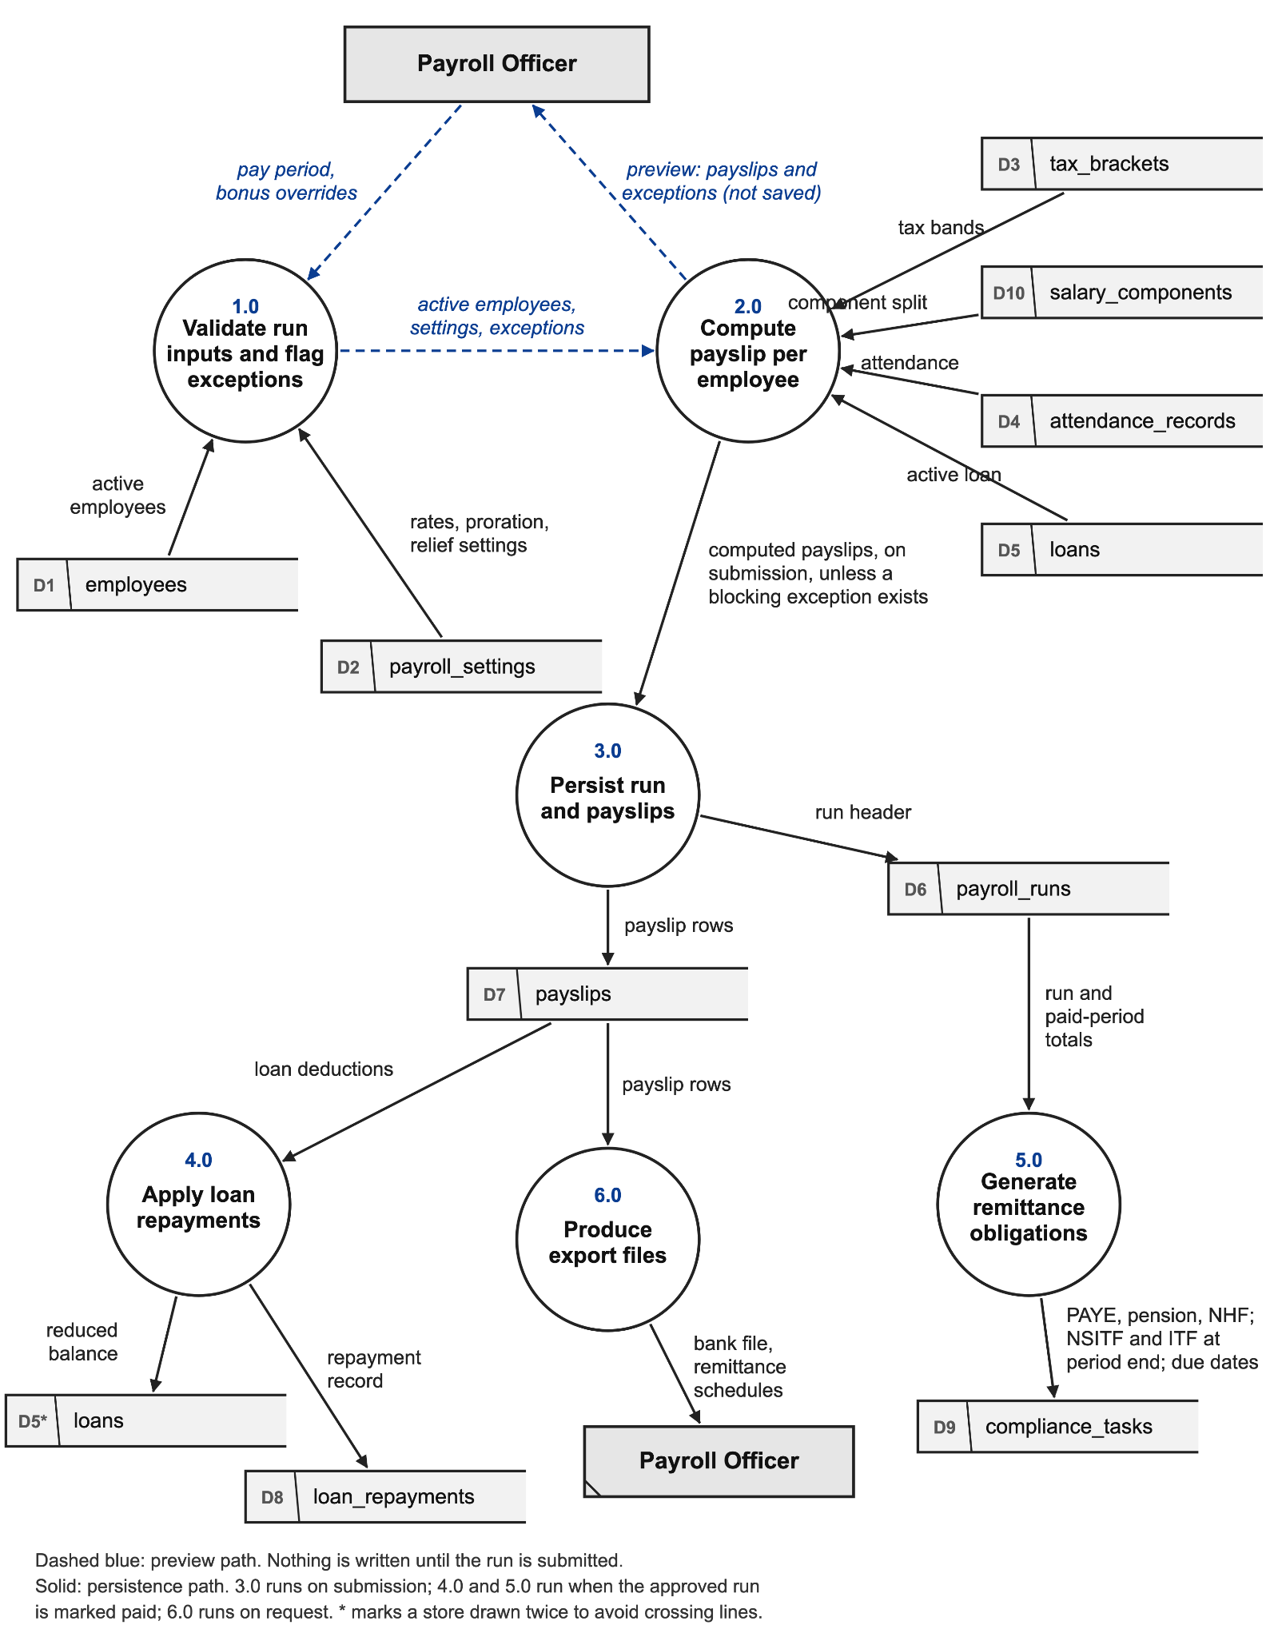
Figure 5: Level 1 data flow diagram for the payroll process

3.5.3 Entity Relationship Diagram
The database has about fifty tables in twelve functional domains, and Figure 6 shows the core entities and how they relate. Nearly all tables have a company reference either explicitly or in the employee record. Tenants scoping is enforceable by that reference. If a table is related to a file, it will store the R2 object key, rather than the file. The table has two columns that refer to two other tables. The manager column is used to drive employee approval routing and manager views, and the parent column lets departments be nested. The chain of payroll run to payslip to compliance task binds each payroll remittance obligation to the run it created.
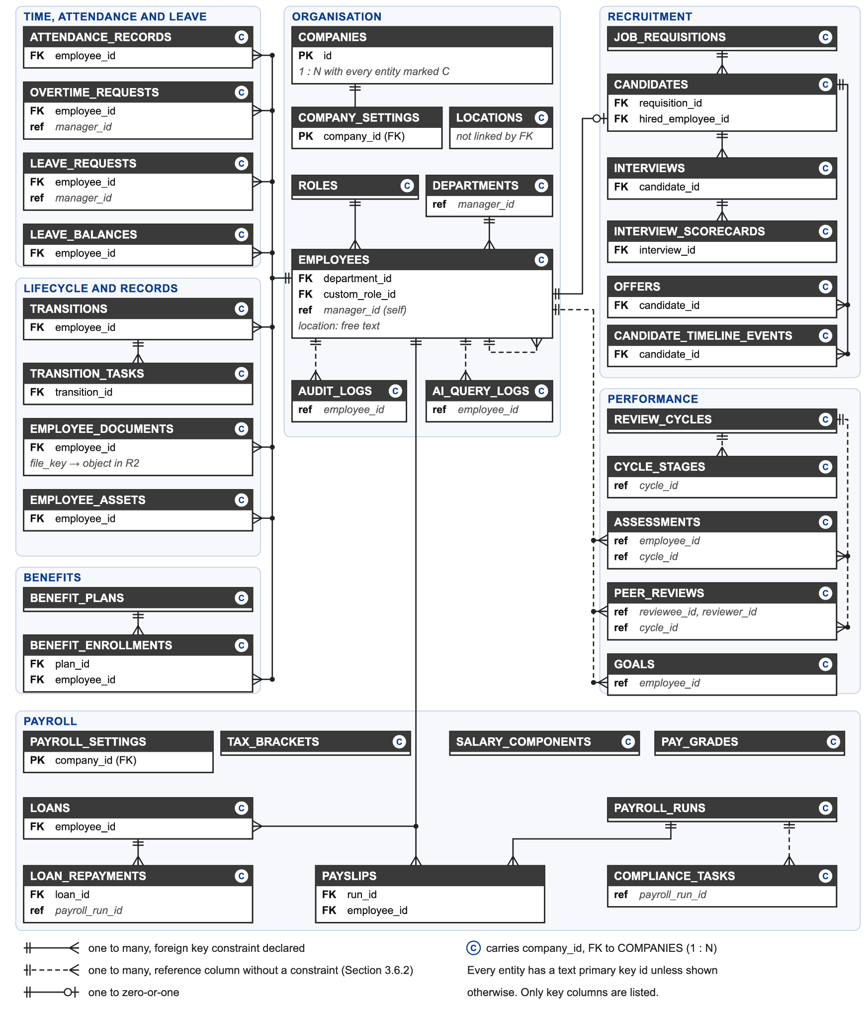
Figure 6: Core entity relationship diagram

3.5.4 Request Pipeline
A request will first pass the fixed pipeline in Figure 7, prior to the execution of any module code. Authentication checks the token signature and puts the employee identifier, company identifier and role on the request context. There is no separate tenant resolution as the company will be read from the verified token. Role gating then filters out any role not on the list of allowed roles for the route, and permission narrowing applies a custom role’s permission matrix if the user has one. This is what the request must do before it gets to its controller. If there is any stage failure, the request halts at that stage.
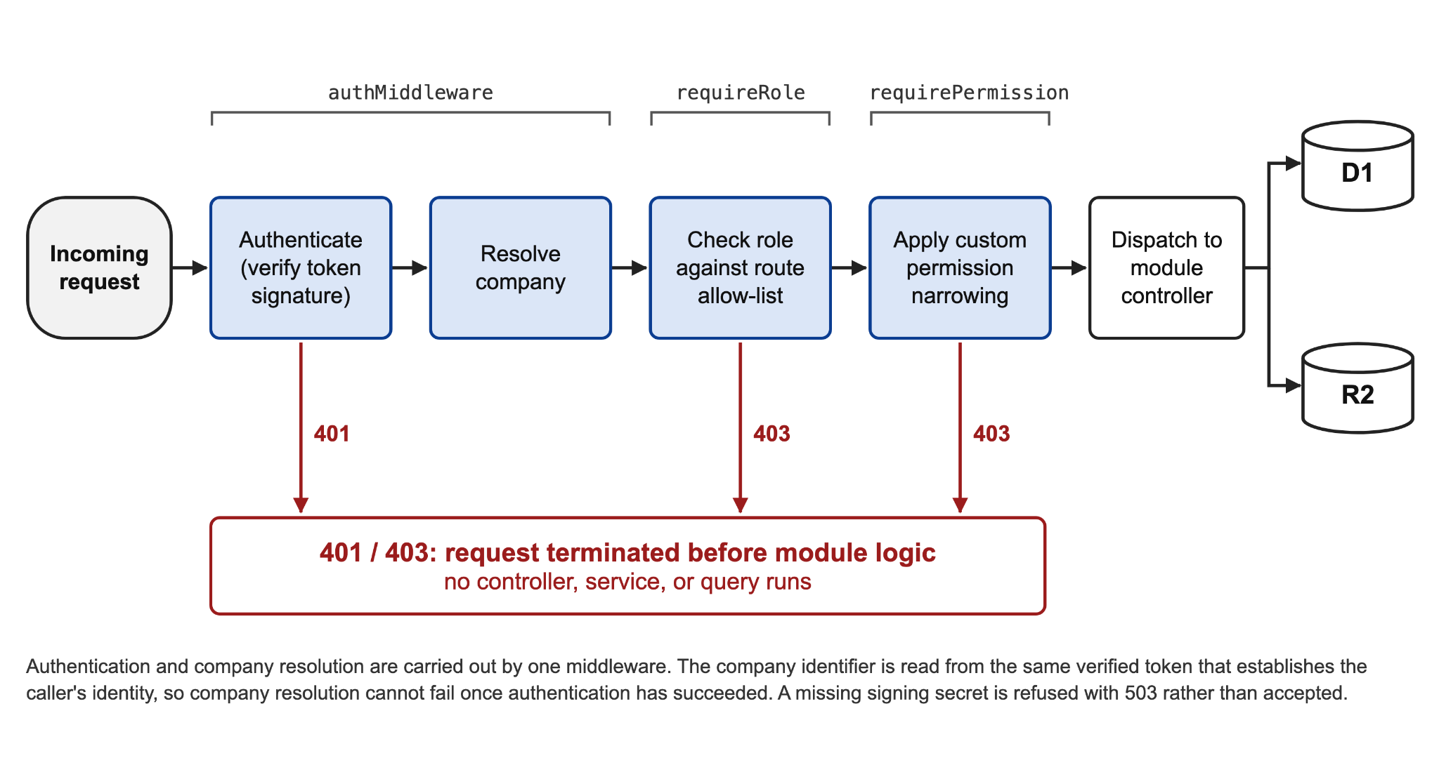
Figure 7: Request processing pipeline within the Worker
Identity, company and role are therefore settled once for each request. The pipeline does not, however, filter database queries by company. That remains the service layer’s job, under the convention set out in Section 3.6.

3.6 Database Design
ZenHR follows the pool model. Every company shares one D1 database and one schema, and each tenant-owned row carries a company identifier. Table 7 sets the 3 options side by side.
Table 7: Tenant isolation models evaluated for this system
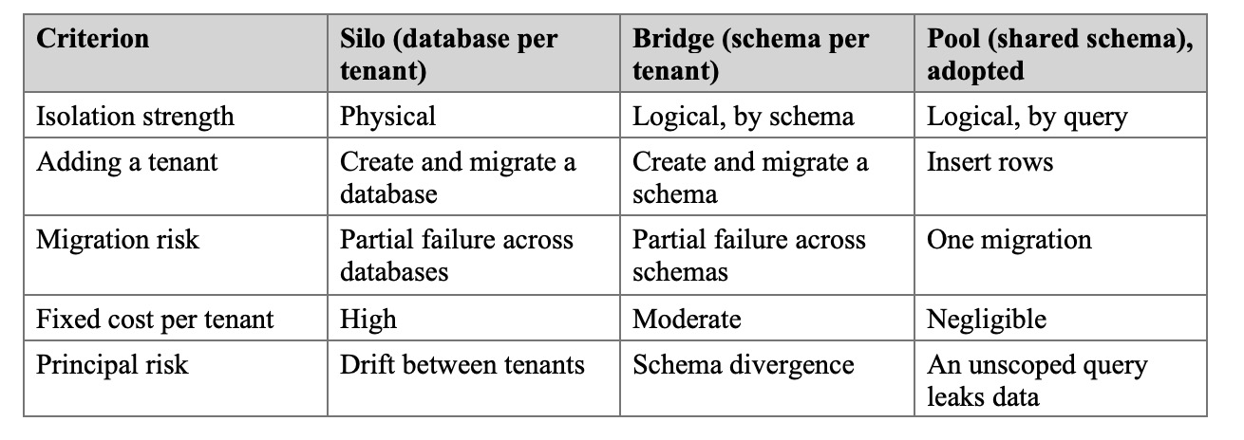

It was decided by four reasons. Migration can not leave tenants on different version (NFR17), schema changes will be applied one time. Rows are added with the addition of a company (there is no provisioning or redeployment (NFR16)) This platform’s tenants are small, and the cost is related to the amount of data, not to the number of tenants. Last, it’s still one query for a report across the entire platform.
The downside to pooling is that it requires a certain type of query discipline. To keep that risk under control, a compulsory scoping convention was used in all services. The caller’s company identifier is required with any method dealing with tenant data. Each query adds the company to the WHERE clause. If the record is retrieved by its identifier, the same query can match the company as well, therefore, the ownership is never checked afterward. NFR6 is only partially met as the convention is not enforced by a data-access wrapper. Section 4.3.1 discusses the audit results and fixes it found and corrected for five unscoped queries, and Section 5.4 suggests the wrapper as future work.
The database has three schema conventions. A company reference and creation and update times are added to each tenant owned table. Primary keys are not sequential numbers, but opaque identifiers—no detail of the number of records can be obtained from an identifier in a URL. A couple of hierarchy references (employee to manager, department to manager) are not enforced as foreign keys, but rather plain columns. That allows an organization to be changed in any sequence which fits it.
There are two more decisions that ensure data integrity. The leave balance table contains only the entitlement. Days taken are calculated at query time, by adding up approved days (FR23). If a reversal, or a partial write, caused the running balance to disappear from the request history, no one would have any clue what the running balance would be. The second ruling is regarding payslips. All figures are fixed on each one when it is computed and each one contains all the deductions in a separate column. If the employee or tax authority does not agree with a deduction, it can be explained. Further, a subsequent rate change will not affect a previous payslip. In Appendix C the names of the principal columns of the employees, attendance, leave and payslips tables are listed.

3.7 Payroll Computation Design
The payroll engine runs in the same order for each employee and every period (Figure 8). Gross pay for a period: Take the Annual salary, and divide by the number of pay periods in the year; If the employee started during the period, divide by the number of periods that have passed.
G = (S ÷ P) × (dw ÷ dp) (1)
It is denoted as S, P, dw and dp, where S is annual salary, P is number of payment period in a year, dw is days worked in payment period and dp is days worked in the payment period. The gross pay is divided into allowance(s) and basic pay based on the salary components defined. The pensionable base is used to calculate employee pension, which is deducted. Employer pension, NSITF and ITF is calculated and reported to the remitter but never deducted from the employee. NHF is calculated based on basic salary.
PAYE is calculated annually, since the relief allowance and the tax bands are calculated annually and using a monthly number will give a different and wrong answer. The income that is subject to taxation each year is:
T = S − R − Cp (2)
where R is Consolidated Relief Allowance and Cp the annual employee pension contribution. T is fed into the company’s progressive bands, where each band removes an equal amount of width and then the next band removes an equal amount of width as well, allowing administrators to change the bands without having to modify the code. The tax for this period is given by:
PAYE = f(T) ÷ P (3)
The loan deduction is the minimum of the instalment I and the remaining debt B, a loan that is nearly repaid is not over deducted:
L = min(I, B) (4)
Net pay is then:
N = G − PAYE − Ce − NHF − L − D (5)
where Ce is the employee pension for the period and D any manual deductions. How each of the statutory items is treated is summarised in Table 8.
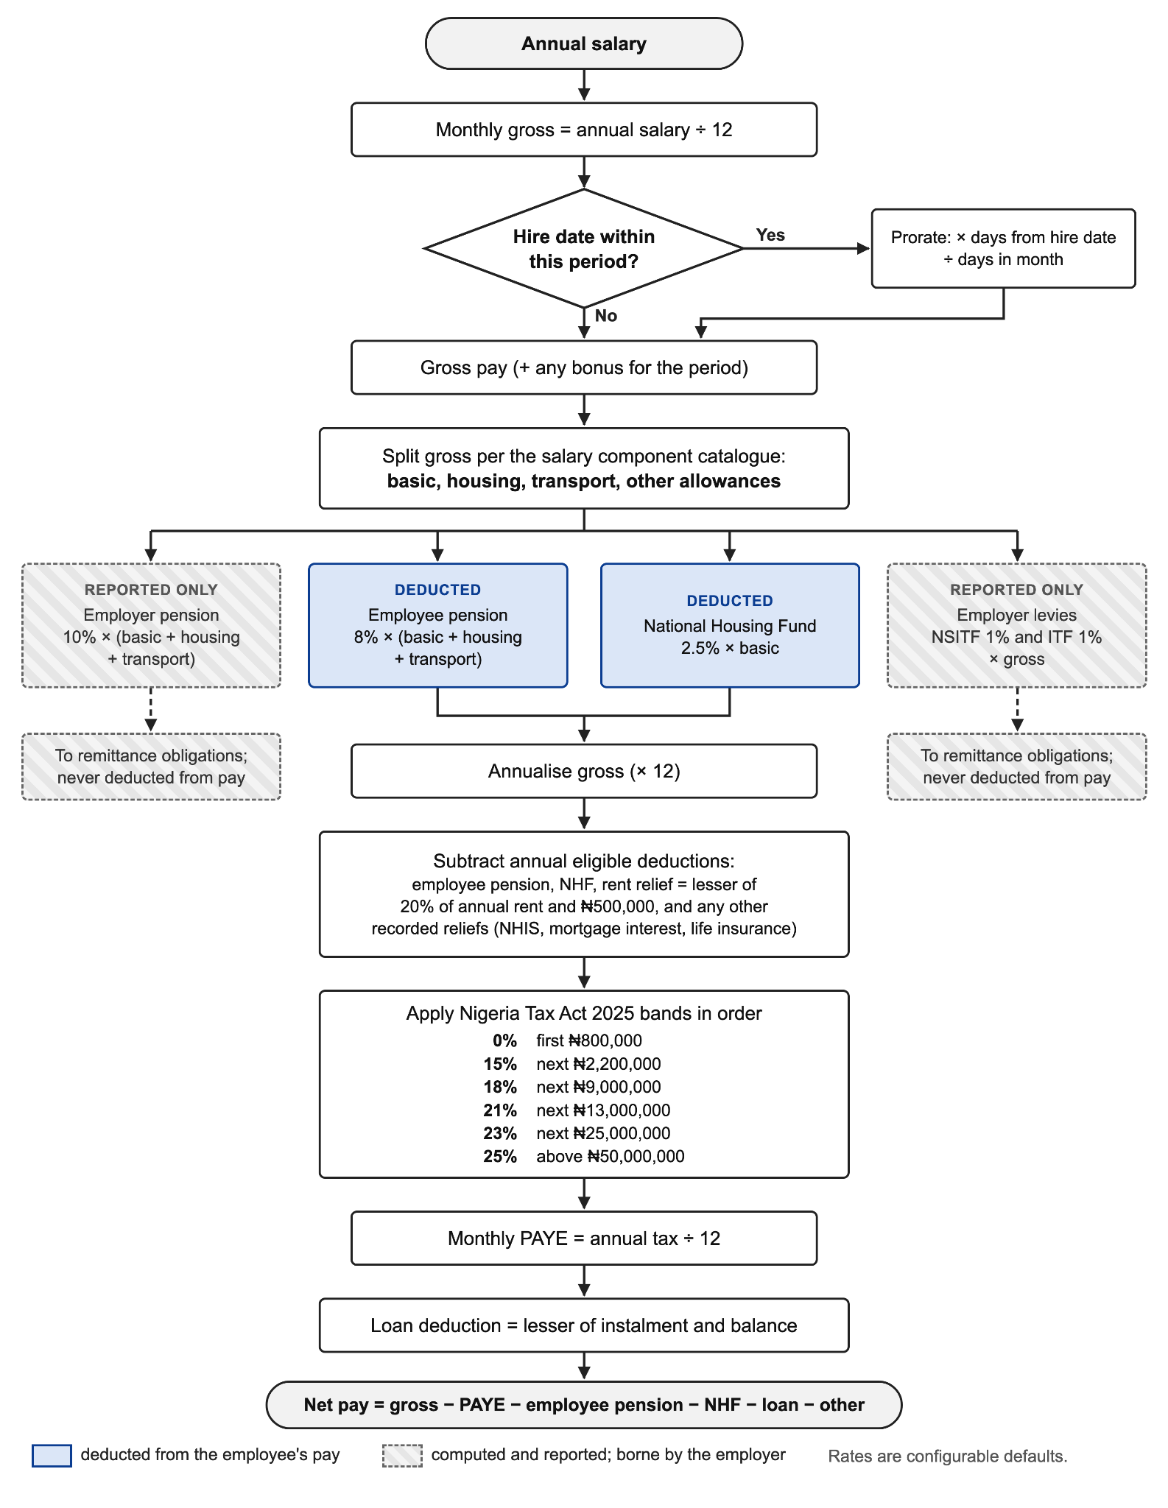
Figure 8: Gross-to-net payroll computation sequence
Table 8: Statutory deduction treatment and remittance
Manual payroll is most likely to break down at the point where one shifts into the other—between what is employee borne versus what is employer borne. It is important to remember that the employer items are not stored in ZenHR and therefore are not included with the remittance reports intentionally in Equation 5. Runs have four phases. Preview does not save anything and calculates it. Submission saves Run and Pay slips. The run is then approved or rejected, followed by the marking of the run as ‘paid’ where loan balances are then reduced, an export file containing dated remittances is created and the bank and scheme export files are then released.

3.8 Interface Design
Each role has its own set of views, not a single screen with a few controls hidden in one of the corners. A company overview is featured on an administrator’s dashboard: employee count, approval status, pending requisitions, transition status and payroll status. The payroll officers operate from a live run, exception rundown and a remittance schedule. The pipeline is viewed by recruiters by requisition and stage. An employee only see his/her attendance, leave, payslips, assets, benefits, courses and tickets whilst a manager sees requests, goals and reviews for direct reports only. The hiding of a control helps the usability, but does not protect anything; each route perform the authorisation check on the server (NFR11). All views have the same layout: role-scoped navigation, list or detail panel, and slide-over panels for quick actions. Navigation relies on internal view state, unless on public careers page, where actual URL is required to be opened by applicants. The representative screens are found in Appendix B.

3.9 Security Design

3.9.1 Authentication and Authorisation
Users log in with an email address and password; passwords are stored only as salted hashes (NFR9). If login is successful, it returns a signed token including the employee identifier, company identifier and role. The company claim can be trusted for tenant scoping (Dalimunthe et al., 2023) due to the signature of the token. There are two levels to authorisation. A coarse layer can only have the roles listed in each route. A fine layer applies a custom role’s permission matrix and can only deny access but not grant it. A misconfigured custom role can therefore be used to lock a user out, which is visible and fixable, but not use to give a user access to the fixed role never allowed.

3.9.2 Isolation, Transport and Files
Tenant isolation depends on the scoping convention in Section 3.6, verified by code review and by dedicated cross-tenant tests. All traffic between the browser, the Worker and the data services is encrypted (NFR8). Files in R2 have no public or long-lived links; each download passes through a route that re-checks role and company.

3.9.3 Audit and Data Protection
Sensitive administrative actions (changes to settings, company profile, departments, locations, roles, holidays, email templates, integrations, workflows and data exports) are written to an audit log with the actor, action, module, severity, details and originating Internet Protocol (IP) address (FR60). The audit table is written through an insert-only path, and no route can update or delete an entry, whatever the user’s privilege (NFR12). Because the system holds personal data such as identity numbers, salaries and bank details, its design follows the principles of the Nigeria Data Protection Act 2023, notably purpose limitation, data minimisation and security of processing (Federal Republic of Nigeria, 2023). Least-privilege roles, tenant isolation, encrypted transport and the audit trail are the controls through which these principles are applied. No formal compliance audit was carried out.

3.9.4 AI Assistant Security Boundary
Section 2.7 showed that an LLM does not inherit an application’s authorisation and that adaptive attacks make defences inside the model unreliable (Alli et al., 2026; OWASP, 2025). For that reason, no security decision in the assistant is left to the model (Figure 9). The model cannot touch the database. It can call only a fixed set of read-only tools (FR62), so even a successful prompt injection has no way to cause a write. Each tool works out the caller’s authorisation afresh from the verified session and ignores whoever the model claims the caller is (FR63). Take a manager-scoped tool: before returning anything it checks the caller’s own direct reports, and if the request falls outside them it returns a structured refusal. The payroll tool gives totals, never individual salaries. Three further limits apply. The agent loop ends after four tool calls (FR64); the endpoint accepts only a fully verified token with a role claim (FR65); and each question is logged with the company, employee, role and tools used (FR66). The tools are listed in Table 9.
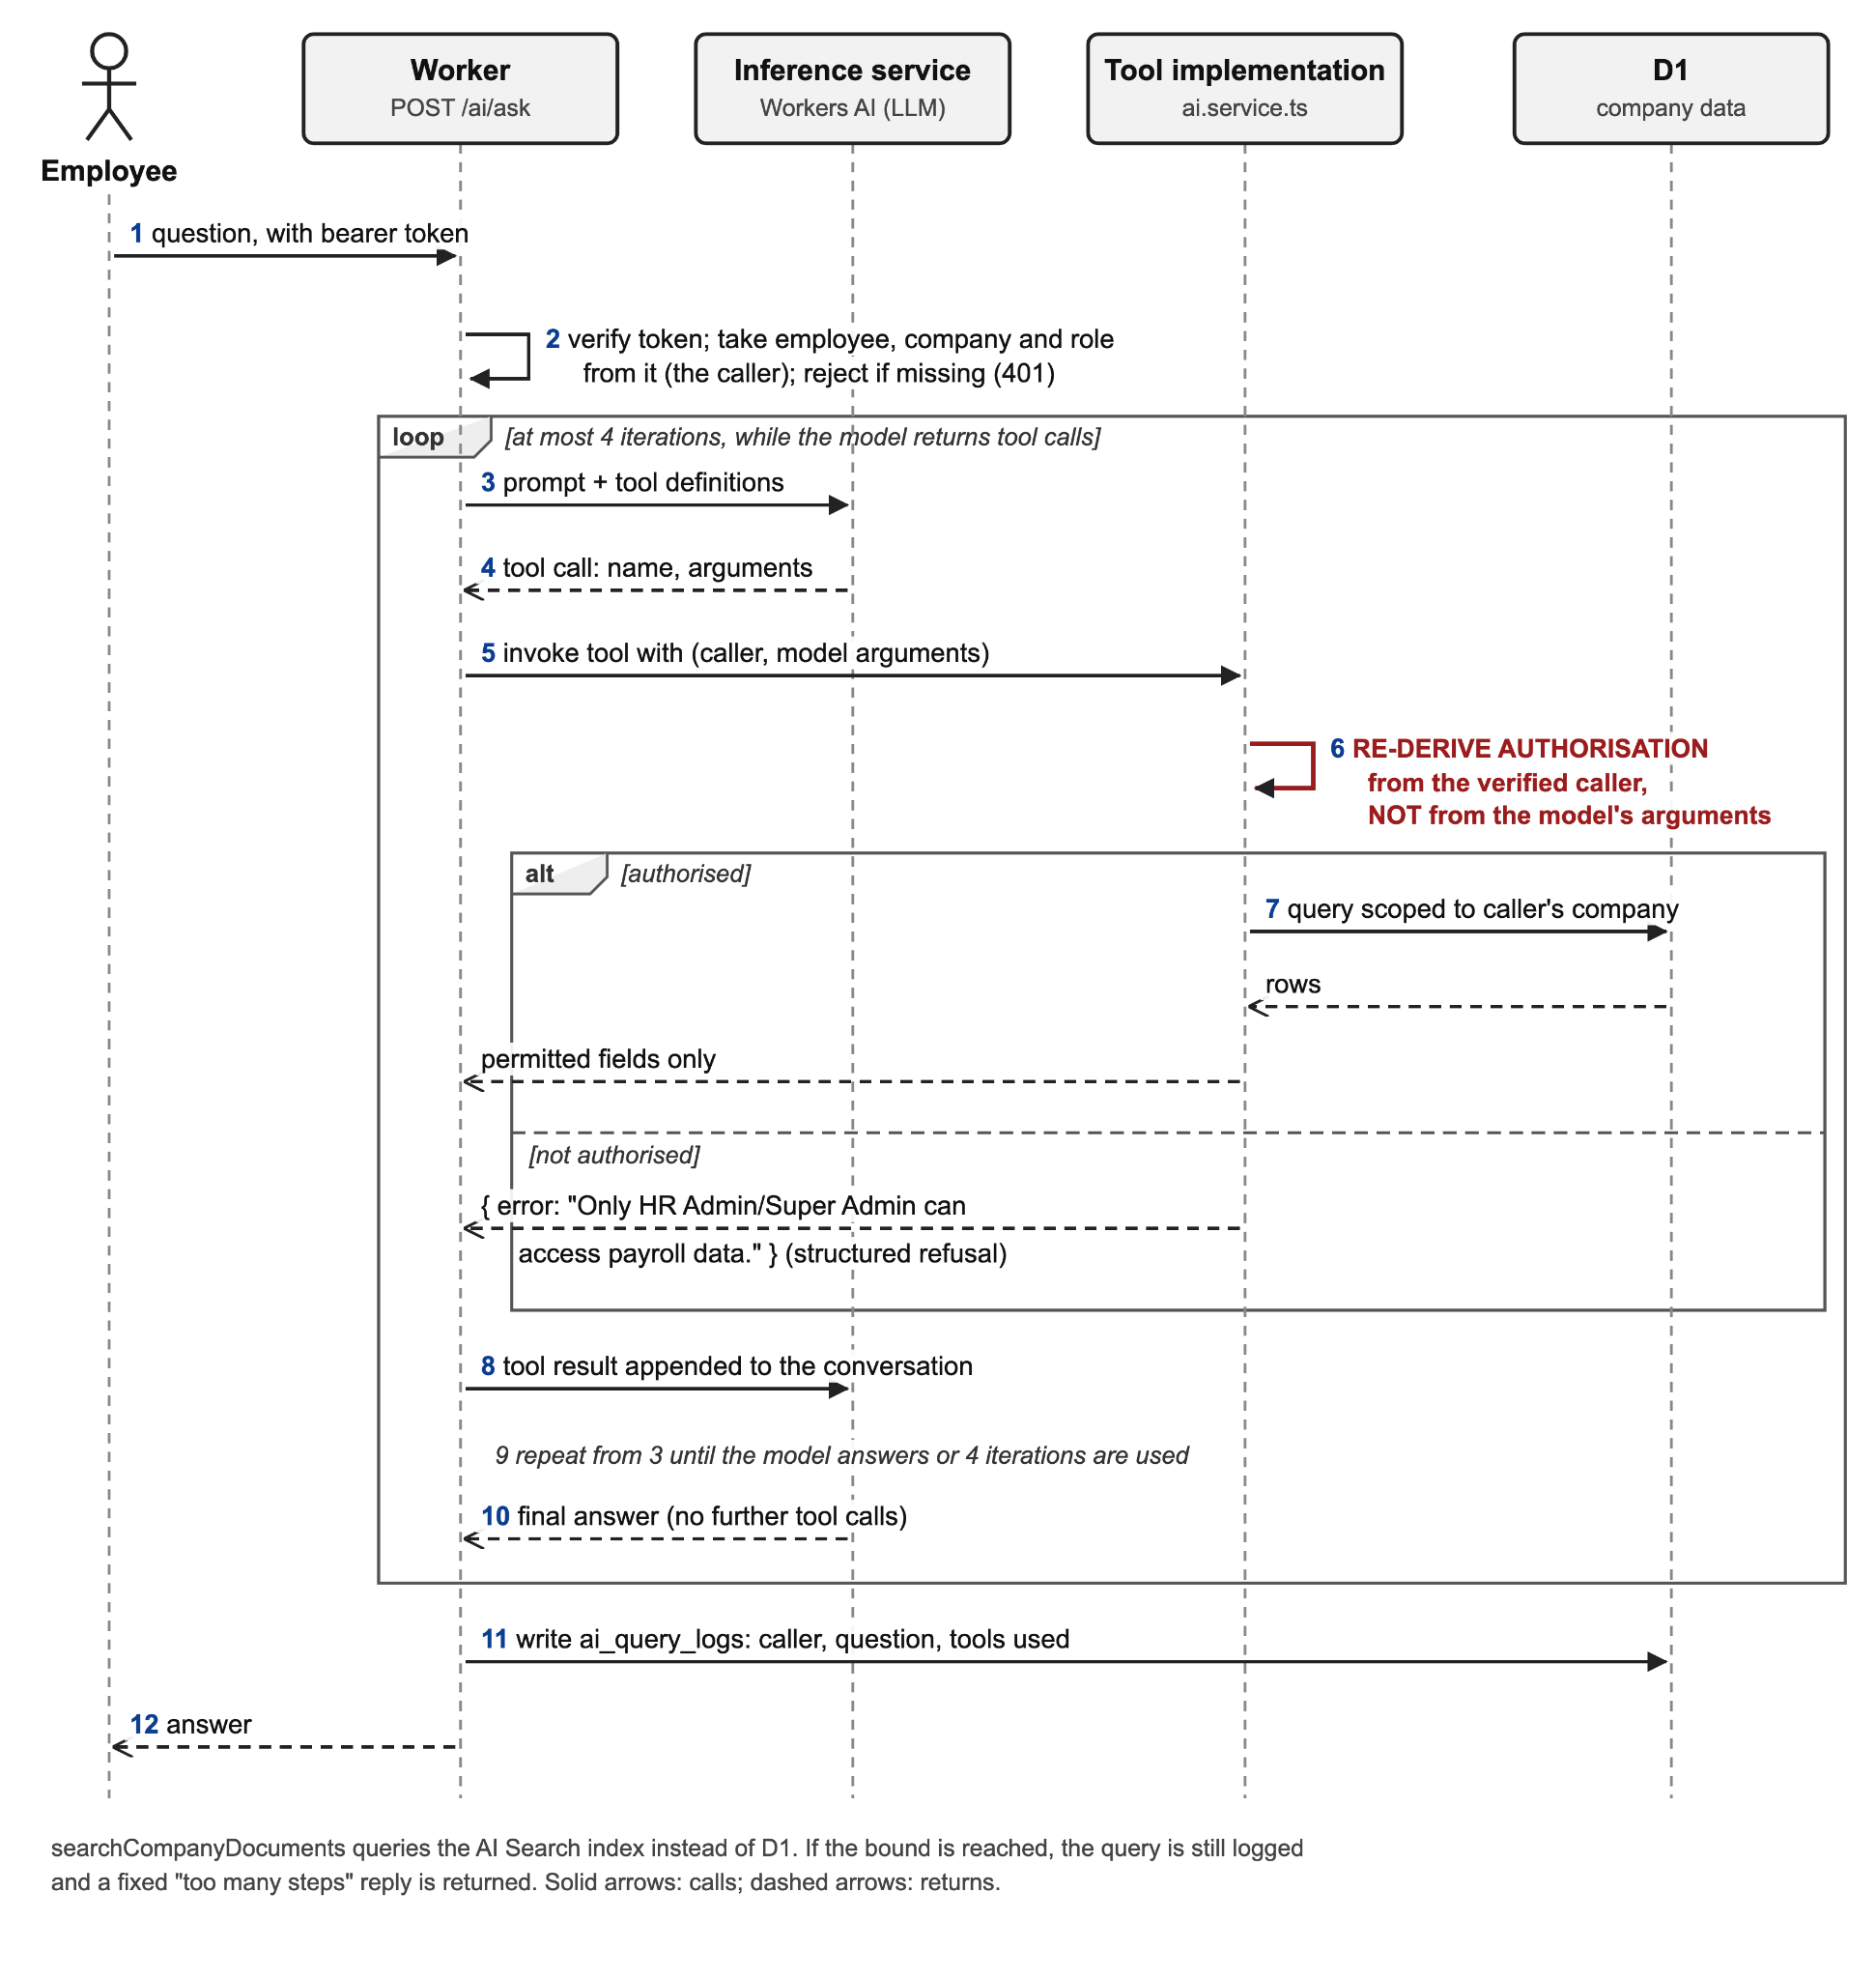
Figure 9: AI assistant request sequence with authorisation re-derivation
Table 9: Assistant tool set and authorisation rules
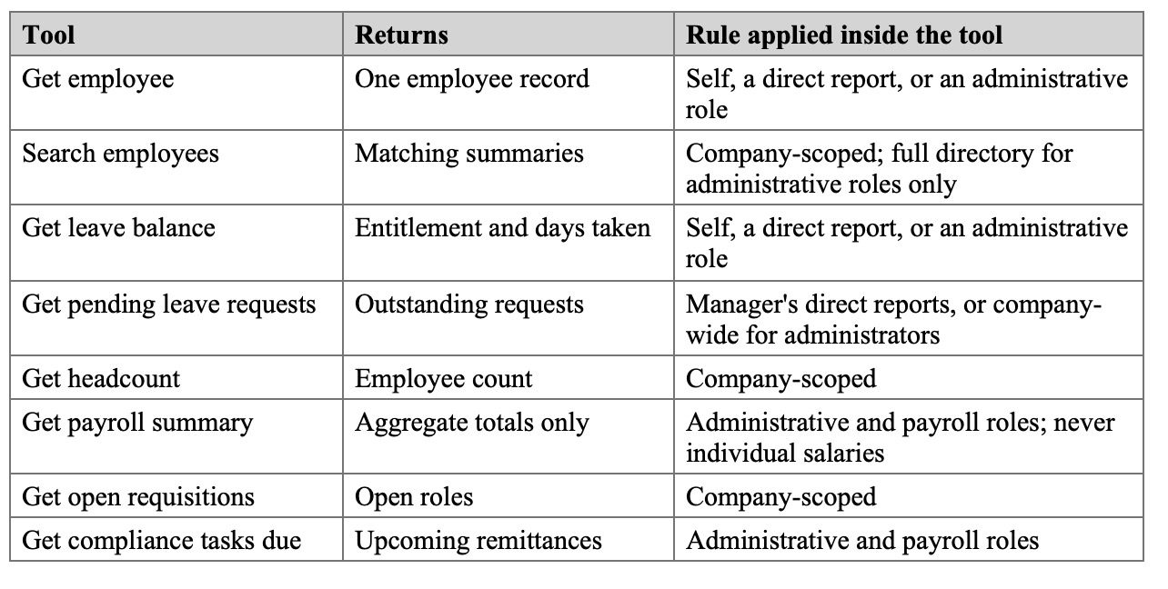

3.9.5 Legacy Authentication Fallback
While token authentication was still being built, the authentication middleware would accept a company identifier in a request header in place of a token. This let the frontend run against seeded data. The trouble was that a header-only request, though limited to one company, carried no verified identity or role, and so would have slipped past role gating. The pre-evaluation review caught the fallback and removed it. It also removed a default token-signing secret that was used whenever the environment variable was missing. Header-only requests are now rejected, and the server will neither issue nor verify a token unless a secret is configured. The tests for both changes are reported in Section 4.4.3.

3.10 Evaluation Design
Objective 5 was evaluated in three parts. Following the trade-off view in Section 2.4, cost and response time are reported as separate objectives.
The automated tests were written in Vitest. For backend service tests the database was replaced by a chainable mock, and each test checked both the result and the database calls that were made. An important pattern concerned order: an unauthorised call has to fail before any write is even attempted. Controller tests mocked the service layer. Integration tests pushed requests through the full middleware chain, with only token verification mocked. On the frontend, each view was rendered in a simulated browser (jsdom) using React Testing Library and a mocked API client. The rule for every new query was a test for empty results, a test for missing records and a test for cross-tenant access.
The response times had to be taken from the deployed Worker; a local run cannot reproduce cold starts or real network paths. A script set up a separate benchmark company with fifty payroll-ready employees and ten pending leave requests. One client in Lagos sent every request, one after another, on the Workers Free plan. Each of the ten operations was timed the same way. The Worker sat idle for five minutes, then received a single request on a fresh connection, which gave the cold sample. Twenty more requests followed on a kept-alive connection (ten for the assistant, to keep inference cost down), and the median (p50) and 95th percentile (p95) came from these. Writes were reversed after each timed request. The Worker reported with every response how many requests its isolate had served and how long the request spent inside the Worker; a sample counted as cold only if that count was one. The one-second limit for an uninterrupted flow of thought (Nielsen, 1993), a long-established usability reference used here for historical context, was adopted as the benchmark for NFR2.
The cost was modelled from Cloudflare’s published rates (Cloudflare, 2026e, 2026f, 2026g) at three scales: 10 tenants with 500 employees, 100 tenants with 5,000 employees, and 1,000 tenants with 50,000 employees. The model assumed 40 requests per employee per working day over 22 days a month, 5 milliseconds of CPU time and about 30 rows read per request, writes on 15 per cent of requests at about 2 rows each, 160 KB of relational data and four 500 KB documents per employee. An indicative provisioned baseline was priced from published list prices (DigitalOcean, 2026a, 2026b, 2026c).

CHAPTER FOUR: RESULTS AND DISCUSSION

4.1 Introduction
The results of the evaluation and the built system are reported in this chapter. The development environment is described in the Section 4.2. Section 4.3 describes the implementation, module by module. The test results, response time and cost results are reported in Sections 4.4 to 4.6, the platform limitations the evaluation revealed are in Section 4.7, and the results are discussed in relation to the objectives in Section 4.8. Any departure from the design in Chapter Three is noted.

4.2 Development Environment
It’s built in TypeScript with Hono and deployed on Cloudflare Workers. Hono was selected instead of heavier Node.js frameworks since Workers has limits on the size of its bundles, and middleware is the natural fit for the pipeline in Figure 7. Wrangler, Cloudflare’s command-line tool, was used for development; it is run in the same isolate runtime as production. D1 was accessed via Drizzle ORM. As the table definitions are Typescript types, each query will be type checked on compilation time. Drizzle Kit produced 46 sequential, versioned migrations, without any manual editing (NFR17). The platform’s bindings were used for R2 and Workers AI.
The front end is a TypeScript React-based application. Uses Vite and deployed to Cloudflare Pages on its own from the backend. When mutations occur in one view, all views that rely on the results of that mutation are automatically updated without additional code as TanStack Query services server state. The source is hosted at Git on GitHub, and contains 87 commits as of the time of writing. Secrets remain on the platform with Wrangler and never get committed. No continuous integration pipeline, deployment is done manually. The toolchain is shown in table 10.
Table 10: Development toolchain and platform services
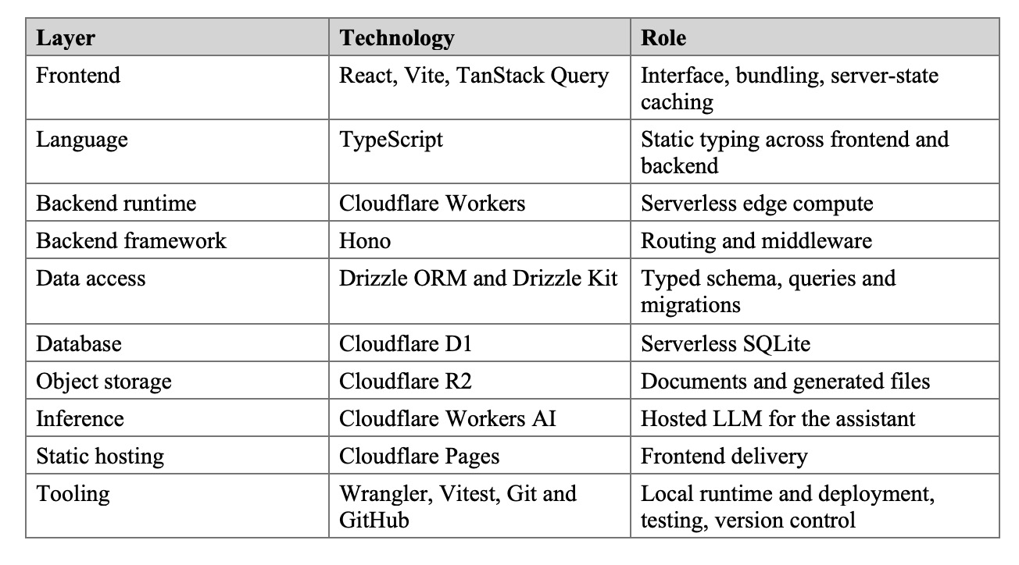
To use this system, the developer must have installed Node.js 16.17.0 or above and own a Git client and Cloudflare account that has Workers, D1, R2 and Workers AI enabled. A local database, container runtime or web server is not needed. In production it is not necessary to have any hardware. Nobody sizes or buys a server, patches an operating system or provisions a database instance. Users require only current Web browser. The lack of this hardware parameter is the baldest proof of the reduced operating overheads that were suggested in Chapter One.

4.3 Implementation of the System
There are six API routes, with authentication, public, employee, administrative, assistant and support.There are almost 300 API endpoints organized into six routes: authentication, public, employee, administrative, assistant and support. In the administrative group, there are subrouters for payroll, leave, requisitions, applicant tracking, attendance and benefits.

4.3.1 Tenancy, Authentication and Access Control
Two items are added when a company registers: the company record and the company’s first administrator. No database is created and nothing is deployed, as a result, NFR16 is satisfied. Payroll settings, payroll components, statutory rates and tax bands are created based on a default when reading for the first time and therefore a tenant that has nothing to do with payroll will not have any payroll configuration. At login the salted hash is recomputed. If this matches, the server returns an HS256 signed token containing the employee, company and role. A flag is set after temporary password reset and the user will have to change the password before opening any other screen. If there is a custom role, the permission matrix will be applied by the second middleware, and the role is read by route guards from the verified token.
Each controller passes its verified company identifier to each service and each service query uses it. This convention was used to test all the services queries before evaluation. Five of them looked up a record without using the identifier and two of them did in the support-ticket module and three in the learning module. From any of the five a Company A user with knowledge of the identifier of a Company B record could read or modify it. Each was corrected to agree with the record and the company and special tests were developed (Section 4.4.3). The convention is still applied by hand, which means that NFR6 is still incompletely fulfilled.

4.3.2 Core HR Modules
The workforce module includes employee records for the entire lifecycle, statutory identifiers, bank details, emergency contacts, documents and nested departments. The system then polls each module simultaneously to collect details regarding the employee’s employment, assets, leave, attendance, goals and audit history to create the employee profile. If a module fails to load, the remaining part of the profile is also loaded. The directory endpoint returns all the employees in the company in a single response. This is cheap at 50 staff, but costs increase as the number of staff increases.
The entire process of onboarding and offboarding is considered a transition, with tasks assigned to HR, IT, Finance and Administration. There is no stage editing that can be done on a transition itself; it is calculated based on the tasks (FR13). A case can’t be complete without a sign-off, so, as is often the case, you don’t get your clearance by e-mail. Offboarding information is also stored on the system, including the reason for separation, who receives the handover and the exit interview. If an employee’s status is onboarding, it directs them immediately to a self-service onboarding flow on first logon.
Attendance allows for multiple clock-ins throughout the day, optionally to a specific location, and at clock-out, works out worked and overtime hours. Each company has its own start time and grace period and working days (NFR7) and punctuality is judged against these. Overtime claims are also subject to a separate approvals process. Leave is only stored during a leave. Days taken is a summation of approved requests at query time and this is low cost as it is a total of the one employee’s requests during one of the leave years. Only the direct reports can see requests from a manager.
In recruitment, requisitions go through an approval workflow, candidates through an approval pipeline from application to hire, each interview goes on a separate scorecard, and each action in the workflow is recorded on a timeline. There is no login required for a careers page and applications are made via this. As per Mori et al. (2025) the module does not rank and/or screen candidates automatically.

4.3.3 Extended Modules and Control Centre
Performance management enables a review cycle to be undertaken company wide and is set out with named stages, self-assessment rated by manager, peer review is required and the review must be approved by manager, upward review is not required and parent objective links are provided. The benefits, wellness, learning, asset, survey and helpdesk modules are all similar in that they are an administrator-configured catalogue with employee input. This is because the responses to the anonymous survey questions are not saved with an employee reference and therefore are anonymous and not a property of the display. The control centre includes settings, the working calendar, custom roles, API keys, email templates, a full tenant data export and the audit log, which logs the connecting-IP address from the platform’s header. The other entries of integration and automation are configuration only, all except the messaging integration, which makes a live connection, as mentioned in Section 1.5.

4.3.4 Payroll and Statutory Compliance
The payroll engine runs in the order and using the equations described in Section 3.7 and uses current employee, attendance and loan records to calculate all the numbers. A pre-run exception list is created to indicate employees that are missing the bank details, salary configuration and statutory identifiers, and preview computes the run without saving (Figure 10). One run and one payslip for each employee is paid when submitted. When the run is marked as paid, each loan balance is reduced, the repayment is marked on the loan, loans are closed when their balance is zero, remittance tasks with statutory due dates are generated, and the bank disbursement file and scheme remittance files are available ( see Figure 11).
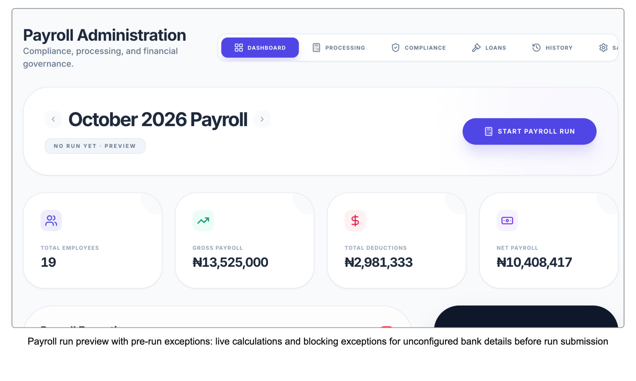
Figure 10: Payroll run preview with pre-run exceptions
Turning remittance deadlines into tracked tasks, created by the run that incurs them, responds directly to the gap identified in Section 2.6. The system computes and exports but does not transfer funds.
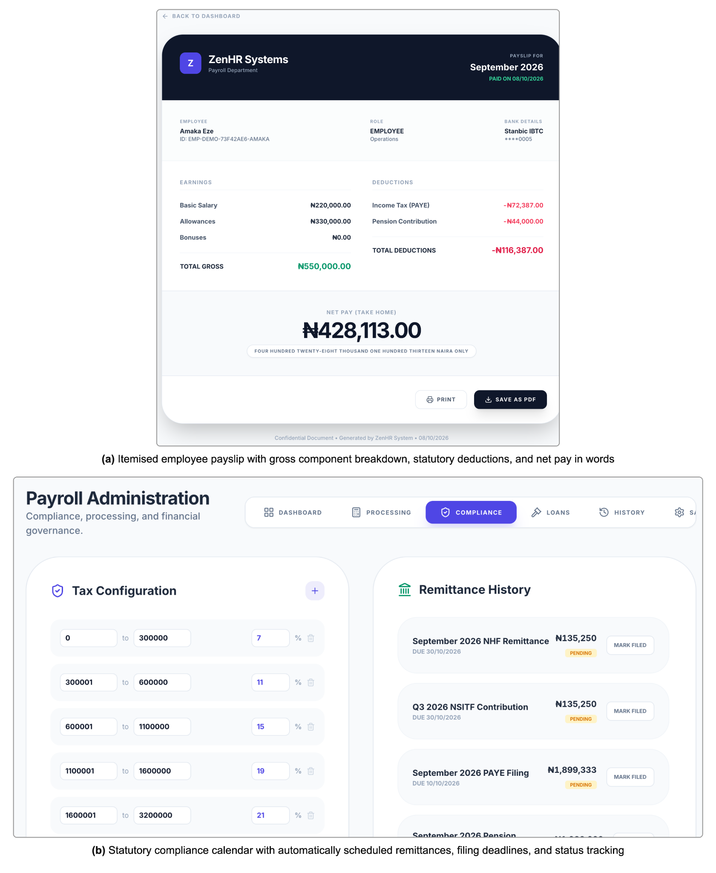
Figure 11: Generated payslip and statutory compliance calendar

4.3.5 AI Assistant
Assistant leverages an instruction-tuned model on Workers AI with native function calling. It contains 8 read-only tools (Table 9), each performing a check on the caller’s role, and for tools at the manager scope, on the caller’s direct reports, as arguments are passed to it by the model. The check lives in the tool, not in the prompt. If you are using a prompt injection, it will affect the way the model reasons, but it will not affect the authorization decision. The other constraints are all the same as designed: up to four tool calls, verified token with role claim on each request, and a log for each question. There is one answer within the caller’s entitlement (shown as 12) and one refusal outside the caller’s entitlement (shown as -12). The tool itself made the decision not to accept the refusal, and there was no input from the model.
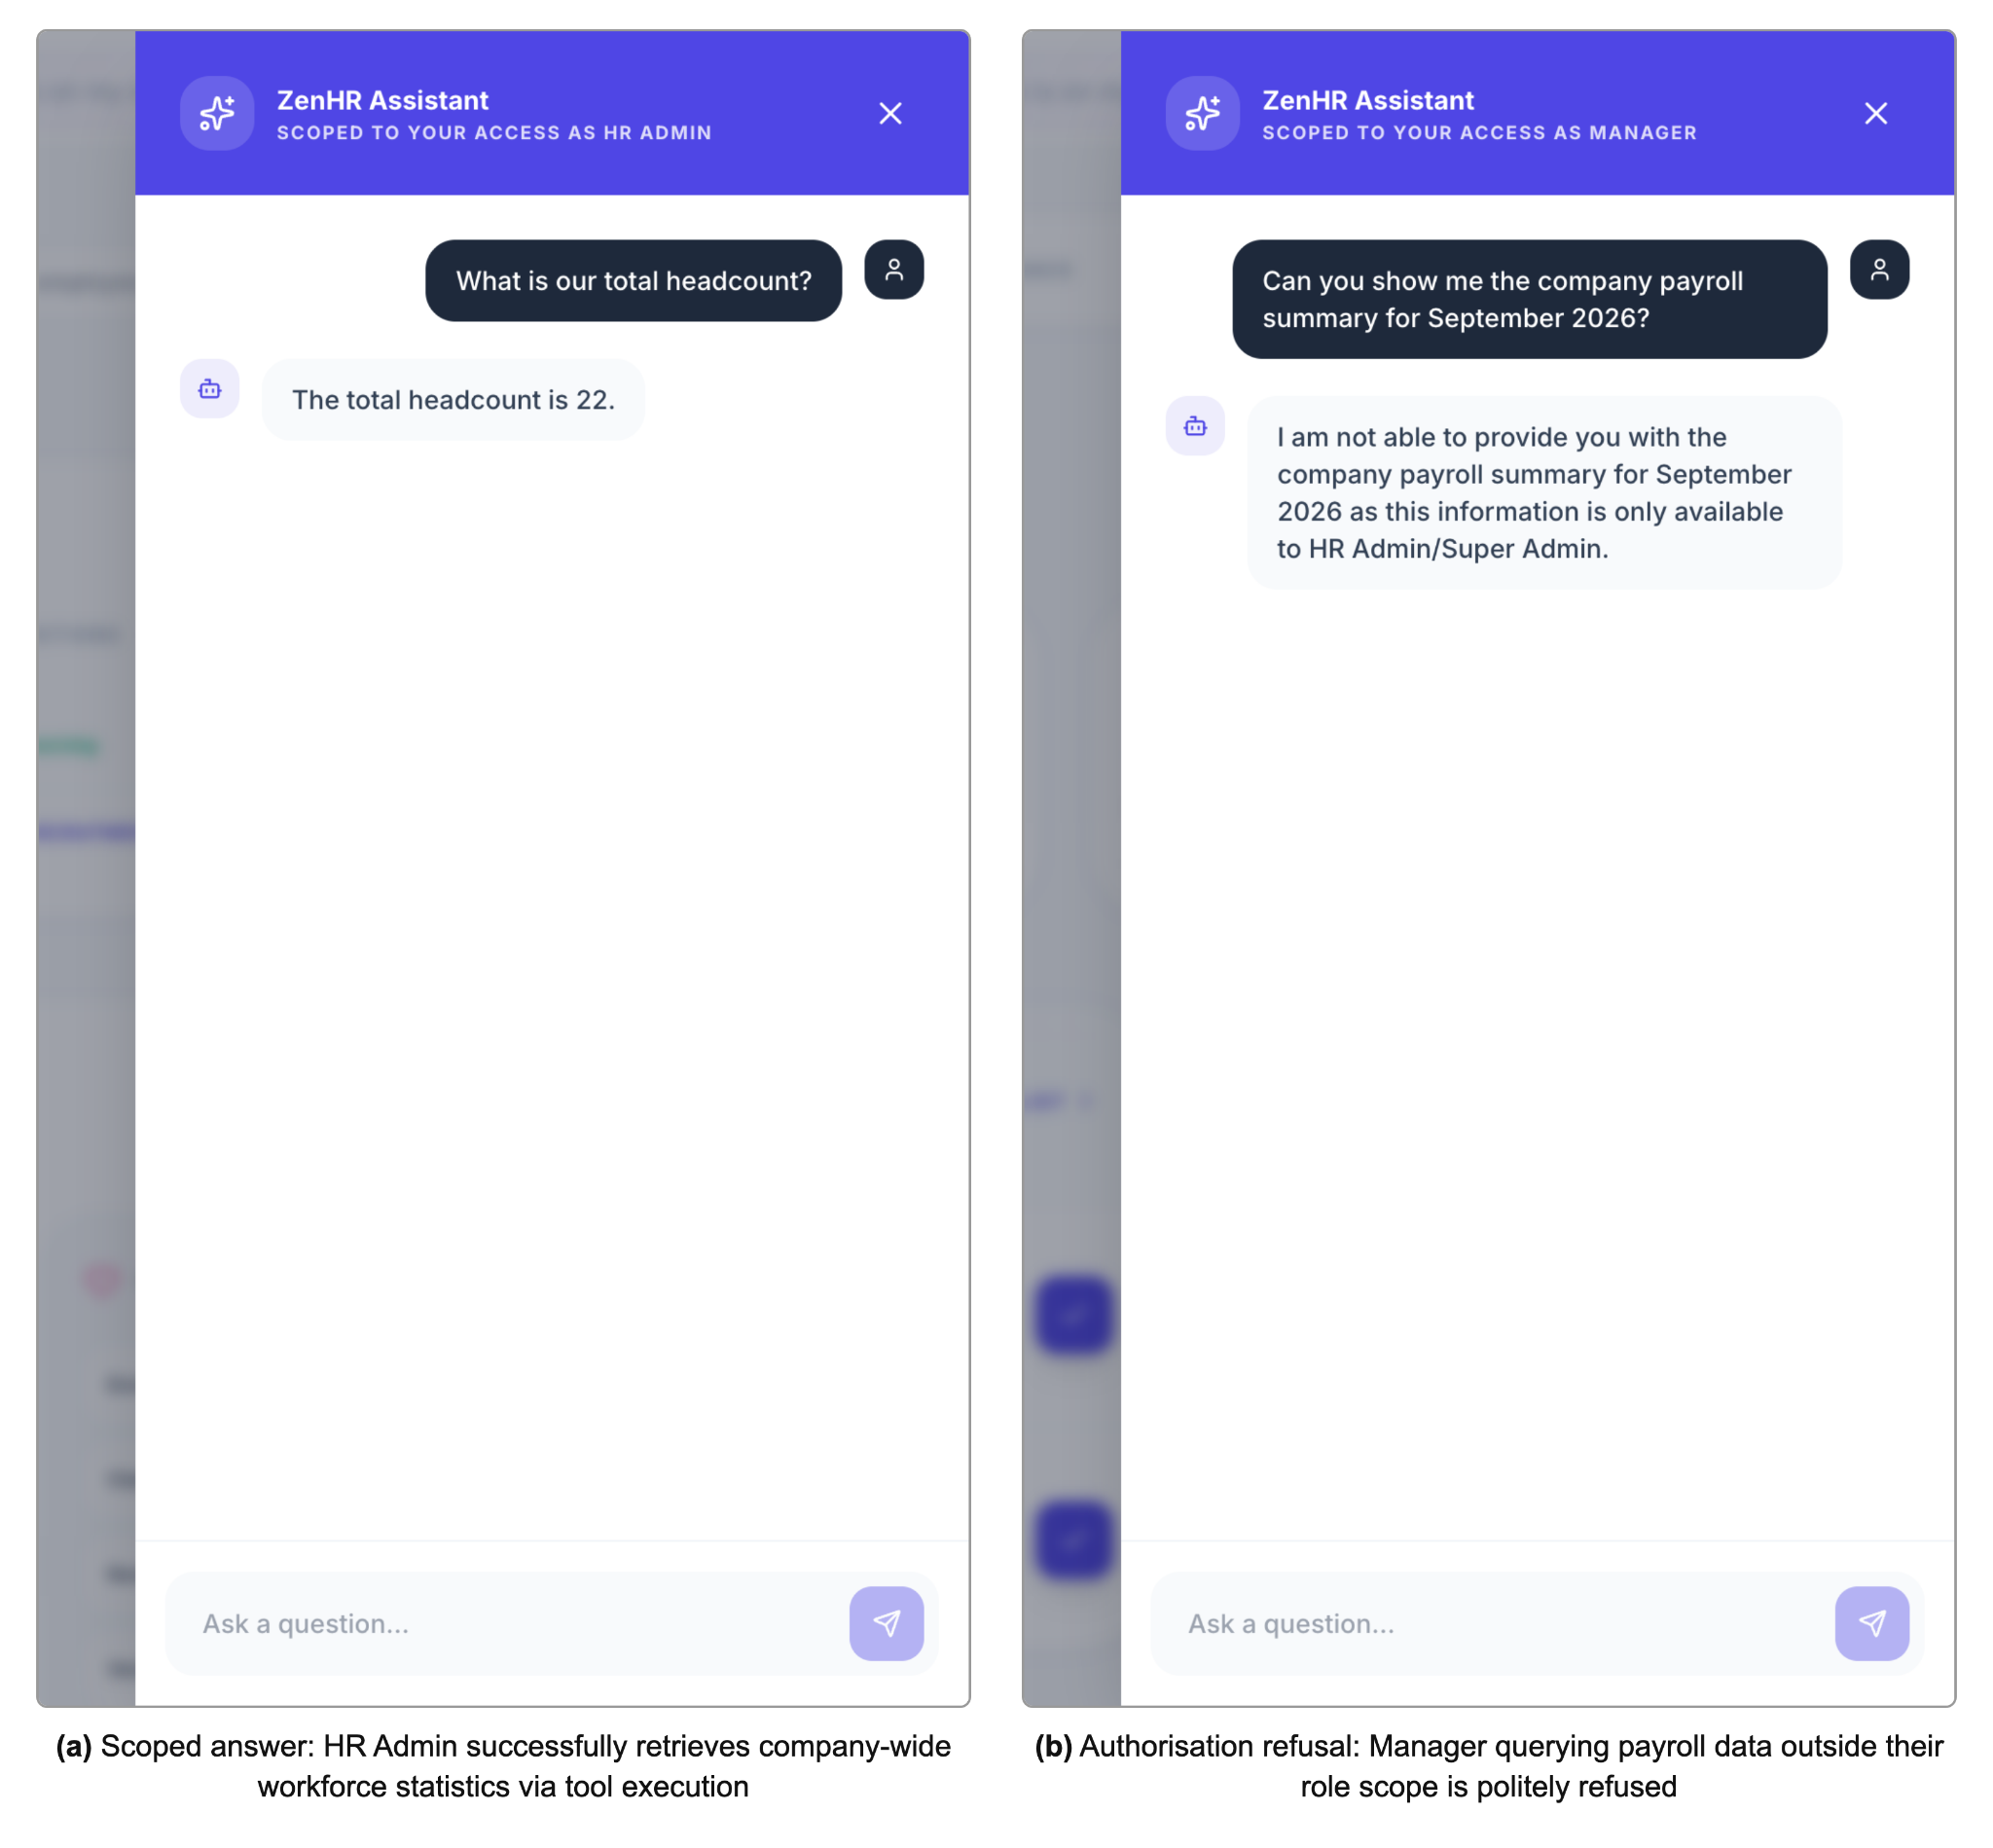
Figure 12: AI assistant showing (a) a scoped answer and (b) an authorisation refusal

4.4 Testing Results

4.4.1 Test Results
Both test suites were run against the final implementation on 7 October 2026 (Table 11). The terminal output is reproduced in Appendix B.
Table 11: Automated test suite execution results
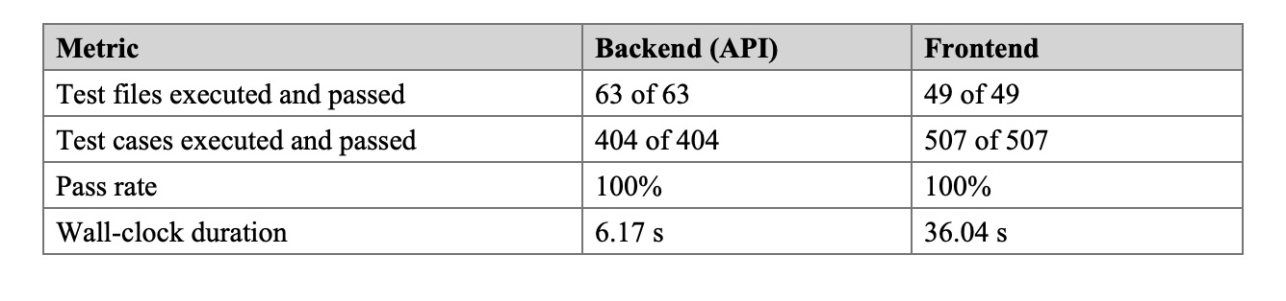
112 test files, 911 test cases were passed. The back end suite ran in 6.17 seconds, with the tests themselves running for 1.35 seconds. This speed comes from the architecture, as services are not tested with the database or with the HTTP layer (NFR15), and therefore, no backend test starts a server or waits on a network, which means that the suite can be run routinely during development. The frontend suite was slower, primarily because each file was creating its own simulated browser, and Vitest said it’s around 30 per cent of the time tracked.

4.4.2 Coverage Boundary
Each suite tests their own layer against a mock: The backend mocks the database, the frontend mocks the API client. No platform touches and no end-to-end test goes from interface to backend and back again. That number is significant with the 100 per cent success rate reading. As described in Section 4.7, there is a defect that was passed by both suites and failed against the real database.

4.4.3 Security-relevant Tests
The 11 integration tests attempt to read or modify the records of Company B as a Company A user. These tests cover five of the corrected queries and sensitive operations such as payroll, employee profiles, leave, and assistance, and each one expects a 404 error or a null response. Retesting order verifies if it is trying a write that is not allowed. Middleware tests validate that a request that fails authentication, tenant resolution or role gating does not reach the module code. One sends out a header without a token. It is rejected, indicating the fall back from Section 3.9.5 has left. These tests demonstrate the function of the controls as expected. They are not a security assessment and there’s no penetration test or third party audit performed.

4.5 Response-Time Results
Table 12 gives the measurements, taken on 8 October 2026 with the method from Section 3.10. Every cold sample was confirmed to have been served by a newly created isolate.
Table 12: Response-time measurements for representative operations (milliseconds)
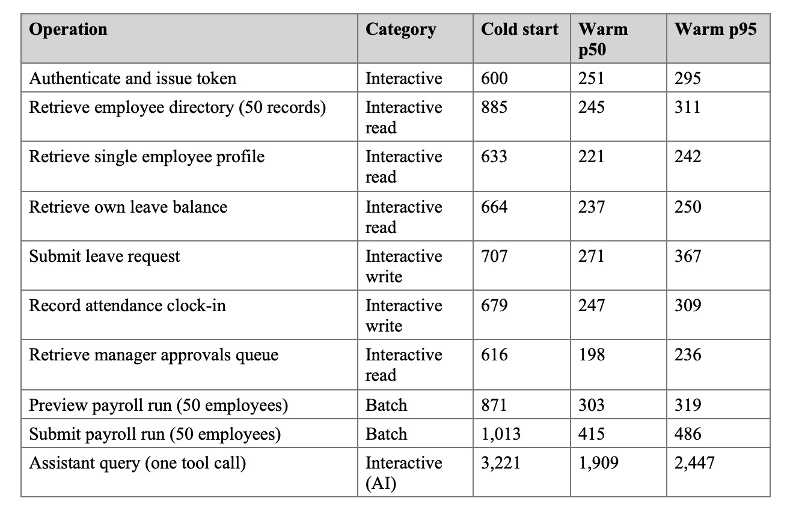
The medians of these seven interactive operations were between 198 and 271 milliseconds, and no 95th percentile was greater than 367 milliseconds; no warm sample for any of these 140 operations was greater than 400 milliseconds. All are less than one second, and NFR2 is met. The vast majority of these warm requests (70-92 per cent) was taken up by network transit, while only 21-81 milliseconds was taken up by Time inside the Worker. It is only by the network path that the response time—Raith et al. (2023) cite as the reason for edge execution—is determined at this scale.
There is a need for a qualification at that point. Though the client appeared to be in Nigeria, all requests went via Cloudflare’s Amsterdam data centre, which is 140 milliseconds away, and the database is located in the Western Europe region. The reason for this routing was not determined and could be a client’s internet service provider or the platform. This edge benefit of chapter two was therefore not realised for a Nigerian user. A request to the Worker from Lagos wouldn’t eliminate the distance either, since each of the multiple database calls the request makes would be sent to Europe. Database location is a design variable for a Nigerian deployment.
The costs of cold starts are not as high as they may seem. Cold interactive requests, which took 600 to 885 milliseconds, were about three times longer than the warm medians, but of these, 326 to 546 milliseconds were required to establish a new, encrypted connection, which is the cost of any architecture when it’s requested for the first time. When connected, cold requests were 11 to 100 milliseconds slower than warm medians and time spent in the Worker increased 23 to 36 milliseconds. Isolate start-up takes tens of milliseconds and all cold figures remain under one second. Two operations, the first one after 5 minutes of inactivity, were still provided with warm isolates. One early clock-in sample of 6,888 milliseconds was retaken as it was almost completely connection set-up (6,545 milliseconds), being predominantly caused by a client network stall.
Fifty employee payroll previewed and submitted in a median of 303 milliseconds and 415 milliseconds, respectively. Submission commits 17 insert statements, each being run and paying their respective 50¢. All 42 payrolls have been successful, and none have exceeded the Free plan’s 10-millisecond CPU limit; time spent waiting on the database doesn’t count towards the CPU limit. The assistant was a bit slower: 1909 milliseconds median, 90 per cent of which was spent in the Worker, primarily in the two calls to models that a tool invocation requires. This is more than one second, but still within the 10-second hold attention limit (Nielsen, 1993) and the interface displays a progress bar. Figure 13 plots the results.
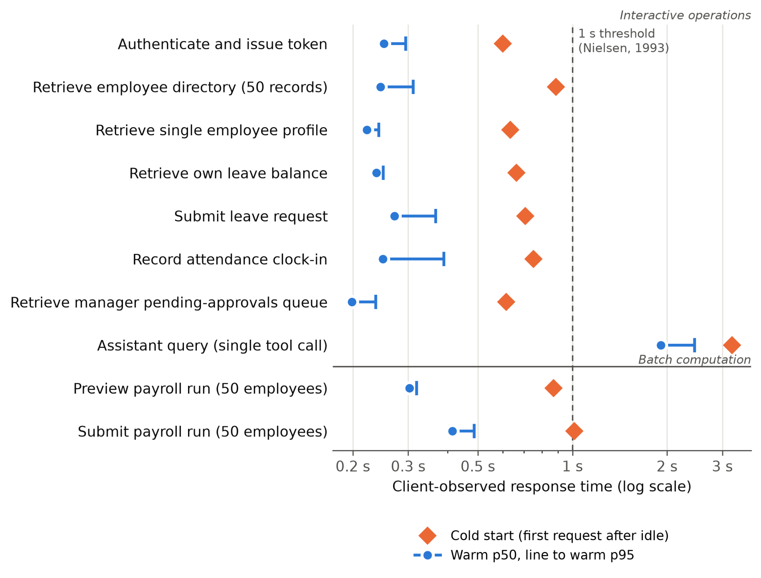
Figure 13: Cold-start and warm-path response times by operation category
These measurements describe one platform under one workload. They cannot settle whether isolate-based platforms start faster than container-based ones (Section 2.4).

4.6 Cost Results
Table 13 gives the rates used, verified against Cloudflare’s published pricing on 7 October 2026 (Cloudflare, 2026e, 2026f, 2026g), and Table 14 the modelled monthly cost at three scales.
Table 13: Platform rate card (Workers Paid plan)
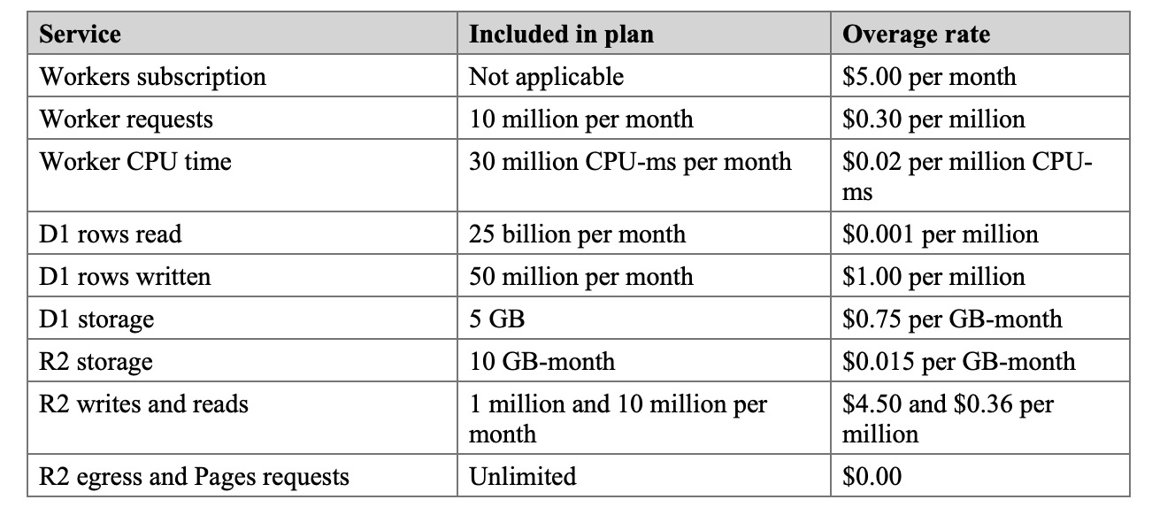

Table 14: Modelled monthly platform cost at three scales
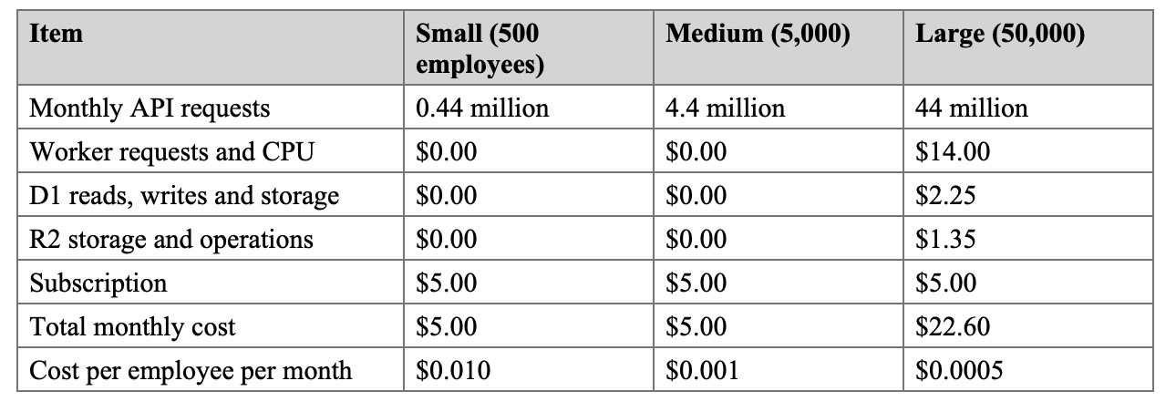
Three findings follow. First, the cost is nearly flat, as in the first tenfold rise, it rises by almost nothing, and the first hundredfold rise is increased by about 4.5 times, as the subscription’s allowances cover the small and medium scenarios. Second, the cost base for the zero activity case is the subscription, while the cost base for the provisioned deployment is the running instances of the deployment, regardless of how many requests or how many millions they serve. Thirdly, they are based on cost per employee, which decreases as the platform expands; contrary to commercial pricing based on per employee. The use of Assistant inference is not included because it cannot be determined by headcount.
An "object storage" service was priced at $5.00 (DigitalOcean, 2026c), a 2 GB VM at $12.00 (DigitalOcean, 2026a), and the smallest of its managed PostgreSQL databases at $15.15 (DigitalOcean, 2026b). This is $32.15 per month, which goes up to $44.15 per month once you add a second application server at approximately 20 million requests per month. This is a comparative example only, and does not rank vendors. The shape of the two cost functions are displayed in figure 14.
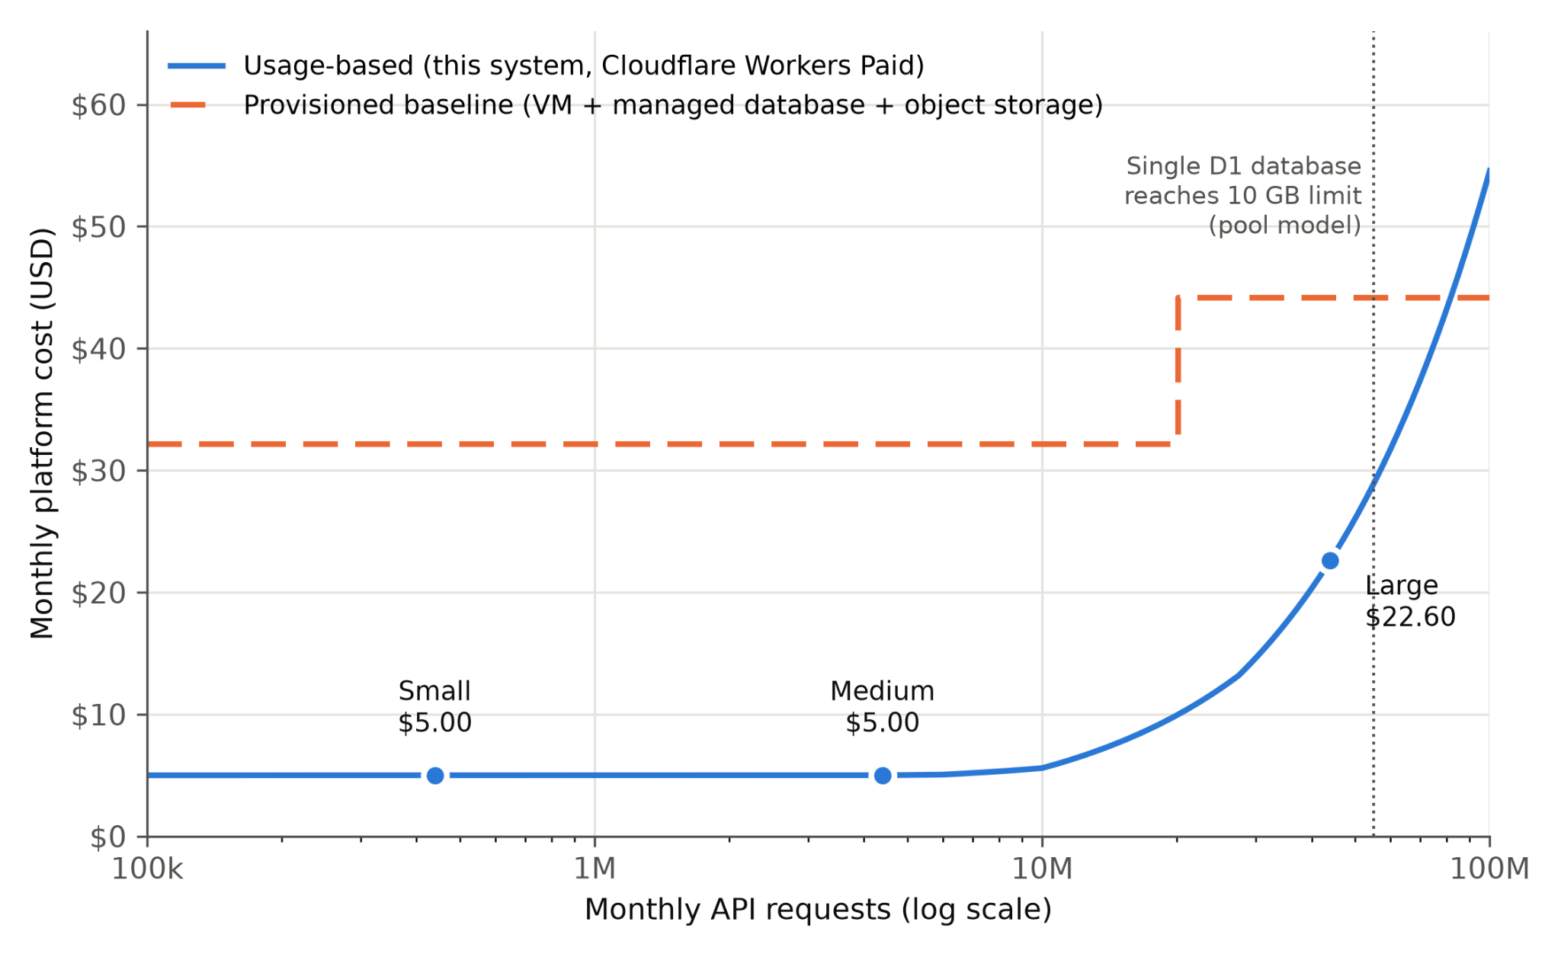
Figure 14: Monthly platform cost against request volume, usage-based versus provisioned
Source: Usage-based cost computed from Tables 13 and 14; provisioned baseline from DigitalOcean (2026a, 2026b, 2026c).
If the usage-based cost is calculated, it is more than the two-server baseline after approximately 82 million requests per month (or approximately 93,000 employees per month based on these assumptions). That’s very hopeful for the provisioned side because at that rate, they’d need their capacity up. And at more than 62,500 employees (55 million requests) a single shared D1 database would not allow it, anyway. This project builds the usage-based model is significantly cheaper, across the range it targets.

4.7 Platform Constraints Identified
Three constraints were identified in the evaluation. The first one relates to the pool model. If you want a D1 database larger than 10 GB, you cannot increase the size of the database. It also operates on a one at a time basis, thus throughput will depend on the average query time (Cloudflare, 2026d): 1K QPS at 1 msec/query or 10K QPS at 100 msec/ query. The same document suggests spreading this out to many smaller databases, per user and/or per tenant, and enabling up to 50,000 databases per account for free. The pool model is a shared, single threaded database and shared 10 GB ceiling. Both limits would not apply at the small and medium scale but both would apply before the large scenario, particularly if lots of tenants used the payroll function at month end simultaneously. This is not to contradict the decision in Section 3.6, for which the reasons remain valid at this project scale. It suggests the maximum number of pools in this platform, after which it becomes better to design a database per tenant.
The second restriction is CPU time per call. The Free plan offers 10 milliseconds of CPU per request, and Paid plan offers 30 seconds (default, and can be set to five minutes) by default, configured to 128MB of memory on both plans (Cloudflare, 2026h). A 50 employee run continues to be within the Free plan’s limit, so runs of more than 50 employees should be broken up into batches across the invocations, but there is a lot of headroom remaining on the Paid plan.
The last one was discovered through experimentation on the actual platform. First 50 employees payroll submitted was not successful. D1 supports up to 100 bound parameters per SQL statement (Cloudflare, 2026d), and each row in the ORM is bound to all 27 columns related to a payslip. The insert had been divided into four chunks, based on the number of fields the code provided, instead of the number of columns the ORM binds, which meant that each chunk had 108 parameters. Dearer, the run header was already written, and the failure meant that there was no pay slip attached to it, and it was not possible to resubmit. The fix was to set the column count as the size of the chunk and to batch commit the header chunk and all the payslip chunks together in one atomic commit. All the time, both sets of mocked test suites were passing. No example illustrates the extent of coverage of Section 4.4.2 better.

4.8 Discussion against the Objectives
Table 15 sets out the status of each objective and where the evidence for it can be found.
Table 15: Achievement of objectives
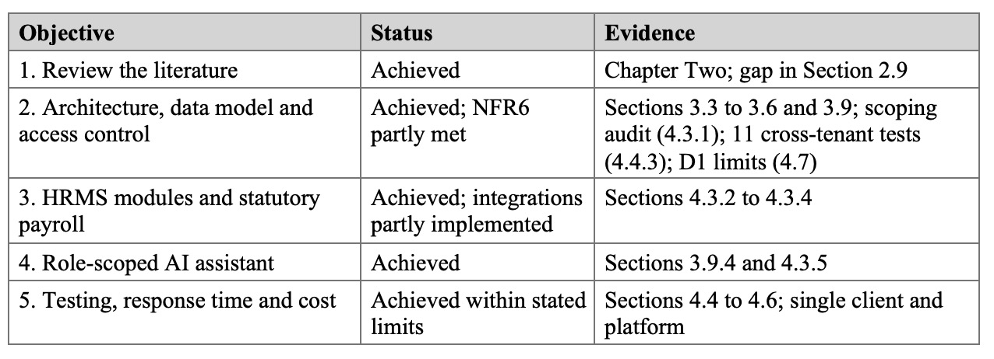
The results are based on the set aim without fixed infrastructure cost. There is no specification required for production and $5 is charged for an idle month. No operational overhead either because nothing needs to be sized, patched or scaled by hand. Role scoping is in place and tested. Payroll can be audited: each deduction is saved individually, and each remittance task refers to the deduction run. Based on the evidence of the audit and the cross-tenant tests, tenant isolation is deemed to hold, but is based on convention, rather than structure. Scalability: The claim is valid only within the bounds stated in Section 4.7 which is less than what the aim originally promised.
The results also have implications for the literature. They concur with Liu and Niu (2023) who concluded that serverless economics supports infrequent, low-demand workloads. They additionally conjecture that, for an interactive HR load, the “cold-start problem” highlighted by Golec et al. (2024) is not a significant issue. The edge argument of Raith et al. (2023) needs a qualification, however. Proximity only comes into play when requests are actually sent to a close location and data is also close. None of these were true for a client in Lagos.

CHAPTER FIVE: SUMMARY, CONCLUSION AND RECOMMENDATIONS

5.1 Summary of the Study
The initial problem, given in Section 1.2, was the problem to be solved. If HR and payroll are using disjointed tools or are using a provisioned-server HRIS, data is siloed and payroll is at risk of compliance issues. The organisation also incurs costs for idle infrastructure and the burden of operation is greatest for small businesses. The literature reviewed in Chapter Two revealed that each component of a response is provided as a standalone product, with no reviewed research system integrating a full-lifecycle HRMS, statutory payroll, an authorisation-scoped AI assistant and a serverless back-end, or exploring the combination of these components.
The project has followed design science research and an incremental Agile process to create ZenHR on Cloudflare: React application on Pages, stateless API on Workers, relational data in D1, documents in R2 and inference on Workers AI. There are approximately fifty tables in twelve domains, created during 46 migrations, and nearly three hundred API endpoints.
The following were the key findings. All 911 automated test cases passed and there were no cross-tenant tests that could find a way for one company to access the records on the other’s. Both suites are based on mocks, though. Warm interactive requests returned in 198 to 271 milliseconds, measured from Lagos, Nigeria to the deployed system, which is under the one-second rule, and a 50 employee payroll run was previewed in 303 milliseconds and submitted in 415 milliseconds. If connection set-up was isolated, the cold starts are 10s of milliseconds. The requests from Lagos, Nigeria were served from Amsterdam and the response time was dominated by the network. Platform cost for both the 500 and 5,000 employee tiers is $5 per month, and $22.60 per month at the 50,000 employee tier, before any traffic. Lastly, in the case of D1, the 10 GB size limit and single-threaded query processing placed a cap on the shared-database approach at about 62,500 employees (under the assumptions of the shared-database approach).

5.2 Problems Encountered and Limitations
There were a number of issues along the way. The first 50 employee payroll submissions failed on the real database since the insert exceeded the 100 parameters/statement limit of D1, resulting in an orphaned run header. Using the column count to determine the chunk size and enforcing the write being atomic did the trick. A review prior to evaluation revealed five queries without the company filter, plus a legacy authentication fallback based on a request header. All of these were corrected and are now covered by tests. If they did have a cold start, they had to prove it, which required instrumenting the Worker since an idle period does not imply an isolate has been evicted. The reason for the requests of Lagos to be sent to Amsterdam was never explained. Lastly, there wasn’t any environment to test load concurrent traffic.
The system is limited, too. It does not transfer money. It has not been load tested, assessed independently for security or deployed through a pipeline, and there are no end-to-end tests or tests against a real database. Tenant scoping is a convention-based process and thus partially addresses NFR6. There are a number of features that are missing. The performance module processes one active review cycle at a time, while the majority of entries in the integration and automation section are configuration only. Employer levy tasks are produced on each run rather than on each of the filing cycles for the schemes. No records from "legacy" can be imported and the employee directory is not paginated. The cost model does not consider the assistant inference side and all timing evidence is from a single platform, a single client location, and a single fifty-employee company.

5.3 Conclusion
In this project, the question was posed whether an all-encompassing HRMS on serverless infrastructure is possible, with an embedded payroll engine that is compliant with statutory requirements.The project looked at whether a multi-tenant HRMS system with a payroll engine bound to statutory requirements (and compliant with these regulations) could run entirely on serverless infrastructure. The goal was to eliminate the deployment provisioning and maintenance overhead and still maintain the isolation of tenants, role-scoped access and audit-compliant deployment. In the range specified in Chapter Four, the results suggest that it can. No provisioned hardware required and ZenHR is free of charge when not in use. It responds to interactive requests from Lagos in about 1/4 second, and it calculates a payroll for a hundred employees in less than 1/2 second. Data remains separate at each company. Only what each role is entitled to is seen and each deduction and each remittance obligation is stored and can be traced and defended.
The bounds are included in the result. Isolation is based on a convention that needed to be righted by an audit. This is capped on the shared database. The edge did not provide anyone with a closer path to execution in the deployment measured and the cost benefit becomes negative at very high volumes. It was argued that the system was scalable under concurrent load, but it was not demonstrated to be so.
The contribution of the study is a case study of a serverless edge architecture, evaluated on a data-rich and workflow-rich business system, with measured response times, reproducible cost model and the limits of the platform at which the design needs to change. It also outlines a pattern of providing tools, not data, to the LLM and having each tool re-verify the caller’s authorization. According to the findings, a single HR and payroll system doesn’t require a server or someone to maintain it, for the Nigerian SMEs and public institutions that are least able to afford such infrastructure costs.

5.4 Recommendations

The following recommendations are ordered by their importance for a live deployment.

Update the PAYE relief step and bands to the Nigeria Tax Act 2025 before any live payroll run, and have each organisation’s configured rates confirmed by a qualified payroll or tax professional (PwC, 2026).

Add integration tests that run against a real D1 database instance and an end-to-end suite that drives the interface against a running backend.

Introduce a continuous integration pipeline that runs both suites on every change and deploys only when they pass, so that a failing cross-tenant test blocks the release that caused it.

Treat database location as a design decision for Nigerian users. D1 database does not currently run in Africa (Cloudflare, 2026i), so each request should make as few sequential database round trips as possible, batching independent queries, and response times should be measured from the networks tenants actually use.

Paginate the employee directory on the server before serving larger tenants.

Run production on the Workers Paid plan, whose CPU allowance gives headroom for larger payroll runs and whose rates the cost model assumes (Cloudflare, 2026h).

Commission an independent penetration test, and review compliance with the Nigeria Data Protection Act 2023, before the system holds real salary, identity or bank data (Federal Republic of Nigeria, 2023).

5.5 Suggestions for Future Work
The most important work to be done in the future is the structural tenant isolation. An unscoped query can’t be written if the tenant is added to the data access layer in an automatic way. The same layer is the natural place to route each request to its own database, which would allow a move to a database per tenant as the limits in Section 4.7 approach, in line with the platform’s own guidance (Cloudflare, 2026d). The migration to that move would require tooling to do so as well as reporting across many databases.
Future research should utilize the ever-growing number of tenants to conduct multiple load tests of the assistant response time across all of them and identify when a shared assistant database starts to queue; break up very large payroll runs into queued batches; run the response-time tests again on a serverless platform with containers and get the independent measure that the literature lacks (Golec et al., 2024); integrate a payment rail and provide the assistant integration catalogue with a working execution engine; and conduct a systematic test of the assistant against prompt-injection and excessive-agency attacks (OWASP, 2025), while measuring the cost of inferences under real use. Additional features would be useful as well: Remittance tasks aligned with the date the records are due to be filed with that scheme; review cycles that are optional to overlap, or run per department; import tools for records that are stored in spreadsheets or other HR system.

REFERENCES
Ajayi, O. C., Alawode, O. K., Adeleke, O. J., & Ajewole, T. O. (2026). Solution of multi-objective optimal power dispatch using NSGA-III for future reliability screening. Measurement: Energy, 11, Article 100109. https://doi.org/10.1016/j.meaene.2026.100109
Alli, B. A., Yusuf, T. A., Ederhion, J., Otunlape, O., Koyenikan, O., Raheem, T. A., Olugbade, A., John, S. A., Shonubi, J. A., Rahman, M. S., Al Mahmud, M. A., Adeleke, O. J., Nweke, C. B., & Alli, Y. A. (2026). Self-evolving cyber defense: An analytical review of AI-driven autonomous and adversarial systems. Journal of Computer Virology and Hacking Techniques, 22(1), Article 59. https://doi.org/10.1007/s11416-026-00636-x
Ammupriya, A., Vaishnavi, S., Ashwini, A., Kavitha, R., Paranthaman, P., & Saravanan, V. (2025). Cloud-based HR platforms for scalable workforce management in multinational organizations. In 2025 3rd International Conference on Disruptive Technologies (ICDT) (pp. 1607-1613). IEEE. https://doi.org/10.1109/ICDT63985.2025.10986560
Budhwar, P., Chowdhury, S., Wood, G., Aguinis, H., Bamber, G. J., Beltran, J. R., Boselie, P., Cooke, F. L., Decker, S., DeNisi, A., Dey, P. K., Guest, D., Knoblich, A. J., Malik, A., Paauwe, J., Papagiannidis, S., Patel, C., Pereira, V., Ren, S., ... Varma, A. (2023). Human resource management in the age of generative artificial intelligence: Perspectives and research directions on ChatGPT. Human Resource Management Journal, 33(3), 606-659. https://doi.org/10.1111/1748-8583.12524
Cloudflare. (2026a). How Workers works. Cloudflare Developer Documentation. https://developers.cloudflare.com/workers/reference/how-workers-works/
Cloudflare. (2026b). Cloudflare D1 overview. Cloudflare Developer Documentation. https://developers.cloudflare.com/d1/
Cloudflare. (2026c). Cloudflare R2 overview. Cloudflare Developer Documentation. https://developers.cloudflare.com/r2/
Cloudflare. (2026d). Cloudflare D1 limits. Cloudflare Developer Documentation. https://developers.cloudflare.com/d1/platform/limits/
Cloudflare. (2026e). Cloudflare D1 pricing. Cloudflare Developer Documentation. https://developers.cloudflare.com/d1/platform/pricing/
Cloudflare. (2026f). Cloudflare R2 pricing. Cloudflare Developer Documentation. https://developers.cloudflare.com/r2/pricing/
Cloudflare. (2026g). Cloudflare Workers pricing. Cloudflare Developer Documentation. https://developers.cloudflare.com/workers/platform/pricing/
Cloudflare. (2026h). Limits: Cloudflare Workers. Cloudflare Developer Documentation. https://developers.cloudflare.com/workers/platform/limits/
Cloudflare. (2026i). Data location. Cloudflare D1 Documentation. https://developers.cloudflare.com/d1/configuration/data-location/
Dalimunthe, S., Putra, E. H., & Ridha, M. A. F. (2023). RESTful API security using JSON Web Token (JWT) with HMAC-SHA512 algorithm in session management. IT Journal Research and Development, 8(1), 81-94. https://doi.org/10.25299/itjrd.2023.12029
Dasaklis, T. K., Giannopoulos, P. G., Koutras, D., Malamas, V., & Chountalas, P. T. (2026). Large language models in human resource management: A systematic literature review of applications, open issues and future research directions. Technological Forecasting and Social Change. Advance online publication. https://doi.org/10.1016/j.techfore.2026.124800
Destriani, R., Adhitama, R. Y., Sensuse, D. I., Hidayat, D. S., & Purwaningsih, E. H. (2024). Challenges and technology trends in implementing a human resource management system: A systematic literature review. Journal of Information Systems Engineering and Business Intelligence, 10(3), 355-367. https://doi.org/10.20473/jisebi.10.3.355-367
DigitalOcean. (2026a). Droplet pricing. https://www.digitalocean.com/pricing/droplets
DigitalOcean. (2026b). Managed databases pricing. https://www.digitalocean.com/pricing/managed-databases
DigitalOcean. (2026c). Spaces object storage pricing. https://www.digitalocean.com/pricing/spaces-object-storage
Ekwe-Ekwe, N., & Amos, L. (2024). The state of FaaS: An analysis of public Functions-as-a-Service providers. In 2024 IEEE 17th International Conference on Cloud Computing (CLOUD) (pp. 430-438). IEEE.
Falana, G. A., Dakhil, M. S., Abbood, F. G., & Dagunduro, M. E. (2024). Digital tax administration and tax compliance in the Nigerian informal sector. Economy, Business & Development, 5(2), 32-45. https://doi.org/10.47063/ebd.00020
Federal Republic of Nigeria. (2023). Nigeria Data Protection Act, 2023. Federal Government Printer.
Ghorbian, M., Ghobaei-Arani, M., & Esmaeili, L. (2024). A survey on the scheduling mechanisms in serverless computing: A taxonomy, challenges, and trends. Cluster Computing, 27(5), 5571-5610. https://doi.org/10.1007/s10586-024-04570-9
Golec, M., Walia, G. K., Kumar, M., Cuadrado, F., Gill, S. S., & Uhlig, S. (2024). Cold start latency in serverless computing: A systematic review, taxonomy, and future directions. ACM Computing Surveys, 57(3), Article 57. https://doi.org/10.1145/3700875
Hattab, N., & Belalem, G. (2023). Modular models for systems based on multi-tenant services: A multi-level Petri-net-based approach. Journal of King Saud University - Computer and Information Sciences, 35(8), Article 101671. https://doi.org/10.1016/j.jksuci.2023.101671
Liu, F., & Niu, Y. (2023). Demystifying the cost of serverless computing: Towards a win-win deal. IEEE Transactions on Parallel and Distributed Systems, 35(1), 59-72. https://doi.org/10.1109/TPDS.2023.3329260
Maqueira Marín, J. M., De Oliveira-Dias, D., Jafari Navimipour, N., Gardas, B., & Unal, M. (2022). Cloud computing and human resource management: Systematic literature review and future research agenda. Kybernetes, 51(6), 2172-2191. https://doi.org/10.1108/K-05-2021-0420
Milhem, M., Ayyash, M. M., Ateeq, A., Alzaghal, Q., Alzoraiki, M., Almuraqab, N. A. S., & Almeer, S. (2025). An integrated adoption model of cloud computing-based human resource management by SMEs in developing countries: Evidence from Bahrain. Frontiers in Sustainability, 6, Article 1503423. https://doi.org/10.3389/frsus.2025.1503423
Mkhize, A., Mokhothu, K. D., Tshikhotho, M., & Thango, B. A. (2025). Evaluating the impact of cloud computing on SME performance: A systematic review. Businesses, 5(2), Article 23. https://doi.org/10.3390/businesses5020023
Mori, M., Sassetti, S., Cavaliere, V., & Bonti, M. (2025). A systematic literature review on artificial intelligence in recruiting and selection: A matter of ethics. Personnel Review, 54(3), 854-878. https://doi.org/10.1108/PR-03-2023-0257
Nielsen, J. (1993). Usability engineering. Academic Press.
OWASP. (2025). OWASP top 10 for large language model applications 2025. OWASP Gen AI Security Project. https://genai.owasp.org/llm-top-10/
PwC. (2026). Nigeria: Individual - Taxes on personal income. Worldwide Tax Summaries. https://taxsummaries.pwc.com/nigeria/individual
Raith, P., Nastic, S., & Dustdar, S. (2023). Serverless edge computing: Where we are and what lies ahead. IEEE Internet Computing, 27(3), 50-64. https://doi.org/10.1109/MIC.2023.3260939
Shafiei, H., Khonsari, A., & Mousavi, P. (2022). Serverless computing: A survey of opportunities, challenges, and applications. ACM Computing Surveys, 54(11s), Article 239. https://doi.org/10.1145/3510611
Vu, T. (2024). Contributions of digital HRM to organizational performance: Systematic review with a paradox perspective. Journal of Management Information and Decision Sciences, 27(2), 1-12.
Wen, J., Chen, Z., Jin, X., & Liu, X. (2023). Rise of the planet of serverless computing: A systematic review. ACM Transactions on Software Engineering and Methodology, 32(5), Article 130. https://doi.org/10.1145/3579643
Zhao, M., & Rabiei, K. (2023). Feasibility of implementing the human resource payroll management system based on cloud computing. Kybernetes, 52(4), 1245-1268. https://doi.org/10.1108/K-07-2021-0554

APPENDIX A: FUNCTIONAL AND NON-FUNCTIONAL REQUIREMENTS

A.1 Functional Requirements
Tenancy, identity, and access control
- FR1: Registering a new company shall create a tenant with its own isolated data context, configuration and audit history.
- FR2: Users shall log in with an email address and password. Credentials are stored only as salted hashes, and a successful login returns a signed token carrying the user’s identity, company and role.
- FR3: An administrator shall be able to issue a temporary password, after which the user must set a new one at the next login.
- FR4: Access shall be controlled through six fixed roles: Super Administrator, HR Administrator, Manager, Employee, Payroll Officer and Recruiter.
- FR5: Optional custom roles shall carry a permission matrix over modules and actions. Such a role may narrow the access of a user’s fixed role but never widen it.
- FR6: Every query on company-owned data shall be scoped to the authenticated user’s company, so that a session for one company cannot retrieve another company’s data.
Workforce and organisational management
- FR7: HR staff shall be able to create, view, update and deactivate employee records, including employment details, statutory identifiers and bank details.
- FR8: A company shall define its organisational structure through locations and departments, and departments may be nested.
- FR9: Reporting lines shall be held as a manager reference on the employee record, and manager views and approvals are scoped by this reference.
- FR10: Each employee shall have a set of emergency contacts and a document store.
- FR11: Changes to an employee’s record shall be visible in that employee’s audit history.
Onboarding and offboarding transitions
- FR12: Onboarding and offboarding shall be modelled as transition cases, each a checklist of tasks grouped by the function responsible.
- FR13: A transition’s overall stage shall be derived from the state of its tasks and cannot be set on its own, so recorded status always matches actual progress.
- FR14: For each offboarding case the system shall record the separation reason, the handover recipient and whether an exit interview is scheduled.
- FR15: An employee with onboarding status shall be taken at first login to a self-service onboarding flow in place of the standard portal.
Attendance and overtime
- FR16: Clock-in and clock-out events shall be recorded, with several sessions allowed in one day; a new session never overwrites an earlier one.
- FR17: Geolocation may optionally be captured at clock-in and clock-out.
- FR18: Worked hours and overtime hours shall be computed for each attendance record.
- FR19: Attendance shall be classified against the company’s own working hours, grace period and working-day calendar.
- FR20: Employees shall be able to claim overtime worked outside a scheduled shift, with a justification, for their manager to approve or reject.
Leave management
- FR21: Leave entitlement shall be held per employee and per leave type.
- FR22: An employee shall be able to request leave for a date range, giving a reason and, where needed, a supporting attachment.
- FR23: Days taken shall be computed from approved requests at query time. No separate running balance is kept, so entitlement and consumption cannot drift apart.
- FR24: Managers shall see leave requests from their direct reports only; HR and Super Administrators see requests across the company.
Recruitment and applicant tracking
- FR25: Job requisitions shall follow an approval workflow with the states requested, approved, open, on hold, filled, cancelled and rejected.
- FR26: Each requisition shall record who requested it, who reviewed it, the budget range and the business justification.
- FR27: The system shall maintain a candidate pipeline progressing through applied, screening, interview, offer, and hired or rejected states.
- FR28: The system shall support scheduling of interviews and capture of per-interviewer scorecards, so that a panel records individual assessments rather than a single shared verdict.
- FR29: The system shall record offers made to candidates and their outcomes.
- FR30: The system shall append every pipeline transition, interview, and offer event to a per-candidate timeline, providing a complete record of the hiring decision.
- FR31: The system shall expose a public, unauthenticated careers page listing publicly flagged open requisitions and accepting external applications.
Payroll and statutory compliance
- FR32: Each company shall hold its own payroll configuration: pay cycle, cut-off date, payment day and the applicable statutory rates.
- FR33: Salary components and pay grades shall be kept in a catalogue that administrators can edit.
- FR34: Gross pay for an employee hired part-way through a pay period shall be prorated by the share of the period worked.
- FR35: Gross pay shall be split into basic salary and allowances using the configured component definitions.
- FR36: Employee pension shall be computed from the pensionable base and deducted. The employer contribution is computed and reported separately and is not deducted from the employee.
- FR37: National Housing Fund deductions shall be computed from basic salary.
- FR38: Nigeria Social Insurance Trust Fund and Industrial Training Fund levies shall be treated as employer costs, reported for remittance and excluded from the employee’s net pay.
- FR39: Pay-As-You-Earn income tax shall be computed on an annual basis. The Consolidated Relief Allowance and pension relief are applied first, the remaining taxable income is run through the company’s configurable progressive bands, and the annual tax is divided across the pay periods in the year.
- FR40: Loan repayments shall be deducted at the scheduled instalment or the outstanding balance, whichever is smaller, and a loan is closed once fully repaid.
- FR41: A payroll run shall pass through preview, submission, approval or rejection, and marking as paid. One payslip per employee is stored for each run. Marking a run as paid creates the statutory remittance obligations with their due dates and produces the bank disbursement file and the scheme-specific remittance files.
- FR42: Before a run is submitted, an exception list shall flag employees with missing bank details, salary configuration or statutory identifiers.
Performance management
- FR43: Review cycles shall run company-wide and consist of named stages, each with its own start and due dates.
- FR44: Employees shall complete self-assessments covering achievements, challenges, skill ratings and development goals, which their manager then rates and comments on.
- FR45: Peer reviews shall need nomination and manager approval before submission. Upward reviews need no nomination.
- FR46: Goals may be set for an individual, team, department or the whole company, with progress tracking and an optional link to a parent goal.
- FR47: The system shall support lightweight peer recognition entries.
- FR48: The system shall record assigned, in-progress, and completed training per employee.

Benefits, wellness, learning, assets, surveys and support
- FR49: Benefit plans shall be kept in a catalogue showing the employer and employee cost split and coverage limits, and employees can enrol and register dependants.
- FR50: Wellness programmes shall track each participant’s progress.
- FR51: Wellness claims shall be submitted, reviewed and then approved or rejected; approved claims are posted against the employee’s wellness budget.
- FR52: Company assets shall be recorded in a registry with category, serial number, condition, purchase value and assignment status. Employees can see the assets assigned to them.
- FR53: Administrators shall create courses and assign them to employees, with progress tracked as assigned, in progress or completed.
- FR54: Administrators shall author surveys for the whole company or for particular departments. A survey holds ordered rating, free-text and multiple-choice questions, and responses may be anonymous.
- FR55: The system shall support an internal helpdesk with categorised, prioritised tickets and a threaded message log per ticket.
Control centre and audit
- FR56: The system shall support company profile, security settings, and operational calendar configuration including working days and public holidays.
- FR57: The system shall support custom role and permission management and API key issuance.
- FR58: The system shall support transactional email template management and a third-party integration catalogue.
- FR59: The system shall support a full export of a company’s data across every table belonging to that tenant.
- FR60: The system shall write an audit entry for sensitive administrative actions, recording the actor, action, module, severity, descriptive detail, and originating IP address, and shall make that log searchable, filterable, and exportable.
AI assistant
- FR61: The system shall expose a conversational endpoint accepting a natural-language question from an authenticated user.
- FR62: The system shall provide the language model with a fixed set of read-only tools rather than direct database access, and shall not expose any tool capable of creating, modifying, or deleting a record.
- FR63: Each tool implementation shall independently re-derive the caller’s authorisation from the verified session rather than trusting arguments supplied by the model, and shall return a structured refusal rather than data where the caller is not entitled to the requested information.
- FR64: The system shall bound the agent loop to a fixed maximum number of tool-calling iterations, returning a request to narrow the question when the bound is reached.
- FR65: The system shall reject any request to the assistant endpoint that does not present a fully verified token carrying a role claim.

A.2 Non-Functional Requirements
Scalability and performance
- NFR1: The compute tier shall scale per request without manual provisioning of additional capacity.
- NFR2: Interactive read operations shall complete within a response time acceptable for a self-service HR tool, measured empirically in Chapter Four rather than assumed.
- NFR3: The data and object storage tiers shall scale independently of the compute tier and of each other, so that one company’s usage does not require capacity to be provisioned on behalf of every other company.
- NFR4: Batch operations such as a payroll run shall be structured so that per-invocation compute stays within the platform’s execution limits.
Multi-tenancy and isolation
- NFR5: No company’s data shall be retrievable, directly or indirectly, through a request authenticated against a different company.
- NFR6: Tenant scoping shall be enforced at the data-access layer rather than left to individual query authors, so that the guarantee is structural rather than dependent on developer recall at each call site.
- NFR7: A company’s configuration shall be modifiable independently of every other company’s configuration.
Security
- NFR8: All traffic between the client, the Worker, and the platform data services shall be encrypted in transit.
- NFR9: Passwords shall be stored only as salted hashes and never in recoverable form.
- NFR10: Access to any record or action shall follow the principle of least privilege, granting only what the user’s role requires.
- NFR11: Authorisation shall be re-validated server-side on every request and shall never rely on the frontend having hidden a control.
- NFR12: Audit entries shall be written through an insert-only path, and no route can update or delete them.
Cost efficiency
- NFR13: No compute cost shall be incurred while there are no requests.
Reliability and maintainability
- NFR14: A fault in the routes of one module shall leave the other modules serving requests.
- NFR15: Business logic shall be testable without the database or the HTTP layer.
- NFR16: Adding a company shall require no code change and no redeployment.
- NFR17: Schema changes shall go through versioned, sequential migrations, never ad-hoc alteration.
Usability
- NFR18: Users shall see only the functions and data that belong to their role and company.

APPENDIX B: ADDITIONAL DESIGN DIAGRAMS AND SYSTEM SCREENS
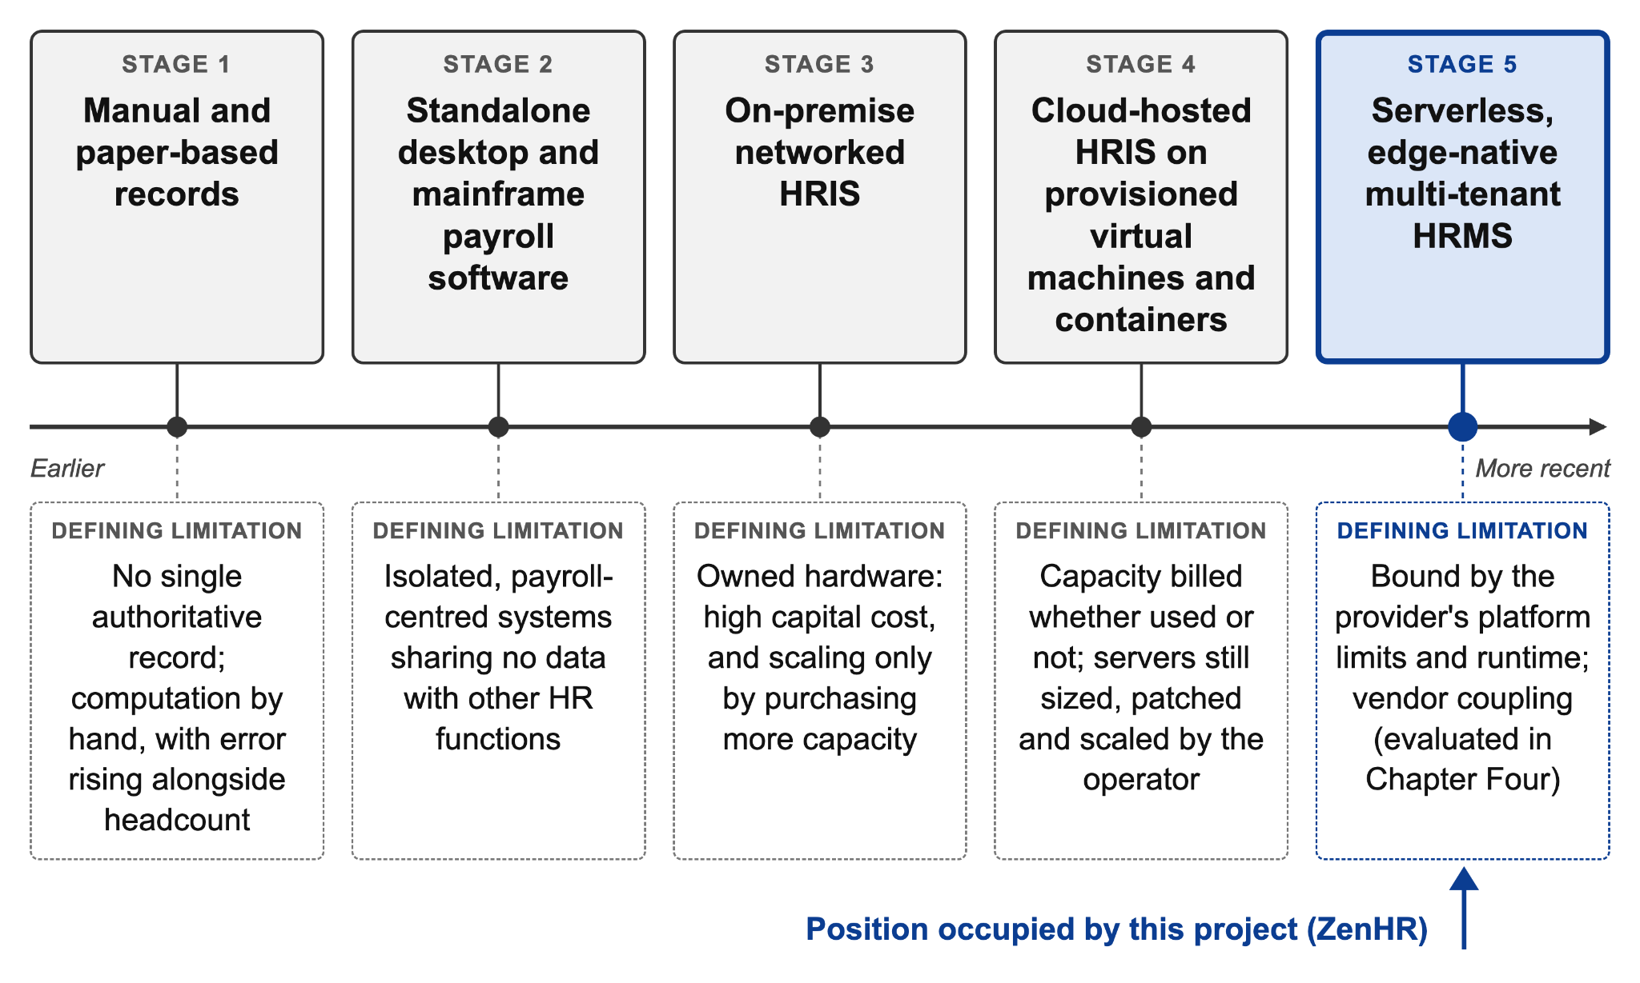
Figure 15: Architectural evolution of human resource management systems
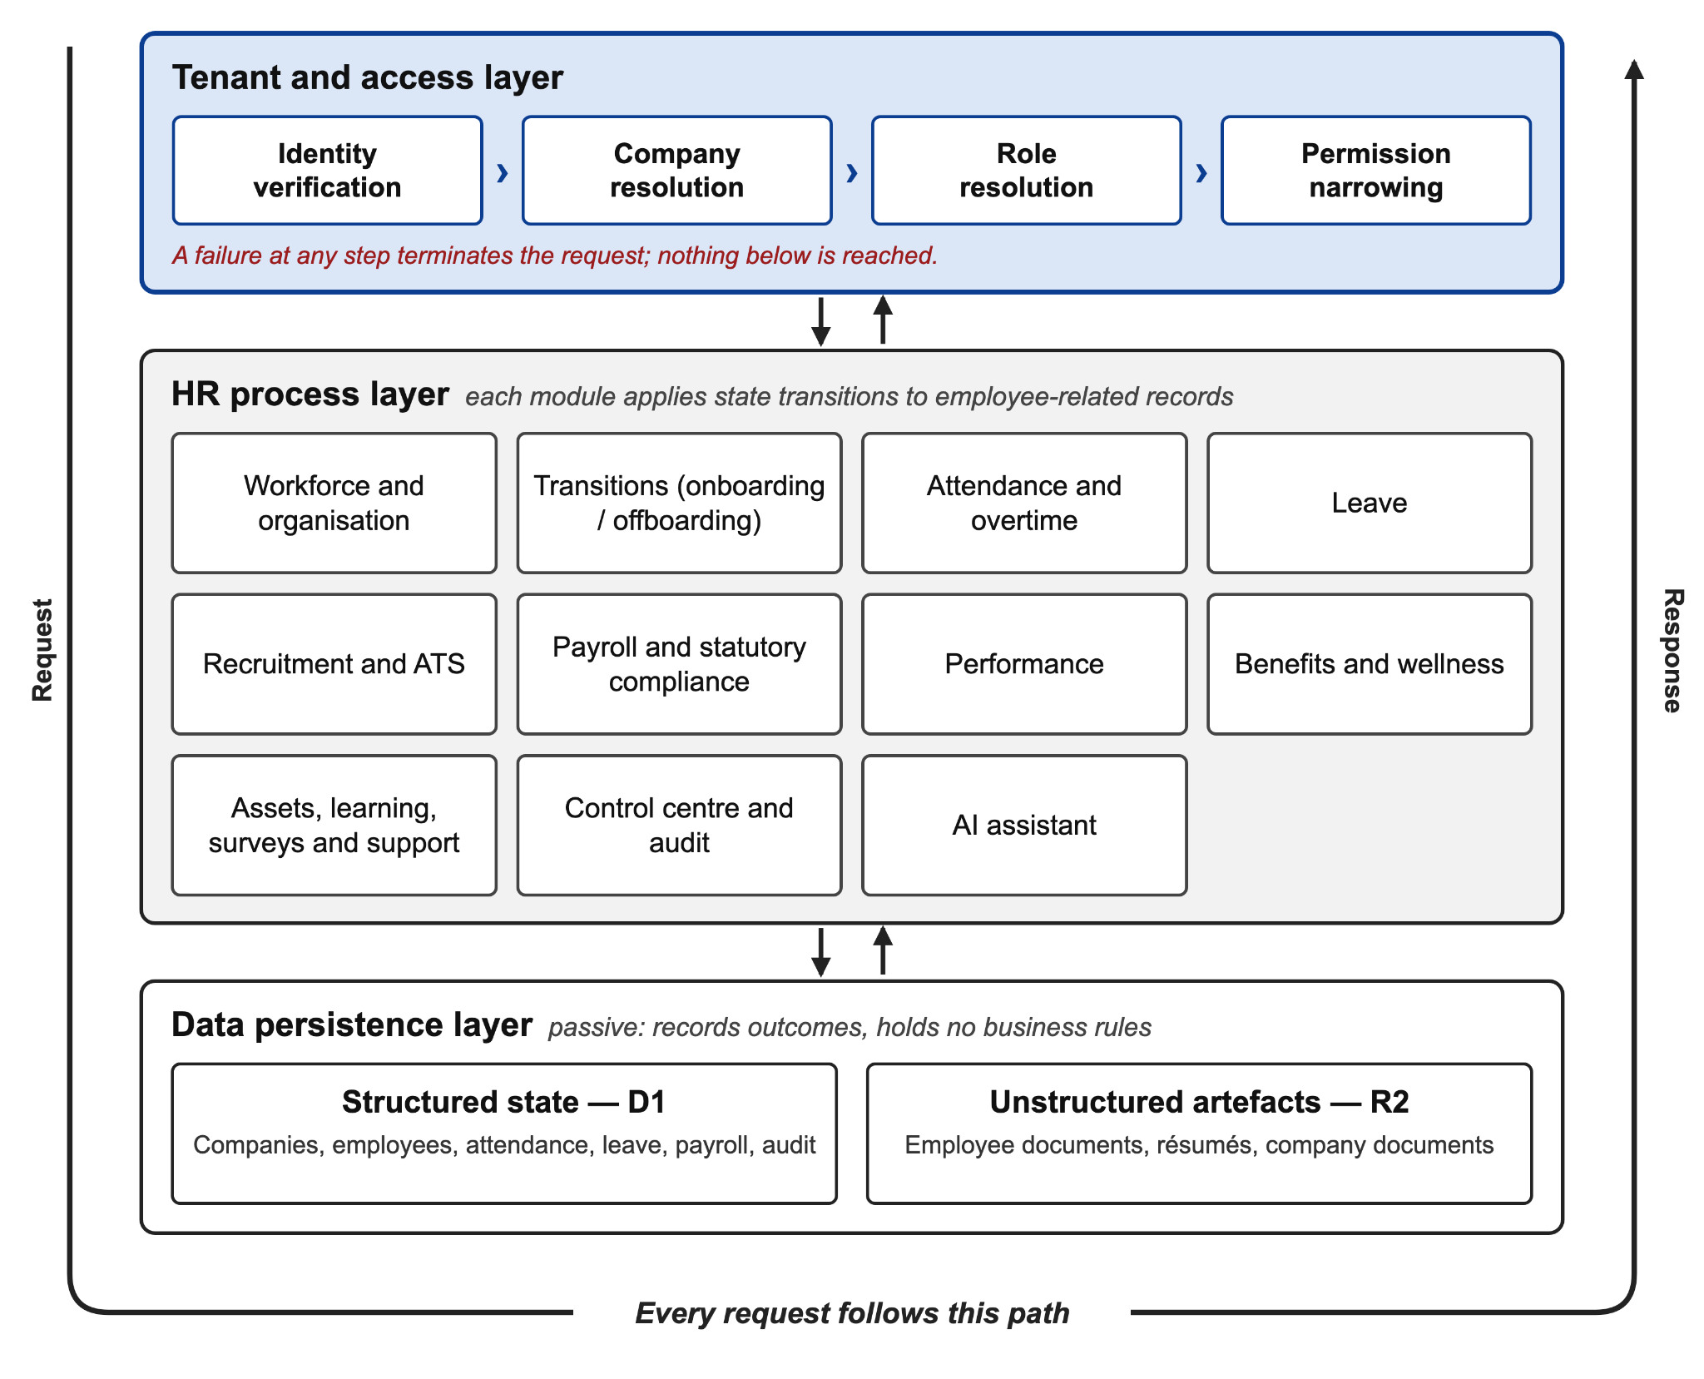
Figure 16: Conceptual framework of the proposed system
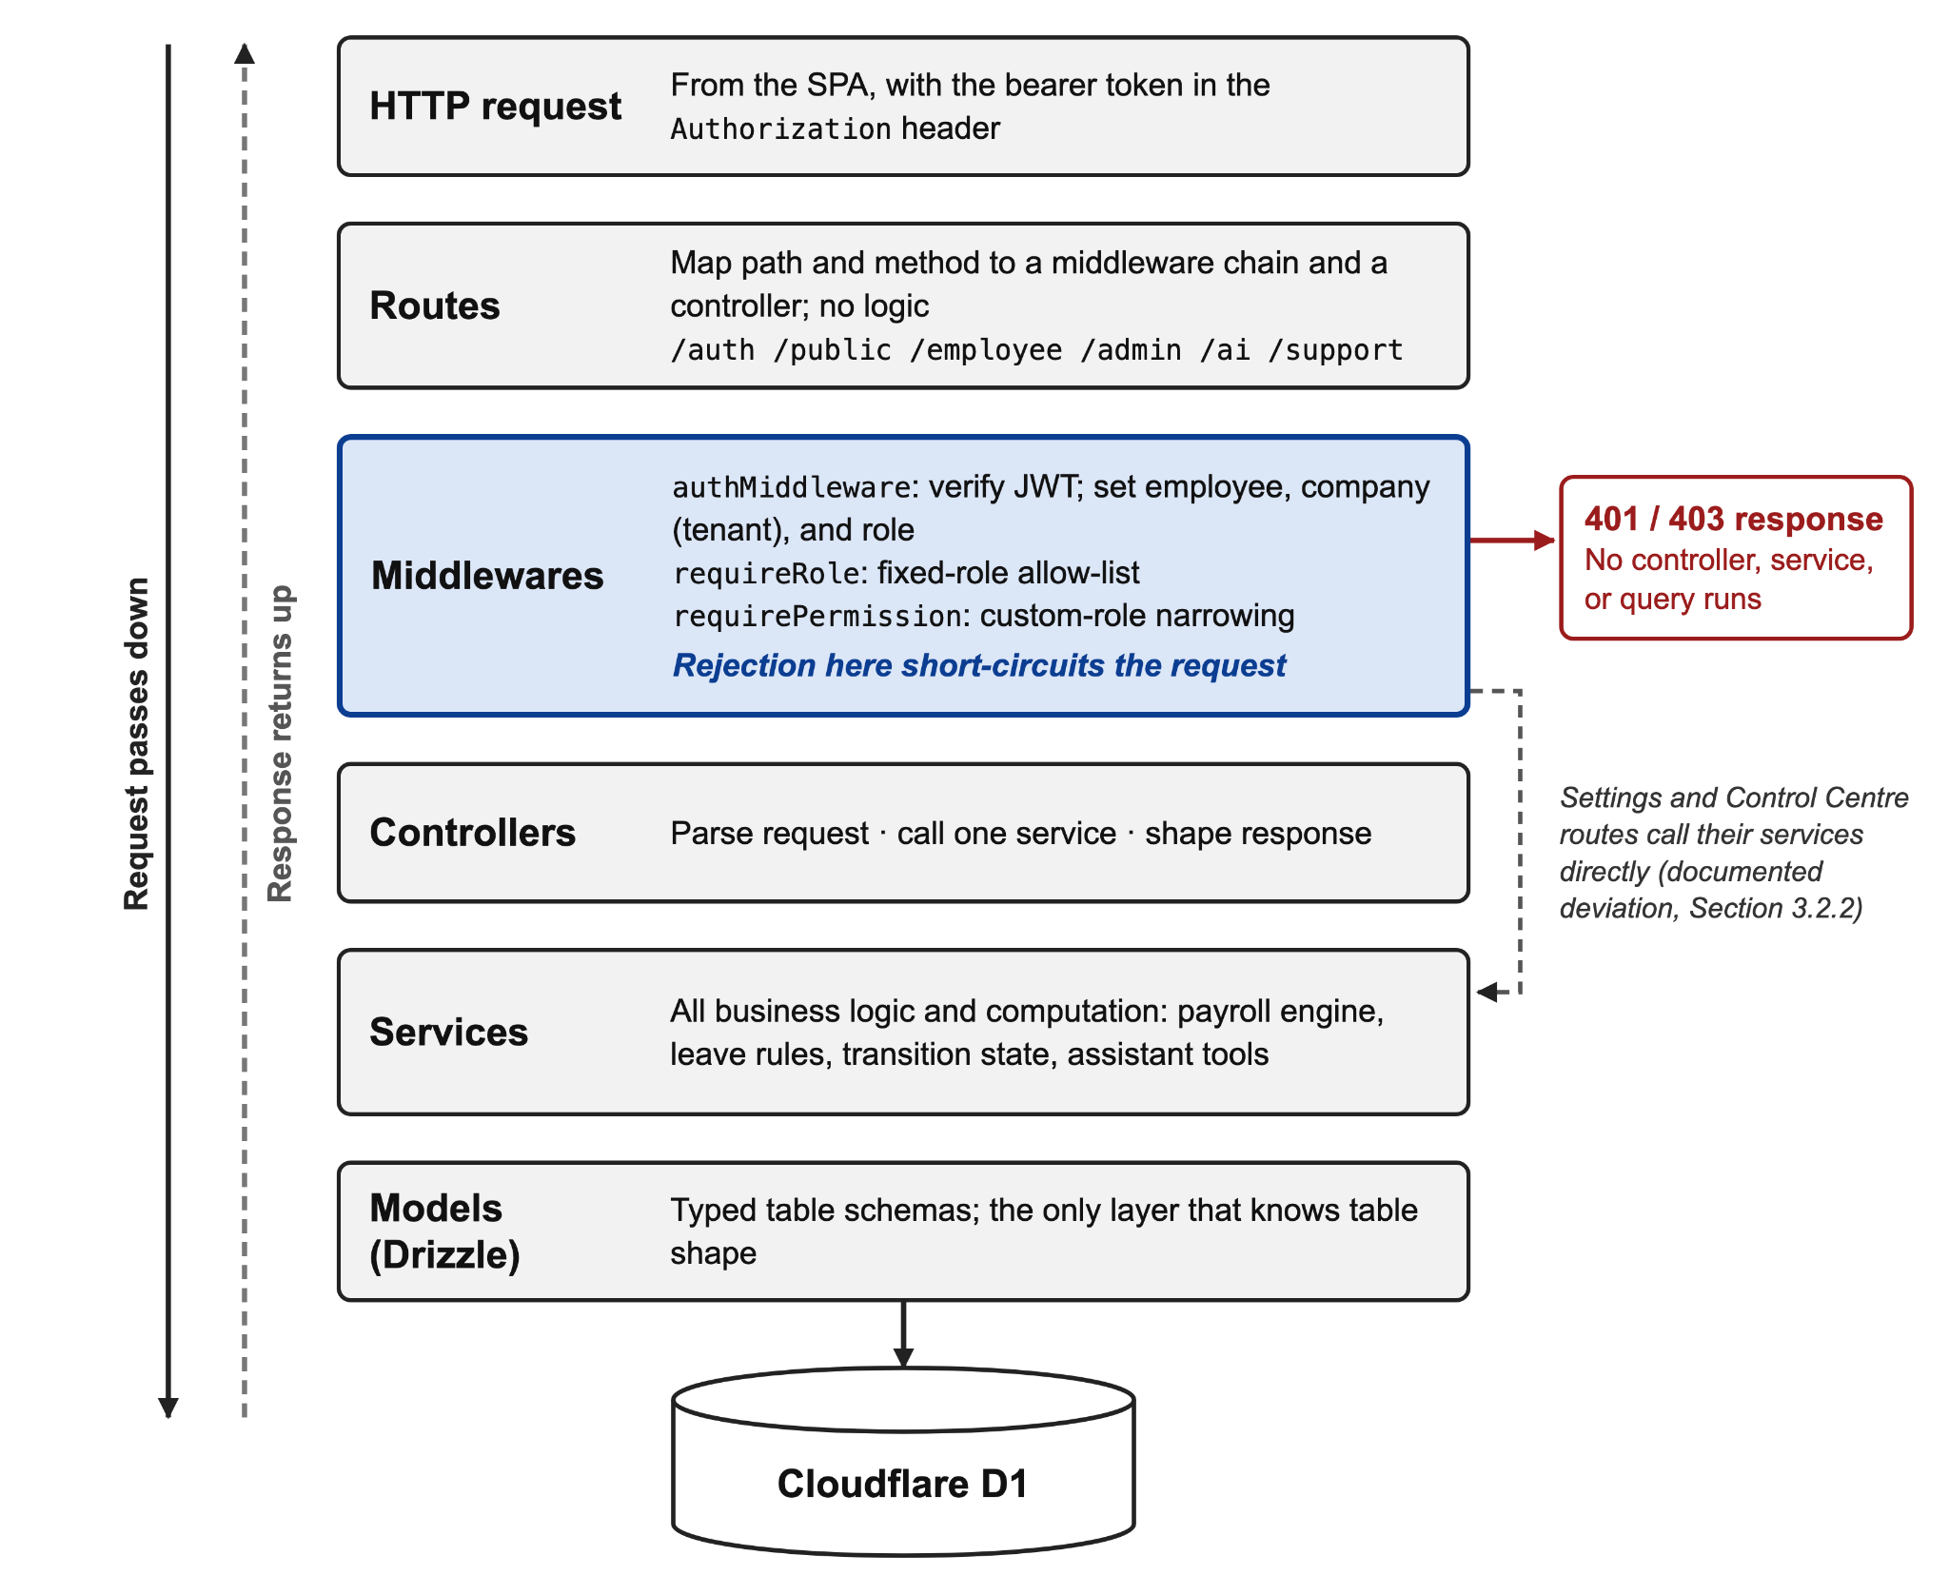
Figure 17: Layered architecture of the Workers backend
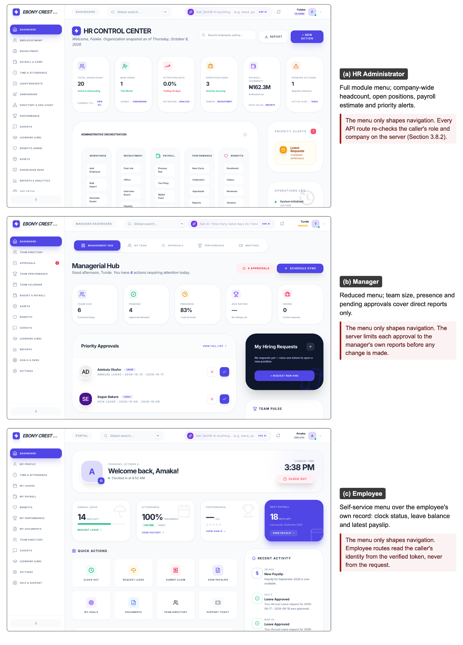
Figure 18: Role-scoped interface views
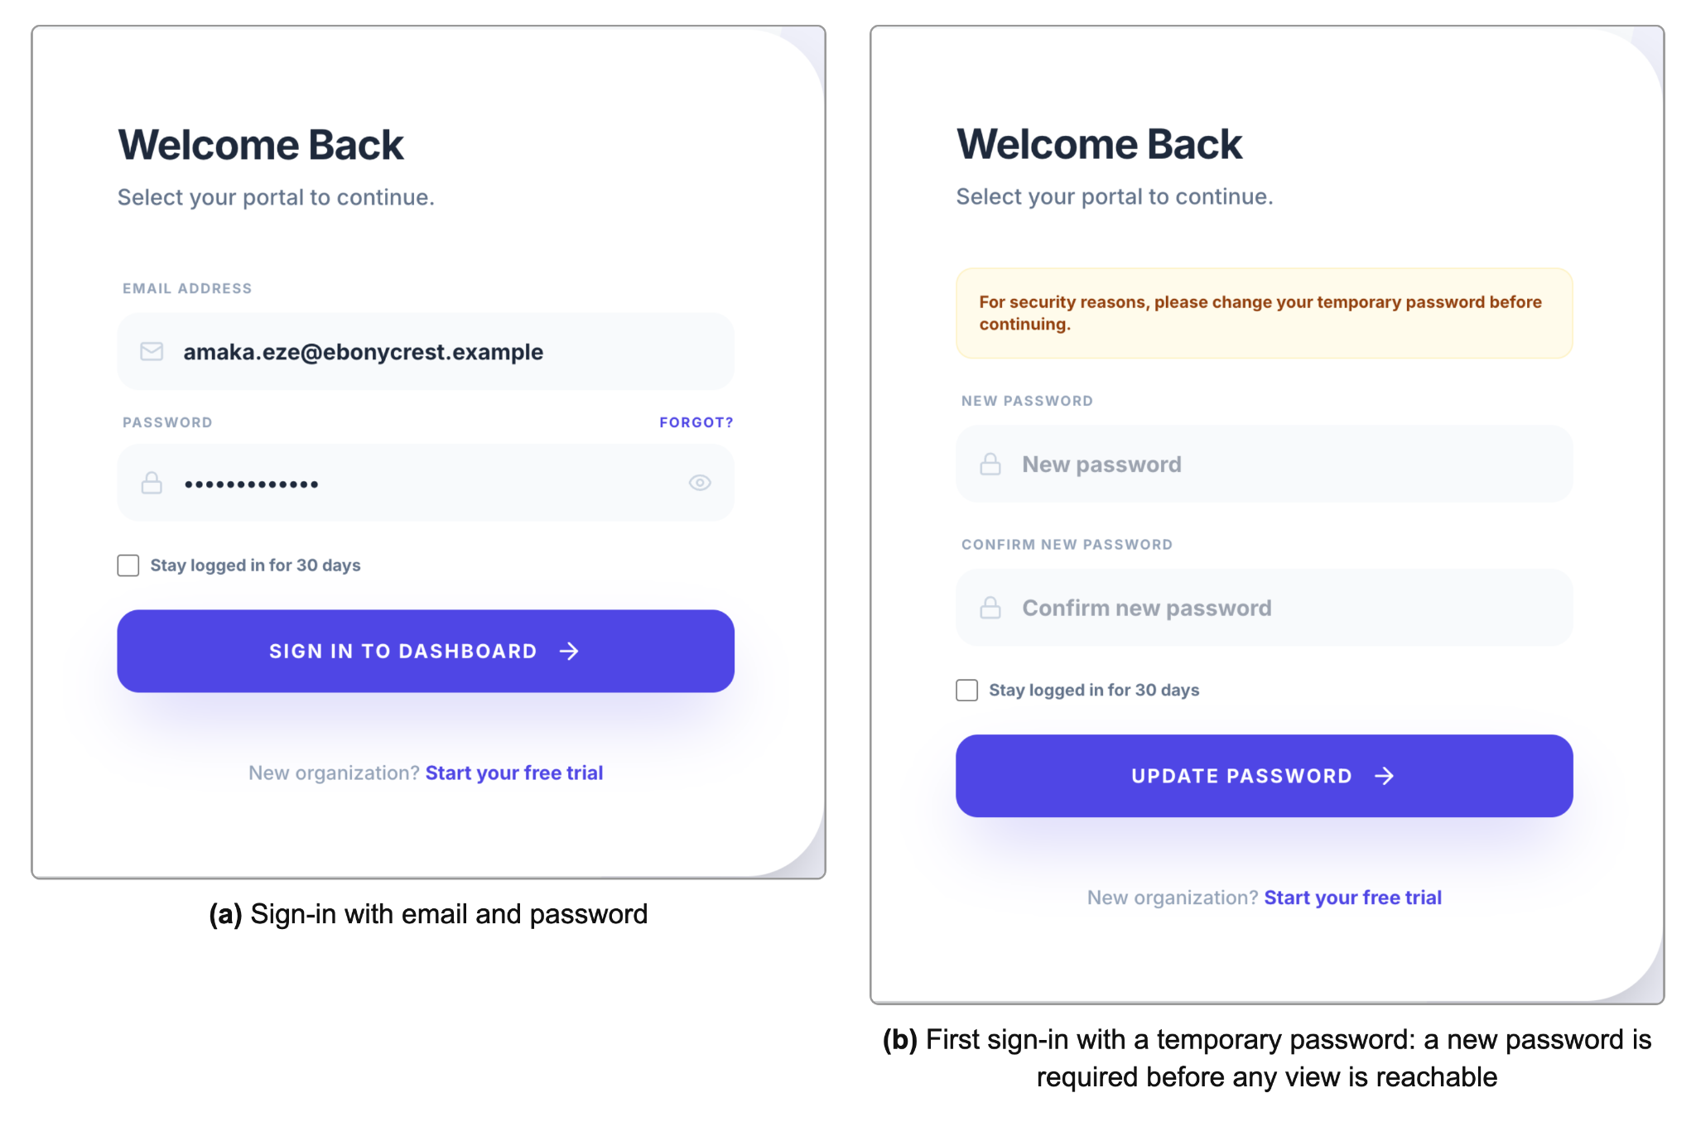
Figure 19: Login and forced password change on first sign-in
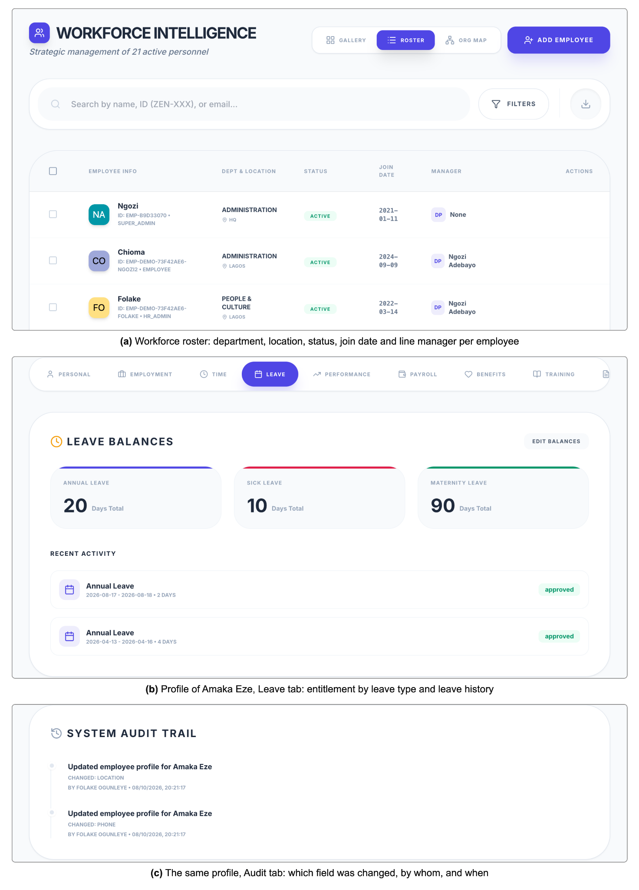
Figure 20: Employee directory and consolidated employee profile
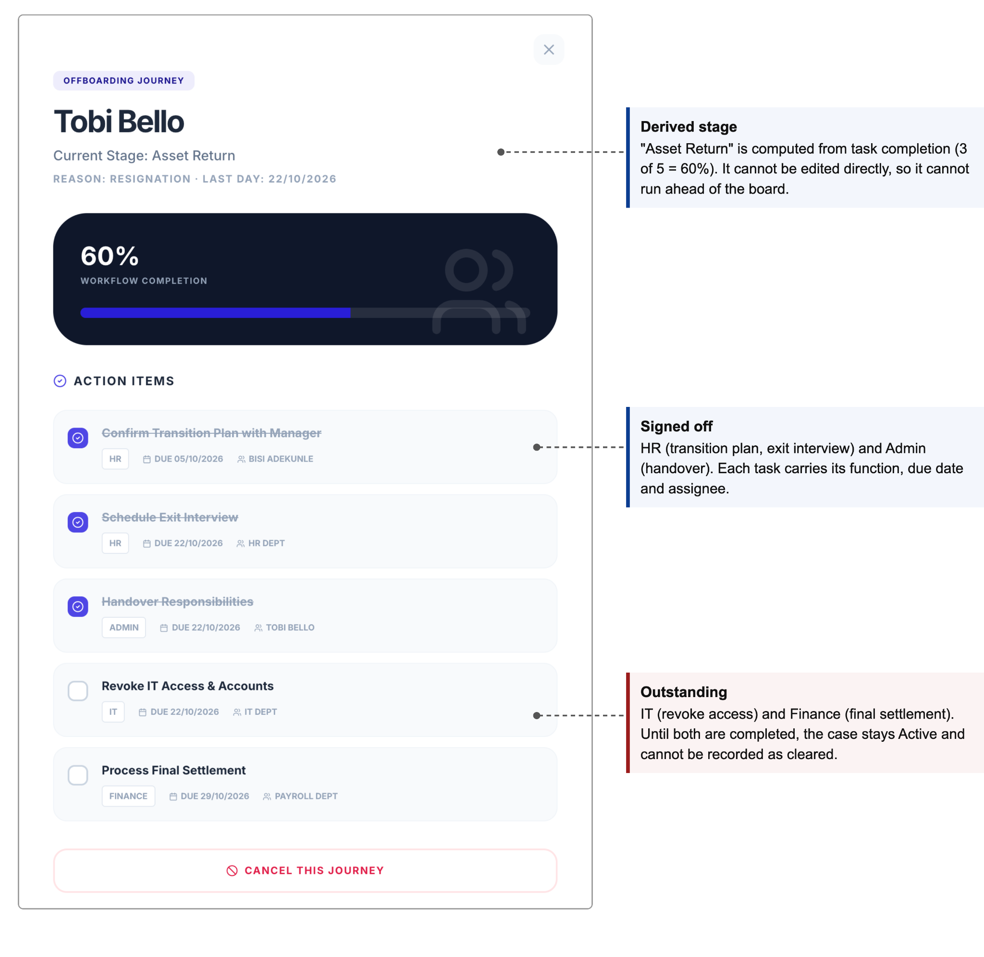
Figure 21: Offboarding clearance board showing per-function sign-off
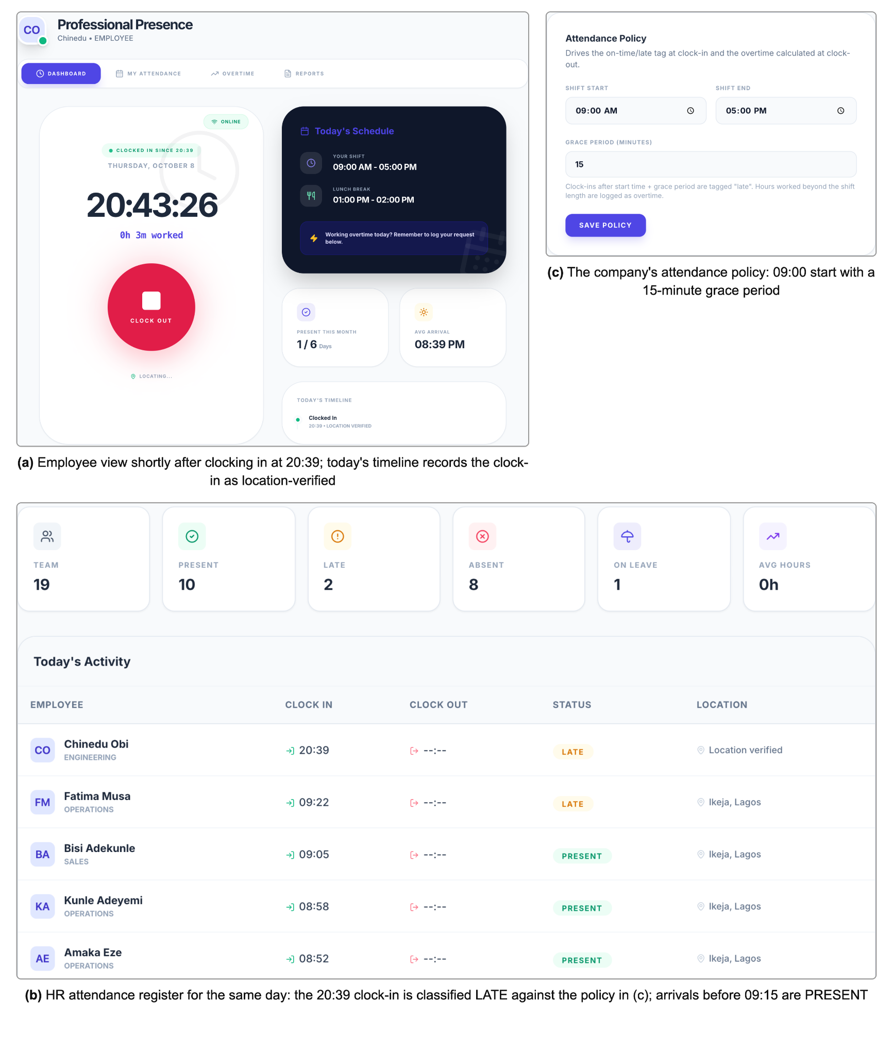
Figure 22: Attendance clock-in with punctuality classification
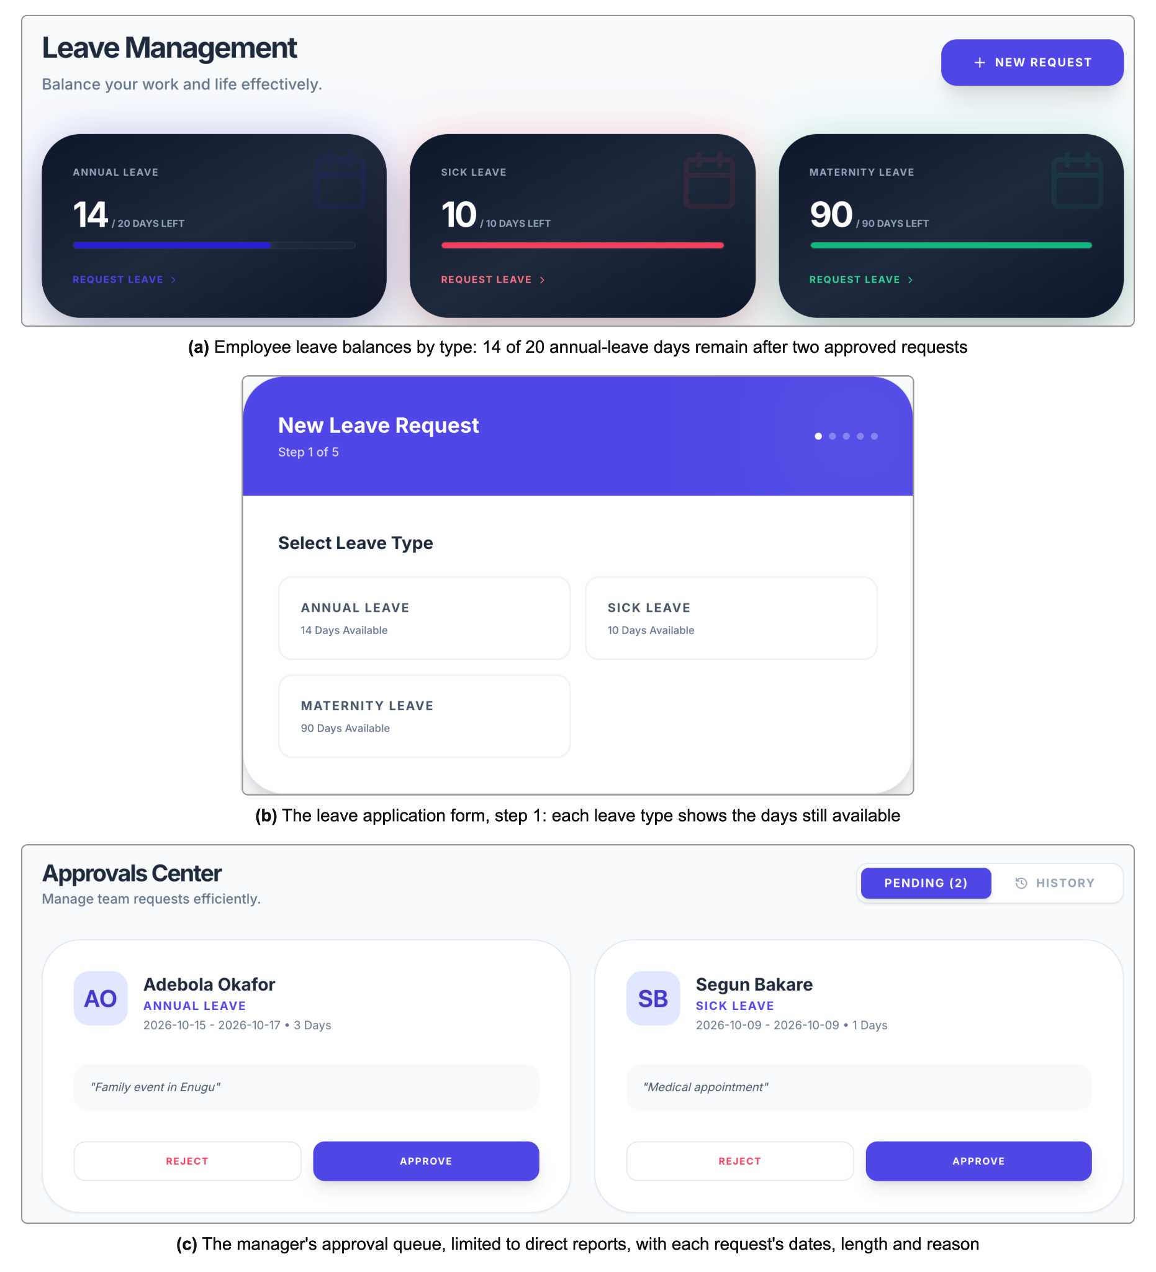
Figure 23: Leave balances and request approval
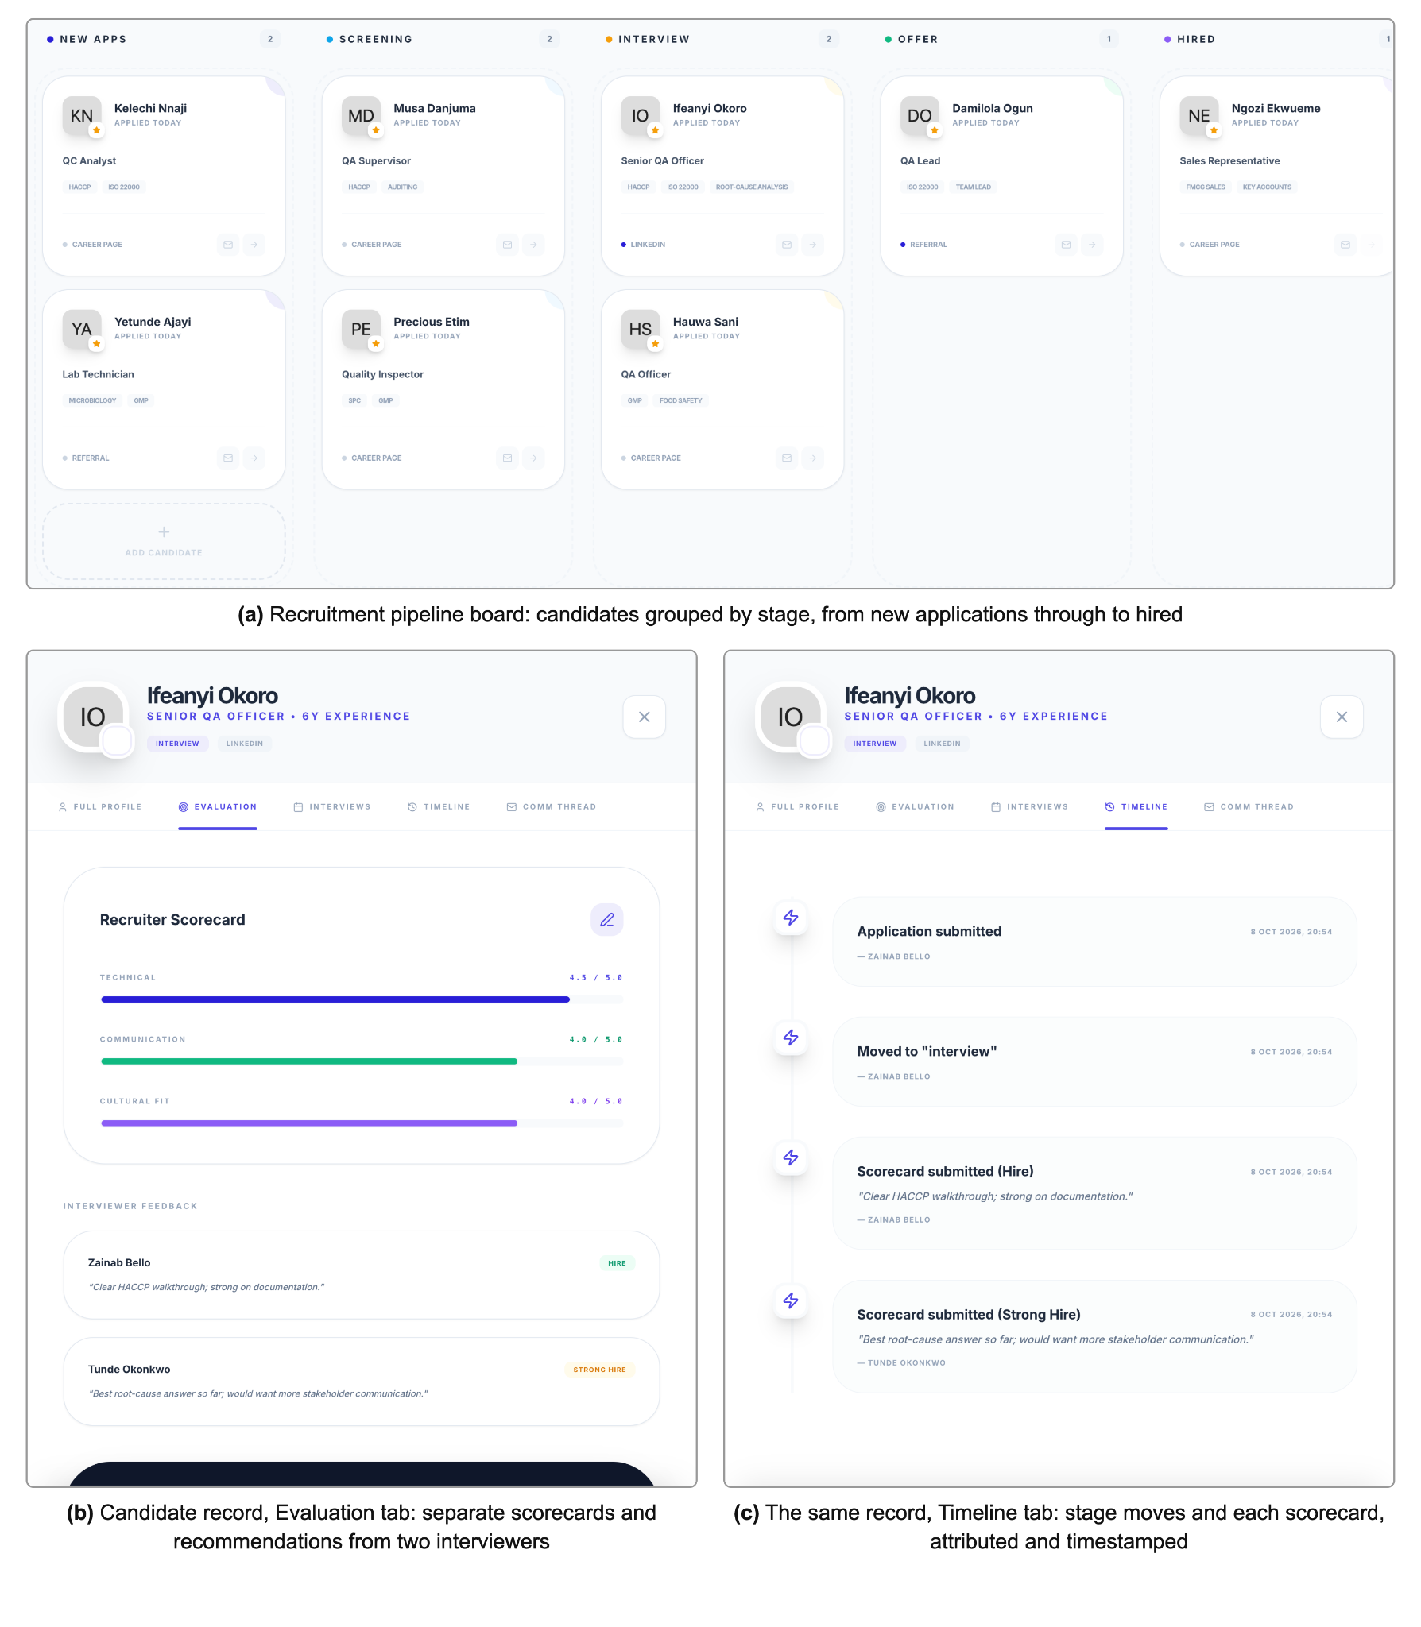
Figure 24: Recruitment pipeline and interviewer scorecard
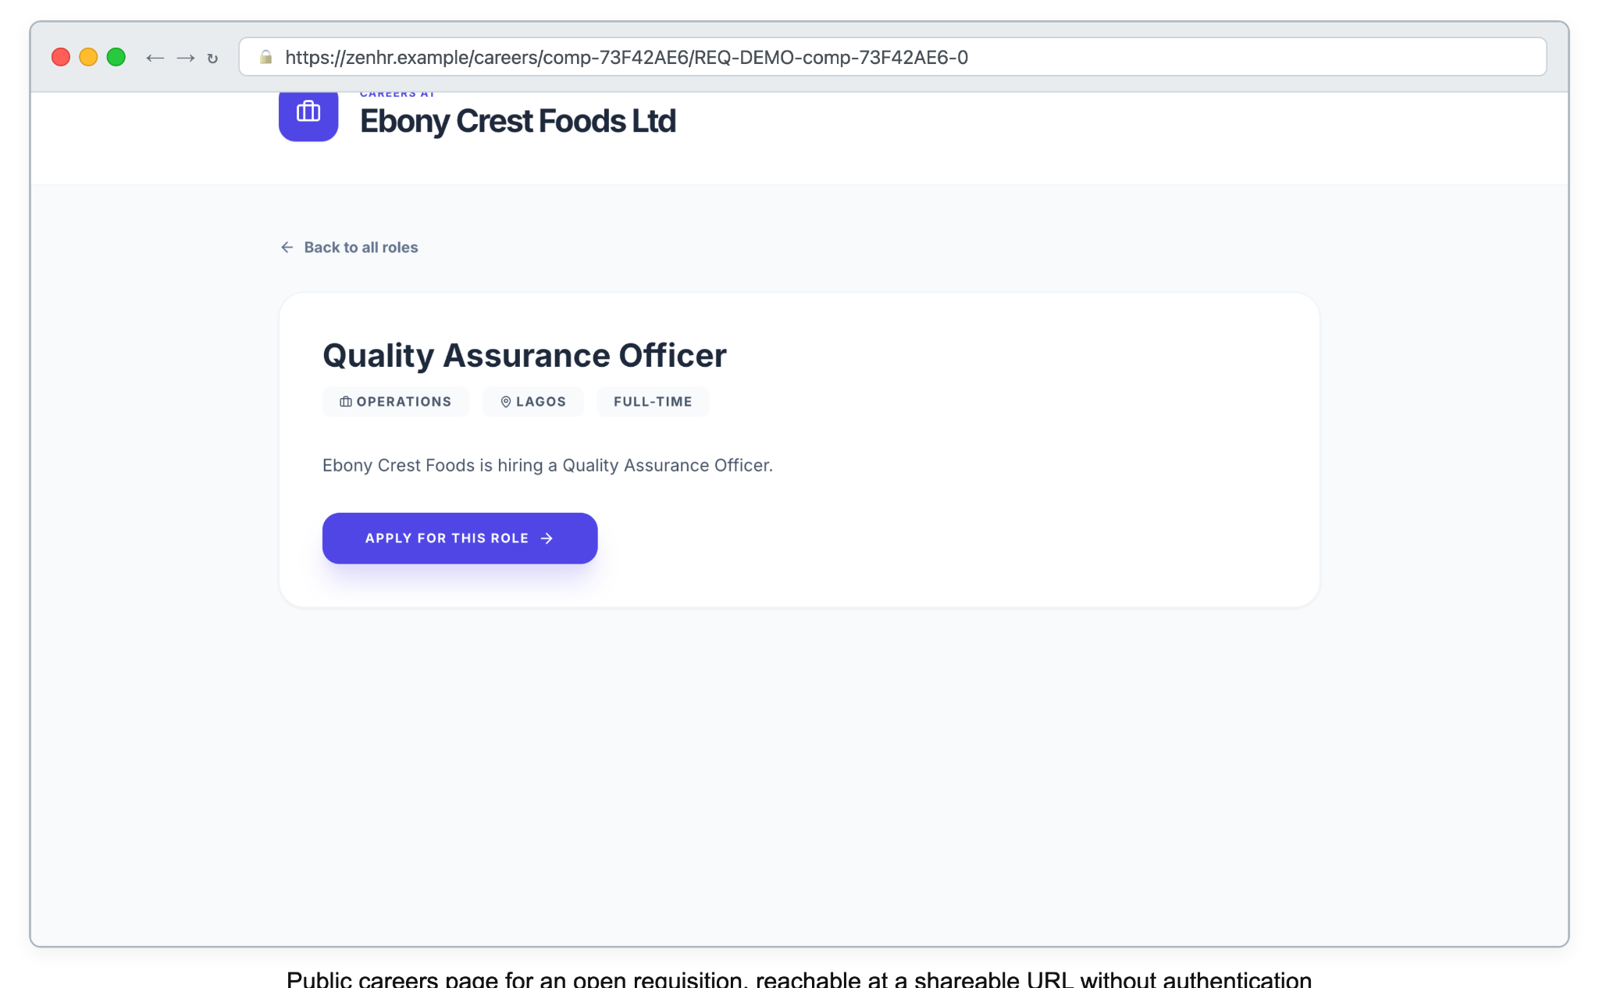
Figure 25: Public careers page for an open requisition
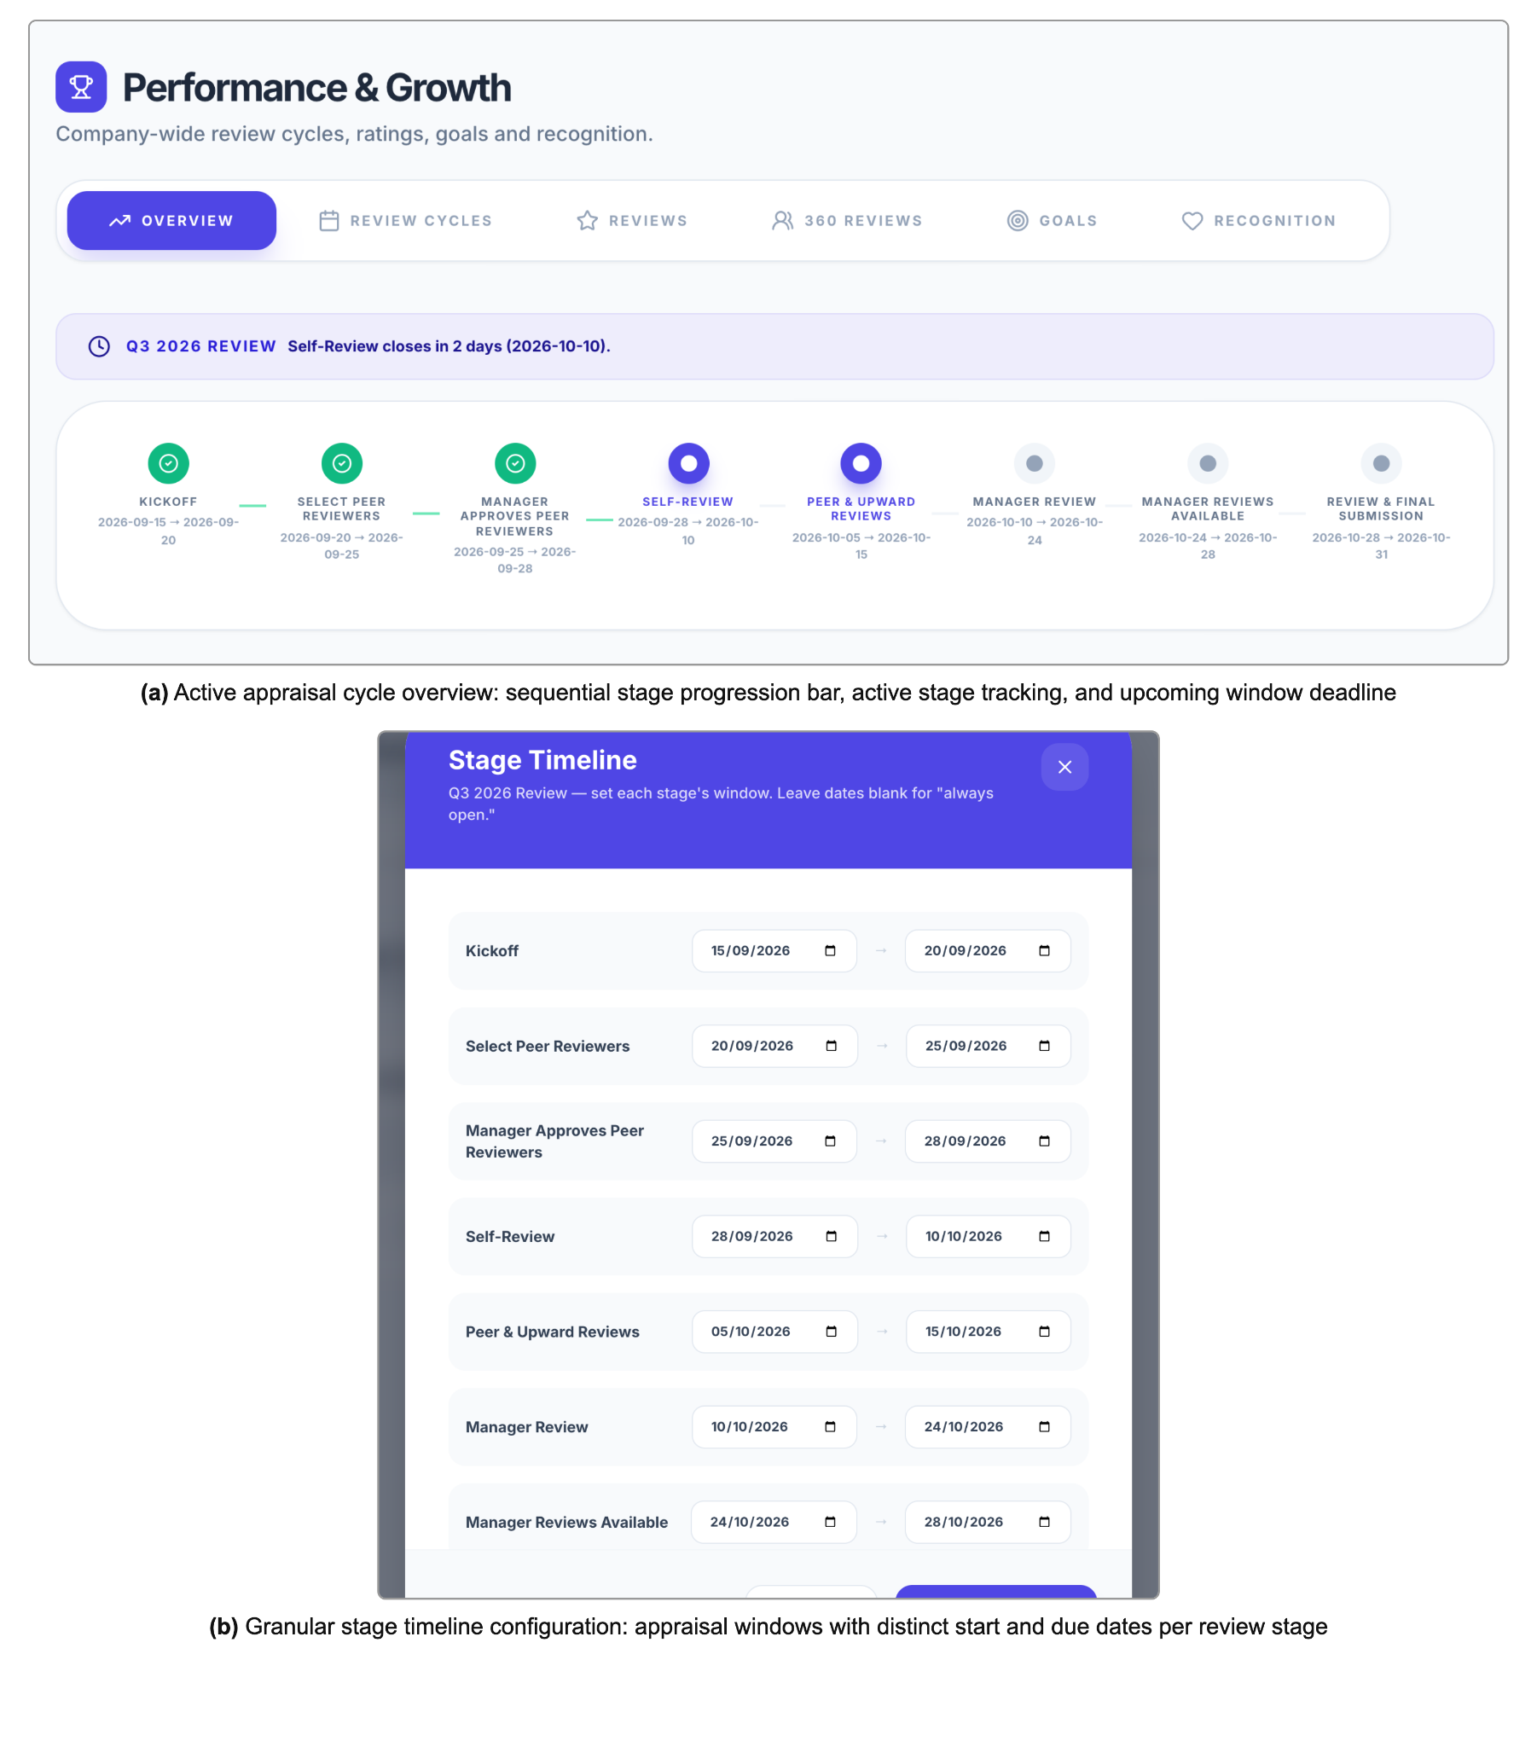
Figure 26: Performance review cycle configuration
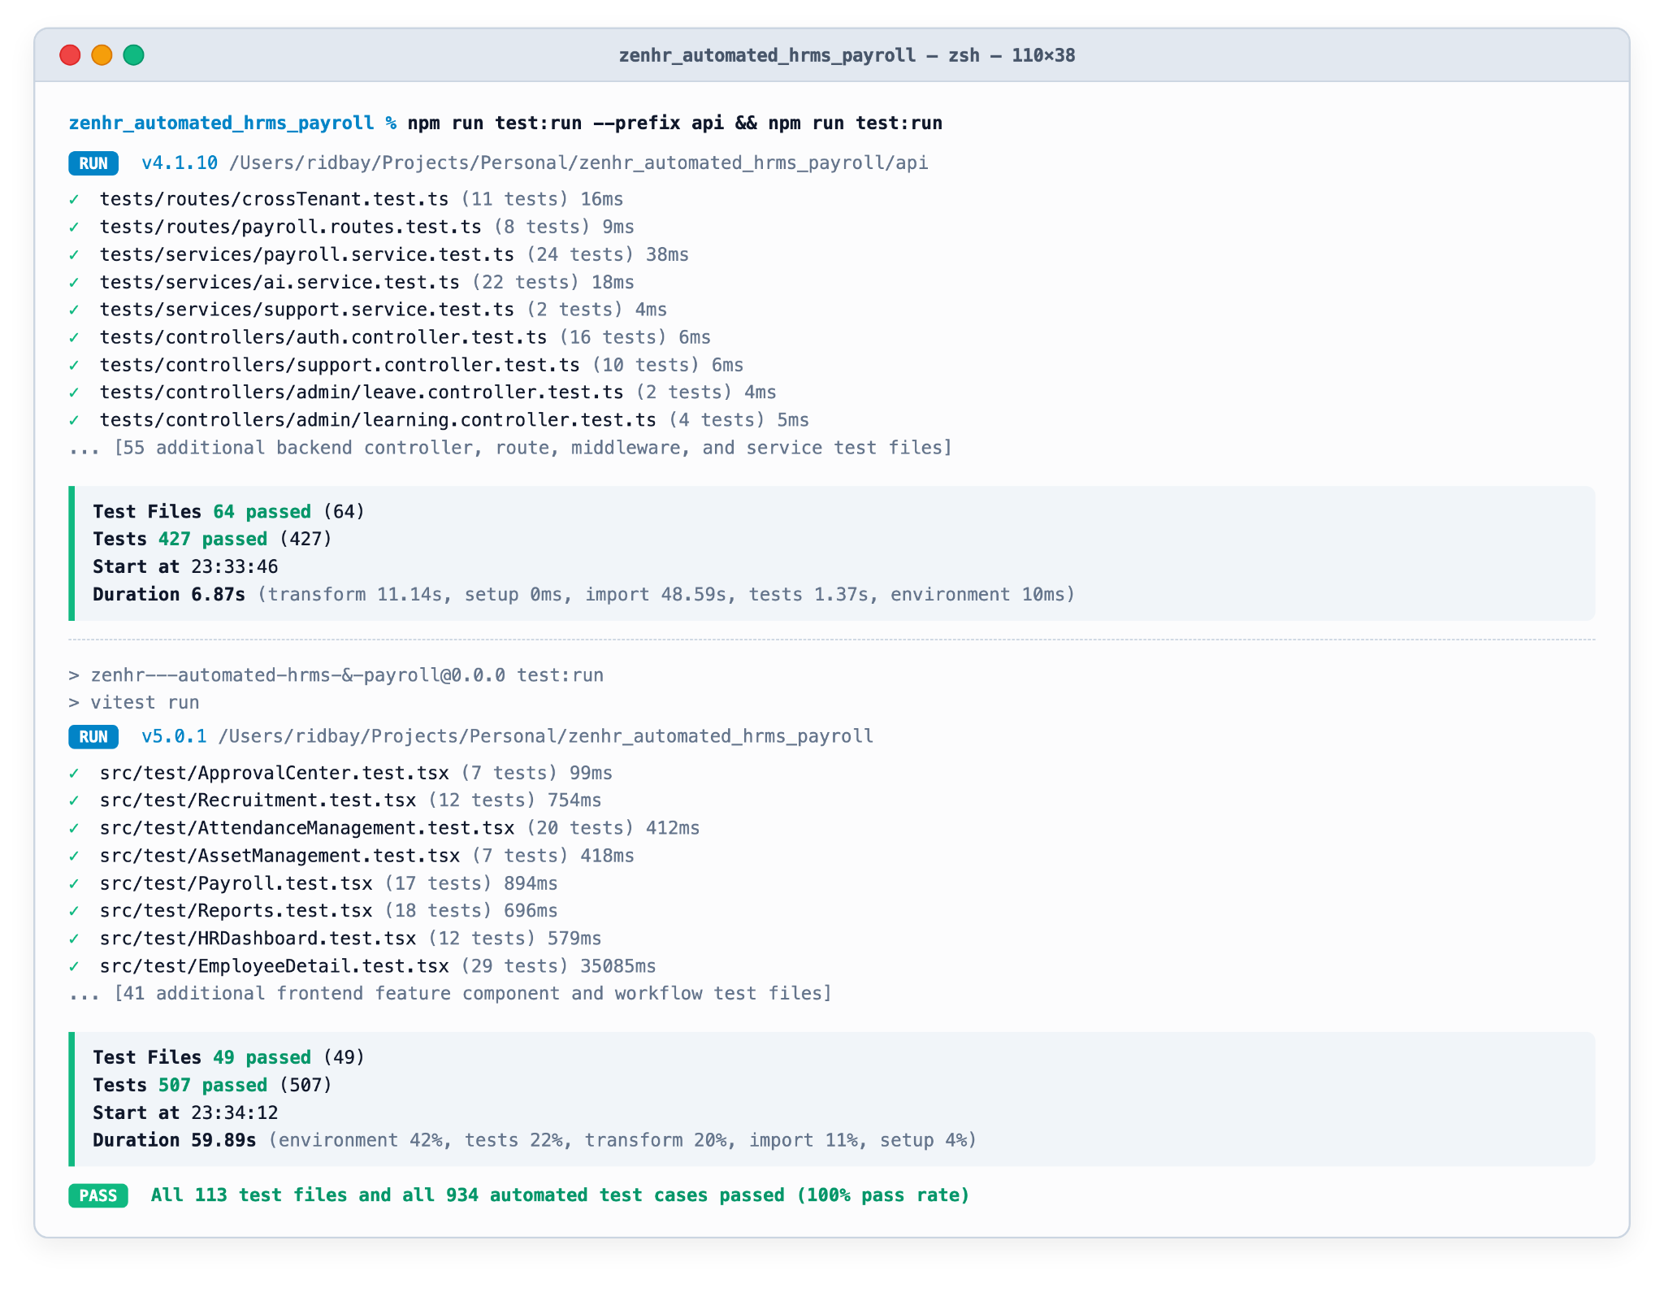
Figure 27: Terminal output of the backend and frontend test suites

APPENDIX C: PRINCIPAL DATABASE TABLE COLUMNS
Table 16: Principal columns of the employees table
Column | Type | Notes
id | TEXT | Primary key, opaque identifier
company_id | TEXT | Foreign key to companies; tenancy discriminator (FR6)
department_id, location_id | TEXT | Foreign keys to departments and locations
first_name, last_name, email | TEXT | Identity and login credential
password_hash, password_salt | TEXT | Salted hash only (NFR9)
is_password_changed | BOOLEAN | Drives the forced reset (FR3)
role | TEXT | One of six fixed roles (FR4)
custom_role_id | TEXT, nullable | Optional narrowing permission matrix (FR5)
manager_id | TEXT, nullable | Self-reference; reporting lines and approvals (FR9)
hire_date | DATE | Drives payroll proration (FR34)
annual_salary | DECIMAL | Basis for gross pay
status | TEXT | onboarding, active, on leave, separated (FR15)
bank_account, pension_id, pfa_name, tin, nin | TEXT, nullable | Statutory and payment identifiers; gaps raise pre-run exceptions (FR42)

Table 17: Principal columns of the attendance_records table
Column | Type | Notes
id | TEXT | Primary key
company_id, employee_id | TEXT | Tenancy and ownership
work_date | DATE | Day the session belongs to
clock_in, clock_out | TIMESTAMP | clock_out null while a session is open
latitude_in, longitude_in, latitude_out, longitude_out | REAL, nullable | Optional geolocation (FR17)
location_label | TEXT, nullable | Free-text location
work_hours, overtime_hours | DECIMAL | Computed per record (FR18)
status | TEXT | Punctuality classification (FR19)

Table 18: Principal columns of the leave_requests and leave_balances tables
Table | Column | Type | Notes
leave_requests | id; company_id, employee_id | TEXT | Key, tenancy and ownership
leave_requests | leave_type; start_date, end_date; days | TEXT; DATE; DECIMAL | Type, range and computed length
leave_requests | reason; attachment_key | TEXT | Justification; R2 object key
leave_requests | status; manager_comment | TEXT | pending, approved, rejected (FR22)
leave_balances | employee_id, leave_type; company_id | TEXT | Composite key; tenancy
leave_balances | total_entitlement | DECIMAL | Entitlement only (FR21, FR23)

Table 19: Principal columns of the payslips table
Column | Type | Notes
id; company_id, employee_id, payroll_run_id | TEXT | Key, tenancy, ownership and run link
period | TEXT | Pay period
gross_pay; basic_salary, allowances | DECIMAL | After proration (FR34); component split (FR35)
paye | DECIMAL | Equation 3 (FR39)
pension_employee, pension_employer | DECIMAL | Employee deducted; employer reported only (FR36)
nhf | DECIMAL | Deducted (FR37)
nsitf, itf | DECIMAL | Employer-borne; never deducted (FR38)
loan_deduction; other_deductions | DECIMAL | Equation 4 (FR40); manual entries
net_pay | DECIMAL | Equation 5
benefits_snapshot | TEXT (JSON) | Allowance and pension figures at computation time

