Academic Year: 2025-26 | Year: Second Year | Term: I
Roll No.: 1012411011 | Name: Riddhee Kulkarni
Subject: Java
Assignment No.: 12 | Title: RMI Programming
Date: 12/10/2025

Aim:
Develop a simple client-server application using RMI Programming.

Theory:
RMI (Remote Method Invocation) is a Java technology that allows a program to call methods on objects located on another computer or JVM over a network. It makes distributed programming easier because the programmer can call remote methods just like normal local methods.
In an RMI client-server system, the server creates and hosts remote objects that provide services, while the client looks up these objects and calls their methods to get results. The communication is handled automatically by RMI, so programmers don’t need to deal with low-level networking.
An RMI application has four main parts:
- Remote Interface – defines the methods that the client can call remotely.
- Remote Object Implementation – provides the actual code for these methods.
- Server – creates the remote object, starts the RMI registry, and binds the object with a name.
- Client – finds the remote object in the registry and calls its methods.
RMI is useful for building distributed applications because it allows objects on different machines to interact seamlessly while hiding network communication details.

Flowchart:
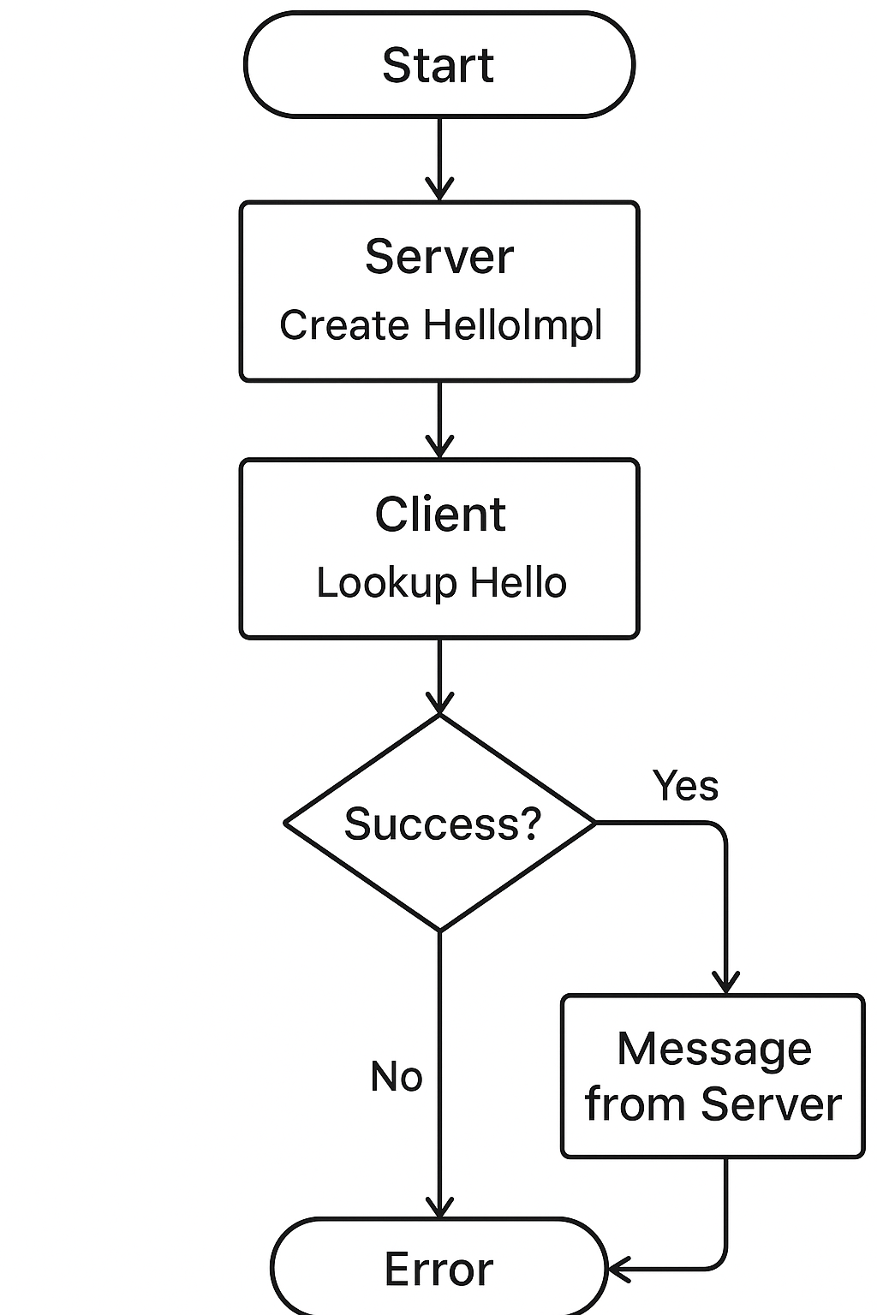

Code:
Hello.java
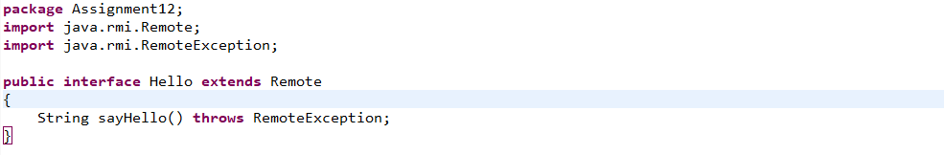

HelloImpl.java
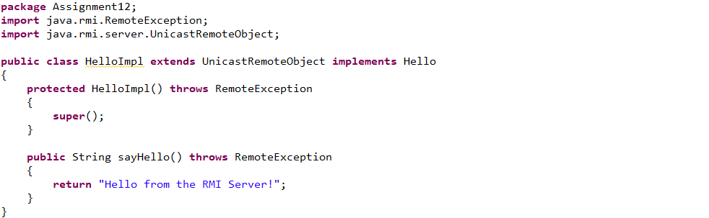
Server.java
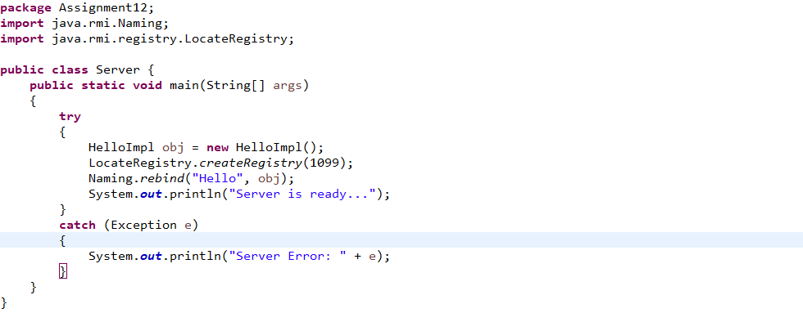
Client.java
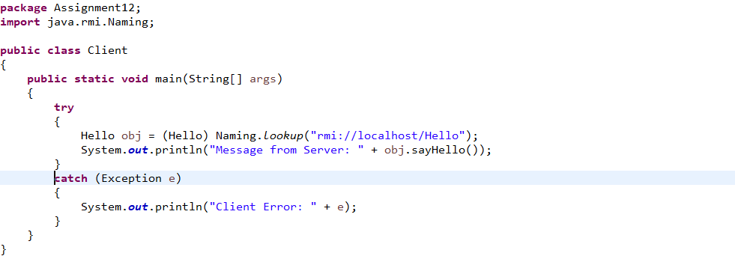

Output:
Server:
Client:

Conclusion:
A simple client-server application using RMI Programming is developed.

