Academic Year: 2025-26 | Year: Second Year | Term: I
Roll No.: 1012411011 | Name: Riddhee Kulkarni
Subject: Java
Assignment No.: 8 | Title: File Handling
Date: 17/09/2025

AIM:
To write a program to read from and write to a file using FileReader, FileWriter, BufferedReader, and BufferedWriter, applicable to any system that requires data storage and retrieval.

THEORY:
File handling in Java is a mechanism that allows programs to create, read, write, and manage files on disk. It is essential for storing data permanently so that it can be retrieved and reused later. File handling is achieved through the classes of the java.io package.
Streams are used to establish communication between the program and the file. An input stream is used when data flows from the file to the program, and an output stream is used when data flows from the program to the file.
FileWriter is used to write text data to a file, and BufferedWriter is used on top of it to improve efficiency by providing a buffer and methods like newLine() for line breaks. Similarly, FileReader is used to read text data from a file, while BufferedReader provides efficient reading using a buffer and supports reading a complete line at once with the readLine() method.

FLOWCHART:
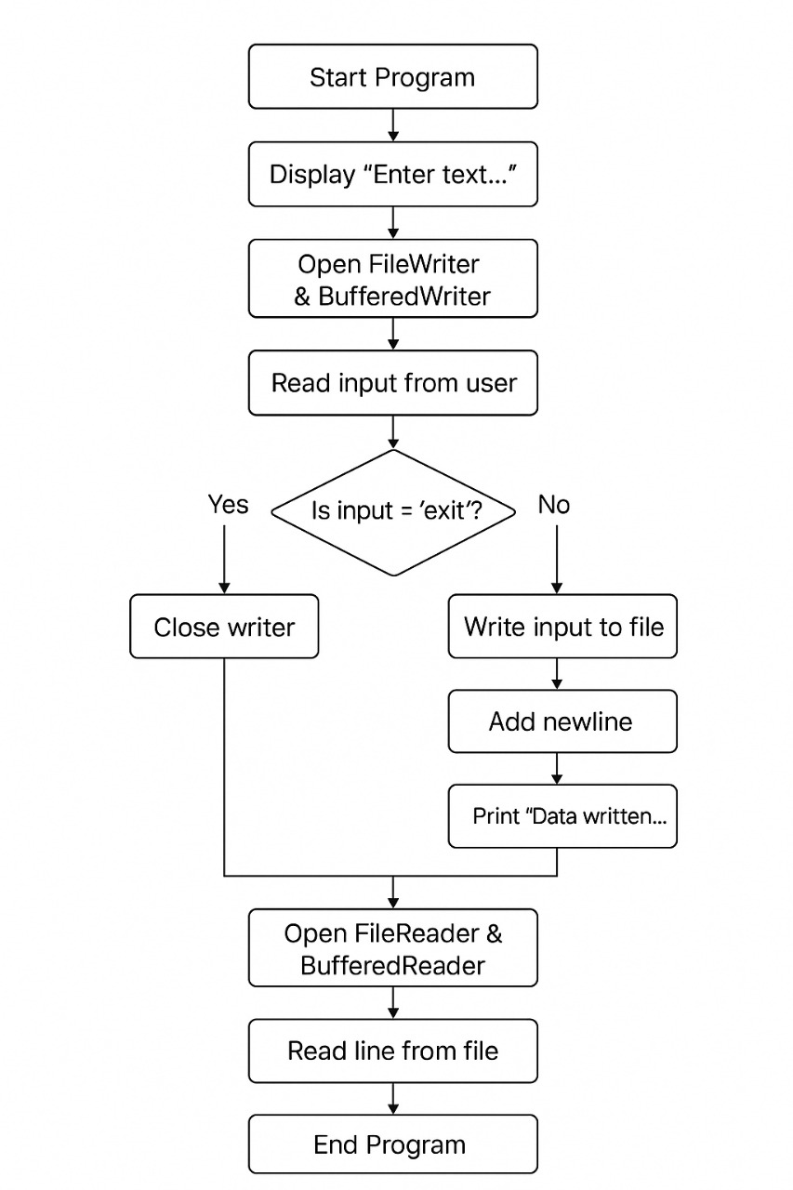
CODE:
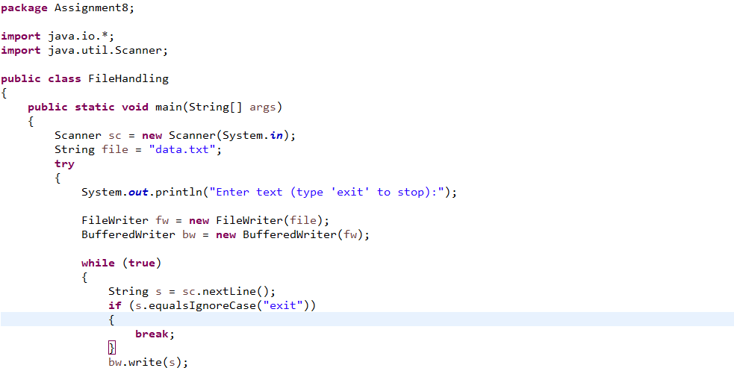
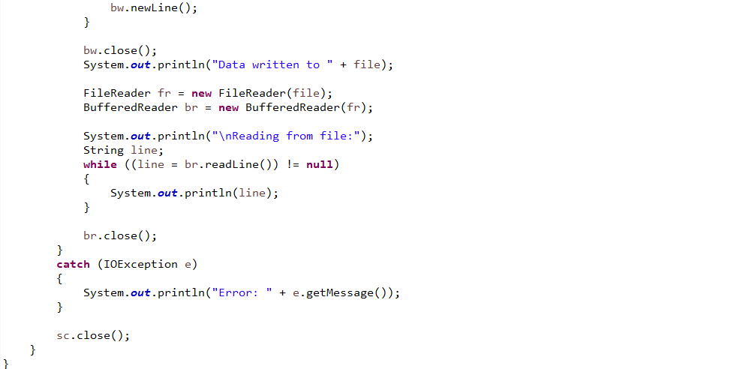

OUTPUT:
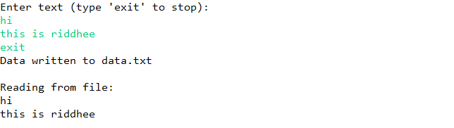

CONCLUSION:
The program demonstrates Java file handling by writing user input to a file using FileWriter and BufferedWriter, and then reading it back using FileReader and BufferedReader. It highlights how data can be stored permanently and retrieved efficiently for use in applications that require data persistence.

