WT Assignment 1
Name: Riddhesh Ture
Div:CS-L-B2
Roll No:24

https://github.com/riddhesh-ture/wt-lab/tree/main/lab-1-bill

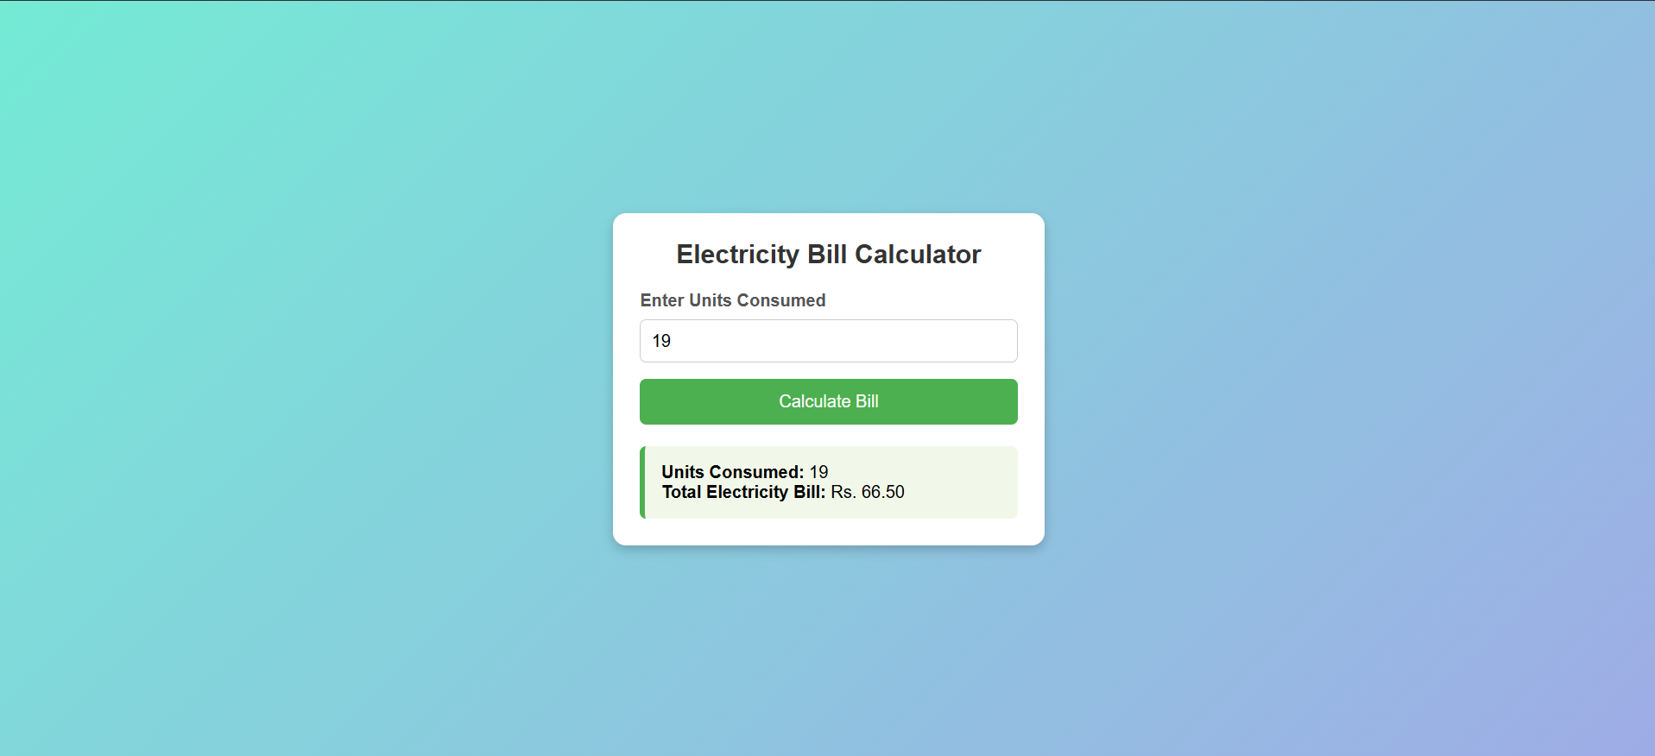
https://github.com/riddhesh-ture/wt-lab/tree/main/lab-2-bill

