SatFIN: Deep Optical-Flow Frame Interpolation for Enhancing the Temporal Resolution of Geostationary Satellite Imagery
Mentor
Riddhesh Morankar | Abhinav Nigade | Virajas Khapli
Atharva Pednekar |  | Preet Jain
Dr.Jayshree Aher

Abstract—Geostationary satellites image the Earth every 10–30 minutes, a cadence too coarse to follow rapidly evolving phenomena such as convective initiation, overshooting tops, wildfire smoke plumes, and flash-flood–producing storms. This paper presents SatFIN, a Satellite Frame Interpolation Network that synthesizes physically plausible intermediate frames between consecutive geostationary observations using deep bidirectional optical flow. SatFIN adapts the real-time intermediate flow estimation (RIFE) paradigm to single- and multi-channel brightness-temperature imagery: a coarse-to-fine IFNet predicts time-conditioned flows and a fusion mask, input frames are backward-warped to an arbitrary target time t, and a lightweight U-Net refines the result. The network is trained on ~1-minute GOES Advanced Baseline Imager (ABI) mesoscale sequences, where temporal sparsity is simulated by sampling frame triplets with 2–10-minute gaps, so that true intermediate frames serve as ground truth. A convective-region-weighted Charbonnier loss emphasizes cold cloud tops (brightness temperature below 235 K) and regions of rapid temporal change. We describe the full pipeline, from anonymous ingestion of NetCDF4 data on AWS through radiance-to-brightness-temperature conversion, training, tiled full-disk inference, and deployment to 30-minute INSAT-3DS imagery (30 → 15 → 7.5 min). On held-out GOES test data, a SatFIN model trained briefly on a CPU outperforms linear blending at every gap (2, 4, and 10 min) in PSNR, SSIM, and brightness-temperature error, and it is the best method at 2 min (48.83 dB, 0.287 K). At 4 and 10 min, however, classical DIS optical flow remains clearly more accurate (40.69 dB vs. 34.82 dB at 10 min), which shows that the learned flow needs substantially longer training before it can exploit its advantages at large gaps.
Index Terms—Frame interpolation, optical flow, deep learning, geostationary satellites, GOES-R ABI, INSAT-3DS, temporal super-resolution, nowcasting, convective storms.

I. Introduction
Geostationary (GEO) meteorological satellites are the backbone of real-time weather monitoring because they observe the same hemisphere continuously. Operational full-disk imaging, however, is typically refreshed only every 10 minutes (GOES-R ABI, Himawari AHI) or every 30 minutes (INSAT-3D/3DR/3DS) [1]–[3]. Many hazardous processes evolve faster than this: a convective cell can go from initiation to a mature, lightning-producing storm in well under an hour, and the cloud-top cooling rates used as convective-initiation predictors are defined over time intervals of minutes [4], [5]. Rapid-scan mesoscale sectors can image at 30–60-s cadence,

but only over small, pre-selected regions, and increasing the cadence of full-disk scans requires new hardware.
Video frame interpolation (VFI) offers a software alternative: given two consecutive frames I₀ and I₁, synthesize the frame I_{t} at an intermediate time t ∈ (0, 1). Flow-based VFI methods such as Super SloMo [6] and RIFE [7] estimate motion between the input frames, warp them toward time t, and fuse the results. These models are trained on natural video, where motion is mostly rigid and appearance changes little between frames. Satellite imagery breaks both assumptions: clouds deform, grow, and dissipate; brightness temperature (BT) is a physical quantity whose absolute value matters; and the most important regions (deep convective cores) are exactly those whose appearance changes fastest.
This paper presents SatFIN, a VFI framework designed specifically for GEO imagery. Its contributions are:
- A training strategy based on simulated temporal sparsity, which draws (I₀, I_{t}, I₁) triplets with configurable gaps from ~1-minute GOES mesoscale sequences, so that real observed frames serve as ground truth for 2–10-minute interpolation.
- A RIFE-style architecture adapted to brightness temperature, with time-conditioned bidirectional flow, backward warping, and residual U-Net refinement, supporting single-band IR and multispectral input.
- A convective-region-weighted loss that up-weights cold cloud tops and pixels with large temporal BT change, which are the regions most relevant for nowcasting.
- An end-to-end, open pipeline covering data ingestion, preprocessing, training, evaluation against classical baselines with physically meaningful metrics (MAE in kelvin), tiled full-disk inference, cross-sensor deployment to INSAT-3DS, and an interactive dashboard.
The rest of the paper is organized as follows. Section II reviews related work. Section III describes the data and preprocessing. Section IV presents the SatFIN model and loss functions. Section V gives the experimental setup, Section VI the results, and Section VII the deployment pipeline. Section VIII discusses limitations and Section IX concludes.

II. Related Work

A. Video Frame Interpolation
Early VFI methods combined classical optical flow, such as Farnebäck's polynomial-expansion method [8] or Dense Inverse Search (DIS) [9], with image warping. Super SloMo [6] introduced end-to-end training of bidirectional flows and visibility maps that can produce frames at arbitrary t. Learned flow estimators such as PWC-Net [10] and RAFT [11] improved motion accuracy but add significant cost. RIFE [7] showed that an intermediate flow network (IFNet) can directly estimate flows from time t to both inputs in a coarse-to-fine manner, reaching real-time speed with competitive quality. SatFIN builds on this design because the computational budget of full-disk inference makes efficiency essential.

B. Optical Flow in Satellite Meteorology
Atmospheric motion vectors derived from feature tracking in successive GEO images are a long-standing operational product, and cloud tracking underlies satellite-based convective-initiation nowcasting [4], [5]. These methods estimate motion for diagnostic purposes rather than synthesizing new imagery.

C. Temporal Interpolation of Satellite Imagery
Vandal and Nemani [12] showed that deep optical-flow interpolation can generate intermediate GOES-16 ABI frames that outperform linear interpolation, which confirms that learned VFI transfers to GEO data. SatFIN extends this line of work with a real-time architecture, arbitrary-t inference, a convection-focused objective, and an explicit cross-sensor deployment path to lower-cadence satellites such as INSAT-3DS.

III. Data and Preprocessing

A. Data Sources
Table I summarizes the sensors used. For training, we use ABI Level-1b radiances (product ABI-L1b-RadM) from the two mesoscale sectors of GOES-19 (GOES-East) and GOES-18 (GOES-West), which are publicly distributed through the NOAA Open Data Dissemination program on Amazon S3 (buckets noaa-goes19 and noaa-goes18) and can be read anonymously. Each mesoscale sector covers roughly 1000 km × 1000 km at ~60-s cadence, and the 2-km IR bands give 500 × 500-pixel frames. Band 13 (10.3 µm, “clean” longwave IR) is the default channel because it is available day and night and responds directly to cloud-top temperature. Himawari-9 AHI data (bucket noaa-himawari9) serve as a secondary source. For deployment, INSAT-3DS imager data are obtained in HDF5 format from MOSDAC after user registration.
TABLE I
Satellite Sensors Used in This Work
Satellite / sensor | Role | Cadence | IR res.
GOES-19 / ABI (East) | Training | ~1 min (meso) | 2 km
GOES-18 / ABI (West) | Training | ~1 min (meso) | 2 km
Himawari-9 / AHI | Training / test | 10 min (FD) | 2 km
INSAT-3DS / Imager | Deployment | 30 min (FD) | 4 km
Meso: mesoscale sector; FD: full disk. Cadences are nominal operational values; verify the scan schedule for the specific dates used.

B. Radiance to Brightness Temperature
ABI L1b files store spectral radiance L. We convert it to brightness temperature using the inverse Planck function with the band-specific coefficients distributed in each file (planck_fk1, planck_fk2, planck_bc1, planck_bc2) [13]:
T_{B} = [ f_{k2} / ln( f_{k1} / L + 1 ) − b_{c1} ] / b_{c2} (1)

C. Normalization and Quality Control
BT is normalized to [0, 1] with fixed physical bounds rather than per-image statistics, so that a given normalized value always corresponds to the same temperature across scenes and sensors:
x = clip( (T_{B} − T_{min}) / (T_{max} − T_{min}), 0, 1 ) (2)
with T_{min} = 180 K and T_{max} = 330 K by default. Fill values and pixels flagged by the data-quality field are masked out of the loss and metrics, and frames with more than a configurable fraction of missing pixels are discarded.

D. Simulated Temporal Sparsity
The key idea of the training strategy is to create low-cadence inputs from high-cadence sequences. From a 1-minute sequence we pick a gap Δ ∈ {2, 4, 10} minutes, take I₀ and I₁ Δ minutes apart, and choose one of the Δ − 1 real intermediate frames as the target I_{t}, with t = k/Δ for k = 1, …, Δ − 1. Because acquisition times are not exactly regular, t is computed from the actual scan-start timestamps in the file names. The value of t is stored with each sample and fed to the network.

E. Splits and Augmentation
Adjacent satellite frames are highly correlated, so random frame-level splits would leak information between training and test sets. We therefore split by time: training, validation, and test sets come from disjoint days (and, where possible, distinct weather events). During training we apply random 256 × 256 crops, horizontal and vertical flips, 90° rotations, and time reversal (swapping I₀ and I₁ and replacing t with 1 − t).

IV. Proposed Method: SatFIN

A. Overview
Fig. 1 shows the complete pipeline and Fig. 2 the network. Given (I₀, I₁, t), SatFIN (i) estimates flows from the target time to both inputs together with a fusion mask, (ii) backward-warps the inputs to time t, (iii) blends them, and (iv) adds a learned residual correction.
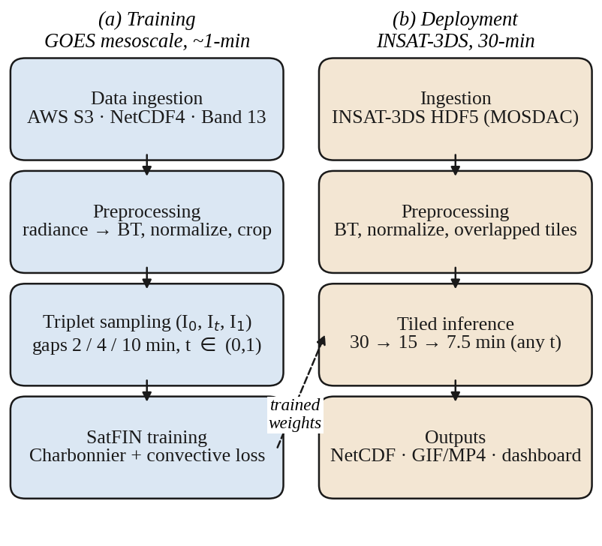
Fig. 1. End-to-end SatFIN pipeline. (a) Training on ~1-minute GOES mesoscale data with simulated temporal sparsity. (b) Deployment of the trained weights to 30-minute INSAT-3DS imagery with tiled inference.

B. Intermediate Flow Estimation (IFNet)
IFNet is a three-level coarse-to-fine estimator operating at 1/4, 1/2, and full resolution. At each level, a convolutional block receives the inputs, the time map t (broadcast as a constant channel), the frames warped with the current flow estimate, and the upsampled flow and mask from the previous level, and it predicts a residual update:
(F_{t→0}, F_{t→1}, M) = IFNet(I₀, I₁, t) (3)
where F_{t→0} and F_{t→1} are dense 2-D flow fields and M ∈ [0, 1] is a per-pixel fusion mask that can down-weight occluded or newly formed cloud in one of the inputs.

C. Backward Warping
Each input is warped to time t with differentiable bilinear sampling [14] (PyTorch grid_sample):
Ĩ₀(p) = I₀( p + F_{t→0}(p) ), Ĩ₁(p) = I₁( p + F_{t→1}(p) ) (4)
and the warped frames are blended with the mask:
Ī_{t} = M ⊙ Ĩ₀ + (1 − M) ⊙ Ĩ₁ (5)

D. Refinement Network
Warping alone cannot represent appearance change, such as a cloud top cooling as it rises or an anvil spreading. A compact U-Net [15], R, receives the warped frames, flows, mask, and multi-scale context features extracted from I₀ and I₁, and predicts a bounded residual:
Î_{t} = clip( Ī_{t} + R(Ĩ₀, Ĩ₁, F, M, c), 0, 1 ) (6)
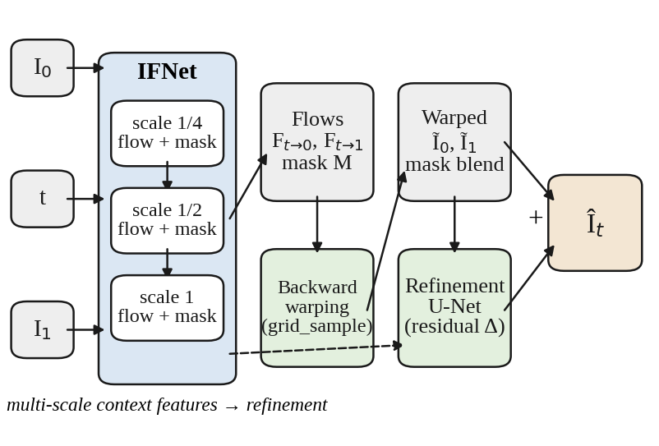
Fig. 2. SatFIN architecture. A three-scale IFNet estimates time-conditioned flows and a fusion mask; the inputs are backward-warped and blended, and a refinement U-Net adds a residual correction to produce the intermediate frame Î_{t}.

E. Loss Functions
The reconstruction term uses the Charbonnier penalty ρ(x) = (x² + ε²)^{1/2} [16], a differentiable, outlier-robust approximation of the L1 loss:
L_{rec} = (1/N) Σ_{p} ρ( Î_{t}(p) − I_{t}(p) ) (7)
To focus learning on hazardous weather, a convective weight map is defined as
w(p) = 1 + α·1[T_{B}(p) < 235 K] + β·g(p) (8)
where 1[·] is the indicator function and g(p) = min(|I₁(p) − I₀(p)| / τ, 1) measures temporal change. The first term marks cold cloud tops typical of deep convection and the second marks rapidly changing pixels. The convective loss is the normalized weighted Charbonnier error:
L_{conv} = Σ_{p} w(p) ρ( Î_{t}(p) − I_{t}(p) ) / Σ_{p} w(p) (9)
An edge-aware first-order smoothness term L_{smooth} regularizes the flows, and an optional census loss L_{cen} [7] preserves cloud edges. The total objective is
L = λ₁L_{rec} + λ₂L_{conv} + λ₃L_{smooth} + λ₄L_{cen} (10)

F. Multispectral Extension
For C-channel input (e.g., ABI bands 8, 10, 13, and 14), the input and output layers are widened to C channels, and a single flow field is shared across channels. Sharing the flow enforces a consistent motion estimate across bands and reduces the misalignment that small inter-band acquisition offsets would otherwise cause.

V. Experimental Setup

A. Implementation Details
SatFIN is implemented in PyTorch [17]. Table II lists the default configuration, which is stored in a YAML file so that every experiment is reproducible. The design targets a single consumer GPU with 8–12 GB of memory. The results in Section VI, however, come from a short CPU-only training run, so they represent an early checkpoint rather than a converged model.
TABLE II
Default Training Configuration
Parameter | Value
Input / band | 1 ch., ABI Band 13 (10.3 µm)
Normalization bounds | 180–330 K
Patch size / batch size | 256 × 256 / 16
Training gaps Δ | 2, 4, 10 min
Optimizer | AdamW [18], weight decay 10⁻⁴
Learning rate | 3×10⁻⁴ → 10⁻⁶ (cosine)
Precision / grad. clip | Mixed (AMP) / 1.0
Convective weights α, β | 2.0, 1.0 (235 K threshold)
Loss weights λ₁–λ₄ | 1.0, 1.0, 0.01, 0.1
Starting values; tune them on the validation set and report the final values used.

B. Baselines
SatFIN is compared with (i) linear blending, Î_{t} = (1 − t)I₀ + t I₁, which is the de facto operational approach; (ii) classical optical-flow interpolation using the OpenCV implementations of Farnebäck [8] and DIS [9], with the same warping and blending as SatFIN but no learning; and (iii) pretrained RIFE [7] applied without satellite fine-tuning, which isolates the benefit of domain-specific training. The evaluation reported in this paper includes linear blending and DIS; Farnebäck and pretrained RIFE are supported by the code but have not yet been evaluated.

C. Evaluation Metrics
Image quality is measured with the peak signal-to-noise ratio (PSNR) on normalized BT and with the structural similarity index (SSIM) [19]:
PSNR = 10 log₁₀( 1 / MSE ) (11)
Because PSNR and SSIM do not have physical units, we also report the mean absolute error in kelvin, over all valid pixels and over convective pixels only (T_{B} < 235 K in the ground truth):
MAE_{K} = (T_{max} − T_{min}) · (1/N) Σ_{p} | Î_{t}(p) − I_{t}(p) | (12)

D. Protocol
Test triplets are drawn from the held-out test split (days not used for training or validation) with gaps Δ ∈ {2, 4, 10} minutes, using a 128 × 128 center crop of each frame. The predicted intermediate frame is compared against the real 1-minute GOES observation at the same time, and metrics are averaged separately for each gap. Runtime is the mean CPU time per interpolated frame on the same machine for all methods.

VI. Results and Discussion

A. Quantitative Results
Table III reports accuracy and runtime for each method and gap, as measured by the evaluation script (python -m satfin.evaluate); Fig. 3 plots PSNR and MAE against the gap. As expected, every method degrades as the gap grows, because the scene changes more between I₀ and I₁. For linear blending, PSNR falls from 48.11 dB at 2 min to 34.22 dB at 10 min, and MAE rises more than fivefold, from 0.297 K to 1.638 K.
TABLE III
Interpolation Accuracy and Runtime Versus Temporal Gap
Gap Δ | Method | PSNR (dB)↑ | SSIM↑ | MAE (K)↓ | CPU time
2 min | Linear | 48.11 | 0.9975 | 0.297 | ~0 ms
 | DIS [9] | 47.26 | 0.9968 | 0.361 | 4 ms
 | SatFIN | 48.83 | 0.9978 | 0.287 | 27 ms
4 min | Linear | 41.11 | 0.9872 | 0.667 | ~0 ms
 | DIS [9] | 45.53 | 0.9947 | 0.459 | 4 ms
 | SatFIN | 42.11 | 0.9894 | 0.606 | 26 ms
10 min | Linear | 34.22 | 0.9327 | 1.638 | ~0 ms
 | DIS [9] | 40.69 | 0.9809 | 0.833 | 4 ms
 | SatFIN | 34.82 | 0.9403 | 1.503 | 27 ms
Best value per gap in bold. Held-out test split, 128 × 128 center crops, early CPU-trained SatFIN checkpoint. CPU time is per interpolated frame.
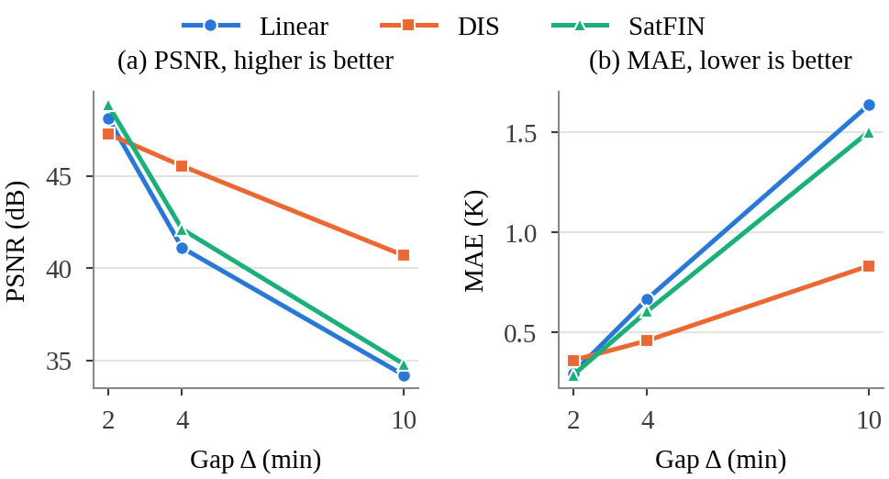
Fig. 3. Accuracy versus temporal gap on the held-out test set. (a) PSNR; (b) MAE in kelvin. SatFIN is best at 2 min and improves on linear blending at every gap, but DIS optical flow is best at 4 and 10 min.

B. SatFIN Versus Linear Blending
SatFIN outperforms linear blending on all three metrics at every gap: by 0.72, 1.00, and 0.60 dB in PSNR at 2, 4, and 10 min, respectively, with MAE reductions of 3.4%, 9.1%, and 8.2% (from 1.638 K to 1.503 K at 10 min). This confirms that the network has learned motion information that simple temporal fading cannot represent. At 2 min, SatFIN is the most accurate method overall (48.83 dB, SSIM 0.9978, MAE 0.287 K), ahead of both linear blending and DIS.

C. SatFIN Versus Classical Optical Flow
At 4 and 10 min, DIS optical flow is clearly the most accurate method, and its advantage over SatFIN grows with the gap: 3.42 dB at 4 min and 5.87 dB at 10 min, where DIS reaches an MAE of 0.833 K compared with 1.503 K for SatFIN. SatFIN's error curve closely follows that of linear blending (Fig. 3), which suggests that the current checkpoint predicts motion that is too small, so its output stays close to a blend of the two inputs. This behavior is consistent with the very short CPU training run: the model has not yet learned to estimate the larger displacements that occur over 4–10 minutes. Interestingly, DIS is slightly worse than linear blending at 2 min (47.26 vs. 48.11 dB). At such short gaps, the true motion is tiny, and small errors in the explicitly estimated flow outweigh its benefit.
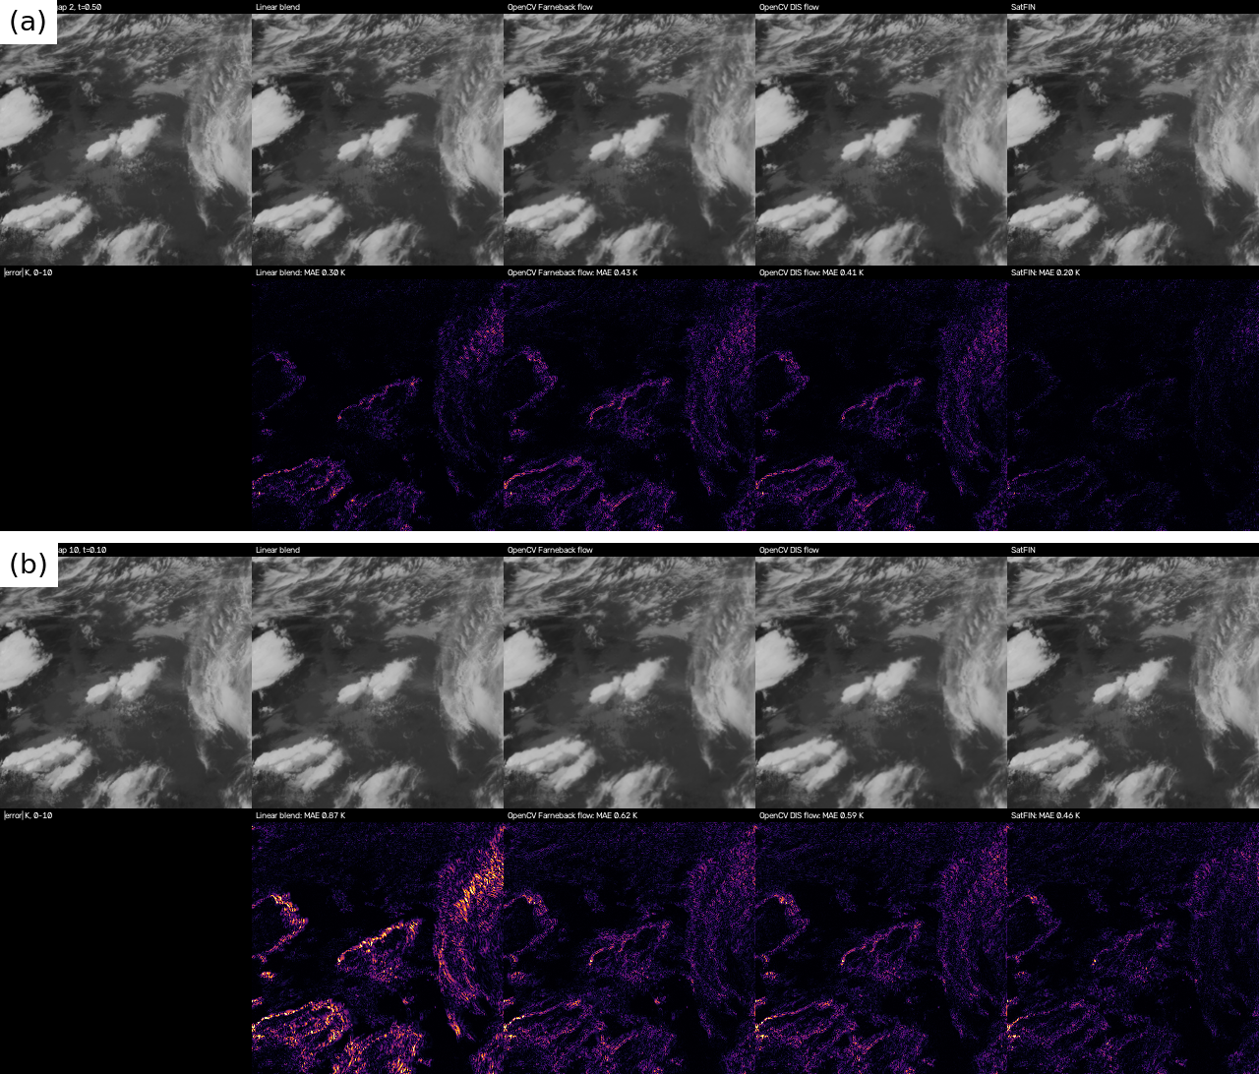
Fig. 4. Qualitative comparison on the GOES-19 test data at (a) a 2-min gap and (b) a 10-min gap: ground truth and each method (top row of each panel), absolute error in kelvin, 0–10 K (bottom row), with the per-frame MAE of each method.

D. Runtime
On the CPU, SatFIN needs 26–27 ms per interpolated frame, compared with about 4 ms for DIS and negligible time for linear blending. Runtime is essentially independent of the gap. Even on a CPU, this is far below the interval between consecutive satellite images, so SatFIN is fast enough for near-real-time use; GPU inference and tiled processing (Section VII) are needed for full-disk scenes.

E. Discussion and Next Steps
These results support the feasibility of the pipeline but do not yet show an advantage of learned interpolation over classical optical flow at operationally relevant gaps. The priorities are therefore: (i) full GPU training with many more iterations and larger crops, so that the network can learn large displacements; (ii) optionally initializing SatFIN from pretrained RIFE weights or using DIS flow as an additional input; (iii) evaluation at 20–30-minute gaps, where non-linear cloud evolution should favor a learned model; and (iv) an ablation of the convective-weighted loss together with MAE over convective pixels (T_{B} < 235 K). Qualitative panels with absolute-error maps in kelvin should accompany these experiments to show where each method fails, such as blurring of rapidly growing cores or ghosting at anvil edges.
Cross-sensor generalization should be assessed by applying the GOES-trained model to Himawari-9 10-minute data, holding out alternate frames (20 → 10 minutes) so that ground truth remains available, before deployment to INSAT-3DS, where true intermediate frames do not exist.
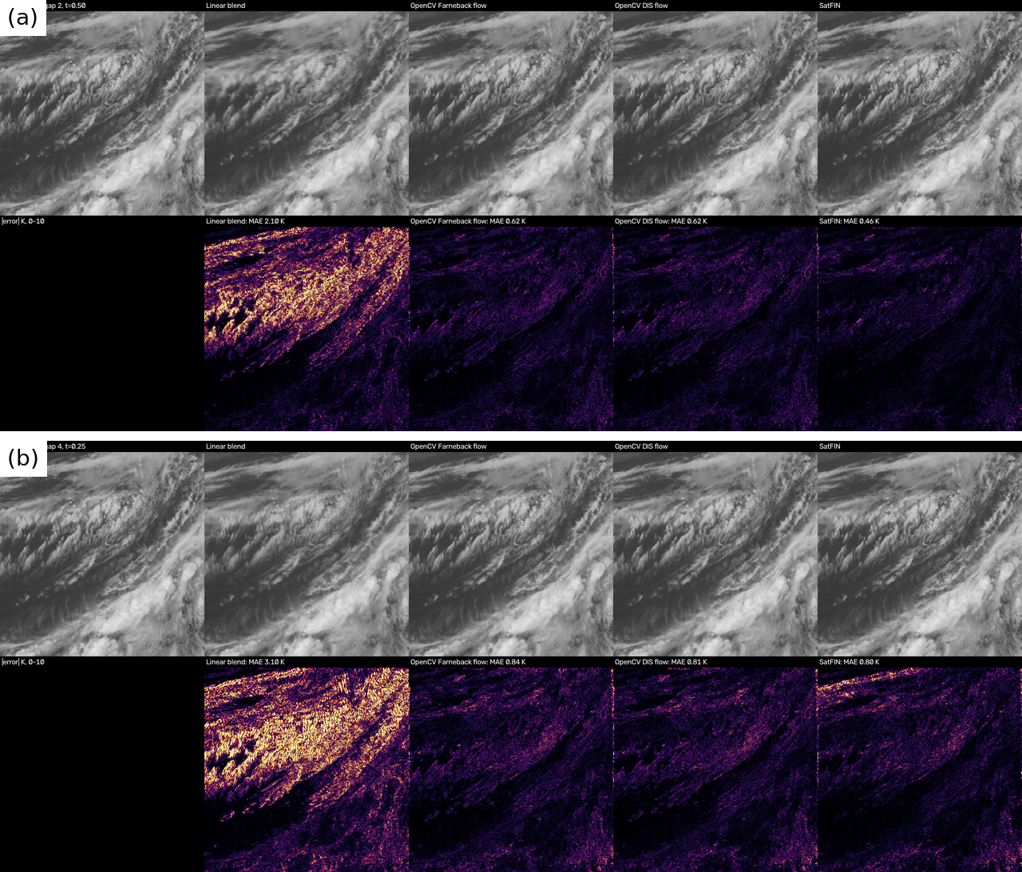
Fig. 5. Cross-sensor example on the Himawari-9 Target sector with gaps of (a) 2 scans and (b) 4 scans: ground truth and each method (top row of each panel), absolute error in kelvin, 0–10 K (bottom row).

VII. Deployment on INSAT-3DS

A. Cross-Sensor Inference
INSAT-3DS imager HDF5 files are read by a dedicated loader, converted to BT with the calibration tables provided in the product, and normalized with the same fixed bounds as in training. Because SatFIN accepts arbitrary t, a 30-minute sequence can be densified in a single pass to any target cadence, or hierarchically (30 → 15 → 7.5 minutes) by inserting midpoints recursively. The single-pass mode avoids accumulating errors from predicted frames.
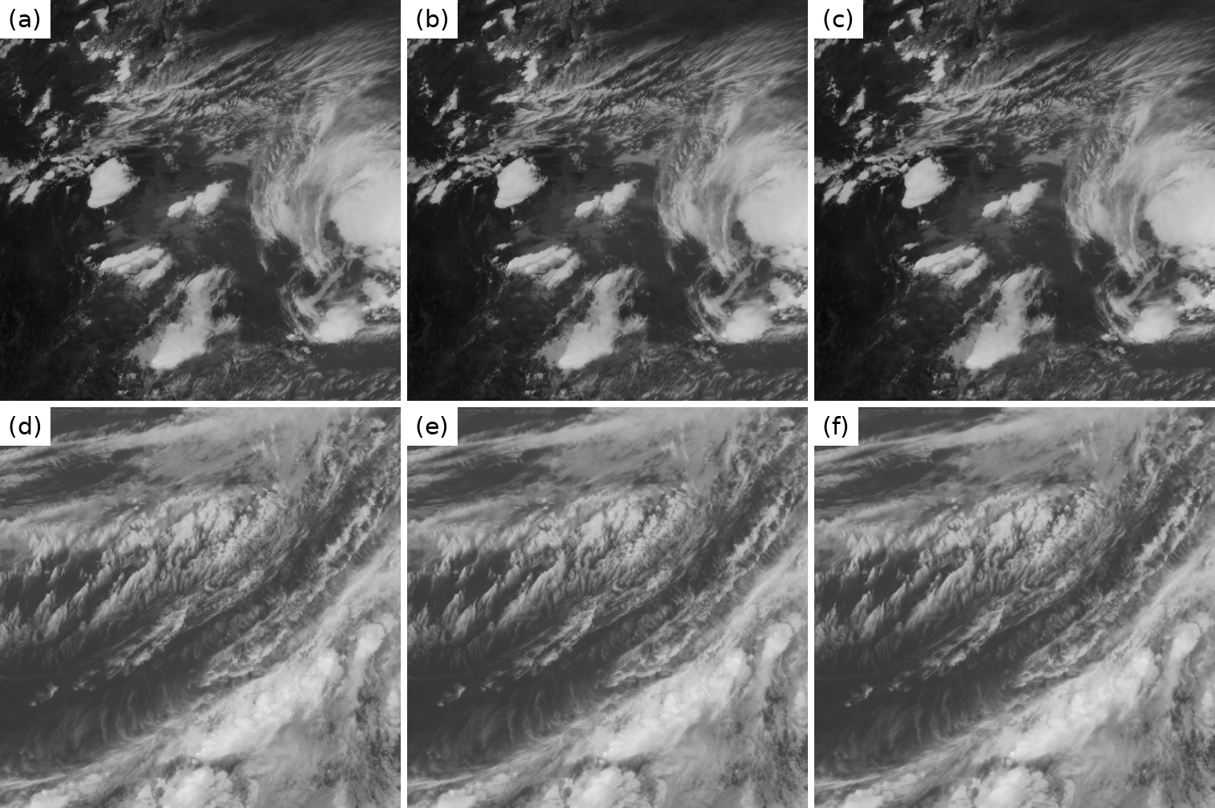
Fig. 6. Consecutive frames of densified sequences produced by SatFIN: (a)–(c) GOES-19 mesoscale sector; (d)–(f) Himawari-9 Target sector.

B. Tiled Full-Disk Inference
Full-disk scenes exceed GPU memory, so inference runs on overlapping tiles. The outputs of the tiles are merged with a smooth window ω_{k} (e.g., a Hann window) to avoid seams:
Î(p) = Σ_{k} ω_{k}(p) Î_{k}(p) / Σ_{k} ω_{k}(p) (13)
Flows near space-view pixels and the limb are masked, and outputs are written as NetCDF/GeoTIFF files that preserve the original geolocation metadata and the synthesized timestamps. Every generated frame is flagged as synthetic in its metadata so that it cannot be mistaken for an observation.
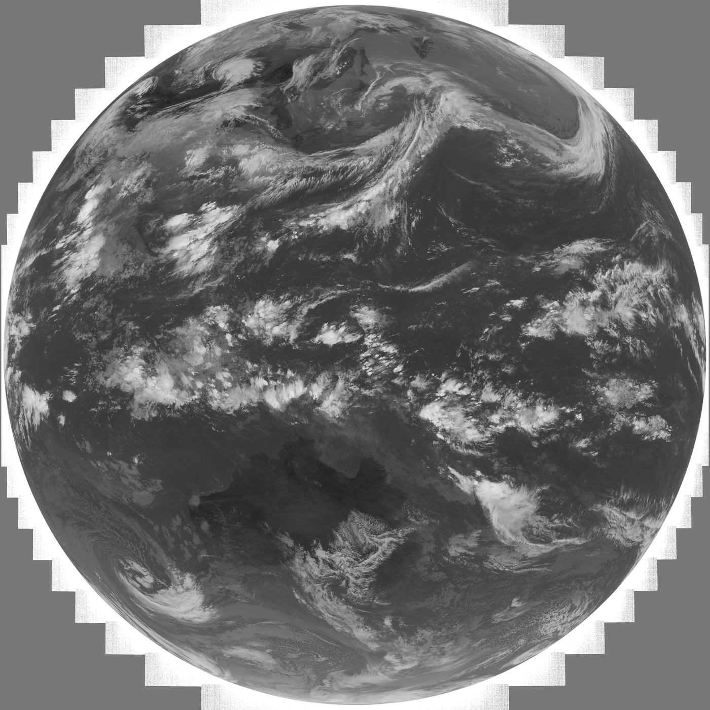
Fig. 7. Himawari-9 full-disk frame (5500 × 5500 pixels) produced with tiled inference.

C. Interactive Dashboard
A Streamlit dashboard lets forecasters load a sequence, choose the interpolation factor, play original and interpolated animations side by side, inspect individual frames with a slider, view difference maps, and download the results as NetCDF, GIF, or MP4.
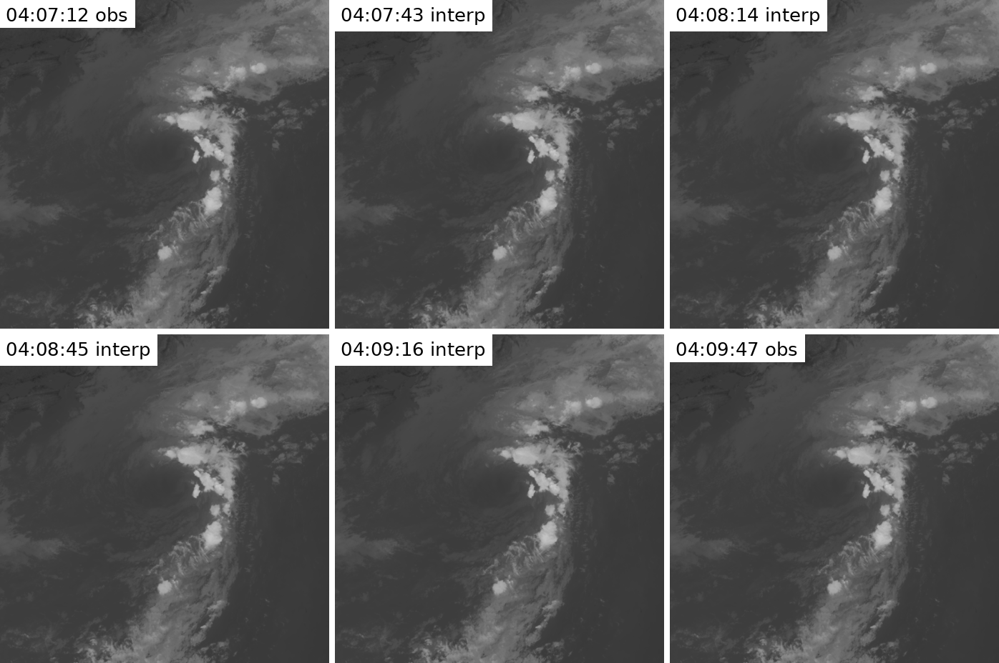
Fig. 8. Near-real-time Himawari-9 Target-sector output: two observed scans 2.5 min apart (04:07:12 and 04:09:47 UTC) and the four frames interpolated between them at ~30-s spacing.

VIII. Limitations and Future Work
Interpolated frames are estimates, not observations. The model can only reproduce evolution that is implicit in the two bounding frames. A storm that initiates and decays entirely within a 30-minute gap cannot be recovered, and claims about earlier warning times must be verified with event-based studies before operational use. The domain gap between 1-minute GOES mesoscale training data and 4-km, 30-minute INSAT-3DS data (different spectral response, resolution, viewing geometry, and larger gaps than seen in training) may reduce accuracy, so fine-tuning on Himawari data or on INSAT-3DS rapid-scan data, where available, is advisable. Future work includes physics-informed constraints on the predicted motion, joint spatio-temporal super-resolution with polar-orbiting data, uncertainty estimates for each synthesized pixel, and verification of downstream products such as convective-initiation detection and nowcasts.

IX. Conclusion
This paper presented SatFIN, a deep optical-flow frame-interpolation framework for increasing the temporal resolution of geostationary satellite imagery without additional orbital hardware. By training on real 1-minute GOES mesoscale observations with simulated temporal sparsity, using a convection-focused loss, and evaluating with physically meaningful metrics against classical baselines, SatFIN provides a reproducible path from public data to denser INSAT-3DS image sequences for monitoring rapidly evolving weather. In an early CPU-trained evaluation, SatFIN improved on linear blending at every gap and was the best method at 2 min, while classical DIS optical flow remained stronger at 4 and 10 min. Full GPU training and evaluation at longer gaps are the next steps toward a learned model that outperforms classical optical flow.

Acknowledgment
The authors thank NOAA for open access to GOES-R and Himawari data through the NOAA Open Data Dissemination program, and ISRO/SAC for INSAT-3DS data provided through MOSDAC.

References
[1] T. J. Schmit, P. Griffith, M. M. Gunshor, J. M. Daniels, S. J. Goodman, and W. J. Lebair, “A closer look at the ABI on the GOES-R series,” Bull. Amer. Meteor. Soc., vol. 98, no. 4, pp. 681–698, 2017.
[2] K. Bessho et al., “An introduction to Himawari-8/9—Japan's new-generation geostationary meteorological satellites,” J. Meteor. Soc. Japan, vol. 94, no. 2, pp. 151–183, 2016.
[3] Meteorological and Oceanographic Satellite Data Archival Centre (MOSDAC), Space Applications Centre, ISRO. [Online]. Available: https://www.mosdac.gov.in
[4] K. M. Roberts and S. A. Rutledge, “Nowcasting storm initiation and growth using GOES-8 and -9 data,” Weather Forecast., vol. 18, no. 4, pp. 562–584, 2003.
[5] J. R. Mecikalski and K. M. Bedka, “Forecasting convective initiation by monitoring the evolution of moving cumulus in daytime GOES imagery,” Mon. Weather Rev., vol. 134, no. 1, pp. 49–78, 2006.
[6] H. Jiang, D. Sun, V. Jampani, M.-H. Yang, E. Learned-Miller, and J. Kautz, “Super SloMo: High quality estimation of multiple intermediate frames for video interpolation,” in Proc. IEEE/CVF CVPR, 2018, pp. 9000–9008.
[7] Z. Huang, T. Zhang, W. Heng, B. Shi, and S. Zhou, “Real-time intermediate flow estimation for video frame interpolation,” in Proc. ECCV, 2022, pp. 624–642.
[8] G. Farnebäck, “Two-frame motion estimation based on polynomial expansion,” in Proc. Scandinavian Conf. Image Anal. (SCIA), 2003, pp. 363–370.
[9] T. Kroeger, R. Timofte, D. Dai, and L. Van Gool, “Fast optical flow using dense inverse search,” in Proc. ECCV, 2016, pp. 471–488.
[10] D. Sun, X. Yang, M.-Y. Liu, and J. Kautz, “PWC-Net: CNNs for optical flow using pyramid, warping, and cost volume,” in Proc. IEEE/CVF CVPR, 2018, pp. 8934–8943.
[11] Z. Teed and J. Deng, “RAFT: Recurrent all-pairs field transforms for optical flow,” in Proc. ECCV, 2020, pp. 402–419.
[12] T. J. Vandal and R. R. Nemani, “Temporal interpolation of geostationary satellite imagery with optical flow,” IEEE Trans. Neural Netw. Learn. Syst., 2021.
[13] NOAA/NASA, “GOES-R Series Product Definition and Users' Guide (PUG), Volume 3: Level 1b Products,” GOES-R Program Office.
[14] M. Jaderberg, K. Simonyan, A. Zisserman, and K. Kavukcuoglu, “Spatial transformer networks,” in Proc. NeurIPS, 2015, pp. 2017–2025.
[15] O. Ronneberger, P. Fischer, and T. Brox, “U-Net: Convolutional networks for biomedical image segmentation,” in Proc. MICCAI, 2015, pp. 234–241.
[16] P. Charbonnier, L. Blanc-Féraud, G. Aubert, and M. Barlaud, “Two deterministic half-quadratic regularization algorithms for computed imaging,” in Proc. IEEE ICIP, 1994, pp. 168–172.
[17] A. Paszke et al., “PyTorch: An imperative style, high-performance deep learning library,” in Proc. NeurIPS, 2019, pp. 8024–8035.
[18] I. Loshchilov and F. Hutter, “Decoupled weight decay regularization,” in Proc. ICLR, 2019.
[19] Z. Wang, A. C. Bovik, H. R. Sheikh, and E. P. Simoncelli, “Image quality assessment: From error visibility to structural similarity,” IEEE Trans. Image Process., vol. 13, no. 4, pp. 600–612, 2004.

