JOVAC PROJECT REPORT
PROJECT 13
Configure IP Addresses and Static Routes Using PNETLab

NETWORKING PROJECT
Configure IP Addresses and Static Routes Using PNETLab
Project Code | Project 13
Domain | Networking / Network Configuration
Platform | PNETLab
Lab Environment | PNETLab with Router Nodes
Academic Year | 2026–27

Table of Contents
1. Introduction 3
2. Problem Statement 3
3. Aim of the Project 3
4. Objectives 3
5. Project Description 4
6. Network Topology 4
7. IP Addressing Table 4
8. Tools and Concepts Used 5
9. PNETLab Topology Setup 5
10. R1 Configuration 6
11. R2 Configuration 6
12. Static Routing on R2 7
13. Verification of Configuration 7
13.1 Interface and Link Status 7
13.2 show ip route 8
14. Connectivity Testing 8
15. Packet Flow 9
16. Troubleshooting 9
17. Results and Observations 10
18. Learning Outcomes 10
19. Future Scope 10
20. Conclusion 10

1. Introduction
This project is about setting up basic IP addressing and static routing between two routers, R1 and R2, using PNETLab. PNETLab is used to build a small virtual network where the routers can be configured through their console, just like real hardware.
In this lab, R1 and R2 are connected to each other through their e0/0 interfaces over the 192.168.12.0/24 network. R1 acts as the router that owns several extra networks, which are represented using four loopback interfaces: 10.1.1.1/24, 10.2.2.2/24, 10.3.3.3/24 and 10.4.4.4/24. R2, on the other hand, is only aware of the network it is directly connected to.
IP addressing has to be configured first because a router cannot communicate with anything until its interfaces have valid IP addresses. Once R1 and R2 can reach each other over 192.168.12.0/24, the next step is to make sure R2 can also reach the loopback networks that exist behind R1. Since R2 is not directly connected to 10.1.1.0/24 or 10.3.3.0/24, it has no automatic way of knowing that these networks exist. This is exactly why static routing is required — a static route is manually added on R2 so that it knows to send traffic for these two networks towards R1.
The 192.168.12.0/24 network is important because it acts as the only link between R1 and R2; all traffic between the two routers, including traffic destined for the remote loopback networks, passes through it. The loopback interfaces on R1 are simple, always-up virtual interfaces, and in this project they are used to represent separate networks so that routing between them and R2 can be practiced without needing extra physical or virtual devices.
Overall, the project is implemented completely inside PNETLab, and it gives a hands-on understanding of IPv4 addressing, loopback interfaces, directly connected networks, remote networks and static routing.

2. Problem Statement
By default, a router only knows about the networks that are directly connected to its own interfaces. In this topology, R2's only interface (e0/0) is connected to the 192.168.12.0/24 network, so R2 has no direct knowledge of the 10.1.1.0/24 and 10.3.3.0/24 networks that exist on R1 as loopback interfaces. If nothing extra is configured, R2 will not be able to send traffic to these networks, and any ping or connection attempt to them will fail. This project solves that problem by manually configuring static routes on R2, telling it exactly how to reach these remote networks through R1.

3. Aim of the Project
The aim of this project is to configure IP addresses on R1 and R2 according to the given network diagram using PNETLab, and to make sure R2 is able to reach the remote networks connected to R1 by using static routing. This includes configuring the four loopback interfaces on R1 and establishing communication between R1 and R2 through the 192.168.12.0/24 network.

4. Objectives
- Create a basic router topology in PNETLab.
- Configure IPv4 addresses on router interfaces.
- Configure four loopback interfaces on R1.
- Connect R1 and R2 using the 192.168.12.0/24 network.
- Configure static routes on R2.
- Verify the routing table and interface status.
- Test connectivity between R2 and the remote loopback networks.

5. Project Description
In this project, two routers, R1 and R2, are configured in PNETLab. R1 and R2 are connected through their e0/0 interfaces using the 192.168.12.0/24 network. R1 uses 192.168.12.1/24 and R2 uses 192.168.12.2/24.
Four loopback interfaces are created on R1 to represent different networks. The loopbacks use 10.1.1.1/24, 10.2.2.2/24, 10.3.3.3/24 and 10.4.4.4/24. R2 is not directly connected to these networks, so static routes are added for 10.1.1.0/24 and 10.3.3.0/24. Both routes use 192.168.12.1 as the next hop.
The final configuration is verified through routing and connectivity commands. Successful tests confirm that R2 can use R1 to reach the required remote networks.

6. Network Topology
The topology used in the project contains two routers. R1 is connected directly to R2 through the e0/0 interface. The link between the routers belongs to the 192.168.12.0/24 network. R1 also has four loopback networks configured on it, representing separate remote networks that R2 must learn to reach.
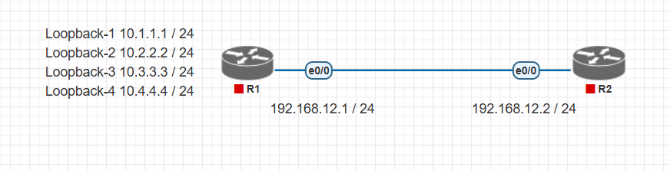
Figure 1: Project 13 network topology as provided for the exercise.
The diagram shows R1 on the left and R2 on the right. R1 has four loopback networks, while the link between R1 and R2 uses 192.168.12.1/24 on R1 and 192.168.12.2/24 on R2.

7. IP Addressing Table
Device | Interface | IP Address | Subnet Mask
R1 | e0/0 | 192.168.12.1 | 255.255.255.0
R1 | Loopback1 | 10.1.1.1 | 255.255.255.0
R1 | Loopback2 | 10.2.2.2 | 255.255.255.0
R1 | Loopback3 | 10.3.3.3 | 255.255.255.0
R1 | Loopback4 | 10.4.4.4 | 255.255.255.0
R2 | e0/0 | 192.168.12.2 | 255.255.255.0

8. Tools and Concepts Used
PNETLab:
PNETLab is used to create the virtual topology and configure the routers through their console.
IPv4 Addressing:
IPv4 addresses identify router interfaces and networks. The project mainly uses /24 networks.
Loopback Interface:
A loopback is a logical router interface. In this project it is used to represent separate networks on R1.
Static Routing:
A static route is manually entered into the routing table. R2 uses R1 as the next hop for the two required remote networks.

9. PNETLab Topology Setup
PNETLab is opened and a new project is created. Two router nodes are added and named R1 and R2. The routers are connected using their e0/0 interfaces and then started. The console of each router is opened for configuration.
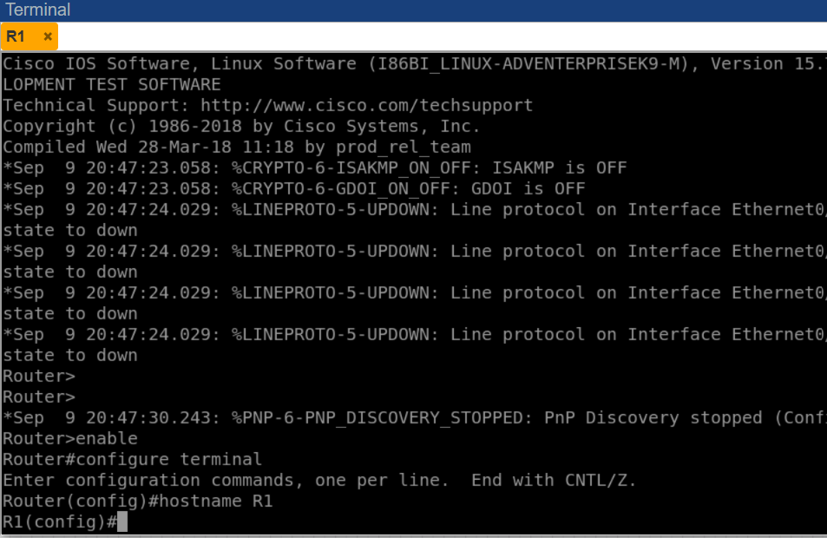
Figure 2: R1 and R2 topology created in PNETLab, with the R1 console open after the hostname is set.

10. R1 Configuration
R1 is configured first. The hostname is set to R1, the e0/0 interface is assigned 192.168.12.1/24, and the interface is enabled. Four loopback interfaces are then configured.
R1 main interface:
configure terminal
hostname R1
interface e0/0
ip address 192.168.12.1 255.255.255.0
no shutdown
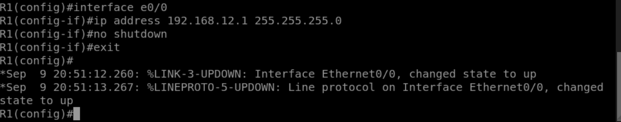
Figure 3: R1 e0/0 interface configuration and interface coming up.
Loopback configuration:
interface loopback1
ip address 10.1.1.1 255.255.255.0
interface loopback2
ip address 10.2.2.2 255.255.255.0
interface loopback3
ip address 10.3.3.3 255.255.255.0
interface loopback4
ip address 10.4.4.4 255.255.255.0
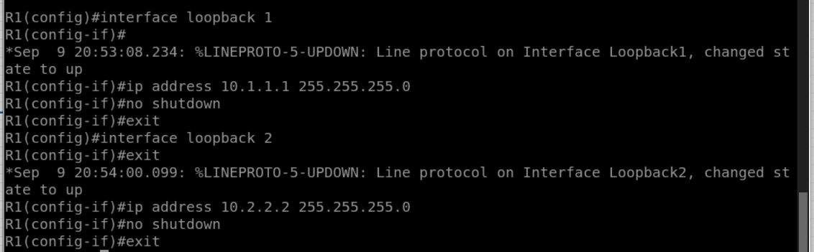
Figure 4: R1 loopback interfaces being configured on the console.

11. R2 Configuration
After completing R1, the R2 console is opened. The hostname is set to R2 and its e0/0 interface is configured with 192.168.12.2/24. The interface is enabled using the no shutdown command.
configure terminal
hostname R2
interface e0/0
ip address 192.168.12.2 255.255.255.0
no shutdown
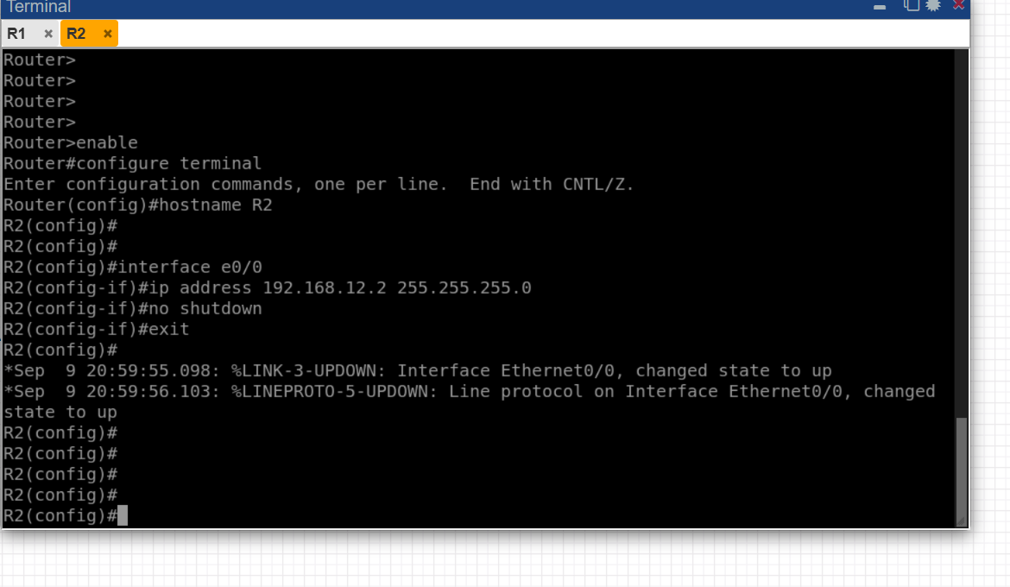
Figure 5: R2 e0/0 interface configuration, with the Ethernet0/0 link changing state to up.

12. Static Routing on R2
R2 is directly connected to 192.168.12.0/24, but the 10.1.1.0/24 and 10.3.3.0/24 networks are represented by loopback interfaces on R1. Therefore, R2 needs static routes to reach them.
The following static routes are configured on R2:
ip route 10.1.1.0 255.255.255.0 192.168.12.1
ip route 10.3.3.0 255.255.255.0 192.168.12.1
In these commands, 10.1.1.0 and 10.3.3.0 are the destination networks, 255.255.255.0 is the subnet mask, and 192.168.12.1 is the next-hop address. R2 sends traffic for these networks to R1.
Figure 6: Static route configuration entered on R2.

13. Verification of Configuration
After configuration, the interfaces and routing table are checked to make sure the addresses and routes have been entered correctly.

13.1 Interface and Link Status
As each interface is brought up with the no shutdown command, PNETLab logs a link-state message on the console confirming that the interface is active. This can be seen for R1's e0/0 interface in Figure 3 and for R2's e0/0 interface in Figure 5, where the %LINK-3-UPDOWN and %LINEPROTO-5-UPDOWN messages confirm that both interfaces changed state to up.

13.2 show ip route
The routing table on R2 is checked using:
show ip route
The R2 routing table contains the static routes for 10.1.1.0/24 and 10.3.3.0/24 through 192.168.12.1, both marked with the letter S. It also shows 192.168.12.0/24 as a directly connected network on e0/0.
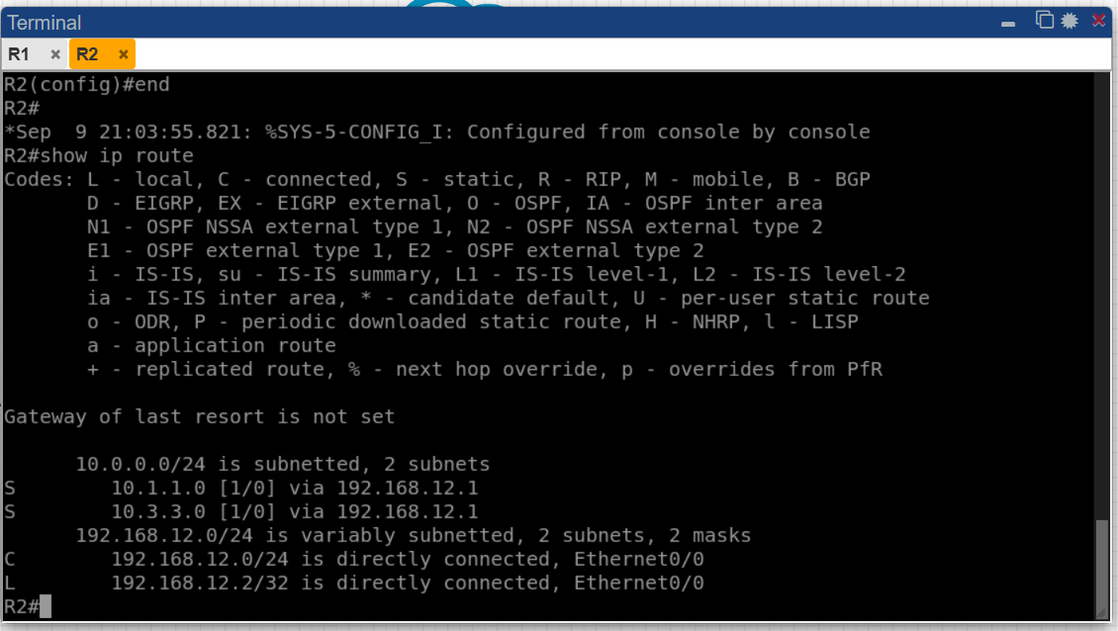
Figure 7: R2 routing table showing the configured static routes.

14. Connectivity Testing
Ping is used to check whether the configured networks are reachable from R2.
First test:
ping 192.168.12.1
This checks connectivity between R2 and R1.
Second test:
ping 10.1.1.1
This checks whether R2 can reach R1's Loopback1 through the configured static route.
Third test:
ping 10.3.3.3
This checks whether R2 can reach R1's Loopback3 through the second static route.
All three pings returned a 100 percent success rate, confirming that the static routes are working correctly.
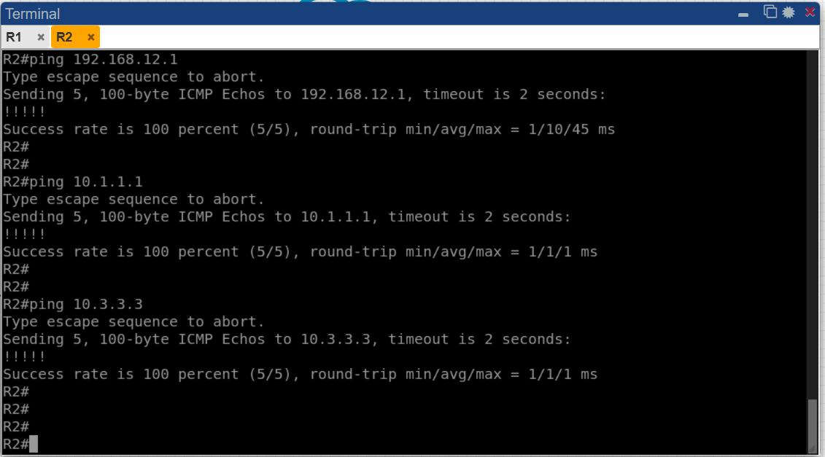
Figure 8: Successful ping results from R2 to 192.168.12.1, 10.1.1.1 and 10.3.3.3.

15. Packet Flow
The packet flow can be understood by taking the example of R2 trying to reach 10.1.1.1. When R2 receives a packet for 10.1.1.1, it checks its routing table. It finds the static route for 10.1.1.0/24 and sees that the next hop is 192.168.12.1.
- R2 receives a packet destined for 10.1.1.1.
- R2 checks its routing table.
- The static route for 10.1.1.0/24 points to 192.168.12.1.
- R2 forwards the packet to R1.
- R1 receives the packet through its 192.168.12.1 interface.
- R1 knows the 10.1.1.0/24 network through Loopback1 and forwards the packet accordingly.
The same basic process is followed when R2 sends traffic towards 10.3.3.3, except that R1 uses Loopback3 for the 10.3.3.0/24 network.

16. Troubleshooting
If connectivity does not work, the first step is to check the interface status and IP addresses using show ip interface brief. Both R1 and R2 must have the correct addresses on e0/0 and the interfaces should be active.
The R1-R2 link can be tested using ping 192.168.12.1 from R2. If this fails, the interface addresses, interface status and PNETLab connection should be checked.
If R2 cannot reach 10.1.1.1 or 10.3.3.3, the routing table should be checked with show ip route. The static routes must point to 192.168.12.1.
The important route commands are:
ip route 10.1.1.0 255.255.255.0 192.168.12.1
ip route 10.3.3.0 255.255.255.0 192.168.12.1

17. Results and Observations
The topology was configured successfully in PNETLab. R1 and R2 were connected through the 192.168.12.0/24 network. R1 was configured with four loopback interfaces and R2 was configured with 192.168.12.2/24 on e0/0.
Static routes were added to R2 for 10.1.1.0/24 and 10.3.3.0/24, both using 192.168.12.1 as the next-hop address. The routing table and interface configuration were checked, and connectivity was tested using ping.
The successful verification shows that R2 can use R1 as the next hop to reach the required remote networks.

18. Learning Outcomes
- Creating a simple router topology in PNETLab.
- Configuring IPv4 addresses through the router CLI.
- Configuring and using loopback interfaces.
- Understanding directly connected and remote networks.
- Configuring static routes with a next-hop address.
- Checking interface status and routing tables.
- Testing network connectivity using ping.
- Performing basic troubleshooting when a route or interface is not working.

19. Future Scope
The current topology is small and uses static routing, which makes it easy to understand how routes are manually added. It can be extended by adding more routers, switches and end devices.
Dynamic routing protocols can also be practiced on a similar topology to compare manually configured routes with routes learned automatically. More networks can be added to study routing decisions in larger topologies. PNETLab can further be used to practice VLANs, inter-VLAN routing, access control, network security and other networking concepts.

20. Conclusion
This project provided practical experience with IP address configuration and static routing using PNETLab. A two-router topology consisting of R1 and R2 was created according to the given diagram.
R1 was configured with the 192.168.12.1/24 address on e0/0 and four loopback interfaces: 10.1.1.1/24, 10.2.2.2/24, 10.3.3.3/24 and 10.4.4.4/24. R2 was configured with 192.168.12.2/24 on e0/0.
Static routes were then configured on R2 for the 10.1.1.0/24 and 10.3.3.0/24 networks using 192.168.12.1 as the next-hop address. The configuration was verified using interface and routing-table commands and tested through ping.
Overall, the project helped in understanding how routers communicate with remote networks and how static routing can be used to manually control the path followed by network traffic.

