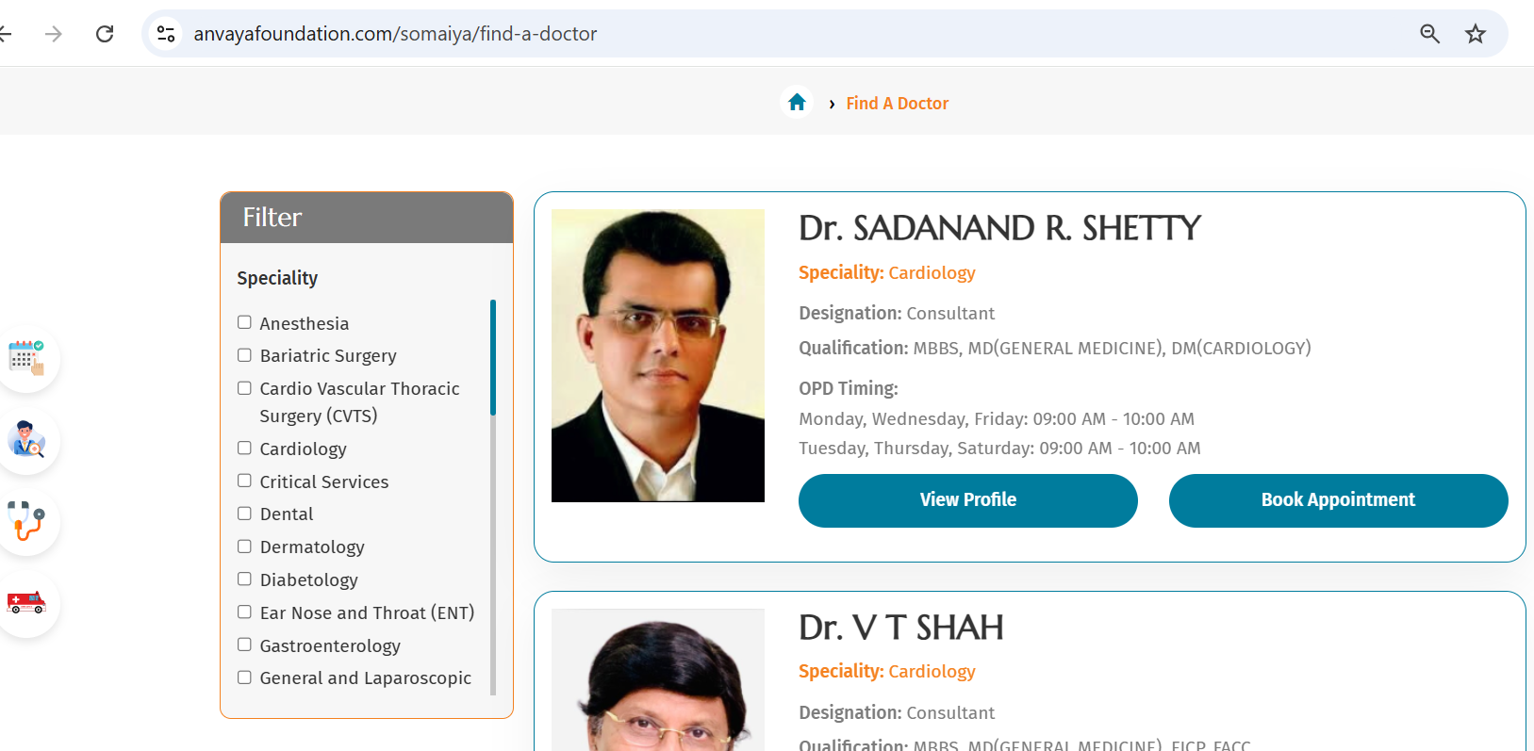

- Remove anaesthesia from filter All the filters are coming dynamically as per the specialities added.

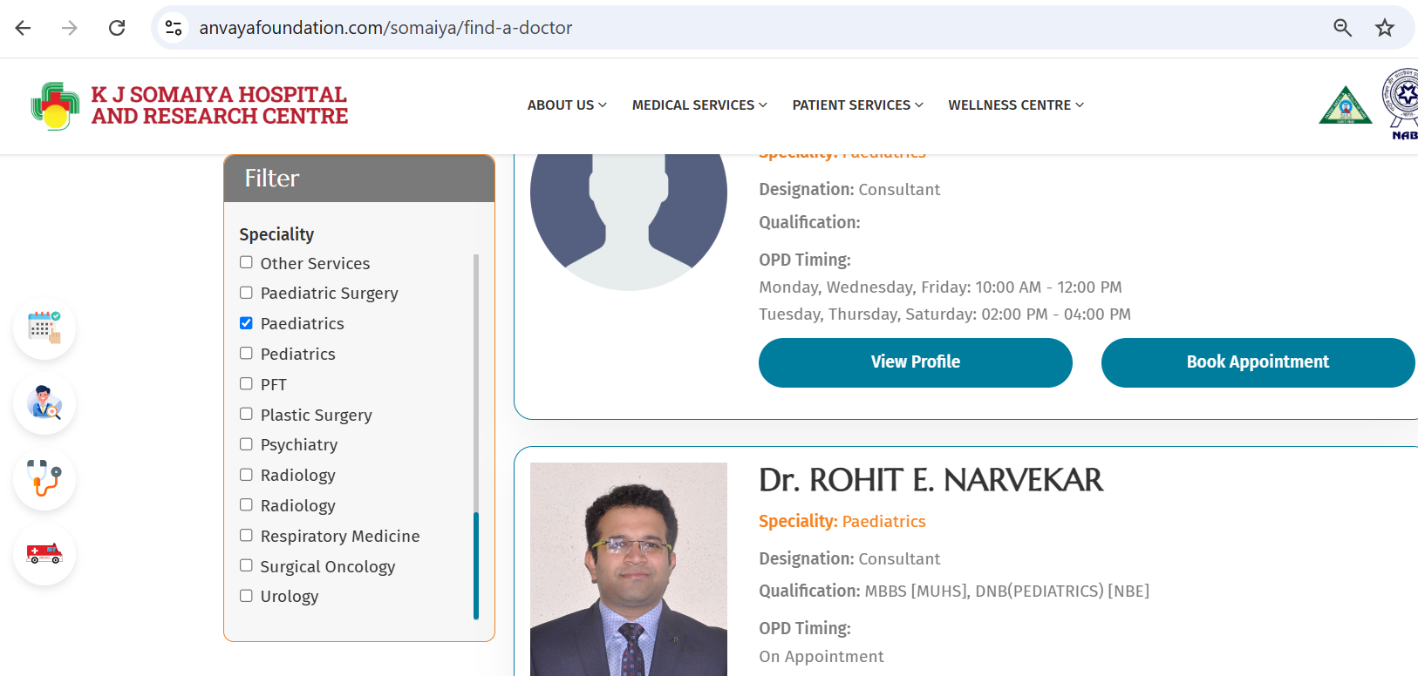

Remove Single Gynaecology and keep Obstetrics and Gynaecology
Remove Second paediatrics and both Radiology, anaesthesia, Non Invasive, Laboratory, Neuro Diagnostics, other services. All the filters are coming dynamically as per the specialities added.
Take Minu Ramakrishna Photo from About us she is the same. DONE

Add Dr. Mayur Mewada in Diabatology DONE

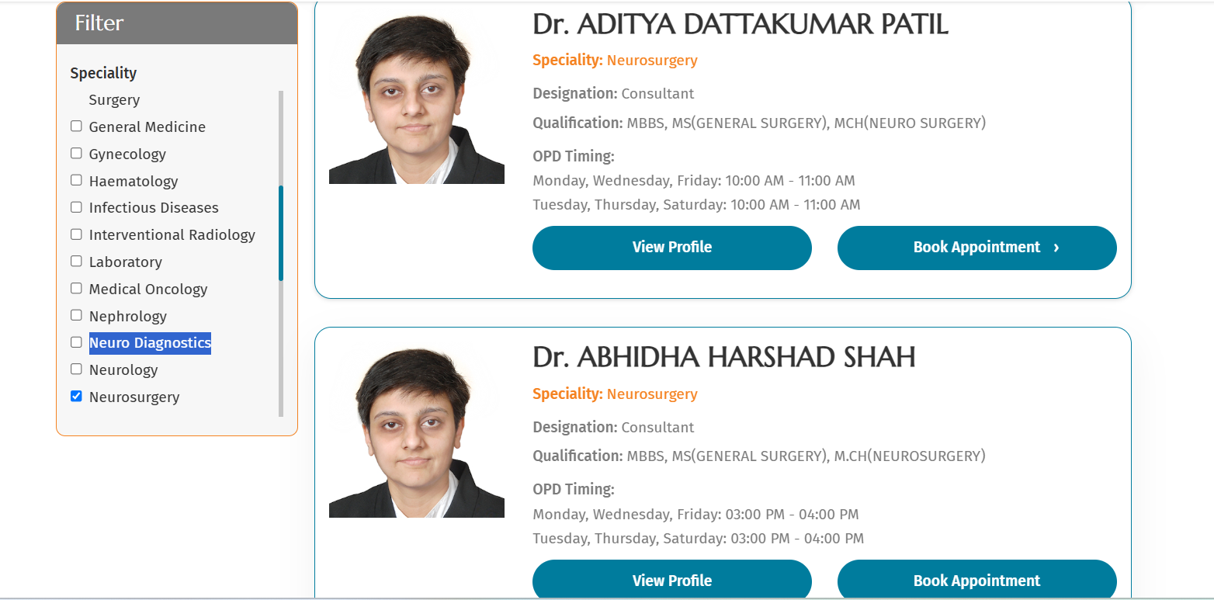
She is Dr.Abhida Shah, orderwise Abhida will come first and then Dr. Aditya will come. DONE

Keep as Filter instead of Filter Panel : DONE
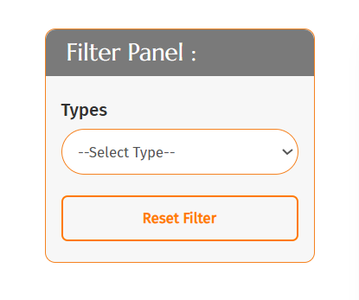

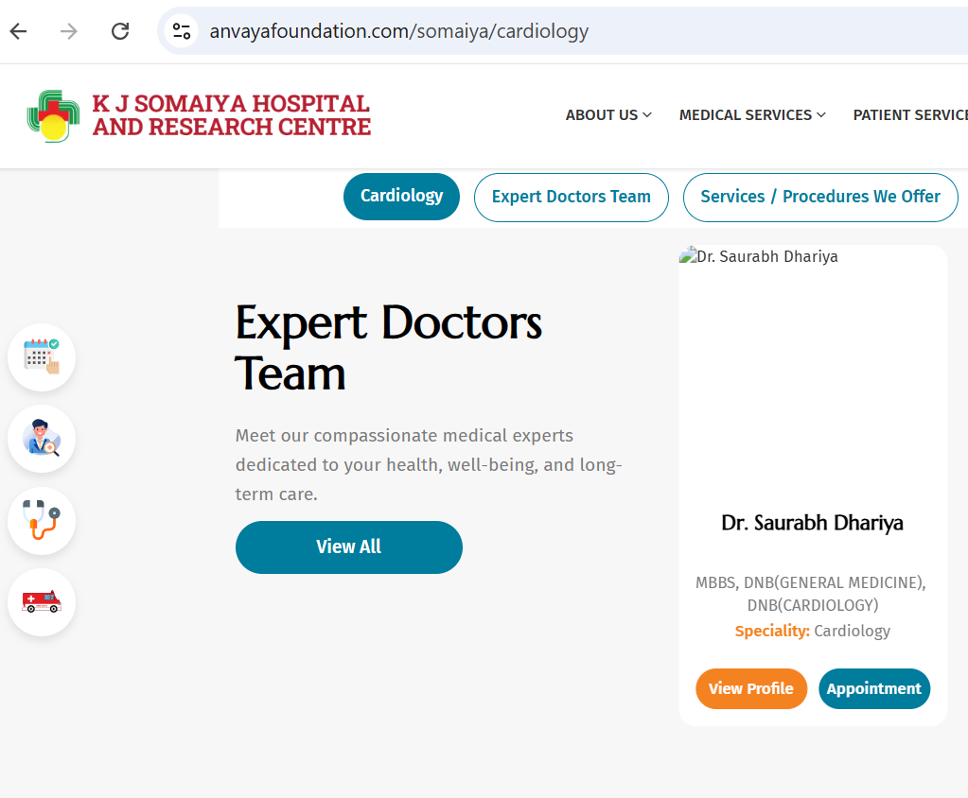Empty photo image not reflecting. Because the Dr image was not uploaded. Have now set a default image for this scenario

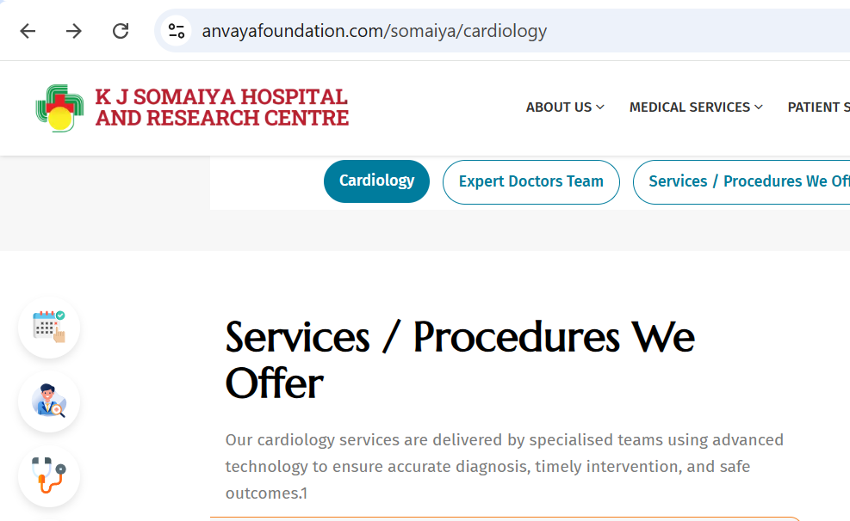
Remove 1 at end of the para. DONE
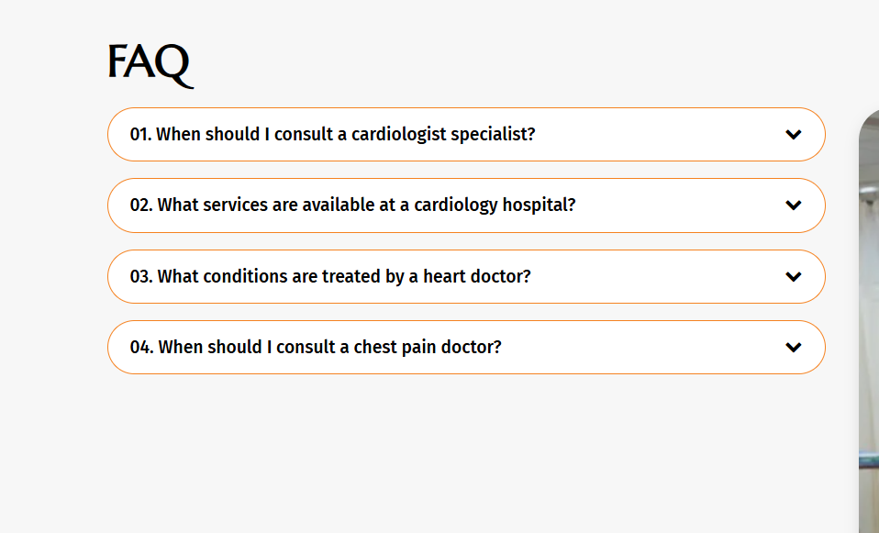
It should be only Cardiologist instead of Cardiologist specialist. DONE
Call now is not working: Let us know which no. To add over there

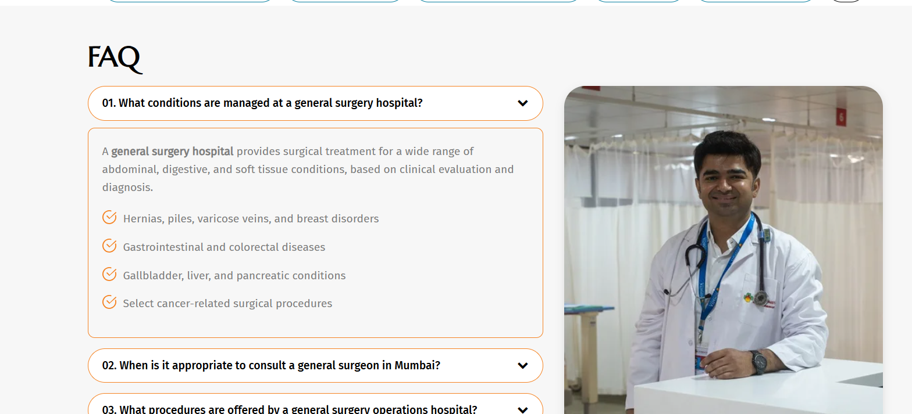

All Speciality is having same photo, please change. DONE
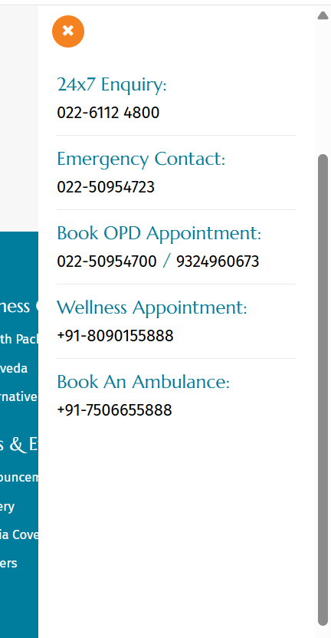
Change OPD Number as 9324960613 DONE
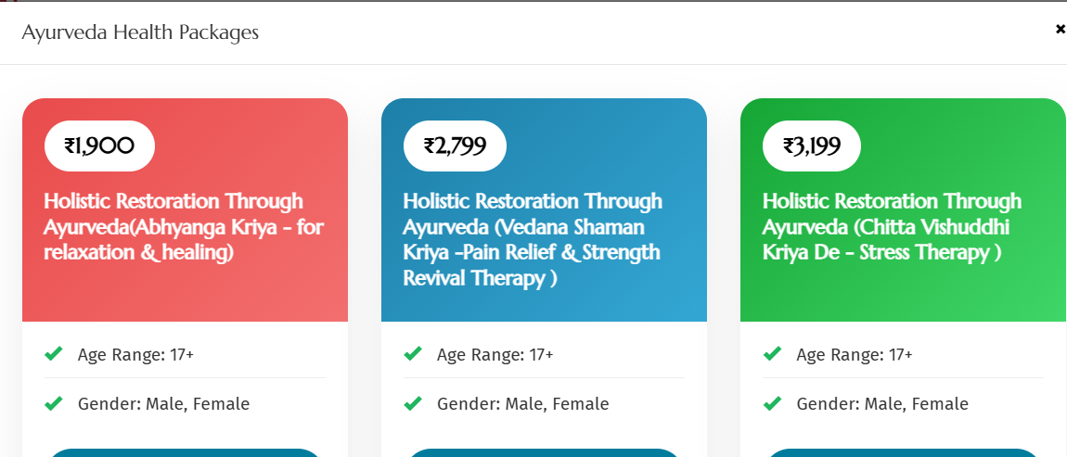
Please look at the font, it should be same like healthcheckup It’s alrdy same
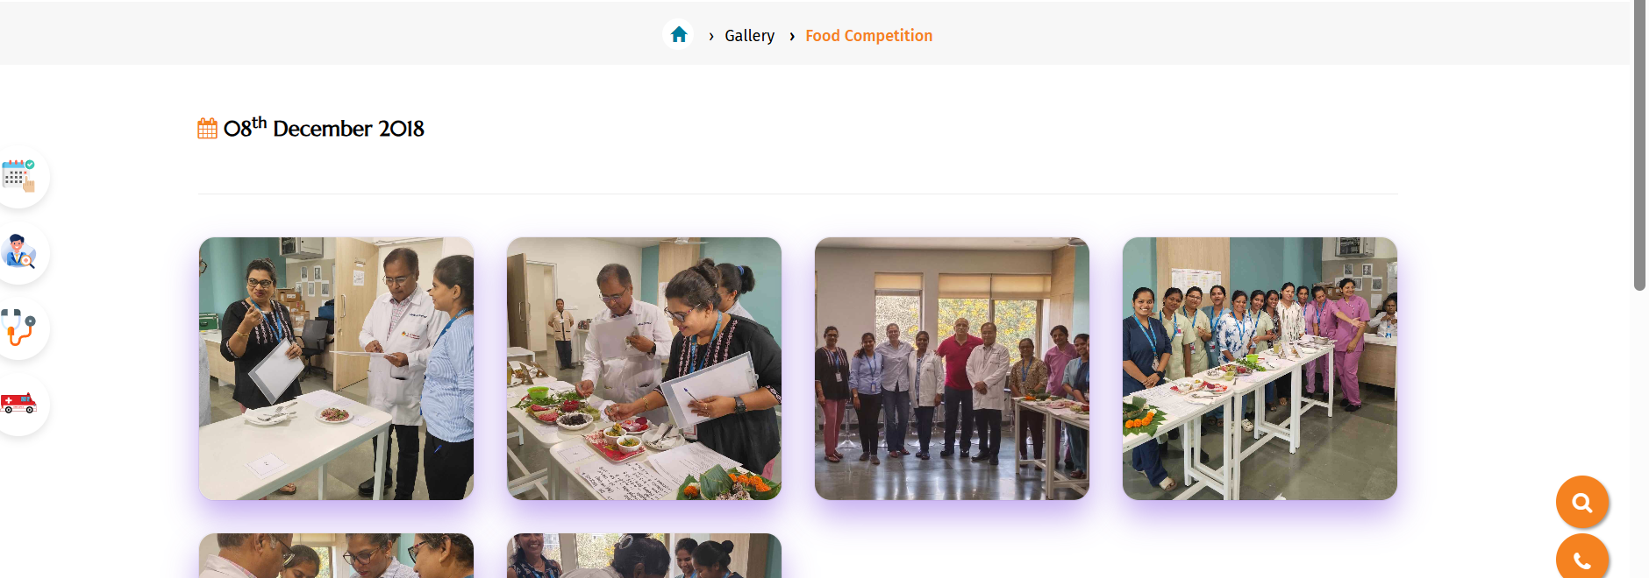
Remove date from gallery DONE
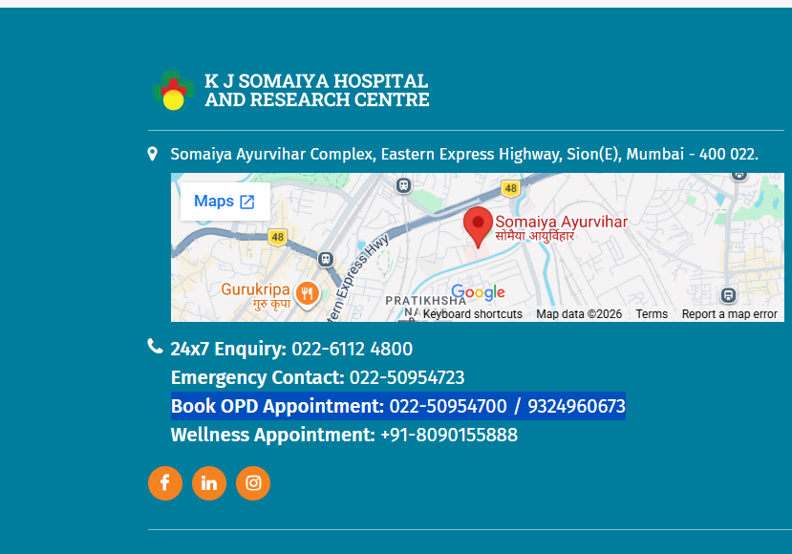
Correct the Number 9324960613 DONE

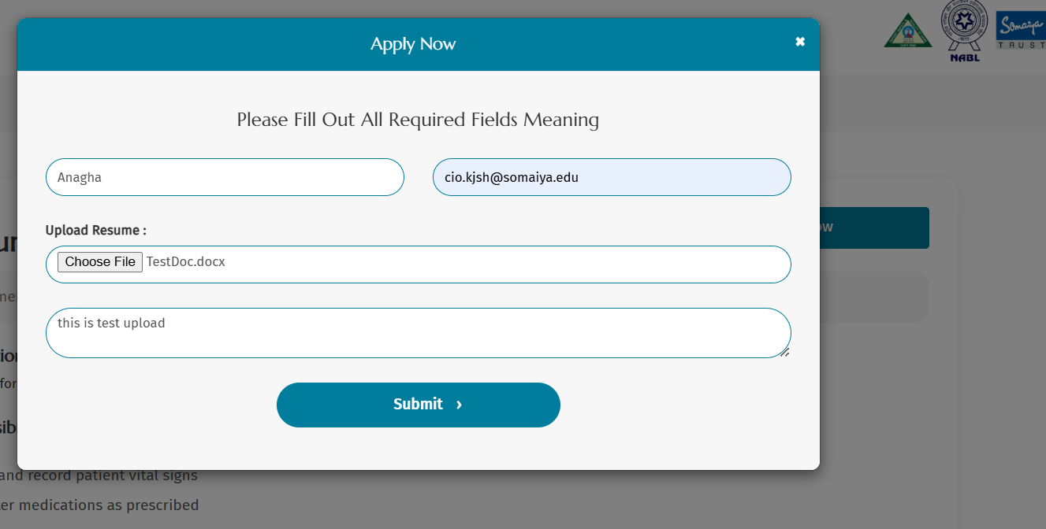
Career section > Apply Now > Submit not working. Already Working

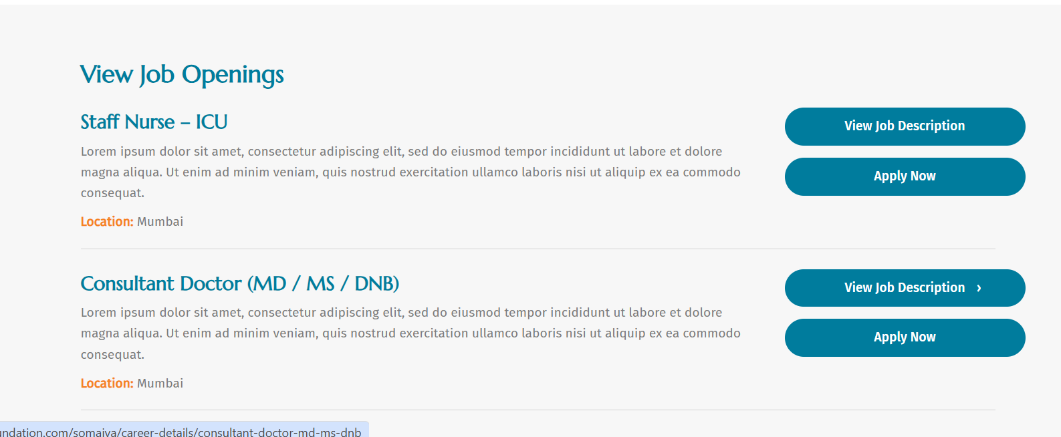
Description is not picking up from database. Remove Lorem Ipsum Description Picking from DB only, Need to update the description there.
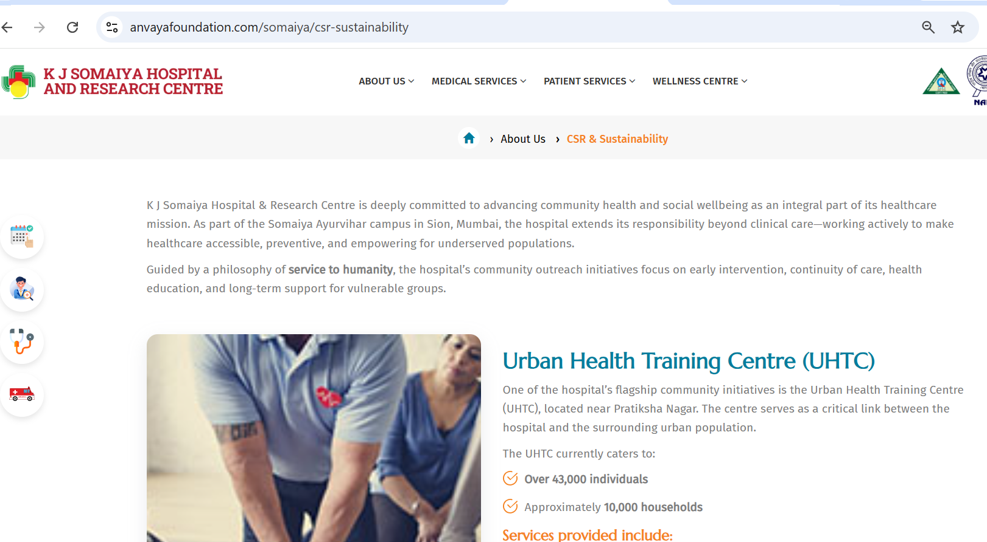
Keep CSR and Community outreach combine and merge Menu as well.--need to ask

Speciality, which does not have Doctor like radiology, Nutrition and dietetics, please hide the section. DONE

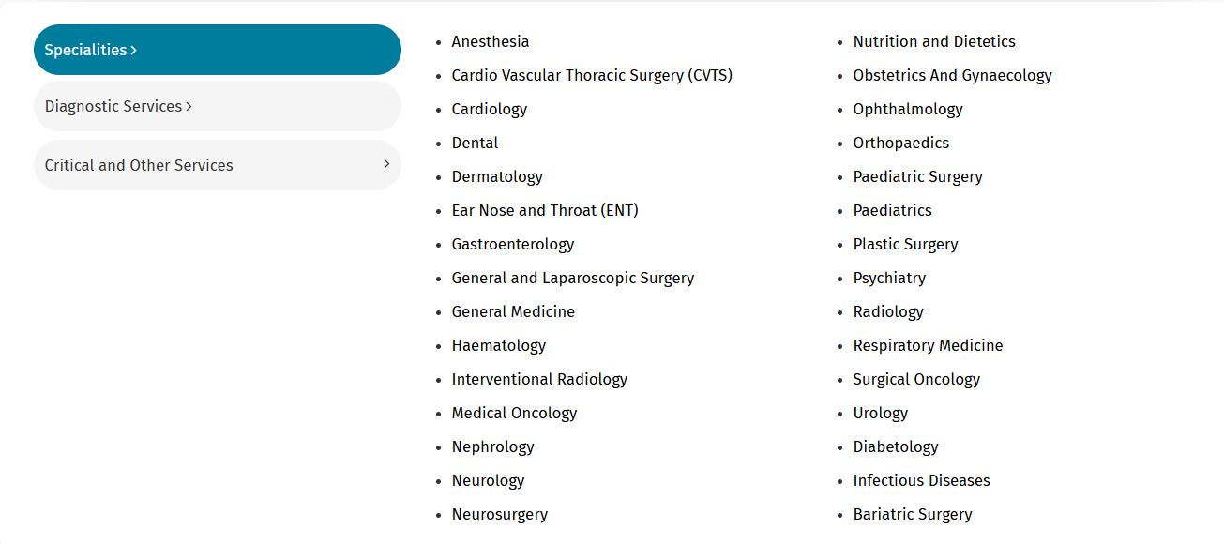
List of Specialities should be in alphabetical order. DONE

