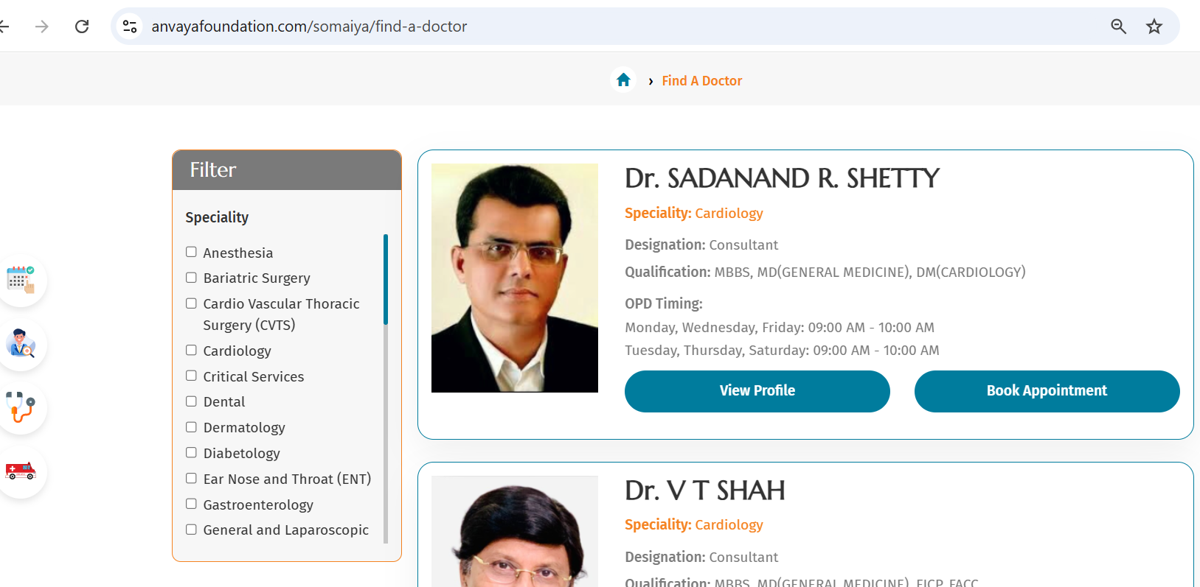

- Remove anaesthesia from filter
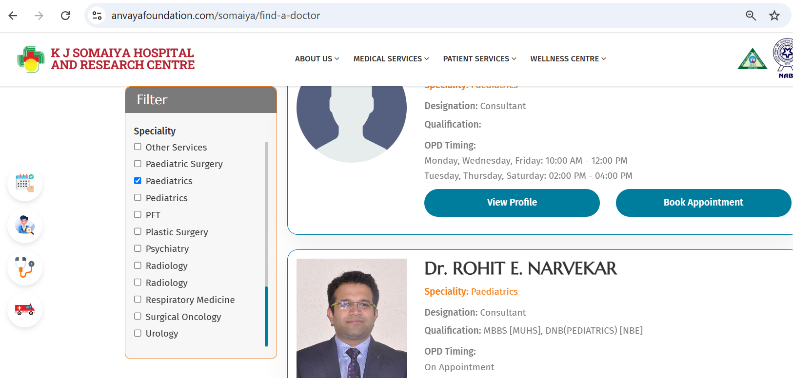

Remove Single Gynaecology and keep Obstetrics and Gynaecology
Remove Second paediatrics and both Radiology, anaesthesia, Non Invasive, Laboratory, Neuro Diagnostics, other services.
Take Minu Ramakrishna Photo from About us she is the same.

Add Dr. Mayur Mewada in Diabatology

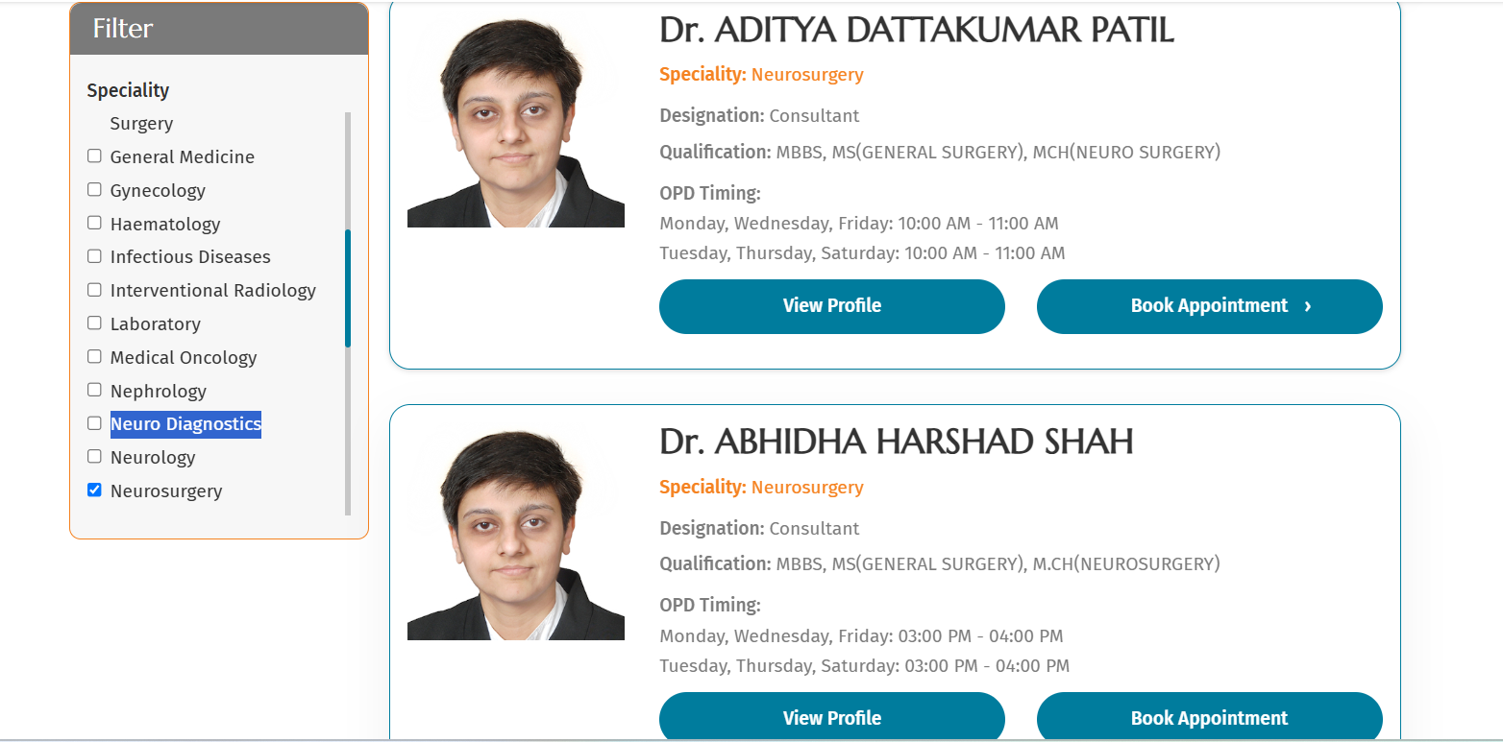
She is Dr.Abhida Shah, orderwise Abhida will come first and then Dr. Aditya will come.

Keep as Filter instead of Filter Panel
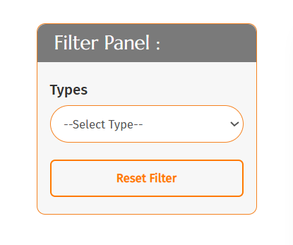

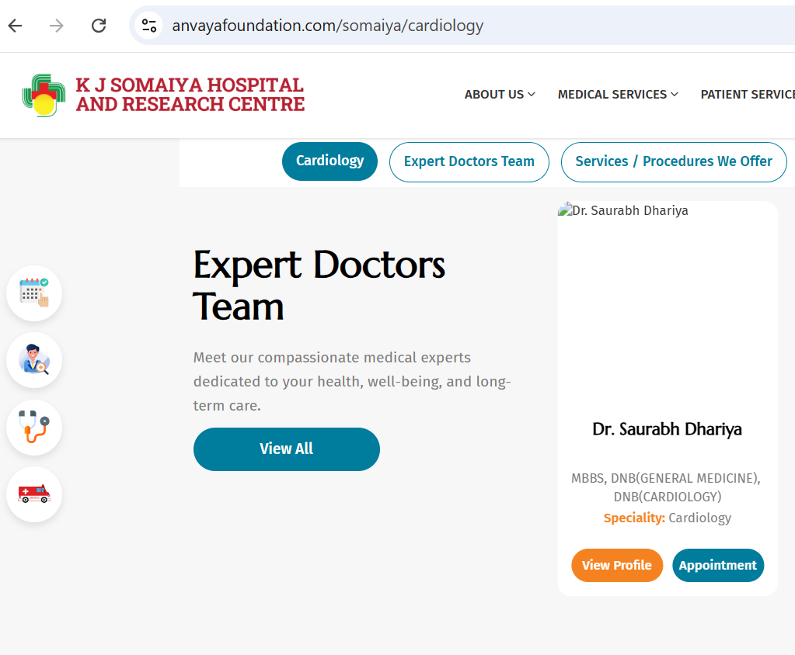Empty photo image not reflecting.

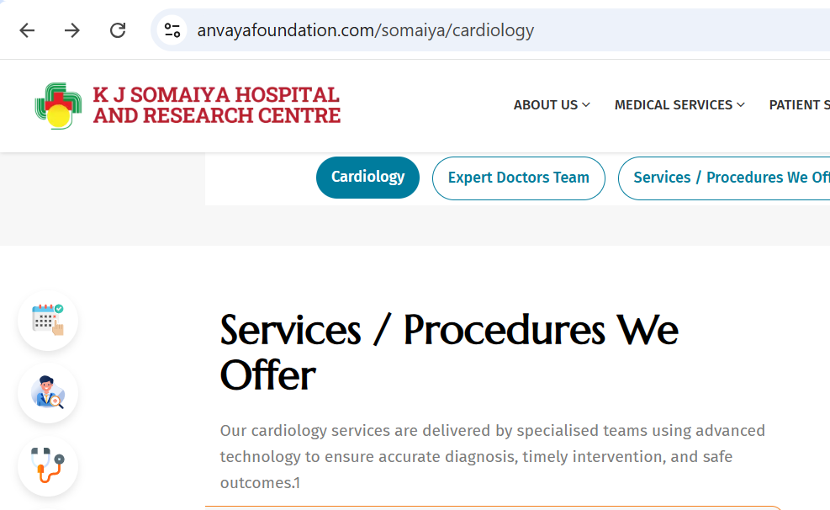
Remove 1 at end of the para.
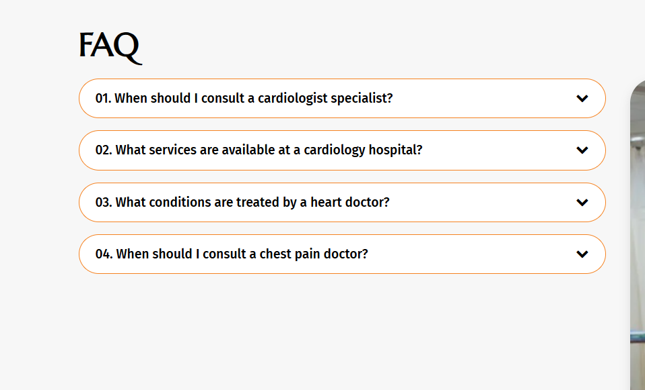
It should be only Cardiologist instead of Cardiologist specialist.
Call now is not working

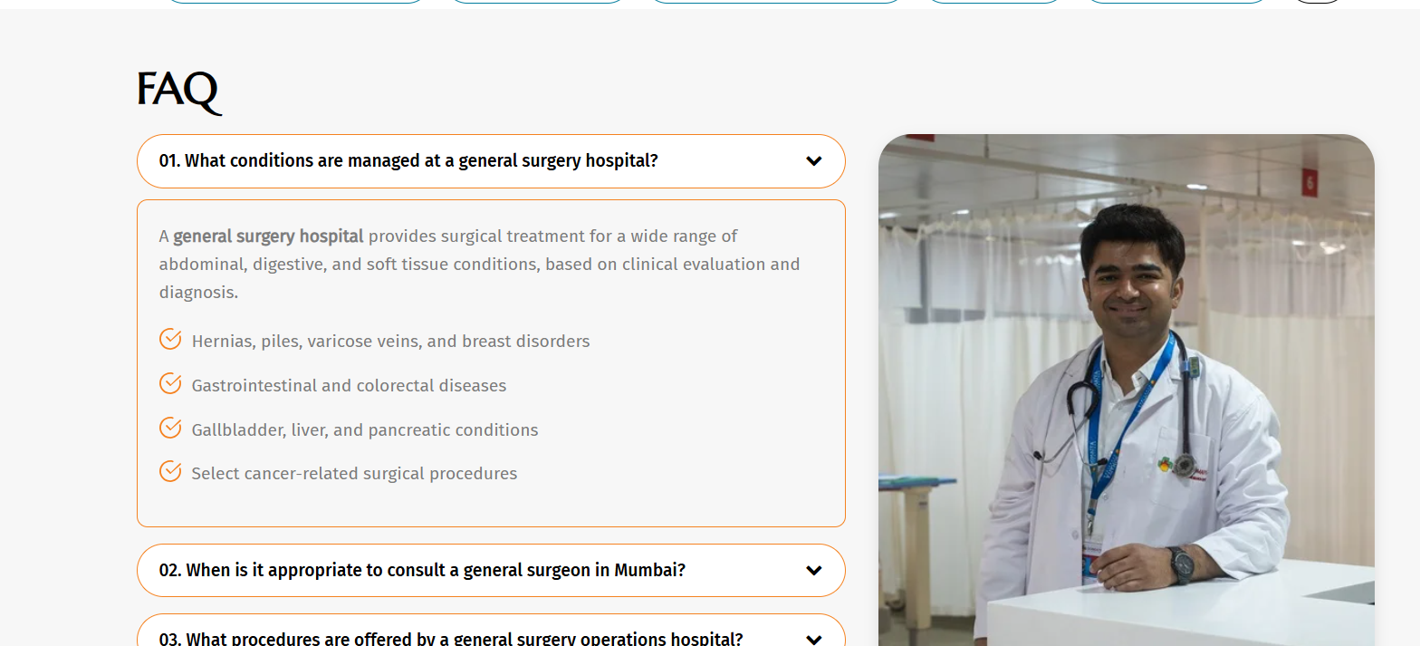

All Speciality is having same photo, please change.
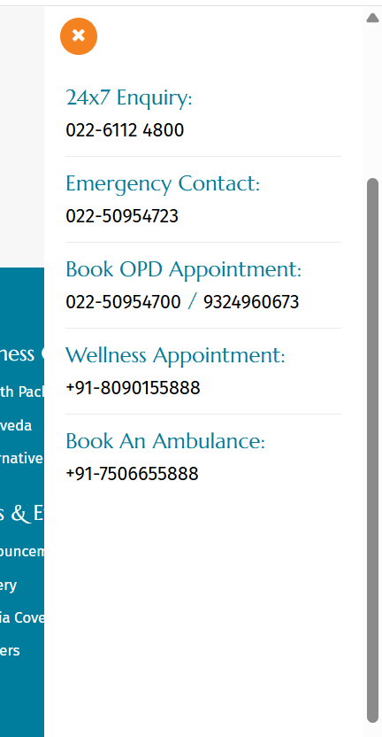
Change OPD Number as 9324960613
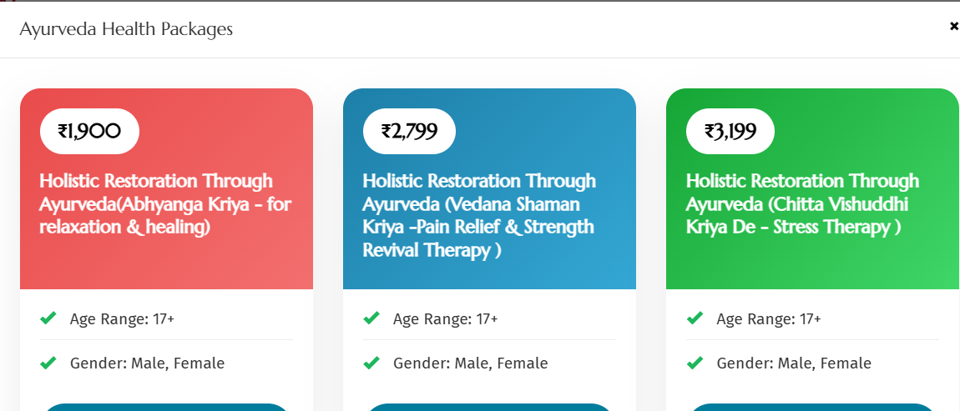
Please look at the font, it should be same like healthcheckup
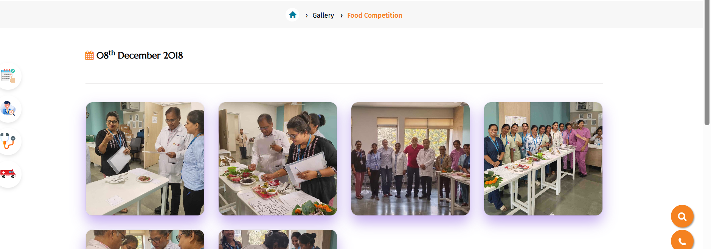
Remove date from gallery
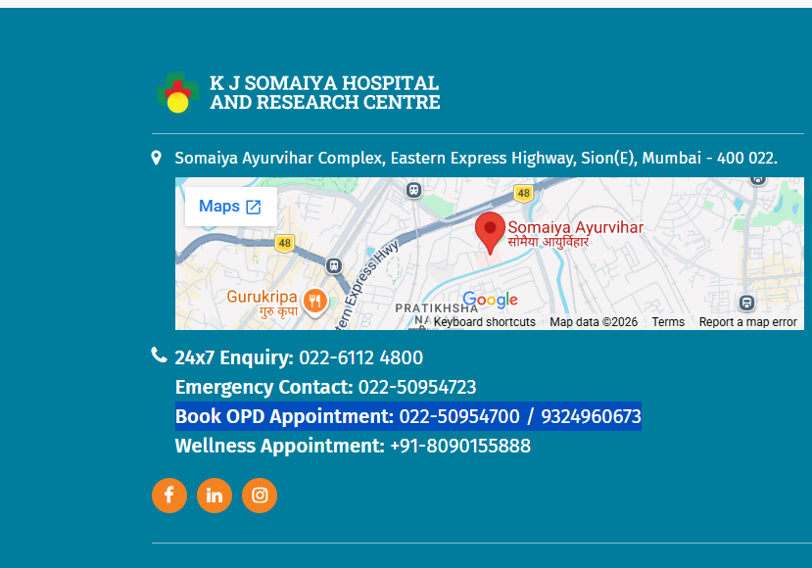
Correct the Number 9324960613

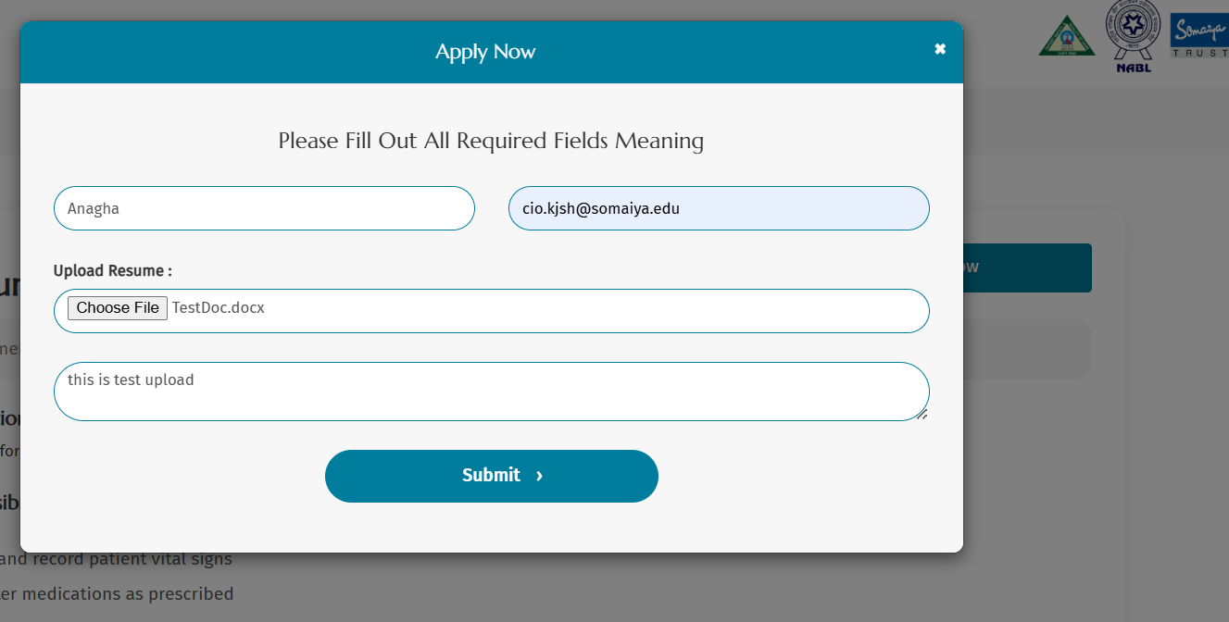
Career section > Apply Now > Submit not working.

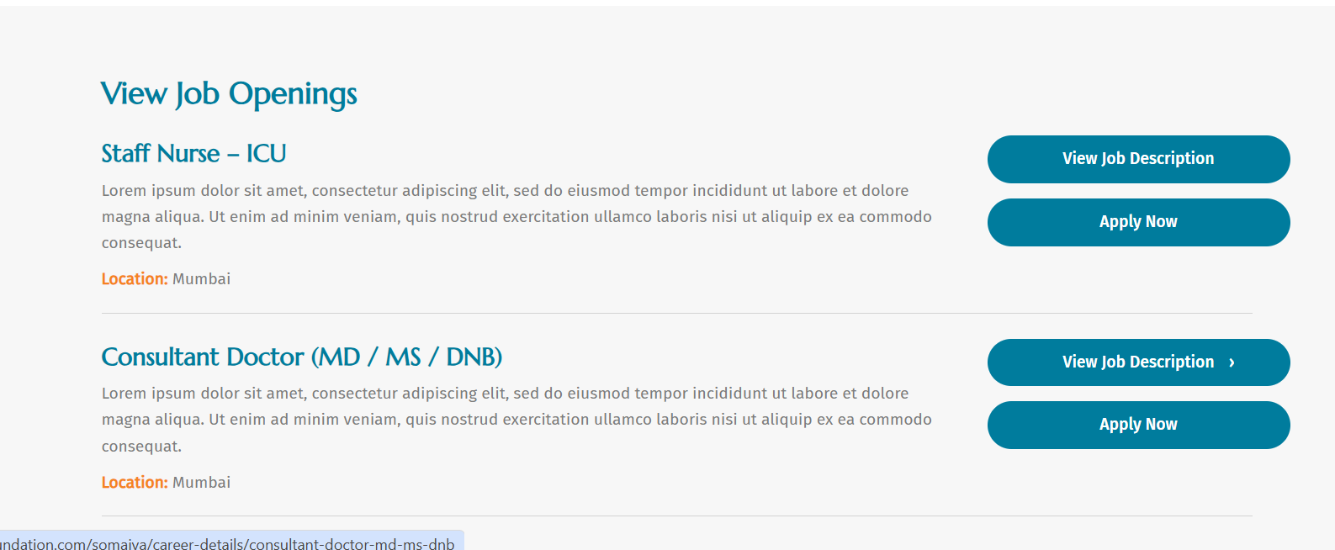
Description is not picking up from database. Remove Lorem Ipsum
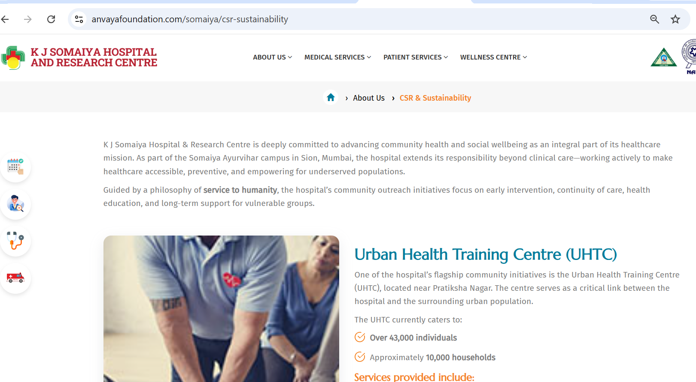
Keep CSR and Community outreach combine and merge Menu as well.

Speciality, which does not have Doctor like radiology, Nutrition and dietetics, please hide the section.

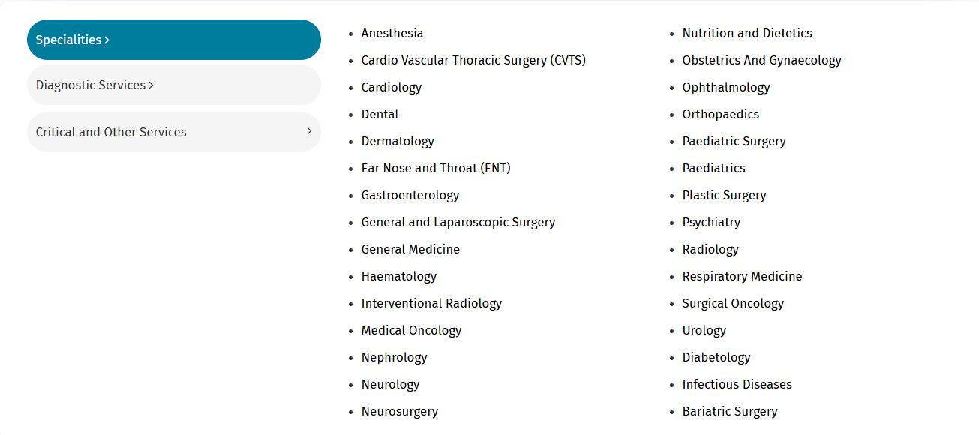
List of Specialities should be in alphabetical order.

