**Practical : -1**

**AIM : - Write a program which creates Binary Search Tree. And also implement recursive and non-recursive tree traversing methods inorder, preorder and post-order for the BST.**

**Code: -**

#include<stdio.h>

#include<conio.h>

#include<stdlib.h>

struct node{

int data;

struct node *rlink;

struct node *llink;

}*tmp=NULL;

typedef struct node NODE;

NODE *create();

void preorder(NODE *);

void inorder(NODE *);

void postorder(NODE *);

void insert(NODE *);

void main(){

int n,i,m;

clrscr();

do{

printf("\n0.create\n1.insert\n2.preorder\n3.postorder\n4.inorder\n5.exit");

printf("\nEnter your choice : ");

scanf("%d",&m);

switch(m){

case 0:

tmp=create();

break;

case 1:

insert(tmp);

break;

case 2:

printf("\nDisplay tree in Preorder : ");

preorder(tmp);

break;

case 3:

printf("\nDisplay Tree in Postorder : ");

postorder(tmp);

break;

case 4:

printf("\nDisplay Tree in Inorder : ");

inorder(tmp);

break;

case 5:

exit(0);

}

}

while(n!=5);

getch();

}

void insert(NODE *root){

NODE *newnode;

if(root==NULL){

newnode=create();

root=newnode;

}

else{

newnode=create();

while(1){

if(newnode->data<root->data){

if(root->llink==NULL){

root->llink=newnode;

break;

}

root=root->llink;

}

if(newnode->data>root->data){

if(root->rlink==NULL){

root->rlink=newnode;

break;

}

root=root->rlink;

}

}

}

}

NODE *create(){

NODE *newnode;

int n;

newnode=(NODE *)malloc(sizeof(NODE));

printf("Enter the Data :");

scanf("%d",&n);

newnode->data=n;

newnode->llink=NULL;

newnode->rlink=NULL;

return(newnode);

}

void postorder(NODE *tmp){

if(tmp!=NULL){

postorder(tmp->llink);

postorder(tmp->rlink);

printf("%d->",tmp->data);

}

}

void inorder(NODE *tmp){

if(tmp!=NULL){

inorder(tmp->llink);

printf("%d->",tmp->data);

inorder(tmp->rlink);

}

}

void preorder(NODE *tmp){

if(tmp!=NULL){

printf("%d->",tmp->data);

preorder(tmp->llink);

preorder(tmp->rlink);

}

}

**OUTPUT:-**

1. Create tree

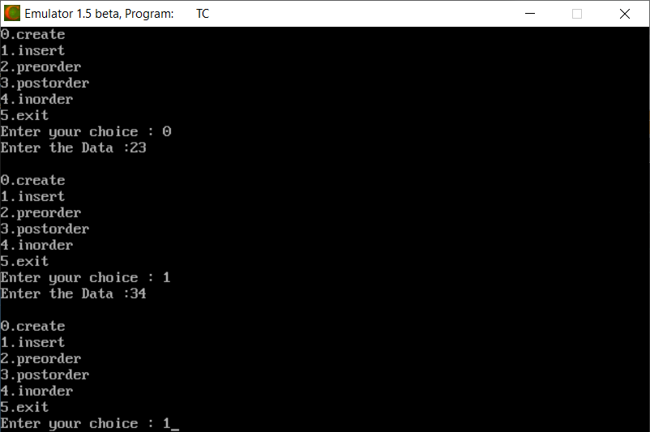

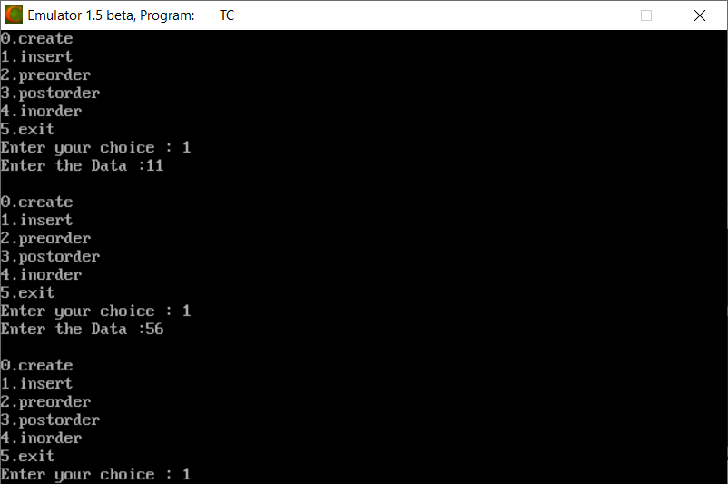

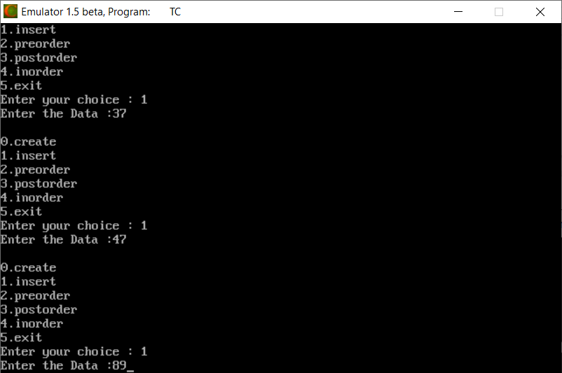

1. Pre order Traversal

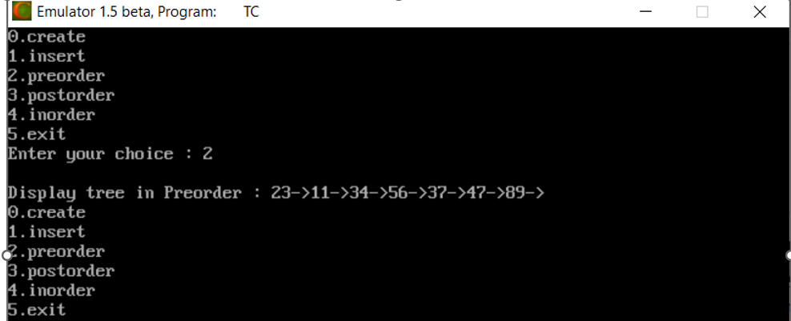

1. Post order Traversal

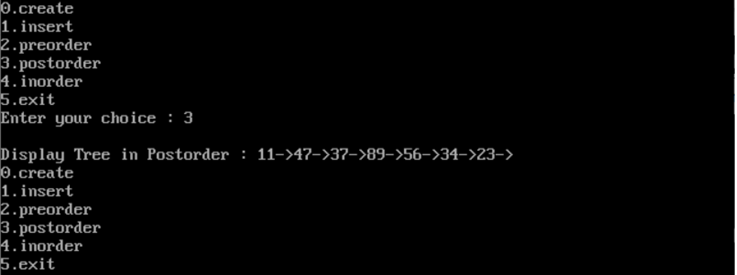

1. In order Traversal

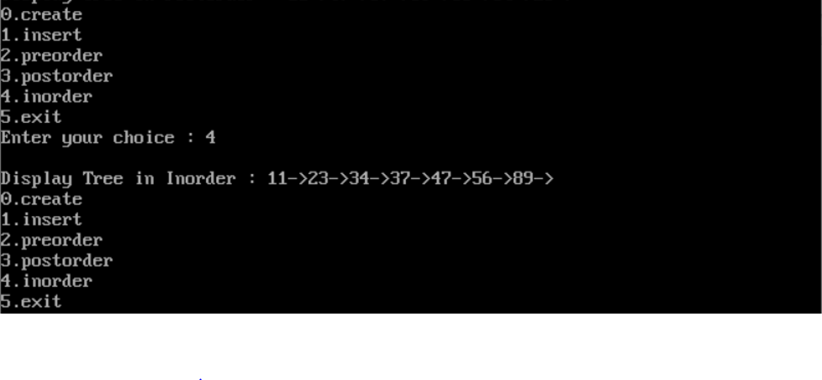

**Practical :-2**

**AIM :- Write a program to implement any two hashing methods. Use any one of the hashing method to implement Insert, Delete and Search operations for Hash Table Management.**

**Code :-**

#include <stdio.h>

#include <stdlib.h>

#include <string.h>

int tableSize = 0, totEle = 0 ,tsize;

struct node *hashTable = NULL;

struct node {

int value, key;

int marker;

};

int hasht(int key)

{

int i ;

i = key%tsize ;

return i;

}

int rehashq(int key, int j)

{

int i ;

i = (key+(j*j))%tsize ;

return i ;

}

void insertInHash(int key, int value) {

int hashIndex = key % tableSize;

if (tableSize == totEle) {

printf("Can't perform Insertion..Hash Table is full!!");

return;

}

while (hashTable[hashIndex].marker == 1) {

hashIndex = (hashIndex + 1)%tableSize;

}

hashTable[hashIndex].key = key;

hashTable[hashIndex].value = value;

hashTable[hashIndex].marker = 1;

totEle++;

return;

}

void deleteFromHash(int key) {

int hashIndex = key % tableSize, count = 0, flag = 0;

if (totEle == 0) {

printf("Hash Table is Empty!!\n");

return;

}

while (hashTable[hashIndex].marker != 0 && count <= tableSize) {

if (hashTable[hashIndex].key == key) {

hashTable[hashIndex].key = 0;

/* set marker to -1 during deletion operation*/

hashTable[hashIndex].marker = -1;

hashTable[hashIndex].value = 0;

totEle--;

flag = 1;

break;

}

hashIndex = (hashIndex + 1)%tableSize;

count++;

}

if (flag)

printf("Given data deleted from Hash Table\n");

else

printf("Given data is not available in Hash Table\n");

return;

}

void searchElement(int key) {

int hashIndex = key % tableSize, flag = 0, count = 0;

if (totEle == 0) {

printf("Hash Table is Empty!!");

return;

}

while (hashTable[hashIndex].marker != 0 && count <= tableSize) {

if (hashTable[hashIndex].key == key) {

printf("Key : %d\n", hashTable[hashIndex].key);

printf("Value : %d\n", hashTable[hashIndex].value);

flag = 1;

break;

}

hashIndex = (hashIndex + 1)%tableSize;

}

if (!flag)

printf("Given data is not present in hash table\n");

return;

}

void display() {

int i;

if (totEle == 0) {

printf("Hash Table is Empty!!\n");

return;

}

printf("Key Value Index \n");

printf("----------------------\n");

for (i = 0; i < tableSize; i++) {

if (hashTable[i].marker == 1) {

printf("%-13d", hashTable[i].key);

printf("%-7d", hashTable[i].value);

printf("%d\n", i);

}

}

printf("\n");

return;

}

void linear_probing() {

int key, value, ch;

printf("Enter the no of elements:");

scanf("%d", &tableSize);

hashTable = (struct node *)calloc(tableSize, sizeof(struct node));

while (1) {

printf("\n MAIN MENU \n");

printf("1. Insertion\n2. Deletion\n");

printf("3. Searching\n4. Display\n");

printf("5. Exit\nEnter ur choice:");

scanf("%d", &ch);

switch (ch) {

case 1:

printf("Enter the key value (for stop -999):");

scanf("%d", &key);

printf("Value (for stop -999:");

scanf("%d", &value);

insertInHash(key, value);

while(key!=-999 && value != -999){

printf("Enter the key value (for stop -999):");

scanf("%d", &key);

printf("Value (for stop -999):");

scanf("%d", &value);

insertInHash(key, value);

}

break;

case 2:

printf("Enter the key value:");

scanf("%d", &key);

deleteFromHash(key);

break;

case 3:

printf("Enter the key value:");

scanf("%d", &key);

searchElement(key);

break;

case 4:

display();

break;

case 5:

exit(0);

default:

printf("U have entered wrong Option!!\n");

break;

}

}

}

void quar_probing()

{

int key,arr[20],hash[20],i,n,s,op,j,k ;

printf ("Enter the size of the hash table: ");

scanf ("%d",&tsize);

printf ("\nEnter the number of elements: ");

scanf ("%d",&n);

for (i=0;i<tsize;i++)

hash[i]=-1 ;

printf ("Enter Elements: ");

for (i=0;i<n;i++)

{

scanf("%d",&arr[i]);

}

for (i=0;i<tsize;i++)

hash[i]=-1 ;

for(k=0;k<n;k++)

{

j=1;

key=arr[k] ;

i = hasht(key);

while (hash[i]!=-1)

{

i = rehashq(i,j);

j++ ;

}

hash[i]=key ;

}

printf("\nThe elements in the array are: ");

for (i=0;i<tsize;i++)

{

printf("\n Element at position %d: %d",i,hash[i]);

}

}

void main()

{

int key,arr[20],hash[20],i,n,s,op,j,k ;

clrscr() ;

do

{

printf("\n HASHING ");

printf("\n1.Linear Probing\n2.Quadratic Probing \n3.Exit \nEnter your option: ");

scanf("%d",&op);

switch(op)

{

case 1:

linear_probing();

break;

case 2:quar_probing();

break;

}

}while(op!=3);

getch() ;

}

**OUTPUT:**

**1)Insertion in Linear Probing**

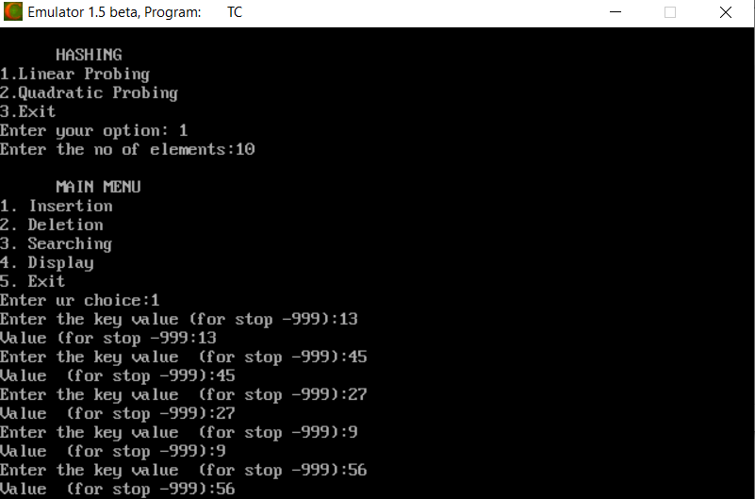

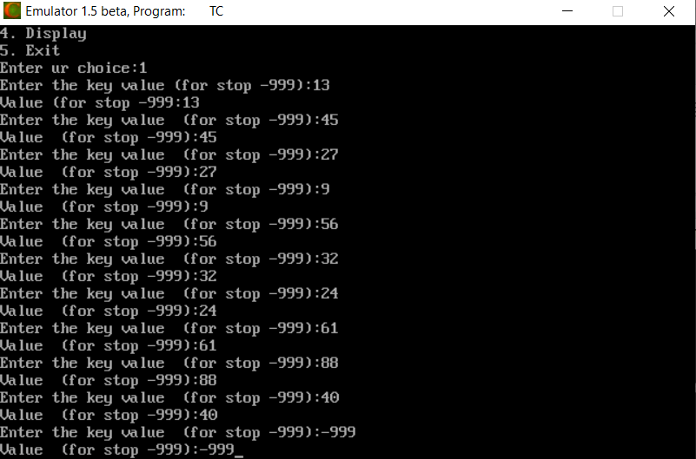

**2)Display in Linear Probing**

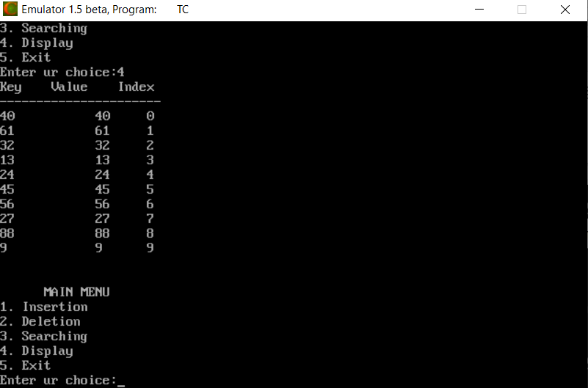

1. **Delete in Linear Probing**

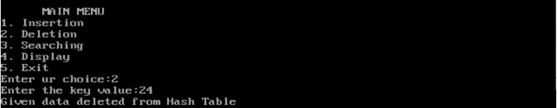

1. **Display after Delete operation in Linear Probing**

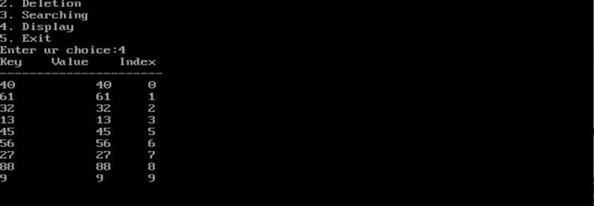

**5) Searching in Linear Probing**

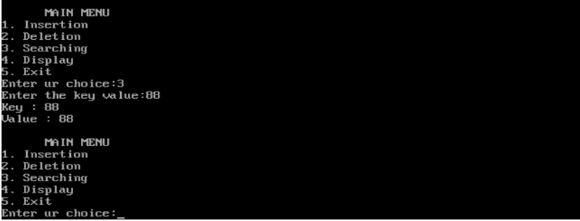

* **Quadratic Probing**

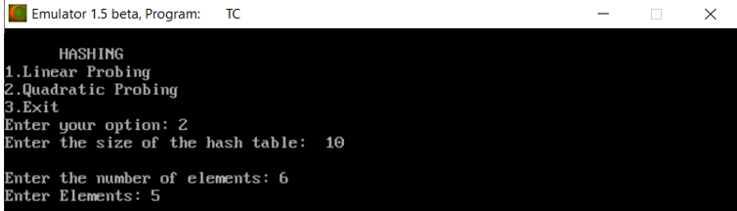

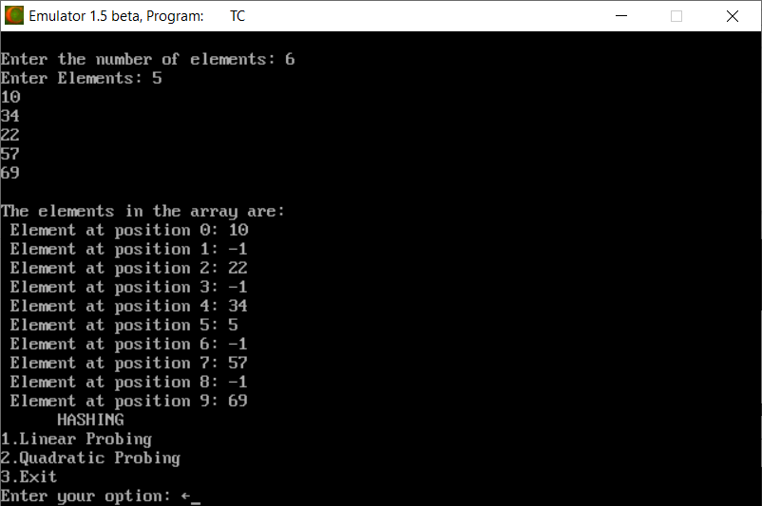

**Practical :- 3**

**AIM :- Explain Dictionary as an Abstract Data Type. Implement Dictionary using suitable Data Structure.**

**Code :-**

#include<stdio.h>

#include<string.h>

#include<stdlib.h>

#include<conio.h>

struct hash *hashTable = NULL;

int eleCount = 0;

struct node {

int roll_no, mark,std;

char name[100];

struct node *next;

};

struct hash {

struct node *head;

int count;

};

struct node * createNode(int roll_no, char *name, int mark,int std) {

struct node *newnode;

newnode = (struct node *)malloc(sizeof(struct node));

newnode->roll_no = roll_no;

newnode->mark = mark;

newnode->std = std;

strcpy(newnode->name, name);

newnode->next = NULL;

return newnode;

}

void insertToHash(int roll_no, char *name, int mark,int std) {

int hashIndex = roll_no % eleCount;

struct node *newnode = createNode(roll_no, name, mark,std);

if (!hashTable[hashIndex].head) {

hashTable[hashIndex].head = newnode;

hashTable[hashIndex].count = 1;

return;

}

newnode->next = (hashTable[hashIndex].head);

hashTable[hashIndex].head = newnode;

hashTable[hashIndex].count++;

return;

}

void deleteFromHash(int roll_no) {

int hashIndex = roll_no % eleCount, flag = 0;

struct node *temp, *myNode;

myNode = hashTable[hashIndex].head;

if (!myNode) {

printf("Given data is not present in hash Table!!\n");

return;

}

temp = myNode;

while (myNode != NULL) {

if (myNode->roll_no == roll_no) {

flag = 1;

if (myNode == hashTable[hashIndex].head)

hashTable[hashIndex].head = myNode->next;

else

temp->next = myNode->next;

hashTable[hashIndex].count--;

free(myNode);

break;

}

temp = myNode;

myNode = myNode->next;

}

if (flag)

printf("Data deleted successfully from Hash Table\n");

else

printf("Given data is not present in hash Table!!!!\n");

return;

}

void searchInHash(int roll_no) {

int hashIndex = roll_no % eleCount, flag = 0;

struct node *myNode;

myNode = hashTable[hashIndex].head;

if (!myNode) {

printf("Search element unavailable in hash table\n");

return;

}

while (myNode != NULL) {

if (myNode->roll_no == roll_no) {

printf("RollNo : %d\n", myNode->roll_no);

printf("Name : %s\n", myNode->name);

printf("Mark : %d\n", myNode->mark);

printf("Class : %d\n",myNode->std);

flag = 1;

break;

}

myNode = myNode->next;

}

if (!flag)

printf("Search element unavailable in hash table\n");

return;

}

void display() {

struct node *myNode;

int i;

for (i = 0; i < eleCount; i++) {

if (hashTable[i].count == 0)

continue;

myNode = hashTable[i].head;

if (!myNode)

continue;

printf("\nData at index %d in Hash Table:\n", i);

printf("Rollno Name Class Mark \n");

printf("-------------------------------------------\n");

while (myNode != NULL) {

printf("%-12d", myNode->roll_no);

printf("%-15s", myNode->name);

printf("%-12d",myNode->std);

printf("%d\n", myNode->mark);

myNode = myNode->next;

}

}

return;

}

int main() {

int n, ch, roll_no, mark,std;

char name[100];

// clrscr();

printf("Enter the number of elements:");

scanf("%d", &n);

eleCount = n;

hashTable = (struct hash *)calloc(n, sizeof (struct hash));

while (1) {

printf("\n DICTIONARY ");

printf("\n1. Insertion\n2. Deletion\n");

printf("3. Searching\n4. Display\n5. Exit\n");

printf("Enter your choice:");

scanf("%d", &ch);

switch (ch) {

case 1:

printf("Enter the Roll NO (stop -999):");

scanf("%d", &roll_no);

printf("Name(stop 'N'):");

scanf("%s",&name);

printf("Marks(stop -999):");

scanf("%d", &mark);

printf("Class(stop -999):");

scanf("%d",&std);

insertToHash(roll_no, name, mark,std);

while(roll_no!=-999&& name!="n" && mark!=-999 && std!=-999){

printf("Enter the Roll NO(stop -999):");

scanf("%d", &roll_no);

printf("Name(stop 'N'):");

scanf("%s",&name);

printf("Marks(stop -999):");

scanf("%d", &mark);

printf("Class(stop -999):");

scanf("%d",&std);

insertToHash(roll_no, name, mark,std);

}

break;

case 2:

printf("Enter the roll_no to perform deletion:");

scanf("%d", &roll_no);

deleteFromHash(roll_no);

break;

case 3:

printf("Enter the roll_no to search:");

scanf("%d", &roll_no);

searchInHash(roll_no);

break;

case 4:

display();

break;

case 5:

exit(0);

default:

printf("U have entered wrong option!!\n");

break;

}

}

return 0;

}

**OUTPUT :**

1. **Insertion in dictionary**

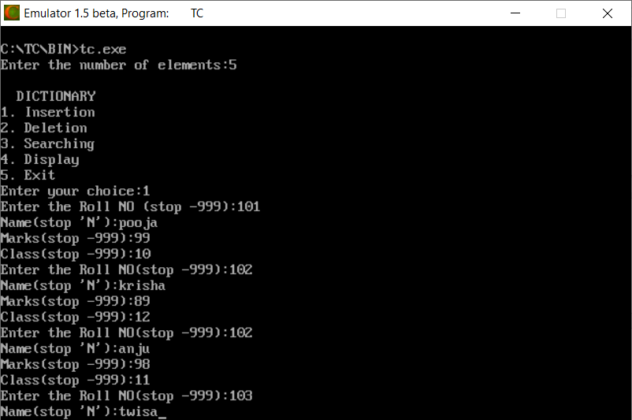

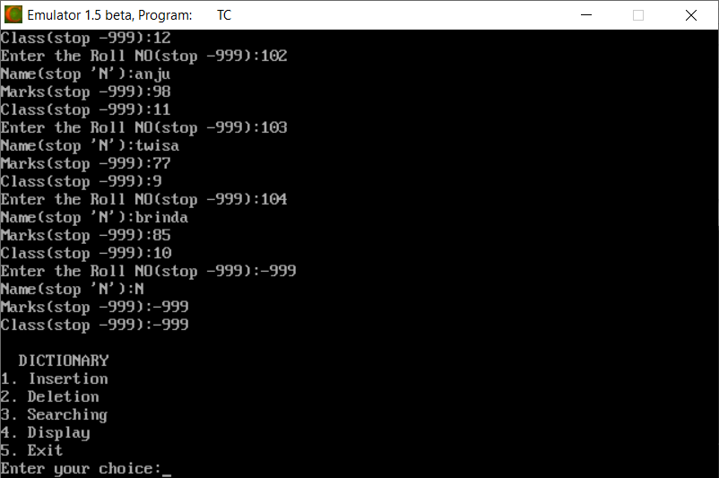

1. **Display of dictionary**

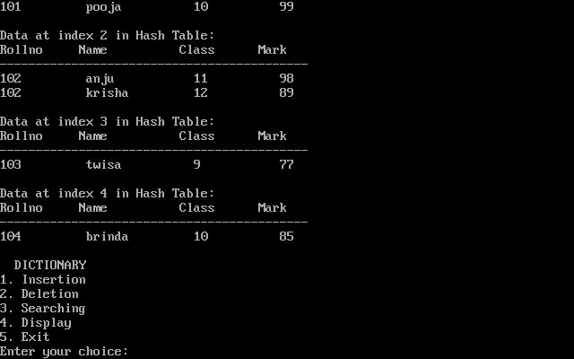

1. **Searching in dictionary**

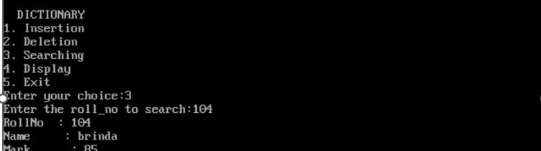

1. **Deletion in dictionary**

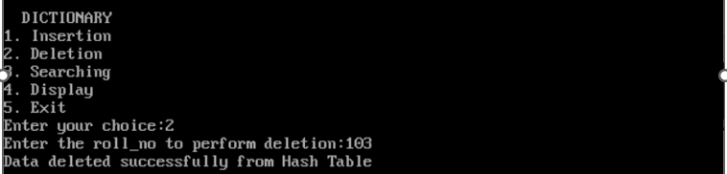

**Practical :- 4**

**AIM :- Write a program which creates AVLTree. Implement Insert and Delete Operations in AVL Tree. (Note that each time the tree must be balanced.)**

**Code :-**

#include<stdio.h>

#include<conio.h>

typedef struct node {

int data;

struct node *left,*right;

int ht;

}node;

node * rotateright(node *x) {

node *y;

y=x->left;

x->left=y->right;

y->right=x;

x->ht=height(x);

y->ht=height(y);

return(y);

}

node * rotateleft(node *x) {

node *y;

y=x->right;

x->right=y->left;

y->left=x;

x->ht=height(x);

y->ht=height(y);

return(y);

}

node * LL(node *T) {

T=rotateright(T);

return(T);

}

node * LR(node *T) {

T->left=rotateleft(T->left);

T=rotateright(T);

return(T);

}

node * RL(node *T) {

T->right=rotateright(T->right);

T=rotateleft(T);

return(T);

}

int BF(node *T) {

int lh,rh;

if(T==NULL)

return(0);

if(T->left==NULL)

lh=0;

else

lh=1+T->left->ht;

if(T->right==NULL)

rh=0;

else

rh=1+T->right->ht;

return(lh-rh);

}

void postorder(node *T) {

if(T!=NULL) {

postorder(T->left);

printf("%d(Bf=%d)",T->data,BF(T));

postorder(T->right);

}

}

node * RR(node *T) {

T=rotateleft(T);

return(T);

}

node * insert(node *T,int x) {

if(T==NULL) {

T=(node*)malloc(sizeof(node));

T->data=x;

T->left=NULL;

T->right=NULL;

}

else

if(x > T->data) { // insert in right subtree

T->right=insert(T->right,x);

if(BF(T)==-2)

if(x>T->right->data)

T=RR(T);

else

T=RL(T);

}

else

if(x<T->data) {

T->left=insert(T->left,x);

if(BF(T)==2)

if(x < T->left->data)

T=LL(T);

else

T=LR(T);

}

T->ht=height(T);

return(T);

}

node * Delete(node *T,int x) {

node *p;

if(T==NULL) {

return NULL;

}

else

if(x > T->data) { // insert in right subtree

T->right=Delete(T->right,x);

if(BF(T)==2)

if(BF(T->left)>=0)

T=LL(T);

else

T=LR(T);

}

else

if(x<T->data) {

T->left=Delete(T->left,x);

if(BF(T)==-2)

if(BF(T->right)<=0)

T=RR(T);

else

T=RL(T);

}

Else {

if(T->right!=NULL) {

p=T->right;

while(p->left!= NULL)

p=p->left;

T->data=p->data;

T->right=Delete(T->right,p->data);

if(BF(T)==2)//Rebalance during windup

if(BF(T->left)>=0)

T=LL(T);

else

T=LR(T);\

}

else

return(T->left);

}

T->ht=height(T);

return(T);

}

int height(node *T) {

int lh,rh;

if(T==NULL)

return(0);

if(T->left==NULL)

lh=0;

else

lh=1+T->left->ht;

if(T->right==NULL)

rh=0;

else

rh=1+T->right->ht;

if(lh>rh)

return(lh);

return(rh);

}

int main() {

node *root=NULL;

int x,n,i,op,ch;

do{

printf("\n1.Create");

printf("\n2.Insert");

printf("\n3.Delete");

printf("\n4.Print");

printf("\n5.Quit");

printf("\nEnter Your Choice:");

scanf("%d",&ch);

switch(ch) {

case 1: printf("\nEnter no. of elements:");

scanf("%d",&n);

printf("\nEnter tree data:");

root=NULL;

for(i=0;i<n;i++) {

scanf("%d",&x);

root=insert(root,x);

}

break;

case 2: printf("\nEnter a data:");

scanf("%d",&x);

root=insert(root,x);

break;

case 3: printf("\nEnter a data:");

scanf("%d",&x);

root=Delete(root,x);

break;

case 4: printf("\nPostorder sequence: ");

postorder(root);

break;

}

}while(ch!=5);

return 0;

}

**OUTPUT :**

1. **Create & Insertion in AVL tree**

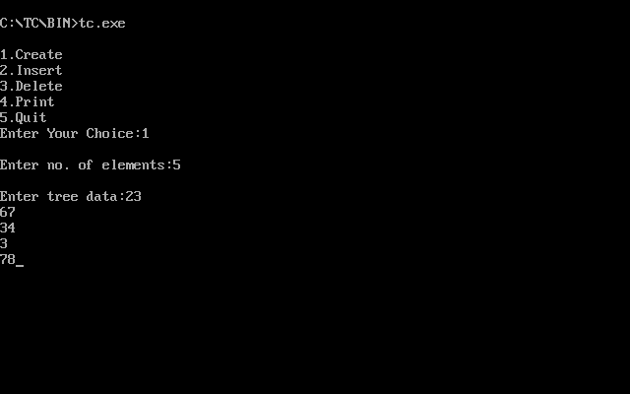

1. **Display AVL tree**

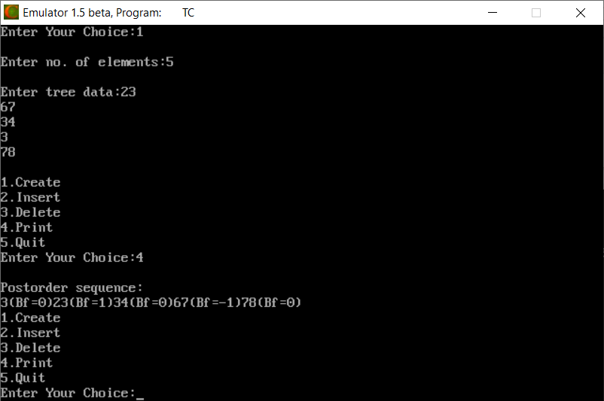

1. **Deletion in AVL tree and display it.**

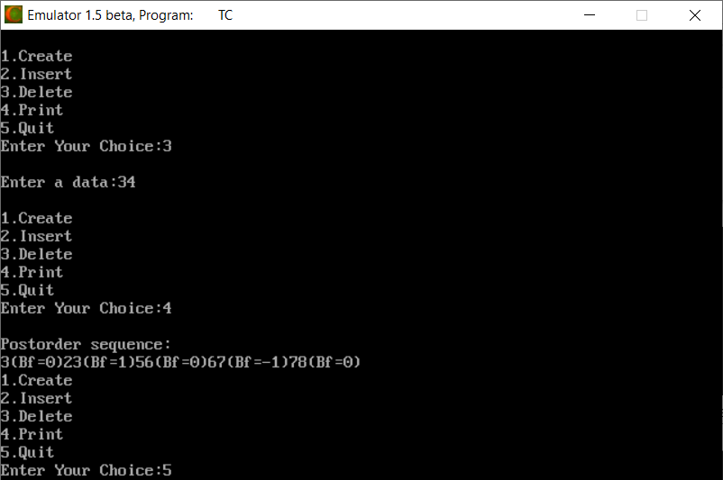

**Practical :- 5**

**AIM :- Implement Red-Black Tree.**

**Code :-**

#include<stdio.h>

#include<conio.h>

#include<stdlib.h>

//enum nodeColor{RED,BLACK};

struct rbNode{

int data, color;

struct rbNode *link[2];

};

struct rbNode *root = NULL;

struct rbNode *createNode(int data){

struct rbNode *newnode;

newnode = (struct rbNode *)malloc(sizeof(struct rbNode));

newnode->data = data;

newnode->color = RED;

newnode->link[0] = newnode->link[1] = NULL;

return newnode;

}

void insertion(int data) {

struct rbNode *stack[98], *ptr, *newnode, *xPtr, *yPtr;

int dir[98], ht = 0, index;

ptr = root;

if (!root){

root = createNode(data);

return;

}

stack[ht] = root;

dir[ht++] = 0;

while (ptr != NULL) {

if (ptr->data == data){

printf("Duplicates Not Allowed!!\n");

return;

}

index = (data - ptr->data) > 0 ? 1 : 0;

stack[ht] = ptr;

ptr = ptr->link[index];

dir[ht++] = index;

}

stack[ht - 1]->link[index] = newnode = createNode(data);

while ((ht >= 3) && (stack[ht - 1]->color == RED)) {

if (dir[ht - 2] == 0){

yPtr = stack[ht - 2]->link[1];

if (yPtr != NULL && yPtr->color == RED){

stack[ht - 2]->color = RED;

stack[ht - 1]->color = yPtr->color = BLACK;

ht = ht - 2;

}

else {

if (dir[ht - 1] == 0){

yPtr = stack[ht - 1];

}

else {

xPtr = stack[ht - 1];

yPtr = xPtr->link[1];

xPtr->link[1] = yPtr->link[0];

yPtr->link[0] = xPtr;

stack[ht - 2]->link[0] = yPtr;

}

xPtr = stack[ht - 2];

xPtr->color = RED;

yPtr->color = BLACK;

xPtr->link[0] = yPtr->link[1];

yPtr->link[1] = xPtr;

if (xPtr == root) {

root = yPtr;

}

else{

stack[ht - 3]->link[dir[ht - 3]] = yPtr;

}

break;

}

}

else{

yPtr = stack[ht - 2]->link[0];

if ((yPtr != NULL) && (yPtr->color == RED)) {

stack[ht - 2]->color = RED;

stack[ht - 1]->color = yPtr->color = BLACK;

ht = ht - 2;

}

else {

if (dir[ht - 1] == 1){

yPtr = stack[ht - 1];

}

else {

xPtr = stack[ht - 1];

yPtr = xPtr->link[0];

xPtr->link[0] = yPtr->link[1];

yPtr->link[1] = xPtr;

stack[ht - 2]->link[1] = yPtr;

}

xPtr = stack[ht - 2];

yPtr->color = BLACK;

xPtr->color = RED;

xPtr->link[1] = yPtr->link[0];

yPtr->link[0] = xPtr;

if (xPtr == root){

root = yPtr;

}

else {

stack[ht - 3]->link[dir[ht - 3]] = yPtr;

}

break;

}

}

}

root->color = BLACK;

}

void deletion(int data) {

struct rbNode *stack[98], *ptr, *xPtr, *yPtr;

struct rbNode *pPtr, *qPtr, *rPtr;

int dir[98], ht = 0, diff, i;

enum nodeColor color;

if (!root){

printf("Tree not available\n");

return;

}

ptr = root;

while (ptr != NULL) {

if ((data - ptr->data) == 0)

break;

diff = (data - ptr->data) > 0 ? 1 : 0;

stack[ht] = ptr;

dir[ht++] = diff;

ptr = ptr->link[diff];

}

if (ptr->link[1] == NULL) {

if ((ptr == root) && (ptr->link[0] == NULL)){

free(ptr);

root = NULL;

}

else if (ptr == root){

root = ptr->link[0];

free(ptr);

}

else {

stack[ht - 1]->link[dir[ht - 1]] = ptr->link[0];

}

}

else{

xPtr = ptr->link[1];

if (xPtr->link[0] == NULL){

xPtr->link[0] = ptr->link[0];

color = xPtr->color;

xPtr->color = ptr->color;

ptr->color = color;

if (ptr == root){

root = xPtr;

}

else {

stack[ht - 1]->link[dir[ht - 1]] = xPtr;

}

dir[ht] = 1;

stack[ht++] = xPtr;

}

else {

i = ht++;

while (1){

dir[ht] = 0;

stack[ht++] = xPtr;

yPtr = xPtr->link[0];

if (!yPtr->link[0])

break;

xPtr = yPtr;

}

dir[i] = 1;

stack[i] = yPtr;

if (i > 0)

stack[i - 1]->link[dir[i - 1]] = yPtr;

yPtr->link[0] = ptr->link[0];

xPtr->link[0] = yPtr->link[1];

yPtr->link[1] = ptr->link[1];

if (ptr == root) {

root = yPtr;

}

color = yPtr->color;

yPtr->color = ptr->color;

ptr->color = color;

}

}

if (ht < 1)

return;

if (ptr->color == BLACK){

while (1){

pPtr = stack[ht - 1]->link[dir[ht - 1]];

if (pPtr && pPtr->color == RED){

pPtr->color = BLACK;

break;

}

if (ht < 2)

break;

if (dir[ht - 2] == 0){

rPtr = stack[ht - 1]->link[1];

if (!rPtr)

break;

if (rPtr->color == RED){

stack[ht - 1]->color = RED;

rPtr->color = BLACK;

stack[ht - 1]->link[1] = rPtr->link[0];

rPtr->link[0] = stack[ht - 1];

if (stack[ht - 1] == root) {

root = rPtr;

}

else{

stack[ht - 2]->link[dir[ht - 2]] = rPtr;

}

dir[ht] = 0;

stack[ht] = stack[ht - 1];

stack[ht - 1] = rPtr;

ht++;

rPtr = stack[ht - 1]->link[1];

}

if ((!rPtr->link[0] || rPtr->link[0]->color == BLACK) &&

(!rPtr->link[1] || rPtr->link[1]->color == BLACK)) {

rPtr->color = RED;

}

else{

if (!rPtr->link[1] || rPtr->link[1]->color == BLACK){

qPtr = rPtr->link[0];

rPtr->color = RED;

qPtr->color = BLACK;

rPtr->link[0] = qPtr->link[1];

qPtr->link[1] = rPtr;

rPtr = stack[ht - 1]->link[1] = qPtr;

}

rPtr->color = stack[ht - 1]->color;

stack[ht - 1]->color = BLACK;

rPtr->link[1]->color = BLACK;

stack[ht - 1]->link[1] = rPtr->link[0];

rPtr->link[0] = stack[ht - 1];

if (stack[ht - 1] == root){

root = rPtr;

}

else{

stack[ht - 2]->link[dir[ht - 2]] = rPtr;

}

break;

}

}

else {

rPtr = stack[ht - 1]->link[0];

if (!rPtr)

break;

if (rPtr->color == RED){

stack[ht - 1]->color = RED;

rPtr->color = BLACK;

stack[ht - 1]->link[0] = rPtr->link[1];

rPtr->link[1] = stack[ht - 1];

if (stack[ht - 1] == root) {

root = rPtr;

}

else{

stack[ht - 2]->link[dir[ht - 2]] = rPtr;

}

dir[ht] = 1;

stack[ht] = stack[ht - 1];

stack[ht - 1] = rPtr;

ht++;

rPtr = stack[ht - 1]->link[0];

}

if ((!rPtr->link[0] || rPtr->link[0]->color == BLACK) &&

(!rPtr->link[1] || rPtr->link[1]->color == BLACK)) {

rPtr->color = RED;

}

else {

if (!rPtr->link[0] || rPtr->link[0]->color == BLACK) {

qPtr = rPtr->link[1];

rPtr->color = RED;

qPtr->color = BLACK;

rPtr->link[1] = qPtr->link[0];

qPtr->link[0] = rPtr;

rPtr = stack[ht - 1]->link[0] = qPtr;

}

rPtr->color = stack[ht - 1]->color;

stack[ht - 1]->color = BLACK;

rPtr->link[0]->color = BLACK;

stack[ht - 1]->link[0] = rPtr->link[1];

rPtr->link[1] = stack[ht - 1];

if (stack[ht - 1] == root){

root = rPtr;

}

else {

stack[ht - 2]->link[dir[ht - 2]] = rPtr;

}

break;

}

}

ht--;

}

}

}

void inorderTraversal(struct rbNode *node) {

if (node) {

inorderTraversal(node->link[0]);

printf("%d ", node->data);

inorderTraversal(node->link[1]);

}

return;

}

int main(){

int ch, data;

while (1){

printf("1. Insertion\t2. Deletion\n");

printf("3. Traverse\t4. Exit");

printf("\nEnter your choice:");

scanf("%d", &ch);

switch (ch){

case 1:

printf("Enter the element to insert:");

scanf("%d", &data);

insertion(data);

break;

case 2:

printf("Enter the element to delete:");

scanf("%d", &data);

deletion(data);

break;

case 3:

inorderTraversal(root);

printf("\n");

break;

case 4:

exit(0);

default:

printf("Not available\n");

break;

}

printf("\n");

}

return 0;

}

**OUTPUT:**

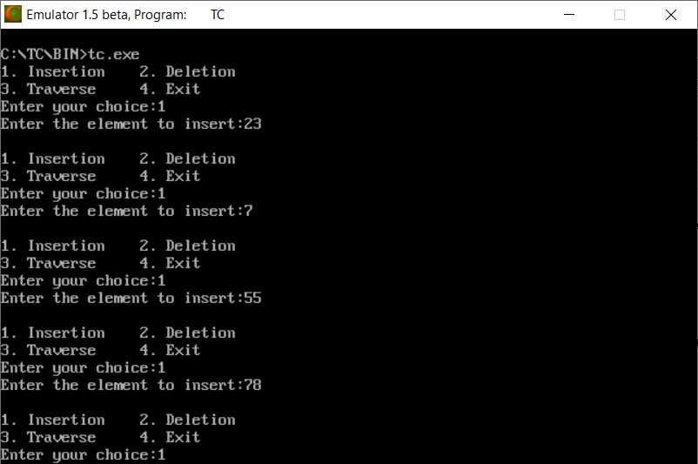

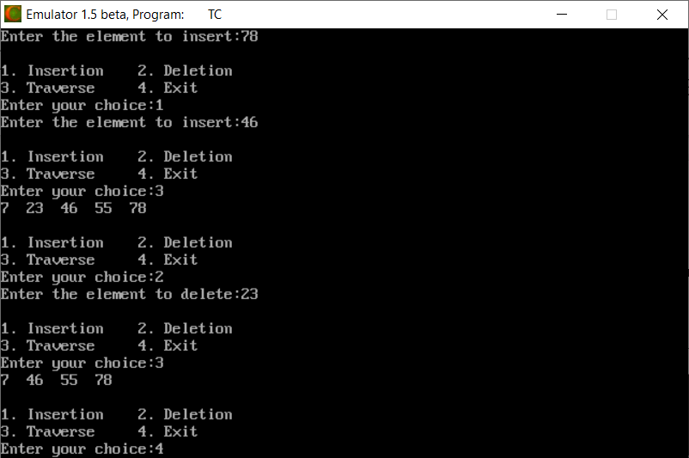

**Practical :- 6**

**AIM :- Implement 2-3 Tree.**

**Code :-**

#include <stdio.h>

#include <stdlib.h>

#define MAX 3

#define MIN 2

struct btreeNode {

int val[MAX + 1], count;

struct btreeNode *link[MAX + 1];

};

struct btreeNode *root;

/* creating new node */

struct btreeNode * createNode(int val, struct btreeNode *child) {

struct btreeNode *newNode;

newNode = (struct btreeNode *)malloc(sizeof(struct btreeNode));

newNode->val[1] = val;

newNode->count = 1;

newNode->link[0] = root;

newNode->link[1] = child;

return newNode;

}

/* Places the value in appropriate position */

void addValToNode(int val, int pos, struct btreeNode *node,

struct btreeNode *child) {

int j = node->count;

while (j > pos) {

node->val[j + 1] = node->val[j];

node->link[j + 1] = node->link[j];

j--;

}

node->val[j + 1] = val;

node->link[j + 1] = child;

node->count++;

}

/* split the node */

void splitNode (int val, int *pval, int pos, struct btreeNode *node,

struct btreeNode *child, struct btreeNode **newNode) {

int median, j;

if (pos > MIN)

median = MIN + 1;

else

median = MIN;

*newNode = (struct btreeNode *)malloc(sizeof(struct btreeNode));

j = median + 1;

while (j <= MAX) {

(*newNode)->val[j - median] = node->val[j];

(*newNode)->link[j - median] = node->link[j];

j++;

}

node->count = median;

(*newNode)->count = MAX - median;

if (pos <= MIN) {

addValToNode(val, pos, node, child);

} else {

addValToNode(val, pos - median, *newNode, child);

}

*pval = node->val[node->count];

(*newNode)->link[0] = node->link[node->count];

node->count--;

}

/* sets the value val in the node */

int setValueInNode(int val, int *pval,

struct btreeNode *node, struct btreeNode **child) {

int pos;

if (!node) {

*pval = val;

*child = NULL;

return 1;

}

if (val < node->val[1]) {

pos = 0;

} else {

for (pos = node->count;

(val < node->val[pos] && pos > 1); pos--);

if (val == node->val[pos]) {

printf("Duplicates not allowed\n");

return 0;

}

}

if (setValueInNode(val, pval, node->link[pos], child)) {

if (node->count < MAX) {

addValToNode(*pval, pos, node, *child);

} else {

splitNode(*pval, pval, pos, node, *child, child);

return 1;

}

}

return 0;

}

/* insert val in B-Tree */

void insertion(int val) {

int flag, i;

struct btreeNode *child;

flag = setValueInNode(val, &i, root, &child);

if (flag)

root = createNode(i, child);

}

/* copy successor for the value to be deleted */

void copySuccessor(struct btreeNode *myNode, int pos) {

struct btreeNode *dummy;

dummy = myNode->link[pos];

for (;dummy->link[0] != NULL;)

dummy = dummy->link[0];

myNode->val[pos] = dummy->val[1];

}

/* removes the value from the given node and rearrange values */

void removeVal(struct btreeNode *myNode, int pos) {

int i = pos + 1;

while (i <= myNode->count) {

myNode->val[i - 1] = myNode->val[i];

myNode->link[i - 1] = myNode->link[i];

i++;

}

myNode->count--;

}

/* shifts value from parent to right child */

void doRightShift(struct btreeNode *myNode, int pos) {

struct btreeNode *x = myNode->link[pos];

int j = x->count;

while (j > 0) {

x->val[j + 1] = x->val[j];

x->link[j + 1] = x->link[j];

}

x->val[1] = myNode->val[pos];

x->link[1] = x->link[0];

x->count++;

x = myNode->link[pos - 1];

myNode->val[pos] = x->val[x->count];

myNode->link[pos] = x->link[x->count];

x->count--;

return;

}

/* shifts value from parent to left child */

void doLeftShift(struct btreeNode *myNode, int pos) {

int j = 1;

struct btreeNode *x = myNode->link[pos - 1];

x->count++;

x->val[x->count] = myNode->val[pos];

x->link[x->count] = myNode->link[pos]->link[0];

x = myNode->link[pos];

myNode->val[pos] = x->val[1];

x->link[0] = x->link[1];

x->count--;

while (j <= x->count) {

x->val[j] = x->val[j + 1];

x->link[j] = x->link[j + 1];

j++;

}

return;

}

/* merge nodes */

void mergeNodes(struct btreeNode *myNode, int pos) {

int j = 1;

struct btreeNode *x1 = myNode->link[pos], *x2 = myNode->link[pos - 1];

x2->count++;

x2->val[x2->count] = myNode->val[pos];

x2->link[x2->count] = myNode->link[0];

while (j <= x1->count) {

x2->count++;

x2->val[x2->count] = x1->val[j];

x2->link[x2->count] = x1->link[j];

j++;

}

j = pos;

while (j < myNode->count) {

myNode->val[j] = myNode->val[j + 1];

myNode->link[j] = myNode->link[j + 1];

j++;

}

myNode->count--;

free(x1);

}

/* adjusts the given node */

void adjustNode(struct btreeNode *myNode, int pos) {

if (!pos) {

if (myNode->link[1]->count > MIN) {

doLeftShift(myNode, 1);

} else {

mergeNodes(myNode, 1);

}

} else {

if (myNode->count != pos) {

if(myNode->link[pos - 1]->count > MIN) {

doRightShift(myNode, pos);

} else {

if (myNode->link[pos + 1]->count > MIN) {

doLeftShift(myNode, pos + 1);

} else {

mergeNodes(myNode, pos);

}

}

} else {

if (myNode->link[pos - 1]->count > MIN)

doRightShift(myNode, pos);

else

mergeNodes(myNode, pos);

}

}

}

/* delete val from the node */

int delValFromNode(int val, struct btreeNode *myNode) {

int pos, flag = 0;

if (myNode) {

if (val < myNode->val[1]) {

pos = 0;

flag = 0;

} else {

for (pos = myNode->count;

(val < myNode->val[pos] && pos > 1); pos--);

if (val == myNode->val[pos]) {

flag = 1;

} else {

flag = 0;

}

}

if (flag) {

if (myNode->link[pos - 1]) {

copySuccessor(myNode, pos);

flag = delValFromNode(myNode->val[pos], myNode->link[pos]);

if (flag == 0) {

printf("Given data is not present in B-Tree\n");

}

} else {

removeVal(myNode, pos);

}

} else {

flag = delValFromNode(val, myNode->link[pos]);

}

if (myNode->link[pos]) {

if (myNode->link[pos]->count < MIN)

adjustNode(myNode, pos);

}

}

return flag;

}

/* delete val from B-tree */

void deletion(int val, struct btreeNode *myNode) {

struct btreeNode *tmp;

if (!delValFromNode(val, myNode)) {

printf("Given value is not present in B-Tree\n");

return;

} else {

if (myNode->count == 0) {

tmp = myNode;

myNode = myNode->link[0];

free(tmp);

}

}

root = myNode;

return;

}

/* search val in B-Tree */

void searching(int val, int *pos, struct btreeNode *myNode) {

if (!myNode) {

return;

}

if (val < myNode->val[1]) {

*pos = 0;

} else {

for (*pos = myNode->count;

(val < myNode->val[*pos] && *pos > 1); (*pos)--);

if (val == myNode->val[*pos]) {

printf("Given data %d is present in B-Tree", val);

return;

}

}

searching(val, pos, myNode->link[*pos]);

return;

}

/* B-Tree Traversal */

void traversal(struct btreeNode *myNode){

int i;

if (myNode) {

for (i = 0; i < myNode->count; i++)

{

traversal(myNode->link[i]);

printf("%d ", myNode->val[i + 1]);

}

traversal(myNode->link[i]);

}

}

int main(){

int val, ch;

while (1){

printf("1. Insertion\t2. Deletion\n");

printf("3. Searching\t4. Traversal\n");

printf("5. Exit\nEnter your choice:");

scanf("%d", &ch);

switch (ch) {

case 1:

printf("Enter your input:");

scanf("%d", &val);

insertion(val);

break;

case 2:

printf("Enter the element to delete:");

scanf("%d", &val);

deletion(val, root);

break;

case 3:

printf("Enter the element to search:");

scanf("%d", &val);

searching(val, &ch, root);

break;

case 4:

traversal(root);

break;

case 5:

exit(0);

default:

printf("U have entered wrong option!!\n");

break;

}

printf("\n");

}

}

**OUTPUT:**

1. **INSERT DATA**

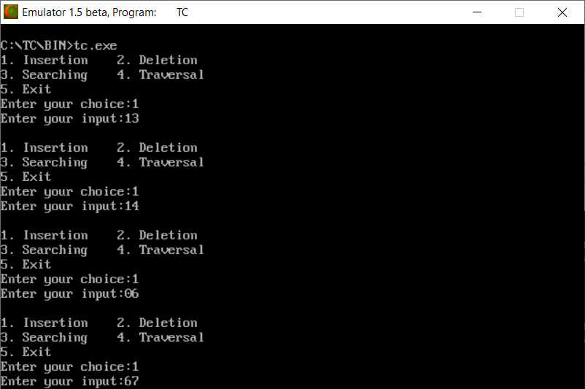

1. **TRAVERSAL**

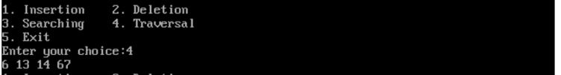

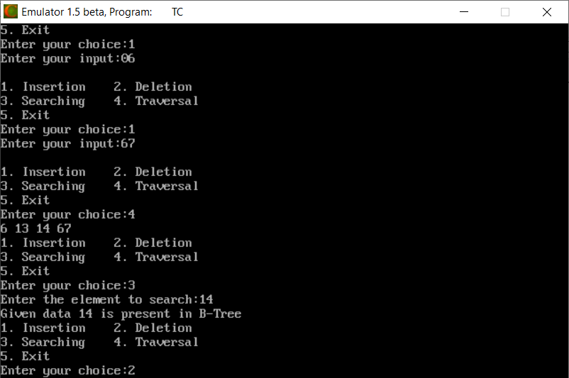

1. **SEARCHING DATA**

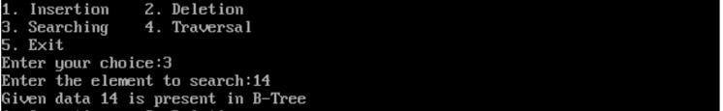

1. **DELETE DATA**

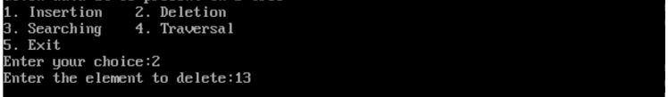

**Practical :- 7**

**AIM :- Implement B Tree.**

**Code :-**

#include <stdio.h>

#include <stdlib.h>

//#include<conio.h>

#define M 3

typedef struct _node {

int n;

int keys[M - 1];

struct _node *p[M];

} node;

node *root = NULL;

typedef enum KeyStatus {

Duplicate,

SearchFailure,

Success,

InsertIt,

LessKeys,

} KeyStatus;

void insert(int key);

void display(node *root, int);

void DelNode(int x);

void search(int x);

KeyStatus ins(node *r, int x, int* y, node** u);

int searchPos(int x, int *key_arr, int n);

KeyStatus del(node *r, int x);

void eatline(void);

void inorder(node *ptr);

int totalKeys(node *ptr);

void printTotal(node *ptr);

int getMin(node *ptr);

int getMax(node *ptr);

void getMinMax(node *ptr);

int max(int first, int second, int third);

int maxLevel(node *ptr);

void printMaxLevel(node *ptr);

int main() {

int key;

int choice;

printf("Creation of B tree for M=%d\n", M);

while (1) {

printf("1.Insert\n");

printf("2.Delete\n");

printf("3.Search\n");

printf("4.Display\n");

printf("5.Quit\n");

printf("6.Enumerate\n");

printf("7.Total Keys\n");

printf("8.Min and Max Keys\n");

printf("9.Max Level\n");

printf("Enter your choice : ");

scanf("%d", &choice); eatline();

switch (choice) {

case 1:

printf("Enter the key : ");

scanf("%d", &key); eatline();

insert(key);

break;

case 2:

printf("Enter the key : ");

scanf("%d", &key); eatline();

DelNode(key);

break;

case 3:

printf("Enter the key : ");

scanf("%d", &key); eatline();

search(key);

break;

case 4:

printf("Btree is :\n");

display(root, 0);

break;

case 5:

exit(1);

case 6:

printf("Btree in sorted order is:\n");

inorder(root); putchar('\n');

break;

case 7:

printf("The total number of keys in this tree is:\n");

printTotal(root);

break;

case 8:

getMinMax(root);

break;

case 9:

printf("The maximum level in this tree is:\n");

printMaxLevel(root);

break;

default:

printf("Wrong choice\n");

break;

}

}

return 0;

}

void insert(int key) {

node *newnode;

int upKey;

KeyStatus value;

value = ins(root, key, &upKey, &newnode);

if (value == Duplicate)

printf("Key already available\n");

if (value == InsertIt) {

node *uproot = root;

root = (node*)malloc(sizeof(node));

root->n = 1;

root->keys[0] = upKey;

root->p[0] = uproot;

root->p[1] = newnode;

}

}

KeyStatus ins(node *ptr, int key, int *upKey, node **newnode) {

node *newPtr, *lastPtr;

int pos, i, n, splitPos;

int newKey, lastKey;

KeyStatus value;

if (ptr == NULL) {

*newnode = NULL;

*upKey = key;

return InsertIt;

}

n = ptr->n;

pos = searchPos(key, ptr->keys, n);

if (pos < n && key == ptr->keys[pos])

return Duplicate;

value = ins(ptr->p[pos], key, &newKey, &newPtr);

if (value != InsertIt)

return value;

if (n < M - 1) {

pos = searchPos(newKey, ptr->keys, n);

for (i = n; i>pos; i--) {

ptr->keys[i] = ptr->keys[i - 1];

ptr->p[i + 1] = ptr->p[i];

}

ptr->keys[pos] = newKey;

ptr->p[pos + 1] = newPtr;

++ptr->n;

return Success;

}/*End of if */

if (pos == M - 1) {

lastKey = newKey;

lastPtr = newPtr;

}

else {

lastKey = ptr->keys[M - 2];

lastPtr = ptr->p[M - 1];

for (i = M - 2; i>pos; i--) {

ptr->keys[i] = ptr->keys[i - 1];

ptr->p[i + 1] = ptr->p[i];

}

ptr->keys[pos] = newKey;

ptr->p[pos + 1] = newPtr;

}

splitPos = (M - 1) / 2;

(*upKey) = ptr->keys[splitPos];

(*newnode) = (node*)malloc(sizeof(node));

ptr->n = splitPos;

(*newnode)->n = M - 1 - splitPos;

for (i = 0; i < (*newnode)->n; i++) {

(*newnode)->p[i] = ptr->p[i + splitPos + 1];

if (i < (*newnode)->n - 1)

(*newnode)->keys[i] = ptr->keys[i + splitPos + 1];

else

(*newnode)->keys[i] = lastKey;

}

(*newnode)->p[(*newnode)->n] = lastPtr;

return InsertIt;

}/*End of ins()*/

void display(node *ptr, int blanks) {

if (ptr) {

int i;

for (i = 1; i <= blanks; i++)

printf(" ");

for (i = 0; i < ptr->n; i++)

printf("%d ", ptr->keys[i]);

printf("\n");

for (i = 0; i <= ptr->n; i++)

display(ptr->p[i], blanks + 10);

}/*End of if*/

}/*End of display()*/

void search(int key) {

int pos, i, n;

node *ptr = root;

printf("Search path:\n");

while (ptr) {

n = ptr->n;

for (i = 0; i < ptr->n; i++)

printf(" %d", ptr->keys[i]);

printf("\n");

pos = searchPos(key, ptr->keys, n);

if (pos < n && key == ptr->keys[pos]) {

printf("Key %d found in position %d of last dispalyed node\n", key, i);

return;

}

ptr = ptr->p[pos];

}

printf("Key %d is not available\n", key);

}/*End of search()*/

int searchPos(int key, int *key_arr, int n) {

int pos = 0;

while (pos < n && key > key_arr[pos])

pos++;

return pos;

}/*End of searchPos()*/

void DelNode(int key) {

node *uproot;

KeyStatus value;

value = del(root, key);

switch (value) {

case SearchFailure:

printf("Key %d is not available\n", key);

break;

case LessKeys:

uproot = root;

root = root->p[0];

free(uproot);

break;

default:

return;

}/*End of switch*/

}/*End of delnode()*/

KeyStatus del(node *ptr, int key) {

int pos, i, pivot, n, min;

int *key_arr;

KeyStatus value;

node **p, *lptr, *rptr;

if (ptr == NULL)

return SearchFailure;

/*Assigns values of node*/

n = ptr->n;

key_arr = ptr->keys;

p = ptr->p;

min = (M - 1) / 2;/*Minimum number of keys*/

pos = searchPos(key, key_arr, n);

// p is a leaf

if (p[0] == NULL) {

if (pos == n || key < key_arr[pos])

return SearchFailure;

/*Shift keys and pointers left*/

for (i = pos + 1; i < n; i++)

{

key_arr[i - 1] = key_arr[i];

p[i] = p[i + 1];

}

return --ptr->n >= (ptr == root ? 1 : min) ? Success : LessKeys;

}/*End of if */

if (pos < n && key == key_arr[pos]) {

node *qp = p[pos], *qp1;

int nkey;

while (1) {

nkey = qp->n;

qp1 = qp->p[nkey];

if (qp1 == NULL)

break;

qp = qp1;

}/*End of while*/

key_arr[pos] = qp->keys[nkey - 1];

qp->keys[nkey - 1] = key;

}/*End of if */

value = del(p[pos], key);

if (value != LessKeys)

return value;

if (pos > 0 && p[pos - 1]->n > min) {

pivot = pos - 1; /*pivot for left and right node*/

lptr = p[pivot];

rptr = p[pos];

rptr->p[rptr->n + 1] = rptr->p[rptr->n];

for (i = rptr->n; i>0; i--) {

rptr->keys[i] = rptr->keys[i - 1];

rptr->p[i] = rptr->p[i - 1];

}

rptr->n++;

rptr->keys[0] = key_arr[pivot];

rptr->p[0] = lptr->p[lptr->n];

key_arr[pivot] = lptr->keys[--lptr->n];

return Success;

}/*End of if */

//if (posn > min)

if (pos < n && p[pos + 1]->n > min) {

pivot = pos; /*pivot for left and right node*/

lptr = p[pivot];

rptr = p[pivot + 1];

/*Assigns values for left node*/

lptr->keys[lptr->n] = key_arr[pivot];

lptr->p[lptr->n + 1] = rptr->p[0];

key_arr[pivot] = rptr->keys[0];

lptr->n++;

rptr->n--;

for (i = 0; i < rptr->n; i++) {

rptr->keys[i] = rptr->keys[i + 1];

rptr->p[i] = rptr->p[i + 1];

}/*End of for*/

rptr->p[rptr->n] = rptr->p[rptr->n + 1];

return Success;

}/*End of if */

if (pos == n)

pivot = pos - 1;

else

pivot = pos;

lptr = p[pivot];

rptr = p[pivot + 1];

/*merge right node with left node*/

lptr->keys[lptr->n] = key_arr[pivot];

lptr->p[lptr->n + 1] = rptr->p[0];

for (i = 0; i < rptr->n; i++) {

lptr->keys[lptr->n + 1 + i] = rptr->keys[i];

lptr->p[lptr->n + 2 + i] = rptr->p[i + 1];

}

lptr->n = lptr->n + rptr->n + 1;

free(rptr); /*Remove right node*/

for (i = pos + 1; i < n; i++) {

key_arr[i - 1] = key_arr[i];

p[i] = p[i + 1];

}

return --ptr->n >= (ptr == root ? 1 : min) ? Success : LessKeys;

}/*End of del()*/

void eatline(void) {

char c;

while ((c = getchar()) != '\n');

}

void inorder(node *ptr) {

if (ptr) {

if (ptr->n >= 1) {

inorder(ptr->p[0]);

printf("%d ", ptr->keys[0]);

inorder(ptr->p[1]);

if (ptr->n == 2) {

printf("%d ", ptr->keys[1]);

inorder(ptr->p[2]);

}

}

}

}

int totalKeys(node *ptr) {

if (ptr) {

int count = 1;

if (ptr->n >= 1) {

count += totalKeys(ptr->p[0]);

count += totalKeys(ptr->p[1]);

if (ptr->n == 2) count += totalKeys(ptr->p[2]) + 1;

}

return count;

}

return 0;

}

void printTotal(node *ptr) {

printf("%d\n", totalKeys(ptr));

}

int getMin(node *ptr) {

if (ptr) {

int min;

if (ptr->p[0] != NULL) min = getMin(ptr->p[0]);

else min = ptr->keys[0];

return min;

}

return 0;

}

int getMax(node *ptr) {

if (ptr) {

int max;

if (ptr->n == 1) {

if (ptr->p[1] != NULL) max = getMax(ptr->p[1]);

else max = ptr->keys[0];

}

if (ptr->n == 2) {

if (ptr->p[2] != NULL) max = getMax(ptr->p[2]);

else max = ptr->keys[1];

}

return max;

}

return 0;

}

void getMinMax(node *ptr) {

printf("%d %d\n", getMin(ptr), getMax(ptr));

}

int max(int first, int second, int third) {

int max = first;

if (second > max) max = second;

if (third > max) max = third;

return max;

}

int maxLevel(node *ptr) {

if (ptr) {

int l = 0, mr = 0, r = 0, max_depth;

if (ptr->p[0] != NULL) l = maxLevel(ptr->p[0]);

if (ptr->p[1] != NULL) mr = maxLevel(ptr->p[1]);

if (ptr->n == 2) {

if (ptr->p[2] != NULL) r = maxLevel(ptr->p[2]);

}

max_depth = max(l, mr, r) + 1;

return max_depth;

}

return 0;

}

void printMaxLevel(node *ptr) {

int max = maxLevel(ptr) - 1;

if (max == -1) printf("tree is empty\n");

else printf("%d\n", max);

}

**OUTPUT :**

1. **INSERT DATA**

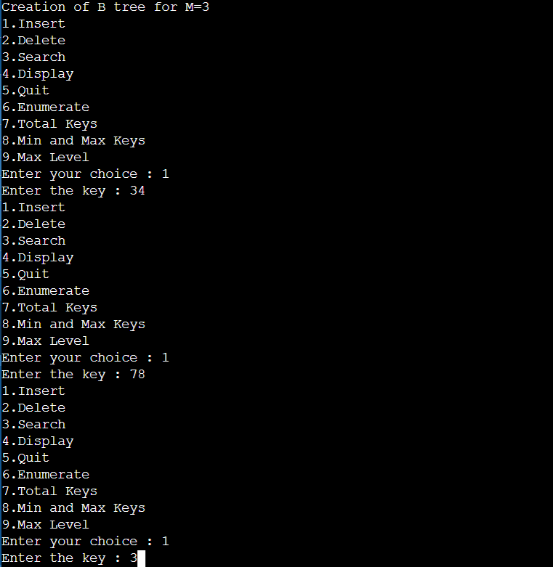

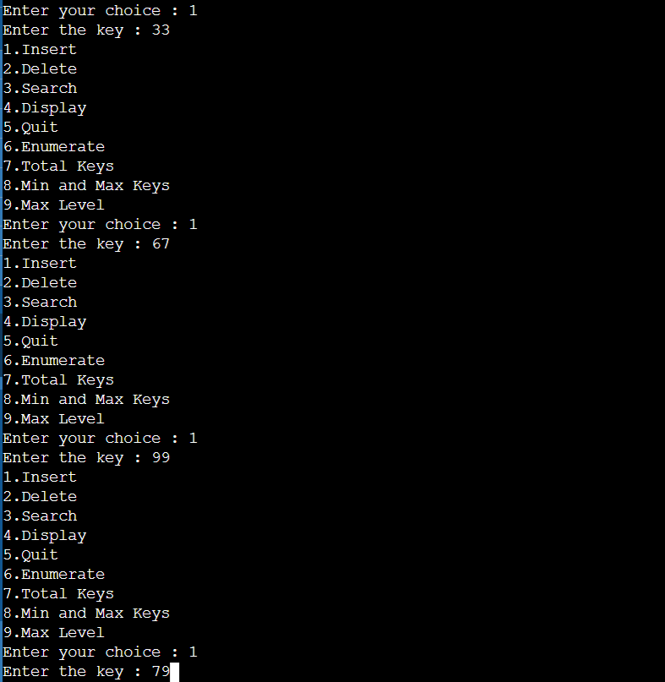

1. **DISPLAY DATA**

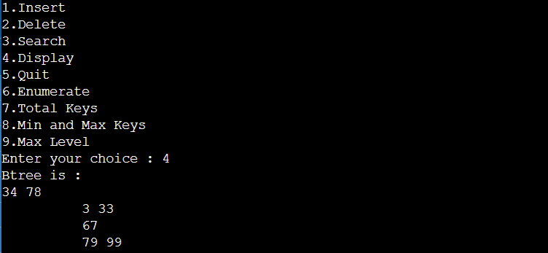

1. **ENUMERATE DATA**

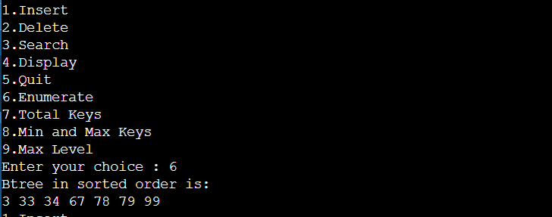

1. **TOTAL KEYS**

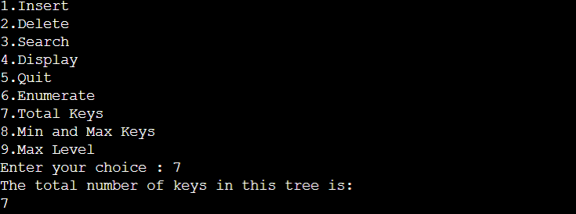

1. **MIN AND MAX KEYS**

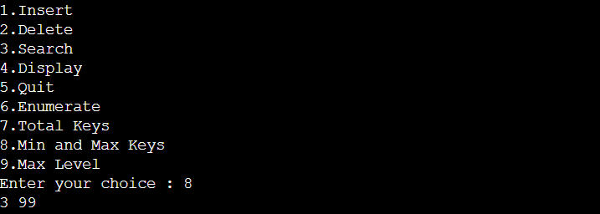

1. **MAX LEVEL**

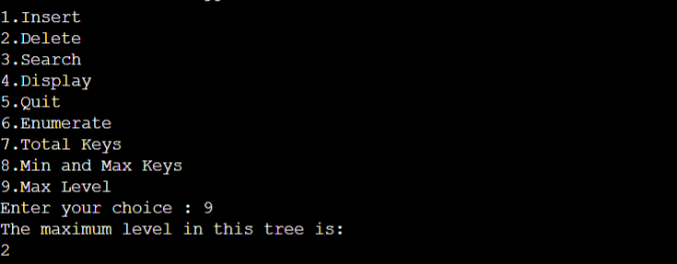

1. **SEARCH KEY**

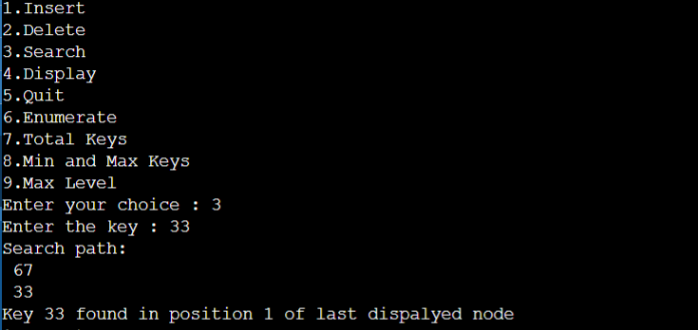

1. **DELETE KEY**

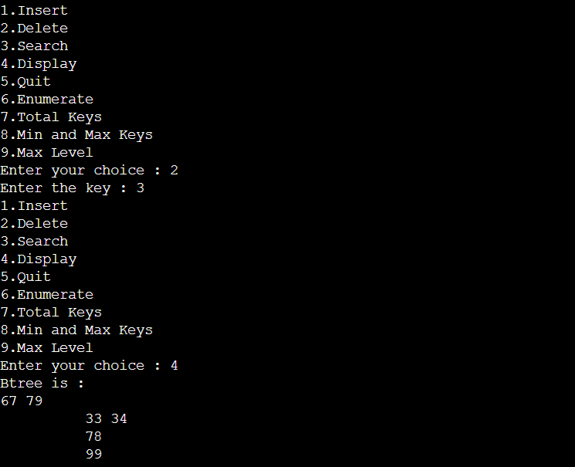

**Practical :- 8**

**AIM :- Implement a program for String Matching using Boyer Moore Algorithm on a text file content.**

**Code :-**

# include <limits.h>

# include <string.h>

# include <stdio.h>

# define NO_OF_CHARS 256

int max (int a, int b) { return (a > b)? a: b; }

void badCharHeuristic( char *str, int size, int badchar[NO_OF_CHARS]){

int i;

for (i = 0; i < NO_OF_CHARS; i++)

badchar[i] = -1;

for (i = 0; i < size; i++)

badchar[(int) str[i]] = i;

}

void search( char *txt, char *pat){

int m = strlen(pat);

int n = strlen(txt);

int s=0;

int badchar[NO_OF_CHARS];

badCharHeuristic(pat, m, badchar);

while(s <= (n - m)){

int j = m-1;

while(j >= 0 && pat[j] == txt[s+j])

j--;

if (j < 0){

printf("\n pattern occurs at shift = %d", s);

s += (s+m < n)? m-badchar[txt[s+m]] : 1;

}

else

s += max(1, j - badchar[txt[s+j]]);

}

}

void main(){

char txt[] = "Hello How Are You!!";

char pat[] = "Are";

clrscr();

search(txt, pat);

getch();

}

**OUTPUT:**

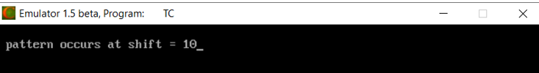

**Practical :- 9**

**AIM :- Implement a program for String Matching using Knuth-Morris-Pratt Algorithm on a text file content.**

**Code :-**

#include<stdio.h>

#include<string.h>

#include<stdlib.h>

void computeLPSArray(char *pat, int M, int *lps);

void KMPSearch(char *pat, char *txt) {

int M = strlen(pat);

int N = strlen(txt);

//create lps[] that will hold the longest prefix suffix values for pattern

int *lps = (int *)malloc(sizeof(int) * (M + 1));

int i=0; //index for txt[]

int j= 0; //index for pat[]

//Preprocess the pattern (calculate lps[] array)

computeLPSArray(pat, M, lps);

//at this point i may be incremented while i < N && txt[i] != pat[0] - for performance

while (i < N){

if (pat[j] == txt[i]) {

i++;

j++;

if (j == M) {

printf("Found pattern at index %d \n", i-j);

j = lps[j];

}

}

else {//if (pat[j] != txt[i]) //mismatch after j matches

//Pattern shift

j = lps[j];

if (j < 0) {

i++;

j++;

//at this point i may be incremented while i < N && txt[i] != pat[0] - for performance

}

}

}

free(lps); //to avoid memory leak

}

void computeLPSArray(char *pat, int M, int *lps) {

int i=1;

int j=0;

lps[0] = -1;

while (i < M) {

if (pat[j] == pat[i]) {

lps[i] = lps[j];

i++;

j++;

}

else { // (pat[j] != pat[i])

lps[i] = j;

j = lps[j];

while (j >= 0 && pat[j] != pat[i]) {

j = lps[j];

}

i++;

j++;

}

}

lps[i] = j;

}

// Driver program to test above function

int main() {

// clrscr();

char *txt = "hello how are you";

char *pat = "you";

KMPSearch(pat, txt);

return 0;

}

**OUTPUT:**



**Practical :- 10**

**AIM :- Implement Huffman-Coding Method. Show the result with suitable example.**

**Code :-**

#include<string.h>

#include<stdio.h>

#include<stdlib.h>

typedef struct node {

char ch;

int freq;

struct node *left;

struct node *right;

}node;

node * heap[100];

int heapSize=0;

void Insert(node * element) {

heapSize++;

heap[heapSize] = element;

int now = heapSize;

while(heap[now/2] -> freq > element -> freq) {

heap[now] = heap[now/2];

now /= 2;

}

heap[now] = element;

}

node * DeleteMin() {

node * minElement,*lastElement;

int child,now;

minElement = heap[1];

lastElement = heap[heapSize--];

for(now = 1; now*2 <= heapSize ;now = child) {

child = now*2;

if(child != heapSize && heap[child+1]->freq < heap[child] -> freq ) {

child++;

}

if(lastElement -> freq > heap[child] -> freq) {

heap[now] = heap[child];

}

else{

break;

}

}

heap[now] = lastElement;

return minElement;

}

void print(node *temp,char *code) {

if(temp->left==NULL && temp->right==NULL {

printf("char %c code %s\n",temp->ch,code);

return;

}

int length = strlen(code);

char leftcode[10],rightcode[10];

strcpy(leftcode,code);

strcpy(rightcode,code);

leftcode[length] = '0';

leftcode[length+1] = '\0';

rightcode[length] = '1';

rightcode[length+1] = '\0';

print(temp->left,leftcode);

print(temp->right,rightcode);

}

int main(){

heap[0] = (node *)malloc(sizeof(node));

heap[0]->freq = 0;

int n ;

printf("Enter the no of characters: ");

scanf("%d",&n);

printf("Enter the characters and their frequencies: ");

char ch;

int freq,i;

for(i=0;i<n;i++) {

scanf(" %c",&ch);

scanf("%d",&freq);

node * temp = (node *) malloc(sizeof(node));

temp -> ch = ch;

temp -> freq = freq;

temp -> left = temp -> right = NULL;

Insert(temp);

}

if(n==1) {

printf("char %c code 0\n",ch);

return 0;

}

for(i=0;i<n-1 ;i++) {

node * left = DeleteMin();

node * right = DeleteMin();

node * temp = (node *) malloc(sizeof(node));

temp -> ch = 0;

temp -> left = left;

temp -> right = right;

temp -> freq = left->freq + right -> freq;

Insert(temp);

}

node *tree = DeleteMin();

char code[10];

code[0] = '\0';

print(tree,code);

}

**OUTPUT:**

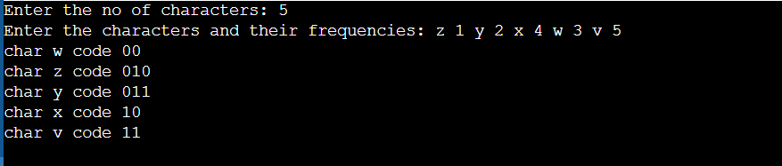

**Practical :- 11**

**AIM :- Write a program which creates Skip Lists. Implement Insert, Search and Update Operations in Skip-Lists.**

**Code :-**

#include<stdio.h>

#include<stdlib.h>

#include<time.h>

typedef struct node np;

struct node{

int data;

np *up;

np *down;

np *left;

np *right;

};

np *list=NULL;

int height=1,width=1;

int toss_coin();

np *createNode();

void print_sl();

void toss_it(np *x);

int search_sl(int item);

int delete_sl(int item);

void main(){

srand(time(NULL));

//option for choice

int choice=1;

while(choice!=0){

printf("\nOption for operation:\n 0)Exit 1)insert 2)search 3)print List 4)delete\nOption: ");

scanf("%d",&choice);

while(choice<0 || choice>4){

printf("Select correct option: ");

scanf("%d",&choice);

}

int data;

switch(choice){

case 1:

printf("\nEnter a nonnegative value: ");

scanf("%d",&data);

if(insert_sl(data)==1){

printf("\n%d was inserted successfully\n",data);

}

else{

printf("\n%d was not inserted!!\n",data);

}

break;

case 2:

printf("\nEnter a value to search: ");

scanf("%d",&data);

if(search_sl(data))

printf("\n%d has been found.\n",data);

else

printf("\n%d is not available.\n",data);

break;

case 3:

print_sl();

break;

case 4:

printf("\nEnter a value to delete: ");

scanf("%d",&data);

if(delete_sl(data))

printf("\n%d has been deleted.\n",data);

else

printf("\n%d is not available.\n",data);

break;

}

}

}

int delete_sl(int item){

np *curr=list,*temp;

int down_count=0;

while(curr!=NULL){

temp=curr;

if(curr->right && curr->right->data<item){

curr=curr->right;

printf("Right-");

}

else if(curr->right && curr->right->data==item){

np *node=curr->right;

while(node) {//go down one by one

if(node->left->data==-1 && node->right==NULL) {

down_count++;//count the level from uppermost level

}

if(node->right){

node->right->left=node->left;

node->left->right=node->right;

}

else{

node->left->right=NULL;

}

np *nd=node->down;

free(node);

node=nd;

}

//update the width and height

width--;

height=height-down_count;

return 1;

}

else {

curr=curr->down;

printf("Down-");

}

}

return 0;

printf("\n");

}

int search_sl(int item){

np *curr=list,*temp;

while(curr!=NULL){

temp=curr;

if(curr->right && curr->right->data<item){

curr=curr->right;

printf("Right-");

}

else if(curr->right && curr->right->data==item)return 1;

else {

curr=curr->down;

printf("Down-");

}

}

return 0;

printf("\n");

}

int insert_sl(int item){

if(item<0)return 0;

if(!list){//for the first item

list=createNode();

np *newnode=createNode();

list->right=newnode;

newnode->left=list;

newnode->data=item;

//toss to go upper level

toss_it(list->right);

width++;

return 1;

}

//if list is not empty, find the right position

np *curr=list,*temp;

while(curr!=NULL){

temp=curr;

if(curr->right && curr->right->data<item){

curr=curr->right;

printf("Right-");

}

else if(curr->right && curr->right->data==item)return 0;

else {

curr=curr->down;

printf("Down-");

}

}

printf("\n");

np *newnode=createNode();

newnode->data=item;

if(temp->right==NULL){//when added at the right most

temp->right=newnode;

newnode->left=temp;

}

else{//when added between two nodes

newnode->left=temp;

newnode->right=temp->right;

temp->right->left=newnode;

temp->right=newnode;

}

toss_it(newnode);

width++;

return 1;

}

void toss_it(np *x){

int h=1;

while(toss_coin()){

printf("\nToss Win");

h++;

if(h>height){//create a new level

height=h;

np *ln=createNode();

ln->down=list;

list->up=ln;

list=ln;

//add the node to the new level

np *newnode=createNode();

ln->right=newnode;

newnode->data=x->data;

newnode->down=x;

newnode->left=ln;

x->up=newnode;

x=newnode;

}

else{//add the node to an existing level

np *temp=x->left;

while(temp->up==NULL){

temp=temp->left;

}

temp=temp->up;

np *newnode=createNode();

newnode->data=x->data;

newnode->left=temp;

newnode->down=x;

temp->right=newnode;

x->up=newnode;

x=newnode;

}

}

}

np *createNode(){

np *newnode=(np *)malloc(sizeof(np));

newnode->data=-1;

newnode->left=NULL;

newnode->down=NULL;

newnode->up=NULL;

newnode->right=NULL;

return newnode;

}

void print_sl(){

if(!list)return;

int v[height][width],i,j;

for(i=0;i<height;i++){

for(j=0;j<width;j++){

v[i][j]=-1;

}

}

np *base=list;

for(base=list;base->down;base=base->down);

j=0;

for(;base;base=base->right) {

i=height-1;

np *goup=base;

for(;goup;goup=goup->up){

v[i][j]=goup->data;

i--;

}

j++;

}

printf("\n");

for(i=0;i<height;i++){

for(j=1;j<width;j++){

if(v[i][j]==-1){

printf(" - ");

}

else{

printf("%3d",v[i][j]);

}

}

printf("\n");

}

printf("\n");

}

int toss_coin(){

float t=(float)(rand()%100)/100;

return t>0.5?1:0;

}

**OUTPUT:**

1. **INSERT DATA**

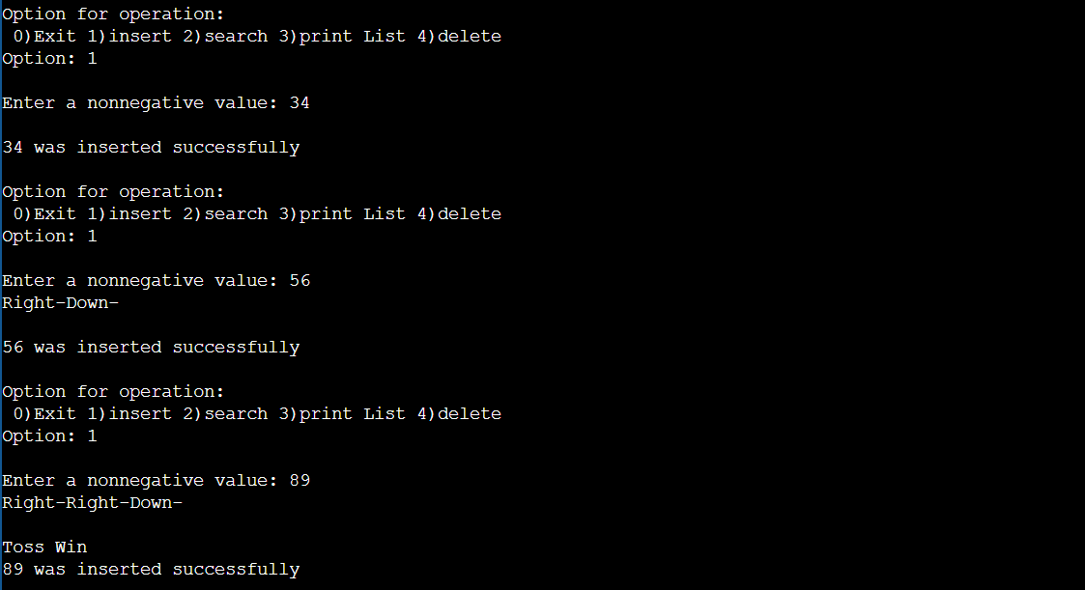

1. **DISPLAY DATA**

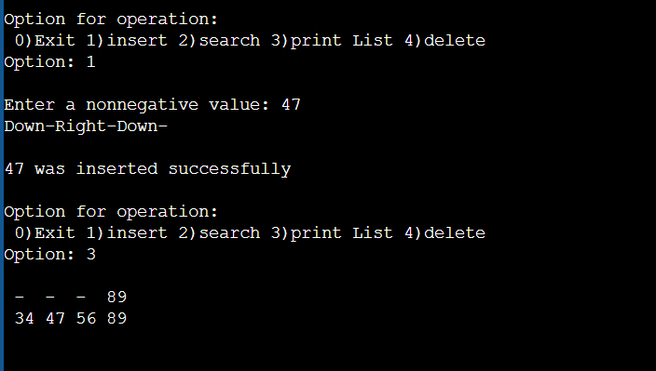

1. **SEARCH DATA**

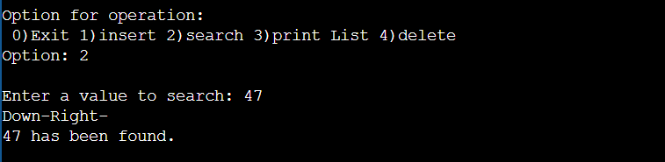

1. **DELETE DATA**

