Q1

<!DOCTYPE html>

<html>

<head>

    <title>JSF Q1</title>

</head>

<body>

    <script>

        function square(x) {

            return (x \* x);

        }

        function double(x) {

            return (x \* 2);

        }

        function composedValue(square, double, x) {

            return square(double(x));

        }

    </script>

</body>

</html>

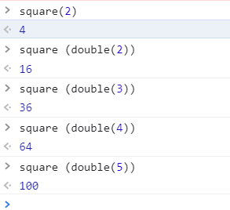

Q2

<!DOCTYPE html>

<html>

<head>

    <title>JSF Q2</title>

</head>

<body>

    <script>

        function square(x) {

            return (x \* x);

        }

        function double(x) {

            return (x \* 2);

        }

        var f1 = console.log(square(double(5)))

        var f1 = console.log(square(double(10)))

        var f2 = console.log(double(square(5)))

        var f2 = console.log(double(square(10)))

    </script>

</body>

</html>

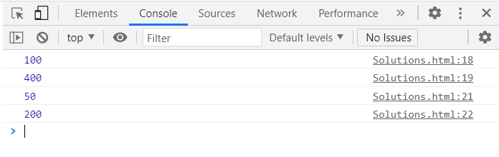

Q3.

<!DOCTYPE html>

<html>

<head>

    <title>JSF Q3</title>

</head>

<body>

    <script>

        function isEven(num) {

            return (num % 2 == 0);

        }

        function find() {

            return array;

        }

        console.log(find[1, 3, 5, 4, 2], isEven);

    </script>

</body>

</html>

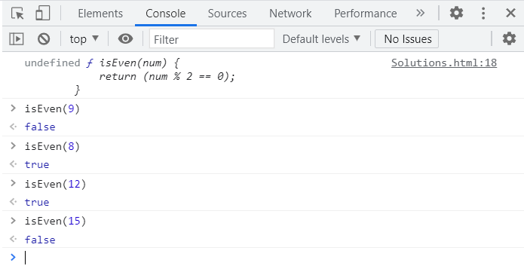

Q4.

<!DOCTYPE html>

<html>

<head>

    <title>JSF Q4</title>

</head>

<body>

    <script>

        let arr1 = [1, 2, 3, 4, 5];

        let map1 = arr1.map(x => Math.pow(x, 2));

        console.log("Square of the array is: [" + map1 + "]");

        let arr2 = [1, 4, 9, 16, 25];

        let map2 = arr2.map(x => Math.sqrt(x, 2));

        console.log("Square root of the array is: [" + map2 + "]");

    </script>

</body>

</html>

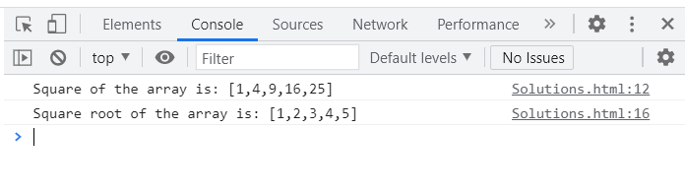

Q6. <!DOCTYPE html>

<html>

<head>

    <title>JSF Q4</title>

</head>

<body>

    <script>

 let numbers = [1,4,9,16,25];

 let results = numbers.map(Math.sqrt);

 console.log(results);

    </script>

</body>

</html>

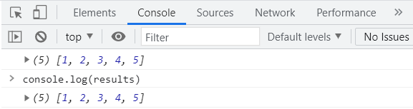

<!DOCTYPE html>

<html>

<head>

    <title>JSF Q1</title>

</head>

<body>

    <script>

 const array1 = [1, 2, 3, 4, 5];

// pass a function to map

const map1 = array1.map(x => x \* x);

console.log(map1);

    </script>

</body>

</html>

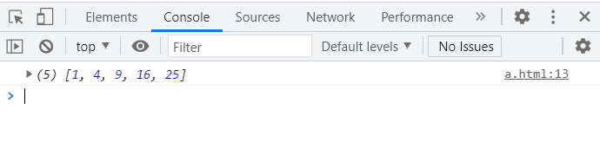

Q7.

<!DOCTYPE html>

<html>

<head>

    <title>JSF Q1</title>

</head>

<body>

    <script>

 var a = false,

    result = [1,2,3,4].map(

        function a(n){

            return ( n\*n ) ;

        });

    </script>

</body>

</html>

Q5.

<!DOCTYPE html>

<html>

<head>

    <title>JSF Q5</title>

</head>

<body>

    <script>

        function isEven(num) {

            return (num % 2 == 0);

            find([1,3,5,2,4], isEven);

        }

    </script>

</body>

</html>

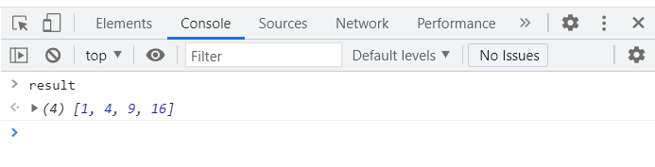

<!DOCTYPE html>

<html>

<head>

    <title>JSF Q7</title>

</head>

<body>

    <script>

 var a = function myself(callAgain){

    console.log( 'Hello Riddhi' );

    if (callAgain === true) myself(false);

};

a(true);

    </script>

</body>

</html>

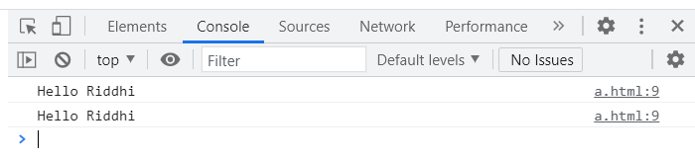

Q5

<!DOCTYPE html>

<html>

<head>

    <title>JSF Q5</title>

</head>

<body>

    <script>

        function isEven(num) {

            return (num % 2 == 0);

            find([1,3,5,2,4], isEven);

        }

    </script>

</body>

</html>

React JS

Q1.

Hello World using npx through VS terminal

npx create-react-app hello-world

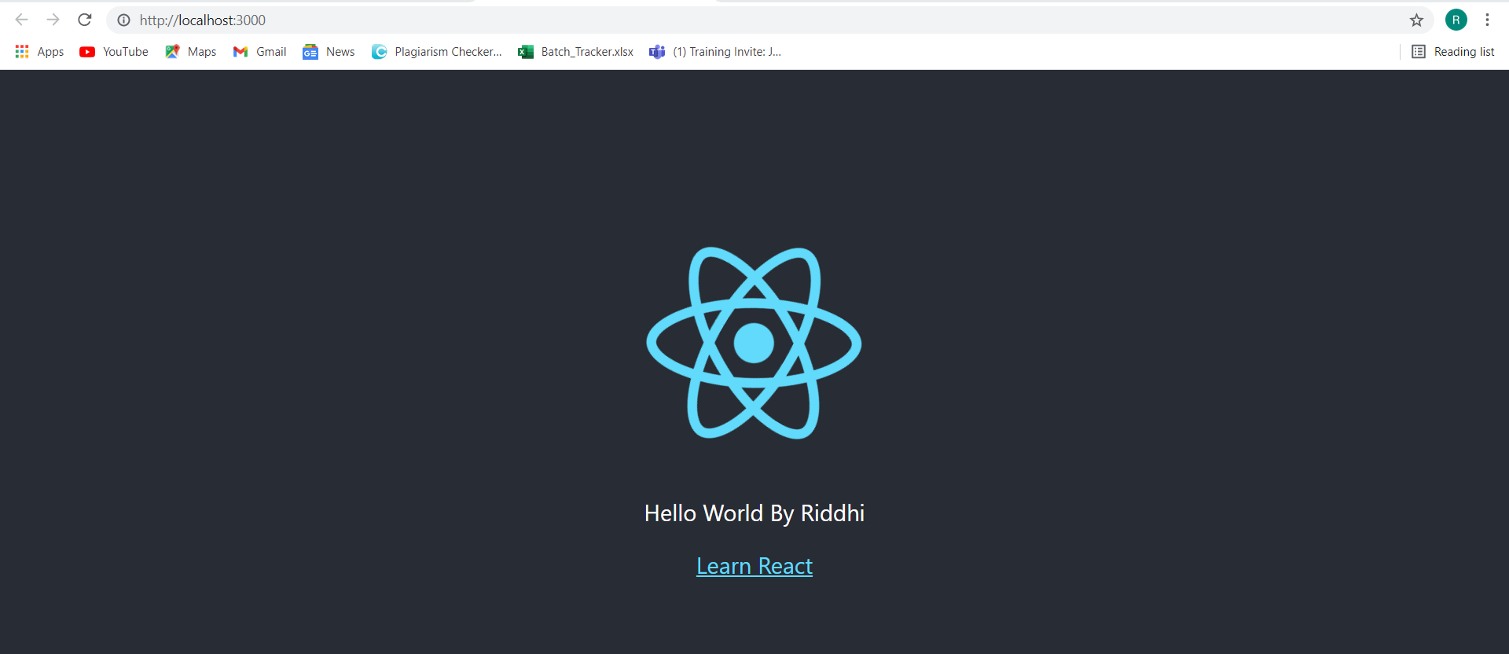

Fucntional component

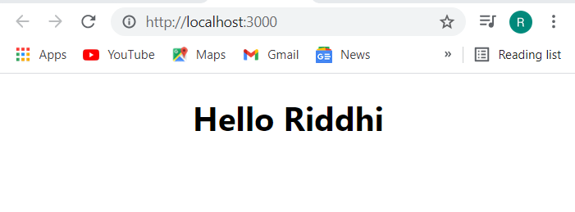

Class Component.

