CUSTOMER SEGMENTATION USING K-MEANS CLUSTERING

Submitted By:
Riddhi Bhati

Internship:
Data Analytics Internship

Tools Used:
• Python
• Pandas
• Matplotlib
• Scikit-learn
• Power BI

Submission Date:
July 2026
Table of Contents

1. Introduction
2. Objective
3. Dataset Description
4. Tools & Technologies
5. Data Preprocessing
6. Exploratory Data Analysis
7. K-Means Clustering
8. Elbow Method
9. Customer Segments
10. Power BI Dashboard
11. Business Insights
12. Conclusion
13. References

Introduction
Customer segmentation is the process of dividing customers into groups based on shared characteristics such as demographics, purchasing behaviour, and spending habits. It helps businesses better understand their customers, develop targeted marketing strategies, improve customer satisfaction, and increase profitability. In this project, the Mall Customers dataset was analysed using the K-Means clustering algorithm to identify meaningful customer groups. Python was used for data preprocessing, analysis, and visualization, while Power BI was used to create an interactive dashboard for presenting the results.

Objective
• Analyse customer demographic and purchasing behaviour.
• Perform customer segmentation using the K-Means clustering algorithm.
• Identify meaningful customer groups based on annual income and spending score.
• Visualize customer segments using Python and Power BI.
• Generate business insights and recommendations for targeted marketing strategies.

Dataset Description

Dataset Overview
The project uses the Mall Customers Dataset, which contains demographic and spending information for customers visiting a shopping mall.

Dataset Summary
Attribute | Value
Dataset Name | Mall Customers Dataset
Number of Records | 200
Number of Columns | 5
File Format | CSV

Dataset Features
Column | Description
Customer ID | Unique customer identifier
Gender | Male or Female
Age | Customer age
Annual_Income_(k$) | Annual income in thousands of dollars
Spending_Score | Spending score assigned by the mall
Tools & Technologies

Tool | Purpose
Python | Data analysis
Pandas | Data manipulation
NumPy | Numerical computations
Matplotlib | Data visualization
Seaborn | Statistical visualization
Scikit-learn | K-Means clustering
Power BI | Dashboard creation
GitHub | Project hosting
Data Preprocessing
Data Loading
The dataset was imported into Python using the Pandas library.

Data Inspection
The following checks were performed:
- Displayed the first few records using head().
- Examined data types and structure using info().
- Generated descriptive statistics using describe().

Missing Values
Duplicate rows were checked using duplicated(). sum().
Result: No duplicate records were found.

Duplicate Records
Duplicate rows were checked using duplicated().sum().
Result: No duplicate records were found.
Exploratory Data Analysis (EDA)

Age Distribution
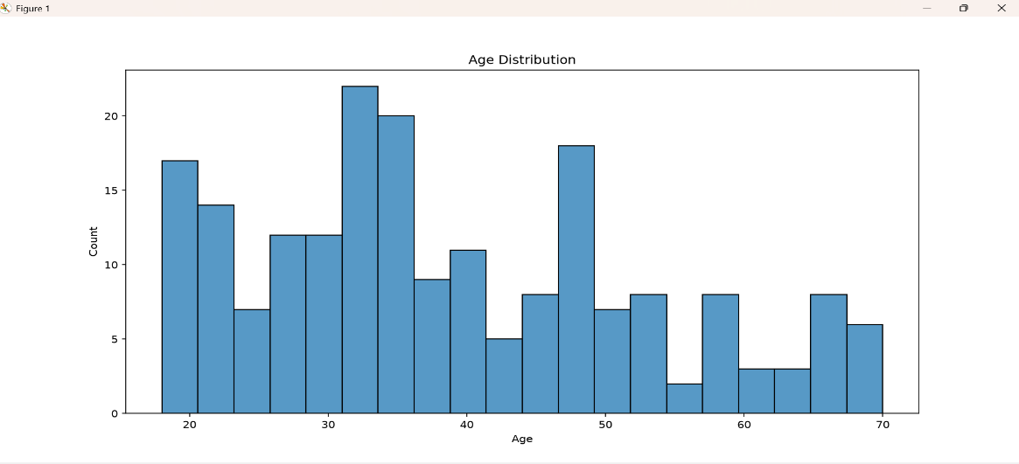
Figure 1: Age Distribution of Customers

Interpretation:
Most customers fall within the young adult to middle-aged group, indicating that the mall serves a broad range of age groups

Gender Distribution
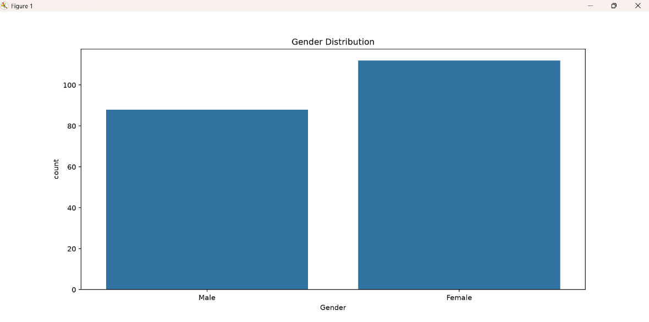
Figure 2: Gender Distribution

Interpretation:
The dataset contains both male and female customers, providing a balanced demographic for customer segmentation.

Income Distribution
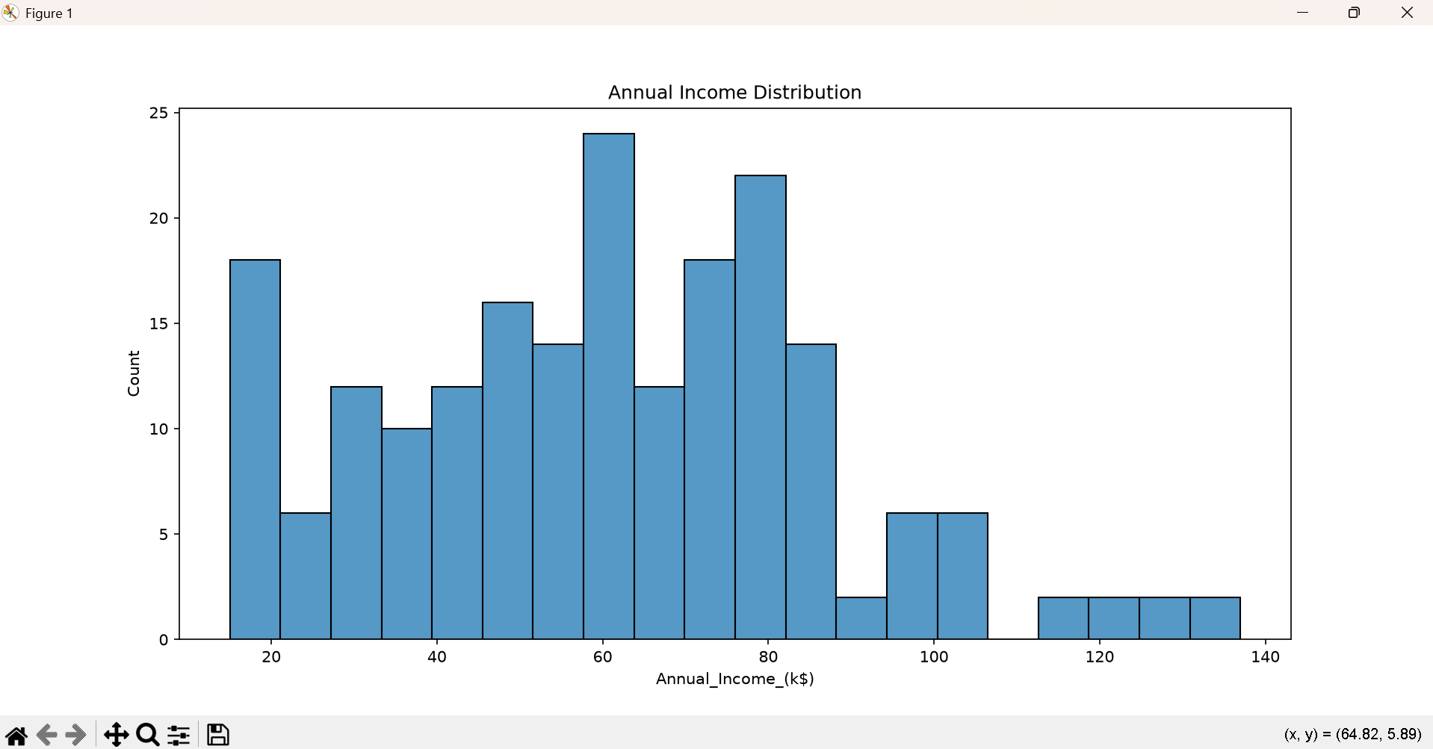
Figure 3: Annual Income Distribution

Interpretation:
Annual income is distributed across multiple ranges, making it a suitable feature for clustering customers.

Spending Distribution
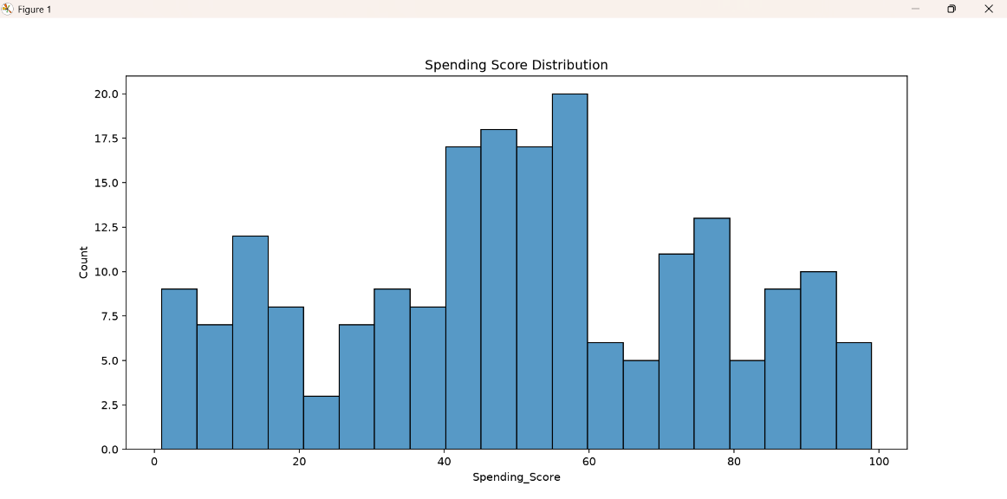
Figure 4: Spending Score Distribution

Interpretation:
Spending scores vary considerably among customers, indicating different purchasing behaviours.

Income vs Spending
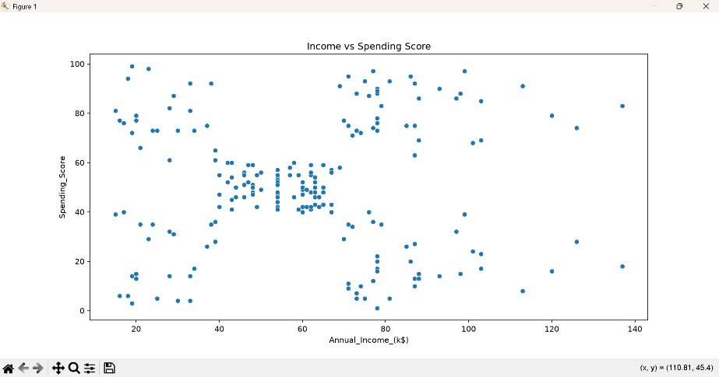
Figure 5: Income vs Spending Score
Interpretation:
The scatter plot suggests natural groupings of customers, supporting the use of clustering techniques.
Feature Selection & K-Means Clustering

Feature Selection
For clustering, the following features were selected:
- Annual_Income_(k$)
- Spending_Score
These features were chosen because they best represent customer purchasing behaviour.

Feature Scaling
The selected features were standardized using Standard Scaler to ensure both variables contributed equally during clustering.

Why K-Means?
K-Means clustering was selected because it is a simple and effective algorithm for partitioning numerical data into groups based on similarity.

Elbow Method & Cluster Analysis
Elbow Method
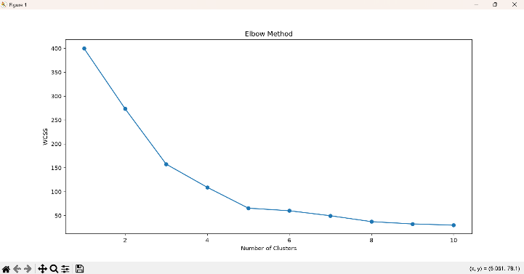
Figure 6: Elbow Method
Interpretation:
The elbow occurs at five clusters, indicating that five is the optimal number of customer segments.
Cluster Plot
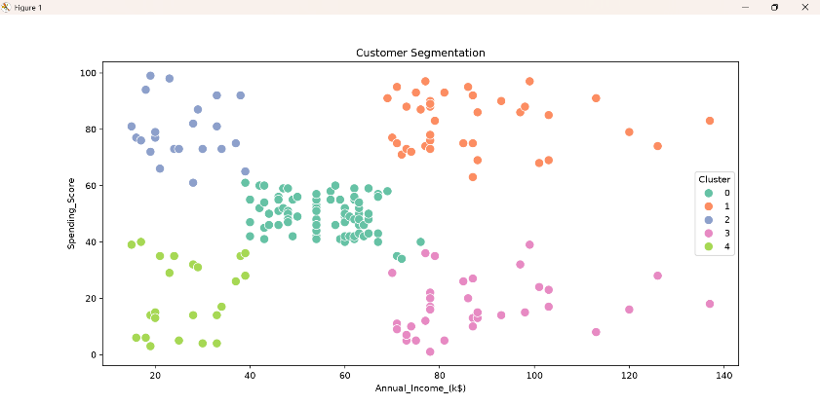
Figure 7: Customer Segments using K-Means

Cluster | Interpretation
Cluster 0 | High income, high spending customers
Cluster 1 | High income, low spending customers
Cluster 2 | Low income, low spending customers
Cluster 3 | Low income, high spending customers
Cluster 4 | Moderate income and moderate spending customers
Power BI Dashboard
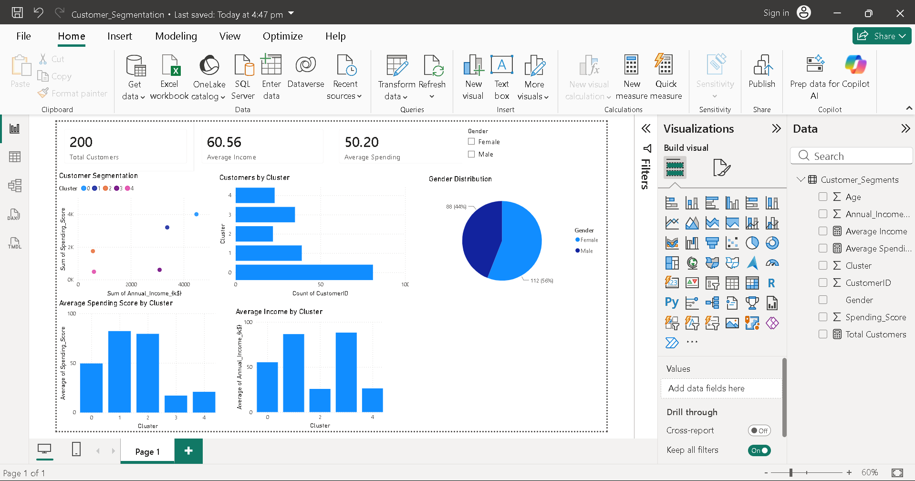
Figure 8: Customer Segmentation Dashboard

- KPI Cards summarize the total customers and average values.

- Scatter Chart displays customer segments by income and spending score.

- Bar Chart shows the number of customers in each cluster.

- Pie Chart presents the gender distribution.

- Column Charts compare average income and spending score across clusters.

- Slicer allows filtering the dashboard by gender.

Business Insights & Recommendations

Business Insights
- High-income, high-spending customers are valuable and should be targeted with loyalty programs.
- High-income, low-spending customers may respond well to personalized promotions.
- Budget-conscious customers can be engaged through discounts and value-based offers.
- Segment-specific marketing can improve customer engagement and business performance.

Recommendations
- Introduce premium membership programs.
- Offer personalized product recommendations.
- Design targeted campaigns for different customer segments.
- Monitor segment behaviour regularly and update strategies based on new data.

Conclusion & References

Conclusion
This project successfully applied K-Means clustering to segment customers based on annual income and spending score. Exploratory Data Analysis provided insights into customer demographics and purchasing behavior, while the Power BI dashboard enabled interactive visualization of the results. The identified customer segments can support data-driven marketing strategies and improve business decision-making.

References
- Mall Customers Dataset (Kaggle)
- Python Documentation
- Scikit-learn Documentation
- Power BI Documentation

