Pizza Sales SQL Queries Documentation

- To find out the total revenue
select sum(total_price) as Total_Revenue from pizza_sales_excel_file1
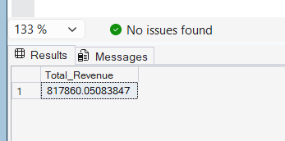

- To find out the Average order value
select sum(total_price)/COUNT(distinct order_id) as Average_order_value from pizza_sales_excel_file1
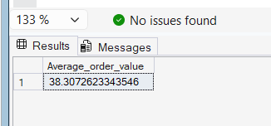

- Total Pizzas solds
select SUM(quantity) as Total_sold_pizzas from pizza_sales_excel_file1
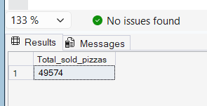

- To find out the Total orders
select COUNT(distinct order_id) as Total_Placed_Orders from pizza_sales_excel_file1
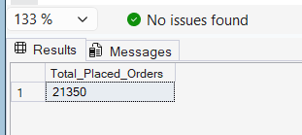

- Average pizzas per order id
select cast (cast(SUM(quantity) as decimal (10,2)) / cast(COUNT(distinct order_id)as decimal(10,2)) as decimal(10,2)) as avg_pizza_per_order from pizza_sales_excel_file1
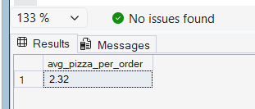

Now to make the chart we are doing this operation:

- Daily trend for total orders(orders per day)
select DATENAME(dw,order_date) as order_per_day,
COUNT(distinct order_id) as Total_Placed_Orders from pizza_sales_excel_file1
group by DATENAME(dw,order_date)
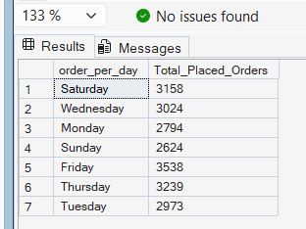

- Monthly Trend for total orders (Orders per month)
select DATENAME(month,order_date) as months,
COUNT(distinct order_id) as Orders_per_month from pizza_sales_excel_file1
group by DATENAME(MONTH,order_date)
order by Orders_per_month desc

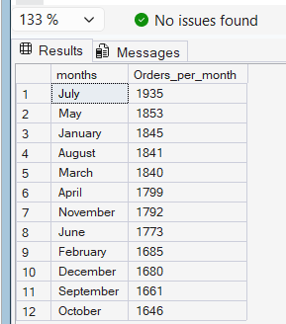

- Percentage of sales by pizza category and total sales
select pizza_category,
cast(sum(total_price)as decimal(10,2)) as total_sales,
cast(sum(total_price)*100/(select sum(total_price)from pizza_sales_excel_file1)
as decimal(10,2))
as pct_of_total_sales from pizza_sales_excel_file1
group by pizza_category
order by pct_of_total_sales desc
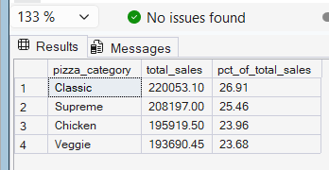

- Percentage of sales by pizza size
select pizza_size,
cast(sum(total_price)as decimal(10,2)) as total_sales,
cast(sum(total_price)*100/(select sum(total_price)from pizza_sales_excel_file1)
as decimal(10,2)) as pct_of_total_sales_by_size from pizza_sales_excel_file1
group by pizza_size
order by pct_of_total_sales_by_size desc

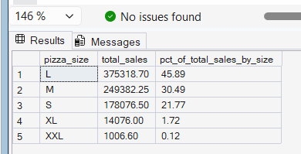

- Top 5 best sellers by revenue, total quantify and total orders
select top 5 pizza_name, cast(sum(total_price) as decimal(10,2))as price_by_pizza_name from pizza_sales_excel_file1
group by pizza_name
order by price_by_pizza_name desc

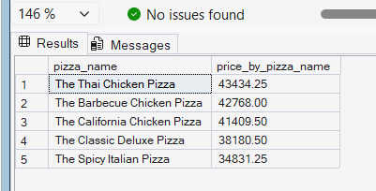

- Bottom 5 sellers by revenue, total quantify and total orders
select top 5 pizza_name, cast(sum(total_price) as decimal(10,2))as price_by_pizza_name from pizza_sales_excel_file1
group by pizza_name
order by price_by_pizza_name asc
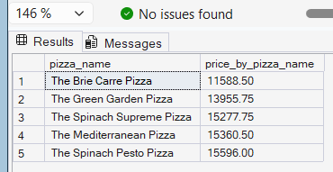

- Top 5 sellers but according to the quantity
select top 5 pizza_name,sum(quantity) as price_by_pizza_quantity from pizza_sales_excel_file1
group by pizza_name
order by price_by_pizza_quantity desc

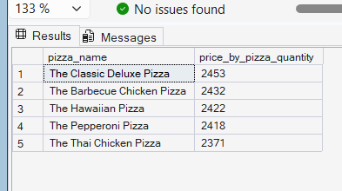

- Bottom 5 sellers but according to the quantity
select top 5 pizza_name,sum(quantity) as price_by_pizza_quantity from pizza_sales_excel_file1
group by pizza_name
order by price_by_pizza_quantity

