To Flash BMC:
We are using System 6 to flash BMC but can copy to any system. The folder is under folder:
lab@vr-l117-lt-75:~/Bringup_FW/BMC_FW$
File name: MGX_ARC_26061201_dev_debug_scp_image_new_IOBoard.bin
Copy this file to BMC on any system to flash if you want to.
Run cmd:
lab@vr-l117-lt-75:~/Bringup_FW/BMC_FW$ scp MGX_ARC_26052701_dev_debug_scp_image.bin root@”BMC_IP”:/run/initramfs/image-bmc
Verify md5sum on both sides
[host] md5sum MGX_ARC_26052701_dev_debug_scp_image.bin
[bmc] md5sum /run/initramfs/image-bmc
-------
scp MGX_ARC_26061201_dev_debug_scp_image_new_IOBoard.bin root@10.96.113.203.117:/run/initramfs/image-bmc
ssh-keygen -f "/home.local/lab/.ssh/known_hosts" -R "10.137.203.117"
----------
To Update:
[bmc] /run/initramfs/update #will detect BMC image at /run/initramfs/image-bmc
After finish, cold power system then check IP to see if the same.

To flash CX8:
Copy two files to local BMC from system6 under CX8_QP
fw-ConnectX8-rel-40_97_5427-cx8_P4180_MGX_ARC_QP_Ax.bin
mstflint
Steps to flash Cx8:
Powerctrl.sh power_on
for eid in 60 70; do mctp-client eid $eid type pci data 10 DE 80 02 00 10 00 05 00 00 00 01 00 01 00 00; done && sleep 0.5 && gpioset `gpiofind S_MCU1_RECOVERY_N-O`=0 && gpioset `gpiofind S_MCU2_RECOVERY_N-O`=0 && gpioset `gpiofind S_FNP_CX2_L-O`=0 && gpioset `gpiofind S_FNP_CX1_L-O`=0 && gpioset `gpiofind S_FNP_CX0_L-O`=0 && powerctrl.sh power_cycle
i2cdetect -y 26
i2cdetect-y 28
i2cdetect -y 30
chmod +x /tmp/mstflint
bus=26
/tmp/mstflint -d /dev/i2c-$bus --i2c_secondary 0x48 -i /tmp/fw-ConnectX8-rel-40_97_5427-cx8_P4180_MGX_ARC_QP_Ax.bin -ocr -nofs --ignore_dev_data --no_flash_verify burn
bus=28
Same cmd as above for flash.
bus=30
Same flash cmd as above.
Cold Power cycle system
To check to see if CX8 list out:
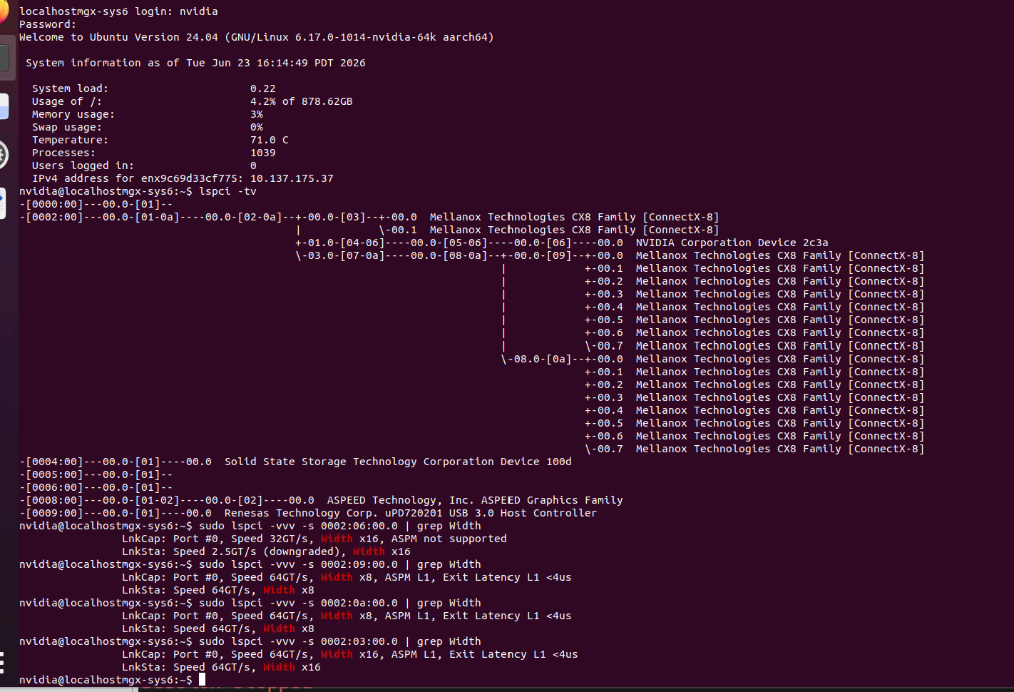

Flash MCU
How to update MCU:

root@mgx-arc:~# mctp-list-eps
Transport| EID| UUID|Supported MCTP Types
USB| 100| "00000000-0000-0000-0000-000000000000"| 0
USB| 12| "c01dc250-5678-11ed-9b6a-0242ac120002"| 126
USB| 14| "f72d6f60-5675-11ed-9b6a-0242ac120002"| 1 5 126 127
SPI| 30| "00000000-0000-0000-0000-000000000000"| 0
SPI| 50| "06030313-1914-1e22-99e7-cf200ed6ec80"| 1 5 126 127
USB| 80| "64da3af3-12f7-6c51-ae9c-2fecf54a270b"| 1 5 126 127
root@mgx-arc:~#
------------
root@mgx-arc:~# lsusb
Bus 001 Device 001: ID 1d6b:0002 Linux 6.12.59-f0e329a-gf0e329aae6b1 ehci_hcd EHCI Host Controller
Bus 001 Device 002: ID 0424:2514
Bus 001 Device 003: ID 0955:ffff
Bus 001 Device 004: ID 0424:2514
Bus 001 Device 005: ID 0424:2514
Bus 001 Device 006: ID 1fc9:0158 NXP SEMICONDUCTOR INC. USB COMPOSITE DEVICE
Bus 001 Device 007: ID 0955:cf11
Bus 001 Device 008: ID 1fc9:0158 NXP SEMICONDUCTOR INC. USB COMPOSITE DEVICE
-------------
gpioset $(gpiofind S_MCU1_RST_N-O)=0
gpioset $(gpiofind S_MCU1_RECOVERY_N-O)=0
gpioset $(gpiofind S_MCU2_RST_N-O)=0
gpioset $(gpiofind S_MCU2_RECOVERY_N-O)=0

[ 0 ] root@mgx-arc:~# lsusb # unflashed MCUs gone now
Bus 001 Device 001: ID 1d6b:0002 Linux 6.12.59-f0e329a-gf0e329aae6b1 ehci_hcd EHCI Host Controller
Bus 001 Device 002: ID 0424:2514
Bus 001 Device 003: ID 0955:ffff
Bus 001 Device 004: ID 0424:2514
Bus 001 Device 005: ID 0424:2514
Bus 001 Device 007: ID 0955:cf11
----------
gpioset $(gpiofind S_MCU1_RST_N-O)=1
blhost --usb-id 1fc9:0158 -- flash-erase-all 0
-----------
>>Inject command 'flash-erase-all'
>>Successful generic response to command 'flash-erase-all'
>>Response status = 0 (0x0) Success.
-----------
blhost --usb-id 1fc9:0158 -- write-memory 0 /tmp/mcxn236-mcufw-p4180-0036.00.0283.0008-rel-debug.bin
-----------
gpioset $(gpiofind S_MCU1_RST_N-O)=0
gpioset $(gpiofind S_MCU1_RECOVERY_N-O)=1
gpioset $(gpiofind S_MCU1_RST_N-O)=1
gpioset $(gpiofind S_MCU2_RST_N-O)=1
-----------
blhost --usb-id 1fc9:0158 -- flash-erase-all 0
-----------
blhost --usb-id 1fc9:0158 -- write-memory 0 /tmp/mcxn236-mcufw-p4180-0036.00.0283.0008-rel-debug.bin
------------
gpioset $(gpiofind S_MCU2_RST_N-O)=0
gpioset $(gpiofind S_MCU2_RECOVERY_N-O)=1
gpioset $(gpiofind S_MCU2_RST_N-O)=1

