INS
LAB-1

1. What is Cryptography?

- Cryptography is mainly used in dealing with network security.
- Meaning of the word:
crypto: secret or hidden
graphos: writing
- Cryptography is the science of secret writing with the intention of keeping the data secret.
- The art and science of concealing the messages to introduce secrecy in information security is recognized as cryptography.
- Following figure can be seen to understand how data can be encrypted and decrypted:

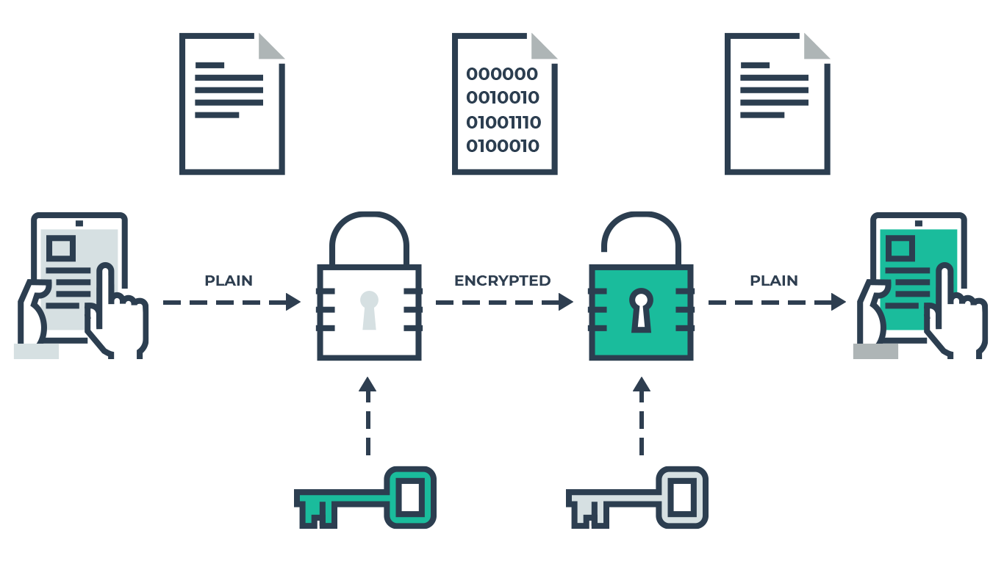
- As shown above, in cryptography, plain text is sent by the sender.
- This text can encrypted to a non-readable format using a secret key.
- This encrypted text is sent to the receiver who decrypts this text to original plain text using another secret key.
- Thus, when the data is sent by the sender to the receiver, it is received securely.
- There are a lot of affecting factors but this is the main idea.

Classification:

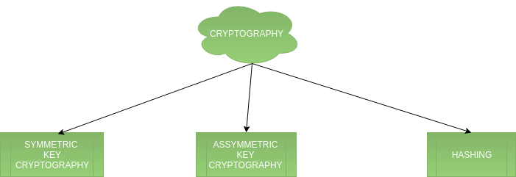
1. Symmetric Key Cryptography:
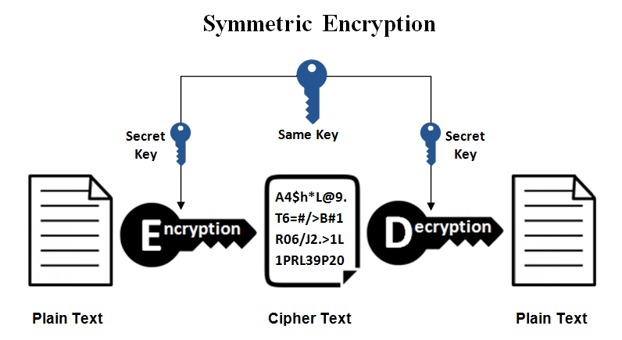
- As shown in above figure, symmetric key cryptography can be easily understood.
- In this type, in order to encrypt and decrypt data, a secret key is used that is shared.
- This key remains same in both, encryption and decryption.
- It is relatively faster than asymmetric key cryptography.
- There arises a key distribution problem as the key has to be transferred from the sender to receiver through a secure channel.

2. Asymmetric Key Cryptography:

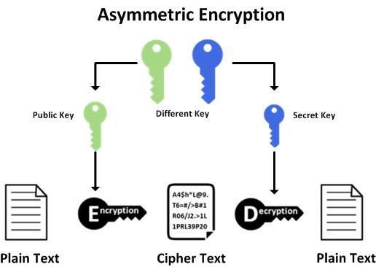

- As shown in above figure, asymmetric cryptography can be easily understood.
- In this type, 2 different keys are used to encrypt and decrypt data.
- Here, the encryption is done with a public key and decryption is done with a secret private key.
- It solves the problem of key distribution as both parties uses different keys for encryption/decryption.
- It is not feasible to use for decrypting bulk messages as it is very slow compared to symmetric key cryptography.

3. Hashing:

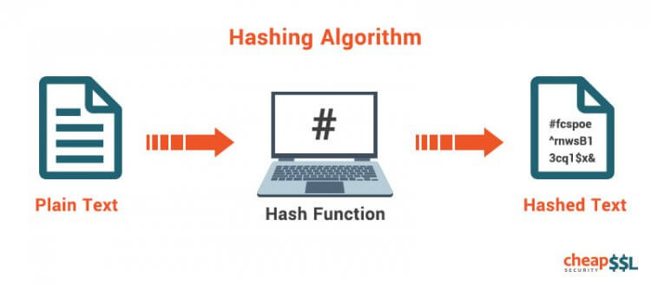
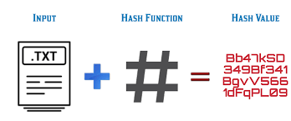

- It involves taking the plain-text and converting it to a hash value of fixed size by a hash function.
- This process ensures integrity of the message as the hash value on both, sender\’s and receiver\’s side should match if the message is unaltered.

2. Explain private key cryptography & public key cryptography?
A) Private Key Cryptography:
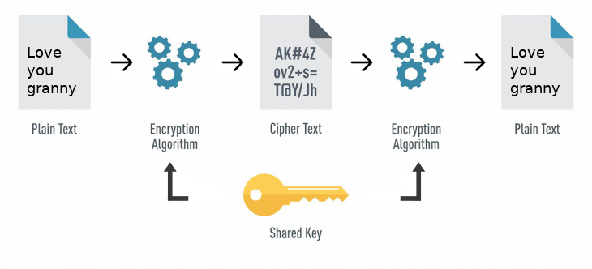
- A private key, also known as a secret key, is a variable in cryptography that is used with an algorithm to encrypt and decrypt code.
- Secret keys are only shared with the key’s generator, making it highly secure.
- It is a fast process since it uses a single key.
- However, protecting one key creates a key management issue when everyone is using private keys.
- The private key may be stolen or leaked.
- Key management requires prevention of these risks and necessitates changing the encryption key often, and appropriately distributing the key.

Challenges of private key encryption:
- While private key encryption does ensure a high level of security, the following challenges must be considered:
1. Encryption key management can become too complex if each user has their own private key.
2. Private keys need to be changed frequently to avoid being leaked or stolen.
3. If the private key is forgotten or lost, the system is broken and messages stay encrypted.
4. Significant computing resources are required to create long, strong private keys.
B) Public Key Cryptography:
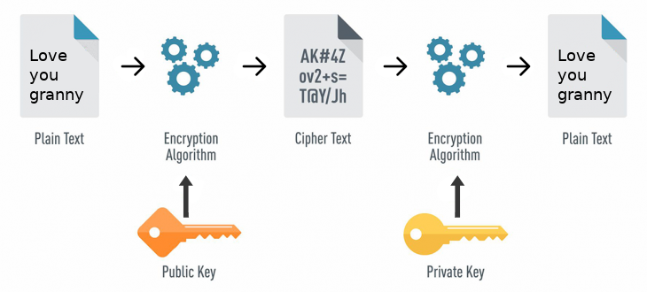
- Public-key cryptography, or asymmetric cryptography, is an encryption scheme that uses two mathematically related, but not identical, keys - a public key and a private key.
- Unlike symmetric key algorithms that rely on one key to both encrypt and decrypt, each key performs a unique function.
- The public key is used to encrypt and the private key is used to decrypt.
- It is computationally infeasible to compute the private key based on the public key.
- Because of this, public keys can be freely shared, allowing users an easy and convenient method for encrypting content and verifying digital signatures, and private keys can be kept secret, ensuring only the owners of the private keys can decrypt content and create digital signatures.
- Since public keys need to be shared but are too big to be easily remembered, they are stored on digital certificates for secure transport and sharing.
- Since private keys are not shared, they are simply stored in the software or operating system you use, or on hardware (e.g., USB token, hardware security module) containing drivers that allow it to be used with your software or operating system.

References

- https://www.geeksforgeeks.org/cryptography-introduction-to-crypto-terminologies/
- https://whatismyipaddress.com/protection-from-malware
- https://searchsecurity.techtarget.com/definition/private-key
- https://koolspan.com/private-key-encryption/
- https://hackernoon.com/symmetric-and-asymmetric-encryption-5122f9ec65b1
- https://www.globalsign.com/en-in/ssl-information-center/what-is-public-key-cryptography/

