LAB MANUAL

.NET TECHNOLOGY

Chavda Foram R.

160470107009

VVPEC CE SEM-6

Contents

Introduction to c#: 1

Inheritence 8

Overloading 12

Reflection 15

File Handling 17

Windows Form Application 20

ASP.NET Validation Control 23

Introduction To Master Pages 26

**Practical-1**

**Aim:**

# Introduction to c#:

Variables:

Initialization

Scope

Constant

Predefined Data Types Value Types

Reference TYpes

Flow Control

Conditional Statements(if, switch)

Loop(for, while, dowhile, foreach)

Jump(goto, break, continue, return)

Eumerations

Passing Arguments

using System;

using System.Threading;

namespace P1

{

class P1

{

static int j = 90;

public enum TimeOfDay

{

Morning = 0,

Afternoon = 1,

Evening = 2

}

public static void Main(string[] args)

{

Console.WriteLine("First Program");

160470107009 INTRO TO C#

int i;

i = 25;

Console.WriteLine("Scope of Variables.\n1:"); int j;

for (int j = 0; j < 2; j++) //removing comment from for loop will

raise error

{

//int j;

//uncomment above line to error "A local variable named 'j' cannot

be declared in this

//scope because it would give a different meaning to 'j', which is

already

//used in a 'parent or current' scope to denote something else"

Console.Write("{0} {1}\n", j, P1.j);

}

Console.WriteLine("2:");

for (int k = 0; k < 3; k++)

{

Console.Write("{0} ", k);

}

Console.Write("\n");

Console.Write(k);

for (int k = 3; k > 0; k--)

{

Console.Write("{0} ", k);

}

Console.WriteLine("Constants");

const int valConst = 100; // This value cannot be changed. Console.WriteLine("{0} is constant value", valConst); valConst = 45;

const int valConst2 = valConst + 9 /* + j*/;

Console.WriteLine("Another Constant: {0}", valConst2);

Console.WriteLine("\nPredefined Data Types\n\nValue Types and Reference Types");

//Value Types

int vali = 2, valj = vali;

Console.WriteLine("vali is: {0} and valj is: {1}", vali,

valj); valj = 90;

Console.WriteLine("vali is: {0} and valj is: {1}", vali, valj);

//Referece Types

Vector x, y; x = new Vector();

x.value = 3;

y = x;

Console.WriteLine("x is: {0} and y is:{1}", x.value, y.value);

y.value = 234;

Console.WriteLine("x is: {0} and y is:{1}", x.value, y.value);

y = null;

Console.Write("Value for y is: " + y.value);

Console.WriteLine("\nInteger Types");

INTRO TO C#

sbyte sb = 33;

short s = 33;

int _i = 33;

long l = 33L;

//Unsigned Integers

byte b = 33; ushort us = 33;

uint ui = 33U;

ulong ul = 33UL;

Console.WriteLine("{0} {1} {2} {3} {4} {5} {6} {7}", sb, s, _i, l, b, us, ui, ul);

//Floating point types float f = 11.22334455F;

double d = 11.2233445566778899;

Console.Write("\nFloat and Double:\n");

Console.WriteLine("{0} and \n{1}", f, d);

//Decimal Type

decimal dec = 111.222333444555666777888999M; Console.WriteLine("Decimal:\n{0}", dec);

//Boolean

Console.WriteLine("\nBoolean:");

bool valBoolean = true;

Console.WriteLine("Status: " + valBoolean);

//Character

Console.WriteLine("\nCharacter:\nSingle Quote \'"); Console.WriteLine("Double Quote \""); Console.WriteLine("Back Slash \\");

char charA = 'A';

Console.WriteLine(charA);

charA = '\0';

Console.WriteLine("Now null: " + charA);

Console.WriteLine("\a"); //Notofication Sound Thread.Sleep(1000);

Console.Beep(); //another notification sound

object o1 = "Hi, I am an Object";

object o2 = 34;

string strObj = o1 as string;

Console.WriteLine(strObj);

Console.WriteLine(o1.GetHashCode() + " " + o1.GetType()); Console.WriteLine(o2.GetHashCode() + " " + o2.GetType());

Console.WriteLine(o1.Equals(o2));

//string

string s1, s2;

s1 = "String 1";

s2 = s1;

Console.WriteLine("S1 is: {0} and s2 is {1}", s1,

s2); s2 = "New String 1";

Console.WriteLine("S1 is: {0} and s2 is {1}", s1, s2); s1 = "c:\\NewFolder\\Hello\\P1.cs";

Console.WriteLine(s1); s1 = @"c:\NewFolder\Hello\P1.cs";

Console.WriteLine(s1);

s1 = @"We can also write

like this";

Console.WriteLine(s1);

//Flow Control

//The if Statement

bool isZero;

Console.WriteLine("\nFlow Control: (if)\ni is " + i); if (i == 0)

{

isZero = true;

Console.WriteLine("i is Zero");

}

else

{

isZero = false;

Console.WriteLine("i is Non - zero");

}

//else if

Console.WriteLine("\nType in a string:");

string input;

input = Console.ReadLine();

if (input == "")

{

Console.WriteLine("You typed in an empty string");

} else if (input.Length < 5)

{

Console.WriteLine("The string had less than 5 characters");

} else if (input.Length < 10)

{

Console.WriteLine("The string had at least 5 but less than 10

characters");

}

Console.WriteLine("The string was " + input);

//Switch

int integerA = 2;

Console.WriteLine("\nSwitch:");

switch (integerA)

{ case 1:

Console.WriteLine("integerA = 1");

break;

case 2:

Console.WriteLine("integerA = 2");

//goto case 3;

break;

case 3:

Console.WriteLine("integerA = 3");

break; default:

Console.WriteLine("integerA is not 1, 2, or 3");

break;

}

//Loops - to be explored

//jump statements goto, break, continue, return - to be explored

//Enumerations

//An enumeration is a user-defined integer type.

//Benefits:

//1.As mentioned, enumerations make your code easier to maintain

//2.Enumerations make your code clearer by allowing you to refer to integer values by descriptive names

//3.Enumerations make your code easier to type, too. When you go to

assign a value to an instance of an enumerated type,

//the Visual Studio .NET IDE will, through IntelliSense, pop up a list

box of acceptable values in order to save

//you some keystrokes and to remind you of what the possible options are.

WriteGreeting(TimeOfDay.Morning);

Console.WriteLine("Argument is: {0}",args[1]);

}

static void WriteGreeting(TimeOfDay timeOfDay)

{

switch (timeOfDay)

{

case TimeOfDay.Morning:

Console.WriteLine("Good morning!");

break;

case TimeOfDay.Afternoon:

Console.WriteLine("Good afternoon!");

break;

case TimeOfDay.Evening:

Console.WriteLine("Good evening!");

break;

default:

Console.WriteLine("Hello!");

break;

}

}

}

public class Vector

{

public int value;

}

}

**Output:**

First Program Scope of Variables. 1:

1. 90
2. 90 2:

0 1 2

3 2 1 Constants

100 is constant value

Another Constant: 109

Predefined Data Types

Value Types and Reference Types vali is: 2 and valj is: 2 vali is: 2 and valj is: 90 x is: 3 and y i s:3

x is: 234 and y is:234

Integer Types

33 33 33 33 33 33 33 33

Float and Double:

11.22334 and 11.2233445566779 Decimal:

111.222333444555666777888999

Boolean:

Status: True

Character:

Single Quote '

Double Quote "

Back Slash \

A

Now null:

Hi, I am an Object

- 1735802816 System.String

34 System.Int32

False

S1 is: String 1 and s2 is String 1 S1 is: String 1 and s2 is New String 1

c: \NewFolder\Hello\P1.cs c:\NewFolder\Hello\P1.cs

We can also write

like this

Flow Control: (if) i is 25

i is Non - zero

Type in a string: bhargav

The string had at least 5 but less than 10 characters The string was bhargav

Switch:

integerA = 2

Good morning!

VVPEC CE SEM-6 7

**Practical-2 Aim:**

# Inheritence

Program 1. Write console based program in code behind language VB or C# to print following pattern.

@@@@@

@@@@

@@@

@@

@

using System;

using System.Collections.Generic; using System.Linq ; using System.Text;

namespace p2

{

class Pattern1

{

static void Main(string[] args)

{

for (int i = 5; i > 0; i--) {

for (int j = i; j > 0; j--) {

Console.Write('@');

}

Console.WriteLine();

}

Console.ReadKey();

}

}

}

**Output:**

@@@@@

@@@@

@@@

@@

@

160470107005

Program 2. Write console based program in code behind language VB or C# to print following pattern.

1

12

123 1234

using System;

using System.Collections.Generic; using System.Linq; using System.Text;

namespace p2

{

class Pattern2

{ static void Main(String[] ar){ for(int i=1;i<5;i++){

for(int j=1;j<=i;j++){

Console.Write(j);

}

Console.WriteLine();

}

Console.ReadKey();

}

}

}

**Output:**

1

12

123

1234

Program 3. Write C# code to prompt a user to input his/her name and country name and then the output will be shown as an example below: Hello Ram from country India

using System; using System.Collections.Generic;

using System.Linq; using System.Text;

namespace p2

{

class Read

{

static void Main(String[] ar) { Console.WriteLine("Enter your name:"); string name = Console.ReadLine(); Console.WriteLine("Enter your City:"); string city = Console.ReadLine(); Console.WriteLine("Hello {0} from city {1}",name,city);

}

}

}

**Output:**

Enter your name:

bhargav Enter your City: rajkot

Hello bhargav from city Rajkot

160470107009 INHERITENCE

Program 4. What is inheritance? Create C# console application to define Car class and derive Maruti and Mahindra from it to demonstrate inheritance.

using System;

using System.Collections.Generic; using System.Linq; using System.Text;

namespace p2

{

public class Car

{

public virtual void display()

{

Console.WriteLine("This is Car class...");

}

}

public class Mahindra : Car

{

public override void display()

{

Console.WriteLine("This is Mahindra class...");

}

}

public class Maruti : Car

{

public override void display()

{

Console.WriteLine("This is maruti class");

}

}

class Inheritance

{

static void Main(String[] ar){ Maruti m = new Maruti();

Mahindra mm = new Mahindra();

m.display();

mm.display();

}

}

}

**Output:**

This is maruti class This is Mahindra class...

**Practical-3 Aim:**

# Overloading

Program 1: Write a c# program to add two integers, two vectors and two metric using method overloading.

using System;

using System.Collections.Generic; using System.Linq; using System.Text;

namespace p2

{

public class P3_1

{

public int add(int a, int b) { return a + b;

}

public static Vector add(Vector v1,Vector v2)

{ Vector v= new Vector();

v.a = v1.a + v2.a;

v.b = v1.b + v2.b;

return v;

}

public static int[,] add(int[,] a, int[,] b) {

int[,] s = new int[2, 2]; for (int i = 0; i < 2; i++) { for (int j = 0; j < 2; j++) {

s[i, j] = a[i, j] + b[i, j];

}

}

return s;

} public static void Main(String[] ar) { int n,n1, n2;

Vector v = new Vector();

Console.WriteLine("Enter Number 1:"); n1 = Convert.ToInt32(Console.ReadLine());

Console.WriteLine("Enter Number 2:");

n2 = Convert.ToInt32(Console.ReadLine());

n = n1 + n2;

Console.WriteLine("Addition of Number:{0}", n);

Console.WriteLine("Enter Vector 1:");

n1 = Convert.ToInt32(Console.ReadLine()); n2 = Convert.ToInt32(Console.ReadLine());

Vector v1 = new Vector(n1,n2);

Console.WriteLine("Enter Vector 2:");

VVPEC CE SEM-6 12

n1 =Convert.ToInt32(Console.ReadLine()); n2 = Convert.ToInt32(Console.ReadLine()); Vector v2 = new Vector(n1,n2);

v = add(v1, v2);

Console.WriteLine("Addition of vector: x={0}, y={1}",v.a,v.b);

int[,] a = new int[,] { { 1, 2 }, { 3, 4 } }; int[,] b = new int[,] { { 5, 6 }, { 7, 8 } };

int[,] c = add(a, b);

Console.WriteLine("Addition of two matrics:"); for (int z = 0; z < 2; z++) {

for (int m = 0; m < 2; m++) {

Console.WriteLine("Addition: "+ c[z, m]);

}

}

Console.ReadKey();

}

} public class Vector { public int a, b;

public Vector() { }

public Vector(int a, int b)

{

this.a = a;

this.b = b;

}

}

}

**Output:**

Enter Number 1:1

Enter Number 2:2 Addition of Number:3

Enter Vector 1:

1 2

Enter Vector 2:

3

4

Addition of vector: x=4, y=6

Addition of two metrics:

Addition: 6

Addition: 8

Addition: 10

Addition: 12

VVPEC CE SEM-6 13

Program 2: Write a c# program that create student object. Overload constructor to create new instant with following details. 1. Name

1. Name , Enrollment
2. Name , Enrollment, Branch

using System;

using System.Collections.Generic; using System.Linq; using System.Text;

namespace p2

{

public class Student

{ string name, enrollment, branch; public Student(string name) {

this.name = name;

Console.WriteLine(“First Constructor initiated..”);

}

public Student(string name, string enrollment) {

this.name = name;

this.enrollment = enrollment; Console.WriteLine(“Second Constructor initiated..”);

}

public Student(string name, string enrollment, string branch)

{ this.name = name; this.enrollment = enrollment;

this.branch = branch;

Console.WriteLine(“Third Constructor initiated..”);

} public static void Main(String[] ar) {

Student s1 = new Student("Bhargav");

Student s2 = new Student("Bhargav","160470107005");

Student s3 = new Student("Bhargav","160470107005","Computer"); }

}

}

**Output:**

First Constructor initiated..

Second Constructor initiated.. Third Constructor initiated..

VVPEC CE SEM-6 14

**Practical-4 Aim:**

# Reflection

Create a c# program to find Methods, Properties and Constructors from class of running program.(Use Class from previous practical)

using System;

using System.Collections.Generic; using System.Linq; using System.Text;

using System.Reflection;

namespace p2

{

class Reflection

{

static void Main()

{

Type T = Type.GetType("p2.Customer");

MethodInfo[] methods = T.GetMethods();

foreach (MethodInfo method in methods)

{

Console.WriteLine(method.ReturnType + " " + method.Name);

}

PropertyInfo[] properties = T.GetProperties();

Console.WriteLine("\nProperties"); foreach (PropertyInfo property in properties)

{

Console.WriteLine(property.PropertyType + " " + property.Name); }

Console.WriteLine("\nConstructors");

ConstructorInfo[] constructors =

T.GetConstructors(); foreach (ConstructorInfo constructor in constructors) {

Console.WriteLine(constructor.ToString()); }

}

}

class Customer

{ public int ID { get; set; }

public string Name { get; set; }

public Customer(int ID, string Name)

{

this.ID = ID;

this.Name = Name;

}

VVPEC CE SEM-6 15 REFLECTION

|  |  |
| --- | --- |
| public Customer()  {  this.ID = -1;  this.Name = string.Empty;  }  public void printID()  {  Console.WriteLine("ID is: {0}", this.ID);  }  public void printName()  {  Console.WriteLine("Name is: {0}", this.Name); }  }    }    **Output:**    System.Int32 get_ID  System. Void set_ID  System.String get_Name  System.Void set_Name  System.Void printID  System.Void printName  System.String ToString  System.Boolean Equals  System.Int32 GetHashCode  System.Type GetType    Properties  System.Int32 ID  System.String Name    Constructors  Void .ctor(Int32, System.String)  Void .ctor() |  |
| VVPEC CE SEM-6 | 16 |

**Practical-5 Aim:**

# File Handling

Program 1: Write a C# program to copy data from one file to another using StreamReader and StreamWriter class.

using System;

using System.Collections.Generic; using System.Linq; using System.Text;

using System.IO;

namespace p2

{

class P4_1

{ public static void Main(){ string f1 = @"f1.txt"; string f2 = @"f2.txt";

using (StreamReader reader = new StreamReader(f1))

using (StreamWriter writer = new StreamWriter(f2)) writer.Write(reader.ReadToEnd());

}

}

}

**Output:**

F1.txt: Hello vvp... F2.txt: Hello vvp...

VVPEC CE SEM-6 17

Program 2: Write a C# Program to Read Lines from a File until the End of File is Reached.

using System;

using System.Collections.Generic; using System.Linq; using System.Text;

using System.IO;

namespace p2

{

public class CopyFile

{ public void copyFile(string f1, string f2)

{ using (StreamReader reader = new StreamReader(f1)) using (StreamWriter writer = new StreamWriter(f2))

{

string line = null;

while ((line = reader.ReadLine()) != null)

writer.WriteLine(line);

}

}

}

public class mmain{

public static void Main(){

CopyFile cp = new CopyFile(); string f1 = @"E:\Sem-6\ p2\f1.txt"; string f2 = @"E:\Sem-6\ p2\f2.txt"; cp.copyFile(f1,f2);

}

}

}

**Output:**

F1.txt: Hello World.....

hii

how are you ???

F2.txt: Hello World.....

hii

how are you ???

VVPEC CE SEM-6 18

Program 3: Write a C# Program to List Files in a Directory.

using System;

using System.Collections.Generic; using System.Linq; using System.Text;

using System.IO;

namespace p2

{

class ListFile

{

public static void Main() {

string[] Directories = Directory.GetDirectories(@"E:\Sem-6\VS"); foreach (string dir in Directories)

Console.WriteLine(dir);

string[] files = Directory.GetFiles(@"E:\Sem-6 "); foreach (string file in files)

Console.WriteLine(file);

Console.ReadKey();

}

}

}

**Output:**

E:\Sem-6\ P1-master

E: \Sem-6\ p2

E:\Sem-6\ Assignment.docx

E: \Sem-6\ C# word.txt

E:\Sem-6\ Doc1.docx

E: \Sem-6\ P1-master.zip

E: \Sem-6\ p1.cs

E:\Sem-6\ p1.exe E: \Sem-6\ VS.docx

VVPEC CE SEM-6 19

**Practical-6**

**Aim:**

# Windows Form Application

Program: Create Windows Form Application for Student Registration and store student Details in Database.

**Form.cs:**

using System; using System.Collections.Generic; using System.ComponentModel; using System.Data; using System.Drawing; using System.Linq; using System.Text; using System.Windows.Forms; using System.Data.SqlClient; using System.IO;

namespace StudentForm

{

public partial class Form1 : Form

{

string imgPath;

public Form1()

{

InitializeComponent();

}

private void btnsave_Click(object sender, EventArgs e)

{

string gen = null;

string subject = null;

if (genMale.Checked == true) {

gen = "m";

}

if (genFemale.Checked == true) { gen = "f";

}

if (ck1.Checked == true) {

subject = subject + " s1";

}

if (ck2.Checked == true) {

subject = subject + " s2";

}

VVPEC CE SEM-6 20

string source = @"Data Source=Bhargav-Patel\SQLExpress;Initial Catalog=DemoDb;Integrated Security=True;Pooling=False";

string insert = "insert into tblstudent

(fname,lname,gender,subject,imgStudent) values ('" + txtfname.Text + "','"

+ txtlname.Text + "','" + gen + "','" + subject + "','" + (imgPath

== null ? "" : imgPath) + "')";

//MessageBox.Show(insert);

//string insert = "insert into tblstudent(fname) values

('jhgjh')"; SqlConnection conn = new SqlConnection(source);

SqlCommand cmd = new

SqlCommand(insert,conn); conn.Open(); int i = cmd.ExecuteNonQuery();

conn.Close();

Console.WriteLine("Success....");

}

private void Form1_Load(object sender, EventArgs e)

{

}

private void btnimg_Click(object sender, EventArgs e)

{

openFileDialog1.Filter = "Jpg|*.jpg"; if (openFileDialog1.ShowDialog() == DialogResult.OK)

{

imgPath = openFileDialog1.SafeFileName;

pictureBox.Image = Image.FromFile(openFileDialog1.FileName);

//MessageBox.Show(imgPath);

}

}

}

}

**Program.cs:**

using System;

using System.Collections.Generic; using S ystem.Linq; using System.Windows.Forms;

namespace StudentForm

{

static class Program {

/// <summary>

/// The main entry point for the application.

/// </summary>

[STAThread]

static void Main()

{

Application.EnableVisualStyles();

Application.SetCompatibleTextRenderingDefault(false); Application.Run(new Form1());

}

}

}

**Output:**

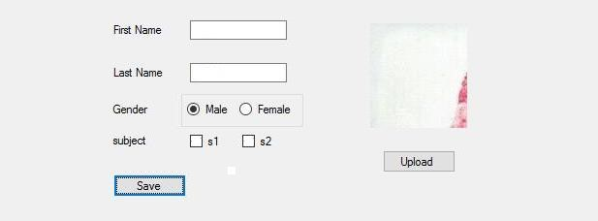

VVPEC CE SEM-6 22 ASP.NET VALIDATION CONTROL

**Practical-7**

**Aim:**

# ASP.NET Validation Control

Program: ASP.NET Validation Control

RequiredFieldValidator

CompareValidator

RegularExpressionValidator

CustomValidator

RangeValidator

ValidationSummary

<%@ Page Title="Home Page" Language="C#" AutoEventWireup="true"

CodeBehind="Default.aspx.cs" Inherits="WebApplication2._Default" %>

< form id="form1" runat="server">

<div>

<table>

<tr>

<td>

<asp:Label runat="server" Text="Name"></asp:Label>

&nbsp;&nbsp;&nbsp;&nbsp;&nbsp;&nbsp;&nbsp;&nbsp;&nbsp;&nbsp;&nbsp

;&nbsp;&nbsp;&nbsp;&nbsp;&nbsp;&nbsp;&nbsp;&nbsp;&nbsp;&nbsp;&nbs p;

<asp:TextBox ID="txtname" runat="server" ></asp:TextBox>

<asp:RequiredFieldValidator ID="RequiredFieldValidator1"

runat="server"

ControlToValidate="txtname"

ErrorMessage="RequiredFieldValidator"></asp:RequiredFieldValidat or>

<br />

</td>

</tr>

<tr>

<td>

<asp:Label ID="Email" runat="server" Text="Email"></asp:Label>

&nbsp;&nbsp;&nbsp;&nbsp;&nbsp;&nbsp;&nbsp;&nbsp;&nbsp;&nbsp;&nbsp

;&nbsp;&nbsp;&nbsp;&nbsp;&nbsp;&nbsp;&nbsp;&nbsp;&nbsp;&nbsp;&nbs p;&nbsp;

<asp:TextBox ID="txtemail" runat="server"></asp:TextBox>

<asp:RegularExpressionValidator ID="RegularExpressionValidator1" runat="server"

ErrorMessage="RegularExpressionValidator"

ValidationExpression="\w+([-+.']\w+)*@\w+([-.]\w+)*\.\w+([-

.]\w+)*"

ControlToValidate="txtemail"></asp:RegularExpressionValidator>

<br />

</td>

</tr>

<tr>

<td>

<asp:Label ID="Label3" runat="server"

Text="Password"></asp:Label>

&nbsp;&nbsp;&nbsp;&nbsp;&nbsp;&nbsp;&nbsp;&nbsp;&nbsp;&nbsp;&nbsp ;&nbsp;&nbsp;&nbsp;&nbsp;&nbsp;

<asp:TextBox ID="txtpass" runat="server"

TextMode="Password"></asp:TextBox>

<br />

</td>

</tr>

<tr>

<td>

<asp:Label ID="Label4" runat="server" Text="Confirm Password"></asp:Label>

&nbsp;&nbsp;&nbsp;

<asp:TextBox ID="txtcpass" runat="server"

TextMode="Password"></asp:TextBox>

<asp:CompareValidator ID="CompareValidator1" runat="server"

ControlToCompare="txtcpass" ControlToValidate="txtpass"

ErrorMessage="CompareValidator"></asp:CompareValidator>

<br />

</td>

</tr>

<tr>

<td>

<asp:Label ID="Label5" runat="server" Text="Sem"></asp:Label>

&nbsp;&nbsp;&nbsp;&nbsp;&nbsp;&nbsp;&nbsp;&nbsp;&nbsp;&nbsp;&nbsp

;&nbsp;&nbsp;&nbsp;&nbsp;&nbsp;&nbsp;&nbsp;&nbsp;&nbsp;&nbsp;&nbs p;&nbsp;&nbsp;

<asp:TextBox ID="txtsem" runat="server"></asp:TextBox>

<asp:RangeValidator ID="RangeValidator1" runat="server"

ControlToValidate="txtsem" ErrorMessage="RangeValidator"

MaximumValue="8"

MinimumValue="1"></asp:RangeValidator>

VVPEC CE SEM

ASP.NET VALIDATION CONTROL

<br />

<asp:ValidationSummary ID="ValidationSummary1" runat="server"

/> </td>

</tr>

<tr>

<td>

<asp:Button ID="Button1" runat="server" Text="Save"

/> </td>

</tr>

</table>

</div>

</form>

**Output:**

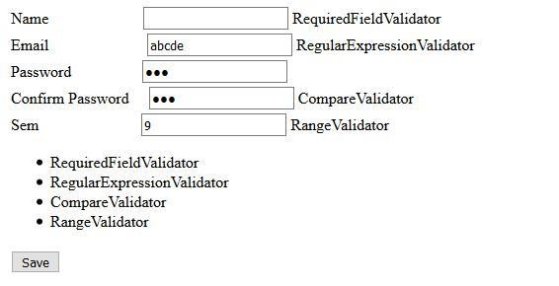

INTRODUCTION TO MASTER PAGES

**Practical-8**

**Aim:**

# Introduction To Master Pages

**Site1.Master:**

<%@ Master Language="C#" AutoEventWireup="true" CodeBehind="Site1.master.cs"

Inherits="WebApplication1.Site1" %>

<!DOCTYPE html PUBLIC "-//W3C//DTD XHTML 1.0 Transitional//EN"

"http://www.w3.org/TR/xhtml1/DTD/xhtml1-transitional.dtd"> <html xmlns="http://www.w3.org/1999/xhtml"> <head runat="server">

<title></title>

<asp:ContentPlaceHolder ID="head"

runat="server"> </asp:ContentPlaceHolder> <style type="text/css">

.style1 { width: 97px;

height: 141px;

}

.style2

{ width: 97px;

height: 105px;

}

.style3

{

width: 97px;

height: 99px;

}

.style4

{ width: 9px;

}

</style>

< /head>

<body>

<form id="form1" runat="server">

<table height="50%" width="50%">

<tr>

<td class="style2" colspan="2">

<asp:Label ID="lblheader" runat="server"

Text="Header"></asp:Label> </td>

</tr>

<tr>

<td class="style4">

<asp:Button ID="btnsearch" runat="server" Text="search" />

VVPEC CE SEM

<asp:TextBox ID="txtsearch" runat="server"></asp:TextBox> </td>

<td class="style3">

<asp:ContentPlaceHolder ID="ContentPlaceHolder1"

runat="server"> content page

</asp:ContentPlaceHolder>

</td>

</tr>

<tr>

<td class="style1" colspan="2">

<asp:Label ID="lblfooter" runat="server"

Text="Footer"></asp:Label> </td>

</tr>

</table>

</form>

< /body>

</html>

INTRODUCTION TO MASTER PAGES

**Site1.Master.cs:**

using System;

using System.Collections.Generic; using System.Linq; using System.Web; using System.Web.UI;

using System.Web.UI.WebControls;

namespace WebApplication1

{

public partial class Site1 : System.Web.UI.MasterPage {

protected void Page_Load(object sender, EventArgs e)

{

}

public Label LblHeader {

get {

return lblheader;

}

} public Button BtnSearch { get {

return btnsearch;

}

} public TextBox TxtSearch { get {

return txtsearch;

}

}

}

}

**WebForm1.aspx:**

<%@ Page Title="" Language="C#" MasterPageFile="~/Site1.Master"

AutoEventWireup="true" CodeBehind="WebForm1.aspx.cs"

Inherits="WebApplication1.WebForm1" %>

<asp:Content ID="Content1" ContentPlaceHolderID="ContentPlaceHolder1" runat="server">

<asp:TextBox ID="txtname" runat="server" ></asp:TextBox>

<asp:Button ID="Button1" runat="server" Text="Set Header" onclick="Button1_Click" />

</asp:Content>

**WebForm1.aspx.cs:**

using System;

using System.Collections.Generic; using System.Linq; using System.Web; using System.Web.UI;

using System.Web.UI.WebControls;

namespace WebApplication1

{

public partial class WebForm1 : System.Web.UI.Page {

protected void Page_Load(object sender, EventArgs e)

{

}

protected void Button1_Click(object sender, EventArgs e)

{

((Site1)Master).LblHeader.Text = txtname.Text;

}

}

}

**WebForm2.aspx:**

<%@ Page Title="" Language="C#" MasterPageFile="~/Site1.Master"

AutoEventWireup="true" CodeBehind="WebForm2.aspx.cs"

Inherits="WebApplication1.WebForm2" %>

<asp:Content ID="Content2" ContentPlaceHolderID="ContentPlaceHolder1" runat="server"> <asp:GridView ID="grdstudent" runat="server">

< /asp:GridView>

</asp:Content>

**WebForm2.aspx.cs:**

using System;

using System.Collections.Generic; using System.Linq; using System.Web; using System.Web.UI; using System.Web.UI.WebControls; using System.Data.SqlClient; namespace WebApplication1

{

public partial class WebForm2 : System.Web.UI.Page {

protected void Page_Init(object sender, EventArgs e)

{

((Site1)Master).BtnSearch.Click += new EventHandler(BtnSearch_Click); }

void BtnSearch_Click(object sender, EventArgs e)

{ getData();

}

protected void Page_Load(object sender, EventArgs e)

{}

void getData() {

string s= ((Site1)Master).TxtSearch.Text;

Console.WriteLine(s);

string source = @"Data Source=Bhargav-Patel\SQLExpress;Initial Catalog=DemoDb;Integrated Security=True;Pooling=False"; string select = "select * from tblstudent where fname like '%"+

((Site1)Master).TxtSearch.Text + "%'";

SqlConnection con = new

SqlConnection(source); SqlCommand cmd = new SqlCommand(select, con); con.Open();

SqlDataReader rdr = cmd.ExecuteReader(); grdstudent.DataSource = rdr;

grdstudent.DataBind();

con.Close();

}

}

}

**Output:**

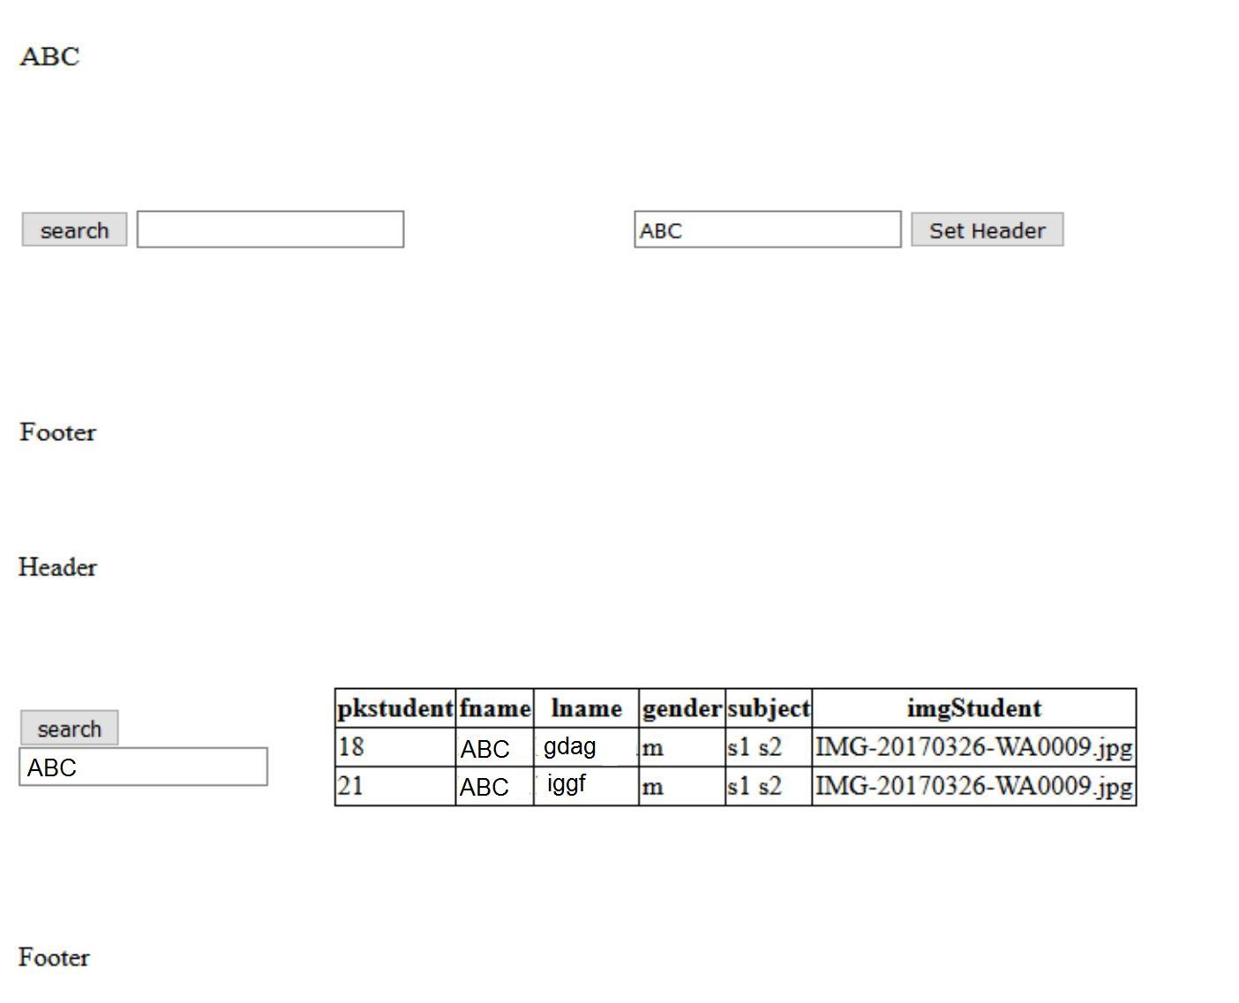

VVPEC CE SEM-6 31