

**COMMANDS**

**#COMMAND TO CREATE DATAFRAME**

mydata <- data.frame(

id = c(1, 2, 3, 4, 5, 6, 7),

weight = c(20, 27, 24, 22, 23, 25, 28),

bp = c(140, 130, 120, 134, 100, 116, 143),

locality = c("urban", "rural", "urban", "urban", "rural", "rural", "urban"),

smoking = c("no", "yes", "no", "yes", "yes", "no", "yes"),

tumour = c("small", "small", "large", "small", "large", "small", "large")

)

**#Command for plotting the graph between weight and blood pressure**

plot(mydata$weight, mydata$bp, xlab = "Weight", ylab = "Blood Pressure", main = "Weight vs. Blood Pressure")

**#Command for creating stacked chart between smoking and tumour.**

counts <- table(mydata$smoking, mydata$tumour)

barplot(counts,

main = "Smoking vs. Tumour",

xlab = "Smoking",

ylab = "Count",

col = c("yellow", "purple"),

legend = rownames(counts),

beside = TRUE)

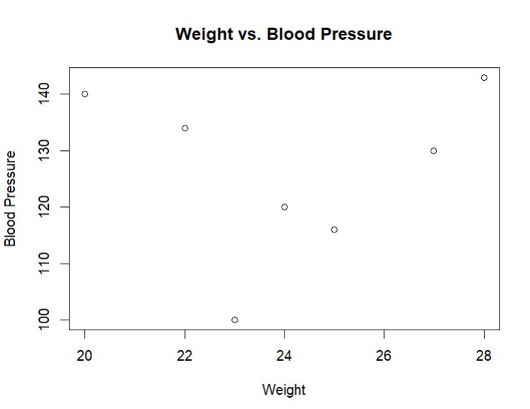**Graph between weight and blood pressure**

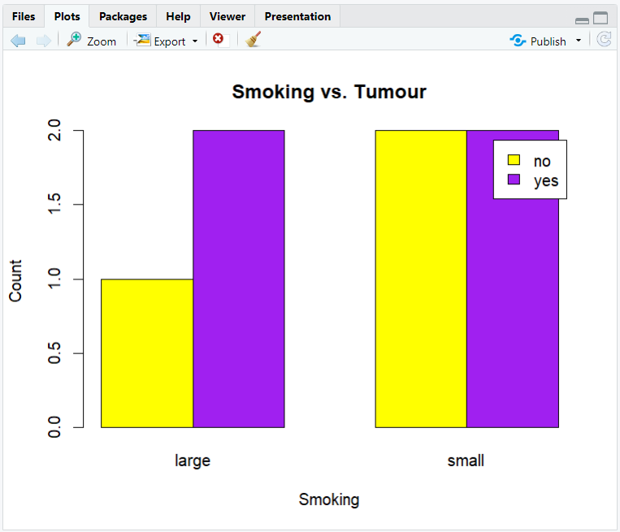**Stacked chart between smoking and tumour.**