

Week-5 Assignment

Topic : FlightBookingSystem w/ WebFlux

-Riddhima Bhanja
Kalinga Institute of Industrial Technology

INDEX

Column Name Page No.

1. Jacoco Report Page 1

MongoDB Page 1
- Booking
- Flight Inventory

Postman Page 2
- Add Inventory
- Search Flights
- Book Flights
- Search by PNR
- Booking History
- Delete

4. JMeter Testing Page 5
- 20 Requests
- 50 Requests
- 100 Requests
- Summary Report
- Result Tree

5. SonarQube Page 6
- Before Errors
- After Errors

- JACOCO Report

90 % Test Coverage
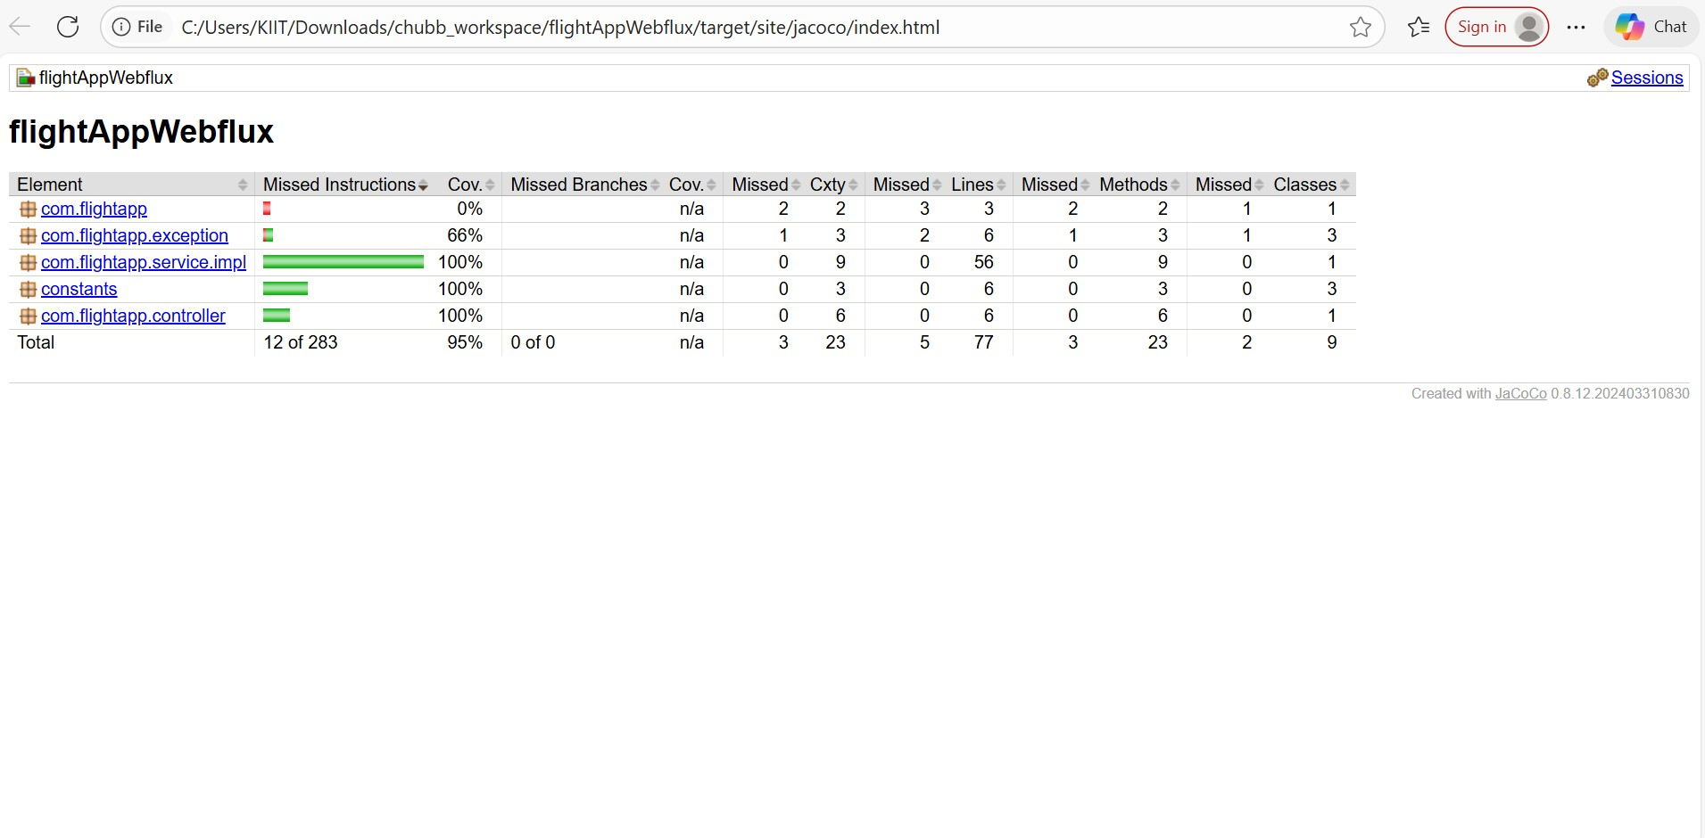

- MongoDB

- Booking:
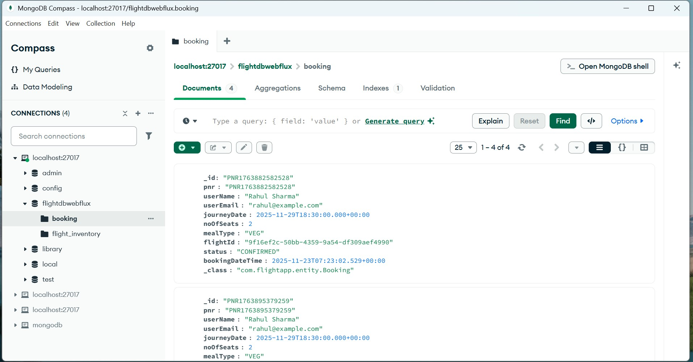

- Flight Inventory
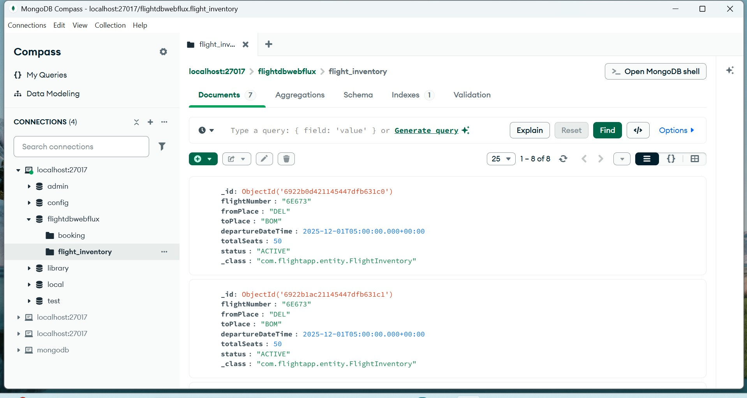

- Postman

- Add inventory
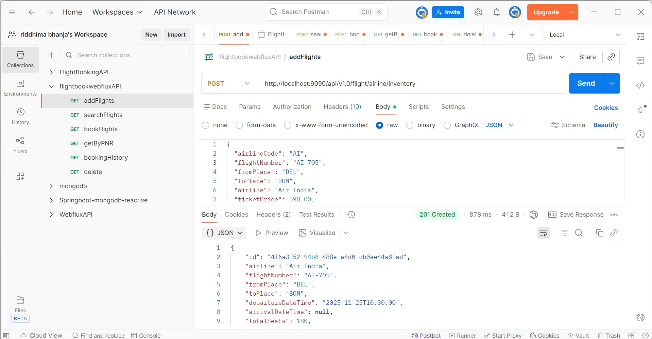

- Book Flights
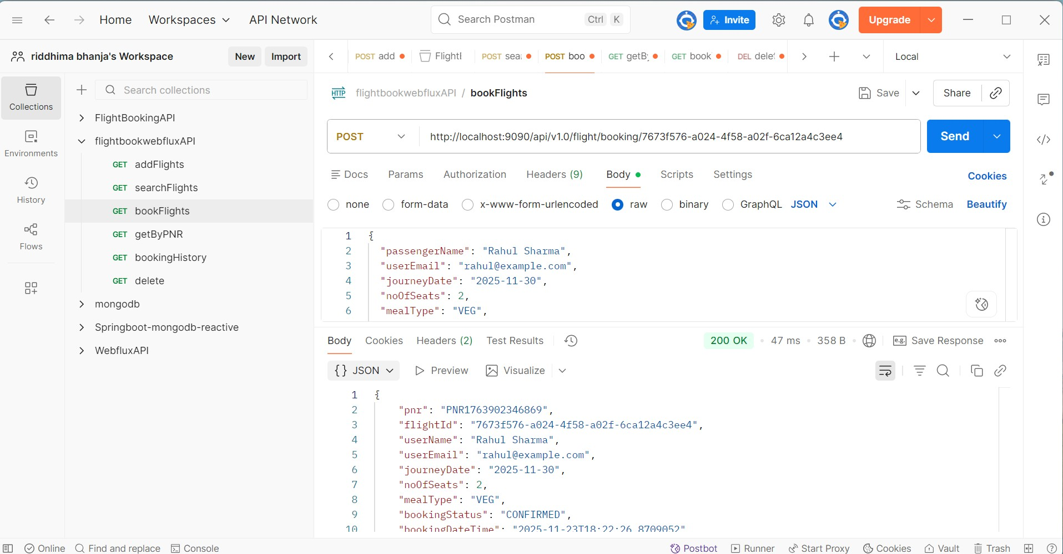

- Booking History

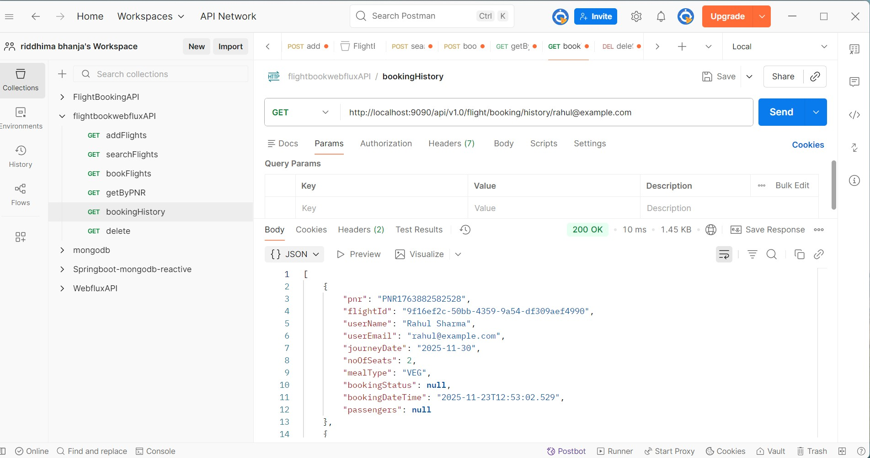

4. Get by PNR
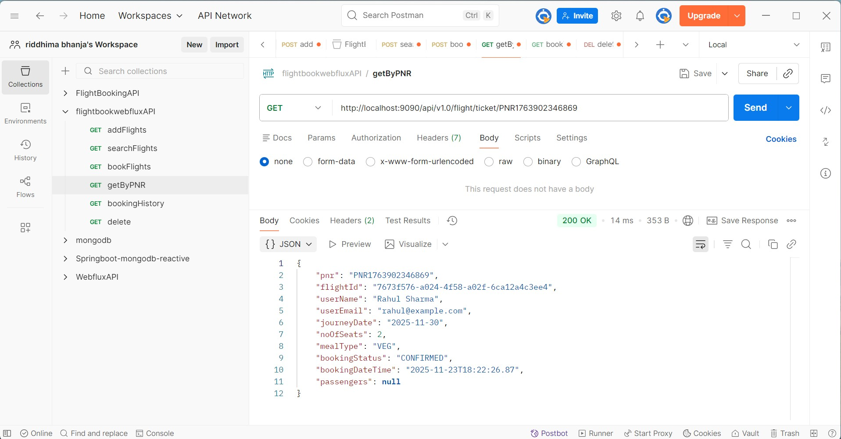

- Search Flights
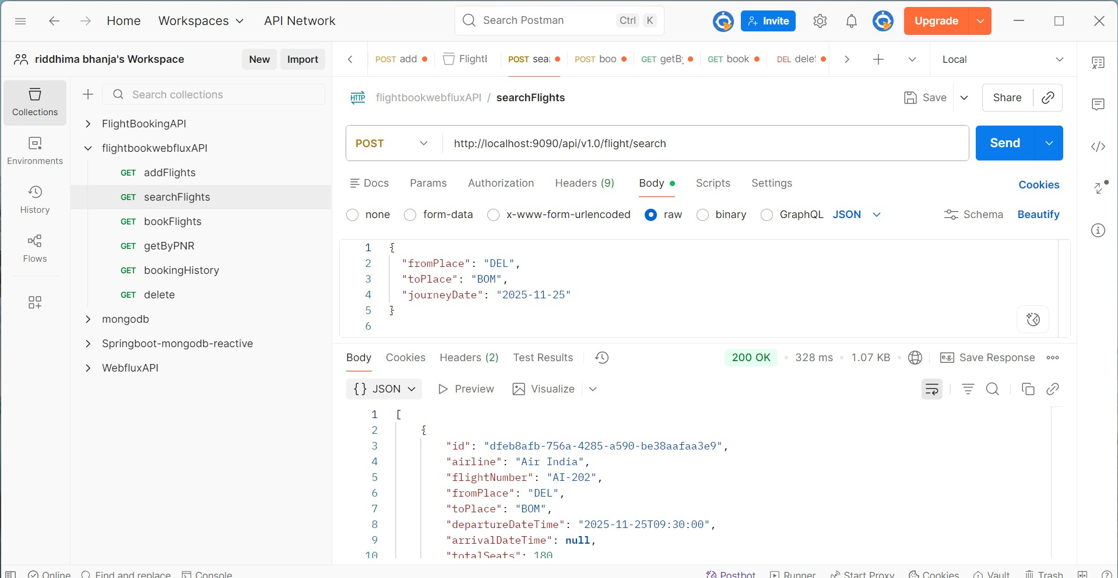

- JMeter Testing
- 20 request
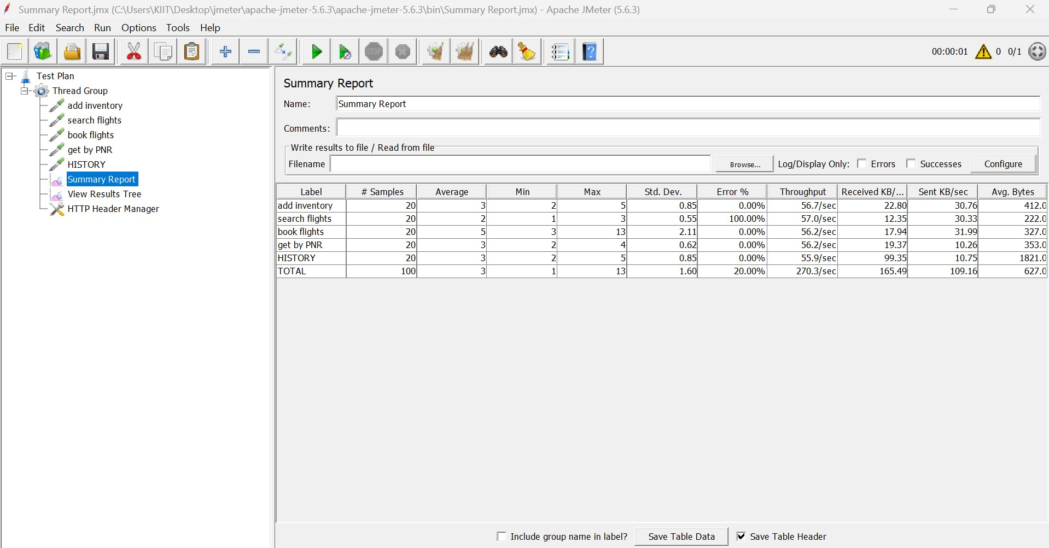

- 50 request
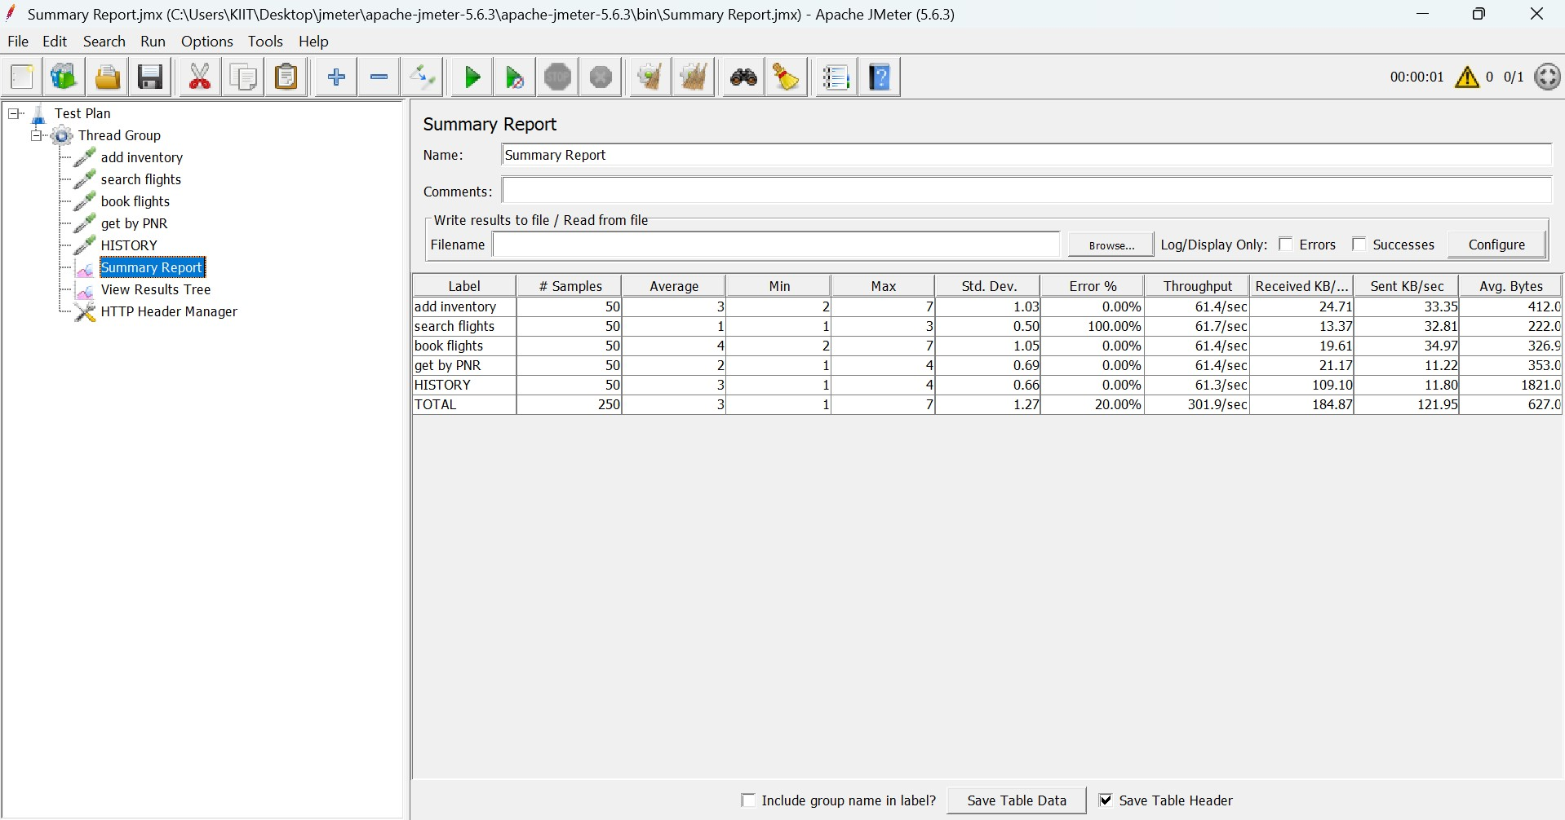

- 100 request
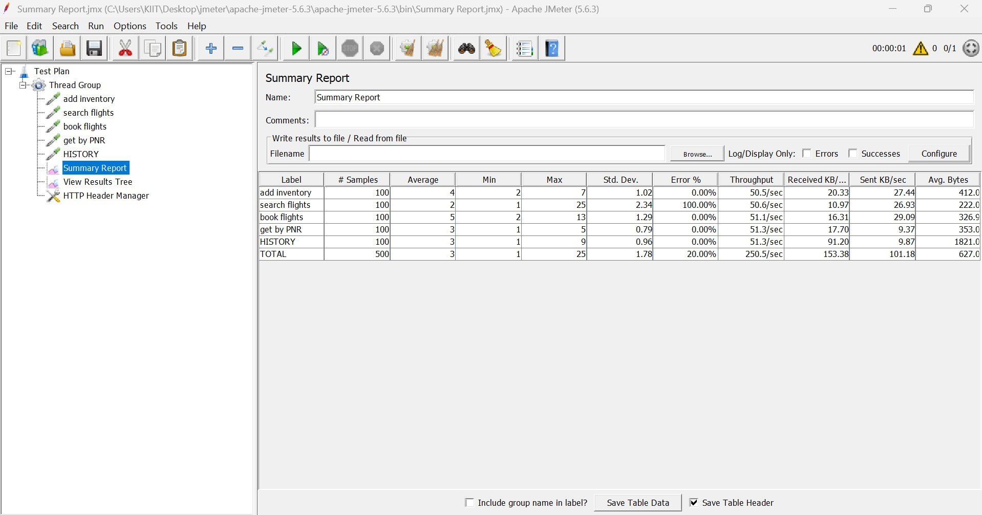

- Result Tree
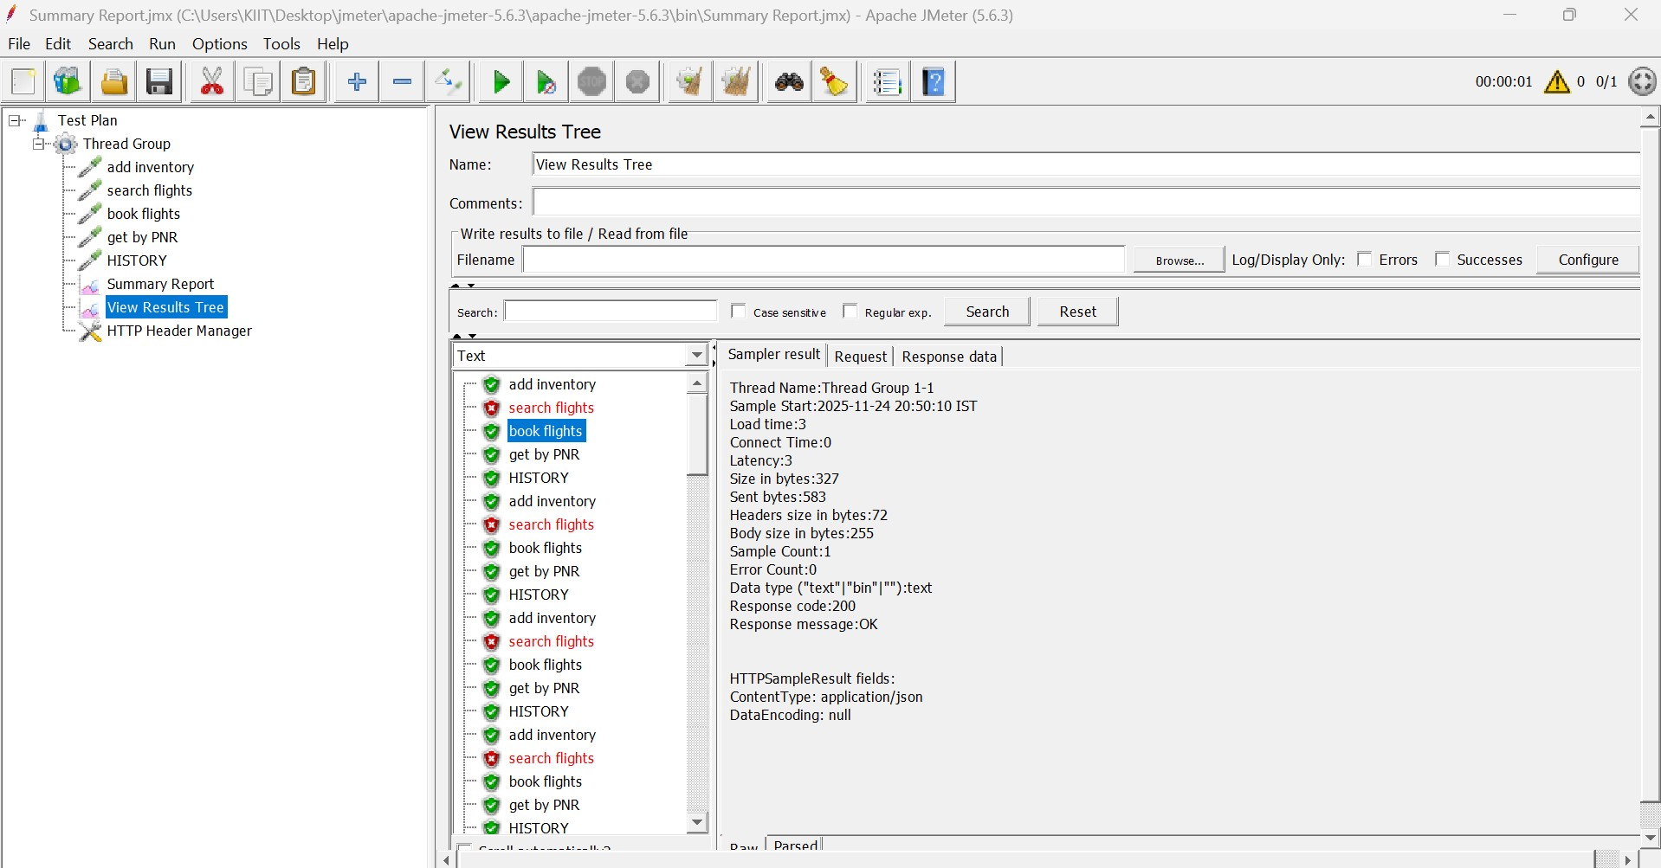

- SonarQube Report
