

WEEK-8 ASSIGNMENT

-Riddhima Bhanja
Kalinga Institute of Industrial Technology
Bhubaneswar(Java Track)
INDEX
(flight app with angular)

S. No. | Main Category | Details Included
1 | Code Coverage Report | • All Files  • Code Coverage Breakdown
2 | Test Run (UI) | • UI Test Execution Results
3 | Home Page | • Home Page UI & Functional Testing
4 | Register Page (Create Account) | • User Registration Flow• Account Creation Validation
5 | Login Page | • User Login Functionality
6 | Search Flights Page | • Flight Search UI  • Search Functionality
7 | Login for Searching Flights | • Authentication Required for Flight Search
8 | Validation Errors | • Search Flights Validation Errors  • Login Validation Errors  • Email Validation Errors  • Registration Page Validation Errors
9 | Build Success | • Successful Build Confirmation
10 | Clean Flight Search Page | • No Pre-filled Data  • UI Reset Validation
11 | Clean Login Page | • Empty Fields Validation
12 | Password Mismatch Error | • Incorrect Password Handling
13 | MongoDB Data | • Database Records Verification
14 | MySQL Workbench | • Relational Database Validation
15 | Password Eligibility Cases | • Length Check  • Strength Rules  • Format Validation
16 | User Already Exists Case | • Duplicate User Registration Handling
17 | Postman Reports | • API Testing Reports  • Request–Response Validation

INDEX
Content | Page No.
1. JACOCO Code Coverage Report | 1
2. SonarQube Report & Issues | 3
3. System Architecture, ER Diagram | 5
4. JMeter & RabbitMQ dashboard | 6
— JMeter Result Tree | 6
— JMeter Summary Report | 6
— Apache JMeter Dashboard | 7
5. Logs | 9
— RabbitMQ Dashboard | 9
— Eureka server, Booking Service | 10
— Flight Service, API Gateway, Notification service | 10
6. MongoDB Screenshots | 11
7. Postman Screenshots | 11
— Circuit Breaker, Message broker | 11
— — JWT security through API Gateway | 12
— — Status,Events | 12
— Health Checks | 13
— — API Gateway Health | 13
— — Booking Service Health | 13
— — Eureka Server Health | 14
— — Flight Service Health | 14
— Add Flight | 15
— Book Flight, get flight by PNR, get flight by ID | 15
— Cancel Booking, FALLBACK CASE | 15
— Get Booking by PNR | 16
— Get Booking History | 16
8. Email | 17
— With PDF | 17
— Without PDF | 17
— Fallback Case | 17
9. Eureka Dashboard, MySQL Workbench | 17

CODE COVERAGE REPORTS
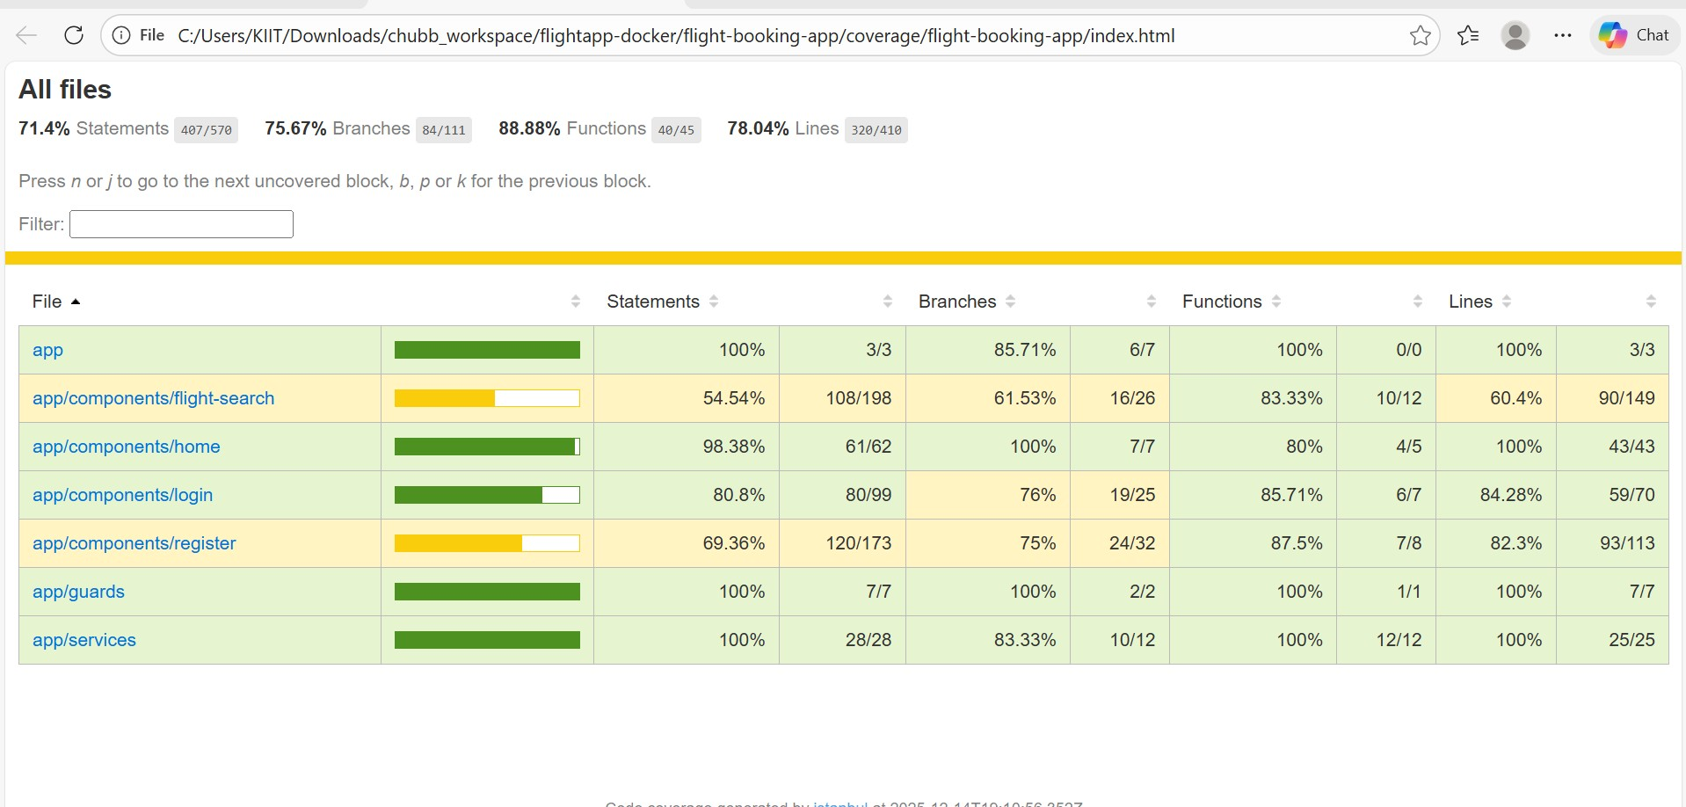

CODE COVERAGE BREAKDOWN
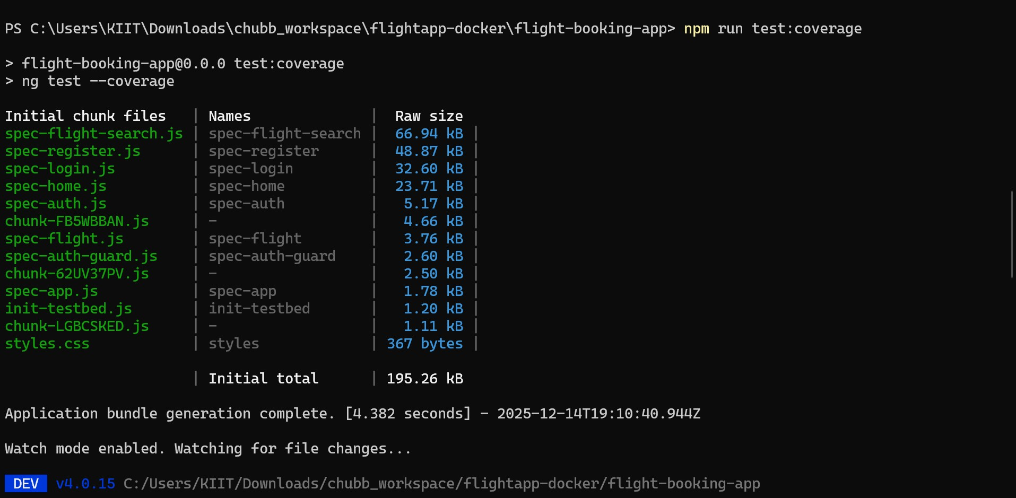

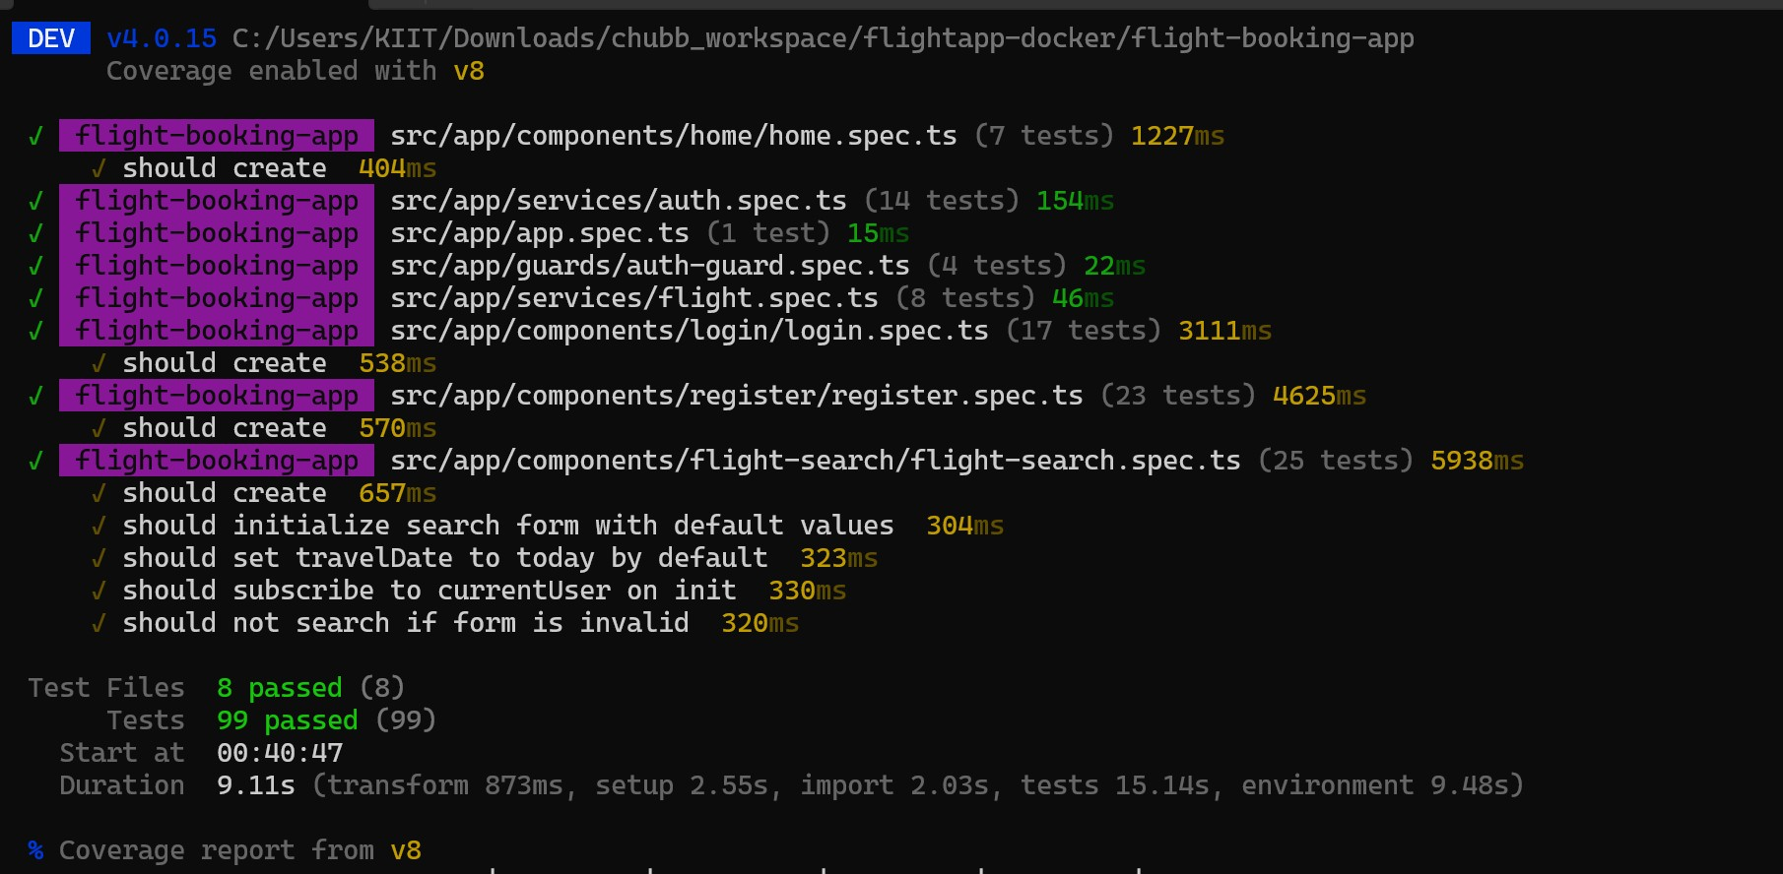
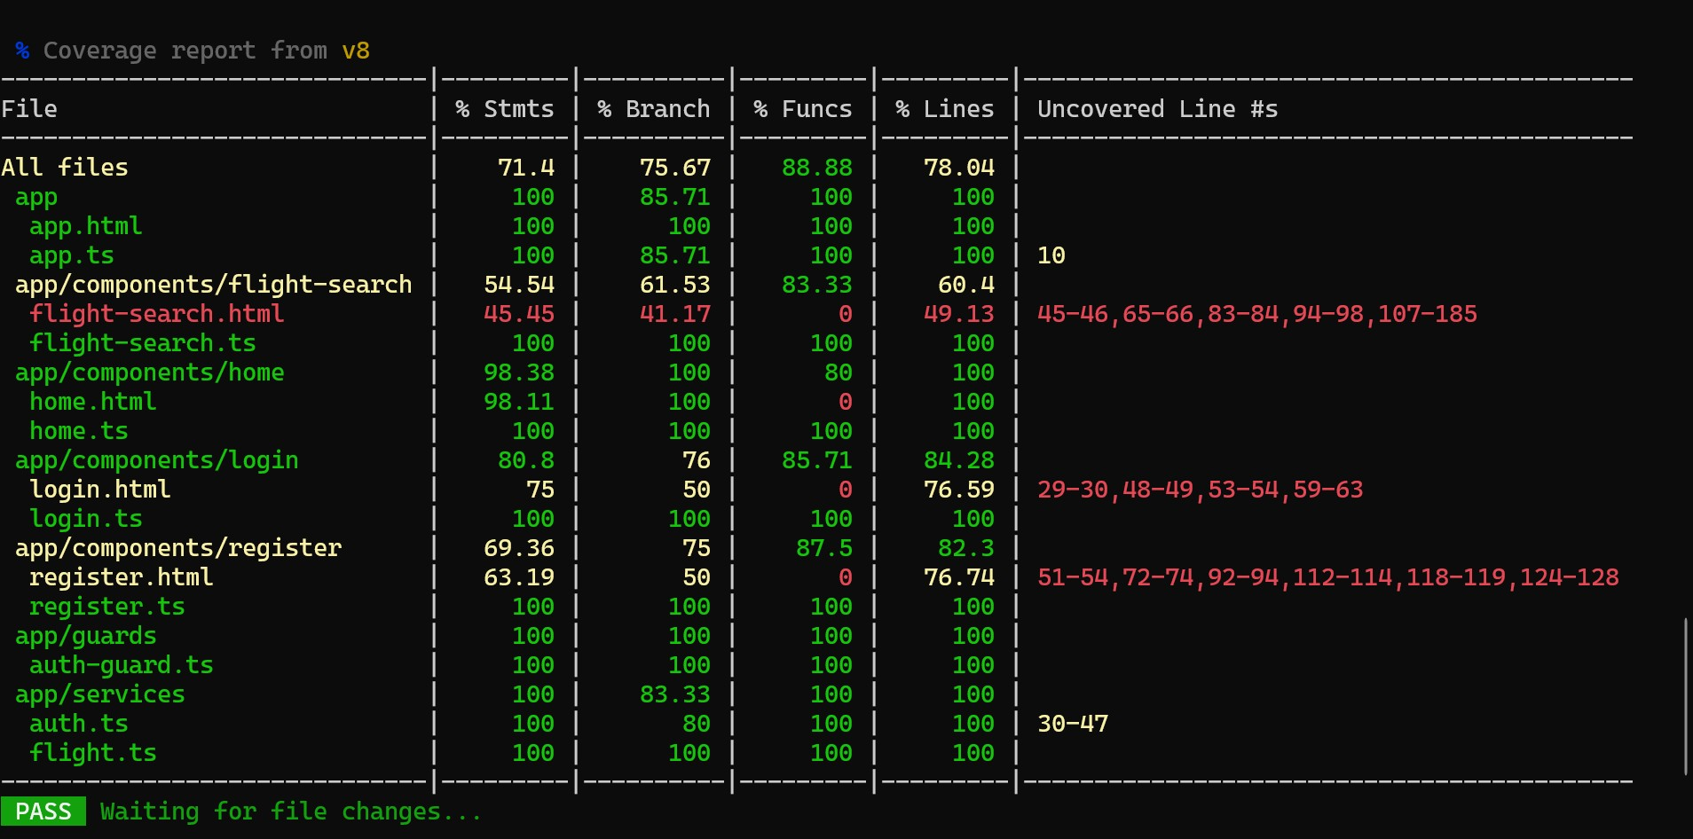
TEST RUN WITH UI
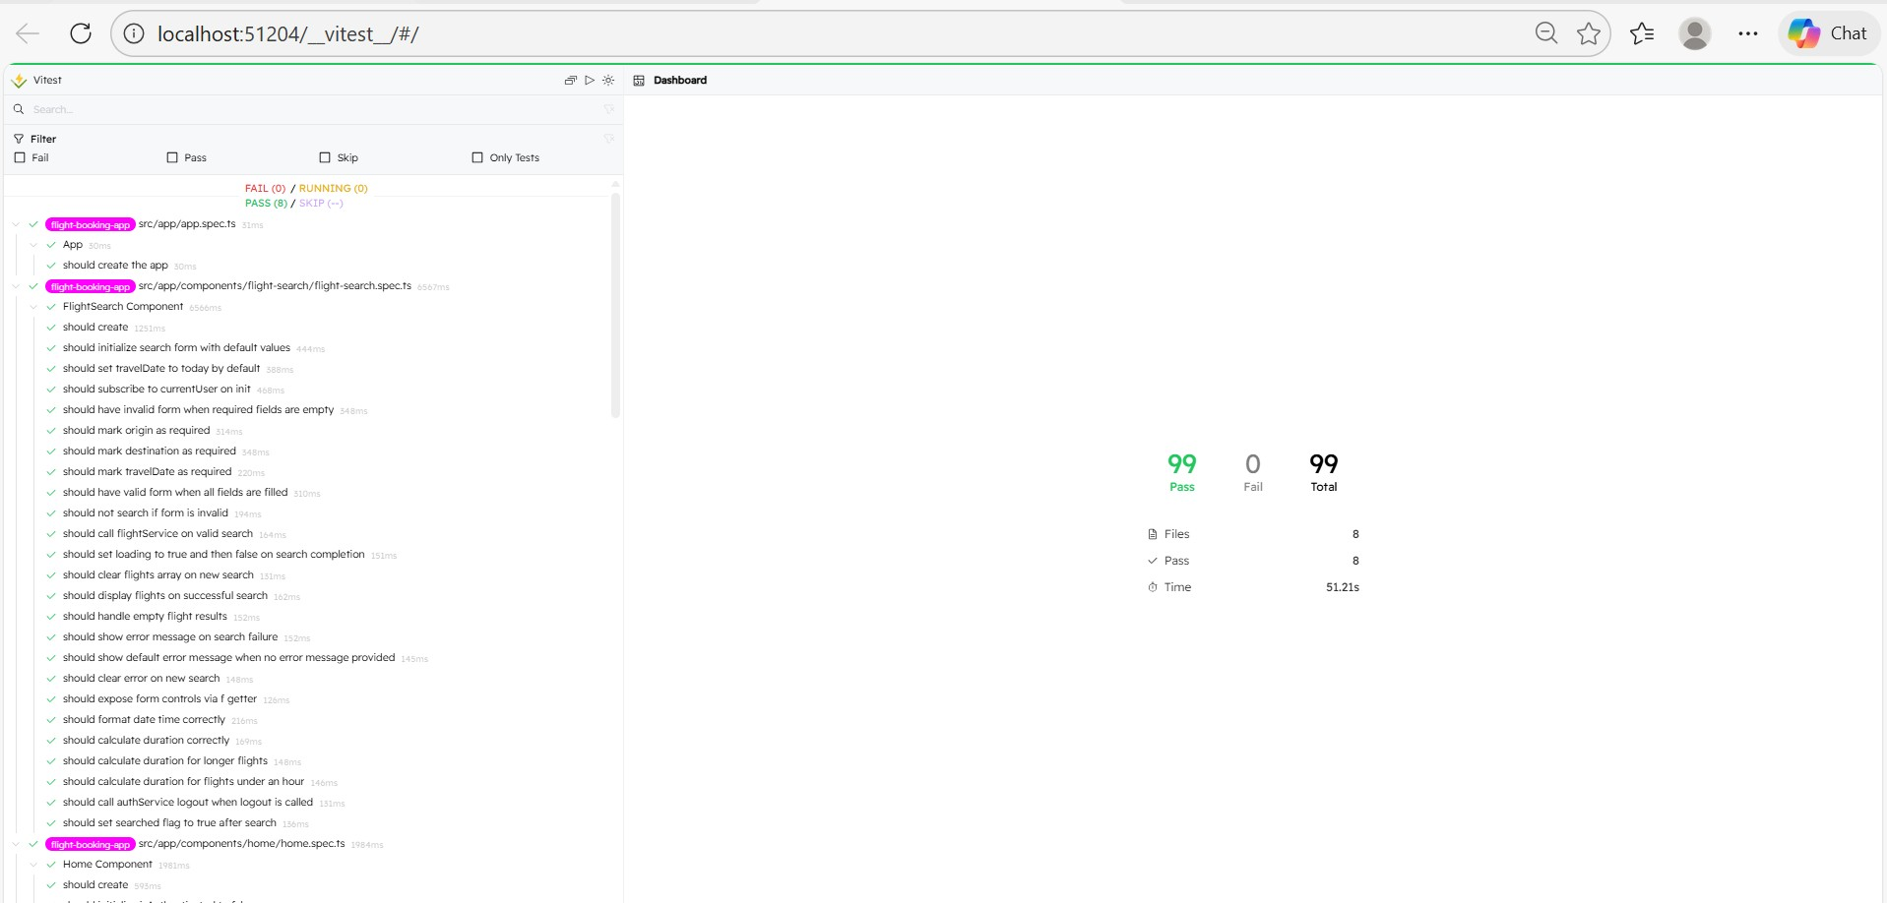
HOME PAGE
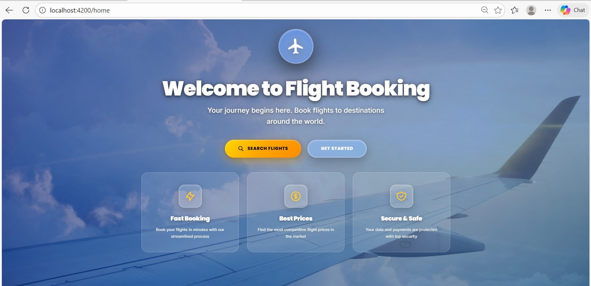

CLEAN REGISTER PAGE
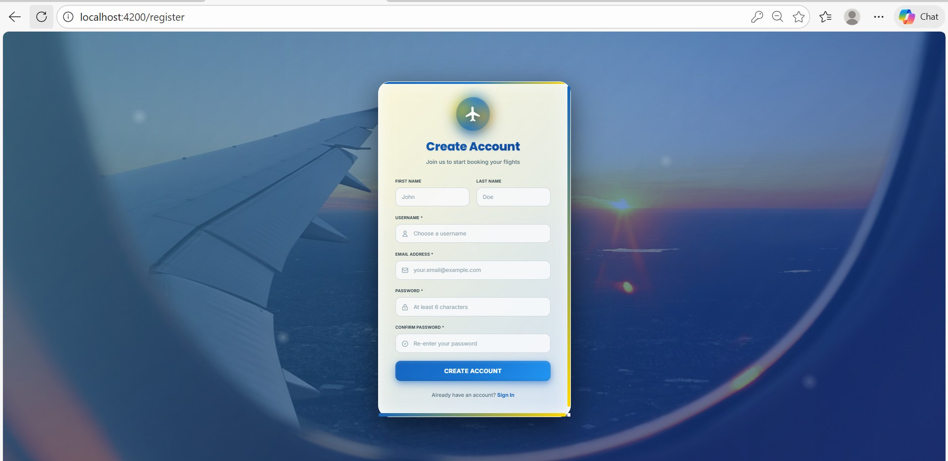

REGISTER PAGE(ACCOUNT CREATION)
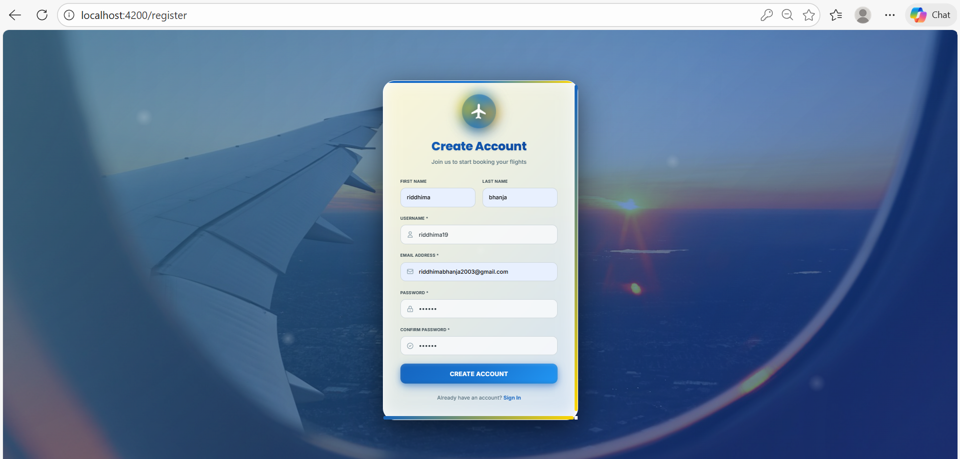

LOGIN PAGE
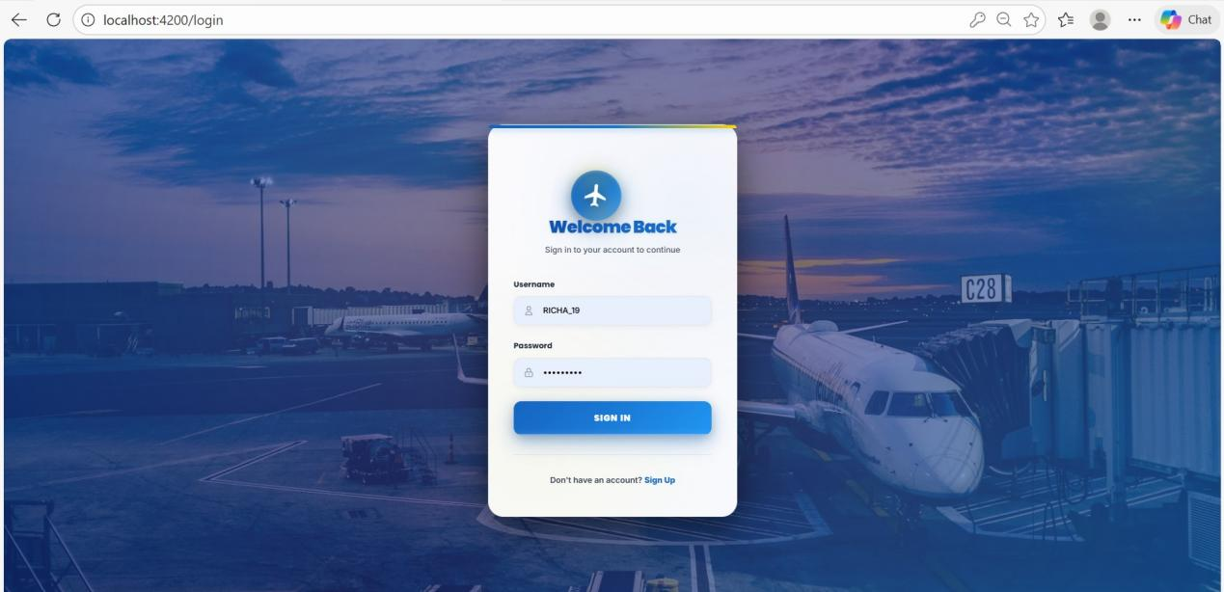

CLEAN LOGIN PAGE
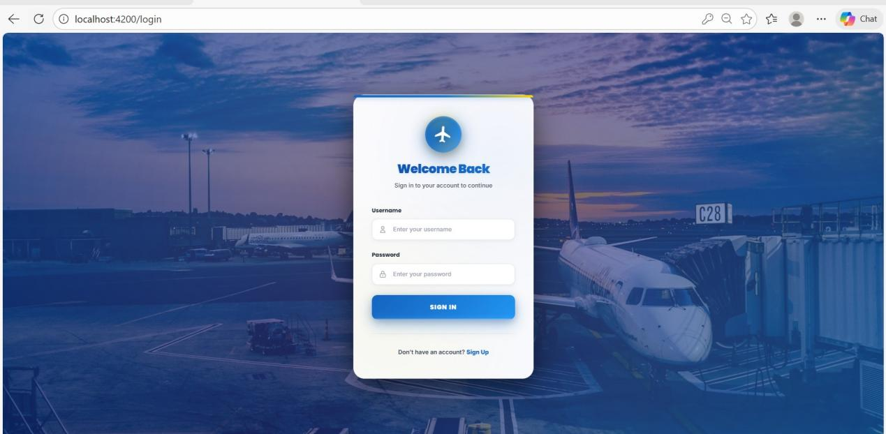

SEARCH FLIGHTS

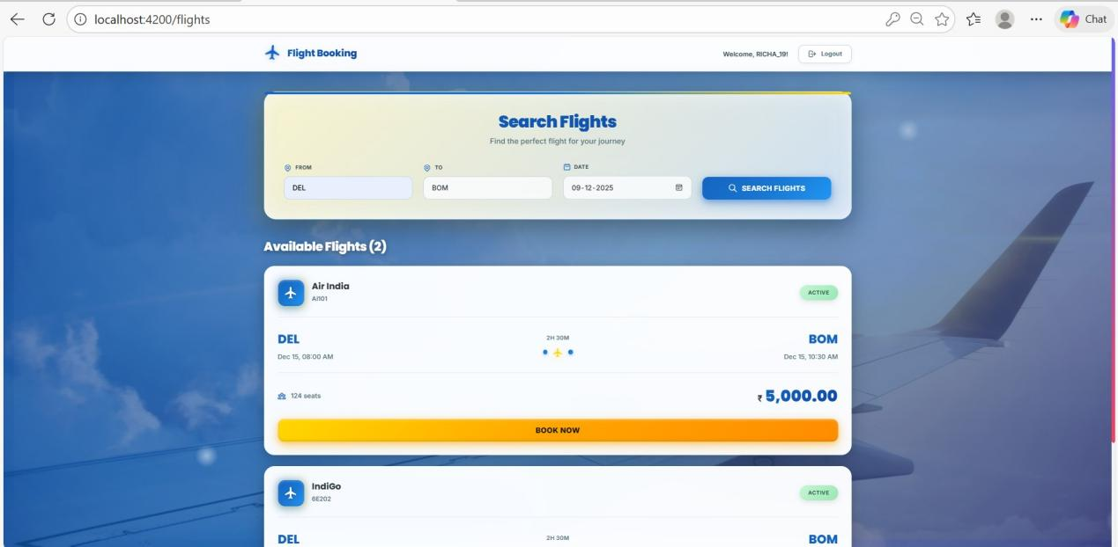

CLEAN SEARCH FLIGHTS

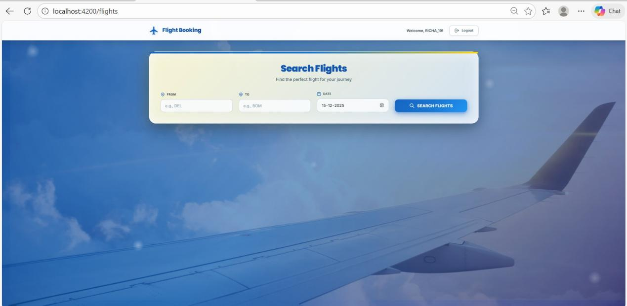

VALIDATION ERRORS

SEARCH FLIGHT VALIDATION ERROR
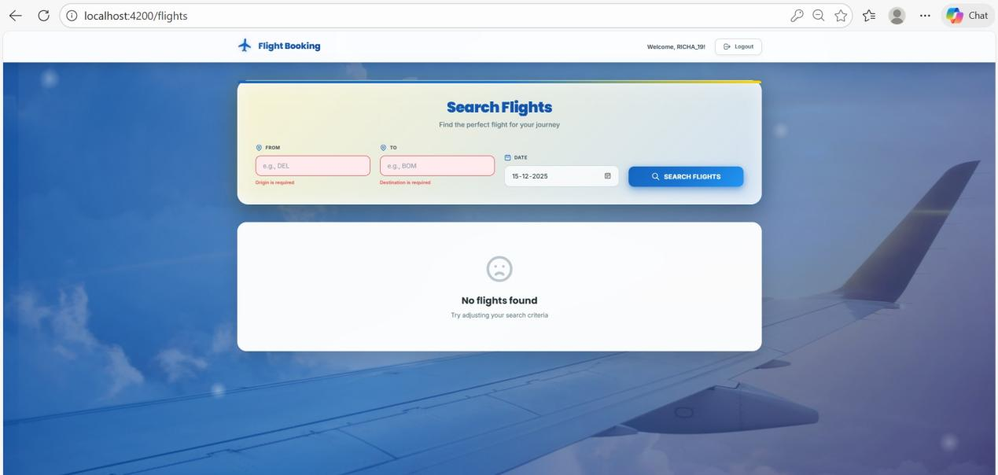

LOGIN VALIDATION ERROR
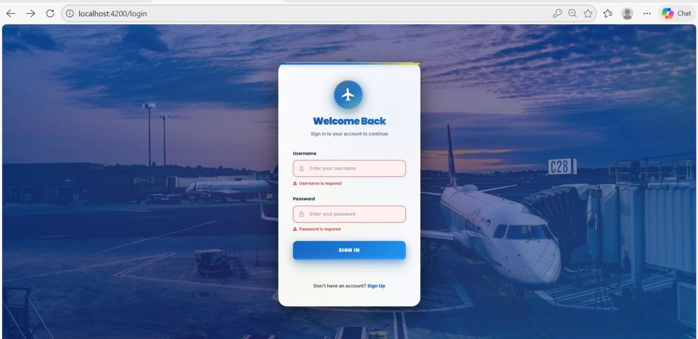

EMAIL VALIDATION ERROR
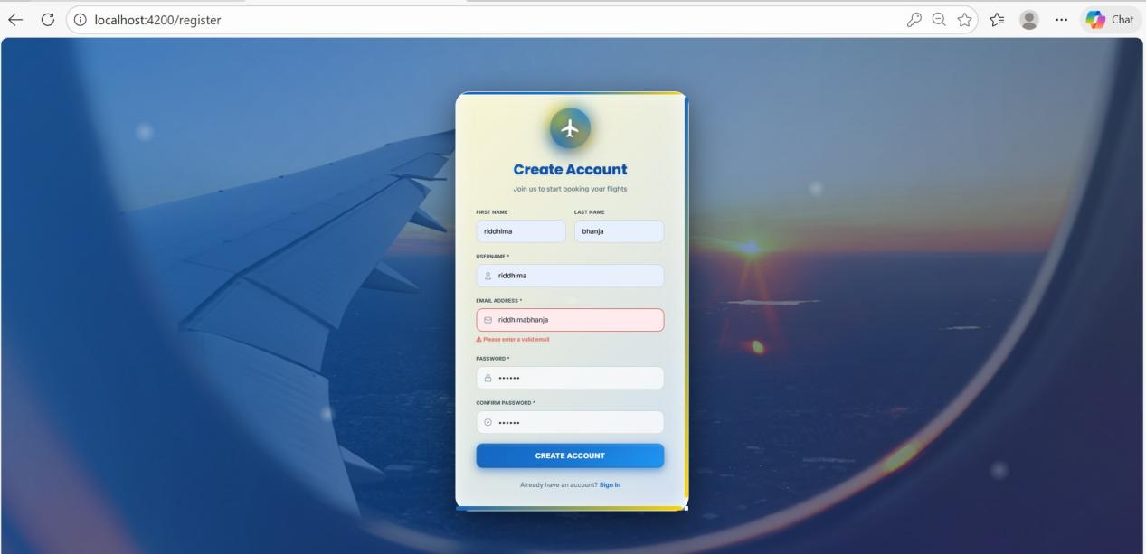

REGISTRATION VALIDATION ERROR

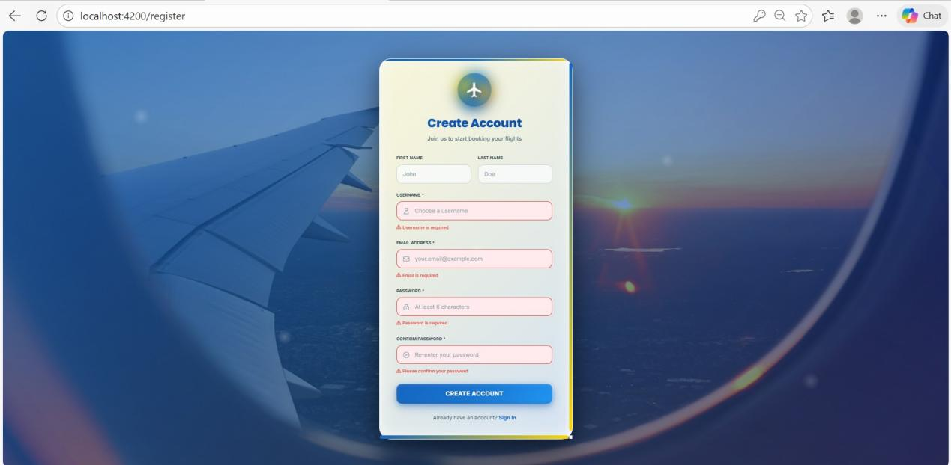

PASSWORD MISMATCH ERROR
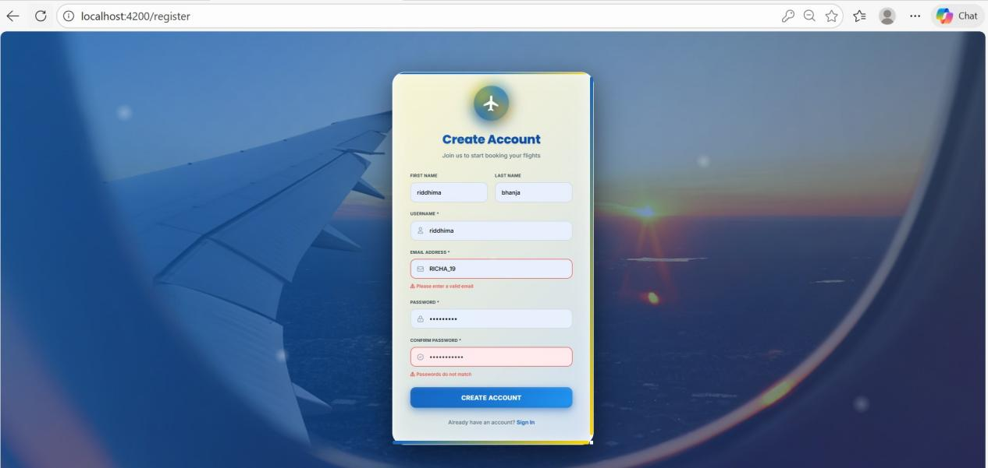

MONGODB DATA
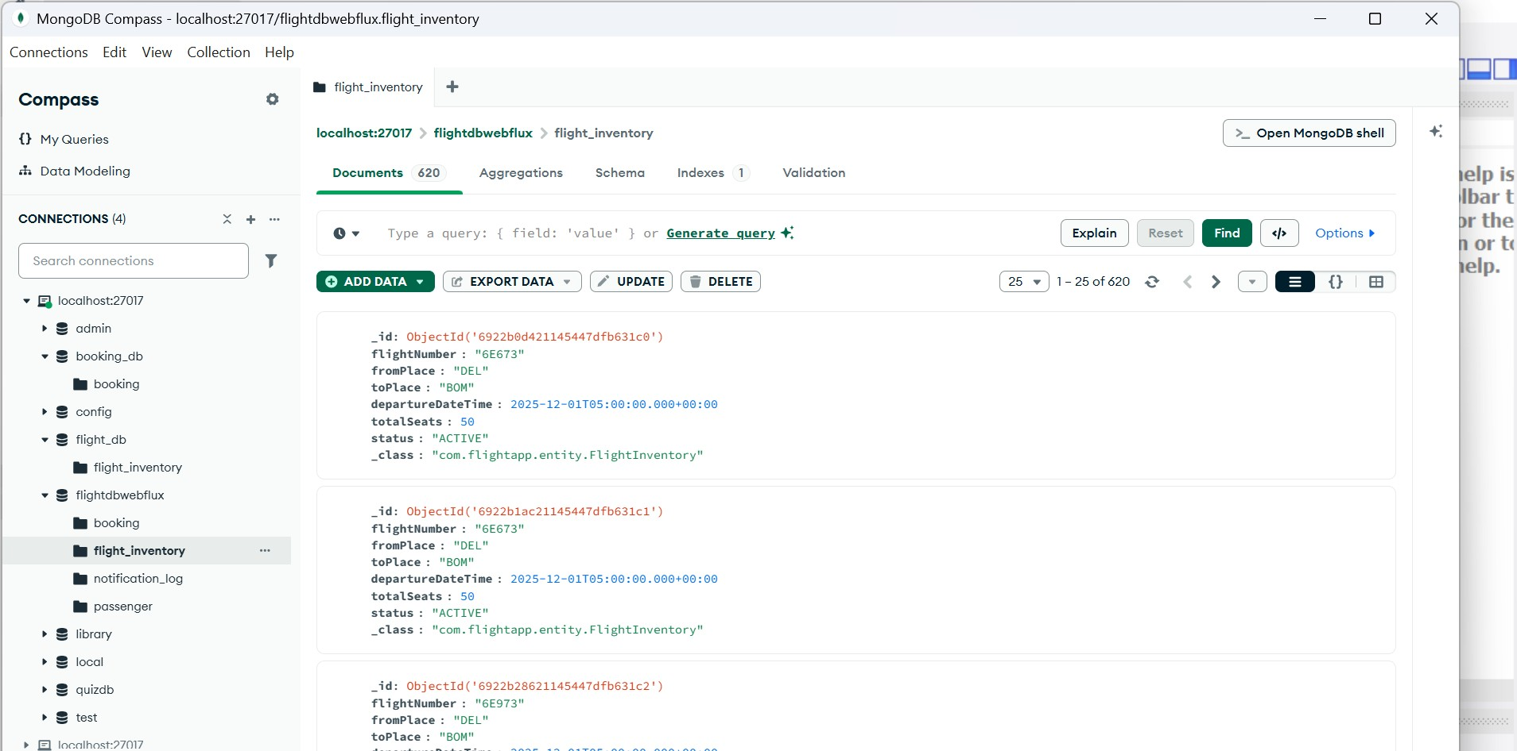

MYSQL WORKBENCH

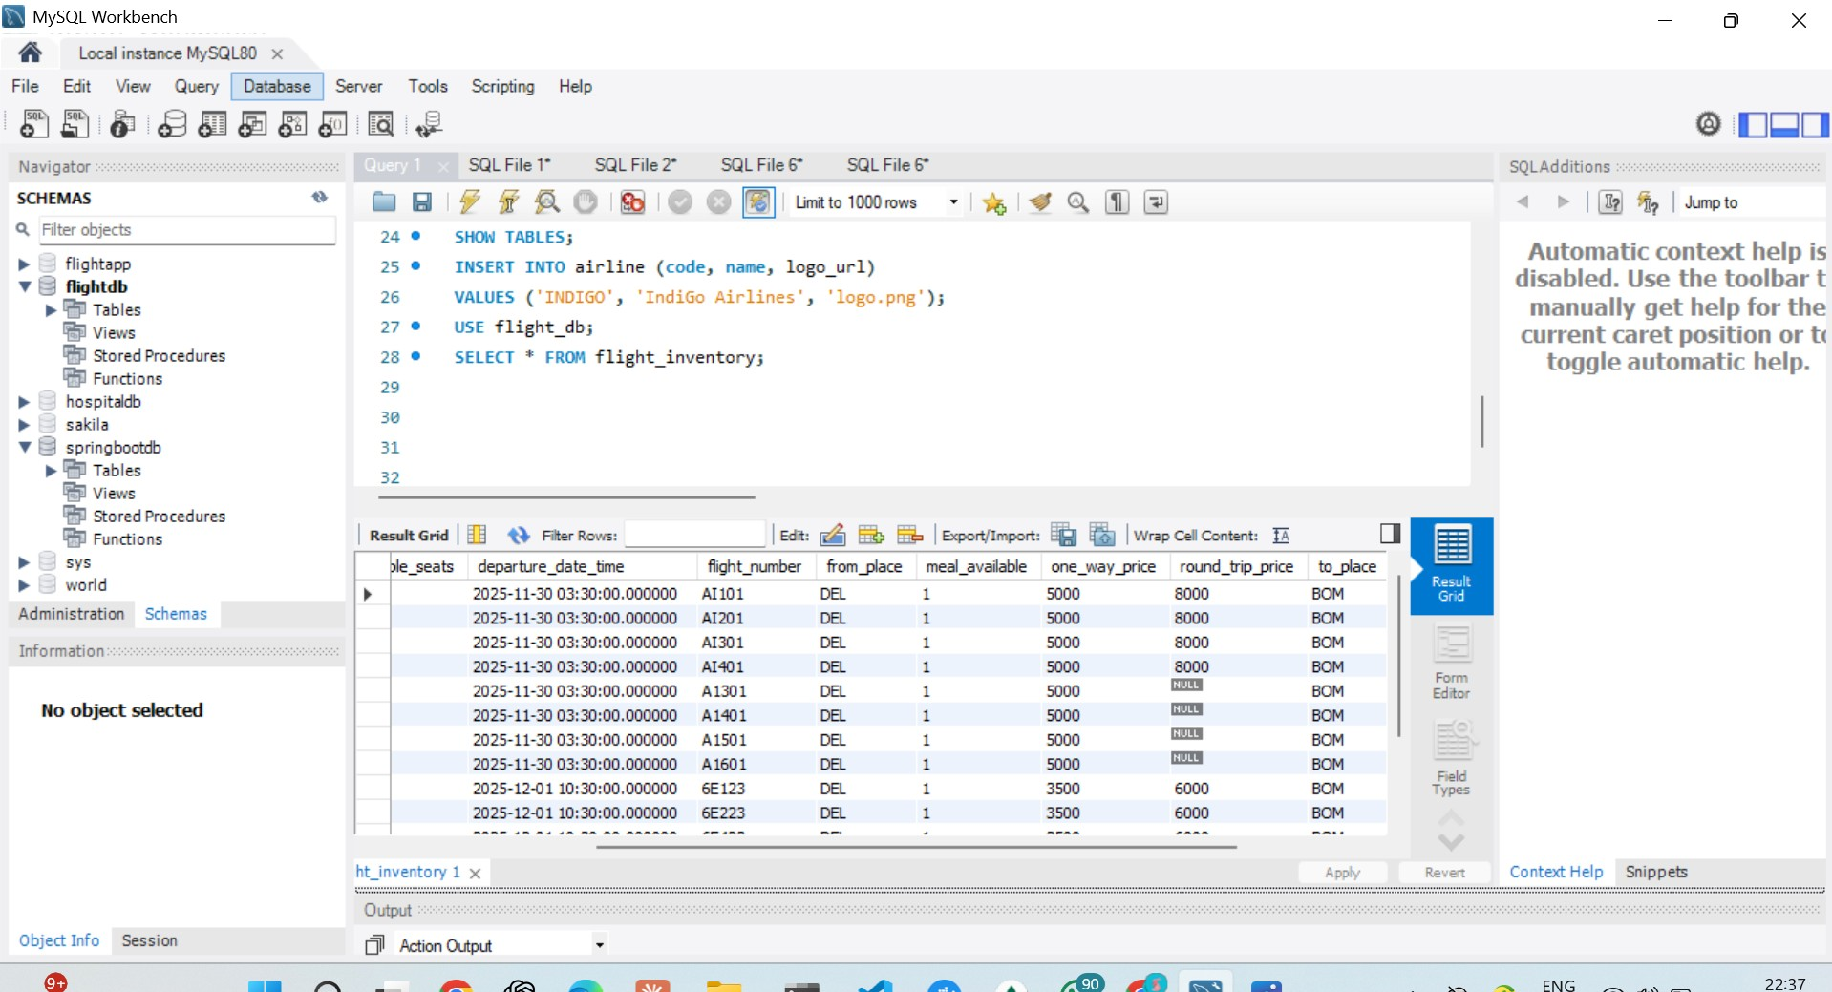

JACOCO REPORTS
FLIGHT SERVICE:
98% COVERAGE

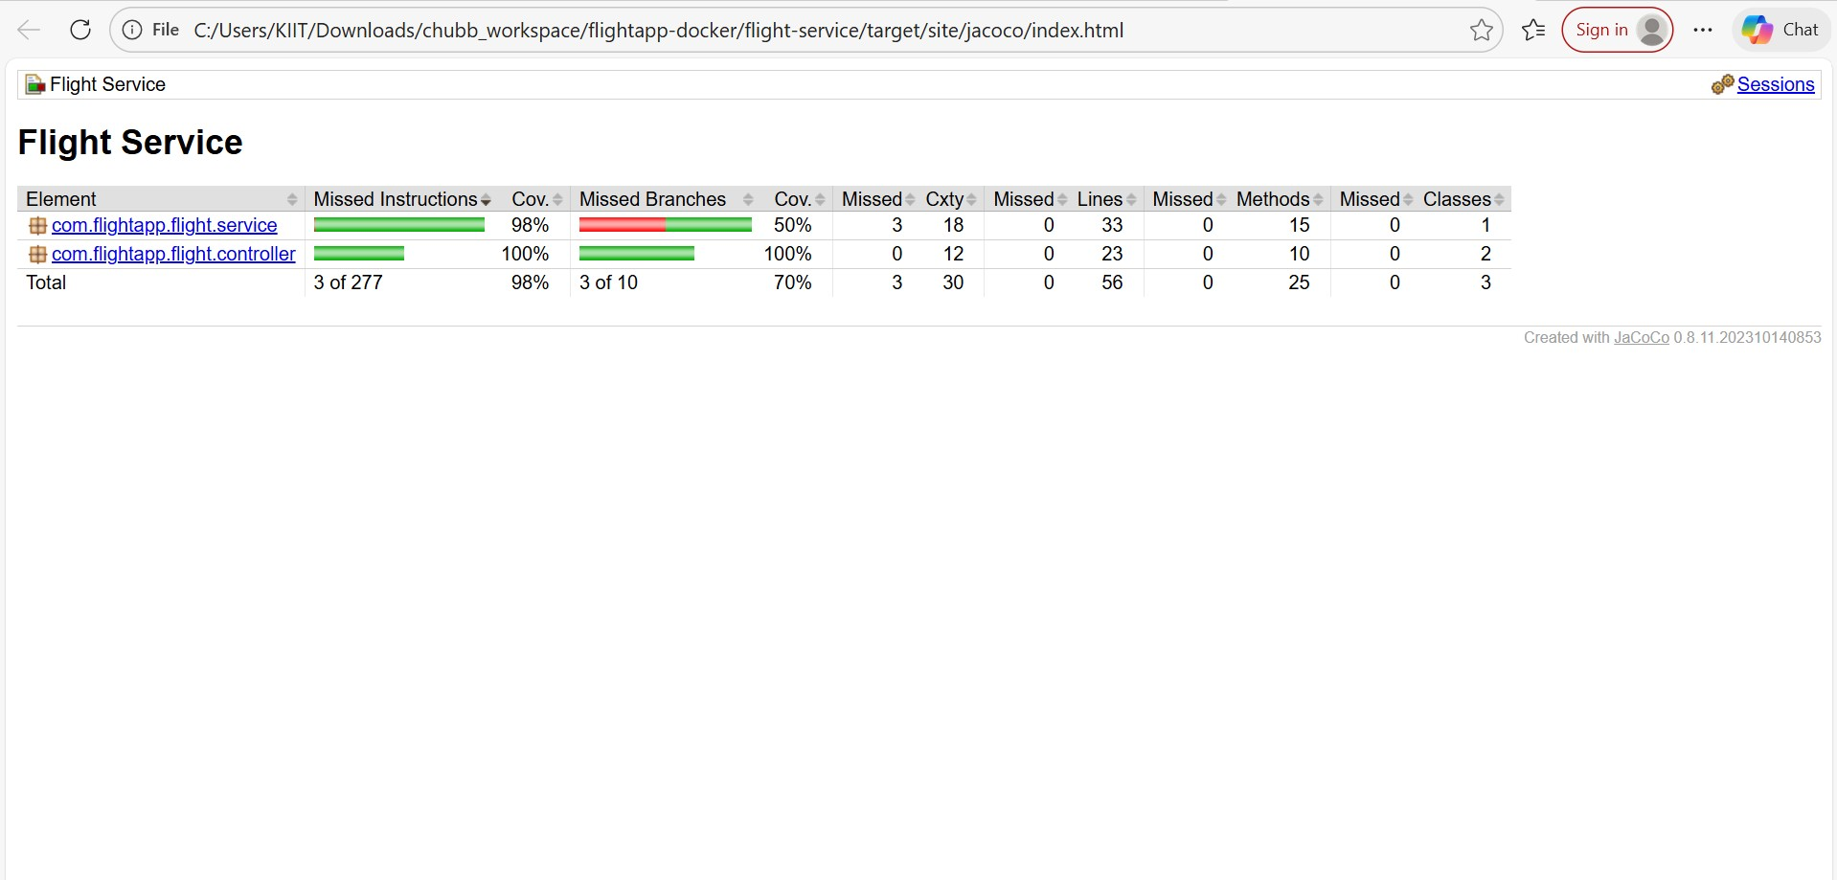

BOOKING SERVICE

94% coverage
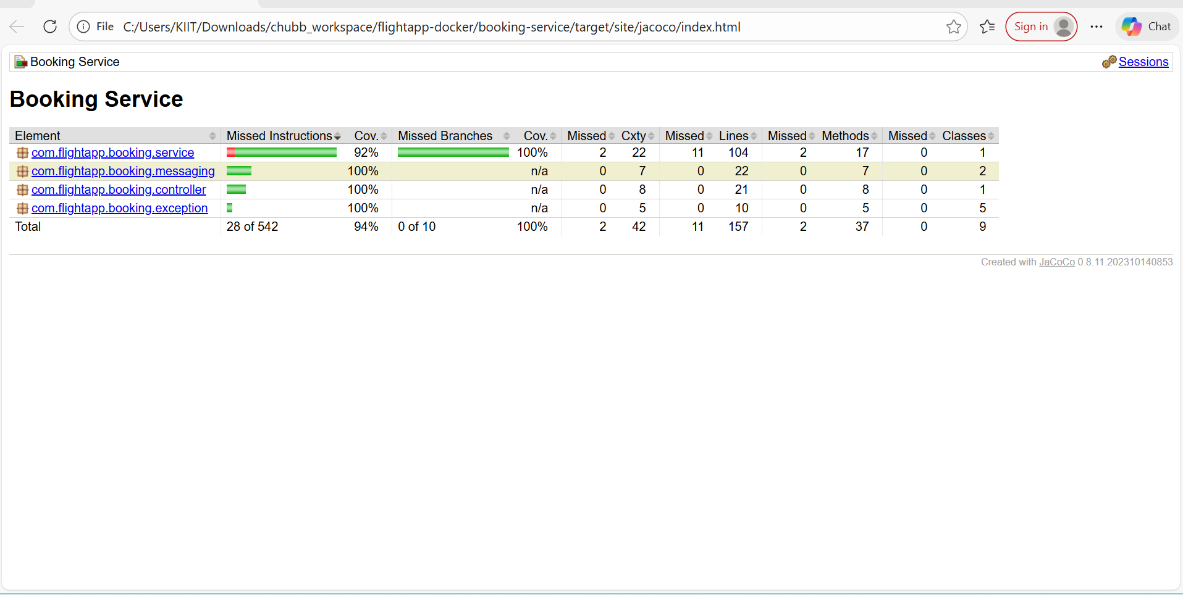

ER DIAGRAM

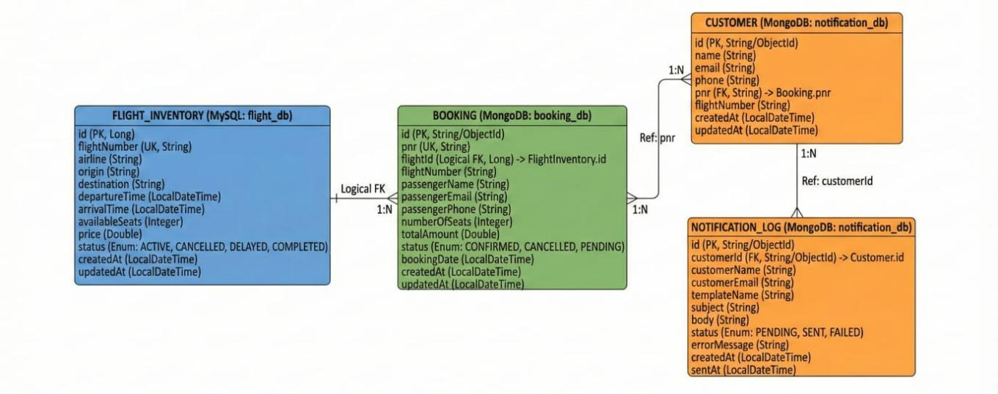

- SonarQUBE Code Coverage

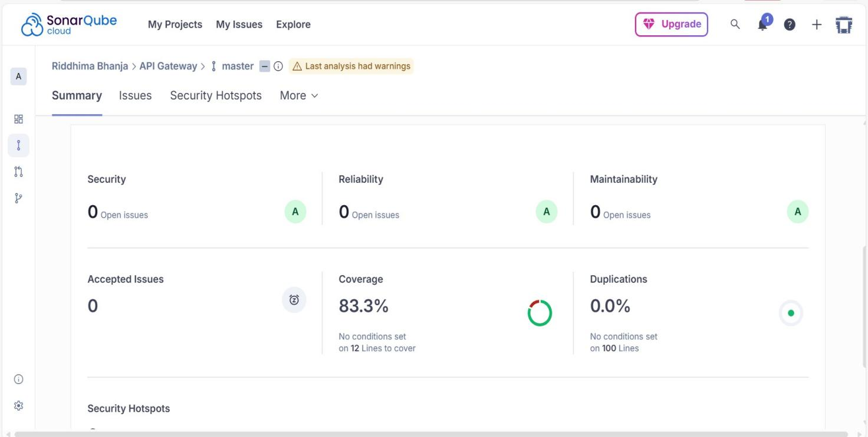

- SonarQube Issues

Before fixing:

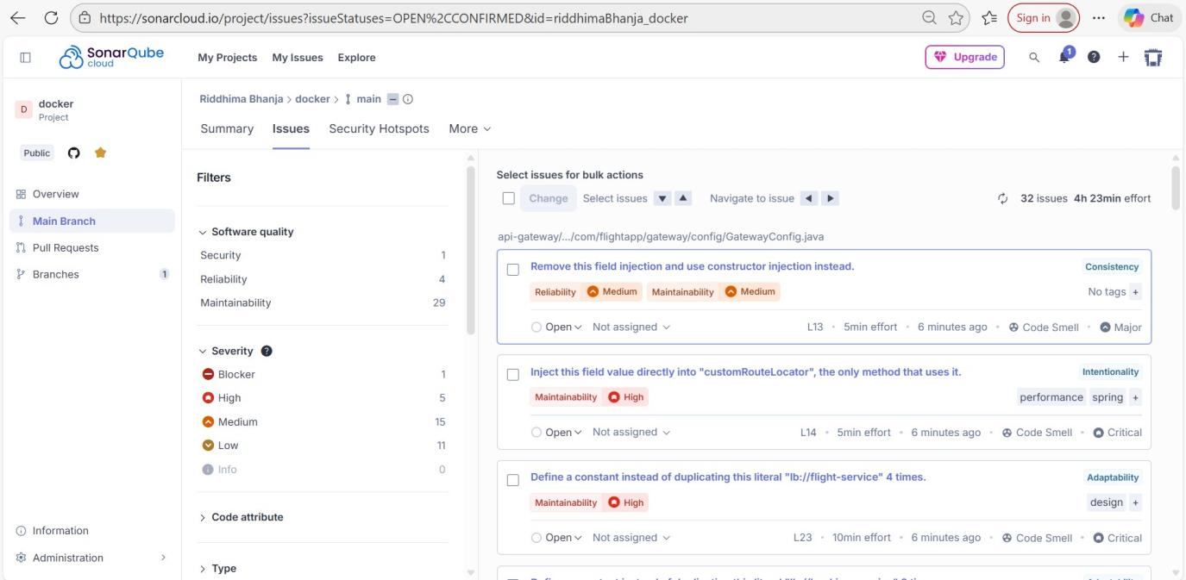

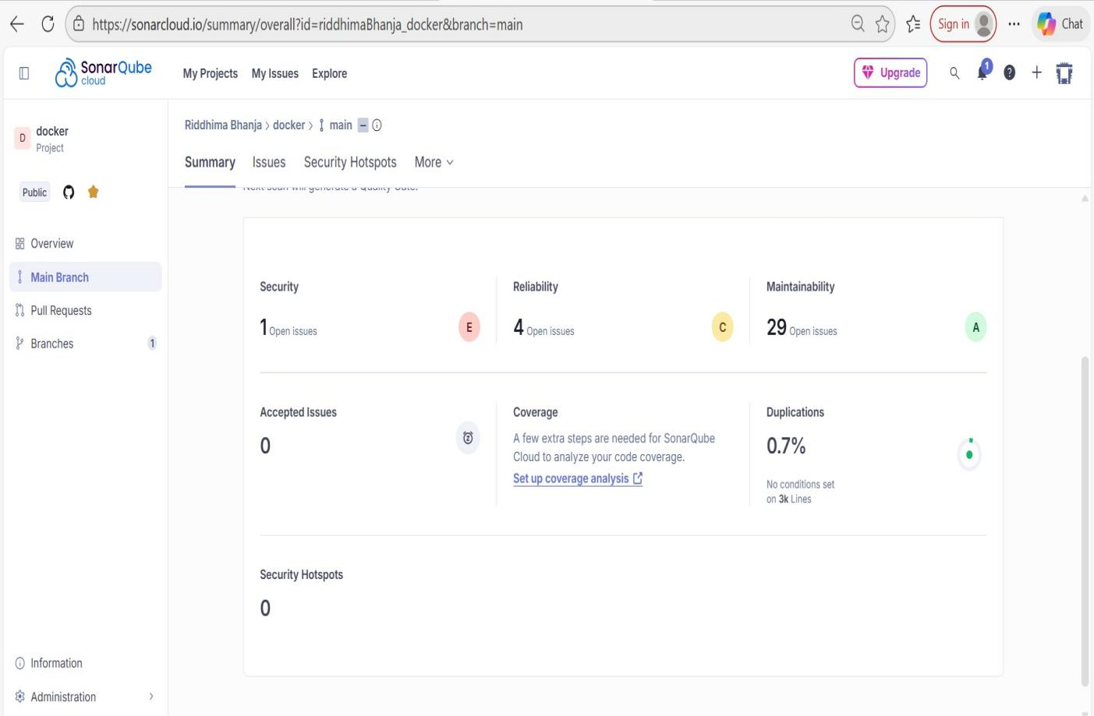

After fixing:

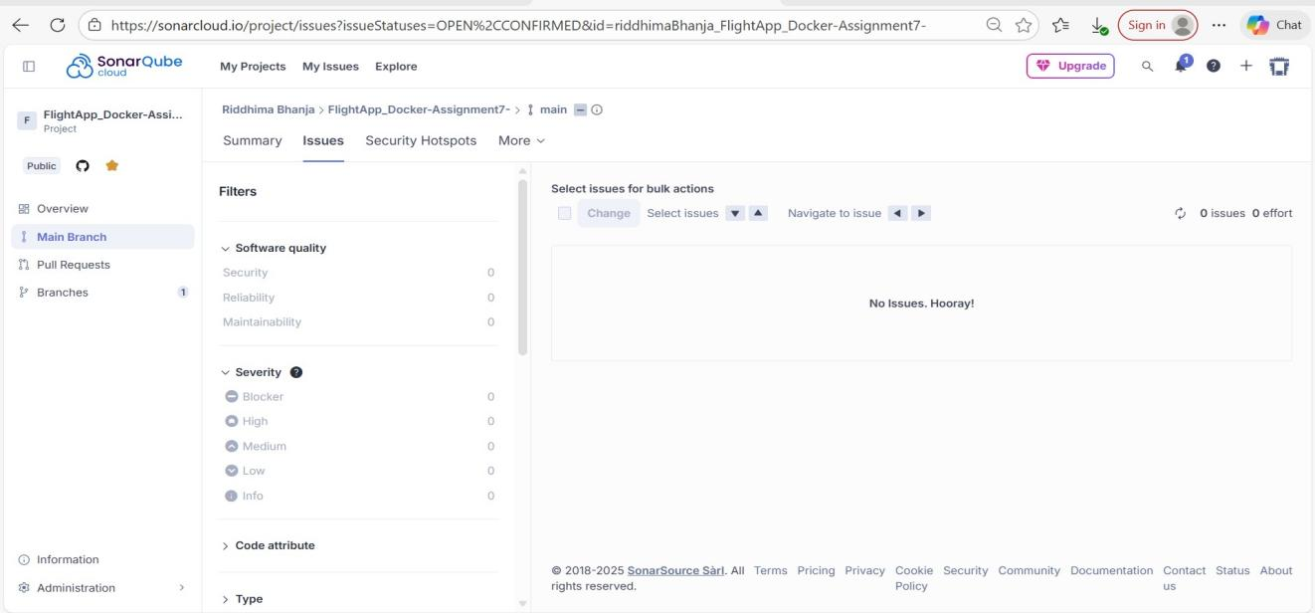

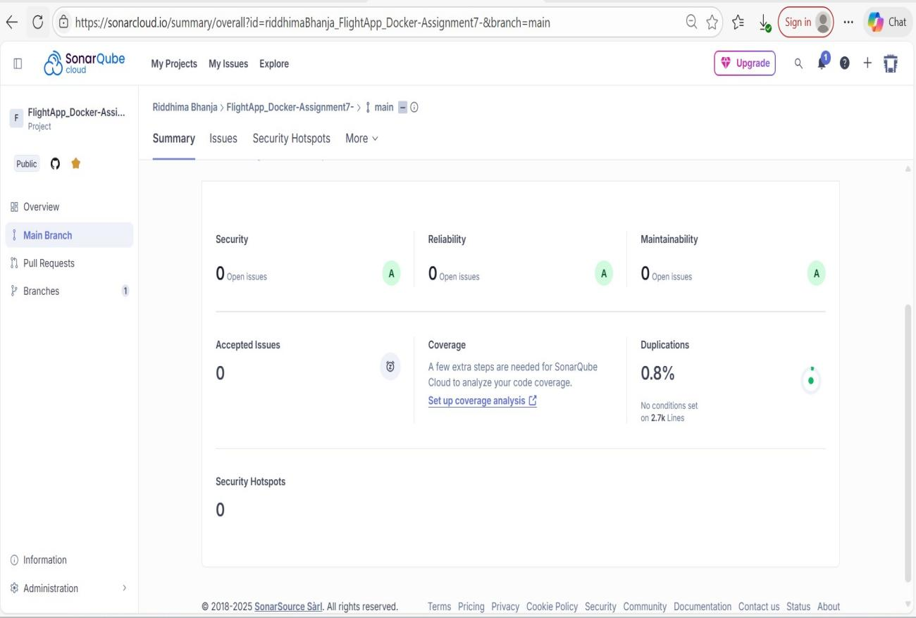

- System Architecture

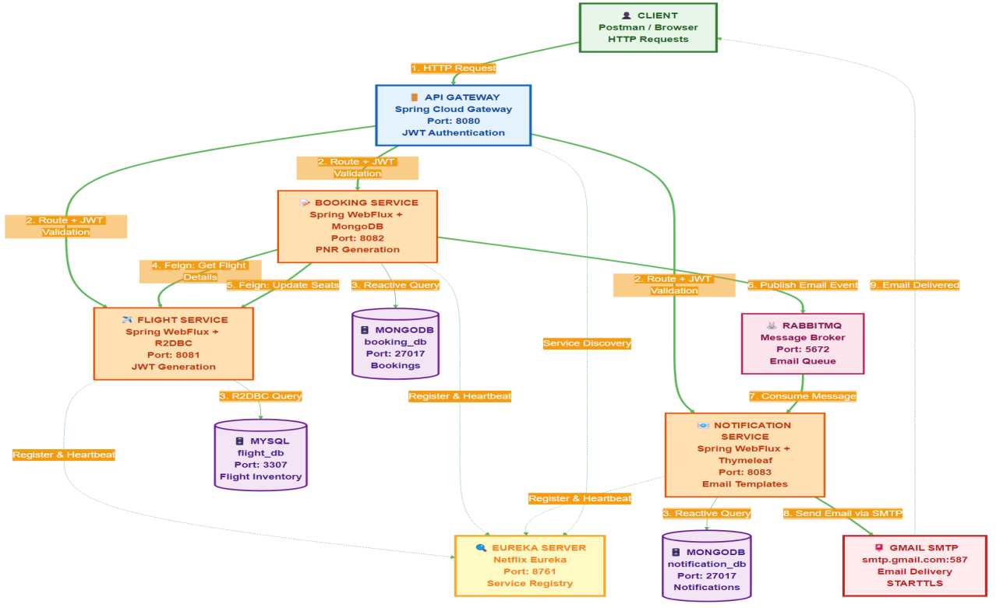

- Jmeter

- Apache Jmeter Dashboard

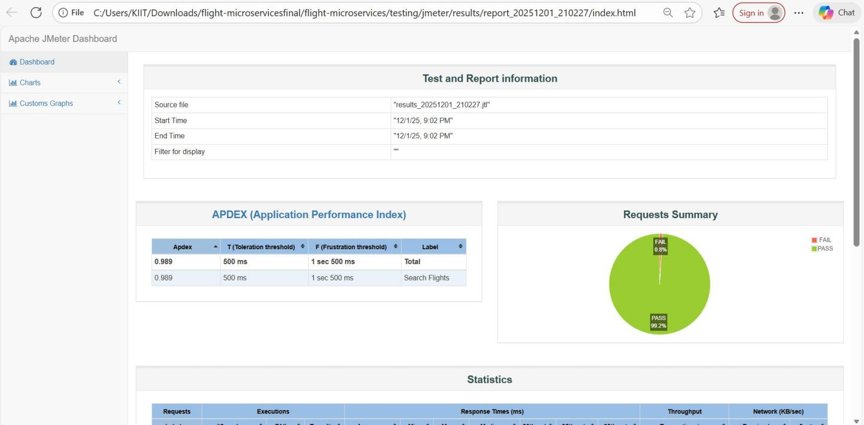

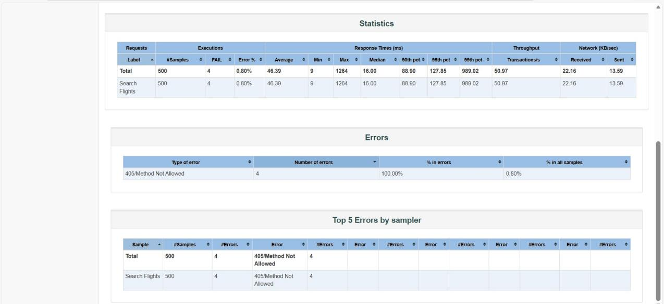

LOGS SCREENSHOTS

DASHBOARD
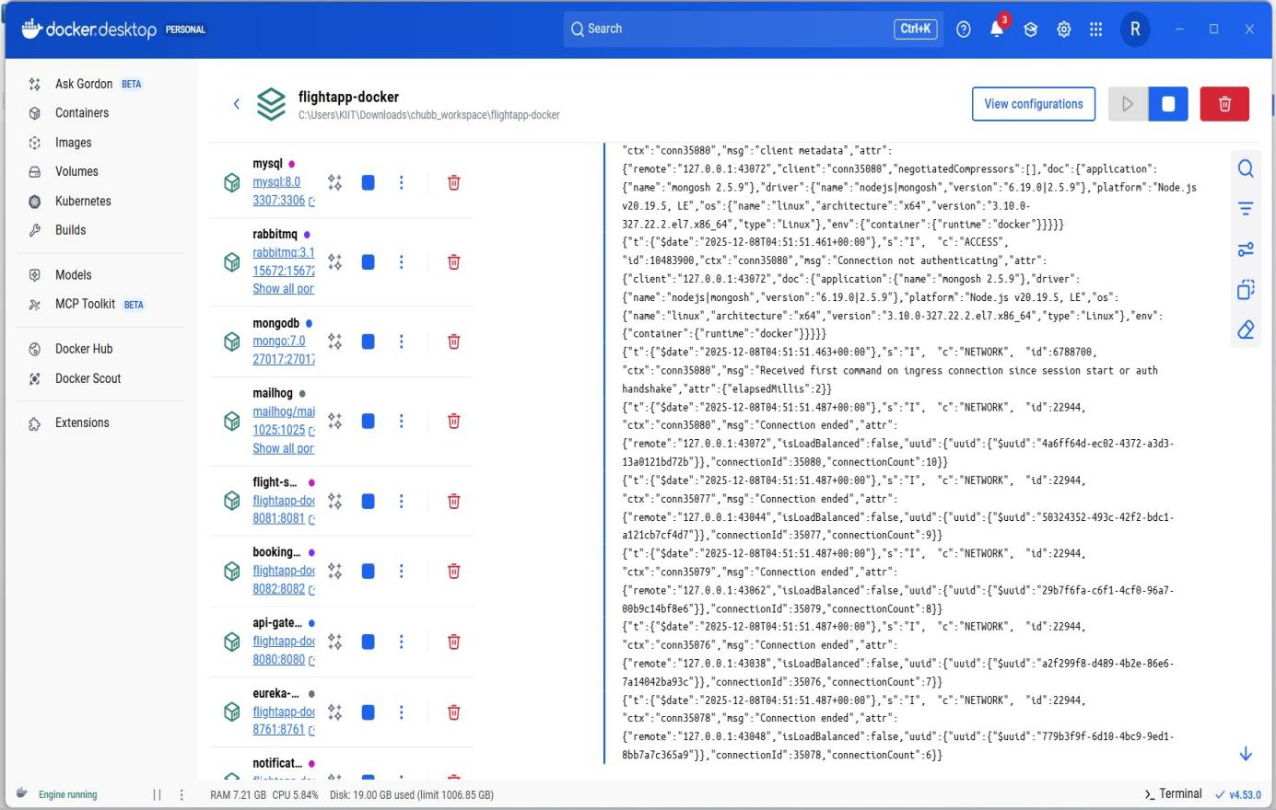

EUREKA SERVER LOGS
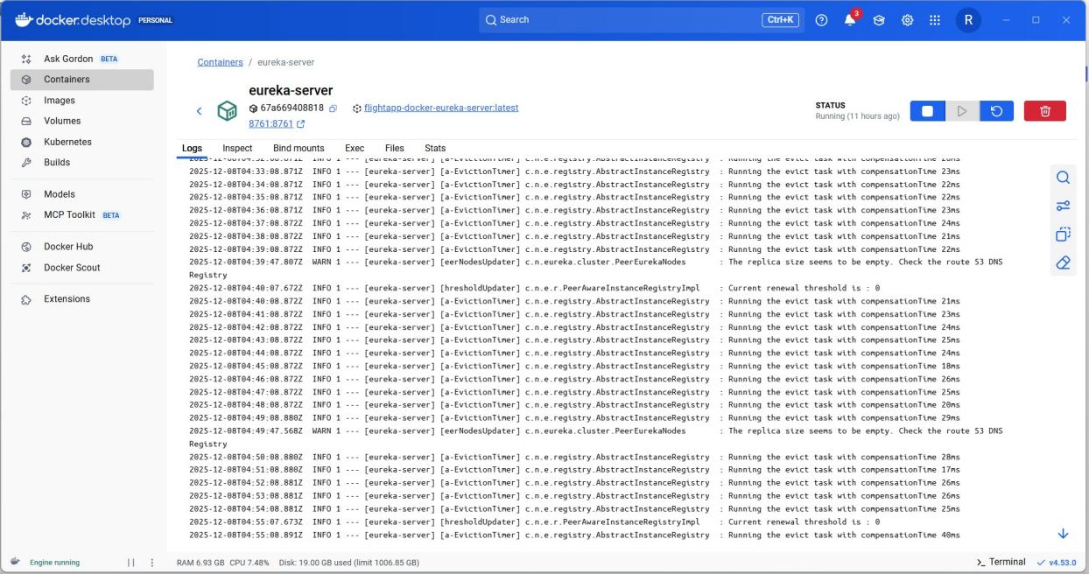

API GATEWAY
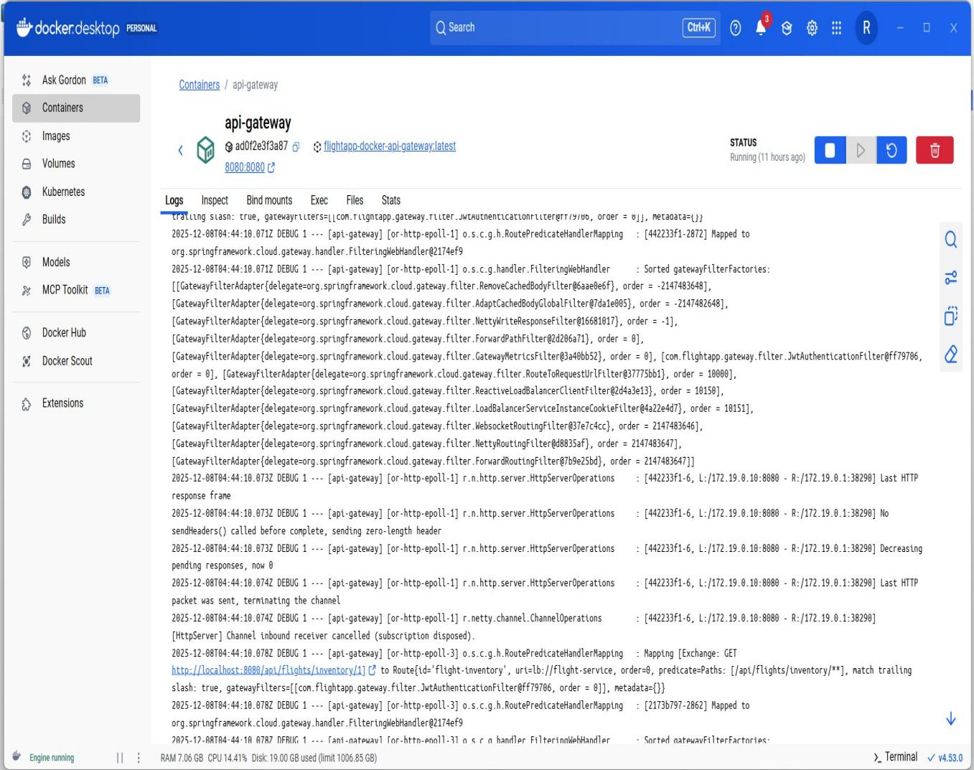
BOOKING SERVICE LOGS
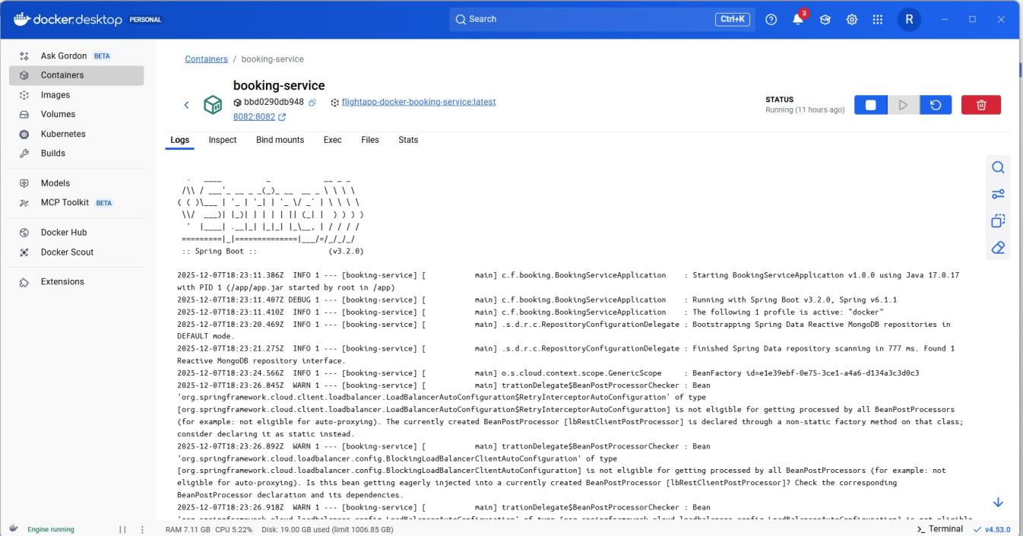

FLIGHT SERVICE LOGS
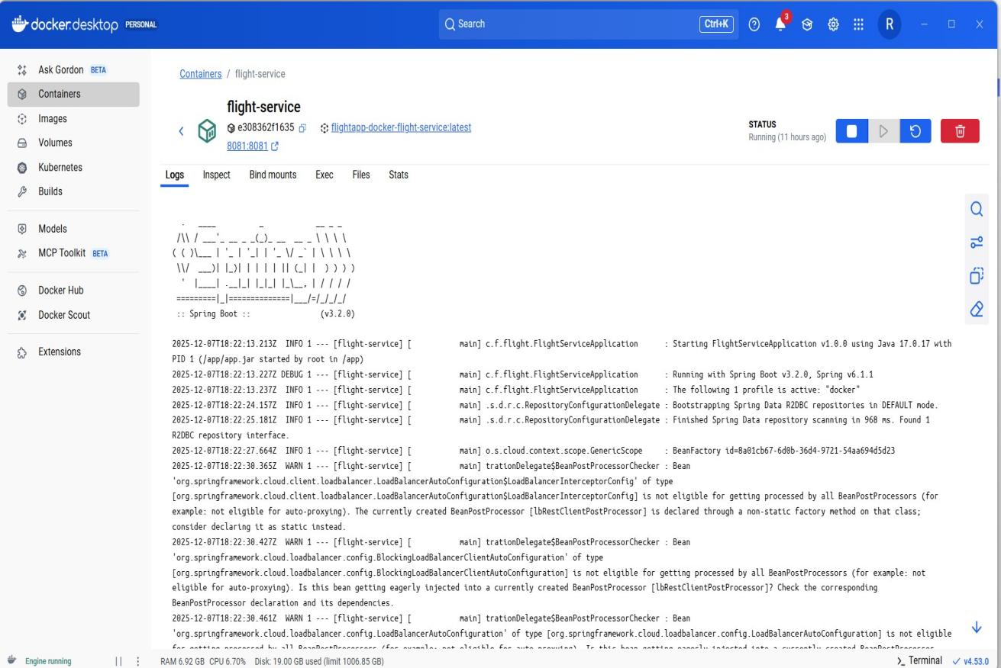

NOTIFICATION SERVICE LOGS
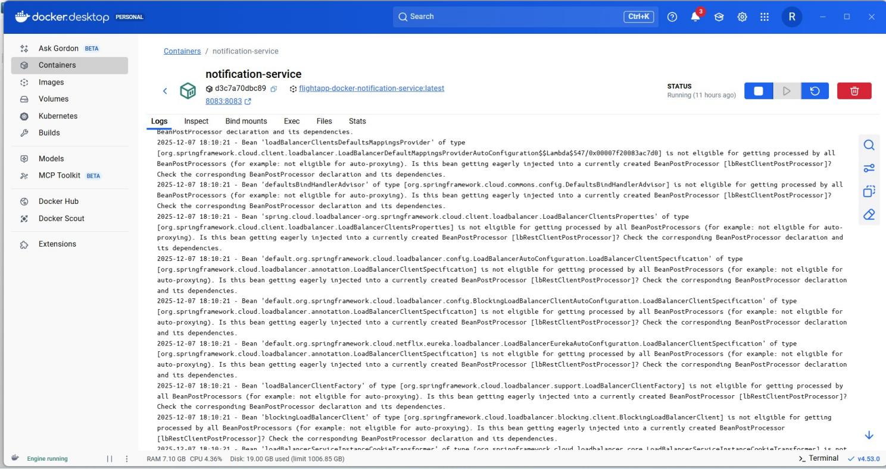

RabbitMQ logs
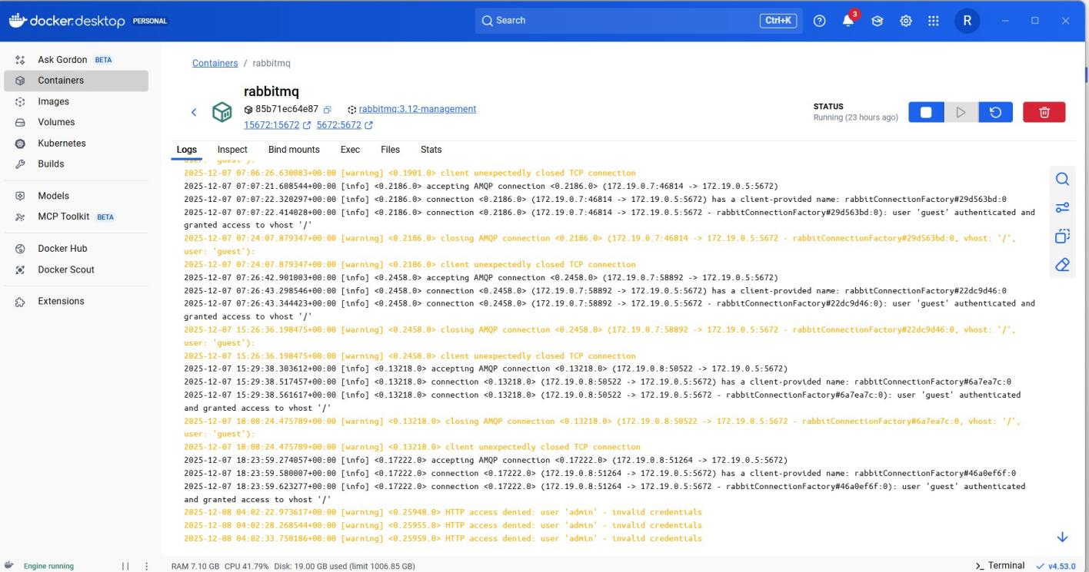

Mongodb logs
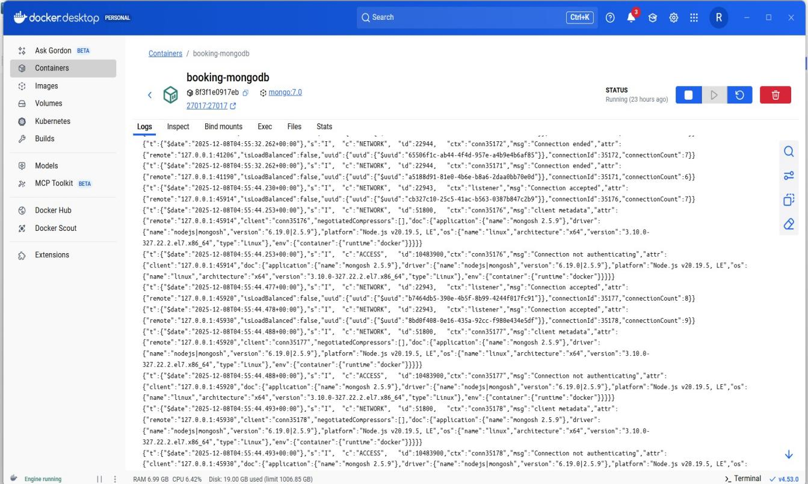

5.Mongodb screenshots

- Booking_db

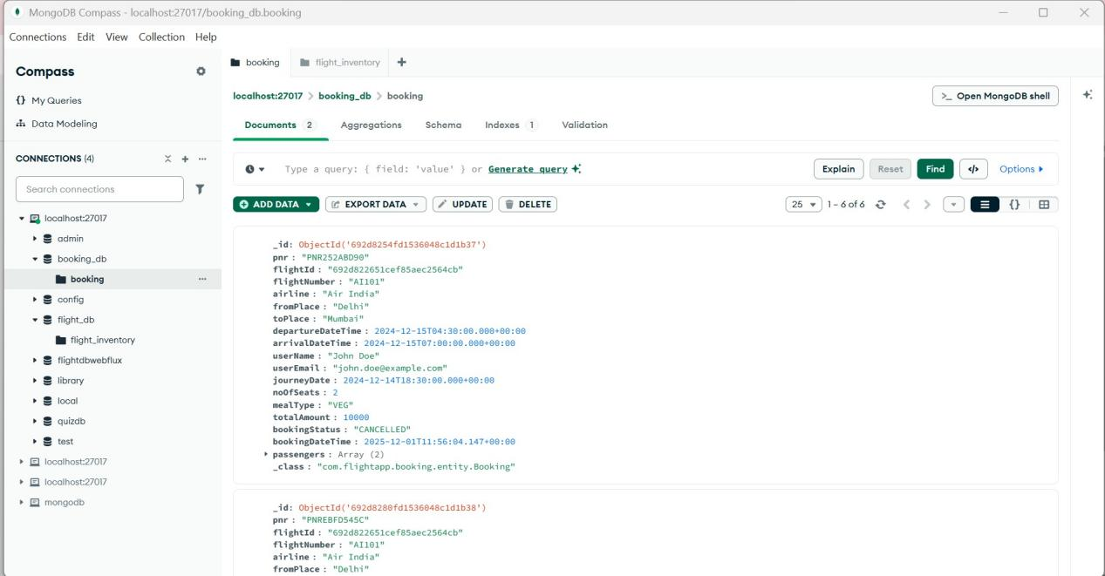

- Flight_db

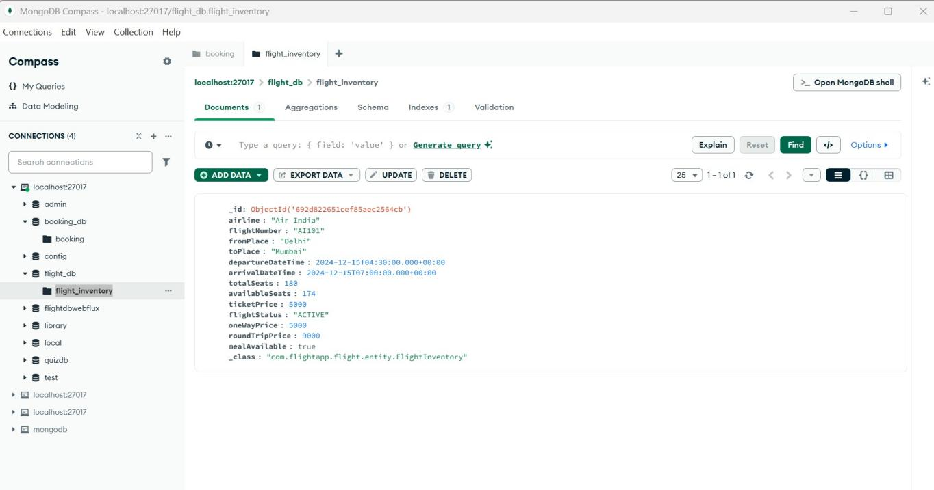

- Notification logs
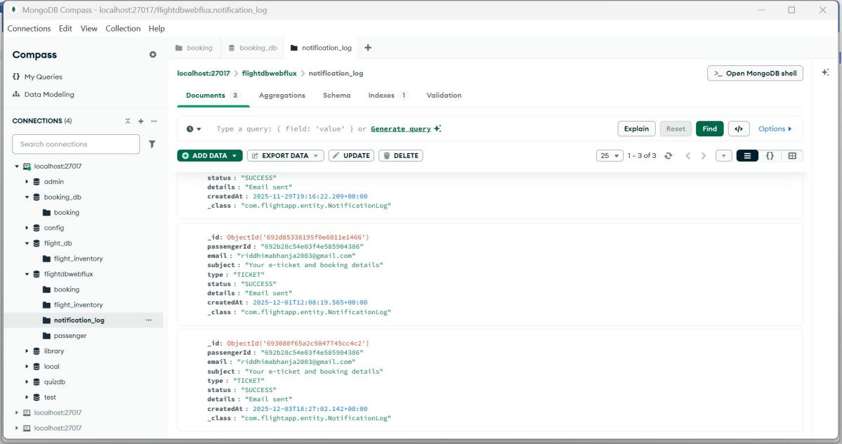

- Email

- Welcome Email

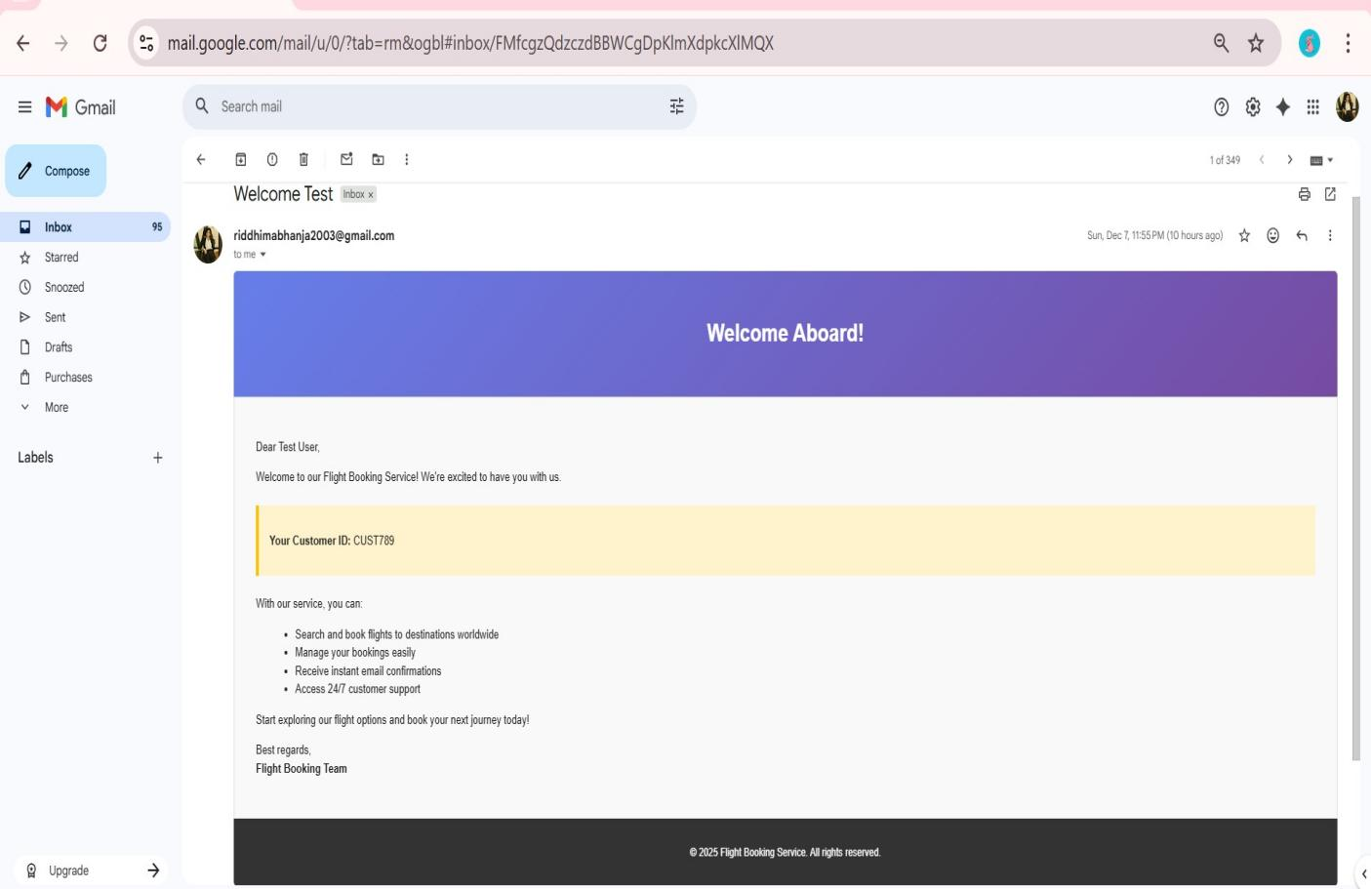

- Confirm Booking Email

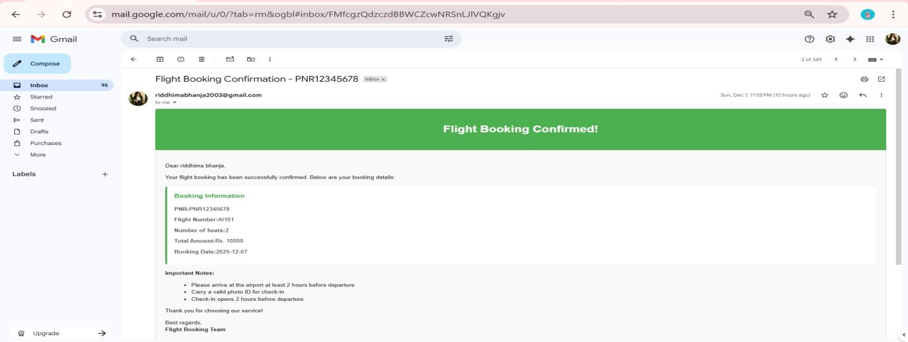

- Flight cancel email

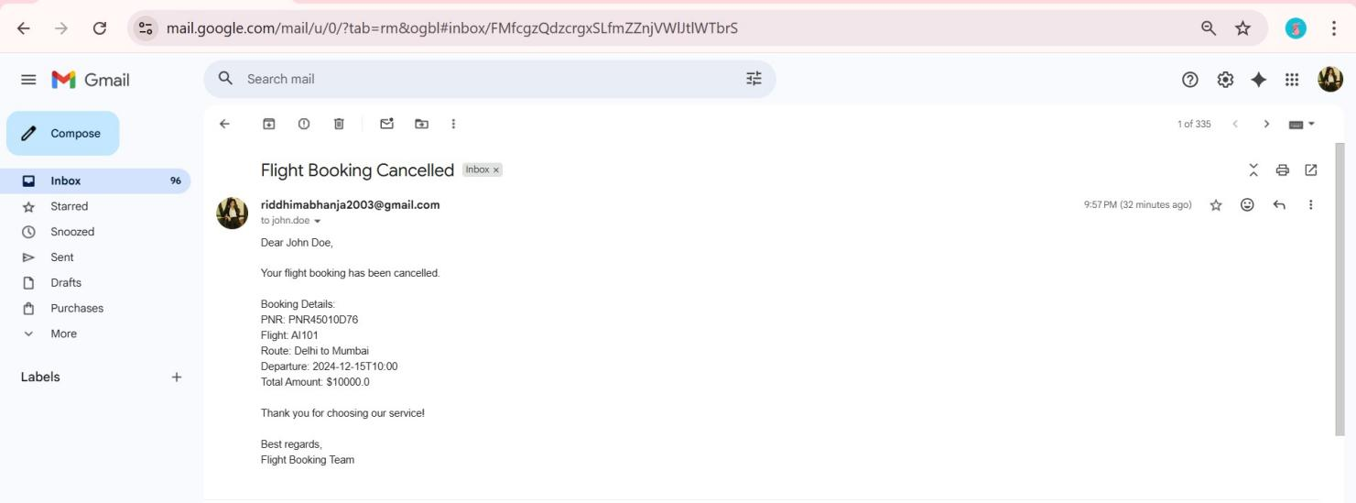

RabbitMQ email-queue dashboard

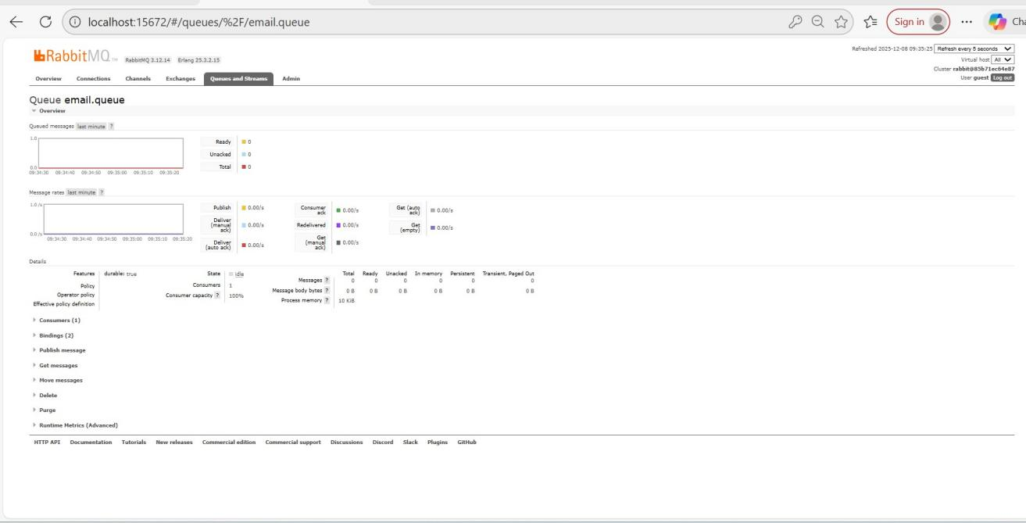

RabbitMQ overview dashboard
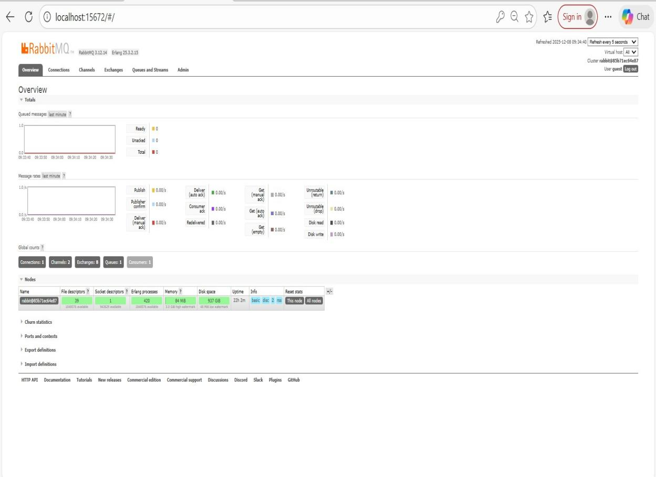

- Postman screenshots

Obtain JWT TOKEN

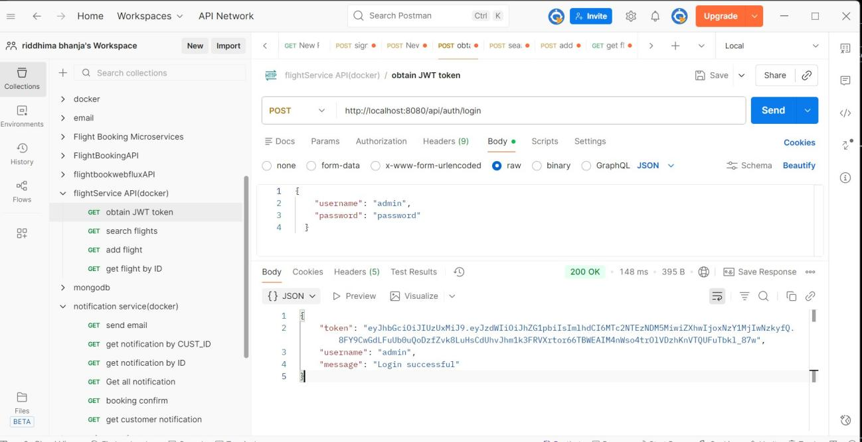

Unauthorized access

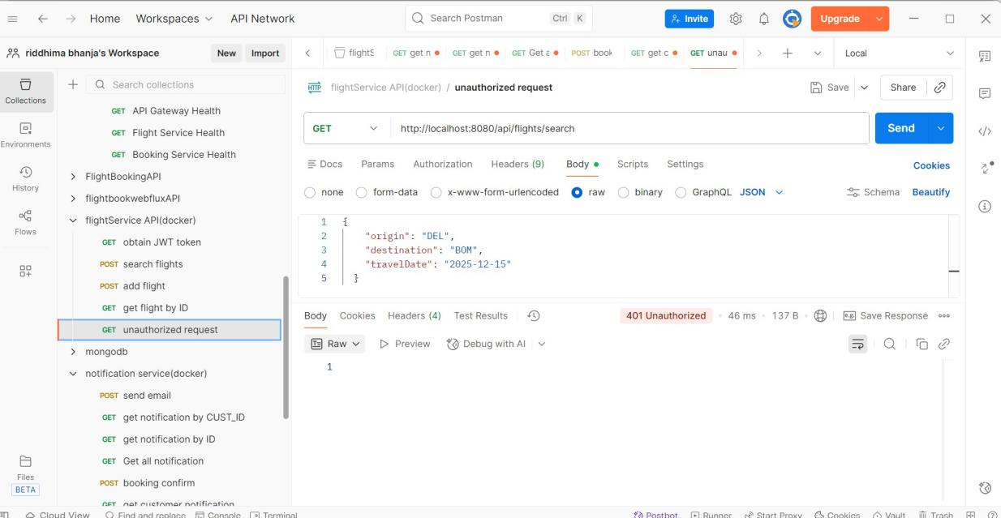

Same endpoint with auth bearer token

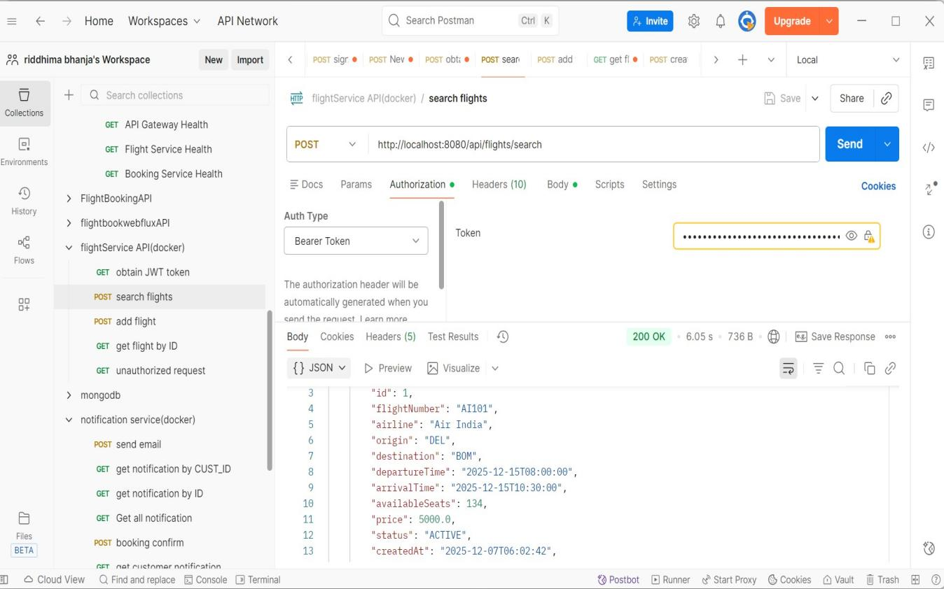

- Circuit Breaker

Events:

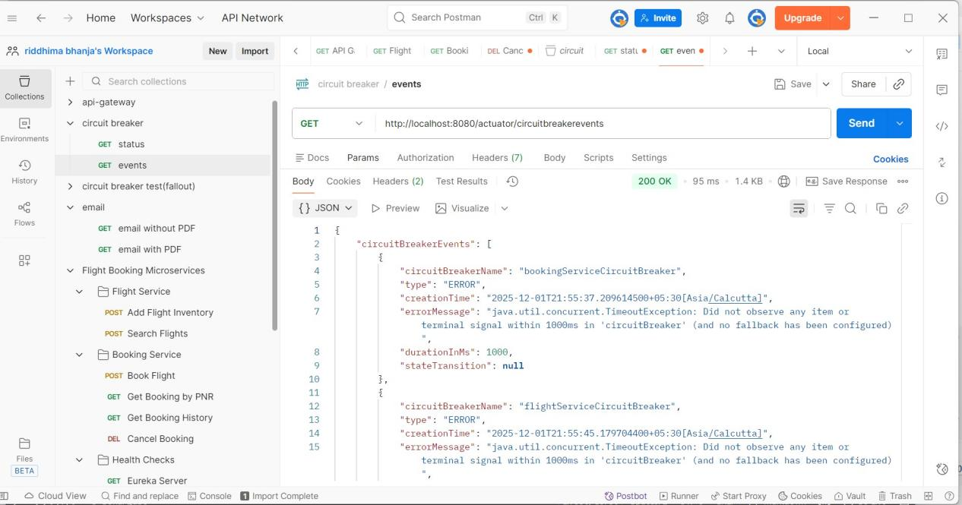

Status:

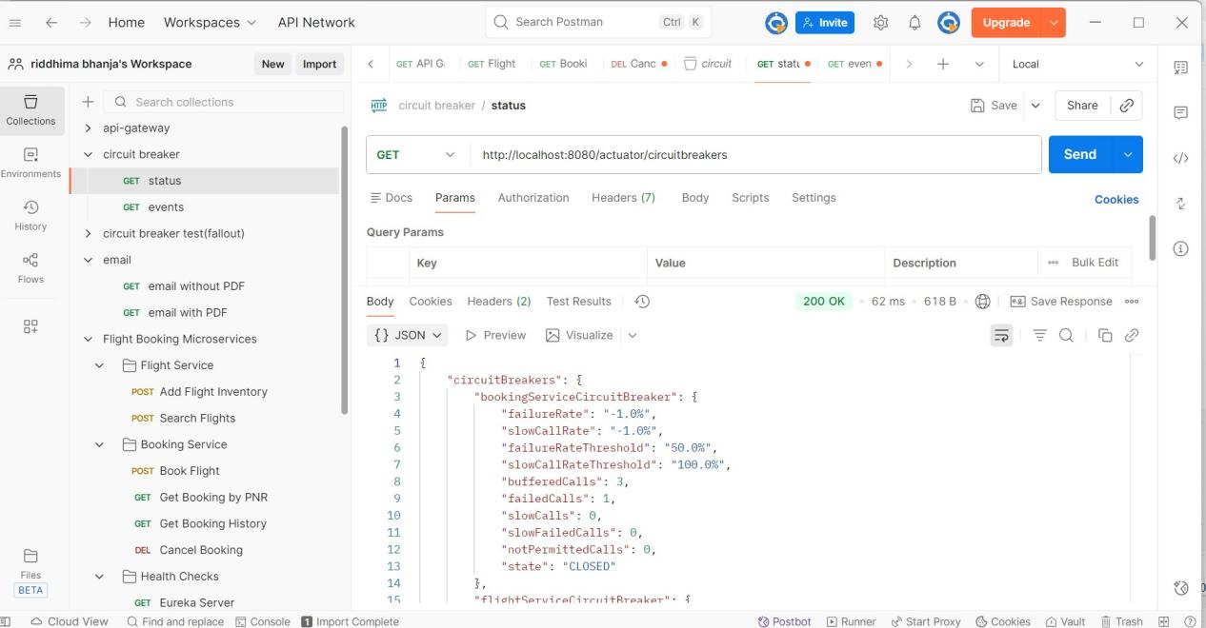

- Health Check

API gateway health:

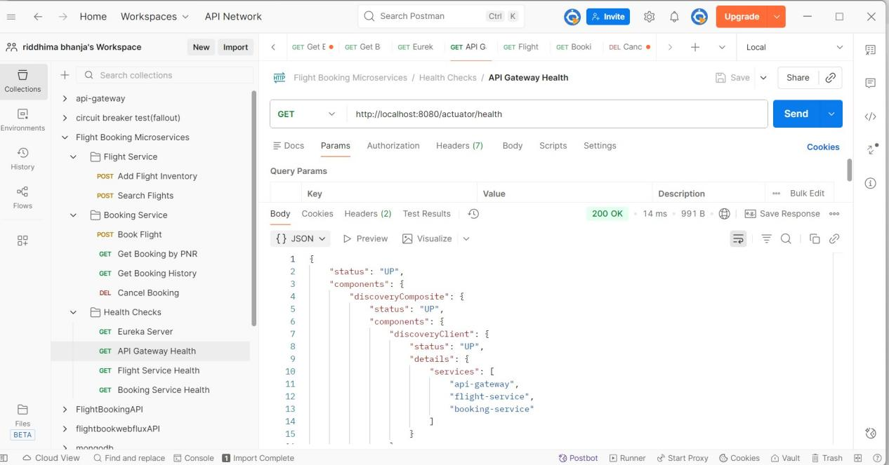

Booking Service Health:

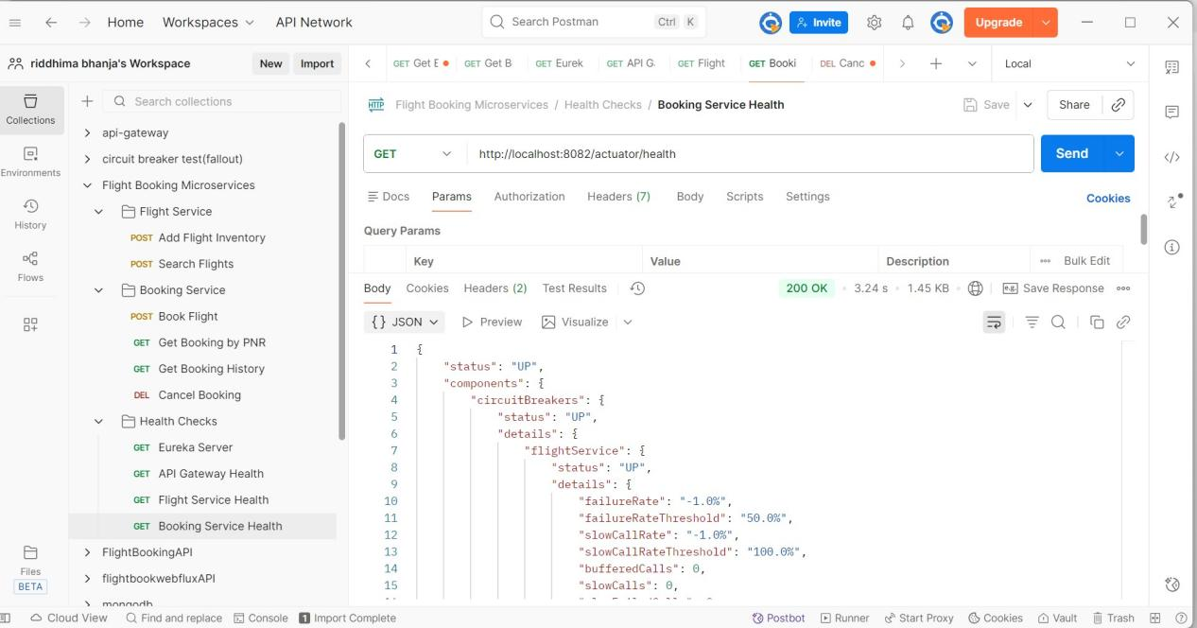

Eureka server:

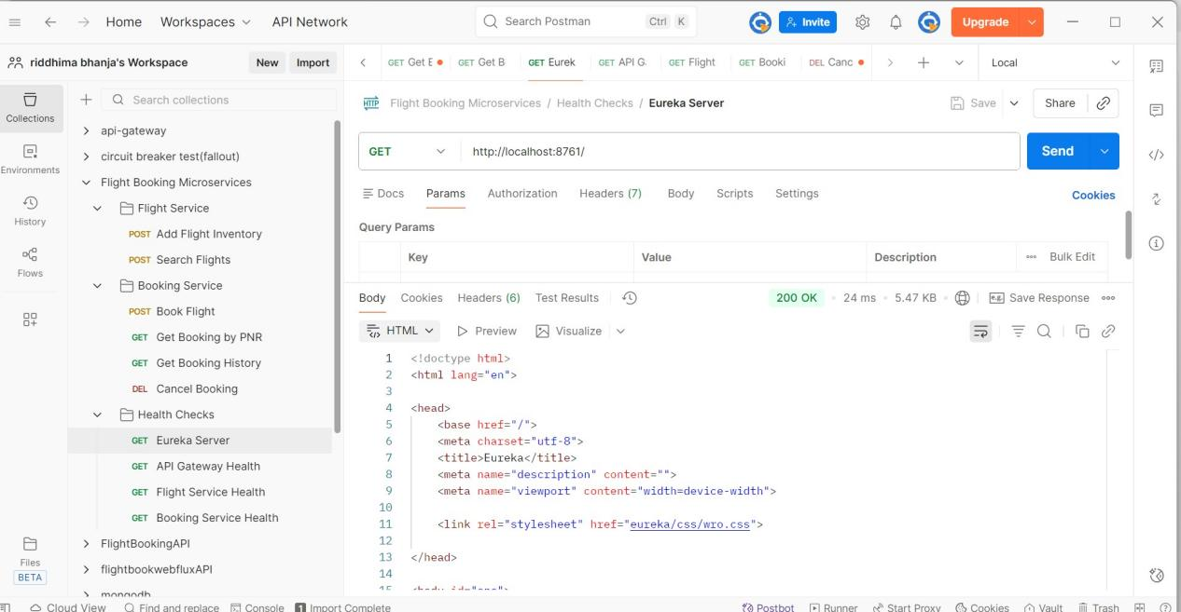

Flight Service Health:

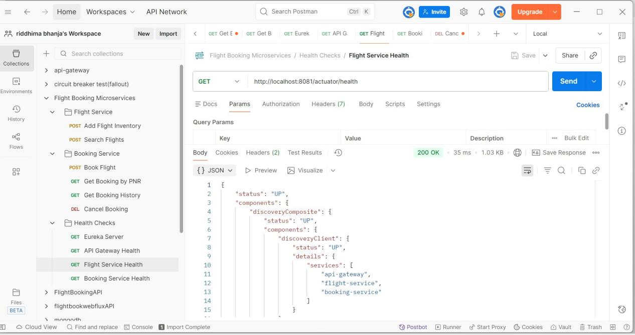

ADD FLIGHT

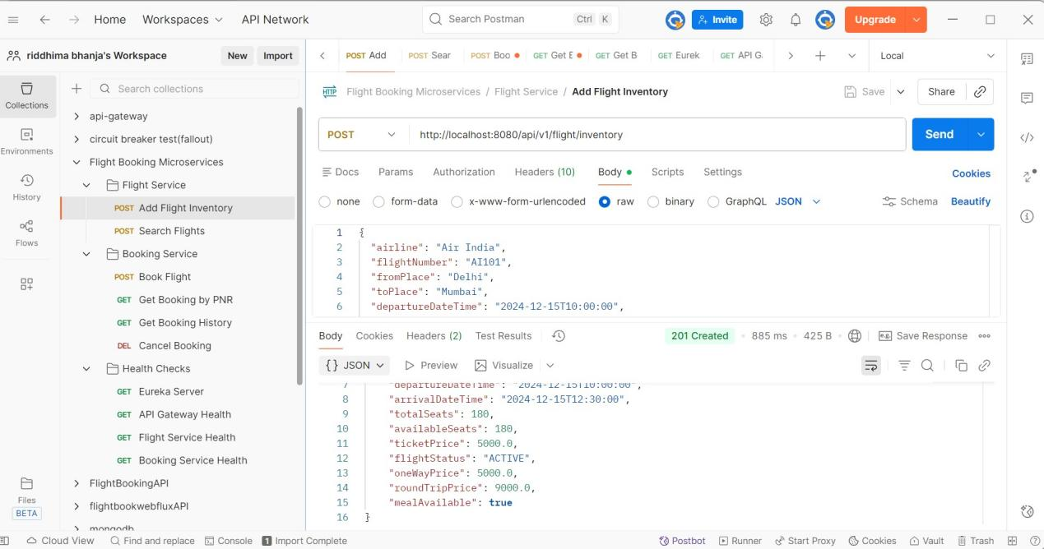

BOOK FLIGHT

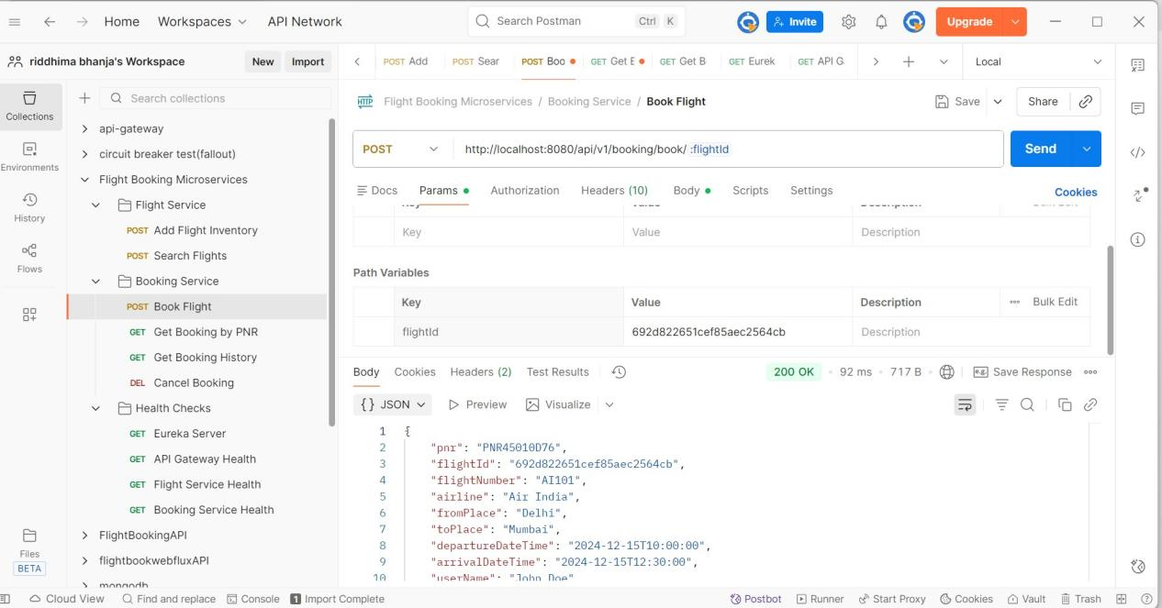

SEARCH FLIGHTS

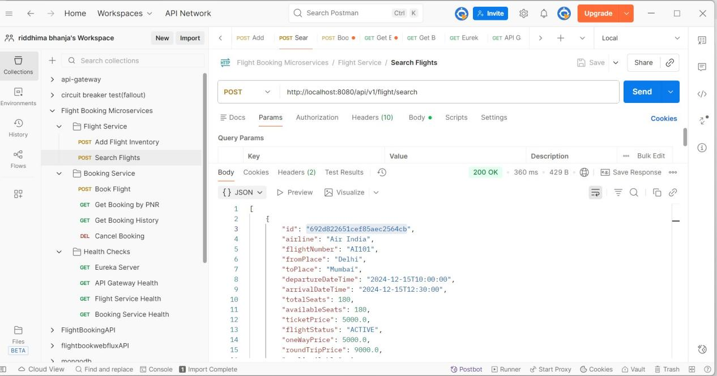

CANCEL BOOKING

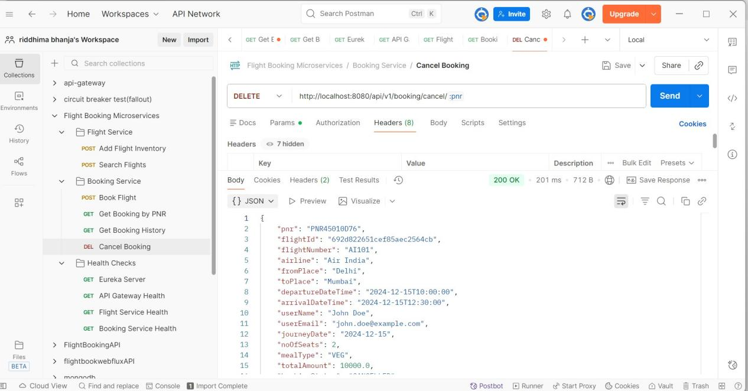

GET BOOKING BY PNR

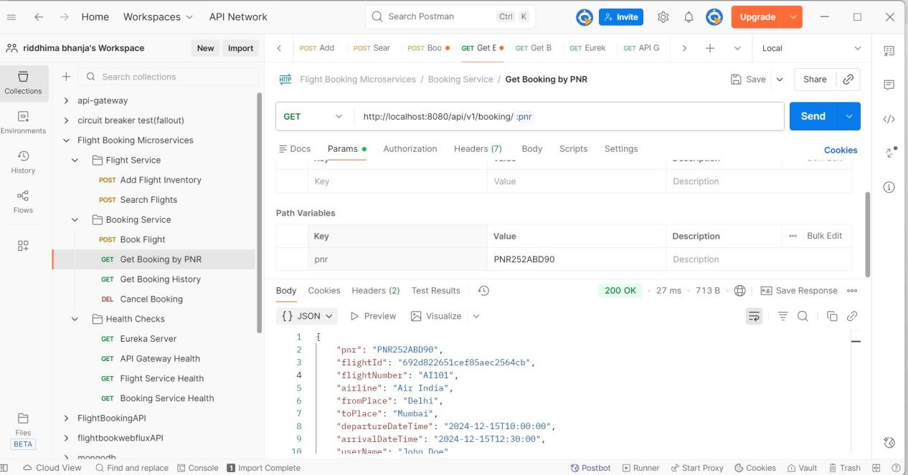

GET BOOKING HISTORY

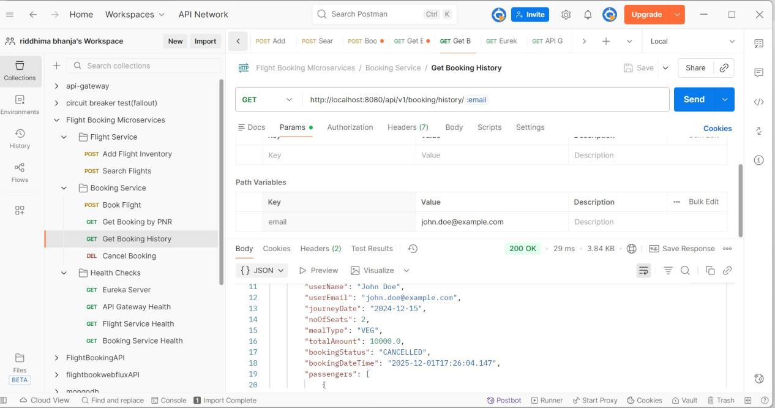

FALLBACK case

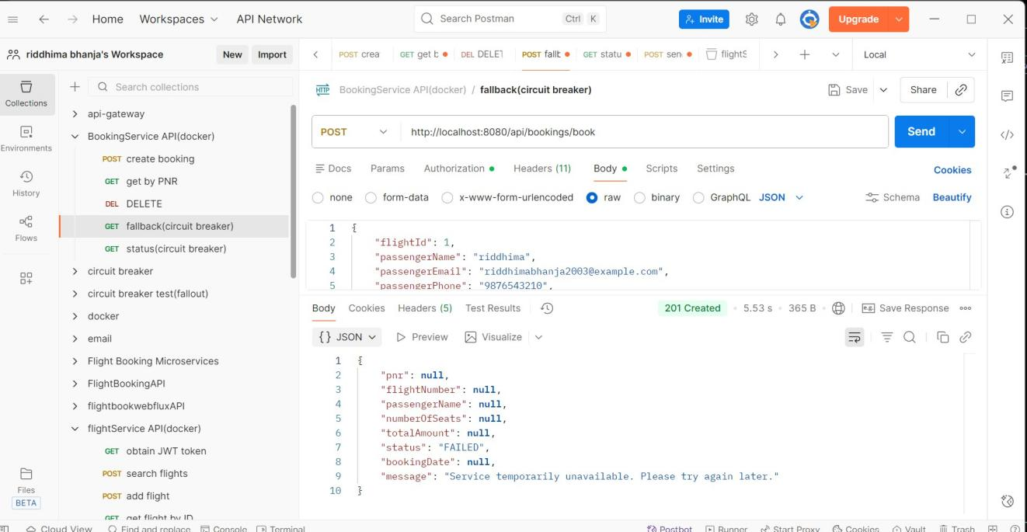
SEND EMAIL
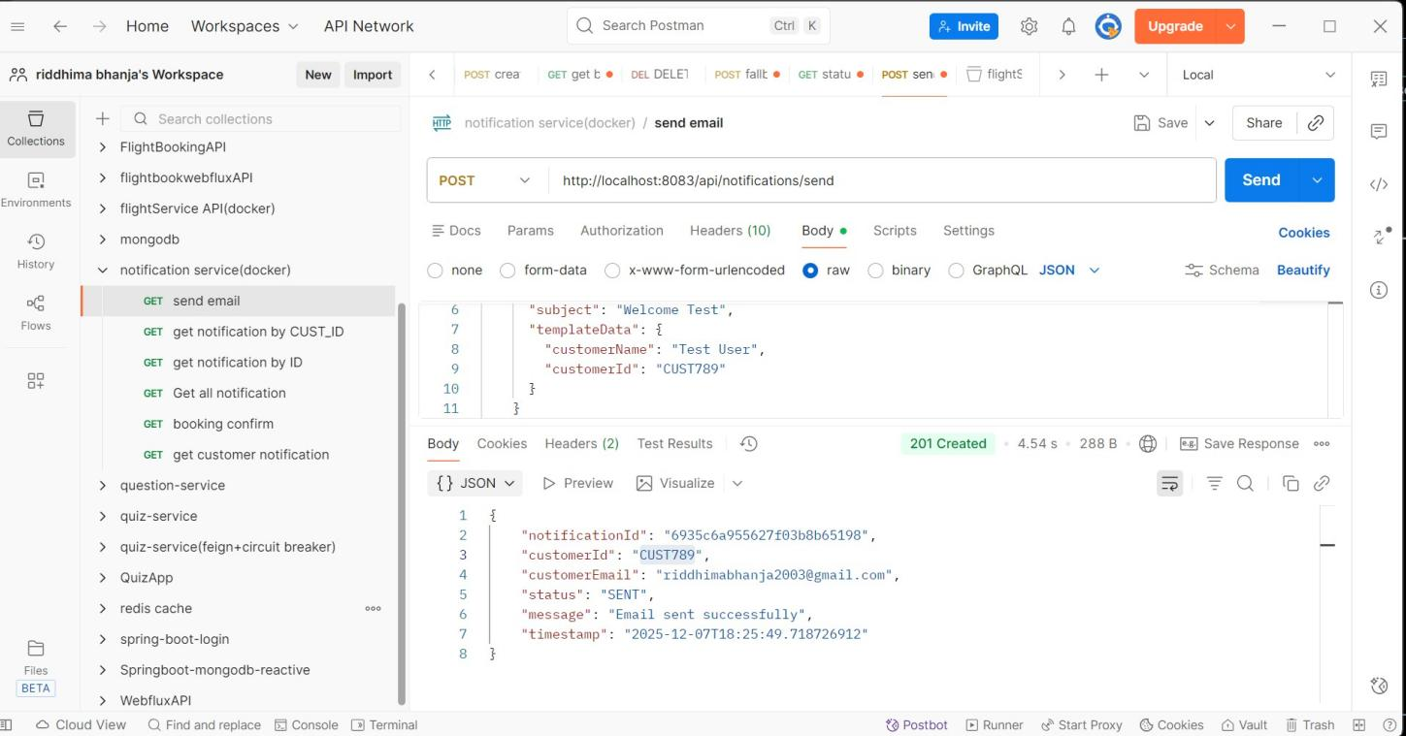

GET BY ID

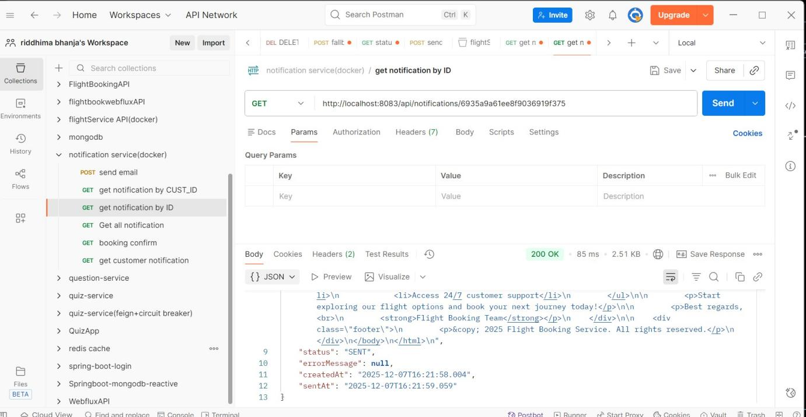

BOOKING CONFIRMATION EMAIL
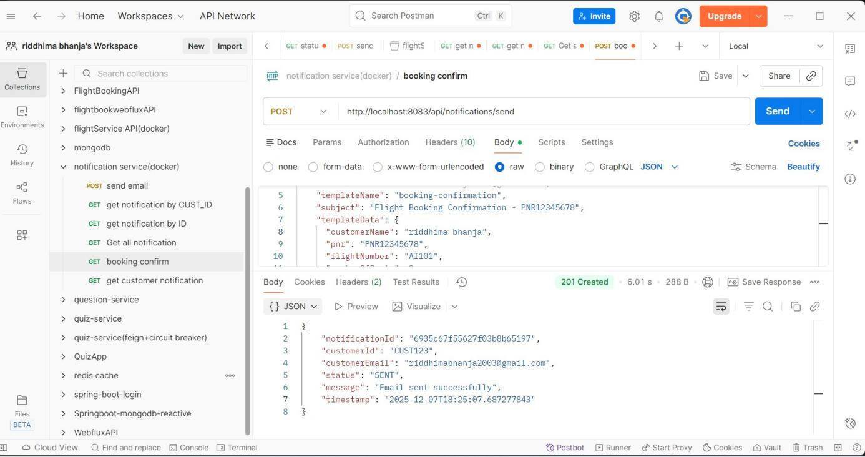

GET ALL NOTIFICATION

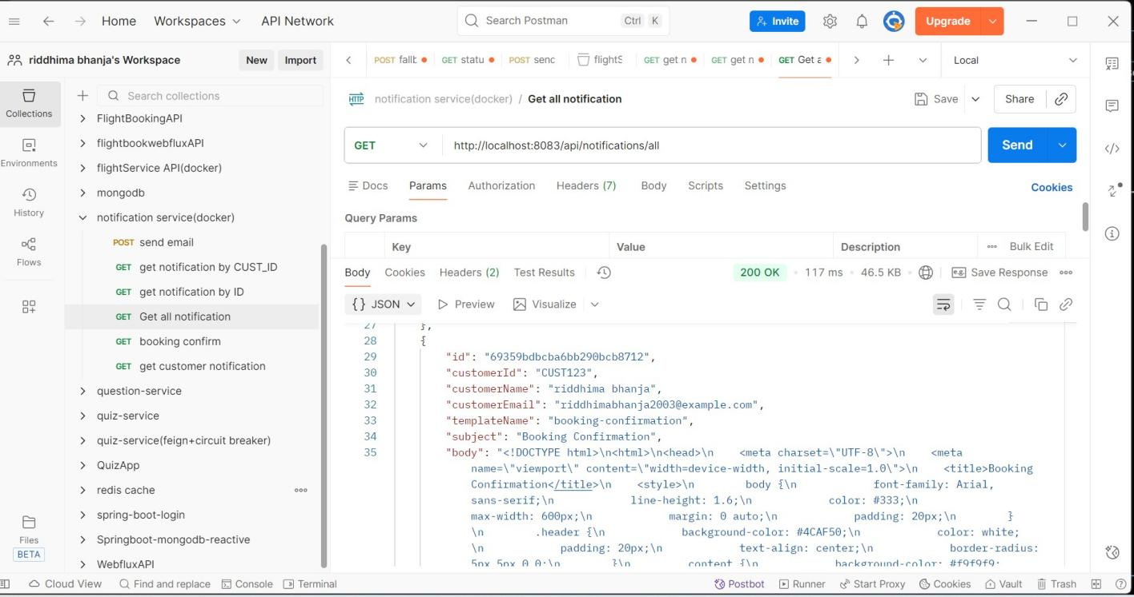

GET CUSTOMER NOTIFICATION

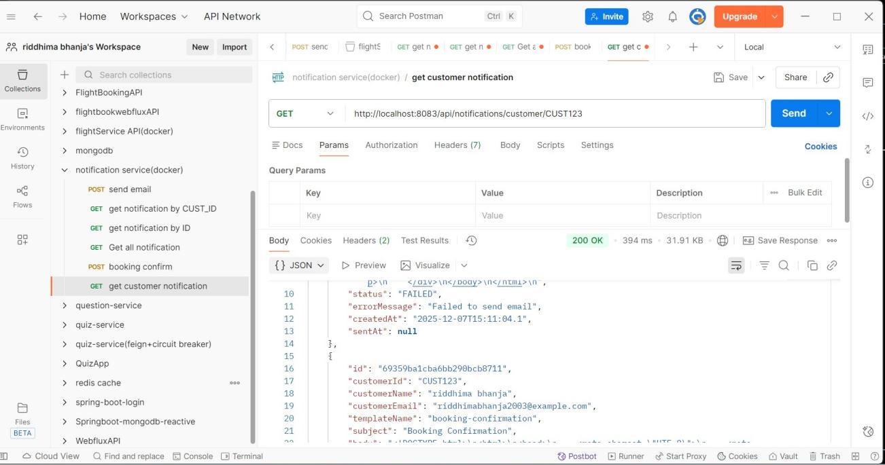

CREATE BOOKING

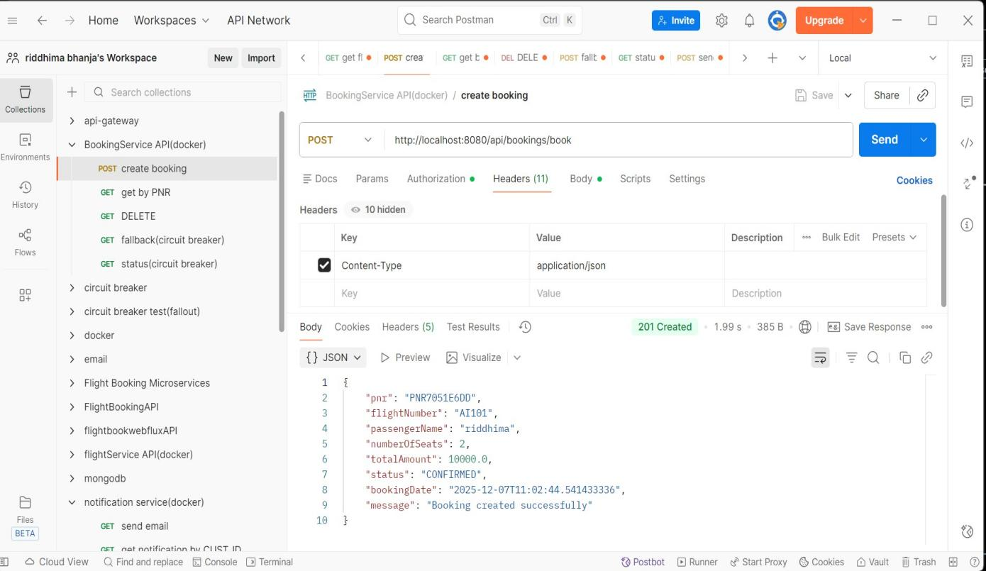

- Jmeter result tree

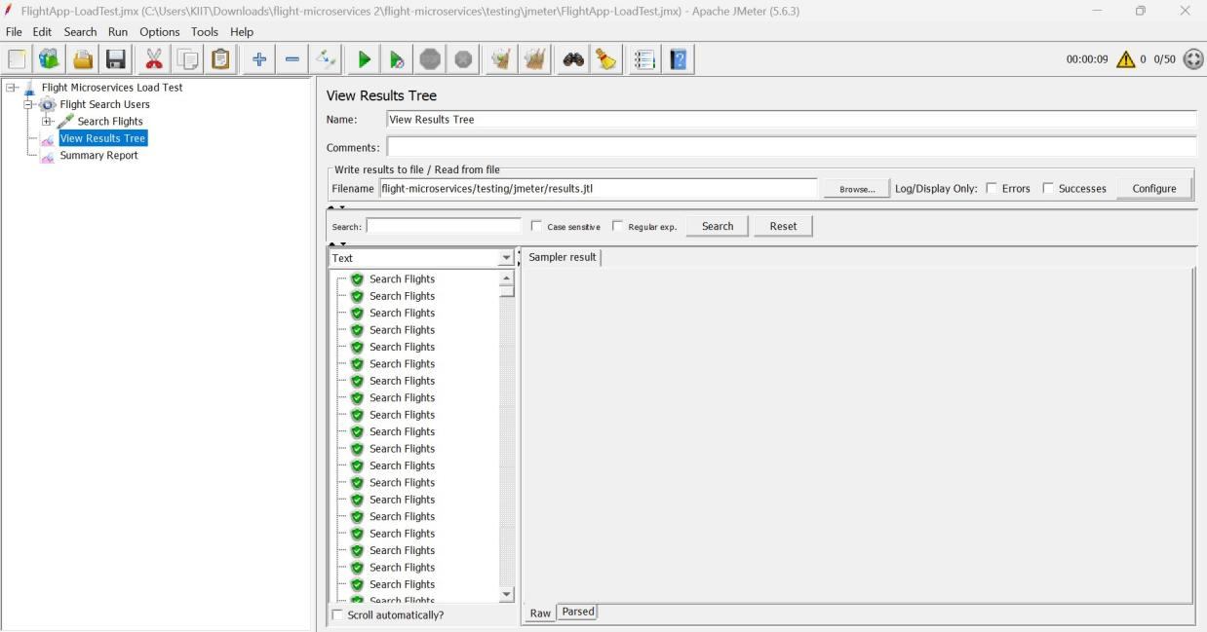

- Jmeter Summary report

20 Requests
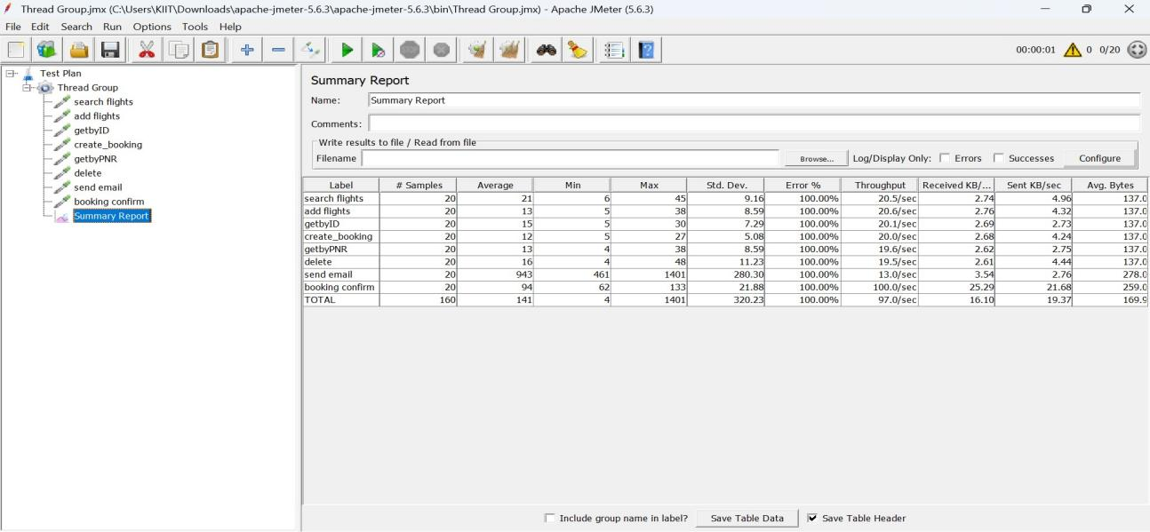

50 Requests

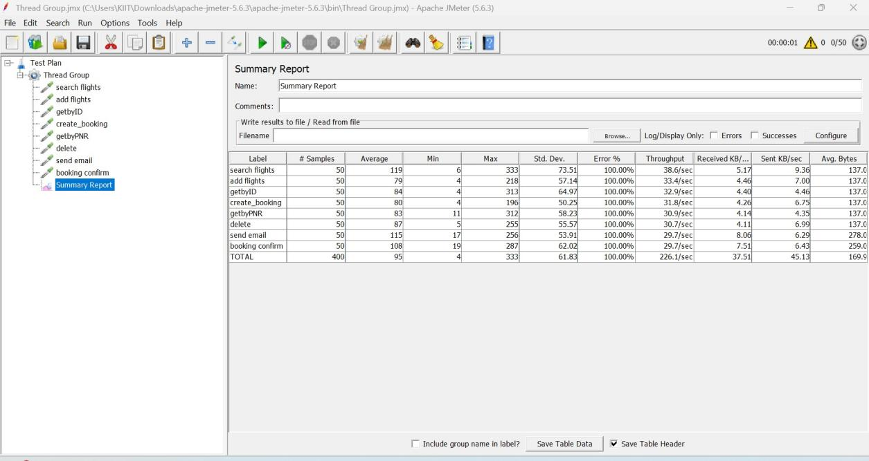

100 Requests

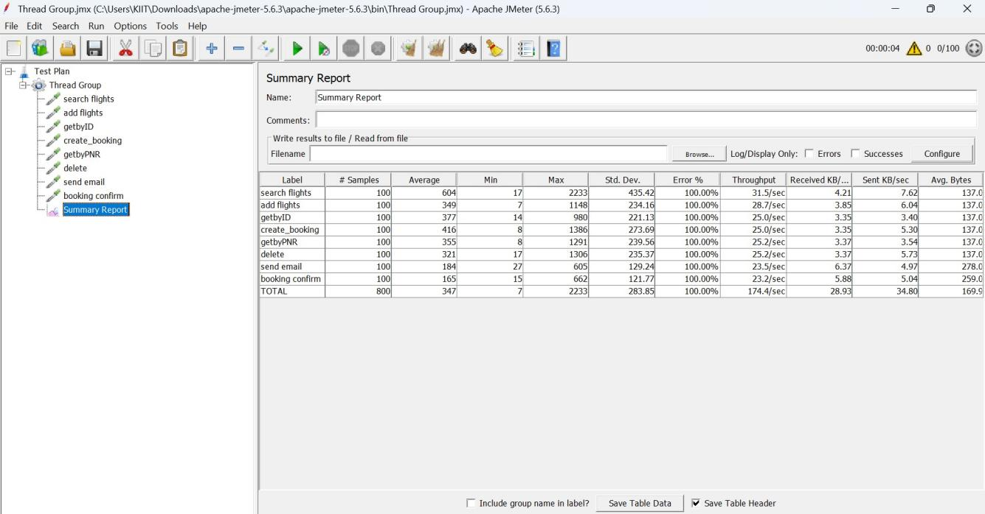

MySQL Workbench
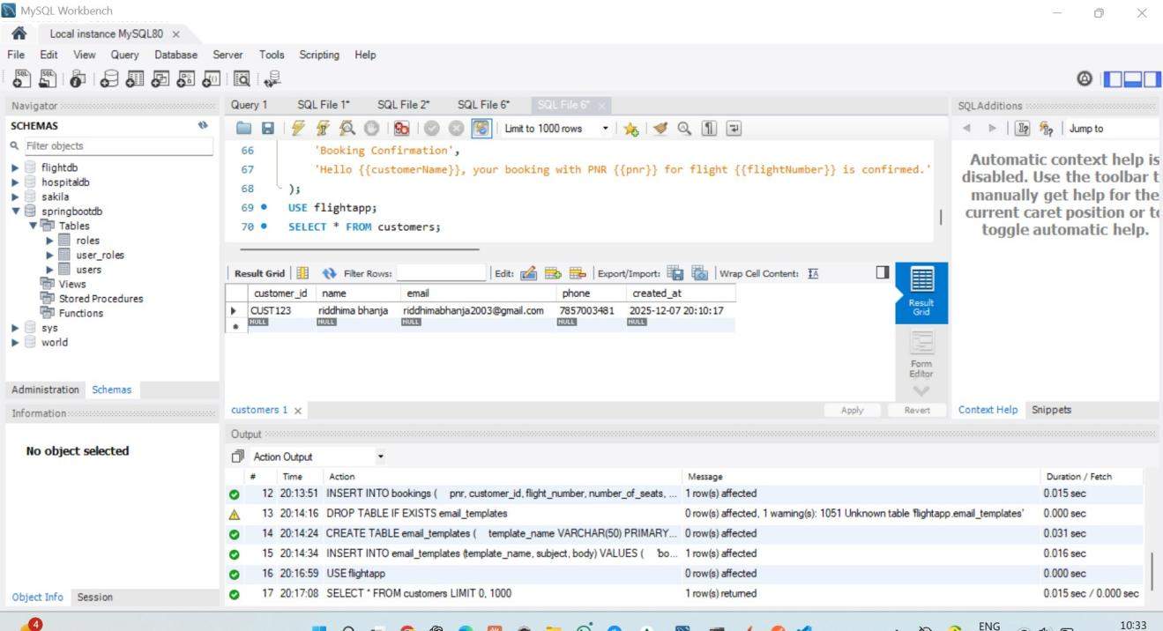

EUREKA DASHBOARD

