Name of Student: Riddhima Wadhane | PRN:25070122154
Semester: III | Year : AY 2026-27
Subject: Programming with Java
ASSIGNMENT No : 19
TITLE : JDBC SELECT Operation
Problem Statement
Develop a Java application to establish connectivity with a database and perform data retrieval using the SELECT operation.
Learning Objectives
To establish database connectivity and retrieve records using JDBC SELECT statements.
Theory
Java Database Connectivity (JDBC) is a standard Java API that enables communication between Java applications and relational databases. It provides a platform-independent mechanism to connect to databases such as MySQL, Oracle, PostgreSQL, and SQL Server. Before executing SQL statements, a JDBC driver is loaded and a connection is established using the DriverManager class. The Connection object represents an active connection to the database, while the Statement object is used to execute SQL queries. The SELECT statement retrieves records from database tables based on specified conditions. The retrieved records are stored in a ResultSet object, which allows sequential access to the data. JDBC simplifies database programming and is widely used in desktop, web, and enterprise applications.

Exercise
- Create a Java application to display student records from database using SELECT query
Program
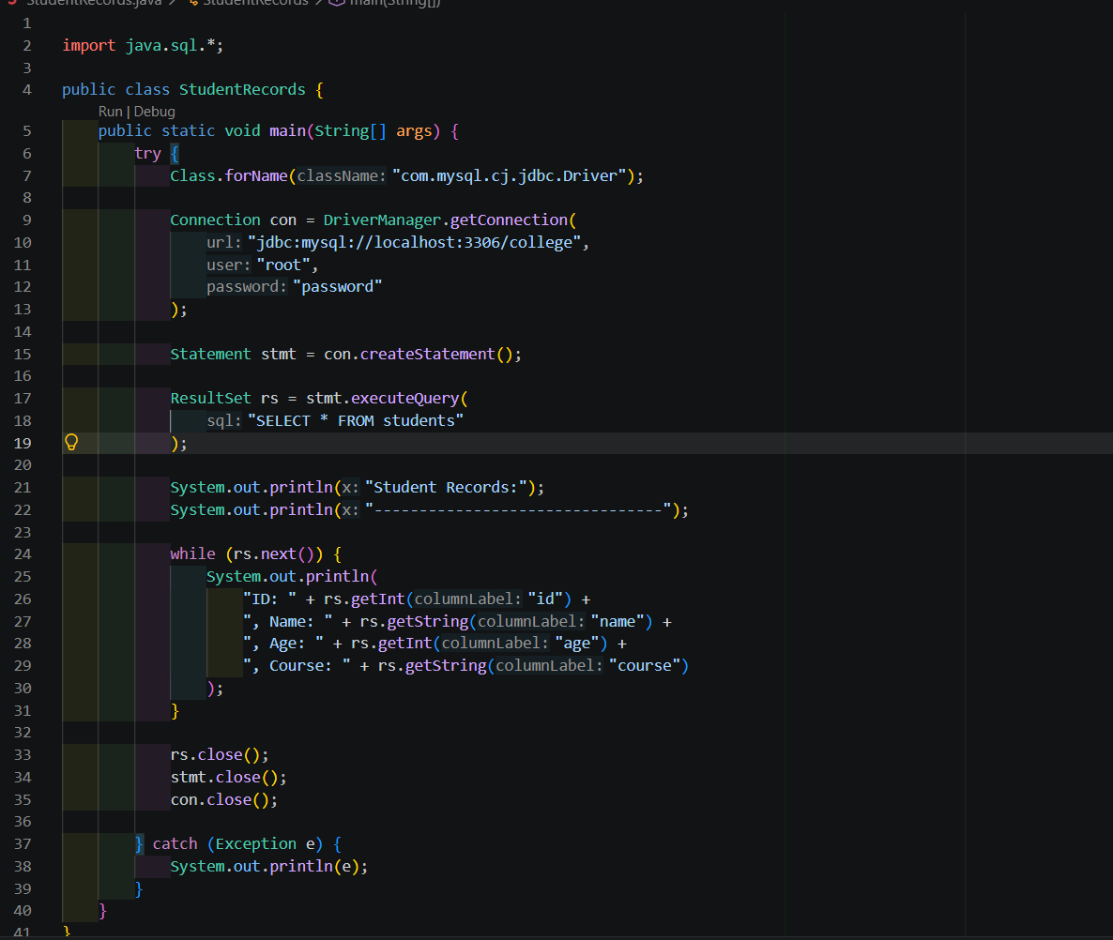
Output
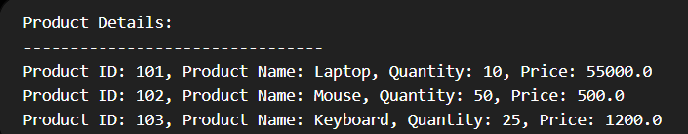
- Create a Java application that connects to a database and displays product details using a SELECT query. Show product ID, product name, quantity, and price

Program
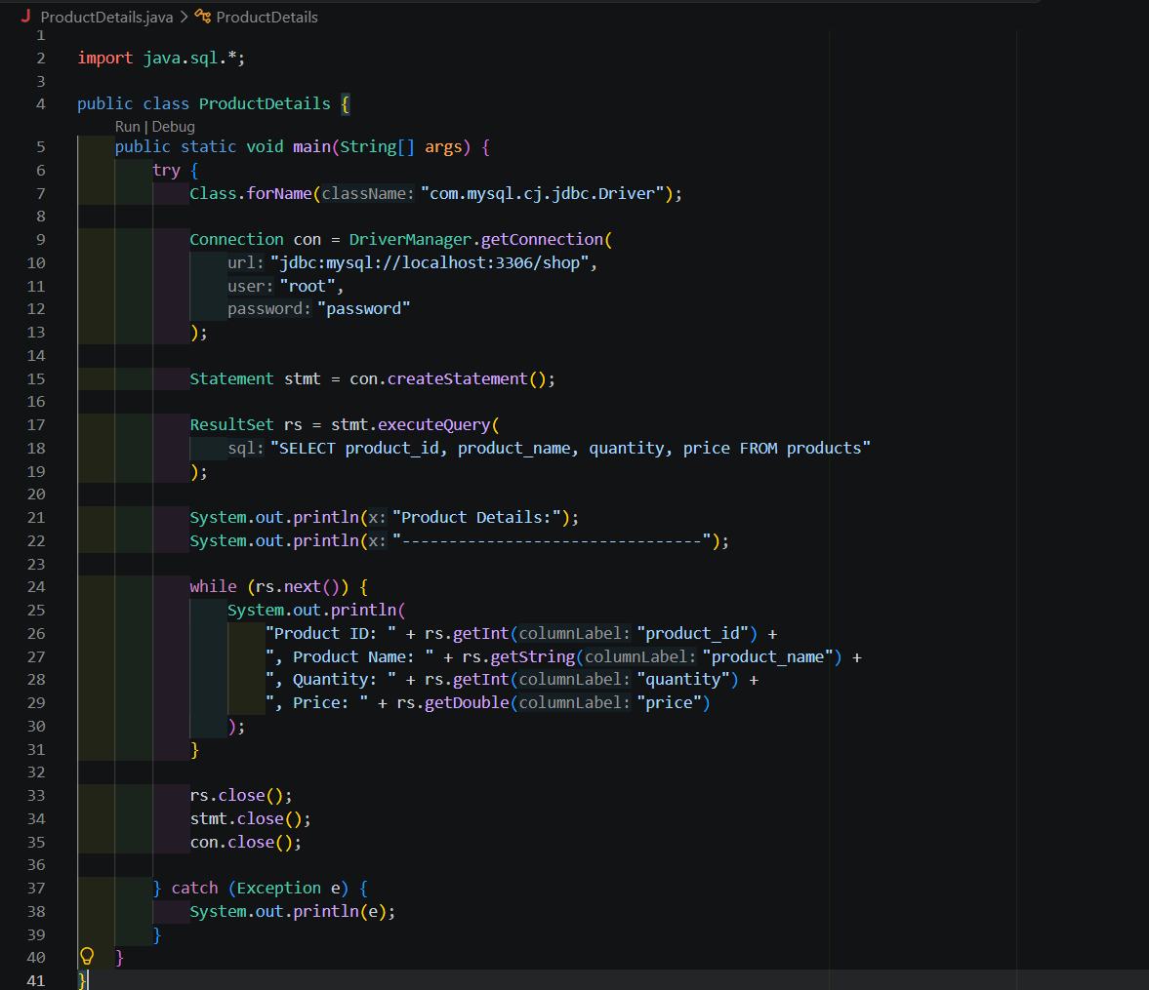

Output
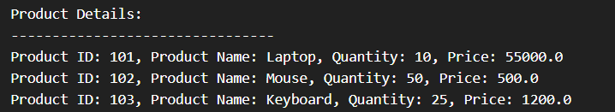
Conclusion
The JDBC programs successfully established a connection between the Java application and the MySQL database. Using the SELECT query, student and product records were retrieved from the database and displayed using the ResultSet object. Thus, JDBC provides an efficient and platform-independent way to access and manage database information through Java applications.

