WEEK 3 :TASK BY: RIDDHI MALHOTRA
SQL
--DATABASE:
--A database is an organized collection of data that can be easily accessed,managed, and updated.
--It is designed to store information in a structured way so that users and applications can retrieve and manipulate it efficiently.

--TERMS OF DATABASE:
--Tables: Data is stored in tables, which are made up of rows (records) and columns (fields).
--Records (Rows): Each row represents a single entry in the table.
--Fields (Columns): Each column represents a specific attribute of the data.

--IMPORTANCE OF DATABASE:
--structured
--consistent
--integrity
--scalability

Create database InternNova_Riddhi_Malhotra
--In SQL, you use the CREATE DATABASE command to make a new database.

use [InternNova_Riddhi_Malhotra]
--After creating it, you need to tell SQL which database you’re working with.

CREATE TABLE Employees (
EmpID INT PRIMARY KEY, -- Unique employee ID
Name VARCHAR(50), -- Employee name
Department VARCHAR(30), -- Department name
Salary DECIMAL(10,2) -- Salary with 2 decimal places
);

--Insert sample records
INSERT INTO Employees (EmpID, Name, Department, Salary)
VALUES
(101, 'Niklaus', 'HR', 50000),
(102, 'Elijah', 'IT', 60000),
(103, 'Rebekah', 'Finance', 55000),
(104, 'Hayley', 'IT', 58000);
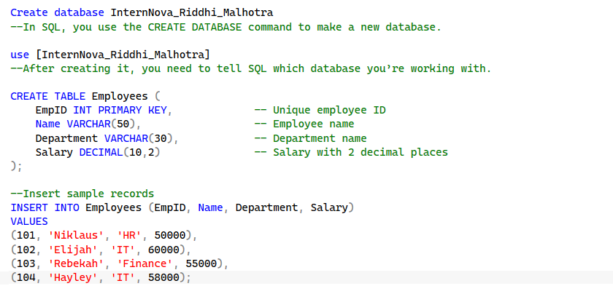
------------------------------------------TASK 1-----------------------------------------------------
--1 SQL query to display all the records
select * from Employees
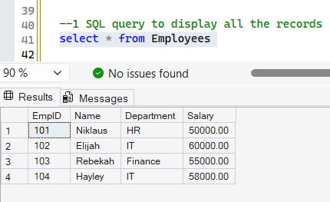
--2 select specific column
select EmpID from Employees
select Name from Employees
select Department from Employees
select Salary from Employees
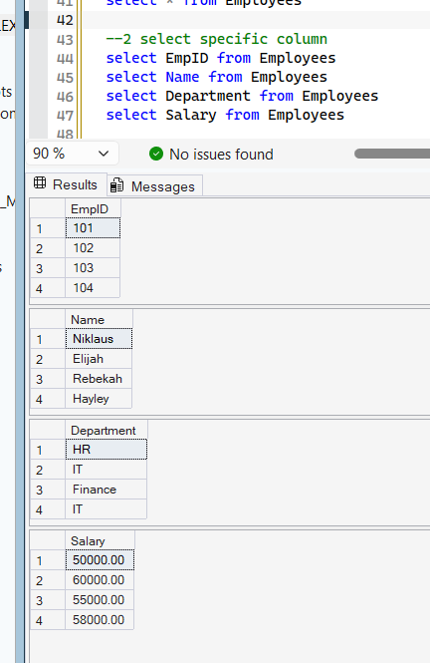
--3 use allias where required
SELECT Name AS EmployeeName, Salary AS MonthlySalary
FROM Employees;
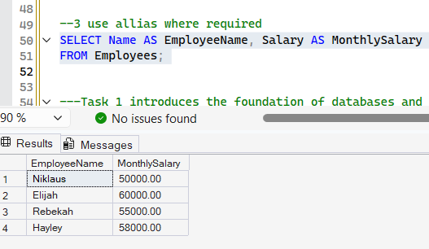

---Task 1 introduces the foundation of databases and demonstrates how the SELECT statement is used to query data.
--It shows how to retrieve all records, specific columns, and how to make results more readable with aliases.

---------------------------------------TASK 2----------------------------------------------
--1 using the where clause
SELECT *
FROM Employees
WHERE Department = 'IT';

--2using comparison operator
SELECT *
FROM Employees
WHERE Salary > 55000;
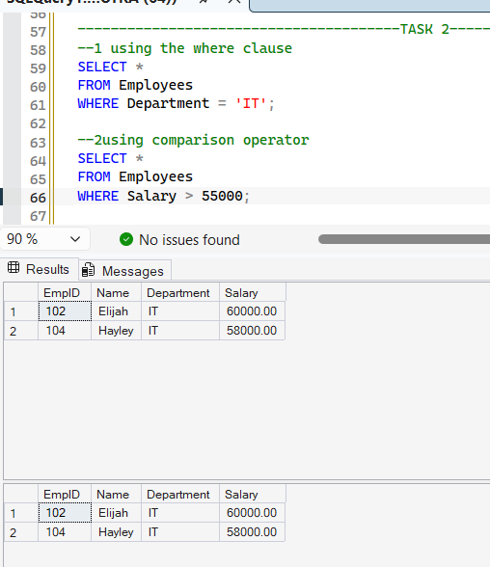

--3 using the order by clause
select * from Employees order by salary
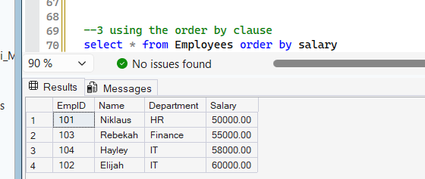
--4 aggregate functions:
--count():to find the total number of records
SELECT COUNT(*) AS TotalEmployees
FROM Employees;

--sum():to calculate the total salary.
SELECT SUM(Salary) AS TotalSalary
FROM Employees;

--avg():to calculate the average salary.
SELECT AVG(Salary) AS AverageSalary
FROM Employees;

--min():to determine the minimum salary.
select min(salary) as MINSALARY from Employees

--MAX():to determine the maximum salary.
select MAX(salary) as MAXSALARY from Employees
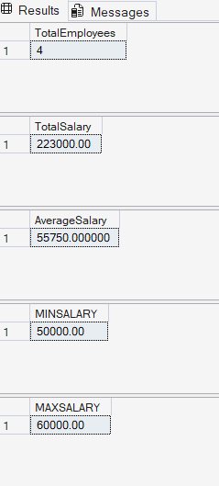

--In Task 2, we explored how to refine and analyze data using SQL.
--The WHERE clause was used to filter records based on specific conditions, such as selecting employees from a particular department or those earning above a certain salary.
--Comparison operators (>, <, =, !=) allowed precise filtering.
--The ORDER BY clause helped sort records in ascending or descending order, making the data easier to interprete.

-----------------------------------------TASK 3----------------------------------------------------------

--1 group the records
SELECT Department, AVG(Salary) AS AvgSalary
FROM Employees
GROUP BY Department;

--2 calculate aggregate values for each group
SELECT Department, SUM(Salary) AS TotalSalary
FROM Employees
GROUP BY Department;

--3 use the having clause
SELECT Department, AVG(Salary) AS AvgSalary
FROM Employees
GROUP BY Department
HAVING AVG(Salary) > 55000;
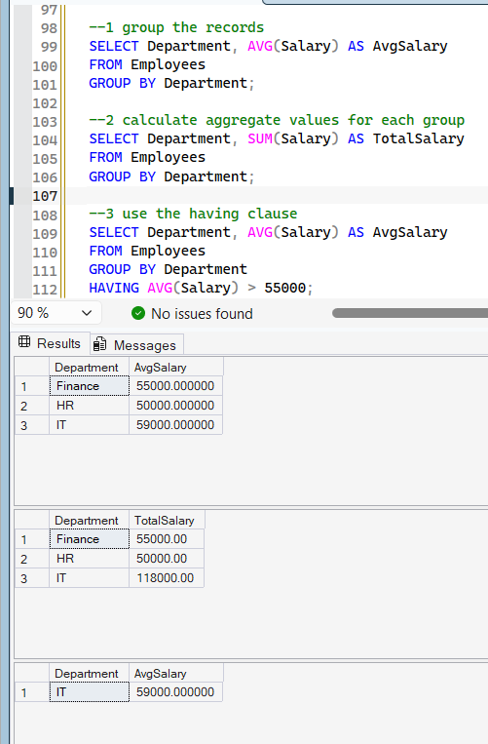

--task 3 shows how grouping and aggregation provide summarized insights,
--while the HAVING clause allows filtering of grouped results based on aggregate conditions.

-----------------------------------------------TASK 4------------------------------------------------
--SQL JOINs are used to combine rows from two or more tables based on a related column.
--They allow us to query across multiple tables and see connected information.
--CREATING THE TWO TABLES FOR JOINING
CREATE TABLE Table1 (
EmpID INT PRIMARY KEY,
Name VARCHAR(50),
Department VARCHAR(30)
);

INSERT INTO Table1 (EmpID, Name, Department)
VALUES
(101, 'Niklaus', 'HR'),
(102, 'Elijah', 'IT'),
(103, 'Rebekah', 'Finance'),
(104, 'Hayley', 'IT');

CREATE TABLE Table2 (
EmpID INT PRIMARY KEY,
Salary DECIMAL(10,2),
Bonus DECIMAL(10,2)
);

INSERT INTO Table2 (EmpID, Salary, Bonus)
VALUES
(102, 60000, 7000),
(103, 55000, 6000),
(104, 58000, 5000),
(105, 45000, 4000);

SELECT * FROM Table1
SELECT * FROM TABLE2
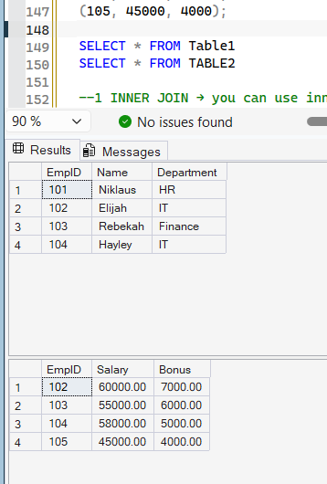

--1 INNER JOIN → you can use inner join if you want to combine rows from two or more tables based on related columns between them
SELECT T1.Empid,T1.name,T1.department,T2.salary,T2.bonus from TABLE1 T1 INNER JOIN TABLE2 T2 on T1.EmpID=T2.EmpID
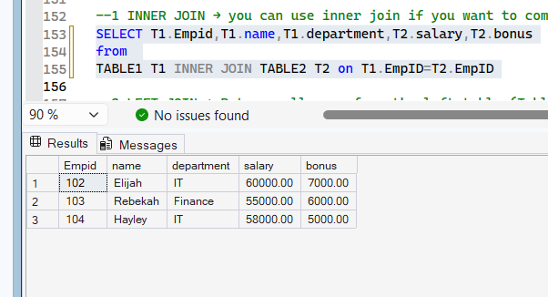

--2 LEFT JOIN → Returns all rows from the left table (Table1), and the matched rows from the right table (Table2). If no match exists, NULL values are shown for right table columns.
SELECT T1.Empid,T1.name,T1.department,T2.salary,T2.bonus from TABLE1 T1 LEFT JOIN TABLE2 T2 on T1.EmpID=T2.EmpID
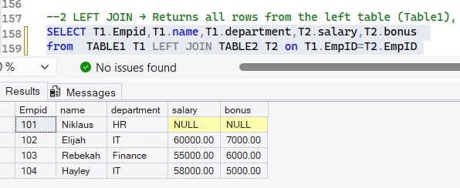

--3 RIGHT JOIN → Returns all rows from the right table (Table2), and the matched rows from the left table (Table1). If no match exists, NULL values are shown for left table columns.
SELECT T1.Empid,T1.name,T1.department,T2.salary,T2.bonus from TABLE1 T1 RIGHT JOIN TABLE2 T2 on T1.EmpID=T2.EmpID
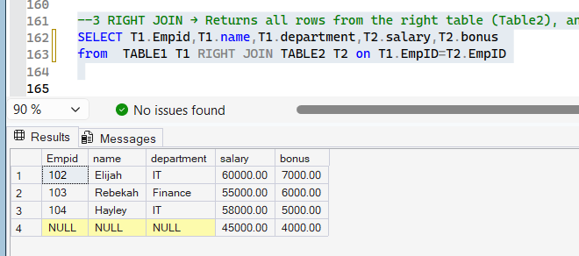
ALL OUTPUT :
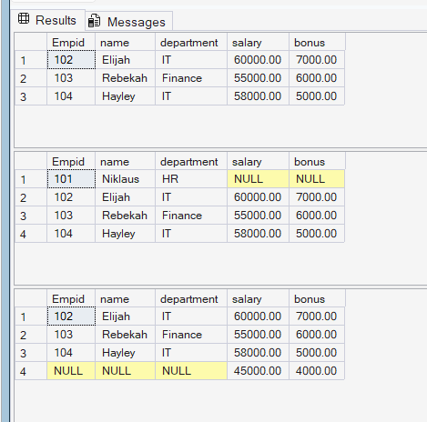

--------------------------------------------TASK 5----------------------------------------------------
--A subquery is a query nested inside another SQL query. It is often used in the WHERE, FROM, or SELECT clauses to perform intermediate calculations or filtering.
--Subqueries allow us to compare values against aggregated results or dynamically generated sets.

--1 Find employees earning more than the average salary.
SELECT Name, Salary
FROM Employees
WHERE Salary > (SELECT AVG(Salary) FROM Employees);

--2 Find employees whose salary equals the maximum salary
SELECT Name, Salary
FROM Employees
WHERE Salary = (SELECT MAX(Salary) FROM Employees);

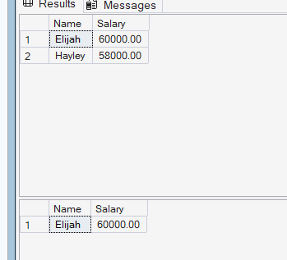
EXCEL
-------------------------------------------TASK 6------------------------------------------
1. Formatting
- Bold and centre the header row.
- Applied a background color to headers ( blue).
- Formatted Salary as currency.
- Formatted JoiningDate as short date.
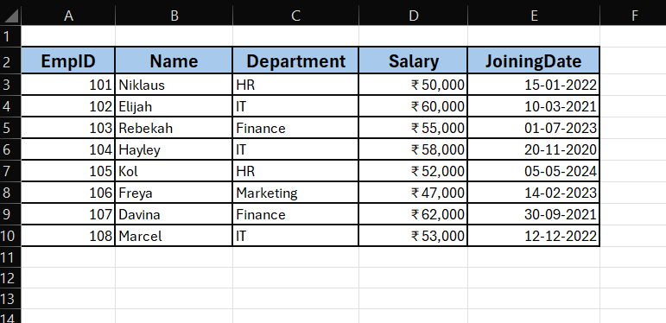

2. Sortted by JoiningDate (Ascending) → earliest hires first.
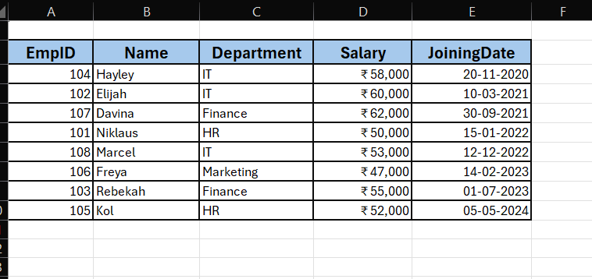

3. Filtering
  - Show only IT Department employees.
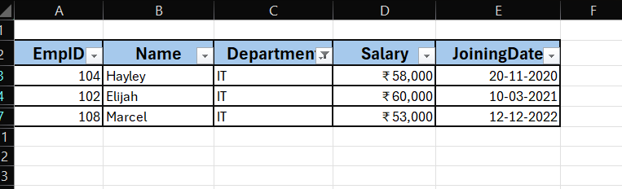

  - Show employees with Salary > 55,000.
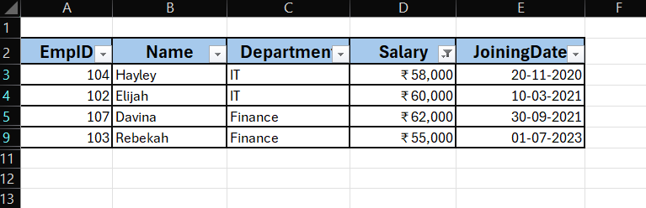

  - Show employees who joined after 01-Jan-2023.
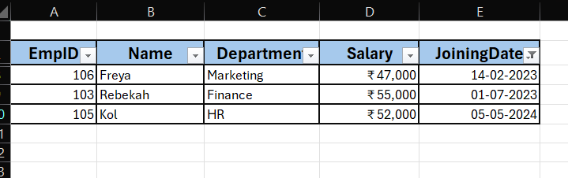

----------------------------------------------------TASK7---------------------------------------------------------
1.Conditional formatting
- Highlight the cell with salary greater than 58,000.
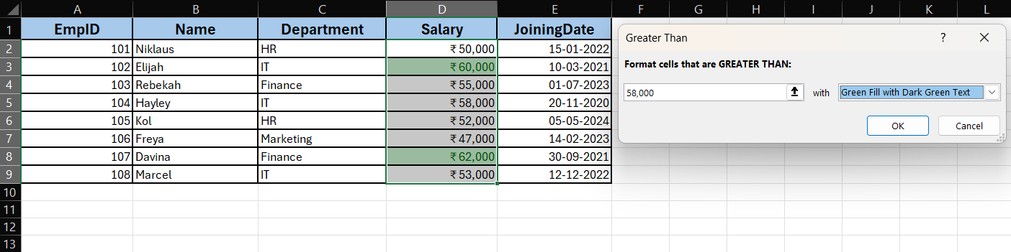
Output:
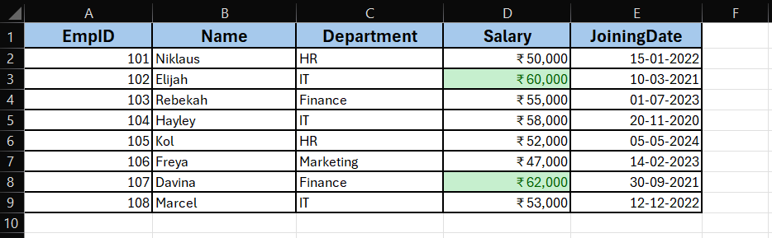
- Highlight the cell if the department is HR
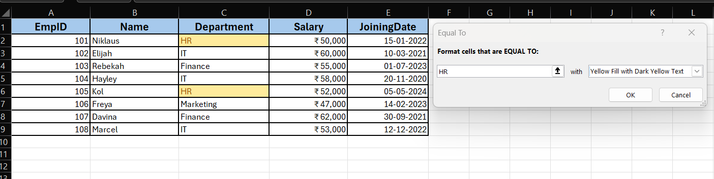

Output:
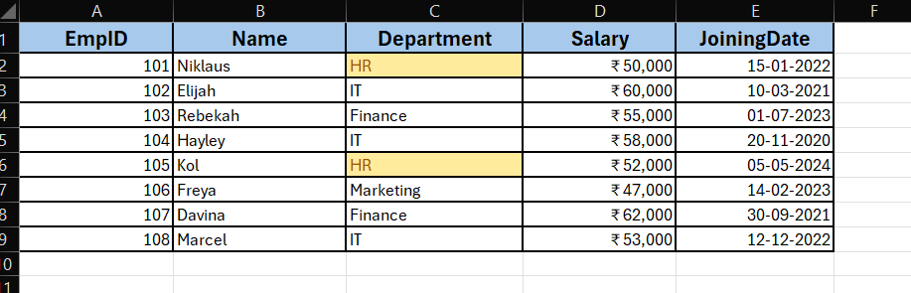

- Conditional Formatting in Excel is a feature that automatically changes the appearance of cells based on rules you define. It’s like telling Excel: “If this condition is true, highlight the cell.”

2.Excel Functions
- If():The IF function in Excel is used to test a condition and return one value if the condition is TRUE, and another if it is FALSE.
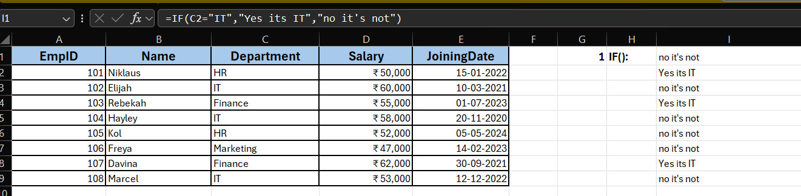
Explanation:
- C2="IT" → checks if the value in cell C2 is exactly “IT”.
- If TRUE → Excel shows Yes it's IT.
- If FALSE → Excel shows No it's not.
- COUNTIF():The COUNTIF function counts the number of cells in a range that meet a specific condition.

- EG 1: count if department is IT
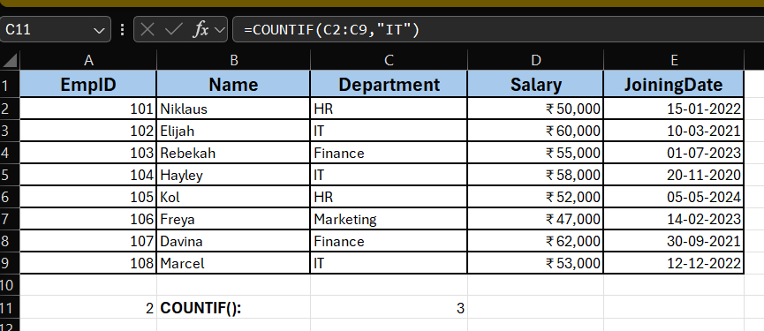

- EG 2: count if salary is greater than 58,000
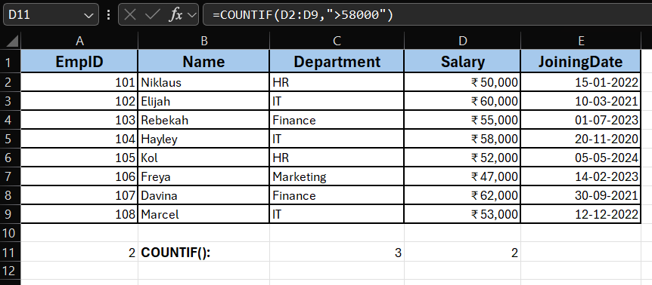

- Sumif(): The SUMIF function adds up values in a range that meet a specific condition. It’s like saying: “Sum only those numbers that match my rule.”
- Eg: find the total salary of finance department
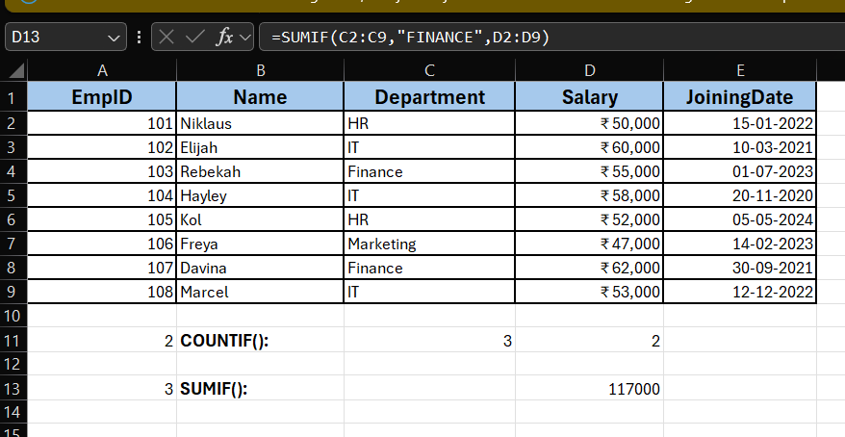

----------------------------------TASK 8--------------------------------------------
TABLES USED FOR LOOKUP FUNCTION TASK
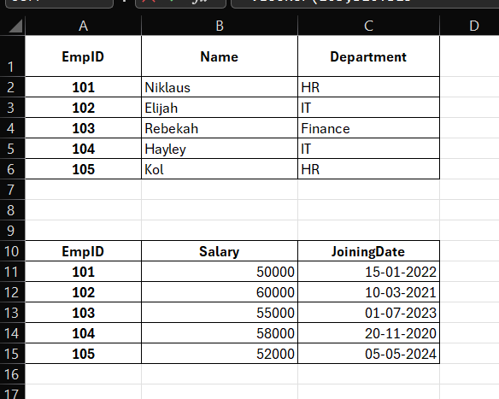

VLOOKUP(): The VLOOKUP() function in Excel is used to search for a value in the first column of a table and return a value from another column in the same row. It stands for Vertical Lookup because it looks down a column to find the match.
- Find the Salary of EmpID = 103 (Rebekah)
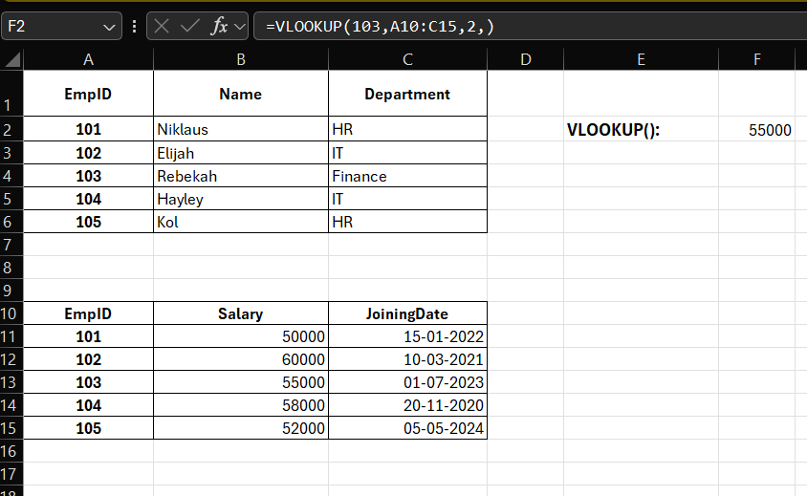
- Find Elijah’s joining date:
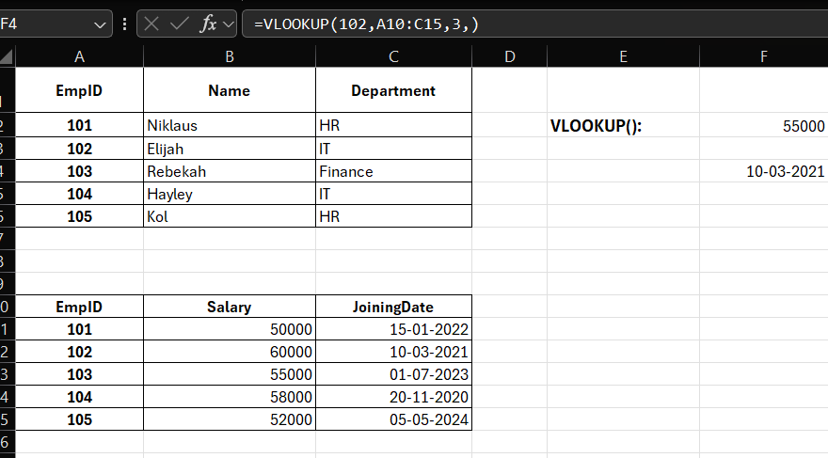
- XLOOKUP():The XLOOKUP() function in Excel is used to search for a value in one column (lookup array) and return a corresponding value from another column (return array). It’s more powerful and flexible than VLOOKUP because it doesn’t depend on column positions.
  - Find the Salary of EmpID = 103
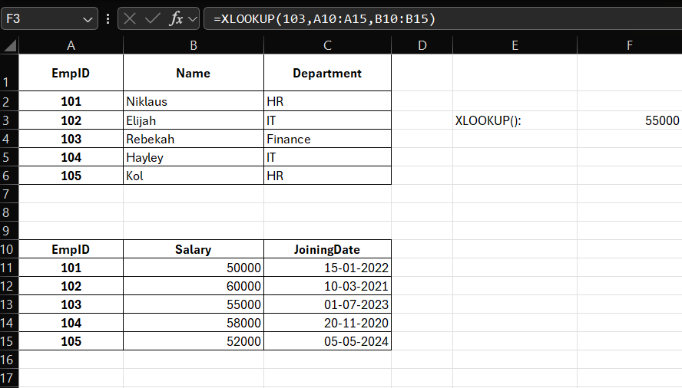
- EMPLOYEE 103 JOINING DATE
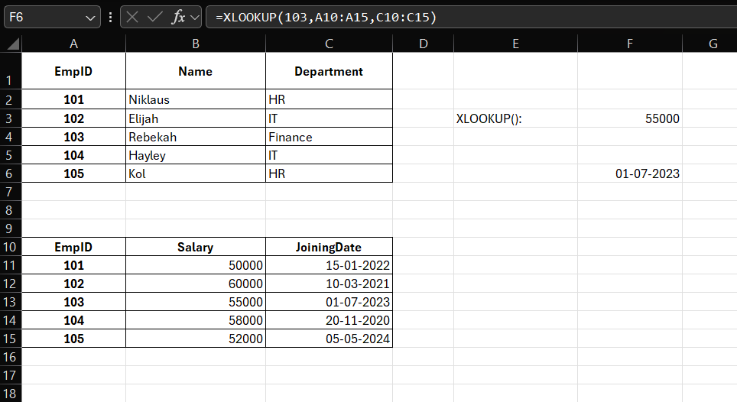

-------------------------------------TASK 9---------------------------------------------
1.What is pivot table?
A Pivot Table is one of Excel’s most powerful tools. It allows you to:
- Summarize large datasets quickly.
- Rearrange (pivot) data to view it from different perspectives.
- Perform calculations like Sum, Count, Average without writing formulas.
- Provide a structured summary that can be linked directly to charts
DATA USED:
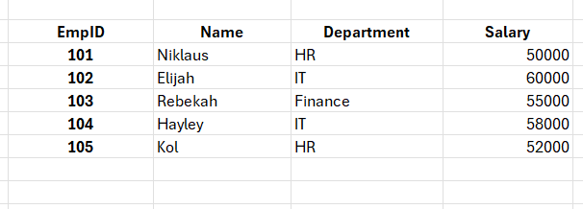
2.Built the pivot table

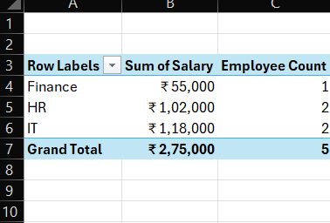

3.Create a chart and analyze the data

- The chart visually represents how salaries are distributed across departments.
- IT department has the highest payroll cost (43%).
- HR department follows with 37%.
- Finance department has the smallest share (20%).
- This helps management quickly identify which department consumes the largest portion of salary expenses.

4.Analyze the chart
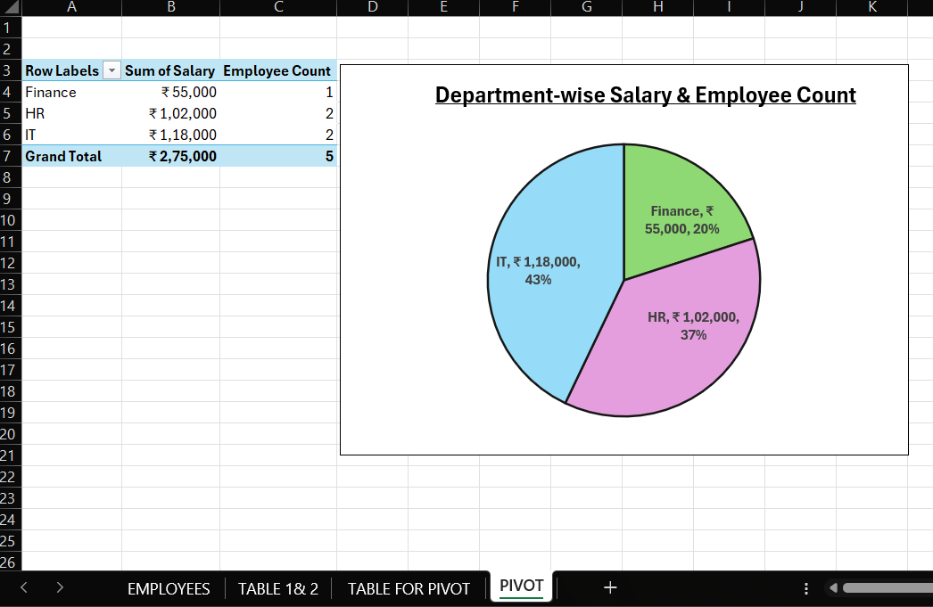

NOTE:
1.OUTPUTS OF EVERY QUERY IS SCREENSHOTTED AND PASTED BELOW EVERY QUERY AND EXCEL OUTPUT IS PROVIDED WITH EXPLANATION AND SCREENSHOTS OF OUTPUT
2.ALL TABLES USED IN EXCEL WORKBOOK ARE ATTACHED IN THE DRIVE AND SQL QUERY IS ALSO ATTCHED IN TEXT FORMAT.

