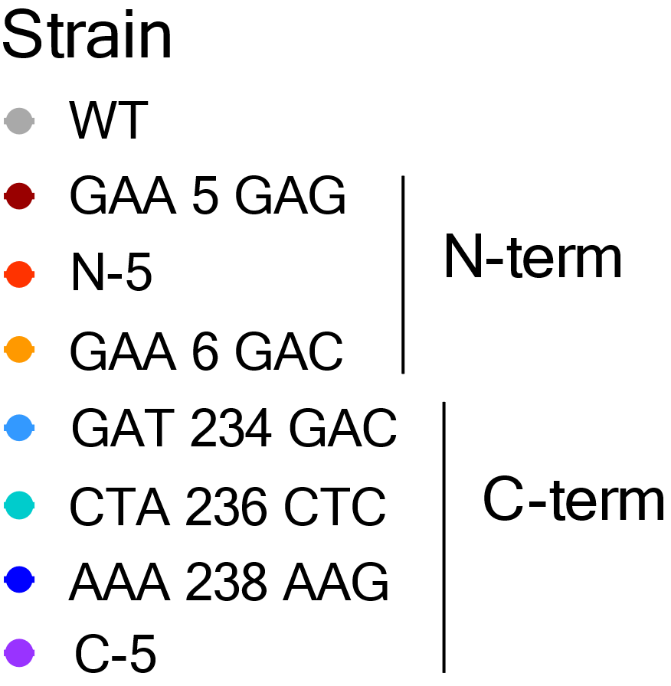

**Strains**

M4/NGFPM4 = GAA 5 GAG

M5F/NGFPM5F = N-5

M6/NGFPM6 = GAA 6 GAC

M7/NGFPM7 = GAT 234 GAC

M9/NGFPM9 = CTA 236 CTC

M11/NGFPM11 = AAA 238 AAG

M5R/NGFPM5R = C-5