REPORT
OF
SENTIMENT ANALYSIS ON MOVIE REVIEWS

Submitted
To
School of Computer Science and Engineering
IILM University, Greater Noida, U.P.

In partial fulfilment of the requirement of degree of
B.Tech CSE



By
Roll Number of Student: 2410031360
Name of Student: RIDDHIMA SHARMA
Batch: 2024-2028 | 3rd Year | Section: 3CSE22 | 2026-27

TABLE OF CONTENTS

Chapter No. | Chapter Name | Page Nos.
1 | Cover Page | ----
2 | Candidate’s Declaration | i
3 | Acknowledgement | ii
4 | Internship Completion Certificate | iii
5 | Project Description | iv
 | 4.1 Introduction | iv
 | 4.2 Organization Profile | v
 | 4.3 Problem Statement | v
 | 4.4 Project Objectives | v
 | 4.5 Scope of the Project | vi
 | 4.6 Technologies and Tools Used | vi
 | 4.7 System Architecture | vii
 | 4.8 Methodology | vii
 | 4.9 Expected Outcomes | ix
 | Bibliography/References | x

CANDIDATE’S DECLARATION

I, Riddhima Sharma, do hereby declare that the internship report titled “Sentiment Analysis on Movie Reviews” has been completed by me to fulfil the requirement for the award of the degree of Bachelor of Technology in CSE. The report describes the design and evaluation of a text-classification pipeline based on the IMDb Large Movie Review Dataset. All references have been acknowledged, and this report has not been submitted to any other institute for any degree or diploma requirement. I shall be solely responsible for any copyright violation in this regard.

Signature: __________________________
Student Name: Riddhima Sharma
Roll No.: 2410031360

ACKNOWLEDGEMENT

I would like to express my sincere gratitude to everyone who supported me during the completion of this project. I am thankful to the School of Computer Science and Engineering, IILM University, for providing the academic environment and guidance needed to explore a practical problem in natural language processing. I also acknowledge Wheeltrix for sharing the project brief and defining the application context for sentiment analysis on movie reviews during my Data Analyst Intern timeline from 27 June 2026 to 27 July 2026.
Their support helped me understand the complete machine-learning workflow, from preparing textual data to evaluating a classifier responsibly.

Signature: __________________________
Student Name: Riddhima Sharma
Roll No.: 2410031360

INTERNSHIP COMPLETION CERTIFICATE

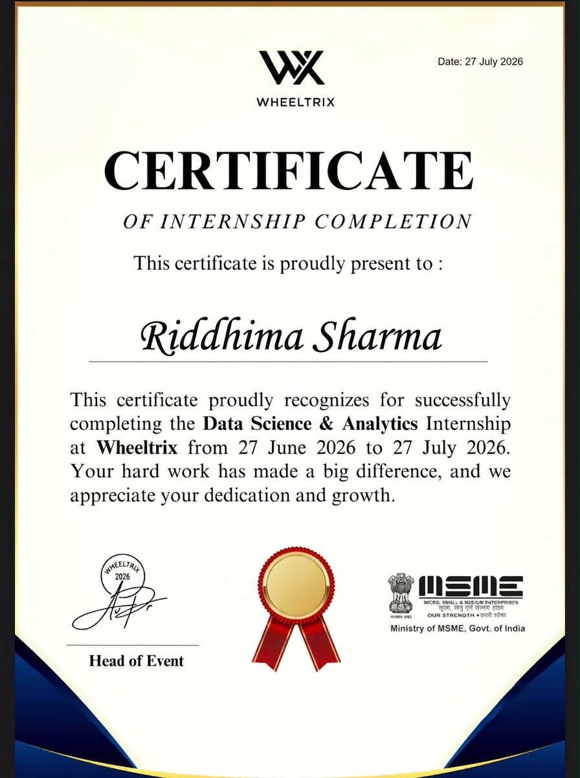

CHAPTER 4
PROJECT DESCRIPTION
4.1 Introduction
Sentiment analysis is a natural language processing task that identifies the opinion expressed in a piece of text. In this project, the task is formulated as binary classification: each movie review is assigned either a positive or a negative label. The system converts unstructured review text into numerical features, learns patterns associated with the two sentiment classes, and predicts the sentiment of previously unseen reviews.
The project follows the scope described in the Wheeltrix Data Science & Analytics brief. It uses a publicly documented IMDb review benchmark, applies text cleaning and normalization, represents reviews using Term Frequency–Inverse Document Frequency (TF-IDF), trains a Logistic Regression classifier, and evaluates the model using accuracy, precision, recall, F1-score, and a confusion matrix. The measured baseline is intended to be transparent and reproducible rather than presented as a production-ready system.
4.2 Organization Profile
Wheeltrix is the organization associated with this internship project. The supplied Data Science & Analytics brief presents sentiment analysis on movie reviews as one of several applied machine-learning project options and identifies the value of extracting audience sentiment for filmmakers, studios, and review platforms. The internship role was Data Analyst Intern, with the timeline 27 June 2026 to 27 July 2026.
4.3 Problem Statement
Movie-review websites contain large volumes of free-form text. Manually reading and categorizing every review is slow, inconsistent, and difficult to scale. The problem is to develop a machine-learning model that can automatically classify the overall sentiment of a review as positive or negative while providing an evaluation process that is clear enough to measure strengths and limitations.
4.4 Project Objectives
- To prepare a labeled dataset of movie reviews for supervised binary sentiment classification.
- To clean and normalize review text while preserving sentiment-bearing words and emphasis markers.
- To transform reviews into numerical TF-IDF features suitable for classical machine-learning algorithms.
- To train a Logistic Regression classifier and evaluate it on an unseen test set.
- To report performance using accuracy, precision, recall, F1-score, and a confusion matrix.
- To document a reproducible pipeline that can be extended to a web-based prediction interface.
4.5 Scope of the Project
The scope covers binary sentiment classification of English-language movie reviews. It includes dataset preparation, preprocessing, feature extraction, model training, testing, metric calculation, and discussion of practical limitations. The current implementation does not claim to detect fine-grained emotions, sarcasm, mixed sentiment, aspect-level opinions, or multilingual sentiment. It also does not include a deployed public application or an official industry certificate because those materials were not supplied.

4.6 Technologies and Tools Used
Table 4.1 Technologies and tools used
Component | Technology / Choice | Purpose
Dataset | IMDb Large Movie Review Dataset | 25,000 labeled training reviews and 25,000 labeled test reviews; additional unlabeled data exists.
Language | Python 3.11 | Data loading, preprocessing, model training, and evaluation.
Feature extraction | scikit-learn TfidfVectorizer | Transforms raw documents into sparse TF-IDF feature matrices.
Classifier | Logistic Regression | Learns a linear decision boundary for positive and negative sentiment.
Evaluation | scikit-learn metrics | Calculates accuracy, precision, recall, F1-score, and confusion matrix.
Documentation | Microsoft Word / DOCX | Formats the project report according to the supplied university template.

4.7 System Architecture
The system is organized as a sequential text-classification pipeline. Training data passes through cleaning and feature extraction before the classifier is fitted. At inference time, a new review is transformed using the already-fitted vectorizer and then classified by the trained model.
Figure 4.1 System architecture represented as a pipeline table
Stage | Input | Output
1. Data collection | Labeled IMDb reviews | Training and test review sets
2. Text cleaning | Raw HTML-containing review text | Normalized review text
3. TF-IDF vectorization | Cleaned documents | Sparse numerical feature matrix
4. Model training | Training feature matrix and labels | Fitted Logistic Regression model
5. Prediction | New review transformed with the same vectorizer | Positive or negative label
6. Evaluation | Predicted labels and test labels | Metrics and confusion matrix

4.8 Methodology
The IMDb Large Movie Review Dataset contains 50,000 labeled reviews divided into 25,000 training examples and 25,000 test examples. The dataset is balanced between the negative and positive classes in each labeled split. The dataset card also documents a separate 50,000-review unsupervised split, which was not used in the reported baseline.
Preprocessing removes HTML break tags, decodes HTML entities, removes non-alphanumeric noise while retaining exclamation and question marks, collapses repeated whitespace, and converts text to lowercase. The aim is to reduce irrelevant variation without deleting all emphasis cues. The same preprocessing logic is applied to both training and test reviews.
TF-IDF is used to represent each review as a sparse vector. The reported configuration uses word unigrams and bigrams, a minimum document frequency of 2, a maximum document-frequency threshold of 0.95, sublinear term-frequency scaling, and a maximum vocabulary of 100,000 features. This representation gives more weight to terms that are informative within the corpus and less weight to terms that occur in many documents.
A Logistic Regression classifier is trained with C=4.0, the liblinear solver, a maximum of 200 iterations, and a fixed random state of 42. The model is evaluated once on the held-out IMDb test split. The evaluation is not a claim about all movie reviews; it is a measured result for the stated dataset and configuration.
Table 4.2 Baseline evaluation results
Metric | Measured value | Interpretation
Accuracy | 90.54% | Share of all 25,000 test reviews classified correctly.
Positive precision | 0.9043 | Among reviews predicted positive, proportion that were positive.
Positive recall | 0.9067 | Among positive reviews, proportion recovered by the model.
Positive F1-score | 0.9055 | Harmonic mean of positive precision and positive recall.
Feature count | 100,000 | Number of TF-IDF columns retained after vocabulary limits.

Table 4.3 Confusion matrix on the IMDb test split
Actual / Predicted | Negative | Positive
Negative | 11301 | 1199
Positive | 1166 | 11334

4.9 Expected Outcomes
The project produces a reproducible baseline for classifying movie reviews into positive and negative sentiment. The measured baseline demonstrates that a classical linear model with TF-IDF features can perform strongly on a balanced benchmark while remaining relatively simple to interpret and deploy. The model can support exploratory audience analysis, review triage, and prototype recommendation workflows, provided that its domain limitations are considered.
The most important practical outcome is a documented workflow rather than a single score. The workflow makes it possible to compare Logistic Regression with Support Vector Machines, test word and character n-grams, introduce cross-validation, and later evaluate transformer-based models such as BERT. Any future deployment should also monitor performance on newer reviews, different genres, informal language, and reviews containing sarcasm or mixed opinions.

CHAPTER 5
BIBLIOGRAPHY / REFERENCES
[1] Maas, A. L., Daly, R. E., Pham, P. T., Huang, D., Ng, A. Y., and Potts, C. “Learning Word Vectors for Sentiment Analysis.” Proceedings of ACL-HLT, 2011. Dataset information is available through the Stanford AI Lab and the Hugging Face dataset card.
[2] Stanford NLP. “Large Movie Review Dataset.” Hugging Face Datasets, dataset card for stanfordnlp/imdb. Accessed 10 September 2026.
[3] Pang, B., Lee, L., and Vaithyanathan, S. “Thumbs up? Sentiment classification using machine learning techniques.” Proceedings of EMNLP, 2002.
[4] scikit-learn developers. “TfidfVectorizer.” scikit-learn API Reference. Accessed 10 September 2026.
[5] scikit-learn developers. “Metrics and scoring: quantifying the quality of predictions.” scikit-learn User Guide. Accessed 10 September 2026.
Source URLs: https://huggingface.co/datasets/stanfordnlp/imdb ; https://www.cs.cornell.edu/home/llee/papers/sentiment.home.html ; https://scikit-learn.org/stable/modules/generated/sklearn.feature_extraction.text.TfidfVectorizer.html

