- INTERFACE REQUIREMENT

USER INTERFACES
The Snapchat user interface should be instinctive such that most of all new Snapchat users are able to use the app without any assistance.

HARDWARE INTERFACES
The hardware should have following specifications:
  - Ability to read gallery
  - Ability to exchange data over network
  - Touch screen for convenience and keypad (in case touchpad not available)
  - Ability to take input from user
  - Ability to connect to different applications and to attach hyperlinks to snaps
  - Ability to locate user on a real-time map
  - Ability to recognize faces using face recognition algorithms
  - Ability to sense and hear the music around whenever Shazamed
  - Ability to keep a track of all birthdates of each and every user and send them a cake, wishes and many more..
- Should be user friendly

SOFTWARE INTERFACES
The software interfaces are specific to the target other user's Snapchat software systems. Snapchat demands software like GPS, camera, etc… on the following mobile OS (environment):
- iOS
- Android

- PERFORMANCE REQUIREMENTS

SCALABILITY
Snapchat should be able to provide instant messaging services to 1 billion users at any given time.

ROBUSTNESS
In case user’s device crashes, a backup is must to to enable recoverability

PERFORMANCE
Application must be lightweight and must send messages instantly.

SPEED
Application’s processing speed should be so high. Also, the application should not crash repeatedly.

CACHE MEMORY
The app shall not consume more cache memory. Even if it does, it must provide a choice to the user to clear app cache manually.

- DESIGN CONSTRAINTS
- Create Snapchat account by entering name and verifying mobile number.
- If not able to exchange data over network, prompt error message "Connection not available”
- In case of not able to access services of mobile hardware if eg: camera is not working, prompt error message, "Can’t access camera".
- In case of spamming by 10 users: Maintain Consecutive marked spam Counter. For every consecutive spam, increment logic counter by 1. Deactivate the account as the spam number reaches 10.

- NON FUNCTIONAL ATTRIBUTES
PRIVACY
The users are provided with the benefit of customizing their privacy settings. Eg: Choose who can view your story and so on.
SECURITY AND SAFETY
Keep your password safe and don't share it with any other people, applications, or websites under any circumstances.
RELIABILITY
It is very important that the app is reliable as 3B+ users use Snapchat simultaneously. All data collected by Snapchat shall be preserved safely and should follow data hiding.
PORTABILITY
Snapchat can be used on any apple or android phones and tablets.
MAINTAINABILITY
Snapchat Beta releases all new updates first and looks for acceptance from its customers.
USER FRIENDLY
This application is user-friendly, meaning to say even if one just installs the app and uses it for the first time, he’d find it easy to operate the application.

SUPPORT
A good software is one which listens to its customers’ feedback and helps them whenever they need something. Snapchat has all supportive help documentation ready.
BACKUP & RESTORE
Snapchat provides a backup and automatic restore facility relating to the online cloud database which back up all your data (upon given your permission) and all the backed up information can be easily restored later.
REPORT SPAM
In case of irrelevant, inappropriate content, misbehavior by any snapchatter, or anything uncomfortable or fishy, the snap users are free to report a complaint to Snapchat. Strict action shall then be taken against the individual or post or anything that’s been reported spam.
FEEDBACK/WRITE A REVIEW
Once the app has been installed, the customer/user can write his valuable feedback. He can rate the app accordingly.

- APPENDICES
- BITMOJI

CREATE:
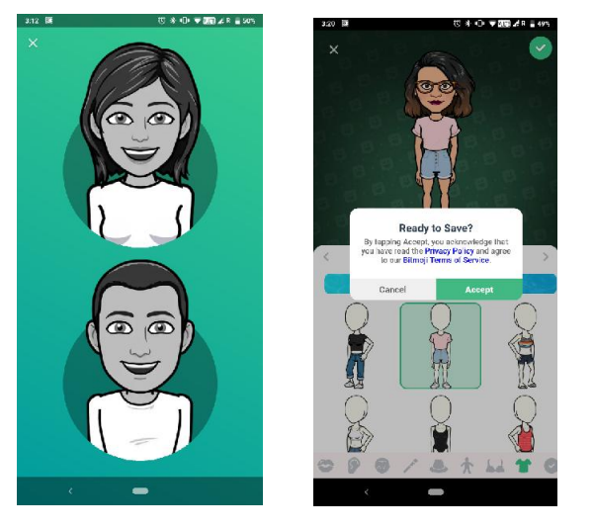

EDIT:
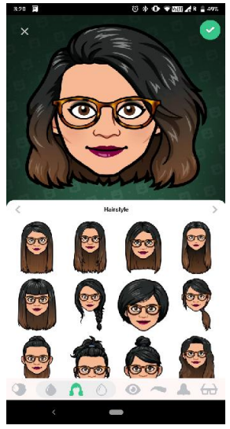 CHANGE OUTFIT:
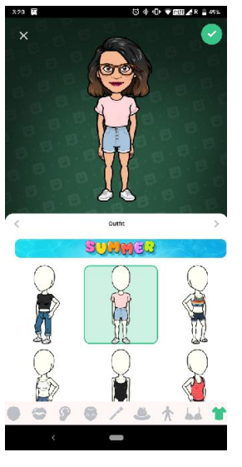
CHOOSE SELFIE:
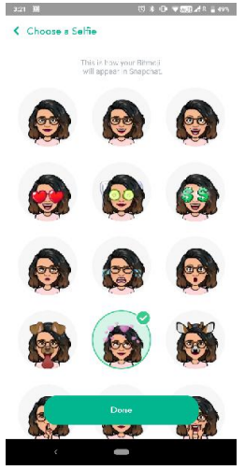
SPACTACLES:
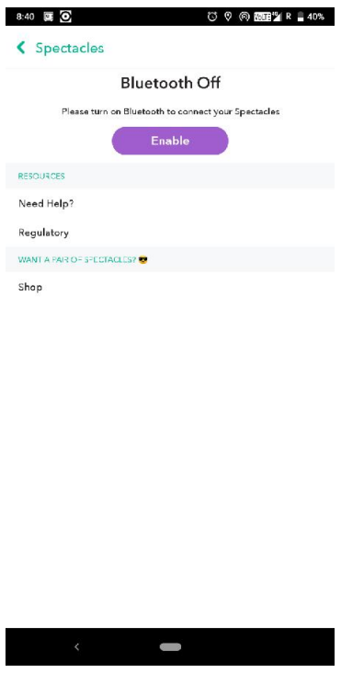

SHAZAM:
