**DBMS**

**Lab Assignment-1**

1. Display the data in existing default employees or emp or employee table.

QUERY: SELECT * FROM emp;

1. Display the structure of the above table.

QUERY: DESC emp;

1. Create a table “**Student**” with following structure:

|  |  |  |  |  |  |  |  |
| --- | --- | --- | --- | --- | --- | --- | --- |
| **Roll** | **Name** | **Age** | **Course** | **Math** | **Physics** | **Computer** | **Birthday** |

**Details of Attributes:-**

Roll Number (5)

Name Varchar2 (30)

Age Number (5)

Course Varchar2 (5)

Math Number (6, 2)

Physics Number (6, 2)

Computer Number (6, 2)

Birthday Date

QUERY: CREATE TABLE Student( Roll INT(5), Name VARCHAR(30),

Age INT(5), Course VARCHAR(5), Math DECIMAL(6,2), Physics DECIMAL (6,2), Computer DECIMAL(6,2), Birthday DATE);



1. Create table **MSc** from the **Student** table with the same fields and same structure but without any data.

QUERY: CREATE TABLE MSc AS SELECT * FROM Student WHERE 1=2;



1. Display the structure of **MSc** table.

QUERY: DESC MSc;

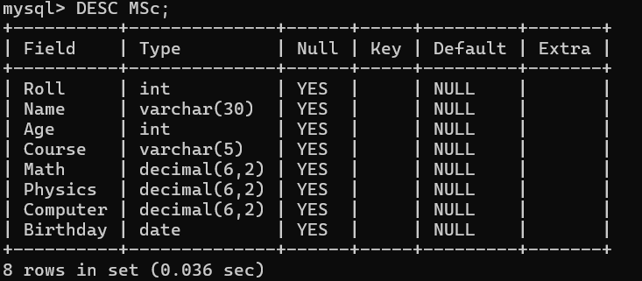

1. Create table ‘**MCA**’ from the **Student** table with the same fields and same structure but without any data. Rename Course with Department and Name with First Name.

QUERY: CREATE TABLE MCA AS SELECT * FROM Student WHERE 1=2;



ALTER TABLE MCA RENAME COLUMN Course to Department;



ALTER TABLE MCA RENAME COLUMN Name to First_Name;

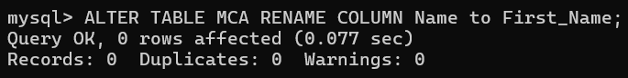

1. Display the structure of **MCA** table.

QUERY: DESC MCA;

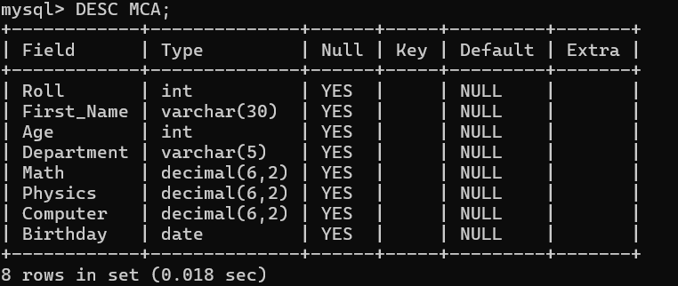

1. Insert following records into the **Student** table:-

* 1, Rahul,19,BCA,79.5,67,89,15-jun-93
* 2,Kunal,21,BCA,68,76,59.5,16-aug-91
* 3,Aditi,20,MSc,90,73,56,20-sep-92
* 4,Sumit,20,MCA,57.5,78,81,07-dec-91
* 5,Anirban,22,MCA,80,68,63,15-sep-94
* 6,Kumkum,21,BCA,72,54.5,60,08-feb-95
* 7,Suman,21,BCA,91.5,32,61,10-mar-94
* 8,Rohit,22,MSc,85,76,92,19-apr-92

QUERY: INSERT INTO Student VALUES

(1, 'Rahul', 19, 'BCA', 79.5, 67, 89, '1993-06-15'),

(2, 'Kunal', 21, 'BCA', 68, 76, 59.5, '1991-08-16'),

(3, 'Aditi', 20, 'MSc', 90, 73, 56, '1992-09-20'),

(4, 'Sumit', 20, 'MCA', 57.5, 78, 81, '1991-12-07'),

(5, 'Anirban', 22, 'MCA', 80, 68, 63, '1994-09-15'),

(6, 'Kumkum', 21, 'BCA', 72, 54.5, 60, '1995-02-08'),

(7, 'Suman', 21, 'BCA', 91.5, 32, 61, '1994-03-10'),

(8, 'Rohit', 22, 'MSc', 85, 76, 92, '1992-04-19');

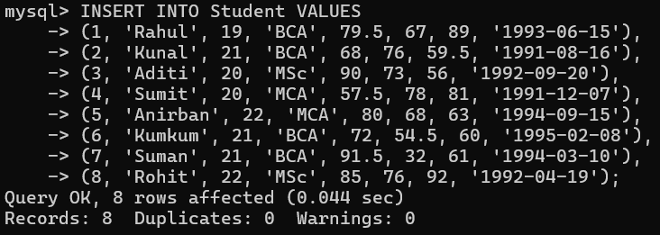

1. Display all the students’ details from **Student** table.

QUERY: SELECT * FROM STUDENT;

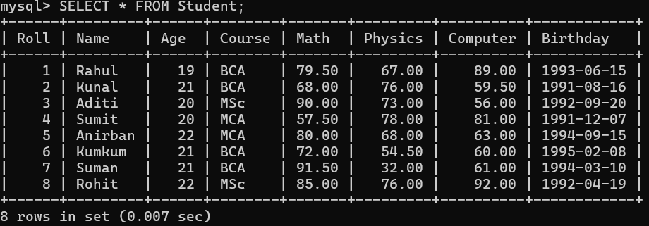

1. Find out the details of the students with roll no 5 from **Student** table.

QUERY: SELECT * FROM Student WHERE Roll=5;

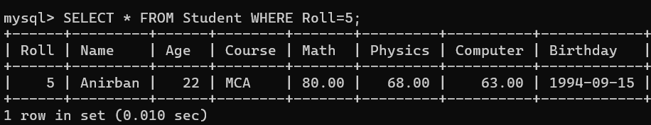

1. Show the roll, name, marks of all subjects for all students from **Student** table.

QUERY: SELECT Roll,Name,Math,Physics,Computer FROM Student;

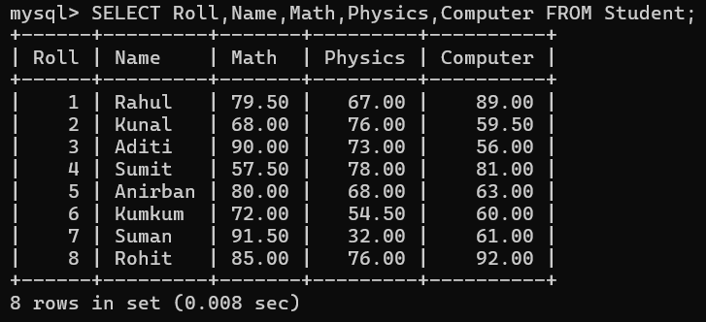

1. Display all the student details belonging to the **BCA** department.

QUERY: SELECT * FROM Student where Course = ‘BCA’;

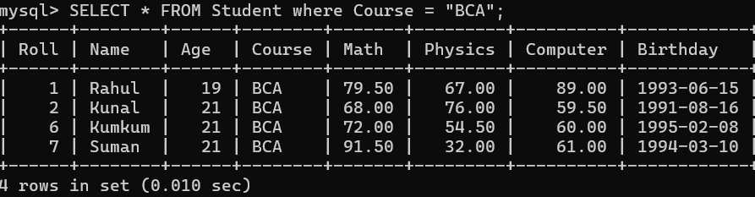

1. Insert data in the ‘**MCA’** table from **‘Student’** table where course is **MCA**.

QUERY: INSERT INTO MCA SELECT * FROM Student WHERE Course = ‘MCA’;

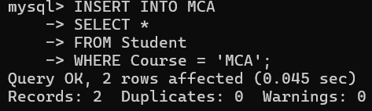

1. Insert data in the **‘MSc’** table from **‘Student’** table where course is **MSc**.

QUERY: INSERT INTO MSc SELECT * FROM STUDENT WHERE Course = ‘MSc’;



1. Display the structure of **‘Student’** and **‘MCA’** table.

QUERY: DESC Student;

DESC MCA;

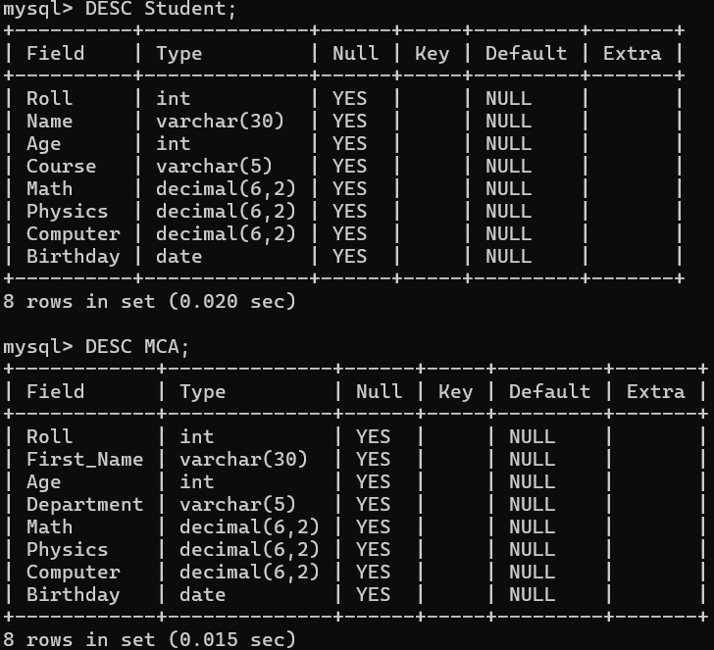

1. Display all the details of each student in **‘Student’** table with Course appearing first in the display column list.

QUERY: SELECT Course,Roll,Name,Age, Math,Physics,Computer, Birthday FROM Student;

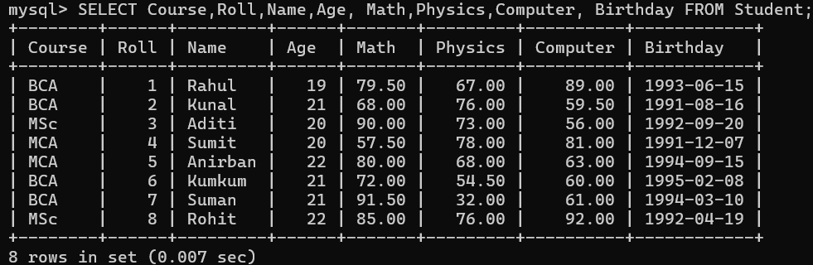

1. Update the Math marks of the student with Roll no 7 from 91 to 95 in the

**‘Student’** table.

QUERY: UPDATE Student SET Math = 95 WHERE Roll=7;

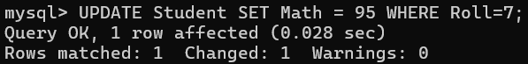

1. Update the Name of the student with Roll no 4 from Sumit to Sumitava

in ‘**MCA’** table.

QUERY: UPDATE MCA SET First_Name = “Sumitava” WHERE Roll=4;

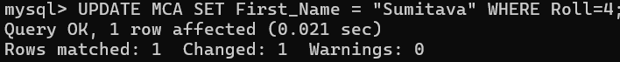

1. Delete the details of the student with Roll no 2 from the **‘Student’** table.

QUERY: DELETE FROM STUDENT WHERE Roll=2;



1. Delete the details of all students from the ‘**Student’** table.

QUERY: DELETE FROM STUDENT;

