LAB Assignment-5
E_ID | FNAME | LNAME | HIRE_  DATE | JOB_ID | SAL | DEPT_ID
PK | NOT NULL | NOT NULL | NOT NULL | NOT NULL | NOT NULL | Should be greater than or equal to 10
- Create a table EMP with following structure.

EMP_ID | FIRST_  NAME | LAST_  NAME | HIRE_  DATE | JOB_ID | SAL | DEPT_  IDselect
198 | Donald | Connell | 21-Jun-99 | SH_CLERK | 2600 | 50
199 | Douglas | Grant | 13-Jan-98 | SH_CLERK | 3000 | 50
200 | Jennifer | Whalen | 17-Sep-87 | AD_ASST | 4400 | 10
201 | Michael | Hartstein | 19-Jan-99 | IT_PROG | 6000 | 20
202 | Pat | Fay | 25-Oct-89 | AC_MGR | 6500 | 20
203 | Susan | Mavris | 26-Nov-76 | AD_VP | 7500 | 40
204 | Hermann | Baer | 23-Aug-95 | AD_PRES | 9500 | 90
205 | Shelley | Higgins | 24-Feb-98 | AC_MGR | 2300 | 60
206 | William | Gitz | 12-Mar-01 | IT_PROG | 5000 | 60
100 | Steven | King | 15-Jun-02 | AD_ASST | 8956 | 100
101 | Neena | Kochar | 10-Jul-03 | SH_CLERK | 3400 | 30

QUERY: CREATE TABLE EMP (EMP_ID INT PRIMARY KEY, FIRST_NAME VARCHAR(20) NOT NULL, LAST_NAME VARCHAR(20) NOT NULL, HIRE_DATE DATE NOT NULL, JOB_ID VARCHAR(20) NOT NULL, SAL DECIMAL(10,2) CHECK (SAL >= 10) NOT NULL, DEPT_ID INT NOT NULL);

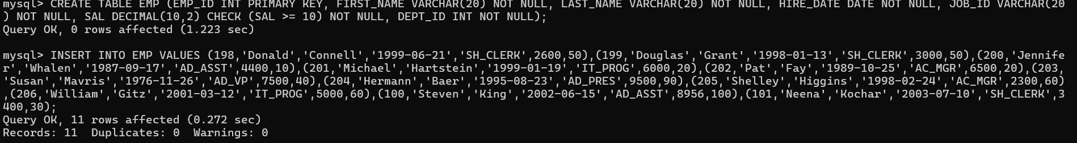

- Display the fname of all employees in ascending order. Give appropriate alias name to the column.
QUERY: SELECT FNAME FROM EMP ORDER BY FNAME;

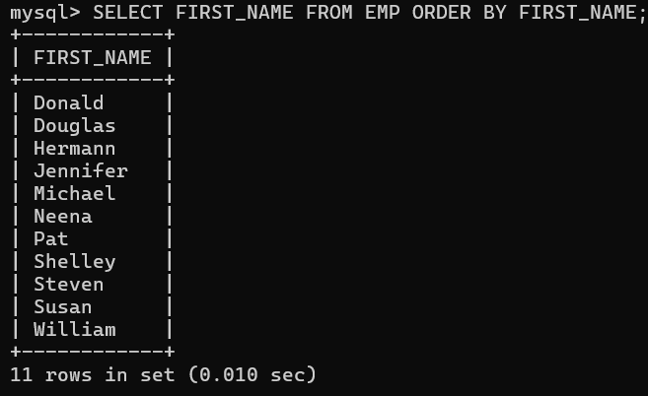

- Display the fname of all employees in descending order. Give appropriate alias name to the column.
QUERY: SELECT FIRST_NAME AS FNAME FROM EMP ORDER BY FIRST_NAME DESC;

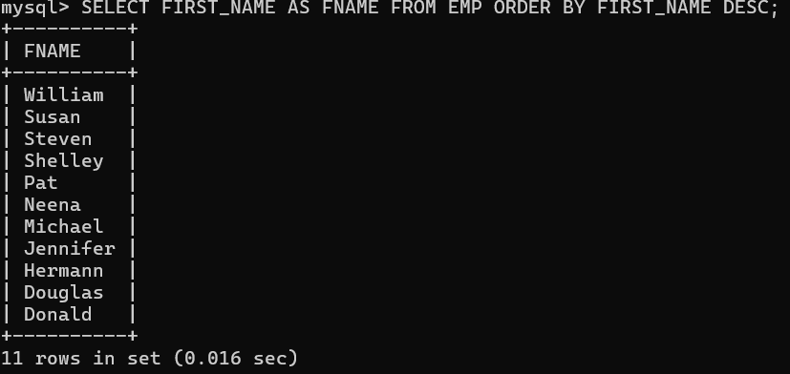

- Display the hire date of all employees in ascending order.
QUERY: SELECT HIRE_DATE FROM EMP ORDER BY HIRE_DATE;

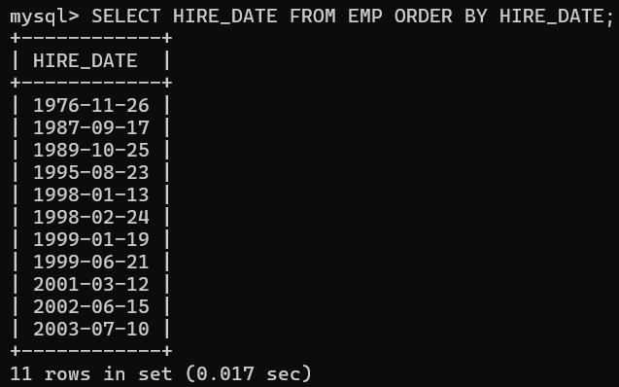

- Display the employee details whose fname starts with either J or M. Sort the result by employee lname.
QUERY: SELECT * FROM EMP WHERE FIRST_NAME LIKE ‘J%’ OR FIRST_NAME LIKE ‘M%’ ORDER BY LAST_NAME;

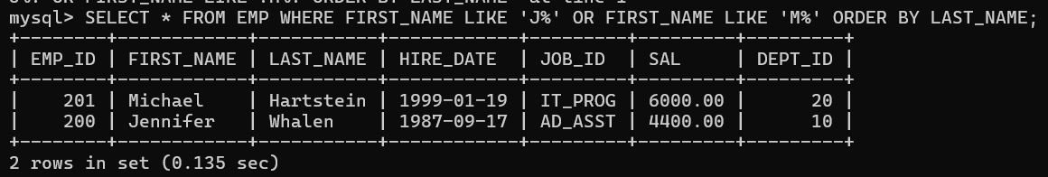

- Find the highest, lowest, average and sum of salary of all employees. Give alias names to all the columns as ‘Max’, ‘Min’, ‘Avg’, ‘Sum’ respectively.
QUERY: SELECT MAX(SALARY) AS MAX, MIN(SALARY) AS MIN, AVG(SALARY) AS AVG, SUM(SALARY) AS SUM FROM EMP;

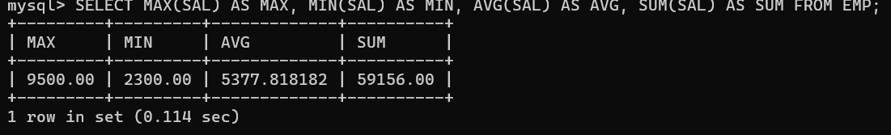
- Find the highest, lowest, average and sum of salary of all employees of each individual job type.
QUERY: SELECT MAX(SAL), MIN(SALARY), AVG(SALARY), SUM(SAL), JOB_ID FROM EMP GROUP BY JOB_ID;

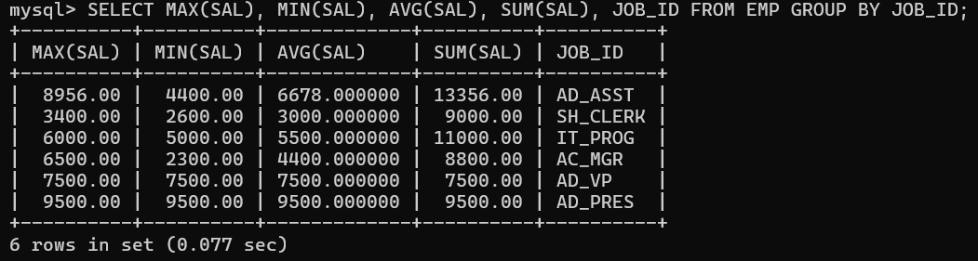

- Display the number of people under each job.
QUERY: SELECT COUNT(*), JOB_ID FROM EMP GROUP BY JOB_ID;

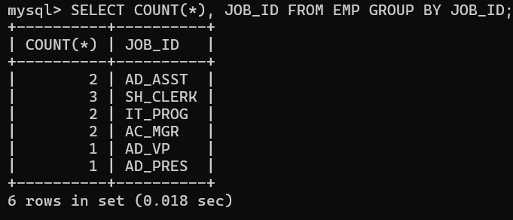

- Display the number of managers in the company without listing their emp_id or names.
QUERY: SELECT COUNT(*), JOB_ID FROM EMP WHERE JOB_ID LIKE ‘%MGR’ GROUP BY JOB_ID;

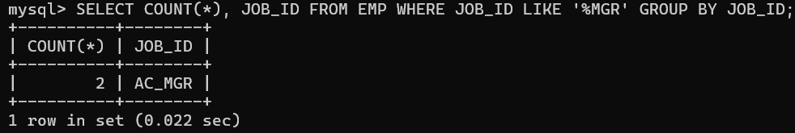

- Find the difference between the highest and the lowest salaries.
QUERY: SELECT (MAX(SAL) – MIN(SAL)) AS SALARY_DIFFERENCE FROM EMP;

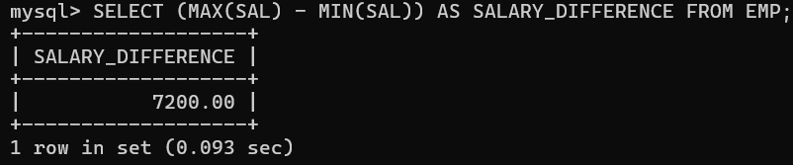

- Display the maximum and average salary of the engineers.
QUERY:
- Display the employee fname that is first and the employee fname that is last in the alphabetized list of all employees.
QUERY: SELECT MIN(FIRST_NAME) AS FIRST_EMPLOYEE, MAX(FIRST_NAME) AS LAST_EMPLOYEE FROM EMP;

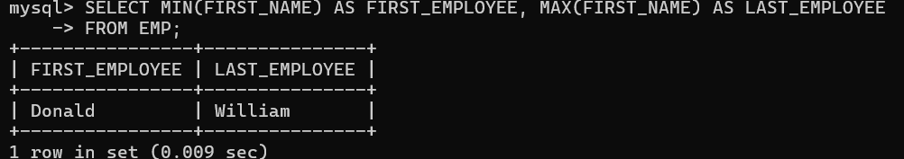

- Display the date when the first employee was hired and last date of hiring the employees. Rename the column as ‘First Hire_Date’ and ‘Last Hire_Date’.
QUERY: SELECT MIN(HIRE_DATE) AS "First Hire_Date", MAX(HIRE_DATE) AS "Last Hire_Date" FROM EMP;

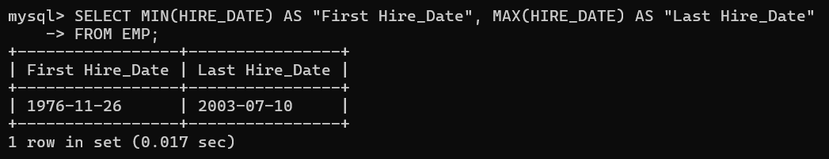

- Display the maximum and average salary of the clerks.
QUERY: SELECT MAX(SAL) AS MAX_SALARY, AVG(SAL) AS AVG_SALARY
FROM EMP WHERE JOB_ID LIKE '%CLERK%';

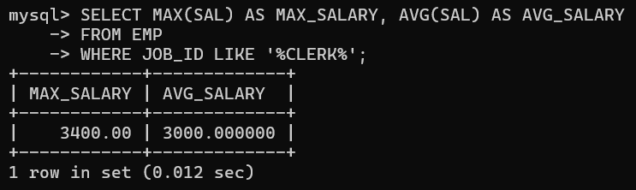

- Display the dept no. and the salary of the lowest paid employee for each department. Give an alias name to the minimum salary column.
QUERY: SELECT DEPT_ID, MIN(SAL) AS MIN_SALARY
FROM EMP GROUP BY DEPT_ID;

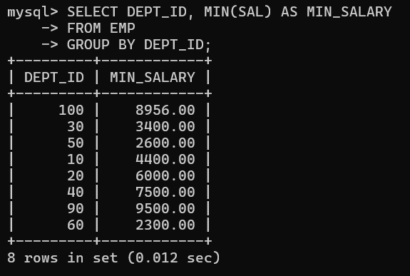

- Display the dept no. and the salary of the lowest paid employee for each department. Exclude any groups where the minimum salary is 3000 or less. Sort the output in descending order of salary.
QUERY: SELECT DEPT_ID, MIN(SAL) AS MIN_SALARY FROM EMP
GROUP BY DEPT_ID HAVING MIN(SAL) > 3000 ORDER BY MIN_SALARY DESC;

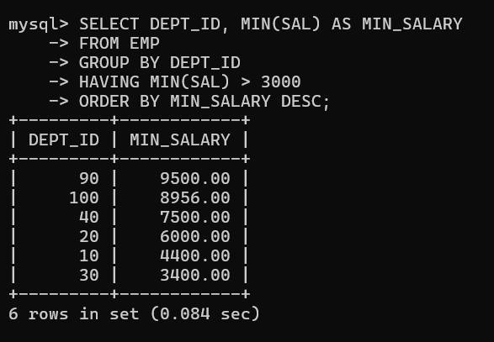

- Display the following for all rows of the table:
<First_name > whose designation is <job_id> gets <Salary> but wants to earn <3*Salary>.
QUERY: SELECT CONCAT(FIRST_NAME, ' whose designation is ', JOB_ID,
' gets ', SAL, ' but wants to earn ', SAL * 3) AS DETAIL FROM EMP;

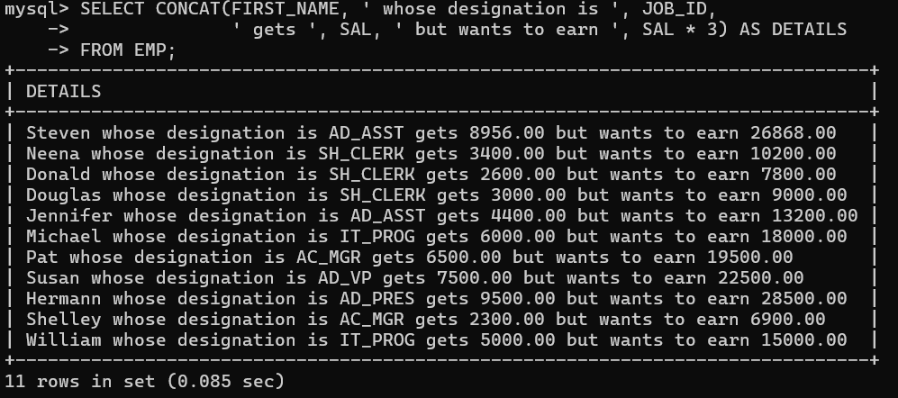

- Display the details of all employees in the following format:
198, Donald, Connell, 21-Jun-99, SH_CLERK, 2600, 50
QUERY: SELECT CONCAT(EMP_ID, ', ', FIRST_NAME, ', ', LAST_NAME, ', ', DATE_FORMAT(HIRE_DATE, '%d-%b-%y'), ', ', JOB_ID, ', ',
SAL, ', ', DEPT_ID) AS EMP_DETAILS FROM EMP;

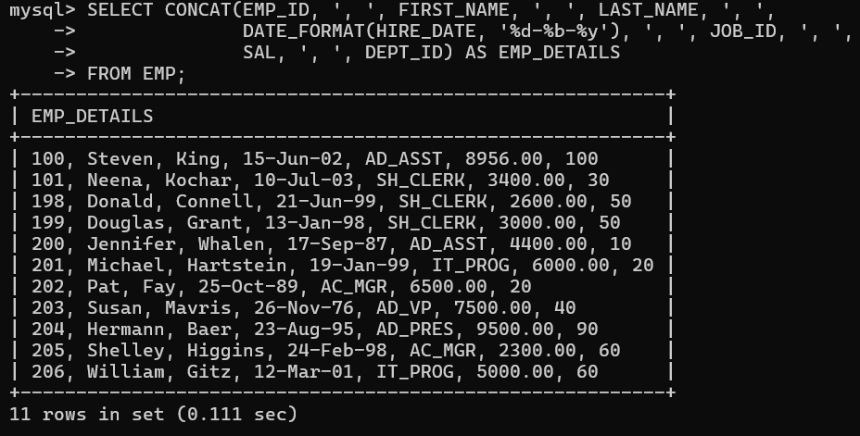

- Display today’s date. Rename the column as TODAY.
QUERY: SELECT CURDATE() AS TODAY;

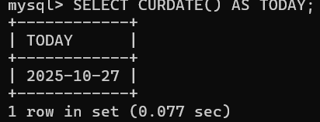

- Display the Employee id, the day and the year in which the employees were hired.
QUERY: SELECT EMP_ID,
DAYNAME(HIRE_DATE) AS DAY, YEAR(HIRE_DATE) AS YEAR FROM EMP;

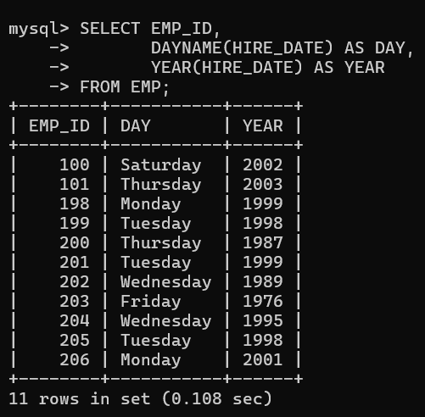

- Display the employee name and the hire date of all employees in the format ‘dd-month-yy’.
QUERY: SELECT CONCAT(FIRST_NAME, ' ', LAST_NAME) AS EMP_NAME,
DATE_FORMAT(HIRE_DATE, '%d-%M-%y') AS HIRE_DATE FROM EMP;

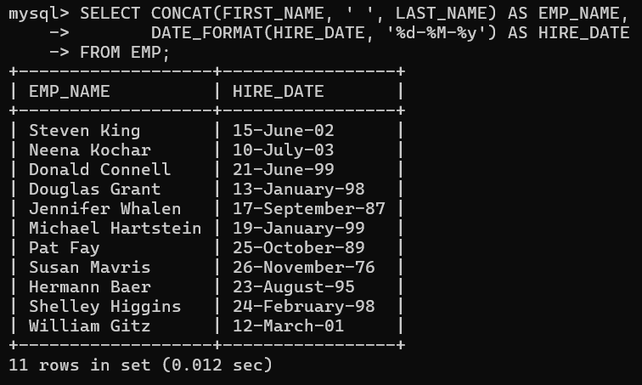

- Display the employee_id, months in which the employees were hired.
QUERY: SELECT EMP_ID, MONTHNAME(HIRE_DATE) AS HIRE_MONTH FROM EMP;

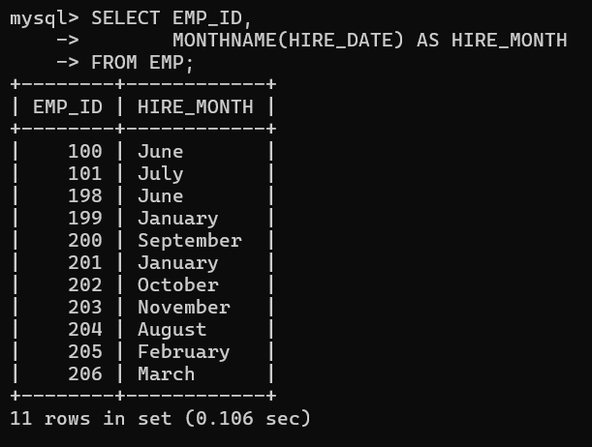

- Display the employee name, Employee id and the hire date of all employees in the format ‘dd-mon-yyyy’.
QUERY: SELECT CONCAT(FIRST_NAME, ' ', LAST_NAME) AS EMP_NAME, EMP_ID, DATE_FORMAT(HIRE_DATE, '%d-%b-%Y') AS HIRE_DATE
FROM EMP;

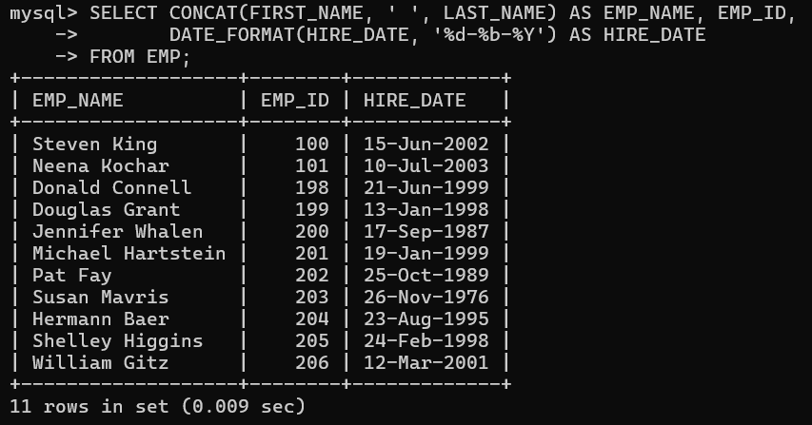
- Display the employee name, Employee id and the hire date of all employees in the format ‘month-dd-yyyy’.
QUERY: SELECT CONCAT(FIRST_NAME, ' ', LAST_NAME) AS EMP_NAME, EMP_ID, DATE_FORMAT(HIRE_DATE, '%M-%d-%Y') AS HIRE_DATE FROM EMP;

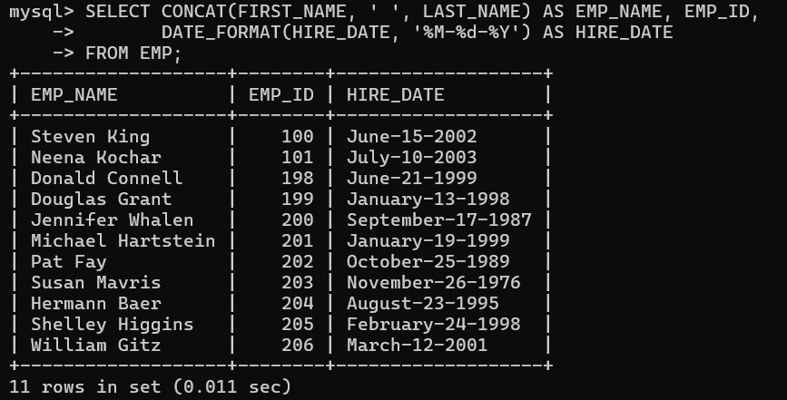

- Display the system year in full spelling.(Ex: Nineteen Ninety Nine for 1999)
QUERY:

- Find date, 15 days after today’s date, 15 days before today’s date.
QUERY: SELECT CURDATE() AS TODAY, DATE_ADD(CURDATE(), INTERVAL 15 DAY) AS `15_DAYS_AFTER`, DATE_SUB(CURDATE(), INTERVAL 15 DAY) AS `15_DAYS_BEFORE`;

- Ensure the domain constraint and entity integrity constraint from the above table.
QUERY: ALTER TABLE EMP MODIFY SAL DEPT_ID (DEPT_ID >= 10);
ALTER TABLE EMP ADD CONSTRAINT PK_EMP PRIMARY KEY (EMP_ID);
- Drop the domain constraint from the table.
QUERY: ALTER TABLE EMP DROP CHECK

- Drop the primary key from the table.
QUERY: ALTER TABLE EMP DROP PRIMARY KEY;

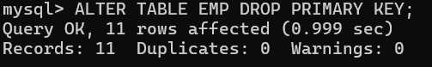

- Drop the created table.
QUERY: DROP TABLE EMP;

